Comsats University Islamabad, Lahore campus

Assignment #3
COAL

Submitted To:
Sir Hamza Hamid

Submitted by:
Zain Yaqoob
Sp24-BSE-125
Section: A

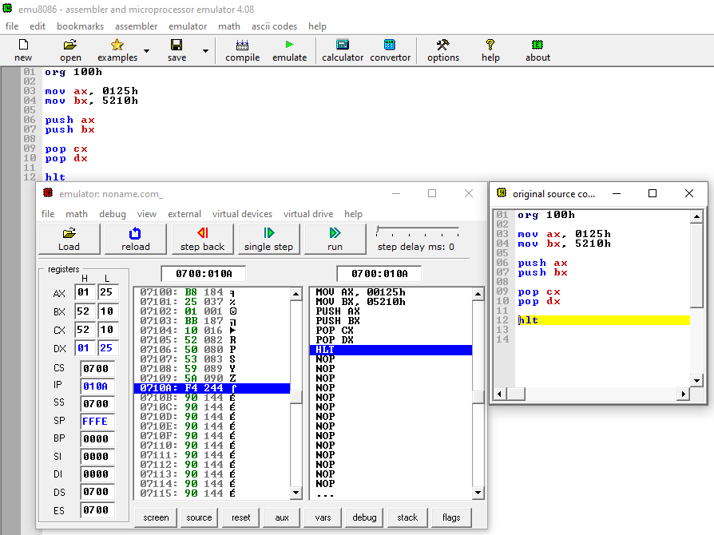
Q1
Part A.

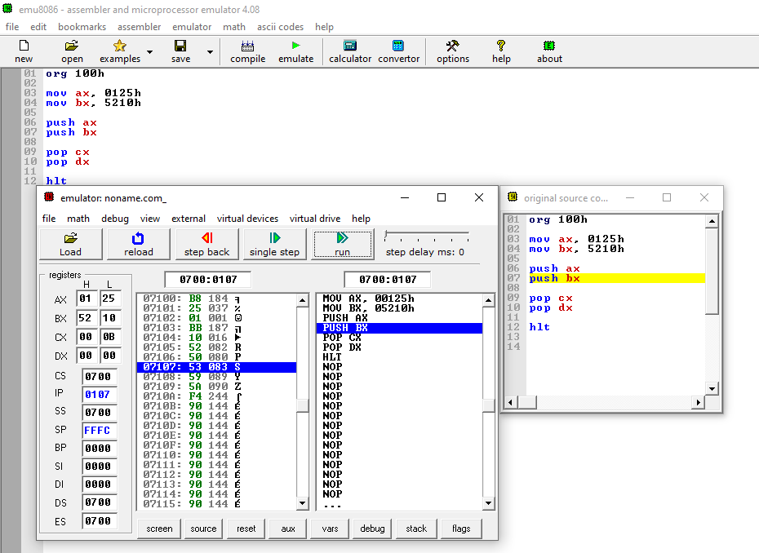
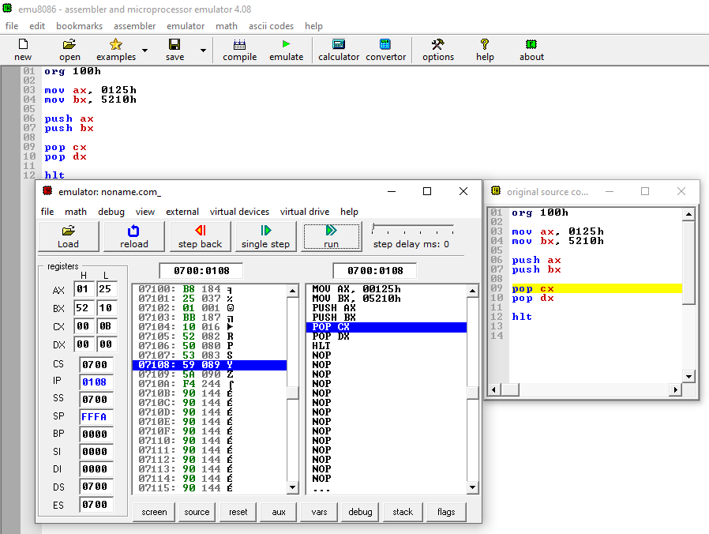

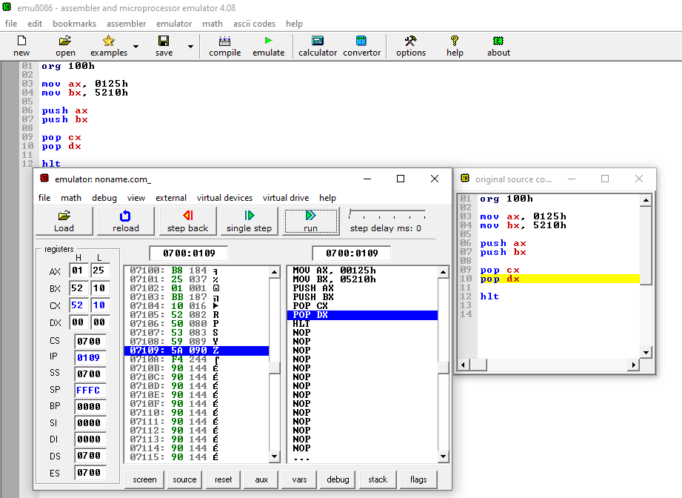

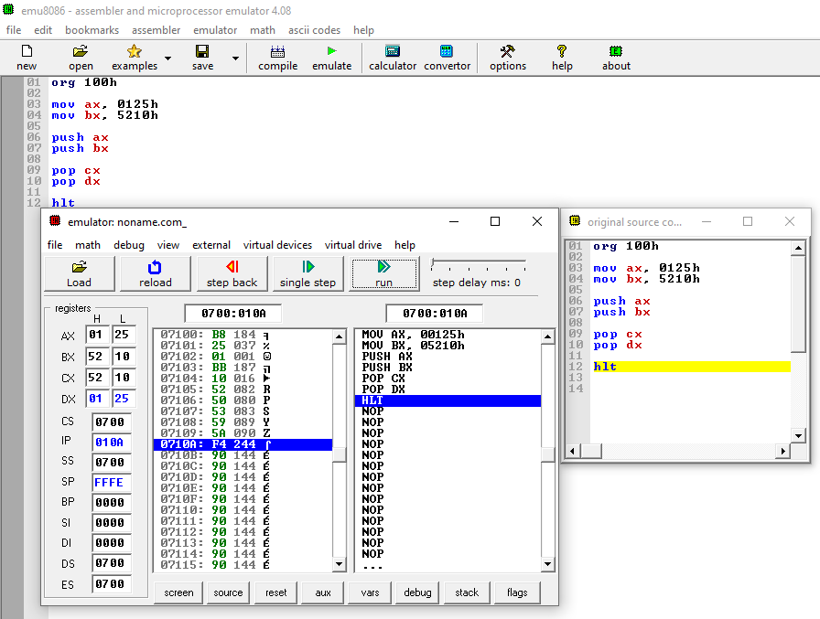

PUSH STACK POINTER MOVEMENT TABLE
Step | Instruction | SP Value | Explanation
1 | Initial | FFFEH | Initial top of stack
2 | PUSH AX | FFFCH | SP decreases by 2, stores 0125H
3 | PUSH BX | FFFAH | SP decreases by 2, stores 5210H

POP STACK POINTER MOVEMENT TABLE
Step | Instruction | SP Value | Explanation
1 | Before POP | FFFAH | Top contains 5210H
2 | POP CX | FFFCH | SP increases by 2
3 | POP DX | FFFEH | SP returns to original value

STACK MEMORY TABLE
SS:FFFA | 5210H
SS:FFFC | 0125H
Top of stack:
SP = FFFA

Part B : Ax And Bx
CX = AX AND BX
CX = 0000
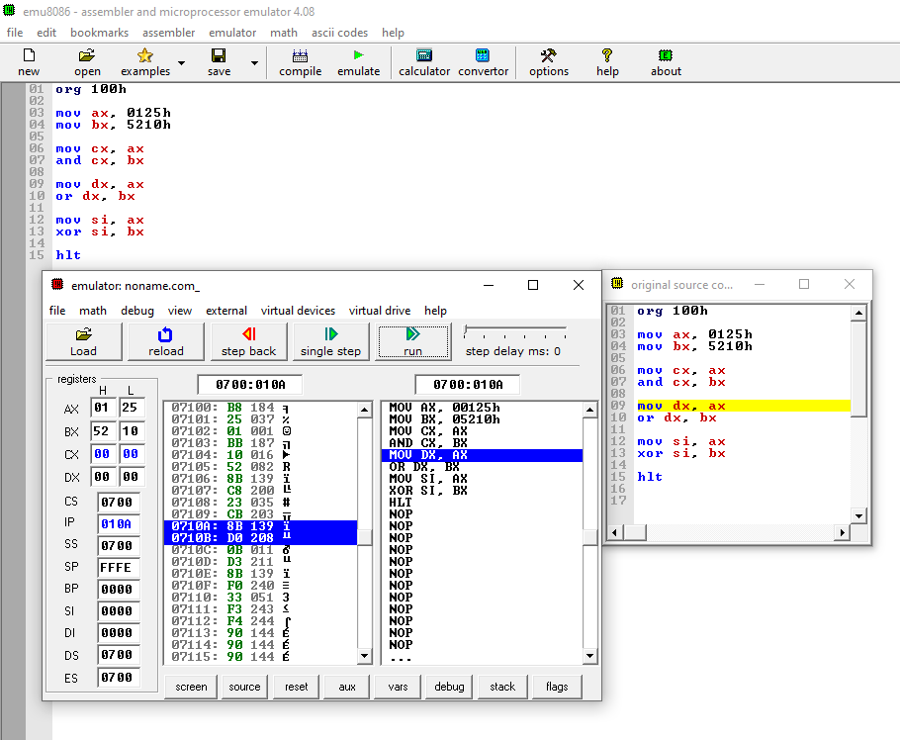

AX Or BX
DX = AX OR BX
DX = 5335
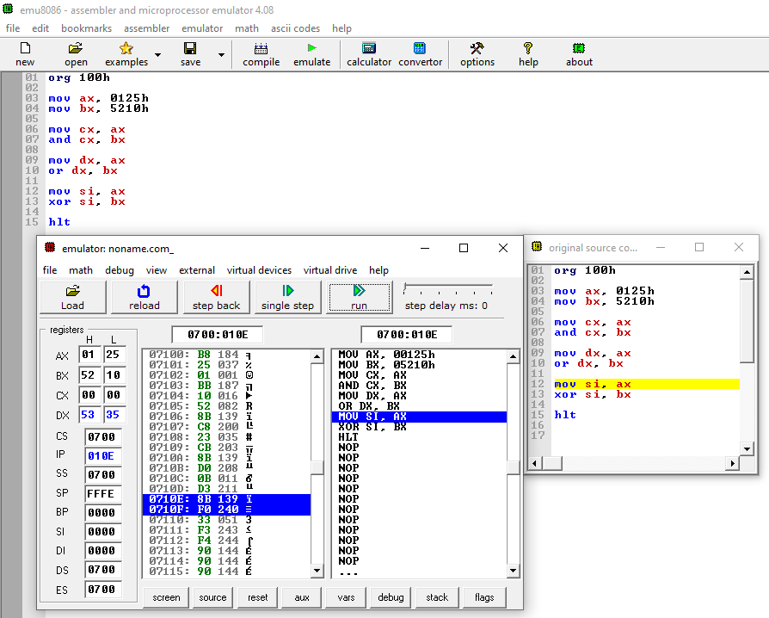

AX XOR BX
SI = AX XOR BX
SI = 5335
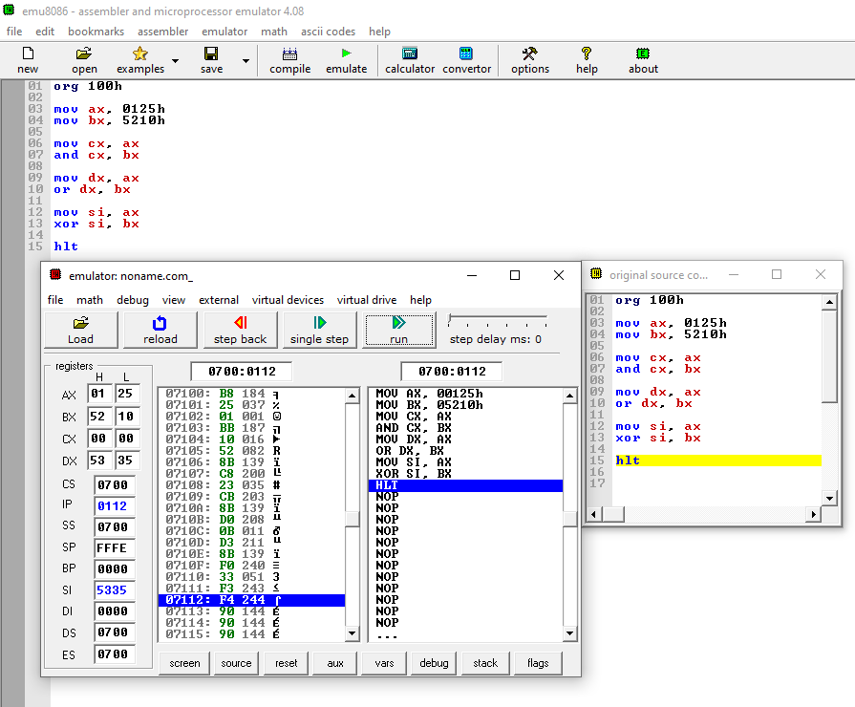

Part C : ROL DX, 3
DX = 0125H
After 1st ROL = 024AH
After 2nd ROL = 0494H
After 3rd ROL = 0928H
DX = 0928H
CF = 0
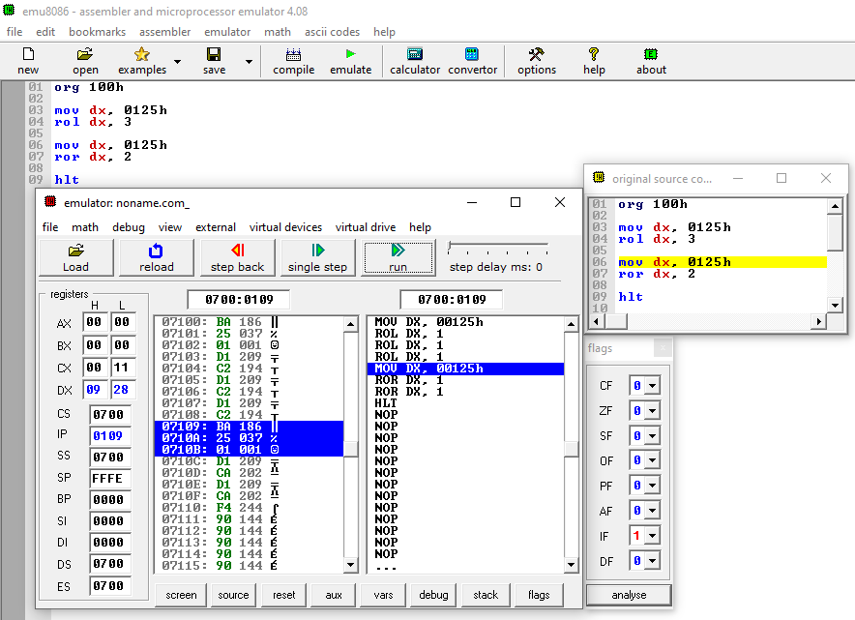

ROR DX, 2
DX = 0125H
After 1st ROR = 8092H
After 2nd ROR = 4049H
DX = 4049H
CF = 0
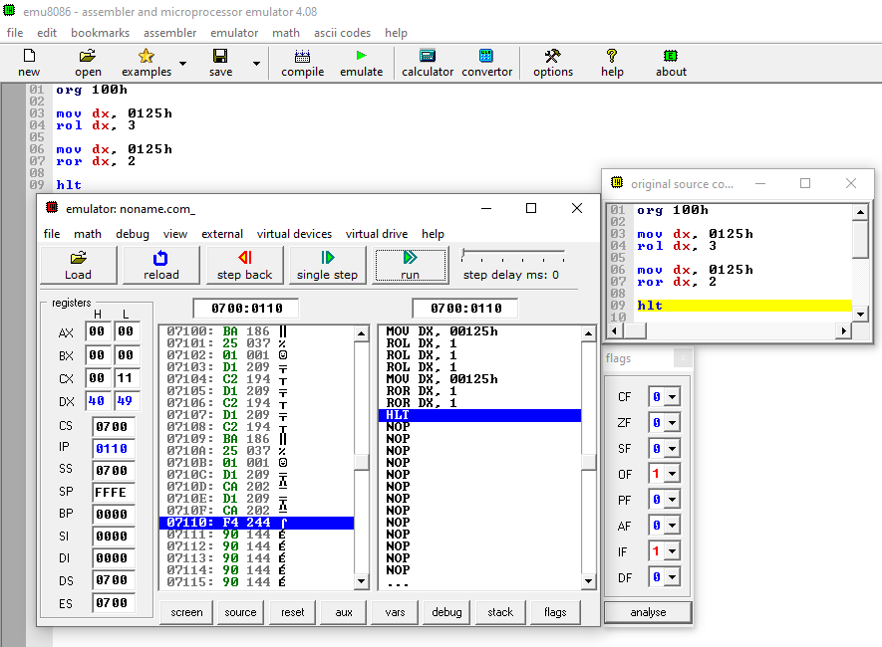

Part D :
5210H ÷ 1111H = 0004H
Remainder = 0DCCH
AX = Quotient
DX = Remainder
Register | Value
AX | 0004H
DX | 0DCCH
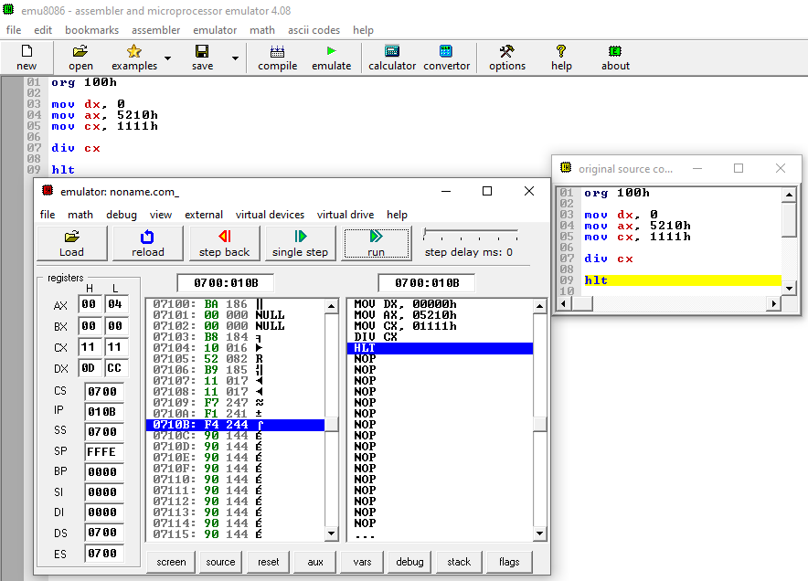

Part E :
STACK WORKING
Push phase
Stack contains: 5 -> 4 -> 3 -> 2 -> 1
Pop + Add
5 + 4 + 3 + 2 + 1 = 15
FINAL MEMORY RESULT
Memory Address | Value
0200H | 0005H
0202H | 000FH
