COMSATS University Islamabad, Lahore Campus


Operating System Assignment #01

Submitted to: Ma’am Zeenat Afzal

Submitted by: Samiullah Ashfaq
Roll# SP24-BSE-107-A

head:
Displays the first part of a file (by default first 10 lines).
Used to quickly preview the beginning of large files.
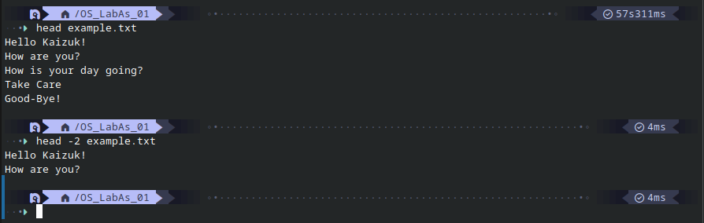

Tail:
Displays the last part of a file (by default last 10 lines).
Often used to monitor logs in real time.

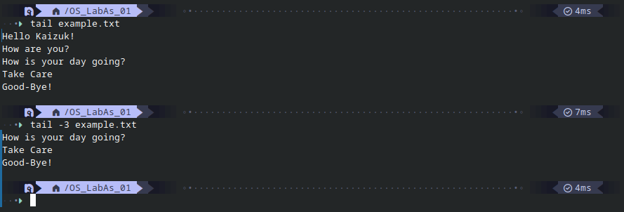

grep:
Searches for a specific pattern or text inside files.
Prints lines that match the given pattern.

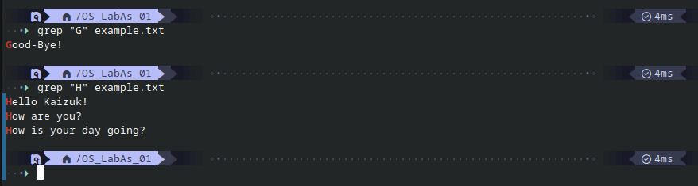

chmod:
Changes file or directory permissions.
Controls read, write, and execute access.

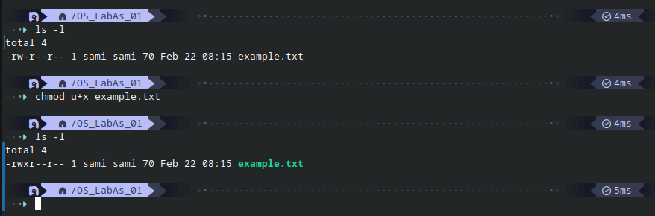
useradd:
Creates a new user account on the system.
Sets up basic user information.
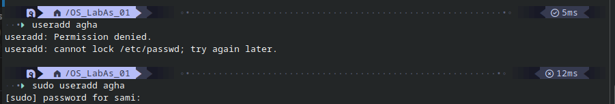
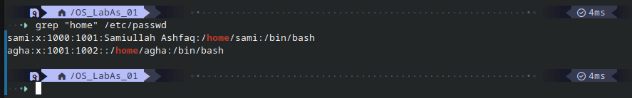

passwd:
Sets or updates a user’s password.
Ensures secure authentication for accounts.

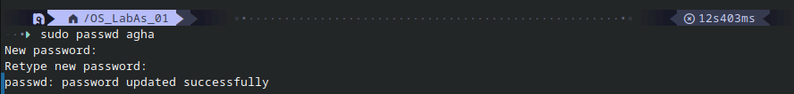
find:
Searches for files and directories in a specified path.
Filters results based on name, size, type, or other criteria.

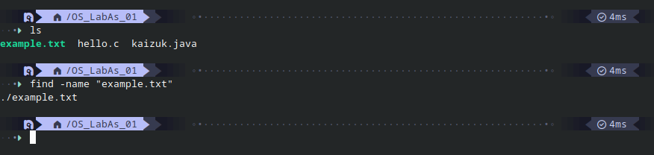

Diff:
Compares two files line by line.
Shows the differences between them.
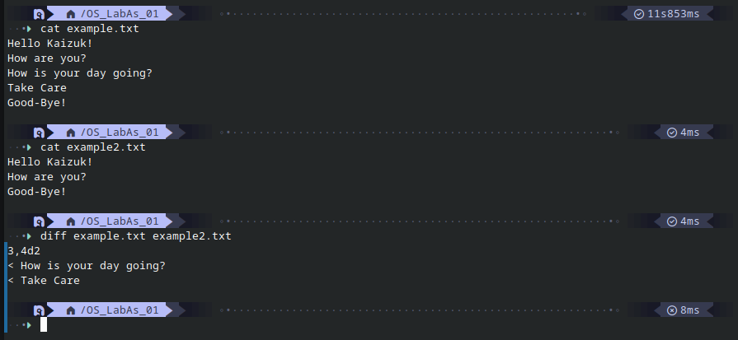
gdb:
A debugger used to test and troubleshoot programs.
Helps analyze crashes and inspect program execution.
