Feature | Well-Structured Problems (WSPs) | Ill-Structured Problems (ISPs)
Definition | Problems with a single "right" solution and clear tests for correctness. | Problems with no explicit formulation and many possible solutions.
Evaluation | Solutions are either Right or Wrong. | Solutions are characterized as Good or Bad.
Stopping Rule | Clear tests demonstrate when the solution is found. | No "stopping rule"; no way to know if the "best" solution is reached.
Method | Solved via mathematical or logical analysis. | Solved via a design process.
Examples | Quadratic equations, financial modeling, database transactions. | Face/voice recognition, bridge building, software development.
CH1: SDA

CH 2
2. Design as a Noun and a Verb
The word "design" is used in two primary ways. You should memorize the two types of the Noun form specifically.
A. Design as a Noun
When used as a noun ("a design"), it refers to a plan for how a goal is to be achieved.
- Physical/Product Design: A plan for how to construct something (e.g., a blueprint for a house or a model of a product).
- Process Design: A plan for how to perform something (e.g., a workflow or a sequence of steps to complete a task).
- Example for Exam: "The architect presented a design (noun) for the new library." This design is a physical model/plan that tells builders how to construct the walls and roof.
B. Design as a Verb
When used as a verb ("to design"), it refers to the act or process of producing that plan. It is a creative activity aimed at creating something that does not yet exist.
- Example for Exam: "The engineer began to design (verb) the bridge." This refers to the creative thinking, sketching, and decision-making process she is currently doing.

CH3
👉 Abstraction means:
Ignore unnecessary details and focus only on what matters.
Why?
- It makes the system easier to understand
- It reduces mental effort (cognitive load)
- It helps us think clearly about the important parts only
In short:
Abstraction = hide small details, keep only useful ideas

👉 What is the real goal of design?
To produce a design solution that satisfies a need.
That need is written in a requirements specification
(Which can be:
- very small notes
- or a long formal document)
Then the designer:
- Creates a design model
- Thinks about different possible options
- Compares them
- Chooses the best one
Example of a big early decision:
👉 Which architecture style should the system use?

After the designer creates a design…
👉 Other people must understand it.
- After the design solution has been created according to a specific need and a design model is also been structured
Next step is to implement the design model
For that u need to communicate your design model to the others so others can understand and implement it.
- This idea originally came from traditional engineering
(buildings, machines, etc.)
- That is why early software design followed a very strict sequence of steps
(like the waterfall idea).
Meaning:
first complete the design
then start implementation
This slide fixes the problem of the previous thinking.
In real projects:
👉 design is NOT always completed before coding.
Instead:
- design and development happen together
- the design can change as we learn more

This is especially useful when:
- requirements are unclear
- the system is still being understood
This leads to more agile-style development.

If a large team is going to build the software,
what must the design model explain?
1️⃣ Overall architecture
- what are the main parts of the system?
- what does each part do?
- how do they interact?
2️⃣ Data objects
- what real-world things are being represented?
- what data does the system store and use?
3️⃣ Algorithms
- what main methods or procedures are used to achieve the functions?
4️⃣ Packaging and organization
- how are components grouped?
- how is the project structured?
5️⃣ Interaction and dependencies
- which parts depend on which other parts?
- what events trigger actions?
- how components communicate?
6️⃣ Interaction with the environment
- users
- browsers
- other software
- external systems

✅ Minimum Coupling
Coupling = how much one module depends on another module
Modules can be:
- classes
- functions
- processes
Minimum meaning:
👉 Keep connections between modules as small as possible
If module A depends heavily on module B, then:
- changing B may break A
Module A can depend on module B by:
- calling its methods
- using its data
- inheriting from it
All of these create dependency.

✅ Maximum Cohesion
Cohesion = how well the things inside one module belong together
Simple meaning:
👉 Everything inside one module should be related to the same job
Example:
If a class stores car information,
then its methods should only:
- update that car data
- display that car data
Not unrelated work.

✅ Information Hiding (Encapsulation)
Simple idea:
👉 Hide internal data and implementation details from other parts of the system.
Other modules should not touch your data directly.
They must use methods.So that later you can change:
- how data is stored
- how it is organised
without breaking other parts.

✅ Evolution of Design Ideas
In the past, designers mainly learned by:
- experience
- working with others
Later, design improved because of:
1. Scientific knowledge
Design started using real scientific understanding.
The slide gives an example of
Christopher Wren,
who designed famous buildings such as
St Paul's Cathedral
and worked as a scientist and mathematician.
2. Reuse
Instead of building everything from scratch:
👉 reuse existing components
Benefits:
- faster development
- cheaper
- less work
But trade-off:
👉 you depend on someone else’s software
👉 sometimes you must design around what already exists
Reuse in software includes:
- patterns
- components
- product lines
✅ Satisficing
Very important exam word.
Satisficing means:
👉 choosing a solution that is “good enough”
👉 not the perfect solution
Why designers do this:
- limited time
- not enough information
- problem is too complex
Often:
👉 the first solution that fits is accepted
Risk:
👉 a solution copied from another system may not fully suit the new context
✅ Nature of Expert Design Knowledge
The slide refers to the idea of “shells of knowledge” by
Fred Brooks.
He says design knowledge can be grouped into three types.

1. Findings
👉 Strong, scientifically proven results
Example:
- results from well-conducted research
Most reliable type.

2. Observations
👉 Things seen in real projects or studies
They describe what happened,
but are not as strong as scientific proof.

3. Rules of Thumb
👉 Practical advice based on experience
Usually:
- not backed by strong data
- but still useful
Example:
- tips from experienced developers

📘 CHAPTER 4 – Software Architecture

1. Software Architecture
Definition:
Software Architecture is the set of principal design decisions about a system software.
👉 It acts as the blueprint for constructing a software system.
Design Principles include:
- Structure → How system components are organized
- Behavior → How components act
- Interaction → How components communicate
- Non-functional Properties → Performance, security, scalability, etc.

2. Principal
Definition:
“Principal” refers to the criteria that decides the importance of design decisions that make them architectural.
👉 Not all decisions are architectural.
Examples:
- ❌ Not architectural → Color of UI (doesn’t affect system)
- ✅ Architectural → Model like MVC (affects system design)
Key Point:
What is “principal” depends on stakeholders’ goals.

3. Other Definitions of Software Architecture
Perry & Wolf:
Software Architecture = {Elements, Form, Rationale}
- Elements → What
- Form → How
- Rationale → Why

Shaw & Garlan:
Software architecture includes:
- Components
- Interactions
- Patterns
- Constraints

Kruchten:
- Focuses on high-level structure
- Includes:
  - Abstraction
  - Decomposition
  - Composition
  - Style
  - Aesthetics

4. Temporal Aspect
- At any given time → system has one architecture
- Over time → architecture changes/evolves
👉 Architecture is not static, it evolves with the system.

5. Prescriptive vs Descriptive Architecture
Prescriptive Architecture
- Design decided before development
- Also called:
  - As-conceived
  - As-intended

Descriptive Architecture
- What is actually implemented
- Also called:
  - As-built
  - As-realized

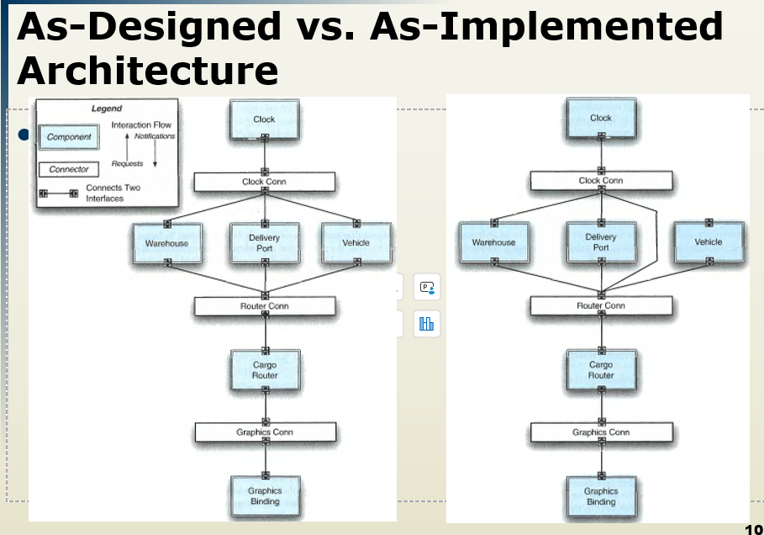

📘 Architectural Evolution & Degradation

Architectural Evolution

Ideal Process:
- Update design first (prescriptive architecture)
- Then update code (descriptive architecture)

Reality:
- Developers often change code directly
- This creates a mismatch between design and implementation

Reasons for this problem:
- Developer sloppiness
- Short deadlines (no time for proper design/documentation)
- Lack of documented prescriptive architecture
- Need/desire for code optimization
- Inadequate tools or techniques

6. Architectural Degradation
👉 Over time, the system becomes messy and harder to manage

Types of Degradation:

a. Architectural Drift
- New design decisions are added in the descriptive architecture
- These are NOT included in the prescriptive architecture
- BUT they do NOT violate the original design
👉 ✔ Safe but not aligned with design

b. Architectural Erosion 🚨
- New design decisions are added in the descriptive architecture
- These are NOT included in the prescriptive architecture
- AND they DO violate the original design
👉 ❌ Dangerous — breaks the system’s architecture

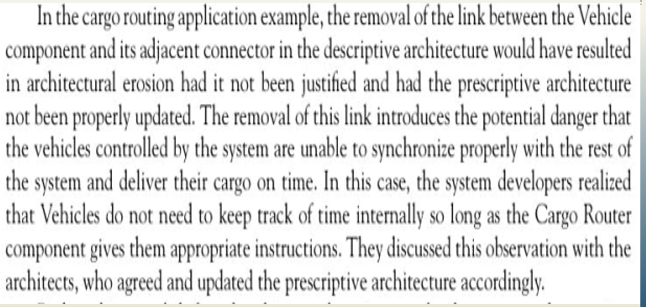

📘 7. Architectural Recovery
Definition:
After architectural degradation, it becomes necessary to recover the system’s architecture.
👉 Architectural Recovery is the process of identifying a system’s architecture from its implementation-level artifacts.
Implementation-Level Artifacts include:
- Source Code
- Executable Files
- Java .class Files

📘 8. Deployment
Definition:
A software system must be deployed to fulfill its purpose.
👉 Deployment means placing all executable modules on actual hardware where they will run.

Why Deployment is Important:
- Helps determine if the system meets its requirements
- Ensures the system works in a real environment
Possible Assessment Dimensions:
- Available Memory → Does the system fit in memory?
- Power Consumption → How much energy it uses
- Network Bandwidth → How much internet/data is required
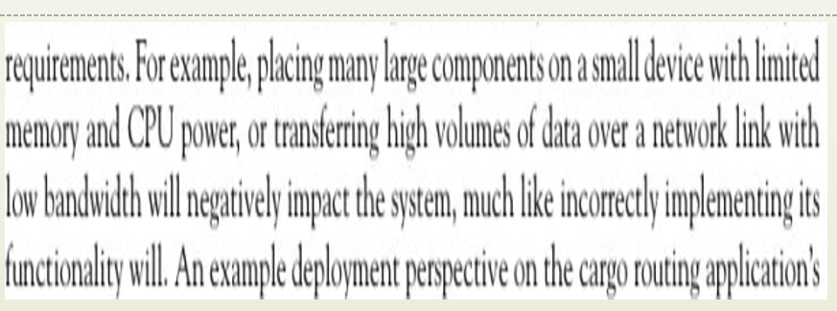
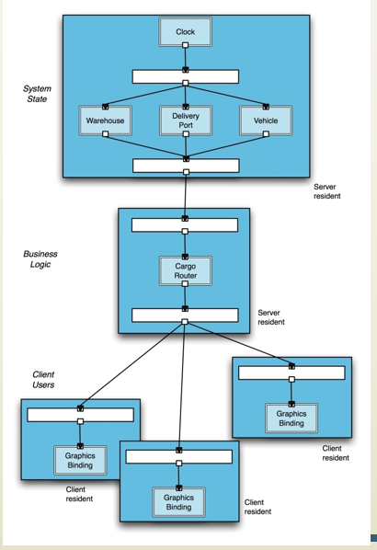

📘 9. Software Architecture’s Elements
A software system’s architecture should not be a single monolith.
Instead, it is usually composed of multiple parts (often microservices).
Main Elements:
- Processing → Logic/operations
- Data (Information/State) → Stored information
- Interaction → Communication between parts

📘 10. Components
Definition:
Components are parts of the system that contain logic (processing) and data.
Key Characteristics:
- Encapsulate a specific part of system functionality
- Restrict access via a well-defined interface
- Have explicit dependencies
- Provide application-specific services

Example (Uber Eats):
- Order Service → Handles orders
- Payment Service → Handles payments
- User Service → Stores user data

📘 11. Connectors
Definition:
Connectors are architectural elements that handle interaction between components.

Examples:
- Function Calls → One module calls another
- APIs → Frontend communicates with backend
- Messages → Communication between services
- Shared Database

Real Example:
User clicks “Order”
➡ Frontend → Backend API → Payment Service
👉 This communication path = Connector

Types of Connectors:
- Procedure Call → Function calling another function
- Shared Memory → Multiple components share data
- Message Passing → Communication via messages
- Streaming → Continuous data flow (e.g., Netflix)
- Distributed → Across multiple machines
- Wrapper/Adapter → Converts formats

📘 12. Configuration
Definition:
An architectural configuration (or topology) is the arrangement of components and connectors in a system.
👉 It defines how everything is connected

📘 13. Architectural Styles
Definition:
An architectural style is a set of design decisions used as a template to build systems.

Examples:
- Client-Server
- Layered Architecture
- Microservices

Why use them?
- Efficient
- Scalable
- Reliable

📘 14. Architectural Patterns
Architectural patterns are reusable solutions to common design problems.

Example: Three-Tier Architecture
- Front Tier (UI)
  - User interface
  - Interaction with users
- Middle Tier (Logic)
  - Core functionality
  - Business logic
- Back Tier (Data)
  - Data storage
  - Database handling

📘 15. Model / Visualization / View
Architecture Model:
- A document describing architectural decisions
Architecture Visualization:
- A way to present architecture (e.g., diagrams)
Architecture View:
- A subset of the architecture focusing on specific concerns
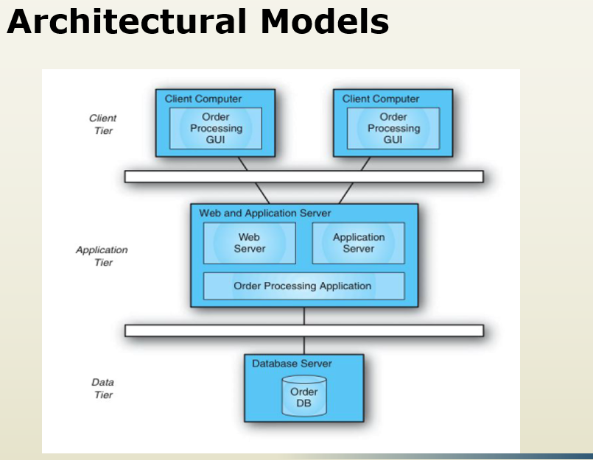

📘 16. Architectural Processes
Lifecycle of Architecture:
- Design the system
- Create diagrams
- Analyze performance
- Implement (coding)
- Deploy system
- Improve (adaptation)

📘 17. Stakeholders
People involved in the system:
- Architects → Design the system
- Developers → Build the system
- Testers → Test the system
- Managers → Plan and manage
- Customers → Pay for the system
- Users → Use the system

CH 5
Main program and Subroutine:
The Main Program and Subroutines architectural style is one of the oldest and most fundamental patterns in software engineering. It follows a "top-down" decomposition approach where a single controller manages the execution of specialized tasks.
Based on your provided image of the "Lunar Lander" system, here is a detailed breakdown of how this style works both in that specific context and in general.

1. Analysis of the "Lunar Lander" Example
In the provided diagram, the architecture is organized into a clear hierarchy:
- The Main Program (The Controller): The "Lunar Lander Main Program" acts as the orchestrator. It doesn't necessarily perform the physics calculations or the UI rendering itself; instead, it decides when those things happen.
- Procedure Calls (The Connectors): The lines connecting the boxes represent "Control Flow." The main program "calls" a subroutine, waits for it to finish, and then moves to the next one.
- Subroutines (The Workers): * Get BurnRate: Handles input.
  - Environment Simulator: Handles the "business logic" or physics (updating altitude and fuel).
  - Display Values: Handles the output.
This specific example shows a cyclic execution: the main program likely loops through these three calls repeatedly to simulate the lander's descent in real-time.
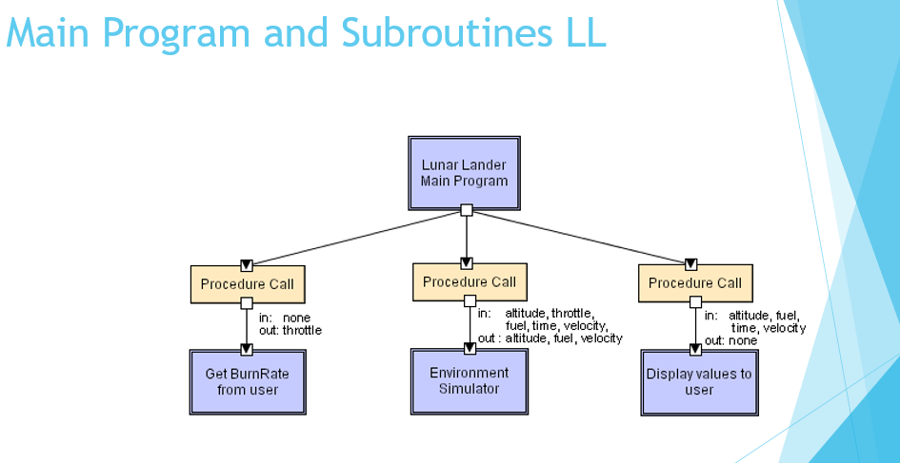

2.Object-Oriented Style
- Components = objects
- Communication = methods/messages

Key idea:
- Each object manages its own data and is hidden from other objects

✅ Advantages:
- Flexible
- Easy to modify

❌ Disadvantages:
- Objects must know each other and identity of servers
- Can cause side effects
💡 Example:
- Java, C++ systems
Clean Code vs. Method Invocation
The bullet point "Clean Code Vs Methods Invocation" refers to a classic architectural tension:
- The "Clean Code" Ideal: Ideally, a function should be "pure"—meaning it takes an input, returns an output, and has zero side effects. This makes code very easy to test and reason about.
- The OO Reality: In OO, methods are designed to interact with and change the state of the object. By definition, they often produce side effects.
- The Conflict: As you invoke more methods across different objects, the chain of side effects becomes harder to manage. If Object A calls Object B, which changes Object C, debugging a "wrong value" becomes a game of hide-and-seek.

