KIRANA STORE — ANALYSIS BRIEF
45 orders · 9 customers · 10 products · 1–22 August 2026
Rs 22,885  Total sales | Rs 1,040  Per day | Rs 509  Per order | 76.6%  Cash collected | Rs 5,365  Not confirmed paid

1. Analysis
The file holds 45 order lines from 1 to 22 August 2026, where each row is one product bought by one customer on one day — there are no multi-item baskets. Nine customers bought 114 units across 10 products, from Rs 20 salt to a Rs 1,450 rice bag, and every product held one fixed price all month, so nothing in this data is explained by a discount or a price change.
Seven data problems had to be fixed before any of it could be trusted. Six orders had no amount written (Rs 2,235 of sales), one total was simply wrong — BKS-018 records Rs 1,200 for two jars of ghee that come to Rs 1,120 — and three orders carry no payment status at all (Rs 1,050, every one of them Neha Verma's). Beyond that, the same nine customers appear under twelve spellings, dates are written in five different formats, and “Paid” turns up as Paid, paid and PAID. None of it was fatal: dates all resolved unambiguously, names standardised to nine real customers, and amounts were recomputed as quantity × price. But the correction matters — the register as written adds up to Rs 20,730 while the true figure is Rs 22,885, so the shop's own book undercounts its sales by Rs 2,155, or 9.4%.
Corrected, the shop turned over Rs 22,885 in 22 days: Rs 1,040 a day, Rs 509 an order, with sales on every single day. Rice 25kg alone brought Rs 8,700 — 38% of everything — from just five orders, and together with Atta 10kg and Ghee 1kg accounts for 65% of income. At the other end, salt and biscuits moved 46 of the 114 units sold and returned Rs 1,130. Customers are similarly top-heavy: the three biggest gave 58% of sales, led by Harpreet Singh at Rs 6,390.
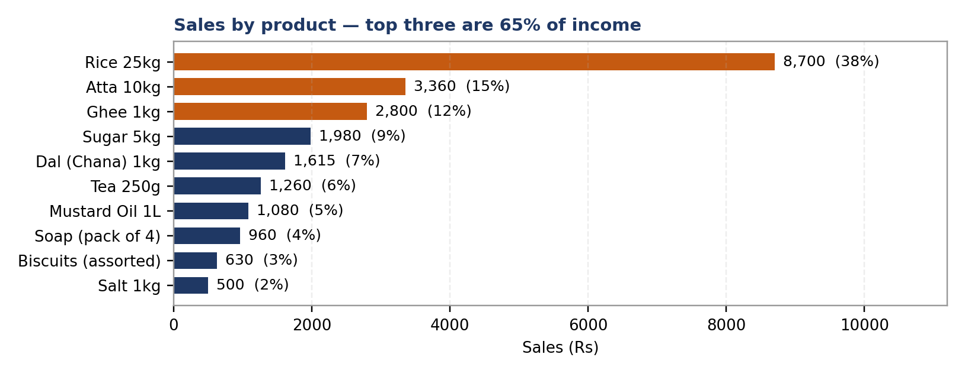
All nine customers are repeat buyers, though that itself is a clue — with a near-perfect two orders a day from a fixed cast of regulars, this is an extract of the ledger rather than the full trading record, so rankings inside it are reliable while total turnover is not. Cash confirmed received was Rs 17,520 against Rs 22,885 of goods handed over, a collection rate of 76.6%. Profitability cannot be assessed at all: the file contains no cost, purchase price or expense field, only the selling price — any margin quoted here would be invented rather than measured.
2. Insights
One bag of rice carries a third of the shop. Rice 25kg produced 38% of sales from five orders, and the top three products together produce 65%. Because rice sells in ones and twos, a single missed sale is visible in the day's takings. A week out of stock, or a neighbouring shop pricing a 25kg bag Rs 50 lower, would put roughly a third of turnover at risk — so these three lines need checking daily, and the local rice price monthly.
Effort and income point in opposite directions. Salt and biscuits are 40% of everything physically handed across the counter but under 5% of the money, while rice and ghee are a tenth of the units and half the income. The cheap items are worth keeping because they bring people in, but they should stop consuming prime shelf space and stock money; the Rs 400-plus staples belong in the customer's line of sight.
The most frequent customer is the least valuable. Ramesh Kumar visits more than anyone — seven orders — but pays cash on only two, so the shop has actually received Rs 1,400 of the Rs 3,615 he has taken. Harpreet Singh comes less often, spends Rs 1,278 an order against a shop average of Rs 509, and has never once taken credit. Visit frequency is not value: rank customers by cash received, and protect the top three, who are 58% of sales.
Nothing here is declining, despite appearances. Order count sits flat at two a day while daily takings swing from Rs 270 to Rs 3,020, because the day's total depends on whether a big-ticket item sold rather than on how many people walked in. The 10% gap between the first and second half of the month is simply where the rice orders landed, not a downward trend — and 22 days is far too short to say anything about seasons or weekdays.
3. Flags
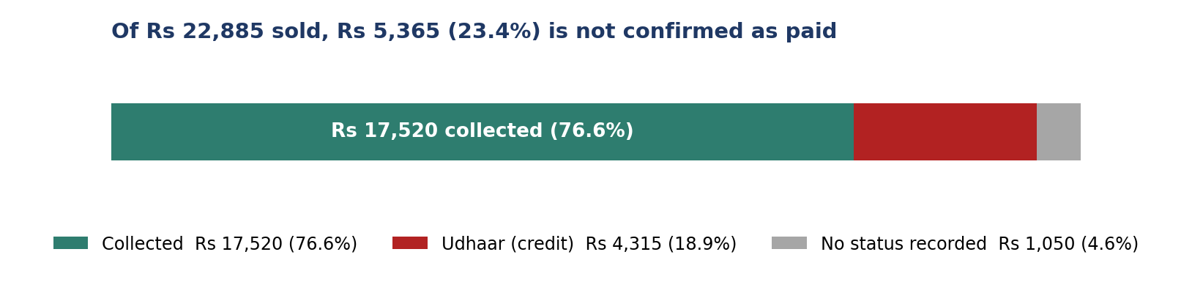
FLAG 1 — Untracked udhaar (urgent)
Rs 4,315 of sales went out on credit and another Rs 1,050 carries no payment status — together Rs 5,365, or 23.4% of the month's sales, roughly 5.2 days of trading in goods the shop has paid a supplier for and cannot prove it has been paid back for. Eight of the nine customers took credit, and Ramesh Kumar alone accounts for Rs 2,215, more than half the entire credit book. The register has no repayment date, no due date and no running balance, so there is no way to tell which of that Rs 5,365 has quietly been settled and which is lost. The pattern also worsens under pressure: Week 2 was the weakest week for takings and ran 42% on credit, and the single largest credit item was a Rs 1,450 rice bag — credit is being extended on exactly the goods the shop can least afford to wait for.
What to do. Open a proper udhaar register (date, name, amount, due date, date repaid, running balance). Cap credit at about Rs 500 per customer — twelve of the thirteen credit orders were already below that, so it costs almost no goodwill while stopping the rice bag and Ramesh's accumulation. Take cash only on rice and ghee, and agree an instalment plan with Ramesh that keeps the customer while changing the terms.
FLAG 2 — The record itself is unreliable
Six missing amounts, one wrong total, three missing payment statuses, three customers spelled two ways and five date formats mean the owner is running the shop on a sales figure 9.4% too low, cannot say who owes what, and cannot even look a customer up because the names do not match.
What to do. This is a habit, not a system: one date format, one spelling per customer, and the amount and payment status filled in every single time would have prevented all seven issues at no cost — pre-print the columns if the register is a paper book. Then add one more column, the purchase price paid to the supplier. That single field is the difference between knowing what the shop sells and knowing what it earns.
What to do first
NOW Open the udhaar register · cap credit at ~Rs 500 a customer · cash only on rice and ghee · instalment plan with Ramesh Kumar (Rs 2,215) · fix the entry habit · never stock out of rice, atta or ghee.
SOON Add a purchase-price column · look after the top three customers (58% of sales) · shelve by value rather than by speed of movement · trial paid delivery, which two of the four note entries already ask for · stop over-ordering salt and biscuits.
LATER Add one or two mid-priced lines to dilute the 38% rice share · build three to six months of clean records before judging seasons or festivals · try small add-on offers at the counter and watch whether the Rs 509 average order rises.
In short. Demand is steady, all nine customers are repeat buyers and nothing is in decline. But a quarter of what was sold has not been confirmed as paid, half of that sitting with one person, and 38% of income rests on a single product. Neither problem needs money to fix — only discipline at the counter.

