DAY 3 · TASK 2 — DATA ANALYSIS USING CLAUDE
Task: To analyse the given dataset, get insights, and report flags
Name: Samiya Sehgal URN: 2302662
KIRANA STORE PERFORMANCE DASHBOARD
1–22 August 2026 · 45 orders · 9 customers · 10 products · 114 items sold
Rs 22,885  Total sales | Rs 1,040  Sales per day | Rs 509  Per order | 114  Units sold | 22  Trading days

Rs 17,520  money received (76.6%) | Rs 5,365  not yet paid (23.4%) | 38%  of money from one product | 58%  of money from 3 customers | Rs 2,155  missing from the register
01 SALES Rs 22,885 in 22 days · the shop sold something every single day
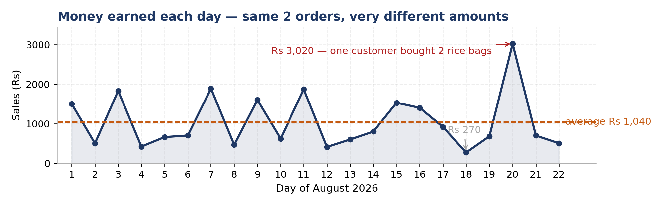
The shop got about two orders every day. But some days brought Rs 3,020 and some only Rs 270. The reason is simple: on a good day, someone bought a big item like a rice bag. The number of customers did not change much. So the shop is not slowing down — the daily money just depends on who buys something big.
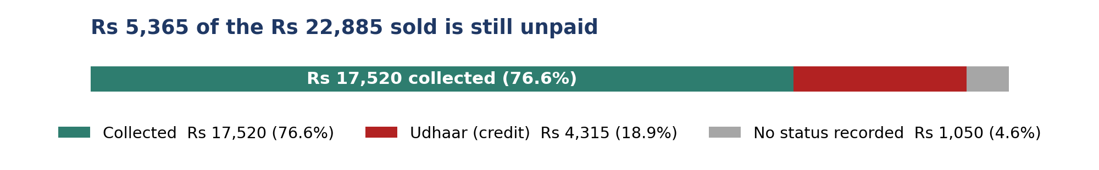
Green is money the shop actually received. Red is goods given on udhaar. Grey is orders where nobody wrote down whether the customer paid or not.
SIMPLE IDEA — Sales are not the same as money in hand
A sale happens the moment goods leave the shop. Cash happens only when the customer pays. When a shop gives udhaar, the two are not the same day — and sometimes not the same month. This is why a shop can look busy and still have an empty cash box. Always ask two questions, not one: how much did I sell, and how much did I actually receive?
02 PRODUCTS One item — Rice 25kg — brings 38% of all the money
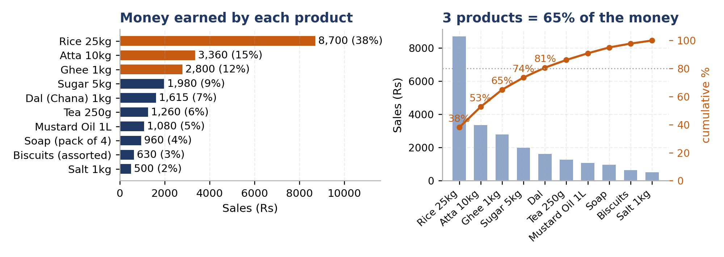
Left: how much money each product brought in. Right: the same products from biggest to smallest. The orange line shows the running total — just 5 of the 10 products give 81% of all the money.
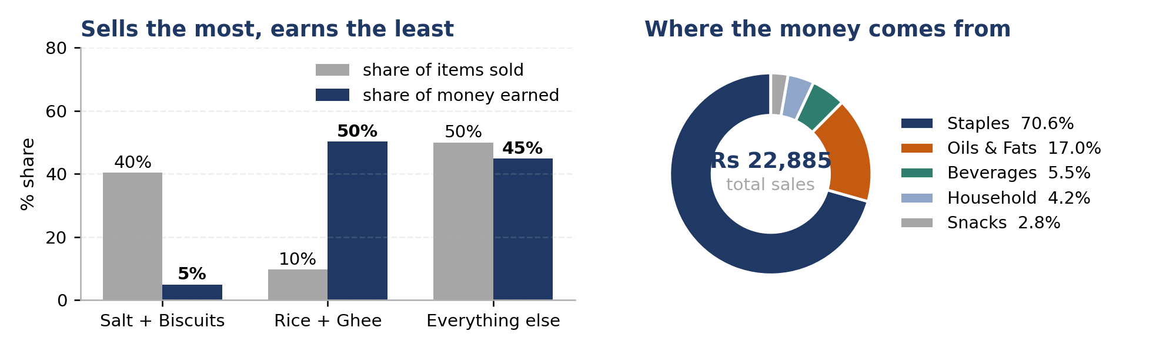
Left: grey is how many pieces were sold, blue is how much money they brought. Salt and biscuits sell a lot but earn little. Right: staples (rice, atta, sugar, dal, salt) bring 70.6% of the money.
SIMPLE IDEA — The 80–20 rule
In almost every shop, a small number of items brings most of the money. People call this the 80–20 rule: about 20% of the products give about 80% of the earnings. Here it is even sharper — 3 products out of 10 give 65%. This is useful in two ways. It tells you which few items you must never run out of. And it warns you that if one of them stops selling, a big part of your income stops with it. That is called depending on too few items.
03 CUSTOMERS 9 regular buyers · the top 3 give 58% of sales · 8 of them take udhaar
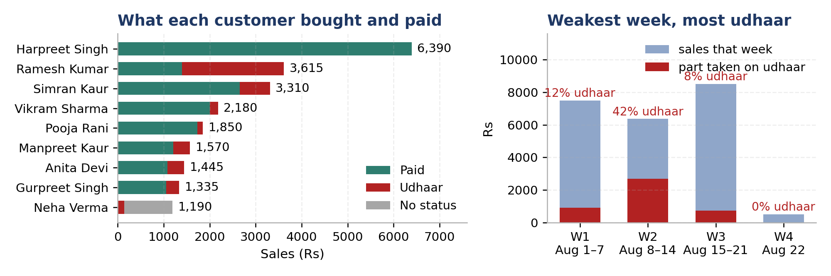
Left: what each customer bought, and how much of it they actually paid for (green = paid, red = udhaar, grey = not written down). Right: each week's sales, with the udhaar part in red. Week 2 was the weakest week and also the biggest udhaar week.
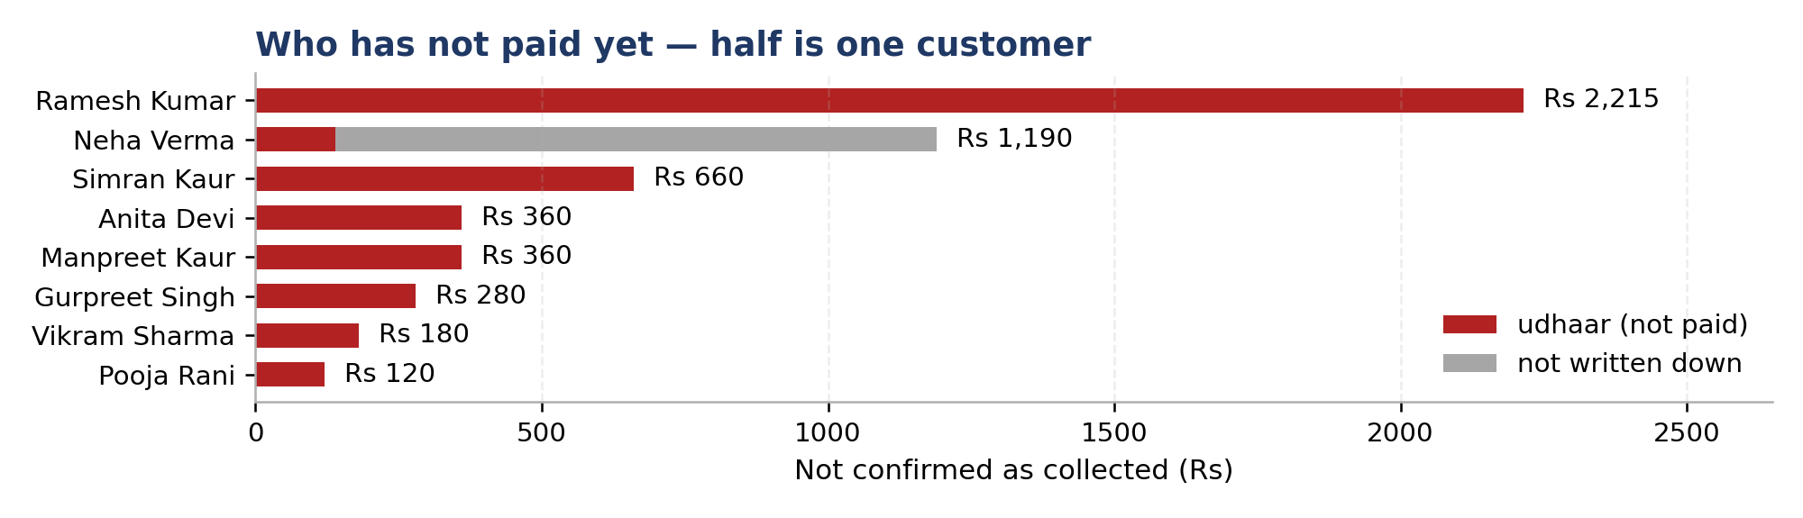
How much money each customer has not paid yet. Harpreet Singh is not on this list at all — he is the biggest buyer (Rs 6,390) and he always pays.
SIMPLE IDEA — A customer's value is the money you receive, not the number of visits
It is easy to think the customer who comes daily is the best one. But the shop earns from money received, not from visits. One quiet customer who pays Rs 1,278 every time is worth more than a friendly one who takes Rs 3,615 and pays back Rs 1,400. When you count your best customers, count the cash they have actually handed over.
04 ORDER SIZE & MONEY COMING IN most orders are small · a few big ones carry the month
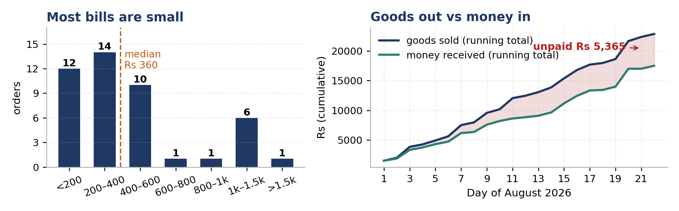
Left: most orders are small — 26 of the 45 orders are below Rs 400. Only 6 orders were above Rs 1,000, and those few orders bring most of the money. Right: the dark line is goods that left the shop, the green line is money that came in. The pink gap between them is Rs 5,365. It keeps getting wider and never closes.
SIMPLE IDEA — Working money — why unpaid amounts hurt
The money in your shop keeps going round: you buy stock, you sell it, the cash comes back, you buy stock again. Udhaar breaks this circle. The goods are gone and the cash has not returned, but the supplier still has to be paid. Here Rs 5,365 is stuck outside the shop — that is about 5 days of business. The stock is sold, but the money to replace it is not there yet.
05 HOW GOOD IS THE RECORD? 7 mistakes found in the register · all fixed before this study
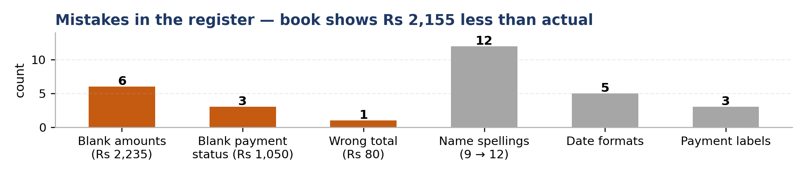
SIMPLE IDEA — Good decisions need a clean register
Every number in this dashboard came from the register. If the register is wrong, every decision built on it is wrong too. That is why the first step of any study is checking the record, not studying it. Three simple habits fix almost everything: write the date the same way, write each name the same way, and never leave a box empty. A register that can be trusted is worth more than any report.
The register has mistakes in it. Six orders have no amount written (Rs 2,235 of sales). One order was added up wrong — BKS-018 shows Rs 1,200 for two ghee jars that cost Rs 1,120. Three orders do not say whether the customer paid (Rs 1,050, all of them Neha Verma's). The same nine customers are written in twelve different ways, the date is written in five different styles, and “Paid” is written as Paid, paid and PAID. All of this was fixed before the study: missing amounts were worked out from quantity × price, and the names were matched up. The register adds up to Rs 20,730, but the real total is Rs 22,885. So the shop's own book is showing Rs 2,155 less than the shop actually sold — about 9% less.
Two things this data cannot tell us. First, we cannot work out profit at all, because the file only has the selling price — there is no record of what the shop paid the supplier. Second, the file shows almost exactly two orders a day from the same nine people, which is too neat to be every sale. It looks like a part of the register, not the whole day's business. So the comparisons here are correct, but the total sales of the shop are probably higher.
06 WHAT THIS MEANS four things worth knowing
SIMPLE IDEA — Careful — a short period can fool you
22 days is a very short time. In such a short period, one big order can make a week look great and its absence can make the next week look bad. That is why this study does not say sales are falling. Before believing a trend, or blaming a festival or a weekday, keep clean records for three to six months. Small differences in a short period are usually luck, not a pattern.
1 One product is holding up the whole shop  Rice 25kg brought Rs 8,700 — 38% of all the money — from only 5 orders. Rice, atta and ghee together bring 65%. Rice sells only once or twice a week, so even one missed sale is felt. If rice is out of stock for a week, or a nearby shop sells the same bag Rs 50 cheaper, the shop loses about one third of its business.  → Never let rice, atta or ghee finish. Check the stock every day, and check what other shops charge for rice once a month. | 2 The items that sell most earn the least  Salt and biscuits are 40 out of every 100 items handed over the counter, but they bring less than 5% of the money. Rice and ghee are only 10 out of every 100 items, but they bring half the money.  → Keep salt and biscuits — they bring people into the shop. But keep them near the counter, and give the good shelf space to rice, atta and ghee.

3 The customer who comes most often pays the least  Ramesh Kumar comes more than anyone — 7 orders — but he paid cash for only 2 of them. He took goods worth Rs 3,615 and the shop has received only Rs 1,400. Harpreet Singh comes less often, spends Rs 1,278 each visit (the shop average is Rs 509), and has never taken udhaar.  → A good customer is one who pays, not one who visits often. Take special care of the top three payers. | 4 Sales are not falling — don't worry about that  The second half of the month looks 10% lower than the first half. But that is only because more rice bags happened to sell in the first half. Orders stayed the same, two a day. Also, 22 days is too short to say anything about festivals, seasons or which weekday is best.  → Nothing is going wrong with sales. Put the effort into the two problems below instead.
07 TWO PROBLEMS TO FIX
PROBLEM 1 — Too much udhaar, and no record of it Rs 5,365 · 23.4% of sales · about 5 days of business
Goods worth Rs 4,315 went out on udhaar. Another Rs 1,050 has nothing written about payment at all. Together that is Rs 5,365 — nearly one rupee out of every four. The shop has already paid the supplier for these goods, but the money has not come back. Eight of the nine customers take udhaar, and Ramesh Kumar alone owes Rs 2,215 — more than half of all the udhaar. The biggest worry is this: the register has no column for when udhaar was paid back. So there is no way to know who has already settled and who has not. It also gets worse in slow weeks — in Week 2, the weakest week of the month, 42% of sales went on udhaar. And the biggest udhaar item was a Rs 1,450 rice bag.
What to do. Start one udhaar notebook this week with six columns: date, name, amount, when it should be paid, when it was actually paid, and how much is still left. Then set a limit of about Rs 500 for each customer. This is easy — 12 of the 13 udhaar orders were already below Rs 500, so nobody will feel bad. It only stops the big rice bag and Ramesh Kumar's growing amount. Take cash for rice and ghee. And sit with Ramesh Kumar and agree on small monthly payments — keep him as a customer, but change the rule.
PROBLEM 2 — The register cannot be trusted Rs 2,155 of sales missing from the book
Six orders have no amount. One total is wrong. Three orders do not say if the customer paid. Three customers are written in two different ways, and dates are written in five styles. Because of this, the owner is looking at a sales figure that is about 9% too low, cannot say who owes money, and cannot even search for a customer because the name is spelt differently each time.
What to do. This is only a habit, not a big change. Write the date the same way every time. Write each customer's name the same way every time. Never leave the amount or the payment column empty. If the register is a paper book, draw the columns first. And add one more column — what the shop paid the supplier for that item. That one column is the difference between knowing what you sell and knowing what you earn.
08 WHAT TO DO FIRST
SIMPLE IDEA — Sales, cash and profit are three different things
Sales is the value of goods sold: Rs 22,885. Cash is what actually reached your hand: Rs 17,520. Profit is what is left after paying the supplier — and that cannot be worked out here, because the register does not record what the shop paid for the goods. A shop can have good sales, poor cash, and still not know its profit. Adding one column for supplier cost turns all three into numbers you can see.
THIS WEEK Start the udhaar notebook. Set a Rs 500 udhaar limit per customer. Take only cash for rice and ghee. Agree small monthly payments with Ramesh Kumar for his Rs 2,215. Fill in every column of the register. Never let rice, atta or ghee finish.
NEXT FEW MONTHS Write down what you paid the supplier for each item — then you can finally see your profit. Take care of the top three customers, who give 58% of the money. Give the best shelf space to costly items, not fast-moving ones. Try home delivery for heavy items (two customers have already asked). Order less salt and biscuits.
LATER Add one or two medium-price items so the shop is not so dependent on rice. Keep clean records for three to six months, then look again for festival and season patterns. Try suggesting one small extra item at the counter and see if the average bill goes above Rs 509.
IN SHORT. The shop is doing fine. Customers come back, and sales are not falling. But two things need attention: one rupee in every four has not been paid yet, and half of that is with one person; and one product, rice, brings 38% of the money. Fixing both costs nothing — it only needs care while writing the register.

09 ALL THE NUMBERS the full detail behind this dashboard
Products — how much each one sold and earned
Product | Price | Orders | Units | Sales (Rs) | % of sales | On credit (Rs)
Rice 25kg | 1,450 | 5 | 6 | 8,700 | 38.0% | 1,450
Atta 10kg | 420 | 5 | 8 | 3,360 | 14.7% | 0
Ghee 1kg | 560 | 4 | 5 | 2,800 | 12.2% | 0
Sugar 5kg | 220 | 5 | 9 | 1,980 | 8.7% | 0
Dal (Chana) 1kg | 95 | 5 | 17 | 1,615 | 7.1% | 665
Tea 250g | 140 | 5 | 9 | 1,260 | 5.5% | 840
Mustard Oil 1L | 180 | 4 | 6 | 1,080 | 4.7% | 540
Soap (pack of 4) | 120 | 4 | 8 | 960 | 4.2% | 720
Biscuits (assorted) | 30 | 4 | 21 | 630 | 2.8% | 0
Salt 1kg | 20 | 4 | 25 | 500 | 2.2% | 100
Total |  | 45 | 114 | 22,885 | 100.0% | 4,315

Customers — what each one bought and what is unpaid
Customer | Orders | Sales (Rs) | % of sales | Avg order | Credit (Rs) | Credit % of own spend
Harpreet Singh | 5 | 6,390 | 27.9% | 1,278 | 0 | 0%
Ramesh Kumar | 7 | 3,615 | 15.8% | 516 | 2,215 | 61%
Simran Kaur | 6 | 3,310 | 14.5% | 552 | 660 | 20%
Vikram Sharma | 5 | 2,180 | 9.5% | 436 | 180 | 8%
Pooja Rani | 4 | 1,850 | 8.1% | 463 | 120 | 7%
Manpreet Kaur | 4 | 1,570 | 6.9% | 393 | 360 | 23%
Anita Devi | 5 | 1,445 | 6.3% | 289 | 360 | 25%
Gurpreet Singh | 5 | 1,335 | 5.8% | 267 | 280 | 21%
Neha Verma | 4 | 1,190 | 5.2% | 298 | 140 (+1,050 unrecorded) | 12%
Total | 45 | 22,885 | 100.0% | 509 | 4,315 | 19%

How these numbers were worked out. Sales = quantity × price for all 45 orders, which fills the six missing amounts and fixes the one wrong total. Average bill = 22,885 ÷ 45. Average day = 22,885 ÷ 22. Money received = 17,520 of 22,885. Nothing was removed or guessed. Profit and supplier cost are not in the file, so they are not shown anywhere here.

