7PAM200-APPLIED DATA SCIENCE 1

ASSIGNMENT 2 – STATISTICS AND TRENDS

ELECTRICITY PRODUCTION AND

CO2 EMISSIONS

Sam Jacob

22073281

Abstract

The information that follows the analysis depends on World Bank data that has been subjected to climate change. For this study, seven countries had been selected: Australia, Canada, Denmark, Spain, Finland, France, United kingdom. Overall, the study emphasizes the interaction between energy sources, electricity production, and environmental impact in these countries.

github Repository:

Introduction

It examines seven countries that generate power from various sources such as natural gas, coal, oil, and hydroelectric. In essence, this thorough analysis provides insight into the complex interaction between electricity-producing technologies, CO2 emissions, and environmental impact across various countries and periods.

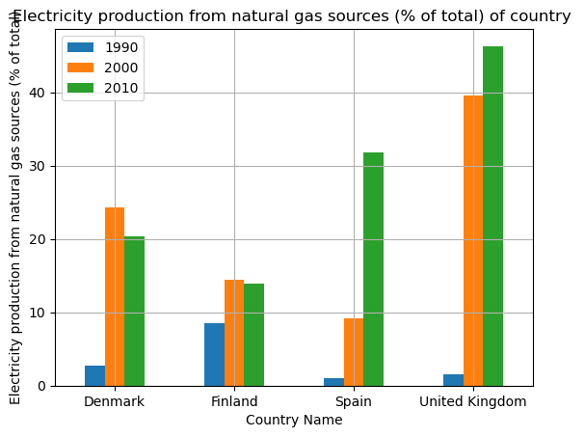 To Examine and compare the electricity production from natural gas sources (% of total) in four specific countries (Denmark, Spain, the United Kingdom, and Finland) over the years 1990, 2000, and 2010. Every country experienced a declining trend starting in 1990, however the United Kingdom experienced a suddenly swift increase starting in 2000. Since then, the trend has continued.

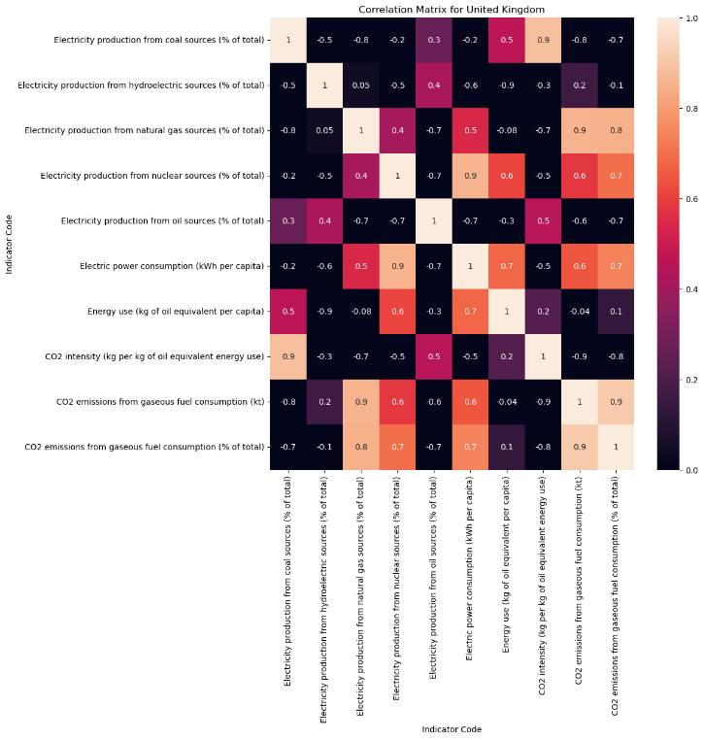

From the heatmap of united kingdom ,When the emission is to be The actions taken regarding electricity generation, particularly the utilization of natural gas, have a direct impact on the amount of CO2 released into the atmosphere

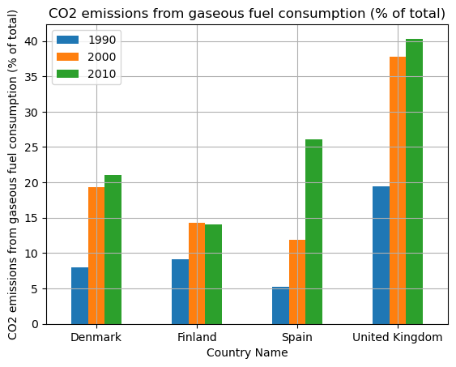

The bar chart represents CO2 emissions from gaseous fuel consumption in four different countries throughout time. The United Kingdom emitted the largest amount of carbon dioxide during those important years. It is assumed that industrial development increases CO2 emissions for these countries.

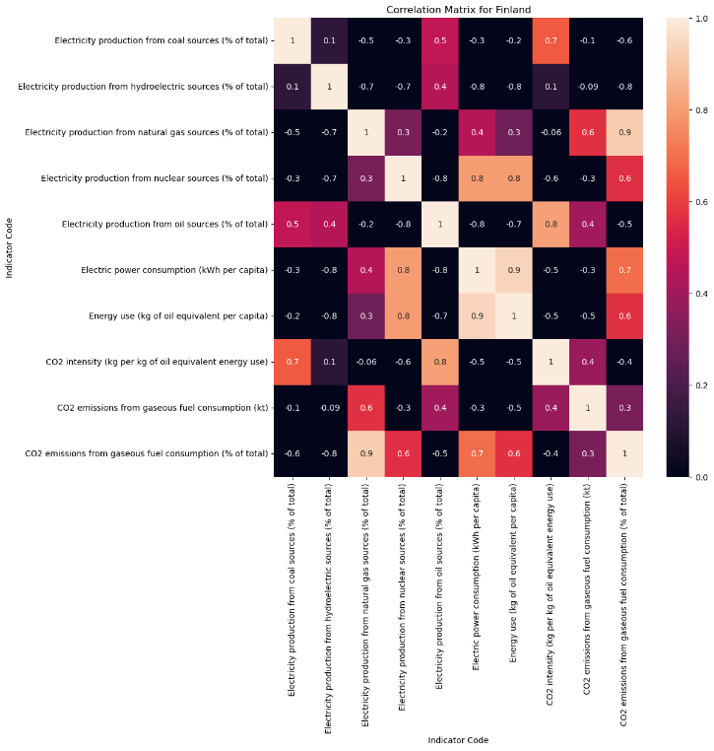

It illustrating CO2 emissions from gaseous fuel consumption and power production from natural gas show a similar rising trend for Finland in particular years

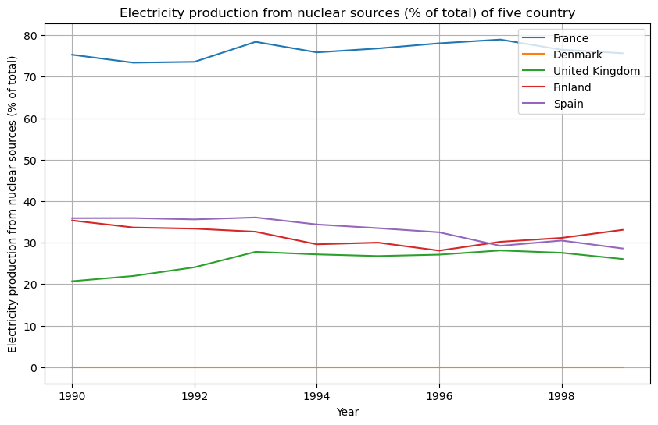 The studies objectives are to represent and compare nuclear generation of electricity as a proportion of all electricity produced for five specific countries (France, Denmark, the United Kingdom, Finland, and Spain) from 1990 to 2000. France having the highest electricity consumed from nuclear source

Here Denmark having electricity production from nuclear energy remain constant from the beginning of 1990 and still it continous

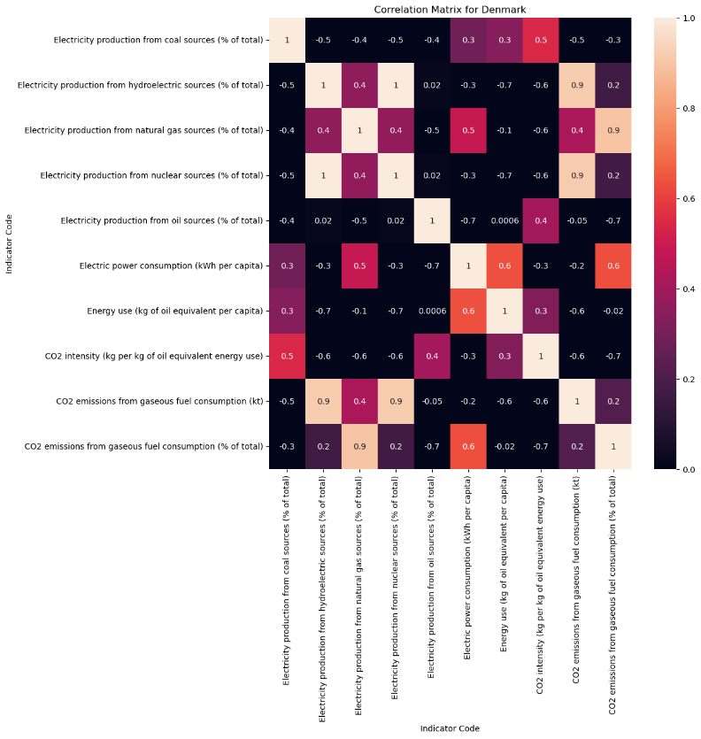

The visual demonstrates how electricity supplied by nuclear sources caused CO2 emissions from gaseous fuel consumption to the ecosystem in countries that includes Denmark.

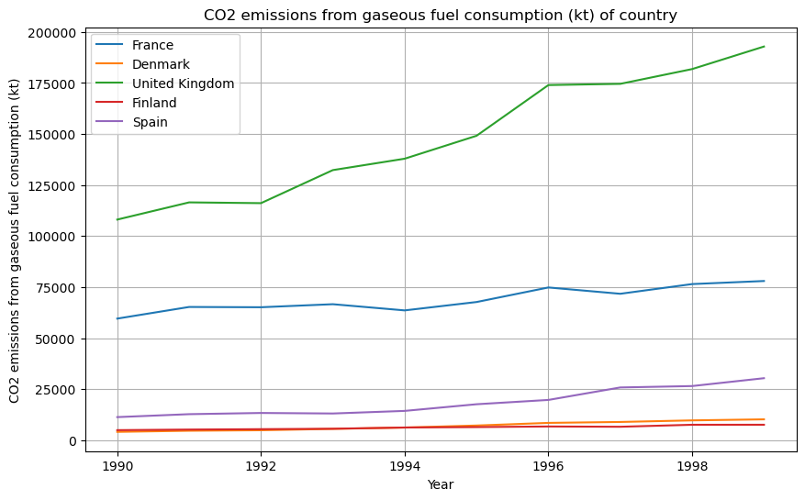

The data shown here displays the CO2 emissions from gaseous fuel usage for major countries in kilotons. However, countries like Denmark CO2 emissions from gaseous fuel had a slight upward trend on these graphs due to the use of nuclear power.