Trader Performance vs Bitcoin Market Sentiment
A Data Analysis of Hyperliquid Trading Behaviour
Data Science / Analytics Internship Submission
Primetrade.ai
Tools & Technologies Used: Microsoft Excel, Power Query, Pivot Tables, and Excel Charts.

1. Title
Trader Performance vs Bitcoin Market Sentiment: A Data Analysis of Hyperliquid Trading Behaviour
This report presents my submission for the Data Science / Analytics Intern role at Primetrade.ai.
The objective of this assignment was to investigate whether Bitcoin market sentiment, represented by the Fear & Greed Index, influences trader behaviour and trading performance on the Hyperliquid platform. The complete analysis—from data cleaning and transformation to data merging, metric creation, pivot table analysis, visualization, and business insights—was performed using Microsoft Excel and Power Query.

2. Objective
The objective of this analysis is to examine how Bitcoin market sentiment relates to trader behaviour and trading performance on Hyperliquid.
Specifically, this report aims to:
- Prepare and clean the provided datasets.
- Merge trader data with daily market sentiment.
- Create key performance metrics such as trade count, Closed PnL, average trade size, buy/sell ratio and win rate.
- Compare trader performance across different market sentiment conditions.
- Generate business insights supported by charts and pivot tables.
- Recommend practical trading strategies based on the observed results.

3. Dataset Description
Two datasets were provided for this assignment.

1. Historical Trader Data
This dataset contains trade-level information including:
- Account
- Coin
- Execution Price
- Size (Token and USD)
- Direction
- Timestamp
- Closed PnL
- Fee
- Trade ID
- Order ID
- Start Position

2. Bitcoin Fear & Greed Index
This dataset contains daily Bitcoin market sentiment, including:
- Unix Timestamp
- Sentiment Value
- Market Classification
- Date
Both datasets were imported as CSV files into Microsoft Excel using Power Query.

4. Data Preparation

4.1 Dataset Dimensions
After data cleaning and merging, the final dataset contains:
- Rows: 184,263
- Columns: 21
Each trade record was successfully matched with its corresponding market sentiment wherever sentiment data was available.

4.2 Missing Values
Missing values were checked during data preparation. The only systematic gap found was on the sentiment side: the Fear & Greed Index dataset ends on 02-05-2025, while the Hyperliquid trader data continues beyond that date. This meant that every trade after 02-05-2025 had no matching sentiment value once the two tables were joined.

4.3 Duplicate Check
No duplicate records were found in either dataset during the cleaning process in Power Query.

4.4 Timestamp Conversion
Both datasets originally stored their date information as Unix timestamps. These were converted into a proper Date format in Power Query so that the two tables could be matched on a common, human-readable date field.

4.5 Merge Process
The datasets were merged using a Left Outer Join in Power Query.
- Primary table: Historical Trader Data
- Secondary table: Fear & Greed Index
- Join key: Converted Date column
This ensured that every available trade record was retained while appending the corresponding daily sentiment classification.

4.6 Data Cleaning
After the merge, all rows with a null/blank sentiment value were removed. These nulls existed only because the sentiment dataset stopped on 02-05-2025 while trading continued afterwards — so this step was simply removing trades for which no sentiment reading was available, not a sign of bad data. Once this cleanup was done, the dataset was ready for Pivot Table analysis. It is worth noting upfront, because it shapes every result in this report: after the merge and cleanup, the only sentiment categories present in the final dataset are Extreme Greed, Greed, and Neutral. There are no Fear or Extreme Fear days in the merged data — this is a genuine characteristic of the overlapping date range between the two source files, not something I removed or chose to leave out.

5. Methodology
The analysis followed the workflow below:
- Imported both CSV datasets into Power Query.
- Converted Unix timestamps into Date format.
- Merged the datasets using a Left Outer Join in Power Query.
- Removed null sentiment records after merging.
- Created analytical fields (listed in 5.1 below).
- Built Pivot Tables for summarization.
- Created Excel charts for visualization.
- Interpreted results to generate business insights and recommendations.

5.1 Metrics Created
- Sum of Closed PnL by Market Sentiment
- Average Closed PnL by Market Sentiment
- Count of Trades by Market Sentiment
- Win/Loss classification and Win Rate by Market Sentiment
- Average Trade Size (USD) by Market Sentiment
- Buy vs Sell (long vs short) trade counts by Market Sentiment
- Trade count by Year, as a view of trading activity over time

5.2 Pivot Tables
All metrics above were built using Pivot Tables in Excel, with Market Sentiment as the primary row/column field and Trade ID, Closed PnL, Side, and Result as the value fields. A separate small pivot was also built to look at trade volume by year (2023, 2024, 2025) to get a sense of how activity is spread across the dataset's time span.

5.3 Charts
Four charts were built directly from the Pivot Tables above:
- Total Closed PnL by Market Sentiment (bar chart)
- Average Trade Size (USD) by Market Sentiment (bar chart)
- Buy vs Sell Trades by Market Sentiment (clustered bar chart)
- Win vs Loss Trades by Market Sentiment (clustered bar chart)

5.4 Analytical Approach
The approach throughout was descriptive and comparative — comparing aggregated metrics across the three available sentiment categories (Extreme Greed, Greed, Neutral) rather than building any predictive model. Since the assignment specifically allowed Pivot Tables and Excel charts as the analysis method, all findings below come directly from those pivot outputs, and I have been careful not to state anything that the pivot data does not actually show.

6. Analysis

6.1 Sentiment-wise Performance Summary
Market Sentiment | Trade Count | Total Closed PnL (USD) | Avg Closed PnL (USD) | Avg Trade Size (USD)
Extreme Greed | 6,962 | $176,965.49 | $25.42 | $5,660.27
Greed | 36,289 | $3,189,616.54 | $87.89 | $3,182.88
Neutral | 141,012 | $6,858,667.57 | $48.64 | $5,148.51
Grand Total | 184,263 | $10,225,249.60 | $55.49 | $4,780.73
Table 1: Sentiment-wise trade count, PnL, and trade size (source: Pivot Table)
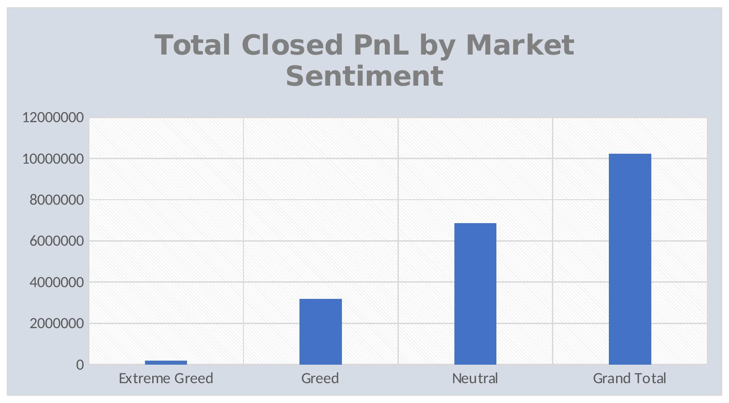
Chart 1: Total Closed PnL by Market Sentiment (as built in Excel)
In plain terms: Neutral days generated the largest total profit ($6.86M) simply because they make up 76.5% of all trades in the dataset. Greed days contributed $3.19M from a much smaller share of trades (19.7%), and Extreme Greed added only about $177K from the smallest slice (3.8%). So total profit here is driven mostly by how much trading happened, not necessarily by how profitable each sentiment was on a per-trade basis — which is why the next chart matters.
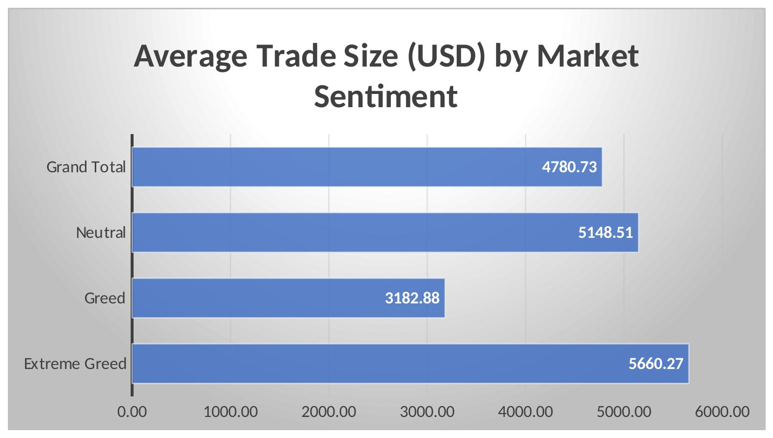
Chart 2: Average Trade Size (USD) by Market Sentiment (as built in Excel)

Average trade size tells a different story. Traders placed their largest average trades during Extreme Greed ($5,660), followed by Neutral ($5,149), while Greed days saw the smallest average trade size ($3,183) — roughly 44% smaller than Extreme Greed's average. This suggests traders were not simply betting bigger just because sentiment was more positive — if anything, they placed smaller trades on average during plain Greed days compared to both Extreme Greed and Neutral.

6.2 Does Performance Differ Between Fear and Greed Days?
This is the one place where I have to be upfront about a real constraint in the data rather than force an answer: after cleaning and merging, the dataset contains no Fear or Extreme Fear days at all — every trade in the final 184,263-row dataset falls under Extreme Greed, Greed, or Neutral. So a direct Fear vs Greed comparison is not possible with this dataset, and I have not invented one.
What I can compare, honestly, is performance across the three sentiment states that do exist. And yes, performance clearly differs between them:
- Average profit per trade is highest during Greed ($87.89), close to half that during Neutral ($48.64), and lowest during Extreme Greed ($25.42).
- Win rate, on the other hand, moves in the opposite direction — it is highest during Extreme Greed (49.01%), a bit lower during Greed (44.65%), and lowest during Neutral (41.02%).
So there is a genuine trade-off visible in the data: Extreme Greed days give traders their best odds of winning a trade, but the smallest reward when they do; Greed days give a lower win rate but a noticeably bigger average payoff per trade. This kind of pattern is exactly the sort of thing the assignment was looking for, even though it could not be framed as “Fear vs Greed” because Fear days simply are not present in this merged dataset.

6.3 Do Traders Change Behaviour Based on Market Sentiment?

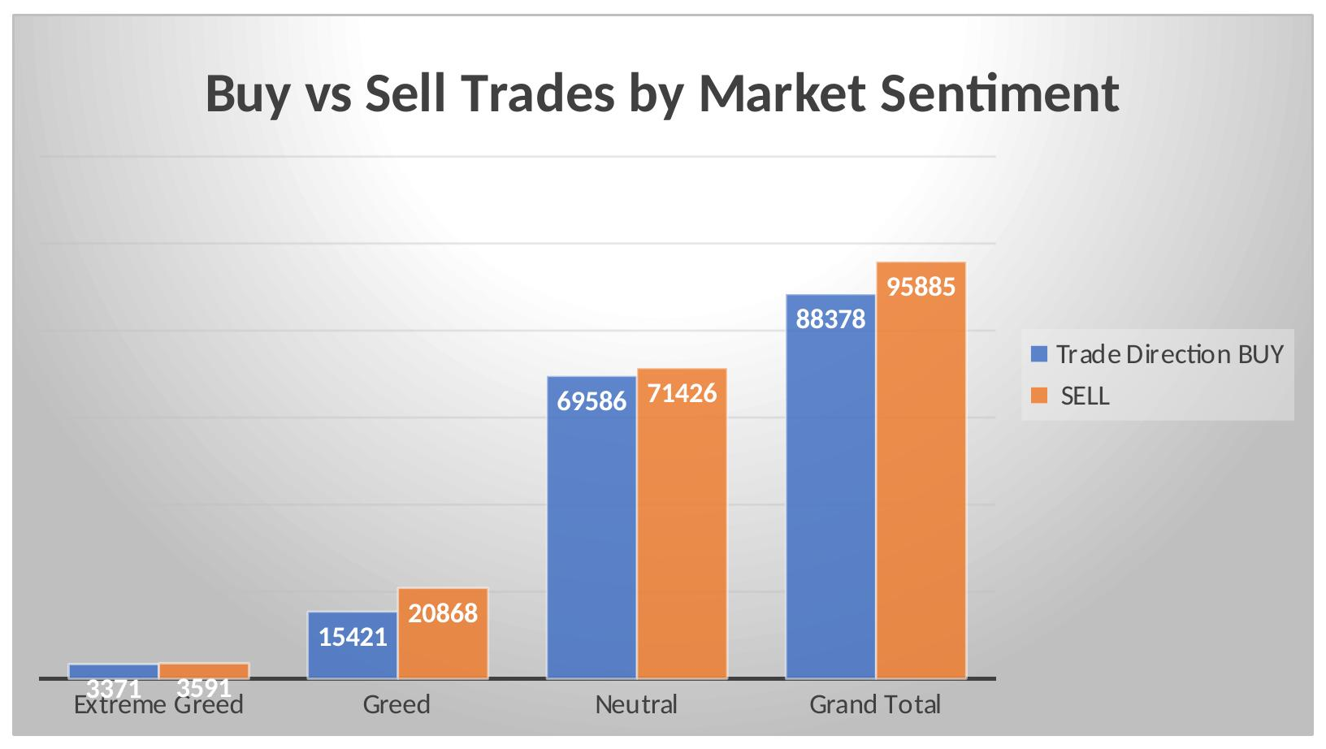
Chart 3: Buy vs Sell Trades by Market Sentiment (as built in Excel)

Market Sentiment | Buy Trades | Sell Trades | Buy % | Sell %
Extreme Greed | 3,371 | 3,591 | 48.4% | 51.6%
Greed | 15,421 | 20,868 | 42.5% | 57.5%
Neutral | 69,586 | 71,426 | 49.3% | 50.7%
Grand Total | 88,378 | 95,885 | 48.0% | 52.0%
Table 2: Buy vs Sell trade share by Market Sentiment (source: Pivot Table)
Yes, behaviour does shift with sentiment, and it is visible in the Buy/Sell split. During Extreme Greed and Neutral, trades are almost evenly split between Buy and Sell (roughly 48–51% either way). But during plain Greed days, selling clearly dominates — 57.5% of trades are Sell against only 42.5% Buy. This is a bit counter-intuitive: one might expect “Greed” to mean more buying, but the data shows the opposite — traders were more active on the sell side specifically during Greed, which could reflect profit-taking or increased short activity once sentiment turns clearly positive.

6.4 Trader Segmentation
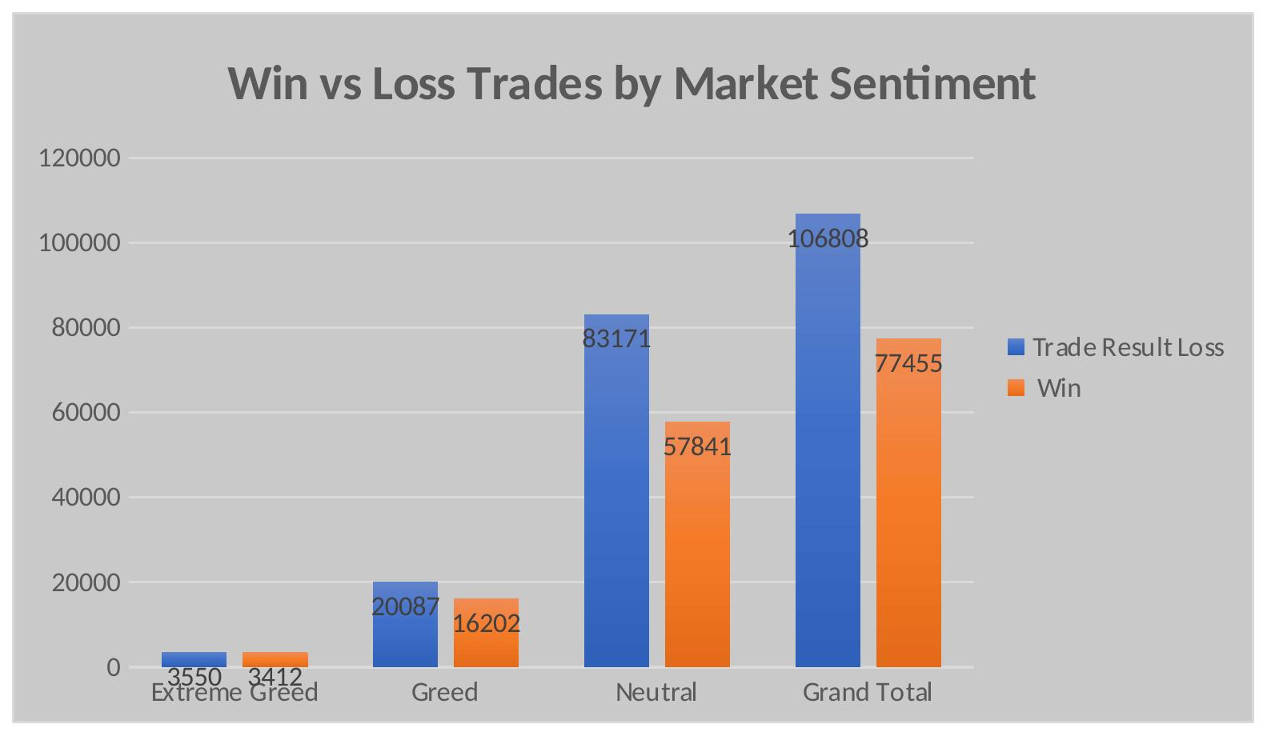
Chart 4: Win vs Loss Trades by Market Sentiment (as built in Excel)
Market Sentiment | Losing Trades | Winning Trades | Total Trades | Win Rate
Extreme Greed | 3,550 | 3,412 | 6,962 | 49.01%
Greed | 20,087 | 16,202 | 36,289 | 44.65%
Neutral | 83,171 | 57,841 | 141,012 | 41.02%
Grand Total | 106,808 | 77,455 | 184,263 | 42.04%
Table 3: Win/Loss trades and win rate by Market Sentiment (source: Pivot Table)
Using the fields available in the pivot outputs, I could reliably build two trade-level segmentations:
- Winning trades vs Losing trades: across the whole dataset, 42.04% of trades were winners and 57.96% were losers. This split gets worse (more losses) as sentiment moves from Extreme Greed towards Neutral, as shown in Table 3 above.
- Larger vs Smaller position trades: using Average Trade Size as a proxy (Table 1), trades placed during Extreme Greed and Neutral run noticeably larger on average ($5,660 and $5,149) than trades placed during Greed ($3,183).
One segmentation I want to flag honestly rather than fake: a true “Frequent vs Infrequent Trader” split (grouping individual accounts by how often they trade) was not part of the Pivot Tables built for this analysis, since that would need a separate pivot keyed on the Account field rather than on Market Sentiment. I have not attempted to estimate this, since doing so without an actual pivot output would mean guessing rather than reporting real numbers. I am listing this clearly under Limitations below as well.

7. Key Insights

Insight 1
Although Neutral accounts for 76.5% of all trades (141,012 trades) and generates the highest total Closed PnL ($6.86M), it records the lowest win rate (41.02%), indicating that higher trading activity does not necessarily lead to better trading efficiency — see Table 1 and Table 3.

Insight 2
Average profitability and win rate move in opposite directions.
- Greed delivers the highest average Closed PnL per trade ($87.89).
- Extreme Greed achieves the highest win rate (49.01%) but the lowest average profit per trade ($25.42).
This suggests traders experience a trade-off between consistency and profitability across different sentiment conditions.

Insight 3
Trading behaviour changes with market sentiment.
During Greed periods:
- Buy trades represent 42.5%
- Sell trades represent 57.5%
Instead of increasing buying activity during optimistic markets, traders appear more inclined toward selling or profit-taking — see Chart 3 / Table 2.

Insight 4
Average trade size does not consistently increase with positive sentiment.
Average trade sizes were:
- Extreme Greed: $5,660
- Neutral: $5,149
- Greed: $3,183
This indicates traders placed their largest positions during Extreme Greed rather than standard Greed conditions — see Chart 2.

8. Actionable Recommendations

Recommendation 1
Prioritize higher-quality trade setups during Greed periods rather than increasing trade frequency, as higher average profitability does not necessarily correspond to a higher win rate.

Recommendation 2
Do not assume Greed automatically signals buying opportunities.
Historical trading behaviour indicates significantly higher selling activity during Greed periods. Trading strategies should therefore rely on additional confirmation rather than market sentiment alone.

Recommendation 3
Focus on improving trade selection during Neutral sentiment.
Since Neutral represents 76.5% of all trading activity, even small improvements in execution during these periods could have the greatest impact on overall portfolio performance.

9. Limitations
- The Fear & Greed Index dataset ends on 02-05-2025 while the Hyperliquid trader dataset continues beyond that date, so trades after this date could not be assigned a sentiment value.
- All rows with a null/missing sentiment value (trades after 02-05-2025) were removed from the analysis, meaning the most recent trading activity beyond that date is not reflected in any of the findings above.
- As a direct consequence of the two points above, the final merged dataset contains no Fear or Extreme Fear days at all — only Extreme Greed, Greed, and Neutral are represented. Any comparison involving Fear sentiment specifically could not be performed with this data.
- The trader dataset does not contain a Leverage column, so leverage-based analysis (for example, whether traders use more leverage during Greed vs Neutral periods) could not be performed.
- A true account-level trader segmentation (Frequent vs Infrequent traders, based on individual trading frequency) was not built as part of this analysis, since it would require a separate pivot on the Account field rather than on Market Sentiment. Only trade-level segmentations (Win vs Loss, Large vs Small average trade size) were performed.
- This analysis is limited to the fields and pivot outputs available in the cleaned dataset; no external data (for example, spot BTC price movement or macro news) was incorporated.
- No predictive model, clustering, or machine learning technique was used anywhere in this analysis — all findings are based purely on descriptive Pivot Table summaries and Excel charts, as required by the assignment.

10. Conclusion
This analysis demonstrates that Bitcoin market sentiment has a measurable relationship with trader behaviour and trading performance on Hyperliquid. Differences were observed in trade profitability, win rate, trade size, and buy/sell behaviour across the available sentiment categories.
Due to the available data range, the final merged dataset contains only Extreme Greed, Greed, and Neutral observations. Consequently, a direct comparison between Fear and Greed could not be performed, and this limitation has been documented rather than inferred.
Despite these constraints, the analysis identifies several meaningful behavioural patterns. Greed periods generate the highest average profit per trade, Extreme Greed records the highest win rate, and Neutral dominates overall trading activity while producing the lowest win rate. These findings provide practical insights that can support more informed trading decisions.
This assignment strengthened my understanding of real-world data preparation, data integration, exploratory analysis, and business reporting using Microsoft Excel and Power Query.

