Preparing the dataset

preparing the dataset was the hardest part.My first approach was to find open source datasets from websites like kaggle for all the games but I couldn’t find any except for fortnite, so I used that [dataset](https://www.kaggle.com/kpriyanshu256/fortnite-images) for fortnite and scraped the rest of the games from google images with python.. But i could only manage to find < 500 images for nearly each game because that was all the images in google images,many of them were logos so I tried removing as many as I could because that was all the images in google images,I data augmented the rest of the images with tensorflow keras.

Deciding on a framework

Transfer learning with tensorflow from the prelims task 2 was not a good experience as changing the model and debugging took alot of time. fastai allows me to write clean code and debug or change stuff very easily.Therefore, I decided to use fastai for this task (its poggers).

Training the model

Before trying out transfer learning for this task I tried using custom cnns with tensorflow and the results were not good as you can see below-

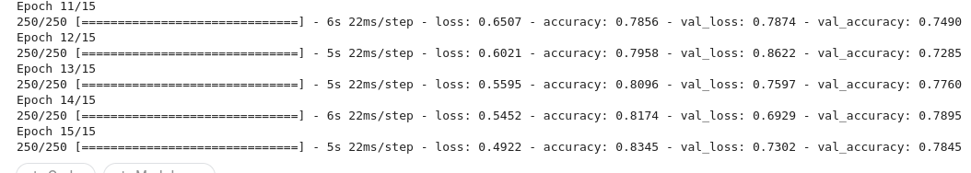

So I decided on transfer learning using fastai. I started with resnet50 and got ok-ok results -

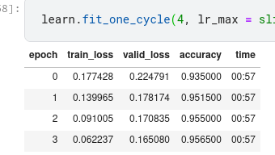

Then I experimented with other models like densenets, alexnet, different resnets etc.

I finally decided to settle on vgg16 as it gave me good results.I used learn.lr_find on the model trained for 4 epochs -

lr_find() -

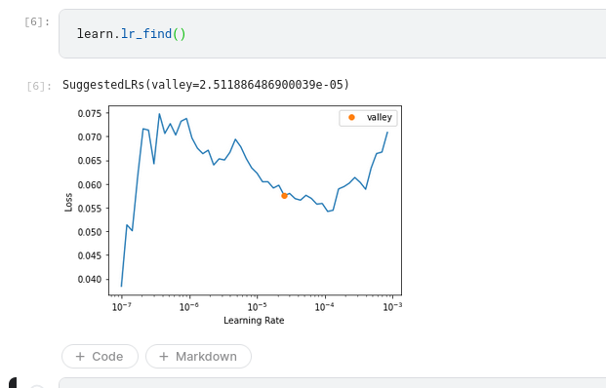

and then i did one more train cycle for 4 epochs with a jumping learning rate with range specified as (1e-08, <lr_find_output>) hoping to get good results with the help of lr_find the results were -

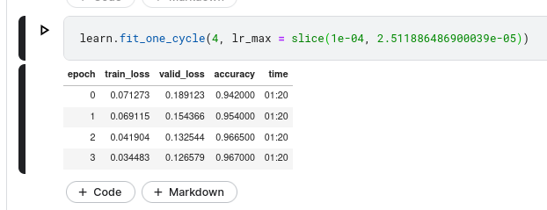

its overfitting a teeeeeensy bit most probably because of the shitty dataset i prepared :((v

After that I predicted images with the help of numpy and opencv and converted the dictionary with all the predictions to csv with pandas and submitted them.

Thanks for reading and letting me participate in this wonderful event and giving me a great learning experience!!