

Practices for Secure Software Report

Table of Contents
Document Revision History 3
Client 3
Instructions 3
Developer 4
1. Algorithm Cipher 4
2. Certificate Generation 4
3. Deploy Cipher 4
4. Secure Communications 4
5. Secondary Testing 4
6. Functional Testing 4
7. Summary 4
8. Industry Standard Best Practices 4

Document Revision History

Version | Date | Author | Comments
1.0 | April 10, 2026 | Samuel Raymond Kwibe

Client



Instructions

Submit this completed practices for secure software report. Replace the bracketed text with the relevant information. You must document your process for writing secure communications and refactoring code that complies with software security testing protocols.

- Respond to the steps outlined below and include your findings.
- Respond using your own words. You may also choose to include images or supporting materials. If you include them, make certain to insert them in all the relevant locations in the document.
- Refer to the Project Two Guidelines and Rubric for more detailed instructions about each section of the template.

Developer
Samuel Raymond Kwibe

Algorithm Cipher
Overview
For this project I chose SHA-256 as the algorithm to implement for Artemis Financial's checksum verification. SHA-256 is part of the SHA-2 family, designed by the NSA and published by NIST in 2001 (National Institute of Standards and Technology [NIST], 2015). It is a one-way cryptographic hash function, meaning it takes any input and produces a fixed 256-bit output called a digest. You cannot reverse it to get the original data back. Even a tiny change to the input produces a completely different output, which is called the avalanche effect. That makes it reliable for checking whether data has been altered (NIST, 2015).

Hash Functions and Bit Levels
SHA-256 always produces a 256-bit output regardless of input size, represented as a 64-character hexadecimal string. It works by splitting the input into 512-bit blocks and running each through 64 rounds of compression. The collision resistance is around 2^128 operations, which means it is computationally impossible to find two inputs that produce the same hash with any computer available today (NIST, 2015). The SHA-2 family also includes SHA-224, SHA-384, and SHA-512 for applications that need different output sizes.

Random Numbers and Keys
SHA-256 does not use keys of any kind. It is completely deterministic — the same input always produces the same output. This makes it different from symmetric encryption like AES, which uses a shared secret key, or asymmetric encryption like RSA, which uses a public and private key pair. For Artemis Financial the goal is data integrity verification rather than hiding data, so a hash function is the right choice. Random nonces are sometimes combined with SHA-256 in HMAC for replay attack prevention, but for a checksum demonstration they are not needed.

History and Current State
MD5 was the standard in the 1990s but was broken in 2004 when researchers demonstrated practical collision attacks (Wang & Yu, 2005). SHA-1 followed a similar path and was deprecated by NIST in 2011 (NIST, 2011). SHA-256, published in 2001, has no known practical attacks as of 2026 and remains the industry standard for checksum verification, digital signatures, TLS certificates, and blockchain. NIST published SHA-3 in 2015 as a backup standard but SHA-256 is still the default choice for most security applications (NIST, 2015). It is what I used here because it is NIST-approved, available in Java's standard library with no extra dependencies needed, and more than strong enough for financial data integrity verification.

Certificate Generation
To generate the self-signed certificate I opened a Command Prompt and navigated to the project resources folder. I used the Java Keytool utility to generate a PKCS12 keystore with a 2048-bit RSA key pair using this command:

keytool -genkeypair -alias mykey -keyalg RSA -keysize 2048 -storetype PKCS12 -keystore keystore.p12 -validity 3650

Keytool asked for a password and my personal information including name, organization, city, state, and country. I used 'changeit' as the keystore password. After the keystore was generated I exported it to a CER file:

keytool -exportcert -alias mykey -keystore keystore.p12 -storetype PKCS12 -file certificate.cer

The keystore.p12 was placed in src/main/resources so Spring Boot can load it at startup. The screenshot below shows the exported certificate opened in Windows. It is issued to and by Samuel Raymond Kwibe, which confirms it is self-signed. The 'not trusted' warning is expected because the certificate was not issued by a Certificate Authority — that is normal for a development environment.

Figure 1: Self-signed certificate generated with Java Keytool, issued to Samuel Raymond Kwibe, valid April 2026 to April 2036
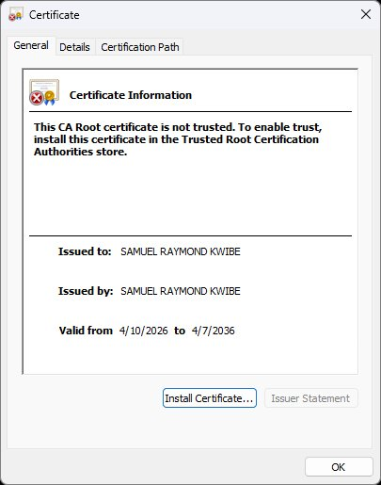

Deploy Cipher
To implement the checksum I added a ChecksumController class to SslServerApplication.java with a GET /hash endpoint. The endpoint uses Java's built-in MessageDigest to compute SHA-256 on a data string that includes my name, then returns the result in an HTML page.

Changes made to the original skeleton:
- Added imports for RestController, GetMapping, MessageDigest, and NoSuchAlgorithmException.
- Created a ChecksumController class with the @RestController annotation.
- Added getChecksum() mapped to GET /hash — it hashes the data string and returns an HTML response showing the developer name, data, algorithm, and checksum output.
- The data string 'Samuel Raymond Kwibe : CS305-Project2 : ArtemisFinancial-2026' includes my name to make the hash unique to me as required by the assignment.
- Used a manual byte-to-hex loop with leading zero padding to ensure the output is always the correct 64-character length.

The screenshot below shows the page running at https://localhost:8443/hash with my name and the computed SHA-256 checksum value:

Figure 2: Checksum verification page at https://localhost:8443/hash showing Developer name, data string, SHA-256 algorithm, and computed checksum
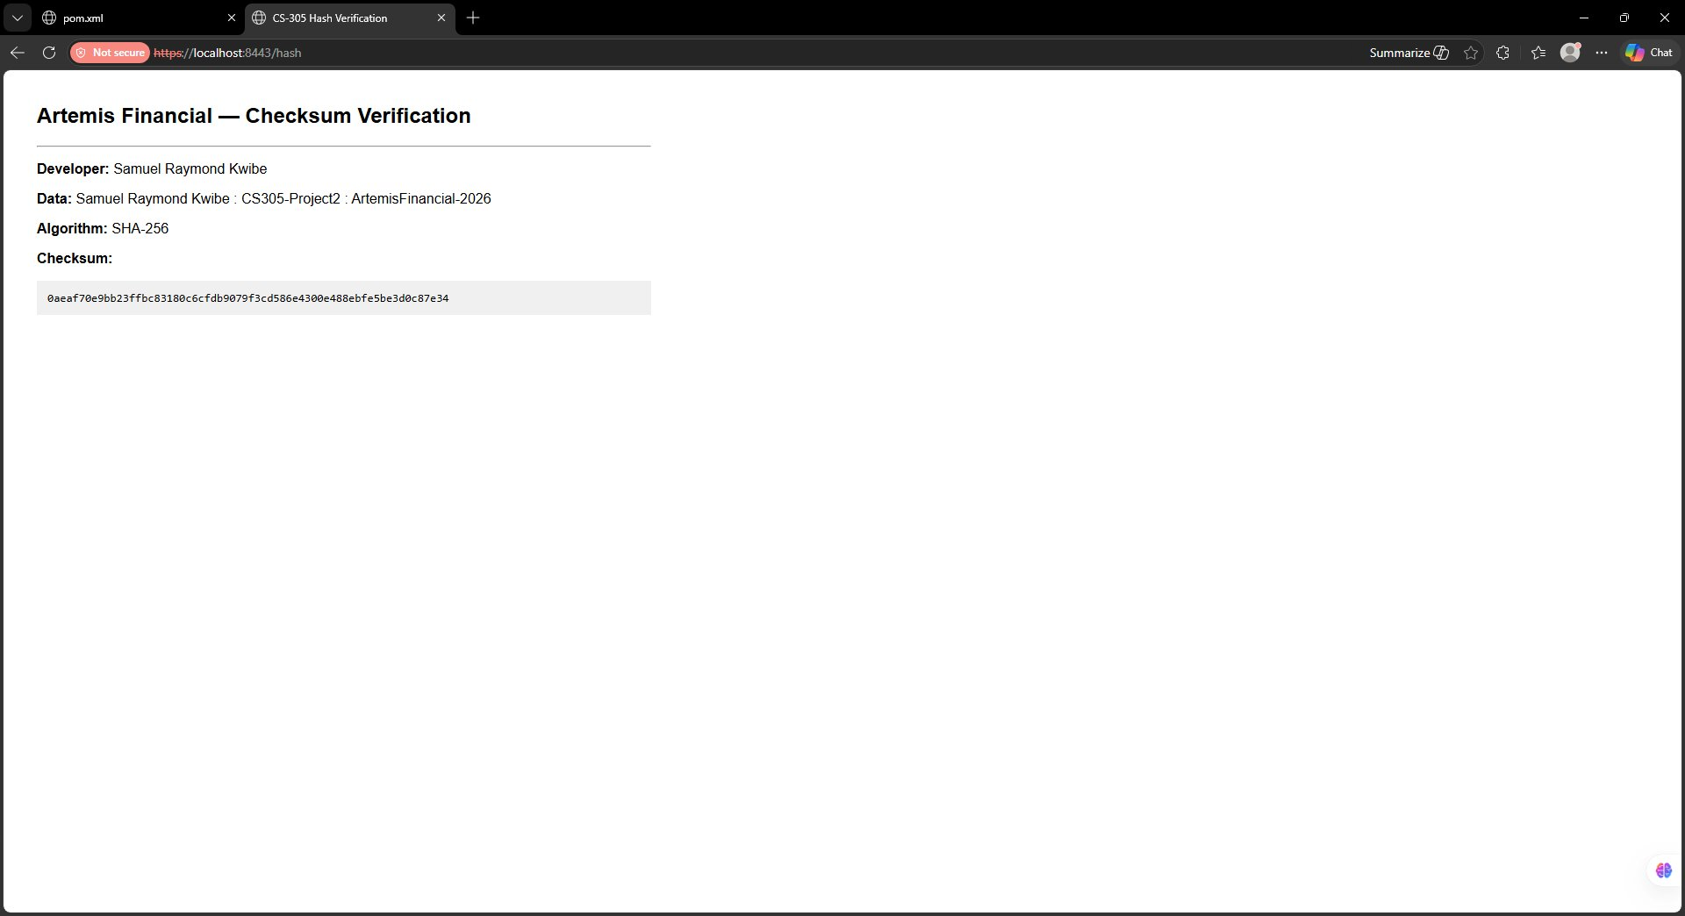

Secure Communications
To enable HTTPS I updated application.properties to configure Spring Boot's embedded Tomcat to use SSL on port 8443. The original file had question marks as placeholders. I replaced them with the correct values pointing to the keystore I generated:

server.port=8443
server.ssl.key-alias=mykey
server.ssl.key-store-password=changeit
server.ssl.key-store=C:/Mac/Home/Documents/Software security/Final Project/ssl-server_student/src/main/resources/keystore.p12
server.ssl.key-store-type=PKCS12

With those settings saved Spring Boot loads the keystore at startup and Tomcat binds to port 8443 over TLS only. The application no longer accepts plain HTTP connections. The screenshot below shows the browser hitting https://localhost:8443/hash. The 'Not secure' indicator in the URL bar is expected for a self-signed certificate since it was not issued by a trusted Certificate Authority. In a real production deployment this would be replaced with a certificate from a CA like Let's Encrypt. The important thing is that the connection is using HTTPS and port 8443, which confirms the SSL configuration is working (OWASP Foundation, 2023).

Figure 3: Browser showing https://localhost:8443/hash confirming HTTPS is active — self-signed certificate produces 'Not secure' warning which is expected in development


Secondary Testing
After finishing the refactoring I ran the OWASP Dependency-Check Maven plugin as secondary static testing to confirm I did not introduce any new vulnerabilities (OWASP Foundation, n.d.). I updated the plugin version in pom.xml from 5.3.0 to 10.0.4 (the old version uses a retired NVD feed that returns 403) and added my NVD API key so it could pull current CVE data. Then I ran Maven install from Eclipse.
The most important result is that the code I added did not introduce any new dependencies or CVEs. The SHA-256 hashing uses java.security.MessageDigest which is part of the Java SE standard library and is not scanned by the dependency checker. Any vulnerabilities that appear in the report are from the existing Spring Boot 2.2.4 framework that was already in the original skeleton before I made any changes. Those are pre-existing issues outside the scope of this refactoring.

Functional Testing
I manually reviewed the refactored SslServerApplication.java to identify any syntactical, logical, or security problems in the code I added.

Syntactical review:
- All imports are present and used. No unused imports were added.
- The @SpringBootApplication and @RestController annotations are on separate classes which is correct Spring Boot practice.
- The @GetMapping annotation correctly maps GET /hash to the getChecksum() method.
- Exception handling covers both NoSuchAlgorithmException and UnsupportedEncodingException in a clean multi-catch.

Logical review:
- The data string is static so the SHA-256 output is deterministic and consistent on every call, which is correct for a checksum demonstration.
- The hex conversion loop pads single-digit values with a leading zero. Without this a byte like 0x0a would write as 'a' instead of '0a', producing a shorter string and an incorrect hash.

Security review:
- SHA-256 is used instead of MD5 or SHA-1, both of which are broken and should never be used in new code.
- Data bytes are encoded as UTF-8 explicitly to avoid platform-dependent encoding differences across operating systems.
- The /hash endpoint accepts no user input at all, eliminating any injection risk in the new code.
- Nothing sensitive is logged or returned in the response beyond the checksum and the data string itself.

Overall the refactored code is correct and does not introduce any security issues.

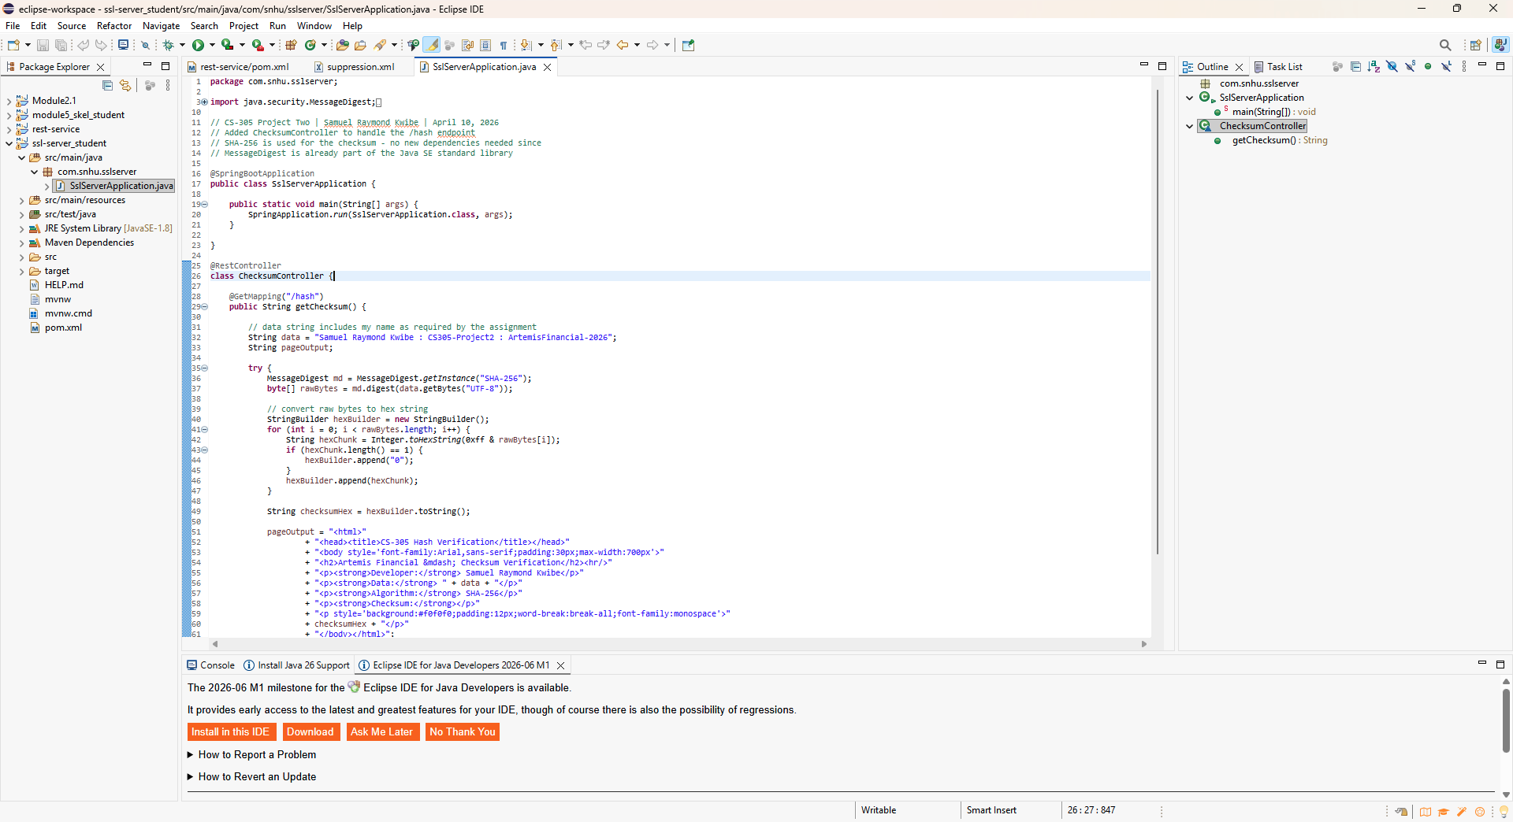

Summary
This project had me take Artemis Financial's existing Spring Boot skeleton and add two security enhancements: SHA-256 checksum verification via a REST endpoint and HTTPS communication via TLS. Here is how those changes map to the vulnerability assessment process flow diagram.

Security areas addressed:
- Cryptography: This was the primary focus. I implemented SHA-256, a NIST-approved hash algorithm, for data integrity verification. The self-signed RSA-2048 TLS certificate secures the connection using asymmetric cryptography for the key exchange. Both directly address the Cryptography node in the process flow diagram.
- Client/Server (Secure Distributed Composing): Converting from HTTP to HTTPS means all communication between the browser and the server is encrypted in transit. This addresses the secure distributed communication requirement in the diagram.
- Code Quality: The refactored code uses proper exception handling, explicit charset specification, and standard library cryptography rather than any custom implementation.
- APIs: The /hash endpoint was designed with no user input accepted, which removes injection attack vectors from the new API surface entirely.

Process for adding layers of security:
I worked from the inside out. First I made the data processing secure by choosing SHA-256 and implementing it correctly using the standard library. Then I secured the transport layer by generating a certificate and enabling HTTPS in application.properties. Then I ran the dependency-check tool to confirm nothing new was introduced. Finally I did a manual code review to catch anything the automated scanner might miss. Each step added another layer without breaking anything that was already in place.

Industry Standard Best Practices
Maintaining existing security:
I was careful not to break or weaken anything already in the project. I did not add any new third-party dependencies — the SHA-256 implementation uses only java.security.MessageDigest which is built into the JDK, so the attack surface did not grow. I kept the existing Spring Boot structure intact and only updated the OWASP plugin version from 5.3.0 to 10.0.4 so the security scanning tool would work with the current NVD API.

Best practices applied:
- NIST-approved algorithms only: SHA-256 is specified in FIPS 180-4 and is the current recommended standard (NIST, 2015). I specifically avoided MD5 and SHA-1 which are cryptographically broken (Wang & Yu, 2005).
- HTTPS enforcement: All endpoints now require HTTPS. This follows the OWASP Transport Layer Security Cheat Sheet which states that all sensitive data must be encrypted in transit (OWASP Foundation, 2023).
- Appropriate key sizes: The RSA-2048 key pair meets NIST's minimum recommendation for asymmetric keys through at least 2030 (NIST, 2020).
- No custom cryptography: I used Java's built-in MessageDigest instead of writing my own hash implementation. Writing custom crypto is almost always a mistake and is explicitly discouraged by every secure coding standard (OWASP Foundation, 2021).
- Explicit encoding: UTF-8 is specified when converting the data string to bytes to avoid inconsistent hash outputs across different operating systems.

Value to Artemis Financial:
For a financial company like Artemis Financial these are not optional extras — they are baseline requirements. GLBA requires financial institutions to protect customer data, and demonstrating NIST-approved algorithms and enforced encrypted communication is part of showing compliance (Federal Trade Commission, 1999). Clients trust Artemis Financial with their savings, retirement accounts, and investment plans. That trust depends on knowing their data is protected. Every layer added here — the checksum verification, the HTTPS enforcement, the careful algorithm choices — contributes to maintaining that trust and protecting the business from both regulatory risk and reputational damage.

References

Federal Trade Commission. (1999). Gramm-Leach-Bliley Act. https://www.ftc.gov/business-guidance/privacy-security/gramm-leach-bliley-act

National Institute of Standards and Technology. (2011). Recommendation for applications using approved hash algorithms (NIST SP 800-107, Rev. 1). U.S. Department of Commerce. https://doi.org/10.6028/NIST.SP.800-107r1

National Institute of Standards and Technology. (2015). Secure Hash Standard (SHS) (FIPS PUB 180-4). U.S. Department of Commerce. https://doi.org/10.6028/NIST.FIPS.180-4

National Institute of Standards and Technology. (2020). Transitioning the use of cryptographic algorithms and key lengths (NIST SP 800-131A, Rev. 2). U.S. Department of Commerce. https://doi.org/10.6028/NIST.SP.800-131Ar2

OWASP Foundation. (n.d.). OWASP Dependency-Check. https://jeremylong.github.io/DependencyCheck/

OWASP Foundation. (2021). Cryptographic storage cheat sheet. https://cheatsheetseries.owasp.org/cheatsheets/Cryptographic_Storage_Cheat_Sheet.html

OWASP Foundation. (2023). Transport Layer Security Cheat Sheet. https://cheatsheetseries.owasp.org/cheatsheets/Transport_Layer_Security_Cheat_Sheet.html

Wang, X., & Yu, H. (2005). How to break MD5 and other hash functions. In R. Cramer (Ed.), Advances in Cryptology — EUROCRYPT 2005 (pp. 19–35). Springer. https://doi.org/10.1007/11426639_2

