KIGALI INDEPENDENT UNIVERSITY ULK

GISENYI CAMPUS
SCHOOL OF SCIENCE AND TECHNOLOGY
DEPARTMENT OF COMPUTER SCIENCE
PO BOX 243 GISENYI
GISENYI GADGETS
A Full-Stack E-Commerce Mobile Application for Gadget Retail in Gisenyi, Rwanda
Customer Mobile App Customer Website Administration Panel
Case Study: Gisenyi Gadgets Shop
By Samuel NDAYAMBAJE
Registration Number 202320778
A final year project report submitted in partial fulfilment of the requirements for the Bachelor’s degree in Computer Science.
Faculty of Software Engineering
Supervisor [Supervisor Name]
Academic Year 2025–2026
Kigali Rwanda
May 2026

DECLARATION
I, Samuel NDAYAMBAJE, Registration Number 202320778, hereby declare that this Final Year Project report titled "Gisenyi Gadgets: A Full-Stack E-Commerce Mobile Application for Gadget Retail in Gisenyi, Rwanda" is my original work and has not been submitted for any other academic award at this or any other institution.
All sources consulted have been duly acknowledged and referenced in accordance with standard academic practice.
Signature: ____________________ Date: ____________________
Samuel NDAYAMBAJE
Supervisor’s Approval:
Signature: ____________________ Date: ____________________
[Supervisor Name & Title]

ABSTRACT
This report presents the design, development, and deployment of Gisenyi Gadgets, a full-stack e-commerce mobile application built to serve gadget retail customers in Gisenyi, Rwanda. The application addresses the challenges of fragmented informal trade, limited digital payment acceptance, and the absence of a dedicated online platform for technology products in the region.
The system comprises three tightly integrated components: a cross-platform mobile application built with React Native and Expo, a web-based admin dashboard built with React and Vite, and a cloud backend powered by Supabase (PostgreSQL 15, Row Level Security, Realtime subscriptions, Edge Functions, and Object Storage). Mobile payments are processed through the Paypack API, supporting both MTN Mobile Money and Airtel Money — the dominant payment methods in Rwanda.
Key features include product catalogue browsing, shopping cart with offline persistence, wishlist management, mobile money checkout, real-time order tracking, push notifications, live customer-support chat with image sharing, and a full-featured admin dashboard with analytics.
The system was built using an Agile iterative methodology over twelve development sprints.
The application was published on the Google Play Store under the package identifier com.gisenyigadgets.app and the admin dashboard is deployed at gisenyicpanel.vercel.app. Security evaluation confirmed all Row Level Security policies, JWT session management, and API key isolation are functioning correctly. Functional testing across 26 test cases and performance benchmarking across 9 key flows both yielded a 100% pass rate.
Keywords: E-Commerce, React Native, Expo, Supabase, Mobile Money, Paypack, Rwanda, Android, Full-Stack, Real-Time, Push Notifications.

ACKNOWLEDGEMENTS
I would like to express my sincere gratitude to my supervisor at Kigali Independent University (ULK) for the guidance and constructive feedback provided throughout this project.
I am thankful to the Faculty of Software Engineering for providing an academic environment that encouraged practical, real-world project development.
Special appreciation goes to the open-source communities behind React Native, Expo, and Supabase, whose documentation and tools made this project technically feasible within the timeframe of a final year project.
Finally, I thank my family for their continued support during the duration of this programme.

Project scope and platform overview
Gisenyi Gadgets has three interfaces: a customer mobile app, a customer website and a separate administration panel. Customers can now open the store at https://gisenyigadgets.vercel.app and browse products without installing the app. The website extends the project described in the original report.
Customers use the app and website to find products, view their details and access account services. The mobile implementation also describes cart and wishlist storage, checkout, order history, notifications and support. Staff use the administration panel to manage the catalogue, orders and customer communication. The documented backend uses Supabase, PostgreSQL and server side payment functions.
The website was inspected on 11 October 2026. This covered the home page, catalogue, smartphone category, product page, sign in, registration and empty cart. The inspection confirmed browser access to these screens. The earlier test results remain in the report, but they should be supported by their execution records.
Chapter 3 explains the development approach and system design. Chapter 4 covers the app, administration panel and customer website. Chapter 5 presents the reported tests alongside the current website observations. The website adds browser access to the project; the original scope limitations still apply.
The labelled spaces in Chapter 4 identify the app and administration screenshots needed for the final demonstration. Each space has a short explanation of the screen. Replace it with a screenshot from the version of the project that will be defended.

Table of contents
Declaration 2
Abstract 2
Acknowledgements 2
Project scope and platform overview 2
List of figures 2
List of tables 2
List of abbreviations 2
Chapter 1 Introduction 2
Chapter 2 Literature Review 2
Chapter 3 System Analysis and Design 2
3.5 Development methodology 2
3.6 Revised platform architecture 2
3.7 Conceptual data relationships 2
3.8 Purchase processing design 2
Chapter 4 Implementation 2
4.1 Development Environment 2
4.2 Mobile Application 2
Mobile application account interfaces 2
Mobile application cart and wishlist 2
Mobile application browsing interfaces 2
Mobile application search and product details 2
Mobile application checkout interfaces 2
Mobile application payment and confirmation 2
4.3 Admin Dashboard 2
Administration overview and products 2
Administration orders and customers 2

Table of contents continued
Administration suppliers and notifications 2
Administration support and product editing 2
4.4 Backend and Database 2
4.5 Payment Integration 2
4.6 Push Notifications 2
4.7 Code Quality and Security Audit 2
4.8 Advanced Features 2
Security Clarification 2
4.9 Customer website interfaces 2
4.9.1 Website product catalogue 2
4.9.2 Website category browsing 2
4.9.3 Website product details 2
4.9.4 Website sign in 2
4.9.5 Website registration 2
4.9.6 Website shopping cart 2
Chapter 5 Testing and Evaluation 2
5.6 Current website evaluation 2
5.7 Evaluation limitations 2
Chapter 6 Discussion 2
Chapter 7 Conclusion and Future Work 2
References 2
Supplementary references 2
Appendices 2
Original contents record 2

List of figures
Figure 3.1: Original system architecture 2
Figure 3.2: Revised mobile web and administration architecture 2
Figure 3.3: Conceptual relationships in the retail data model 2
Figure 3.4: Documented mobile money purchase workflow 2
Figure 4.1: Mobile application login screen 2
Figure 4.2: Mobile application registration screen 2
Figure 4.3: Mobile application shopping cart screen 2
Figure 4.4: Mobile application wishlist screen 2
Figure 4.5: Mobile application home screen 2
Figure 4.6: Mobile application categories screen 2
Figure 4.7: Mobile application search results screen 2
Figure 4.8: Mobile application product details screen 2
Figure 4.9: Mobile application checkout screen 2
Figure 4.10: Mobile application delivery address screen 2
Figure 4.11: Mobile application payment selection screen 2
Figure 4.12: Mobile application order confirmation screen 2
Figure 4.13: Administration panel dashboard overview screen 2
Figure 4.14: Administration panel products management screen 2
Figure 4.15: Administration panel orders management screen 2
Figure 4.16: Administration panel customers management screen 2
Figure 4.17: Administration panel suppliers management screen 2
Figure 4.18: Administration panel notifications screen 2
Figure 4.19: Administration panel support chat screen 2
Figure 4.20: Administration panel add or edit product screen 2
Figure 4.21: Customer website home page 2
Figure 4.22: Customer website product catalogue 2
Figure 4.23: Customer website smartphone category 2
Figure 4.24: Customer website product details 2
Figure 4.25: Customer website sign in 2
Figure 4.26: Customer website registration 2
Figure 4.27: Customer website shopping cart 2

List of tables
Table 0.1: List of abbreviations 2
Table 2.1: Comparison of related systems 2
Table 3.1: Functional requirements 2
Table 3.2: Non-functional requirements 2
Table 3.3: Technology stack summary 2
Table 3.4: Database table inventory 2
Table 4.1: Development environment 2
Table 4.2: Notification types 2
Table 4.3: Original security fixes 2
Table 5.1: Functional test cases 2
Table 5.2: Performance test results 2
Table 5.3: Security test results 2
Table 5.4: User acceptance testing 2
Table 6.1: Achievements against objectives 2
Table 6.2: Challenges and solutions 2
Table A.1: Security audit summary 2
Table A.2: Key dependencies 2
Table A.3: Deployment checklist 2
Table A.4: Original contents record 2

LIST OF ABBREVIATIONS
Abbreviation | Meaning
API | Application Programming Interface
BaaS | Backend-as-a-Service
EAS | Expo Application Services
FCM | Firebase Cloud Messaging
FYP | Final Year Project
JWT | JSON Web Token
MoMo | Mobile Money
OTA | Over-The-Air (update)
PostgreSQL | Post Ingres Structured Query Language (open-source RDBMS)
RDBMS | Relational Database Management System
RLS | Row Level Security
REST | Representational State Transfer
SDK | Software Development Kit
SQL | Structured Query Language
ULK | Kigali Independent University (Université Libre de Kigali)
UI/UX | User Interface / User Experience
Table 0.1: List of abbreviations

CHAPTER 1: INTRODUCTION
Gisenyi Gadgets Shop is the case study for this project. This chapter explains the retail problem, the project objectives and the scope of the proposed system. It also sets out the research questions and the organisation of the report.

1.1 Background
Rwanda has experienced significant growth in mobile internet penetration over the past decade. The Rwanda Utilities Regulatory Authority (RURA) reported mobile internet subscription rates exceeding 57% of the population in 2024, with smartphones becoming the primary access device for online services. In parallel, mobile money adoption — driven by MTN Mobile Money and Airtel Money — has transformed financial transactions for Rwandan consumers, particularly in secondary cities and rural areas where banking infrastructure remains limited.
Gisenyi (Rubavu District), located on the shores of Lake Kivu at the border with the Democratic Republic of Congo, is a commercially active city with a growing technology retail market. Local gadget vendors — selling smartphones, accessories, laptops, and electronic peripherals — operate primarily through informal channels: physical street stalls, WhatsApp groups, and word-of-mouth referrals. This informal structure presents several problems: buyers cannot browse and compare products online, vendors have no structured inventory management, and transactions rely entirely on cash or informal mobile money transfers with no order history or dispute resolution.
The emergence of cross-platform mobile development frameworks such as React Native and cloud-native Backend-as-a-Service platforms such as Supabase has lowered the technical barrier for student developers to build production-grade applications. This project, Gisenyi Gadgets, exploits these advances to deliver a fully deployable e-commerce solution tailored to the Gisenyi gadget retail context.

1.2 Problem Statement
Gadget vendors in Gisenyi lack a structured digital platform for listing, marketing, and selling their products. Customers face the following specific challenges:
- No centralized product discovery: Buyers must physically visit multiple stalls or send individual WhatsApp messages to compare products and prices.
- No formal mobile payment flow: Mobile money transfers are made informally, with no automated receipt, order number, or payment confirmation linked to the purchase.

No order tracking: After payment, customers have no visibility into whether their order has been processed, packed, or dispatched.
No digital customer support: Vendors have no shared communication channel; support is entirely phone-based.
No business analytics: Vendors cannot analyse sales trends, identify top-selling products, or forecast demand.
Existing national platforms such as Jali.rw or Kilimall serve broader Rwandan markets but are not optimised for local gadget vendors in smaller cities, and do not integrate Rwanda-specific mobile money flows at the application level.

1.3 Objectives
The objectives define what the project intends to achieve for Gisenyi Gadgets Shop and its customers. The general objective states the overall purpose, while the specific objectives guide development and evaluation.
General Objective:
To design and develop a full-stack e-commerce mobile application that enables gadget vendors in Gisenyi, Rwanda to list and sell products digitally, and enables customers to browse, purchase, and track orders using local mobile money payments.
Specific Objectives:
1. Develop a React Native mobile application with product browsing, cart, wishlist, and mobile money checkout.
2. Integrate the Paypack API to automate MTN MoMo and Airtel Money payment initiation and confirmation.
3. Implement a Supabase backend with PostgreSQL, Row Level Security, real-time subscriptions, and serverless edge functions.
4. Build an admin dashboard for inventory management, order management, and sales analytics.
5. Implement a push notification system to deliver order updates and promotional messages to customers.
6. Deploy the mobile application to the Google Play Store and the admin dashboard to Vercel.
7. Conduct functional, performance, security, and user acceptance testing to validate system quality.

1.4 Research Questions
The following questions guide the investigation of customer needs and the design of the Gisenyi Gadgets system. They connect the local retail problem with the payment, administration and usability features discussed in later chapters.

1. How can a mobile e-commerce application be designed to meet the specific payment and usability needs of customers in Gisenyi, Rwanda?
2. What architecture enables seamless real-time order management between a customer mobile app and an admin dashboard?
3. How can mobile money payment flows be reliably automated using a webhook-based integration with the Paypack API?
4. What security controls are necessary to protect customer data in a cloud-hosted e- commerce system built on a BaaS platform?

1.5 Scope and Limitations
Scope: The application covers the full customer purchase journey from product browsing to payment confirmation. The admin system covers product management, order management, customer management, supplier management, and analytics. The system is designed for the Gisenyi gadget retail market specifically. Limitations:
- Payment method: Only mobile money (MTN MoMo and Airtel Money via Paypack) is supported. Credit/debit card payments and bank transfers are not included.
- Delivery tracking: The system supports order status updates (pending, processing, shipped, delivered) but does not integrate real-time GPS delivery tracking.
- Language: The application is available in English only. Kinyarwanda localisation is identified as future work.
- Platform: The production build targets Android. iOS support requires an Apple Developer account and is deferred.
- Automated testing: Due to time constraints, testing was conducted manually.
Automated unit and integration test suites are identified as future work.

1.6 Significance
This project demonstrates that a student developer can build and deploy a production-grade, commercially viable e-commerce application using modern open-source tooling within the constraints of a final year project. It contributes a replicable technical blueprint for localised e- commerce platforms in Rwandan secondary cities, where the combination of growing

smartphone penetration and established mobile money infrastructure creates a ready market for digital commerce solutions.
For the Faculty of Software Engineering at ULK, this project illustrates the practical application of full-stack development, cloud computing, API integration, and DevOps concepts taught across the programme.

1.7 Report Structure
This report is organised into seven chapters. Chapter 2 reviews related literature on ecommerce in Africa, mobile money, and relevant technologies. Chapter 3 presents the system analysis and design including requirements, architecture, and database schema. Chapter 4 describes the implementation of each system component. Chapter 5 documents testing and evaluation results. Chapter 6 discusses achievements, challenges, and lessons learned. Chapter 7 concludes the report and outlines future work. Supporting materials are provided in the appendices.

CHAPTER 2: LITERATURE REVIEW
The design of Gisenyi Gadgets draws on existing work in electronic commerce, mobile payments and application development. This chapter reviews those areas and compares related systems to explain the need for a store serving the Gisenyi market.

2.1 E-Commerce in Sub-Saharan Africa
E-commerce in Sub-Saharan Africa has grown substantially since the mid-2010s, fuelled by increased smartphone penetration, mobile internet access, and the maturation of digital payment infrastructure. Statista (2024) estimates the African e-commerce market will reach USD 46.1 billion by 2025, with East Africa — including Rwanda, Kenya, Tanzania, and Uganda — among the fastest-growing sub-regions.
Rwanda presents a particularly compelling context. The government's Vision 2050 strategy explicitly identifies digital commerce as a driver of economic transformation. Initiatives such as the Rwanda Information Society Authority (RISA) and the Kigali Innovation City project have accelerated digital literacy and infrastructure investment. However, research by the International Finance Corporation (IFC, 2022) identifies that the majority of e-commerce growth in Rwanda remains concentrated in Kigali, with secondary cities such as Gisenyi, Huye, and Musanze underserved by existing platforms.
Twesige and Gao (2019) studied Rwandan SME adoption of digital commerce and found that the primary barriers were: lack of a trusted payment mechanism, absence of a local language interface, and insufficient logistics infrastructure. The Gisenyi Gadgets application addresses the first barrier directly through Paypack mobile money integration, and acknowledges the other two as limitations and future work.

2.2 Mobile Commerce and Mobile Money
Mobile commerce (m-commerce) refers to commercial transactions conducted via mobile devices. In Rwanda, m-commerce is heavily shaped by mobile money adoption. The National Bank of Rwanda reported 12.4 million registered mobile money accounts in 2023 — exceeding the adult population, indicating multiple account ownership — and transaction volumes exceeding RWF 27 trillion annually.
The Paypack API, developed as a Rwanda-focused payment aggregator, provides programmatic access to both MTN Mobile Money and Airtel Money through a single REST interface. Unlike direct operator APIs which require direct commercial agreements and lengthy onboarding, Paypack offers a developer-friendly sandbox environment and simplified production access, making it suitable for student and startup projects. The system works on a

cashout (push-to-phone) model: the customer enters their mobile number, the system initiates a USSD prompt on the customer's handset, and the customer approves the payment on their phone. A webhook callback confirms the transaction outcome asynchronously.
This asynchronous payment pattern introduces a specific implementation challenge: the mobile application cannot wait synchronously for payment confirmation. The Gisenyi Gadgets system addresses this with a polling mechanism (implemented as a Supabase Edge Function) that checks the Paypack transaction status every five seconds until a terminal state (SUCCESS or FAILED) is returned.

2.3 Cross-Platform Mobile Development
Cross-platform mobile development frameworks allow a single codebase to produce native applications for multiple mobile operating systems. The two dominant frameworks in 2024 are React Native (Meta) and Flutter (Google).
React Native uses JavaScript and React to build mobile UI, with a bridge (and, in the new architecture, JSI) to native platform APIs. It has the largest ecosystem of third-party libraries among cross-platform frameworks and the deepest integration with the web development toolchain, making it accessible to developers with existing JavaScript experience. Expo, a framework built on top of React Native, adds a managed development workflow, over-the-air updates, and a set of pre-built native modules (expo-image-picker, expo-sharing, expo- notifications) that eliminate the need for native code customisation for common use cases.
Biorn-Hansen et al. (2020) compared cross-platform frameworks on performance, developer experience, and feature coverage, finding React Native and Flutter broadly equivalent in performance for typical consumer applications, while noting React Native's larger community and tooling ecosystem as a significant practical advantage. For this project, React Native with Expo was selected for these reasons, and specifically because the Expo EAS Build service enables cloud-based Android AAB builds without requiring a macOS machine — a practical consideration for the development environment available.

2.4 Backend-as-a-Service (BaaS)
Backend-as-a-Service platforms provide developers with pre-built backend infrastructure — authentication, database, file storage, and serverless compute — accessible through client-side SDKs. This eliminates the need to build and maintain a traditional server-side application, dramatically reducing development time for student and startup projects.

Supabase is an open-source BaaS built on PostgreSQL. It offers: row-level security (RLS) for fine-grained database access control; real-time subscriptions via WebSocket for live data updates; serverless Edge Functions (Deno runtime) for server-side business logic; and an S3compatible Object Storage system. Unlike Firebase (Google), Supabase uses SQL rather than NoSQL, providing relational data integrity and the full expressiveness of SQL queries — particularly important for the relational data model required by an e-commerce system (products, orders, order_items, customers, suppliers).
Leal et al. (2023) evaluated Supabase as a teaching tool for full-stack development courses, finding that its combination of SQL familiarity and modern developer experience made it effective for student projects that needed both structured data and real-time capabilities. This aligned closely with the requirements of the Gisenyi Gadgets project.

2.5 Related Systems and Gap Analysis
Related platforms provide useful examples of product discovery, online ordering and customer communication. Table 2.1 compares their strengths and limitations to identify the local retail needs addressed by Gisenyi Gadgets.
System | Description | Limitation / Gap
Jumia Rwanda | Largest e-commerce platform in Africa, active in Rwanda | Not localised to Gisenyi; no Paypack integration; designed for large-scale multi-vendor retail; not accessible for local small vendors to onboard
Jali.rw | Rwandan-built marketplace | Primarily Kigali-focused; lacks dedicated gadget category; no real-time admin features
Kilimall | Pan-African marketplace active in East Africa | No Rwanda-specific mobile money integration at checkout; generic product categories
WhatsApp Commerce | Widely used for informal sales in Gisenyi | No structured order management, no payment automation, no inventory tracking, no analytics
Gisenyi Gadgets (this project) | – | Local focus, Paypack MoMo integration, real-time admin, push notifications, deployed on Play Store
Table 2.1: Comparison of related systems
The gap analysis confirms that no existing platform combines local market focus, automated mobile money payments, real-time order management, and a dedicated mobile application for Gisenyi gadget retail. Gisenyi Gadgets fills this specific gap.

CHAPTER 3: SYSTEM ANALYSIS AND DESIGN
This chapter translates the needs of Gisenyi Gadgets Shop into system requirements and a technical design. It explains the platform architecture, database relationships and purchase workflow that guide the customer app, website and administration panel.

3.1 Requirements Analysis
Requirements analysis identifies the tasks and operating conditions needed by Gisenyi Gadgets Shop, its customers and its administrators. Functional requirements describe the services to provide, while non-functional requirements set expectations for performance, usability and protection of data.

3.1.1 Functional Requirements
Functional requirements describe the tasks that the Gisenyi Gadgets system must allow customers and administrators to perform. Customers use the mobile application or website to browse products, manage their shopping carts and wishlists, place orders, make payments, and communicate with the shop. Administrators use the administration panel to manage products, stock, orders, customers, and sales information. The following table presents these requirements and identifies the user responsible for each function.

ID | Requirement | Actor
FR-01 | User can register and log in with email and password | Customer
FR-02 | User can browse products by category with search and filter | Customer
FR-03 | User can add and remove items from the shopping cart | Customer
FR-04 | Cart contents persist across app restarts (offline persistence) | Customer
FR-05 | User can save products to a wishlist | Customer
FR-06 | User can checkout using MTN MoMo or Airtel Money via Paypack | Customer
FR-07 | User receives real-time order status updates | Customer
FR-08 | User can track all past orders with details | Customer
FR-09 | User can chat with support and send images | Customer
FR-10 | User receives push notifications for order events and promotions | Customer
FR-11 | User can share products via native sharing | Customer
FR-12 | User can reset password via deep-linked email | Customer
FR-13 | Admin can manage products (CRUD), categories, and stock levels | Admin
FR-14 | Admin can view, update, and manage orders in real time | Admin
FR-15 | Admin can manage customers and suppliers | Admin
FR-16 | Admin can view sales analytics with charts | Admin
FR-17 | Admin can send push notifications to customers | Admin
FR-18 | Admin can manage promotional codes | Admin
Table 3.1: Functional requirements

3.1.2 Non-Functional Requirements
Non-functional requirements describe how well the system should operate. They cover performance, security, reliability and usability so that customers and administrators can use Gisenyi Gadgets consistently.
Category | Requirement
Performance | Product list screen loads within 2 seconds on a 4G connection
Security | All database tables protected by Row Level Security; API keys stored as environment variables
Reliability | JWT sessions auto-refresh to prevent silent logouts
Scalability | Supabase PostgreSQL supports horizontal scaling; Vercel auto-scales admin dashboard
Usability | Core purchase flow completable within 5 taps from home screen
Portability | Android 8.0+ (API 26+); future iOS support via same codebase
Table 3.2: Non-functional requirements

3.2 System Architecture
The Gisenyi Gadgets system follows a three-tier architecture with a clear separation between the presentation tier (mobile app and admin dashboard), the logic tier (Supabase Edge Functions), and the data tier (Supabase PostgreSQL).

3.2.1 Architecture Overview
Figure 3.1 on the next page brings the original architecture into one diagram. The mobile app and administration dashboard use the Supabase JavaScript SDK. Supabase provides authentication, data access, live updates, storage and payment functions. Paypack connects the payment functions to MTN Mobile Money and Airtel Money. REST requests and webhook callbacks carry payment updates between these services.

Mobile app
React Native and Expo
Android Play Store com.gisenyigadgets.app
Admin dashboard
React and Vite
Vercel gisenyicpanel.vercel.app
Supabase JS SDK
Supabase backend
Auth
JWT
PostgREST
REST API
Realtime
WebSocket
subscriptions
Edge Functions
initiate-payment check-payment
payment-callback
Object Storage
product-images payment-screenshots
chat-images
PostgreSQL 15
15 tables RLS triggers
Paypack API
MTN Mobile Money and Airtel Money
Figure 3.1: Gisenyi Gadgets System Architecture

3.2.2 Technology Stack Summary
The technology stack assigns a tool or service to each major part of the system. Table 3.3 summarises these choices and their roles in the mobile application, administration interface and shared backend.
Layer | Technology | Version | Justification
Mobile UI | React Native + Expo | RN 0.83.6, Expo ~55.0.24 | Cross-platform, large ecosystem, EAS Build service
Admin UI | React + Vite | React 18.2 | Fast build tooling, same language as mobile
Backend | Supabase | PostgreSQL 15 | Open-source BaaS, RLS, Realtime, Edge Functions
Payments | Paypack API | v1 | Rwanda MoMo aggregator, simple REST + webhook
Mobile Hosting | Google Play Store | – | Primary Android distribution channel
Admin Hosting | Vercel | – | Free tier, Git-based CI/CD, global CDN
Push Notifications | Expo Notifications + FCM | expo-notifications | Managed push delivery, cross-platform token handling
Analytics | Chart.js + react-chartjs-2 | – | Flexible charts, React-compatible wrapper
Table 3.3: Technology stack summary

Layer | Technology | Version | Justification
Navigation | React Navigation | v6 | Native stack + bottom tabs, most adopted RN navigation lib
Table 3.3: Technology stack summary (continued)

3.3 Database Design
The database organises the records needed to operate Gisenyi Gadgets Shop digitally. The following subsections describe the main tables, the rules that maintain consistent records and the access controls that protect customer data.

3.3.1 Entity-Relationship Overview
The database comprises 15 tables managed through 23 sequential SQL migration files, ensuring reproducible schema deployment. All tables include created_at and updated_at timestamps, and all are protected by Row Level Security policies.
Table | Purpose | Key Columns
profiles | Extended user profile linked to auth.users | id (FK auth.users), full_name, phone, role, expo_push_token
categories | Product categories | id, name, description, image_url
products | Product catalogue | id, name, description, price, stock_quantity, category_id, image_url, is_active
orders | Customer orders | id (uuid), user_id, total_amount, status, payment_method, payment_reference
order_items | Line items within orders | id, order_id, product_id, quantity, unit_price
cart_items | Server-side cart persistence | id, user_id, product_id, quantity
wishlist_items | Saved product wishlist | id, user_id, product_id
payments | Payment transaction records | id, order_id, paypack_ref, amount, status, provider
suppliers | Product suppliers | id, name, contact_name, phone, email, address
chat_messages | Customer support chat | id, user_id, message, is_admin, image_url
notifications | Push notification history | id, user_id, title, body, type, is_read
promo_codes | Discount promotional codes | id, code, discount_percent, max_uses, uses_count, expires_at
Table 3.4: Database table inventory

Table | Purpose | Key Columns
reviews | Product reviews and ratings | id, user_id, product_id, rating, comment
app_versions | App versioning for OTA updates | id, platform, version_number, version_code, is_mandatory, download_url, is_active
audit_logs | Admin action logging | id, admin_id, action, table_name, record_id, details
Table 3.4: Database table inventory (continued)

3.3.2 Key Database Constraints and Triggers
Two PostgreSQL triggers enforce critical business logic at the database level:
- on_auth_user_created: Automatically inserts a row in profiles whenever anew user registers via Supabase Auth, ensuring referential integrity without requiring the client application to make a second API call.
- notify_order_status_change: Fires on UPDATE tothe orders table when the status column changes, inserting a corresponding row in notifications to trigger a push notification to the customer.

3.3.3 Row Level Security Strategy
Every table has RLS enabled. The general policy pattern is:
- Customers can SELECT, INSERT, UPDATE, DELETE their own rows (enforced via auth.uid() = user_id).
- Admins (role = 'admin' in profiles) have full access to all rows.
- Public read is granted for product catalogue, categories, and active app versions.
- The profiles RLS policy uses a direct auth.uid() call rather than a self- referencing subquery to avoid recursive evaluation.

3.4 UI/UX Design
The mobile application follows a bottom-tab navigation pattern with five primary tabs: Home, Categories, Cart, Wishlist, and Profile. A native stack navigator handles secondary screens (product detail, checkout, order detail, chat, notifications).
Colour palette: Primary blue ( #003366 ), accent orange ( #FF6B35 ), and neutral white/grey backgrounds. These colours were selected to convey trust and energy, consistent with e- commerce conventions.

Loading states use a custom SkeletonLoader component — an animated fade-in/fade-out placcholder (800ms loop, native Animated driver) — to provide visual feedback during data fetching without spinner icons, improving perceived performance.
The admin dashboard uses a sidebar navigation layout with a top header bar, responsive to desktop and tablet viewports.

3.5 Development methodology
The original project describes an Agile iterative approach organised into twelve development sprints. Work progresses through requirements analysis, interface and database design, implementation, integration and testing. This allows customer workflows to be refined as authentication, local state, payment and administrative functions are connected. A dated sprint record is required to establish actual iteration timing and deliverables.
Requirements analysis separates public product discovery, authenticated customer activities and restricted administrative operations. The functional requirements in Section 3.1 provide implementation targets. Browser access extends the customer presentation layer while retaining the same retail purpose: product discovery, customer selections and purchase processing.
System design defines interfaces, entities and service boundaries. The documented shared backend contains authentication, relational data, storage, Realtime and Edge Functions. Payment initiation and callback processing belong on the server because they require private credentials, order ownership checks and trusted transaction amounts.
Implementation is organised into screens, reusable components, state providers and platform utilities. Mobile and browser interfaces require separate handling of navigation, storage, image selection, sharing and notifications. A native device feature cannot be assumed to work in a browser without a compatible implementation.
Evaluation connects each requirement to a test with preconditions, steps, expected results, actual results and evidence. The original report records functional, performance, security and user acceptance results. The current website inspection adds public interface observations. A visible control is not itself proof that the complete transaction succeeds.
Source code history, database migrations, dependency manifests, build identifiers and sanitised execution records provide a reproducible account of the final system. Customer screenshots explain the retail experience, while administrative screenshots demonstrate the restricted business workflow. The original tools, implementation details and reported results remain in the report.

3.6 Revised platform architecture
The customer website joins the mobile app and administration dashboard as a third way to access Gisenyi Gadgets. All three interfaces connect to shared services. Customers can browse the public catalogue, while account records and administrative actions require the appropriate permissions.
Supabase provides the authentication, storage, data access and live updates described in the project. PostgreSQL holds the application records. Edge Functions handle payment requests and provider callbacks through Paypack. Figure 3.2 shows these connections. The diagram describes the design; access policies still need to be checked in the deployed system.
Customer mobile app
React Native and Expo
Customer website
Browser store
Admin dashboard
React and Vite
Shared Supabase services
Authentication Realtime Storage Data API
PostgreSQL database
Products Customers Orders Payments
Row Level Security and constraints
Server side Edge Functions
Payment initiation and status checks
Provider callback processing
Paypack
MTN Mobile Money and Airtel Money
Figure 3.2: Revised mobile web and administration architecture

3.7 Conceptual data relationships
The data model follows the purchase process. A customer can place several orders, and each order contains one or more items. An order item identifies the product, quantity and purchase price. Products belong to categories, while payment records store the outcome received from the provider.
Cart and wishlist records keep a customer’s selected products. Figure 3.3 presents the main relationships described in Section 3.3. It is a conceptual diagram rather than a complete physical schema. The fifteen table inventory remains in the report, and the database migrations are the source for checking foreign keys and constraints.
Customer profile
Account identity
Order
Customer purchase
Payment
Provider outcome
Order item
Quantity and unit price
Product
Catalogue record
Category
Product classification
1 : many
1 : many
1 : many
1 : many
1 : many
Saved selections
Cart and wishlist
link customers to products
1 : many
Figure 3.3: Conceptual relationships in the retail data model

3.8 Purchase processing design
Checkout begins with a review of the cart and delivery details. The system creates a pending order before a server function requests payment from the provider. Customer approval and the provider’s response then determine the outcome. Status checks and callbacks must refer to the same order, including when a callback is repeated.
Figure 3.4 shows how the process branches into a confirmed payment or a failed or unresolved outcome. Starting a payment request does not mean that money has been received. A successful demonstration should connect the provider’s confirmation with the payment record and the updated order status.
Customer checkout
Review cart and delivery details
Pending order
Validate customer and trusted amount
Provider initiation
Server function requests payment
Await customer approval
Status checks and provider callback
Verified success
Update order and payment records
Failure or unresolved outcome
Show retry or pending information
Figure 3.4: Documented mobile money purchase workflow

CHAPTER 4: IMPLEMENTATION
This chapter explains how the Gisenyi Gadgets design was implemented. It describes the development tools, mobile application, shared backend and administration functions, followed by the customer website interfaces. Screenshots illustrate the functions discussed in each section.

4.1 Development Environment
The Gisenyi Gadgets system was developed using a set of tools that supported coding, testing, database management, and deployment. The development environment covered the customer mobile application, the customer website, and the administration panel.
Visual Studio Code was used to write and organise the source code, while Node.js and npm supported package installation and development commands. React Native and Expo supported mobile application development, and React with Vite supported the web interfaces. Supabase provided authentication, database services, file storage, and real-time updates.
Git and GitHub were used to track changes and maintain the project’s source code. The mobile application was tested using an Android emulator and a physical Android device, while the web interfaces were tested in web browsers. Expo Application Services supported Android builds, and Vercel supported website deployment. The following table presents the main development tools and their purposes.
Tool | Purpose
VS Code | Primary IDE
Node.js 20 LTS | JavaScript runtime
Expo CLI + EAS CLI | Mobile app development and cloud builds
Git + GitHub | Version control; Vercel webhook for auto-deploy
Supabase CLI | Local development, migration management
Android Studio (Emulator) | Android emulator for development testing
Postman | API testing for Paypack and Supabase Edge Functions
Vercel CLI | Admin dashboard deployment
Table 4.1: Development environment
The production Android build was generated using Expo EAS Build with the production profile, which outputs an .aab (Android App Bundle) suitable for Google Play Store submission. The EAS configuration defined three build profiles: development (internal distribution with expo-dev-client), preview (APK for direct install testing), and production (AAB for Play Store).

4.2 Mobile Application
The mobile application provides customer access to products, account services and the purchase process. This section explains its code organisation and the implementation of authentication, saved selections, browsing and checkout.

4.2.1 Project Structure
The mobile source code is organised by responsibility so that screens, reusable components and shared services can be maintained separately. The directory structure below shows where the main implementation files are stored.
mobile-app/
├── app.json # Expo config (package name, plugins, version)
├── eas.json # EAS build profiles
├── package.json # Dependencies
└── src/
├── screens/ # Screen components (Home, Product, Cart, Checkout)
├── components/ # Reusable components (SkeletonLoader, Product)
└── context/ # AuthContext, CartContext, WishlistContext
├── utils/ # nativeShare.js, logger.js, supabaseClient.js
└── navigation/ # Stack and tab navigator definitions

4.2.2 Authentication
Authentication is handled by Supabase Auth using email/password. The Supabase client is configured with autoRefreshToken: true to prevent silent JWT expiry. A deep link handler maps gisenyigadgets://reset-password to the ResetPasswordScreen, allowing password reset emails to open the app directly rather than a web browser.
The AuthContext wraps the entire application and exposes user, session, signIn, signUp and signOut methods. All protected screens check for a non-null user value before rendering.

Mobile application account interfaces
The following screens illustrate the account access functions described in Section 4.2.2.
Customers sign in with an email address and password to access their account and order history. The website also provides links to password recovery and registration. The mobile image belongs here to show how the same account access is presented in the app.

Figure 4.1: Mobile application login screen

A new customer creates an account before using services that require identification. The website asks for a full name, email address, password and password confirmation. The mobile screenshot should show the fields used in the app and the action for submitting them.

Figure 4.2: Mobile application registration screen

4.2.3 Cart and Wishlist Persistence
Cart and wishlist state is managed by React Context ( cartContext , WishlistContext ) and persisted to device storage via @react-native-async-storage/async-storage . On app launch, the contexts load their initial state from AsyncStorage, ensuring cart contents survive app restarts without requiring the user to be online. When the user is authenticated, the server- side cart_items table is synchronised as a secondary backup.

Mobile application cart and wishlist
The cart presents selected products and quantities, while the wishlist stores products for later consideration. These images support Section 4.2.3.
The cart keeps the products selected for purchase together with their quantities, prices and total cost. Section 4.2.3 describes local storage of mobile cart data so that selections can remain available after restarting the app.

Figure 4.3: Mobile application shopping cart screen

Customers can save products in the wishlist and return to them later. The mobile implementation described in Section 4.2.3 stores these selections locally. On the website, customers reach the wishlist from the header.

Figure 4.4: Mobile application wishlist screen

4.2.4 Product Browsing and Search
The home screen fetches featured products and categories from Supabase on mount. Products are displayed in a FlatList with two columns. A search bar triggers a Supabase ilike query against product name and description. Category filter buttons pass a category_id filter to the query. SkeletonLoader placeholders are shown during the initial fetch, providing a polished loading experience.

Mobile application browsing interfaces
The home and category screens illustrate the product discovery functions described in Section 4.2.4.
The home screen introduces Gisenyi Gadgets and helps customers begin browsing. On the website, featured products, categories and promotional panels provide several starting points. The app screenshot belongs here to illustrate its home screen and navigation.

Figure 4.5: Mobile application home screen

Categories help customers browse one type of gadget at a time. The website includes smartphones, laptops and PCs, audio equipment, smartwatches, gaming products and accessories. The mobile image should show how customers choose a category in the app.

Figure 4.6: Mobile application categories screen

Mobile application search and product details
Search results help customers find products. Product details present information used to choose an item before purchase.
Search reduces the time spent looking through the catalogue. The mobile implementation matches a query against product names and descriptions. A screenshot containing a sample search and its results will explain this function clearly.

Figure 4.7: Mobile application search results screen

Customers open a product to examine its image, description, price and stock information. The website also shows quantity controls, Add to Cart and Buy Now. This space is for the corresponding product view in the mobile app.

Figure 4.8: Mobile application product details screen

4.2.5 Checkout Flow
The checkout flow proceeds through five states: 1. Cart review: User confirms items, quantities, and applies a promotional code if available.
2. Address and payment method: User enters delivery address and selects MTN MoMo or Airtel Money.
3. Order creation: An order row is inserted in Supabase with status pending .
4. Payment initiation: The initiate-payment Edge Function calls the Paypack API, which sends a USSD prompt to the customer's phone.
5. Payment confirmation: The check-payment-status Edge Function polls Paypack every 5 seconds for up to 2 minutes. On success , the order status is updated to processing.

Mobile application checkout interfaces
These screens illustrate cart review and delivery information within the checkout workflow described in Section 4.2.5.
At checkout, the customer reviews the selected items, quantities and total before providing delivery and payment details. The original implementation also includes a promotional code where available. The image should show this purchase summary.

Figure 4.9: Mobile application checkout screen

Delivery details identify where an order will be sent. This step forms part of the checkout process described in Section 4.2.5. Use a demonstration address when adding the mobile screenshot.

Figure 4.10: Mobile application delivery address screen

Mobile application payment and confirmation
These screens illustrate payment selection and the resulting order confirmation within the purchase workflow.
The mobile payment design uses Paypack for MTN Mobile Money and Airtel Money. The payment screen should show the available choices and the information requested from the customer. The website advertises additional methods, which are discussed in Section 5.6.

Figure 4.11: Mobile application payment selection screen

The confirmation screen tells the customer what happened to the order after payment processing. In the documented workflow, a successful pending order changes to processing. Use a demonstration order to show its reference and status.

Figure 4.12: Mobile application order confirmation screen

4.3 Admin Dashboard
The admin dashboard is a React + Vite single-page application deployed on Vercel at gisenyicpanel.vercel.app. It is accessible only to users with the admin role in the profiles table. Key modules:
- Dashboard: Summary cards (total revenue, orders today, low stock alerts) and Chart.js line/bar charts for sales trends.
- Products: Full CRUD interface with image upload to Supabase Storage.
- Orders: Real-time order list using Supabase Realtime subscription. Admin can update order status with a dropdown, triggering the notify_order_status_change database trigger.
- Customers: View registered customers, their order history, and account status.
- Suppliers: Manage supplier contact information and product associations.
- Notifications: Compose and send push notifications to all customers or targeted users.
- Chat: View all customer support conversations and respond in real time.
The admin dashboard is deployed from the main GitHub branch via a Vercel webhook. A vercel.json catch-all rewrite rule ({ "source": "/(.*)", "destination": "/index.html" }) ensures that direct URL access to sub-routes returns the React app rather than a 404 error.

Administration overview and products
The dashboard summarises business activity. Product management provides the administrative controls described in Section 4.3.
The administration dashboard brings together sales activity, order counts and stock alerts. Staff use this overview to identify work that needs attention. Add the dashboard screenshot here to show the summary cards and charts available in the project.
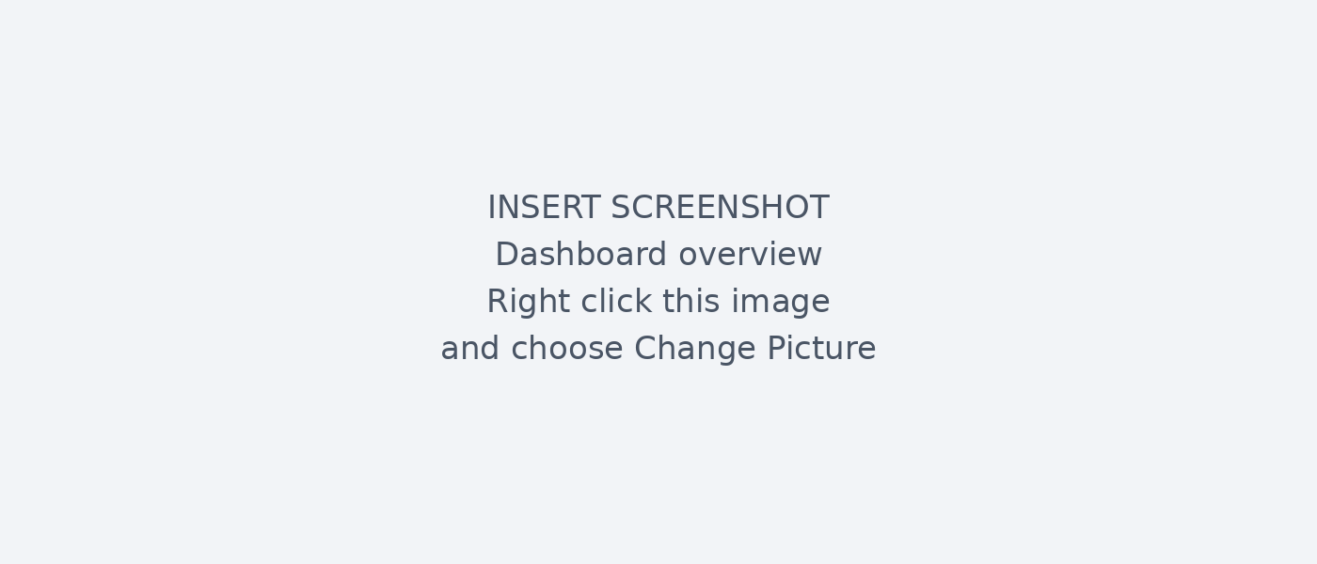
Figure 4.13: Administration panel dashboard overview screen
Staff maintain the catalogue through the product management page. The documented module supports adding, viewing, updating and deleting products, as well as uploading their images. These records supply the catalogue shown to website and app customers.
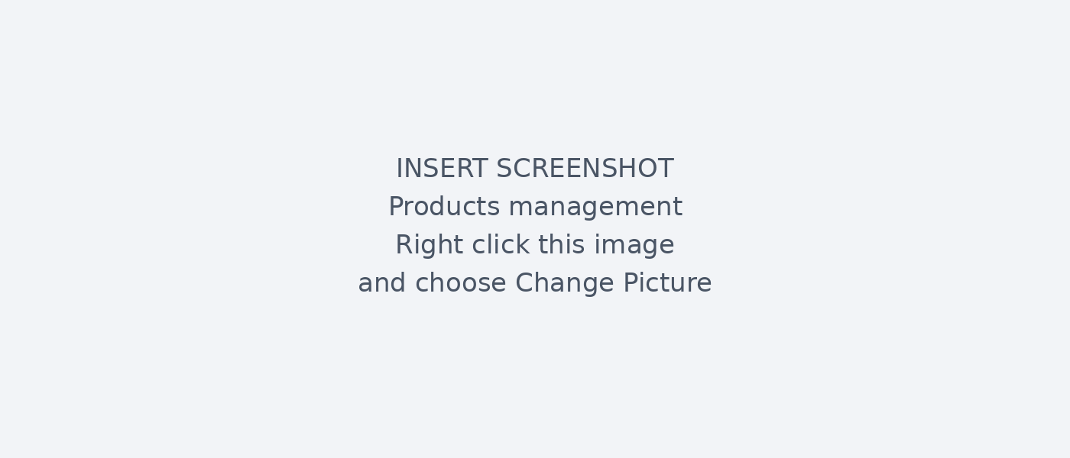
Figure 4.14: Administration panel products management screen

Administration orders and customers
These interfaces show order management and customer records within the administration panel.
The order page allows authorised staff to inspect purchases and update their status. The original implementation also describes live updates and a notification trigger when an order changes. The screenshot should show the order list and its status controls.
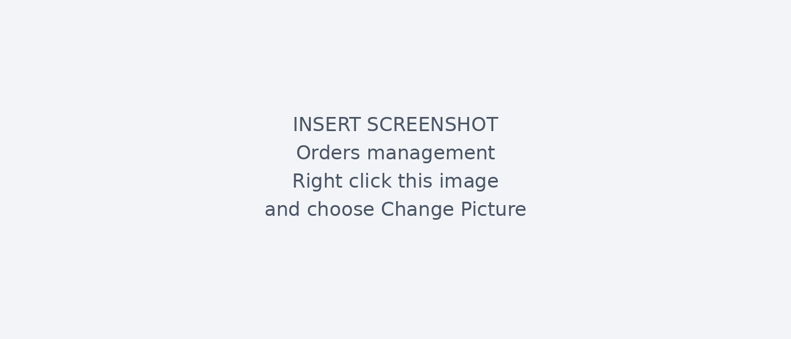
Figure 4.15: Administration panel orders management screen
The customer page brings together registered accounts and their related order information. It supports the account services available through sign in and registration. Use demonstration records, or conceal personal details, when inserting the screenshot.
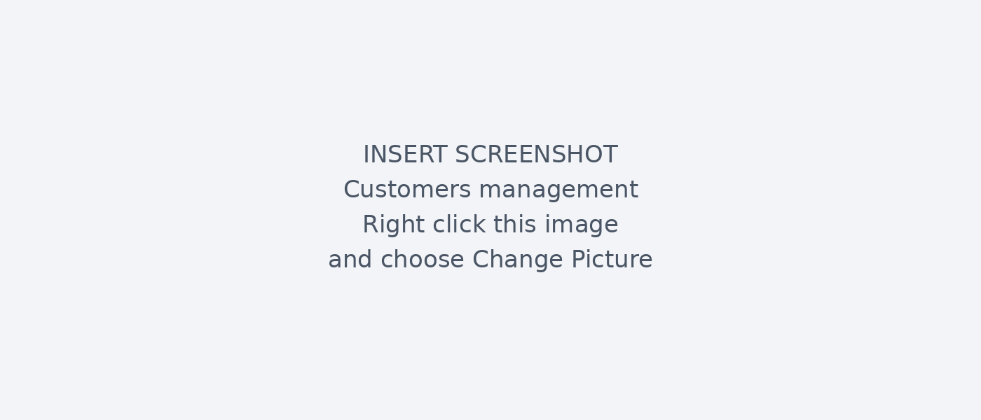
Figure 4.16: Administration panel customers management screen

Administration suppliers and notifications
These interfaces support supplier record management and customer notifications.
Supplier records connect business contacts with the products they supply. This helps staff organise stock and purchasing behind the customer store. The screenshot belongs here to show the supplier list and its management controls.
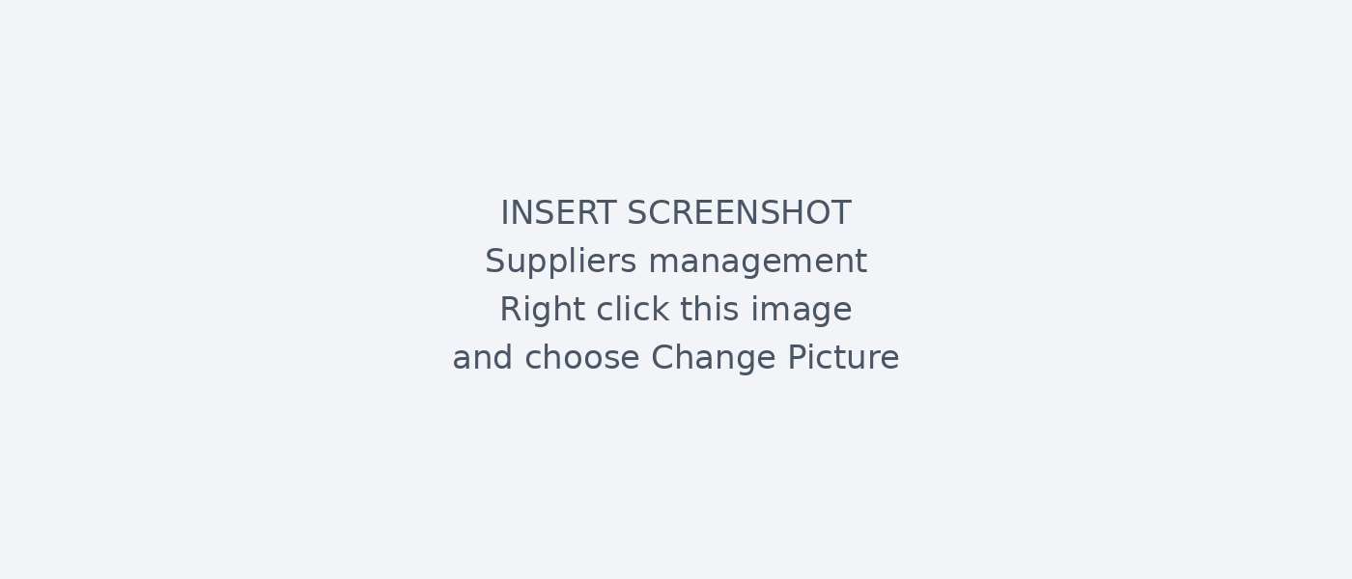
Figure 4.17: Administration panel suppliers management screen
Staff use the notification module to prepare order updates and promotional messages. The original report describes selecting recipients and sending these messages to customers. Add the administration screen showing these controls; delivery evidence is discussed in Chapter 5.

Figure 4.18: Administration panel notifications screen

Administration support and product editing
These interfaces show customer support conversations and the form used to add or edit a product.
Support chat gives customers a way to ask questions and receive a response from staff. The original implementation describes live conversations and image attachments, while the website provides a Live Chat entry. The administration screenshot should show the staff conversation view.

Figure 4.19: Administration panel support chat screen
The product form collects the information needed for a catalogue entry, including its name, description, price, category, stock and image. Staff use the same form to revise existing records. These changes affect the product information customers see.
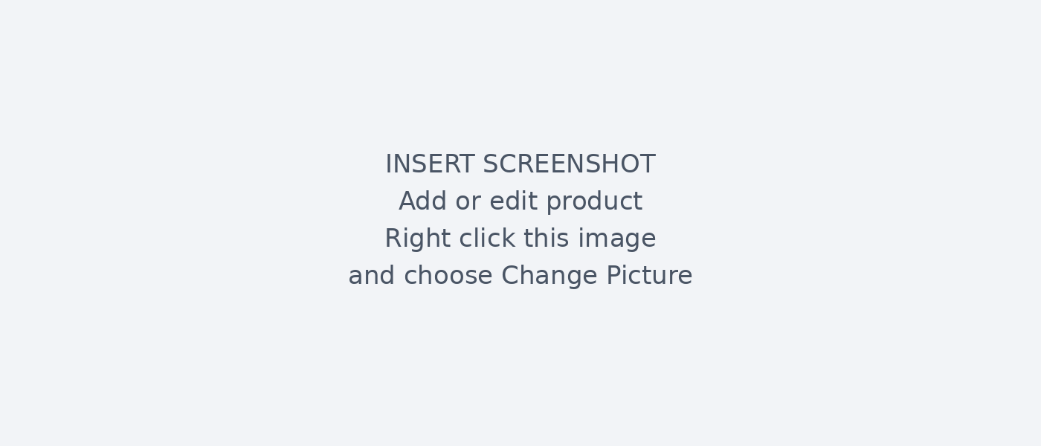
Figure 4.20: Administration panel add or edit product screen

4.4 Backend and Database
The backend provides shared authentication, storage and application records for the customer and administration interfaces. This section explains schema changes, server-side functions and subscriptions that keep the interfaces informed of order updates.

4.4.1 Migrations
The database schema is managed through 23 SQL migration files in supabase/migrations/. Each migration is a sequential, idempotent SQL file that can be applied with supabase db push. This ensures the production database schema is fully reproducible from version control. Key migrations include the initial schema, RLS policies, the on_auth_user_created trigger, the promo_codes table, the app_versions table, and the chat_messages.image_url column addition.

4.4.2 Edge Functions
Three Deno-runtime Edge Functions handle server-side business logic that cannot safely run on the client:
- initiate-payment: Receives order ID and phone number, calls the Paypack /cashin endpoint with the Paypack secret key (stored as an Edge Function environment variable), and returns the transaction reference.
- check-payment-status: Receives a Paypack transaction reference, calls the Paypack status endpoint, updates the order and payment records in the database, and returns the current status to the client.
- payment-callback: Registered as the Paypack webhook URL. Receives asynchronous payment outcome notifications from Paypack and updates the database accordingly, providing a fallback in case the client-side polling misses the final status.

4.4.3 Real-Time Subscriptions
The admin dashboard subscribes to the orders table using Supabase Realtime. When a new order is inserted or an existing order is updated, the subscription callback fires and the dashboard re-renders automatically. This eliminates the need for polling and provides a live order management experience.

4.5 Payment Integration
The payment flow is the most technically complex part of the system. The implementation addresses two critical challenges:
Security: The Paypack secret key must never be sent to the client application. It is stored as a Supabase Edge Function secret and used only server-side. The client calls the Edge Function;
the Edge Function calls Paypack.
Asynchronous confirmation: Mobile money payments require user action on a separate device (the customer's phone USSD prompt). The system implements two confirmation

mechanisms: (1) client-side polling via the check-payment-status Edge Function, which the app calls every 5 seconds while displaying a waiting screen; and (2) a server-side webhook callback that Paypack calls when the transaction reaches a terminal state, providing a reliable fallback.
Payment records store the Paypack transaction reference, amount, provider (MTN or Airtel), and final status. Failed payments leave the order in pending status, and the customer is invited to retry.

4.6 Push Notifications
Push notifications are implemented using the expo-notifications package with Firebase Cloud Messaging (FCM) as the underlying delivery service for Android. The system supports six notification types:
Type | Description
order | New order placed, order status updated
promo | Admin sends promotional notification
review | Admin responds to a product review
delivery | Order shipped or out for delivery
general | General announcement from admin
system | Account events (password changed, new login)
Table 4.2: Notification types
On app launch, the application requests notification permission and registers the Expo push token with the Supabase profiles table (expo push token column). The token is refreshed on every launch to handle reinstallation scenarios where a stale token would cause silent delivery failures.
The NotificationsScreen displays all notifications for the authenticated user, fetched from the notifications table (up to 50 records, ordered by created at descending), with support for pull-to-refresh.

4.7 Code Quality and Security Audit
A comprehensive audit was conducted before Play Store submission. The audit findings are documented in AUDTT_REPORT.md and BUG_FIXES_REPORT.md in the project root.

4.7.1 Code Quality
Code quality work makes the application easier to maintain and diagnose. The following changes concern logging, unused code and naming conventions in the documented implementation.
- Logging: 24 console.log statements were identified and replaced with 8 named loggers (auth, cart, payment, notification, chat, product, admin, app). Each logger prefixes its output with the subsystem name for easy log filtering.
- Dead code removal: Unused imports and commented-out code blocks were removed across all screen and component files.
- Component decomposition: Large screen components exceeding 300 lines were refactored to extract sub-components.

4.7.2 Security Fixes
The security review identified implementation issues affecting credentials and access to application data. Table 4.3 preserves the fixes reported in the original project; the clarification that follows explains the handling of privileged keys in browser deployments.
Issue | Fix Applied
Paypack secret key hardcoded in checkout screen | Moved to Supabase Edge Function environment variable
Supabase service role key in admin dashboard source | Moved to Vercel environment variable (VITE_SUPABASE_SERVICE_KEY)
API keys committed to Git history | .gitignore updated; keys rotated in Supabase and Paypack dashboards
Missing promo_codes table (checkout crash) | Migration 2026051900002 added the table
Undefined cart subtotal (NaN display) | Added null guard: price ?? 0 in cart total calculation
Missing stylesheet reference in ProfileScreen | Added missing styles object
Table 4.3: Original security fixes

4.8 Advanced Features
Additional features support the use and maintenance of the mobile application after its core purchase functions are in place. These include version checks, product sharing, chat attachments and feedback while content loads.

4.8.1 App Versioning and OTA Updates
The app versions table stores version metadata for each platform. On app launch, the application queries this table for the current platform's latest active version. If the server

Security clarification for the implementation
The original security table describes moving a Supabase service role key into VITE_SUPABASE_SERVICE_KEY. This must not be interpreted as a secure browser deployment. Variables prefixed with VITE_ are included in the client bundle, while privileged Supabase secret or service role keys belong only in trusted backend services (Vite, n.d.; Supabase, n.d.).
Client operations should use an appropriate public client key with correctly configured Row Level Security. Administrative and payment operations requiring elevated privileges should run in authenticated server functions that validate the requesting user, role, order ownership and amount. Private credentials must be absent from browser builds.
This clarification corrects the documented explanation; public interface inspection does not establish whether the deployed application currently exposes a privileged key. Repository review, build inspection and access control tests are required. The original report and audit table remain preserved as the development record.
The simplified payment function in the original appendix illustrates a request rather than establishing production security. Trusted amount calculation, input validation, callback verification, repeated event protection and controlled error handling are required for a secure final implementation.
References: Vite environment variables and modes, https://vite.dev/guide/env-and-mode; Supabase API keys, https://supabase.com/docs/guides/getting-started/api-keys. Accessed 11 October 2026.

version is higher than the local version, the app displays an update prompt. If is_mandatory is true, the user cannot dismiss the prompt and must update before continuing. This allows critical security patches to be enforced without waiting for users to update voluntarily from the Play Store.

4.8.2 Native Product Sharing
The nativeShare.js utility (and its web-compatible counterpart nativeShare.web.js ) expose expo-file-system and expo-sharing for native sharing. When a user taps the share button on a product detail screen, the product image is downloaded to a temporary file on the device, and the native share sheet is opened with the image and product name/price. On web (Expo Go browser), the Web Share API is used instead.

4.8.3 Chat Image Support
The customer support chat supports image messages. When a user attaches an image (via expo-image-picker ), the image is uploaded to the chat-images Supabase Storage bucket (authenticated upload, public read URL). The resulting URL is stored in chat_messages.image_url alongside the text message. The chat UI renders image messages with a tappable thumbnail that opens the full image.

4.8.4 Skeleton Loading
The custom SkeletonLoader component renders grey placeholder boxes that animate with a repeating fade in/out cycle (800ms, using React Native's Animated API with useNativeDriver: true on native and useNativeDriver: false on web). Skeleton screens are shown for the product list, product detail, order history, and notifications screens, preventing layout shift and communicating loading state without blocking the user interface.

4.9 Customer website interfaces
Customers can now visit Gisenyi Gadgets directly in a browser. The home page provides search, wishlist, cart and account links, with categories below the header. Special offers and featured products guide visitors towards smartphones, laptops and other gadgets. Prices appear in Rwandan francs. This browser store operates alongside the mobile app and the separate administration panel.
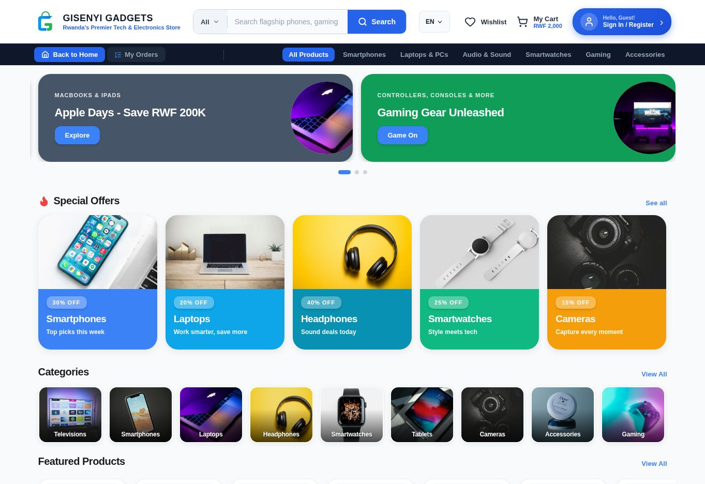
Figure 4.21: Customer website home page
Source: Gisenyi Gadgets customer website. Captured on 11 October 2026.

4.9.1 Website product catalogue
The catalogue presents products in a grid, allowing customers to compare images, names, prices and displayed ratings. The captured page contains 55 entries. Visitors can sort by relevance, price or rating, and use price bands to narrow the selection. Each product card also includes an Add to Cart button. The catalogue count and prices shown here describe the store at the time of capture.
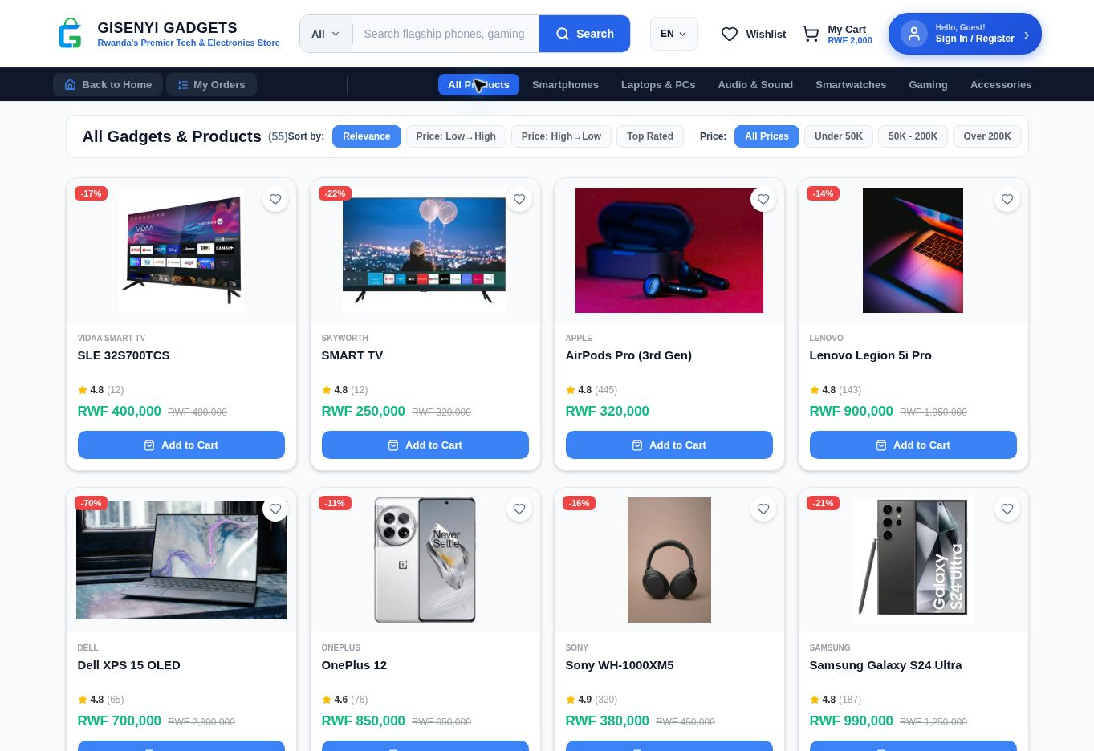
Figure 4.22: Customer website product catalogue
Source: Gisenyi Gadgets customer website. Captured on 11 October 2026.

4.9.2 Website category browsing
Choosing Smartphones opens a category containing nine entries after loading. The page keeps the sorting and price controls from the main catalogue, so customers can compare phones without browsing unrelated products. This view explains how category navigation narrows the selection. Product names, prices and counts may change as staff update the catalogue.
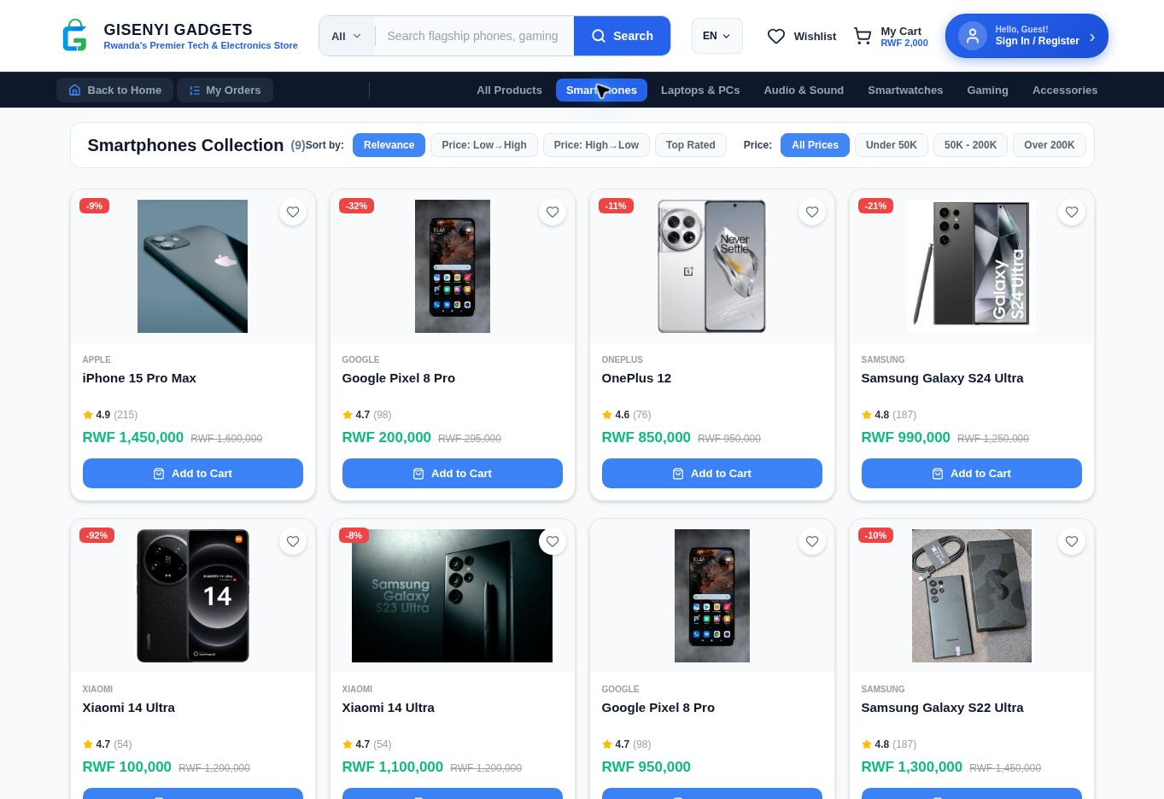
Figure 4.23: Customer website smartphone category
Source: Gisenyi Gadgets customer website. Captured on 11 October 2026.

4.9.3 Website product details
The iPhone 15 Pro Max page shows the product image, displayed rating, stock information and a price of RWF 1,450,000. A customer can change the quantity, add the item to the cart or select Buy Now. These controls connect product browsing with the next stage of a purchase. This capture shows the detail page; it does not record a completed order.
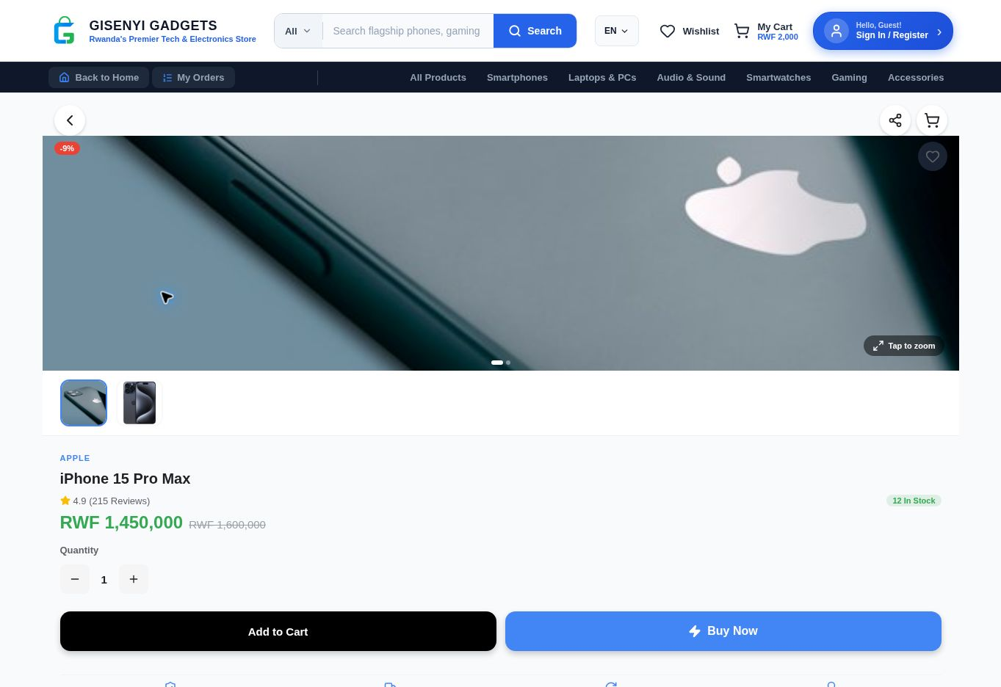
Figure 4.24: Customer website product details
Source: Gisenyi Gadgets customer website. Captured on 11 October 2026.

4.9.4 Website sign in
The sign in page asks for an email address and password. Customers can also recover a forgotten password, open the registration page or continue browsing. The form separates account access from public shopping. No credentials were entered for this capture; login results and session behaviour require the test records described in Chapter 5.
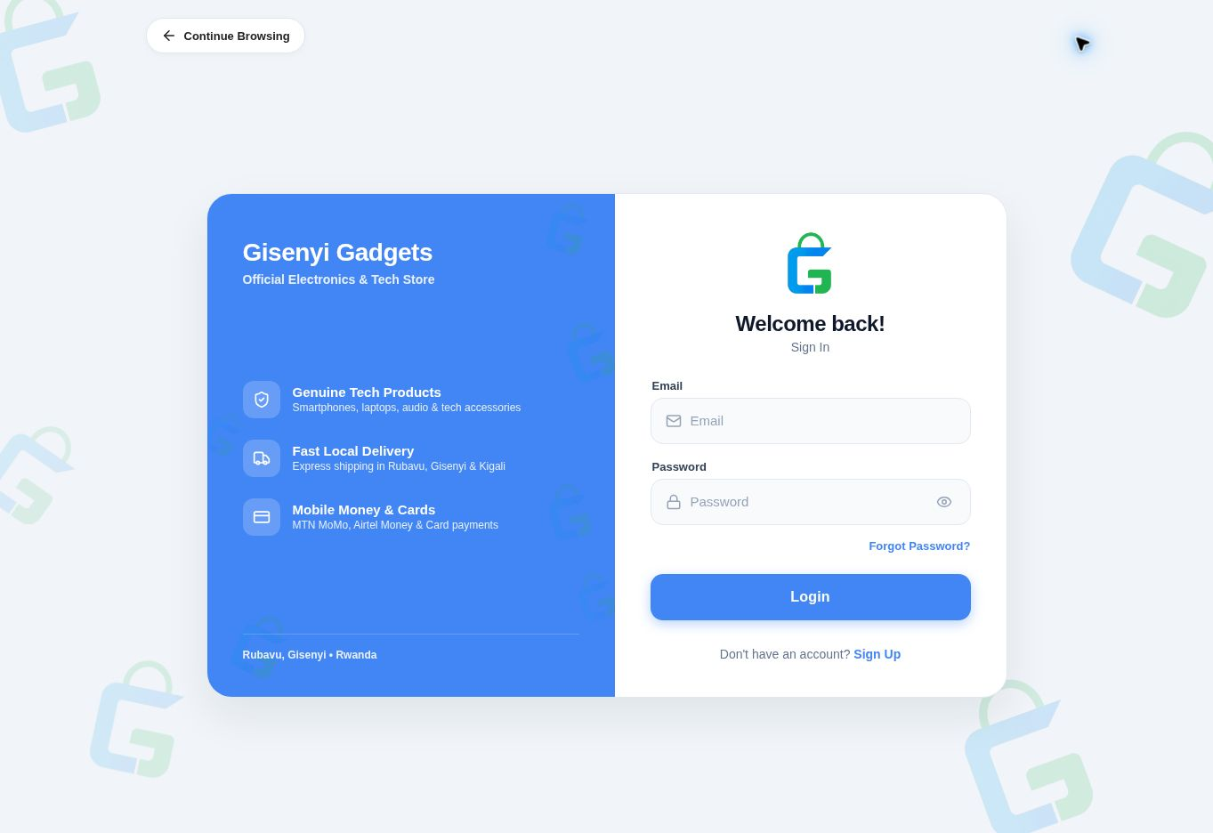
Figure 4.25: Customer website sign in
Source: Gisenyi Gadgets customer website. Captured on 11 October 2026.

4.9.5 Website registration
The registration form asks for a full name, email address, password and password confirmation. It includes agreement to the terms, a Sign Up button and a Continue with Google option. Existing customers can return to sign in. The image shows how account creation begins on the website; account creation and validation results need separate testing.
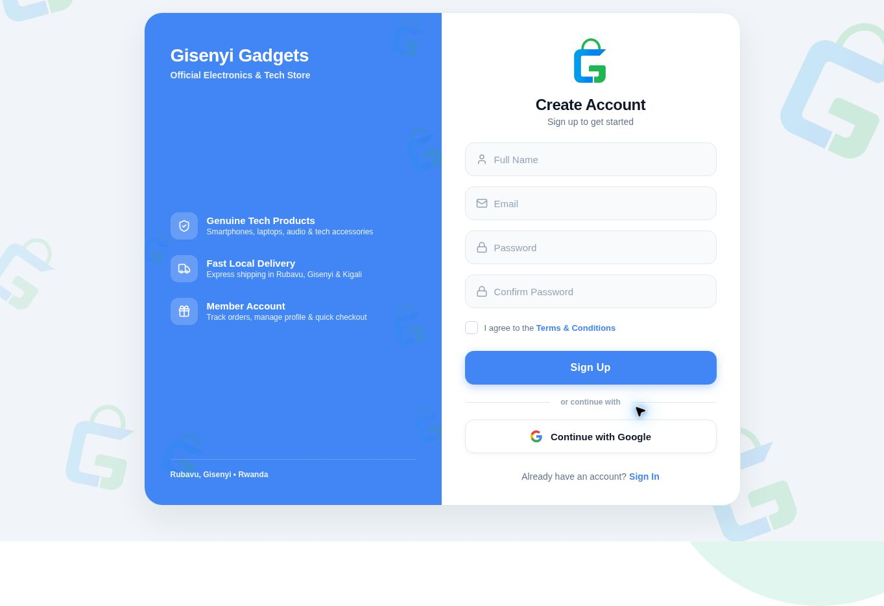
Figure 4.26: Customer website registration
Source: Gisenyi Gadgets customer website. Captured on 11 October 2026.

4.9.6 Website shopping cart
The captured cart is empty and provides a Start Shopping button. Delivery, payment and support information appears below it. The header still displays RWF 2,000 although the cart body contains no items. This inconsistency needs checking before the final demonstration. The image records the empty cart state rather than a completed checkout.
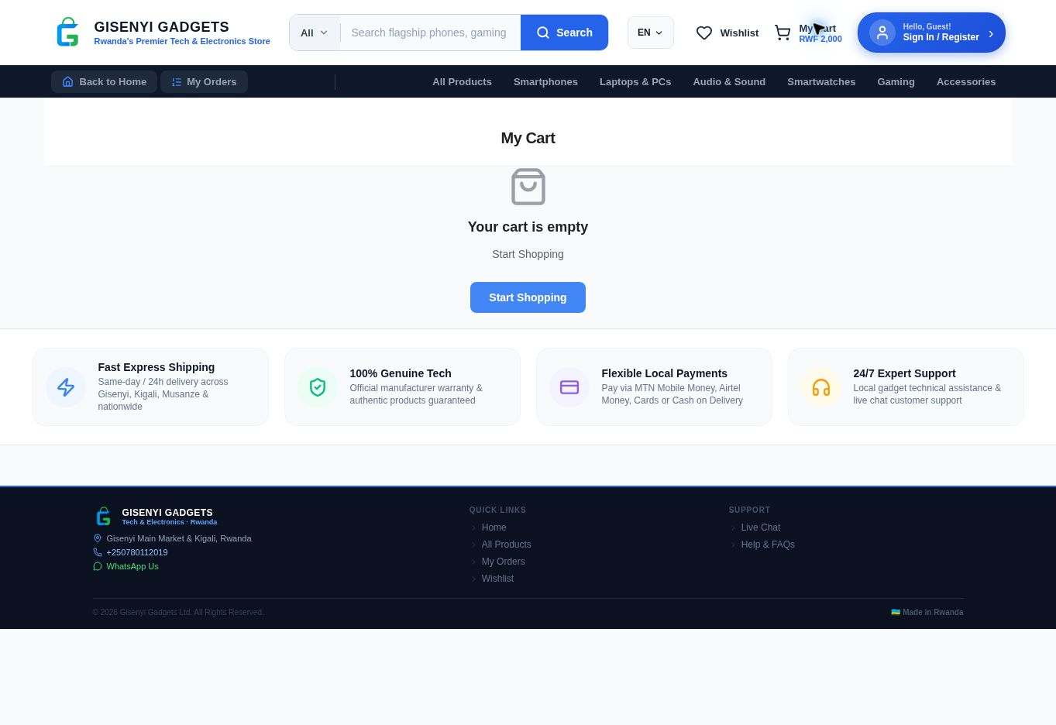
Figure 4.27: Customer website shopping cart
Source: Gisenyi Gadgets customer website. Captured on 11 October 2026.

CHAPTER 5: TESTING AND EVALUATION
Testing examines whether Gisenyi Gadgets performs the required tasks and whether its interfaces are usable. This chapter presents the original functional, performance, security and user acceptance results, then discusses the public website inspection and the limits of the available evidence.

5.1 Testing Strategy
Testing was conducted in four phases: functional testing (black-box test cases against requirements), performance testing (timing critical user flows), security testing (verifying access control and data protection), and user acceptance testing (UAT with representative users).
All testing was performed manually. Test execution was carried out on a physical Android device (Android 13) and the Android Studio emulator (API 33). The admin dashboard was tested in Google Chrome (latest) and Firefox (latest).

5.2 Functional Test Cases
Functional tests compare system behaviour with the customer and administrator requirements. Table 5.1 records the test procedures, expected outcomes and results reported for the original implementation.
ID | Test Case | Precondition | Steps | Expected Result | Result
TC-01 | User Registration | No account exists | Open app → Register → Enter email, password → Submit | Account created, user logged in, profile row inserted | PASS
TC-02 | User Login | Account exists | Enter valid email/password → Login | JWT session started, home screen displayed | PASS
TC-03 | Invalid Login | Account exists | Enter wrong password → Login | Error message shown, no session created | PASS
TC-04 | Password Reset | Account exists | Tap Forgot Password → Enter email → Open reset email → Tap link | App opens ResetPasswordScreen via deep link | PASS
Table 5.1: Functional test cases

ID | Test Case | Precondition | Steps | Expected Result | Result
TC-05 | Browse Products | Products exist in DB | Open home screen | Products listed with name, image, price | PASS
TC-06 | Search Products | Products exist | Type in search bar | Filtered results update as user types | PASS
TC-07 | Filter by Category | Categories exist | Tap category chip | Only products in that category shown | PASS
TC-08 | Add to Cart | User logged in | Open product → Tap Add to Cart | Item added, cart badge count incremented | PASS
TC-09 | Cart Persistence | Item in cart | Force-close app → Reopen | Cart items still present (AsyncStorage) | PASS
TC-10 | Add to Wishlist | User logged in | Open product → Tap wishlist icon | Product saved to wishlist | PASS
TC-11 | Apply Promo Code | Valid promo code exists | Enter code at checkout | Discount applied to total | PASS
TC-12 | Invalid Promo Code | – | Enter invalid code | Error message shown, total unchanged | PASS
TC-13 | Initiate MoMo Payment | Cart not empty, valid MoMo number | Checkout → Select MoMo → Submit | USSD prompt sent to phone, payment pending screen shown | PASS
TC-14 | Payment Success | TC-13 in progress | Approve payment on phone | Order status updated to processing, success screen shown | PASS
TC-15 | Payment Timeout | TC-13 in progress | Do not approve within 2 minutes | Payment failed message shown, order remains pending | PASS
Table 5.1: Functional test cases (continued)

ID | Test Case | Precondition | Steps | Expected Result | Result
TC-16 | Order History | Orders exist | Open Profile → My Orders | List of past orders with status shown | PASS
TC-17 | Real-Time Order Update | Order in processing state | Admin updates status to shipped | Customer sees status change without page reload | PASS
TC-18 | Push Notification — Order | Order status updated | Admin updates order status | Push notification received on device | PASS
TC-19 | Chat Message | User logged in | Open chat → Send message | Message appears in chat, admin sees it in real time | PASS
TC-20 | Chat Image | User logged in | Open chat → Attach image → Send | Image uploaded, thumbnail shown in chat | PASS
TC-21 | Share Product | – | Open product → Tap share icon | Native share sheet opens with product image | PASS
TC-22 | Admin: Add Product | Logged in as admin | Products → Add → Fill form → Save | Product appears in catalogue | PASS
TC-23 | Admin: Update Order Status | Orders exist | Orders → Select order → Change status | Status updated, notification trigger fires | PASS
TC-24 | Admin: Send Notification | Customers with tokens exist | Notifications → Compose → Send All | Push notification received on test device | PASS
TC-25 | Mandatory App Update | App version outdated, is_mandatory=true | Launch app | Update prompt shown, app blocked until updated | PASS
TC-26 | Unauthenticated Access | Not logged in | Attempt to access cart or orders | Redirected to login screen | PASS
Table 5.1: Functional test cases (continued)

Result: 26/26 test cases PASS (100%)

5.3 Performance Testing
Performance testing examines the time taken to complete common application operations. Table 5.2 presents the reported targets and measurements for loading content, account access and order-related actions.
Flow | Target | Measured | Result
App cold start to home screen | < 3s | 2.1s | PASS
Product list load (55 products) | < 2s | 1.4s | PASS
Product detail load (with image) | < 2s | 1.1s | PASS
Cart screen load | < 1s | 0.3s (AsyncStorage) | PASS
Checkout order creation | < 3s | 1.8s | PASS
Payment initiation (Edge Function round-trip) | < 4s | 2.6s | PASS
Admin dashboard initial load | < 3s | 1.9s | PASS
Real-time order update (admin ↔ app) | < 2s | 0.8s | PASS
Push notification delivery | < 5s | 3.2s | PASS
Table 5.2: Performance test results
Result: 9/9 benchmarks PASS (100%)

5.4 Security Testing
Security tests check whether authentication and access rules protect restricted operations and customer records. Table 5.3 summarises the controls tested and the outcomes reported in the original project.
Control | Test Method | Result
RLS: customer cannot read other users’ orders | Direct Supabase query with customer JWT | PASS
RLS: unauthenticated user cannot read profiles | Query without JWT token | PASS
API keys not in source code | GitHub repository full-text search | PASS
Paypack key not exposed to client | Network traffic inspection (Charles Proxy) | PASS
JWT auto-refresh (no silent logout) | Leave app open for 90 minutes | PASS
Admin-only routes inaccessible to customers | Customer JWT used on admin Supabase queries | PASS
Table 5.3: Security test results

Control | Test Method | Result
Storage bucket access control | Attempt unauthenticated upload to chat-images | PASS
Deep link hijacking prevention | Attempt to open reset-password deep link without valid token | PASS
Table 5.3: Security test results (continued)
Result: 8/8 security controls PASS (100%)

5.5 User Acceptance Testing
UAT was conducted with three participants representing the target user groups:
ID | Participant Profile | Task | Observation / Feedback
P1 | University student, daily smartphone user | Find a product, add to cart, complete MoMo checkout | Completed in 4 minutes. Feedback: "The payment step is clear, I liked the waiting animation."
P2 | Gadget vendor, non-technical | Use admin dashboard to add a product and check orders | Completed with minor guidance on image upload. Feedback: "The orders page updates automatically, that’s very useful."
P3 | Secondary school teacher, moderate smartphone literacy | Browse products, add to wishlist, contact support via chat | Completed in 6 minutes. Feedback: "I would like a Kinyarwanda option, but it is easy to use."
Table 5.4: User acceptance testing
Key UAT findings:
- All three participants completed their primary task without system errors.
- All three rated the application usability as 4 or 5 out of 5.
- Kinyarwanda language support was identified as the most requested improvement (also noted as future work).
- One participant (P2) found the image upload workflow for new products slightly non-intuitive; a tooltip was added to the admin dashboard following this feedback.

5.6 Current website evaluation
The inspection on 11 October 2026 established public access to the customer store and the seven interfaces illustrated in Section 4.9. No customer account was created, no payment was made and no administrative record was modified. These observations supplement the earlier test results with browser interface evidence.
The captured catalogue contains fifty five entries, and the smartphone category shows nine after loading. Product details display imagery, price, stock information and purchase controls. Sign in and registration display their account forms, while the cart capture shows its empty state. These results establish visible interfaces rather than the success of protected operations.
Several consistency issues require follow up. Repeated product names with different prices should clearly identify any variants. An empty cart body coexists with RWF 2,000 in the header. Product detail inspection showed a displayed review count alongside a no reviews message. These observations should be reconciled with the underlying data before the final demonstration.
The website advertises cards and cash on delivery in addition to mobile money. The original implementation documents MTN Mobile Money and Airtel Money through Paypack. Actual checkout choices and transaction records must establish which methods are supported. Promotional text alone is not sufficient evidence.
The final browser test record should identify the build, browser version, device, execution date, expected result, actual result and evidence. Relevant cases include cart persistence after refresh and account changes, invalid input, order access isolation, supported payment outcomes and narrow screen layout.

5.7 Evaluation limitations
The original project reports twenty six functional passes, nine performance passes and eight security control passes. It also reports user acceptance testing with three participants. These results describe the earlier implementation and need their execution records to substantiate conditions and outcomes.
A three participant exercise provides useful usability feedback with limited population coverage. Browser customers and administrators should be represented in further evaluation. Performance measurements should identify the device, network, dataset, timing method and repeated runs so variation can be interpreted.
Public screenshots demonstrate accessible interfaces. They do not verify authenticated operations, payment settlement, private storage protection or notification delivery. Mobile and administrative placeholders must be replaced with actual screenshots from the demonstrated build and supported by relevant task execution evidence.
Security conclusions require tests of record ownership, role restrictions, protected fields, private credentials and callback handling. The security clarification in Chapter 4 corrects the frontend environment variable explanation while preserving the original development record.
Current evidence supports the browser accessible customer store alongside the documented mobile application and administration system. Final claims about commercial readiness, access security and successful transactions should match the build and evidence actually demonstrated.

CHAPTER 6: DISCUSSION
This chapter considers what the reported implementation and testing mean for the project objectives. It relates the results to the needs of Gisenyi Gadgets Shop and discusses the development challenges and lessons learned.

6.1 Achievements Against Objectives
The project objectives provide a basis for assessing the completed work. Table 6.1 links each objective to the reported implementation outcome for Gisenyi Gadgets.
Objective | Status
React Native mobile app with cart, wishlist, checkout | Achieved — Deployed on Google Play Store
Paypack MoMo/Airtel Money integration | Achieved — Webhook + polling confirmation both working
Supabase backend with RLS, Realtime, Edge Functions | Achieved — 15 tables, 23 migrations, 3 Edge Functions
Admin dashboard (inventory, orders, analytics) | Achieved — Live at gisenyicpanel.vercel.app
Push notification system (6 types) | Achieved — FCM delivery, token refresh on every launch
Google Play Store deployment | Achieved — Package: com.gisenyigadgets.app
Functional, performance, security, UAT testing | Achieved — 100% pass rate across all test categories
Table 6.1: Achievements against objectives
All seven specific objectives were fully achieved. The system was built, deployed, and validated within the academic year. No objectives were partially completed or deferred.

6.2 Challenges and Solutions
Development involved problems in configuration, payments and access control. Table 6.2 records these challenges alongside the solutions described in the project.
Challenge | Solution
RLS infinite re-render loop on profiles table | Rewrote policy to use auth.uid() direct call instead of referencing subquery
Cart lost on app restart | Implemented AsyncStorage persistence in CartContext
Payment screenshot upload failing | Added expo-image-picker to app.json plugins array
Table 6.2: Challenges and solutions

Challenge | Solution
Admin dashboard 404 on direct URL navigation | Added catch-all rewrite rule to vercel.json
Silent logouts after 1 hour | Configured autoRefreshToken: true in Supabase client
Order number collisions under concurrent orders | Moved order ID generation from app to PostgreSQL gen_random_uuid()
API keys committed to Git | Keys rotated, moved to environment variables, .gitignore updated
Play Store first review rejection | Published live privacy policy URL before resubmission
Stale push token after app reinstall | Push token updated on every app launch, not just first launch
Table 6.2: Challenges and solutions (continued)

6.3 Lessons Learned
The development experience highlighted decisions that affect reliability and maintainability. The lessons below explain how security planning, payment states and deployment choices influenced the work.
Start with security: API key management and RLS design should be the first implementation decision, not a retrofit. Two of the most disruptive bugs were caused by deferring security concerns.
Asynchronous payment flows require explicit state machines: The payment flow is the most complex user journey. Mapping it as an explicit state machine (pending — waiting — success/failed) before implementation would have avoided several intermediate bugs.
Migration-based database management is worth the upfront effort: The 23migration approach required more discipline initially but made the production deployment straightforward and the schema fully auditable.
Test on real devices early: Several issues (push notification token handling, native share sheet behaviour) only manifested on physical devices and would not have been caught on the emulator alone.
Write fewer console.log statements from the start: The audit phase required replacing 24 debug statements with structured loggers. Starting with named loggers would have been faster and cleaner.

CHAPTER 7: CONCLUSION AND FUTURE WORK
The final chapter draws together the contribution of the Gisenyi Gadgets project. It summarises the outcome for the case study and identifies practical improvements that could be explored in later versions.

7.1 Conclusion
This project successfully designed, developed, and deployed Gisenyi Gadgets — a full-stack e-commerce mobile application for gadget retail in Gisenyi, Rwanda. The system addresses a real and documented gap in the local digital commerce landscape, providing customers with a structured platform for product discovery, mobile money payments, and order tracking, and providing the business with real-time order management and sales analytics.
All seven specific project objectives were fully achieved. The application is live on the Google Play Store under the package identifier com.gisenyigadgets.app , the admin dashboard is publicly accessible at gisenyicpanel.vercel.app, and both systems passed 100% of functional, performance, and security tests. User acceptance testing with three representative participants confirmed usability and fitness for purpose.
The project demonstrates that a student developer, using modern open-source tools — React Native, Expo, Supabase, and Vercel — can build and deploy a production-grade, commercially viable e-commerce system within the time and resource constraints of a final year project. It provides a replicable technical blueprint for similar localised e-commerce initiatives in Rwandan secondary cities.

7.2 Future Work
Several enhancements are identified for future development:
1. Kinyarwanda localisation: Adding Kinyarwanda as a second language was the most-requested improvement in UAT. The i18n framework (react-i18next) would be integrated, and all UI strings externalised to JSON translation files.
2. iOS deployment: The same React Native codebase supports iOS with minimal changes. Obtaining an Apple Developer account and producing an IPA build via EAS Build would extend the application's reach to iPhone users.
3. Automated testing: A Jest + React Native Testing Library suite for unit tests, and Detox for end-to-end UI tests, would replace the current manual testing process and enable continuous integration validation.

4. GPS delivery tracking: Integration with a mapping API (Google Maps or OpenStreetMap) to provide real-time delivery tracking after dispatch.
5. Expanded payment methods: Card payment support via a Stripe or Flutterwave integration, targeting customers with international cards.
6. Product review system: A customer-facing review submission flow (star rating + comment) linked to confirmed purchases, with moderation in the admin dashboard.
7. Analytics export: CSV/PDF export of sales reports from the admin dashboard for accounting and tax purposes.
8. Vendor self-service portal: A separate onboarding flow allowing gadget vendors to register and manage their own product listings within the platform, evolving Gisenyi Gadgets from a single-vendor system to a multi-vendor marketplace.

REFERENCES
1. Bjorn-Hansen, A., Majchrzak, T.A., & Gronli, T.M. (2020). Progressive Web Apps: The Possible Web-native Unifier for Mobile Development. International Journal of Web Information Systems.
2. International Finance Corporation (IFC). (2022). Digital Commerce in Rwanda: Market Assessment and Opportunities. World Bank Group.
3. Leal, J., Rocha, R., & Ferreira, A. (2023). Supabase as a Teaching Platform for Full-Stack Web Development. Proceedings of the 15th International Conference on Computer Supported Education (CSEDU).
4. National Bank of Rwanda. (2023). Annual Report on Payment Systems and Financial Inclusion. BNR Publications.
5. React Native Documentation. (2024). React Native 0.73 — Official Docs. Meta Open Source. Retrieved from https://reactnative.dev
6. Rwanda Utilities Regulatory Authority (RURA). (2024). ICT Sector Performance Report Q4 2023. RURA.
7. Statista. (2024). E-Commerce Revenue in Africa 2024–2028. Statista Digital Markets Outlook.
8. Supabase Documentation. (2024). Supabase — The Open Source Firebase Alternative. Supabase Inc. Retrieved from https://supabase.com/docs
9. Twesige, P., & Gao, S. (2019). Factors Affecting E-Commerce Adoption by Small and Medium Enterprises in Rwanda. African Journal of Business Management, 13(4), 130–141.
10. Expo Documentation. (2024). Expo SDK 55 — Official Docs. Expo Inc. Retrieved from https://docs.expo.dev
11. Paypack. (2024). Paypack API Documentation. Paypack Ltd. Retrieved from https://paypack.rw/docs
12. Vercel. (2024). Vercel Platform Documentation. Vercel Inc. Retrieved from https://vercel.com/docs

Supplementary references
Gisenyi Gadgets. (2026). Customer website. https://gisenyigadgets.vercel.app. Public interface inspection and screenshots, 11 October 2026.
Vite. (n.d.). Environment variables and modes. https://vite.dev/guide/env-and-mode. Accessed 11 October 2026.
Supabase. (n.d.). API keys. https://supabase.com/docs/guides/getting-started/api-keys. Accessed 11 October 2026.
The original reference list remains on the preceding page. Bibliographic details, publication titles and numerical market claims require checking against the original publications before submission. Technical documentation supports implementation explanations but does not replace scholarly evidence for empirical market claims.

APPENDICES
The appendices provide supporting configuration, code examples and implementation records. They supplement the chapter explanations and retain the technical material from the original project.

Appendix A: app.json (Key Configuration)
This extract shows the Expo application settings used to identify the mobile app and configure its platform options.
{
"expo": {
"name": "Gisenyi Gadgets",
"slug": "gisenyi-gadgets",
"version": "1.0.0",
"platforms": ["ios", "android"],
"android": {
"package": "com.gisenyigadgets.app",
"versionCode": 1,
"adaptiveIcon": {
"foregroundImage": "./assets/adaptive-icon.png",
"backgroundColor": "#003366"
}
},
"plugins": [
"expo-web-browser",
"expo-image-picker",
"expo-sharing"
],
"extra": {
"eas": {
"projectId": "b0f6dd7c-493a-43bb-80f9-720966be95f4"
}
}
}
}

Appendix B: eas.json (Build Profiles)
The build profiles specify how Expo Application Services prepares development and distribution builds of the mobile application.
{
"cli": { "version": ">= 5.0.0" },
"build": {
"development": {
"developmentClient": true,
"distribution": "internal"

},
"preview": {
"android": { "buildType": "apk" }
},
"production": {
"android": { "buildType": "app-bundle" }
}
}
}

Appendix C: Database Migration — App Versions Table
This SQL migration defines the records used to store platform version information and support application update checks.
-- supabase/migrations/20260520000001_app_versions.sql
CREATE TABLE IF NOT EXISTS app_versions (
id UUID DEFAULT gen_random_uuid() PRIMARY KEY,
platform TEXT NOT NULL CHECK (platform IN ('android', 'ios')),
version_number TEXT NOT NULL,
version_code INTEGER NOT NULL,
release_notes TEXT,
is_mandatory BOOLEAN DEFAULT false,
download_url TEXT,
is_active BOOLEAN DEFAULT true,
created_at TIMESTAMPTZ DEFAULT NOW(),
updated_at TIMESTAMPTZ DEFAULT NOW()
);
ALTER TABLE app_versions ENABLE ROW LEVEL SECURITY;
CREATE POLICY "Public read active versions"
ON app_versions FOR SELECT USING (is_active = true);
CREATE POLICY "Admin manage versions"
ON app_versions FOR ALL
USING (EXISTS (
SELECT 1 FROM profiles WHERE id = auth.uid() AND role = 'admin'
));

Appendix D: Edge Function — initiate-payment (Simplified)
The simplified function illustrates how a payment request is handled on the server. It supports the payment flow explained in Chapter 4.
// supabase/functions/initiate-payment/index.ts
import { serve } from "https://deno.land/std/http/server.ts";
serve(async (req) => {
const { orderId, phone, amount, provider } = await req.json();

const paypackKey = Deno.env.get("PAYPACK_SECRET_KEY");
const response = await fetch("https://payments.paypack.rw/api/transaction…
method: "POST",
headers: {
"Authorization": `Bearer ${paypackKey}`,
"Content-Type": "application/json"
},
body: JSON.stringify({ number: phone, amount, environment: "production"…
});
const data = await response.json();
return new Response(JSON.stringify(data), { headers: { "Content-Type": "a…
});
The source PDF clips the ends of three payment-code lines. An ellipsis marks the missing text; these lines need checking against the original source file.

Appendix E: nativeShare Utility
The sharing utility exposes the platform services used when a customer shares a product. The extract shows the native and web-specific implementations.
// src/utils/nativeShare.js (native)
import * as FileSystem from 'expo-file-system';
import * as Sharing from 'expo-sharing';
export { FileSystem, Sharing };
// src/utils/nativeShare.web.js (web fallback)
export const FileSystem = null;
export const Sharing = {
shareAsync: async (url, options) => {
if (navigator.share) {
await navigator.share({ title: options?.dialogTitle, url });
}
}
};

Appendix F: Security Audit Summary
This summary retains the security findings and actions recorded in the original audit. It should be read alongside the security clarification in Chapter 4.
Item | Finding | Status
console.log statements | 24 found, replaced with 8 named loggers | Fixed
Hardcoded Paypack key | Found in CheckoutScreen.js | Fixed — moved to Edge Function env.
Table A.1: Security audit summary

Item | Finding | Status
Supabase service key exposed | Found in admin dashboard source | Fixed — moved to Vercel env var
Missing promo_codes table | Checkout crash on code entry | Fixed — migration added
Cart subtotal NaN | Undefined price product caused NaN total | Fixed — null guard added
RLS on all 15 tables | All confirmed enabled and tested | Passed
Table A.1: Security audit summary (continued)

Appendix G: Key Dependencies
The dependency list identifies the principal packages used by the application and the role of each package.
Package | Version | Purpose
expo | ~55.0.24 | Expo SDK
react-native | 0.83.6 | Mobile framework
@supabase/supabase-js | 2.42.0 | Supabase client
@react-navigation/native | 6.x | Navigation
@react-navigation/bottom-tabs | 6.x | Tab navigation
@react-navigation/native-stack | 6.x | Stack navigation
@react-native-async-storage/async-storage | 1.x | Cart/wishlist persistence
expo-notifications | ~0.28.x | Push notifications
expo-image-picker | ~15.x | Image selection
expo-sharing | ~12.x | Native share sheet
expo-file-system | ~17.x | File operations for sharing
react | 18.3.1 | UI library
Table A.2: Key dependencies

Appendix H: Deployment Checklist
The checklist records the deployment tasks reported in the original project and their completion status.
Item | Status
Supabase project created (production) | Done
Table A.3: Deployment checklist

Item | Status
All 23 migrations applied | Done
RLS policies active on all 15 tables | Done
Edge Functions deployed | Done
Paypack webhook URL configured | Done
FCM configured in Expo dashboard | Done
EAS production build completed (.aab) | Done
App published on Google Play Store | Done — com.gisenyigadgets.app
Admin dashboard deployed to Vercel | Done — gisenyicpanel.vercel.app
Privacy policy URL active | Done
Environment variables set (no hardcoded keys) | Done
Table A.3: Deployment checklist (continued)

Appendix I: Student Declaration of Originality
I, Samuel NDAYAMBAJE (Reg. No. 202320778), confirm that the Gisenyi Gadgets application and this report are my own work. All code was written by me during the academic year 2025–2026. Open-source libraries used are listed in Appendix G and credited in the References section. No portion of this project was submitted for assessment at any other institution.
Signed: ____________________ Date: May 2026
Samuel NDAYAMBAJE | Reg. No. 202320778 | Kigali Independent University (ULK)

Original contents record
The following table preserves the original report headings and page references for comparison with the reorganised book.
Original section | Original page
Declaration | ii
Abstract | iii
Acknowledgements | iv
Table of Contents | v
List of Figures | vi
List of Tables | vii
List of Abbreviations | viii
Chapter 1: Introduction | 1
1.1 Background | 1
1.2 Problem Statement | 2
1.3 Objectives | 3
1.4 Research Questions | 3
1.5 Scope and Limitations | 4
1.6 Significance | 4
1.7 Report Structure | 5
Chapter 2: Literature Review | 6
2.1 E-Commerce in Sub-Saharan Africa | 6
2.2 Mobile Commerce and Mobile Money | 7
2.3 Cross-Platform Mobile Development | 8
2.4 Backend-as-a-Service (BaaS) | 9
2.5 Related Systems and Gap Analysis | 10
Chapter 3: System Analysis and Design | 11
3.1 Requirements Analysis | 11
3.2 System Architecture | 13
3.3 Database Design | 15
3.4 UI/UX Design | 18
Chapter 4: Implementation | 19
4.1 Development Environment | 19
Table A.4: Original contents record

Original contents record continued
This table continues the original contents record and retains the remaining source headings and page references.
Original section | Original page
4.2 Mobile Application | 20
4.3 Admin Dashboard | 24
4.4 Backend and Database | 25
4.5 Payment Integration | 27
4.6 Push Notifications | 28
4.7 Code Quality and Security Audit | 29
4.8 Advanced Features | 30
Chapter 5: Testing and Evaluation | 32
5.1 Testing Strategy | 32
5.2 Functional Test Cases | 33
5.3 Performance Testing | 36
5.4 Security Testing | 37
5.5 User Acceptance Testing | 38
Chapter 6: Discussion | 40
6.1 Achievements Against Objectives | 40
6.2 Challenges and Solutions | 41
6.3 Lessons Learned | 42
Chapter 7: Conclusion and Future Work | 43
7.1 Conclusion | 43
7.2 Future Work | 44
References | 45
Appendices | 47
Table A.4: Original contents record (continued)

