|  |  |  |  |  |  |
| --- | --- | --- | --- | --- | --- |
| Members who work on the Activity | Detailed Planned Tasks / Individual Accomplishment | Activity | Date Started | Date Finished | Total No. of Days (Actual Duration) |
| Codillo, Ezekiel Robin  De Grano, Margarette | Proposed Title | BRAINSTORMING | 22-9-24 | 27-9-24 | 5 |
| Codillo, Ezekiel Robin | Shared the ideas and flow of the system |  |  |  |
| Songalia, Niñiela  De Grano, Margarette | Assigned activities to the members | 23-11-24 | 05-12-24 | 12 |
| Torres, Yancey | Searched topics relevant to the system |
| Dela Vega, Madizon Mae  Codillo, Ezekiel Robin  Songalia, Niñiela  De Grano, Margarette | Suggested ideas for the contents of the system. | 25-11-24 | 29-11-24 | 4 |
| De Grano, Margarette  Songalia, Niñiela | Assigned in updating the gantt | 06-12-24 | 09-12-24 | 3 |
|  |  |  |  |  |  |
| Songalia, Niñiela | Searched for system designs | **PROTOTYPING / SKETCHING UI/UX** | 29-11-24 | 01-12-24 | 2 |
| Codillo, Ezekiel Robin | Provided ideas and designs for the system | 29-11-24 | 01-12-24 |  |
| Dela Vega, Madizon Mae  Torres, Yancey | Provided links and inspiration designs for the system |
| De Grano, Margarette | Skecthing the gui/ prototype | 07-11-24 | 07-11-24 | 1 |
|  |  |  |  |  |  |
| Codillo, Ezekiel Robin | Gave sources and designs for the admin dashboard | **Creating Admin Dashboard** | 18-11-24 | 06-12-24 | 24 |
| Dela Vega, Madizon Mae | Creating the Admin Dashboard |
|  |  |  |  |  |  |
| De Grano, Margarette  Songalia, Niñiela | Creating User Dashboard | **Creating User Dashboard** | 08-11-24 | 04-12-24 | 27 |
|  |  |  |  |  |  |
| Dela Vega, Madizon  Mae  Codillo, Ezekiel Robin | Creating the Admin Dashboard | **Creating System Section** | 18-11-24 | 06-12-24 | 24 |
|  |  |  |  |  |  |
| De Grano, Margarette | Creating User Dashboard | **Creating** | 18-11-24 | 06-12-24 | 27 |
| Songalia, Niñiela | Providing the details for the Networking Sites |
|  |  |  |  |  |  |
|  |  |  |  |  |  |
|  |  |  |  |  |  |

Group Name: EventZen

SM-3102

**PROOF OF ACTIVITY ACCOMPLISHMENTS**

**BRAINSTORMING**

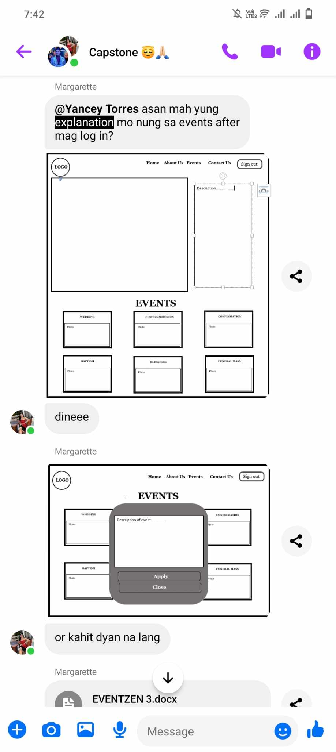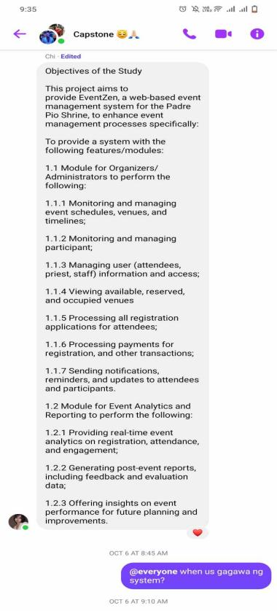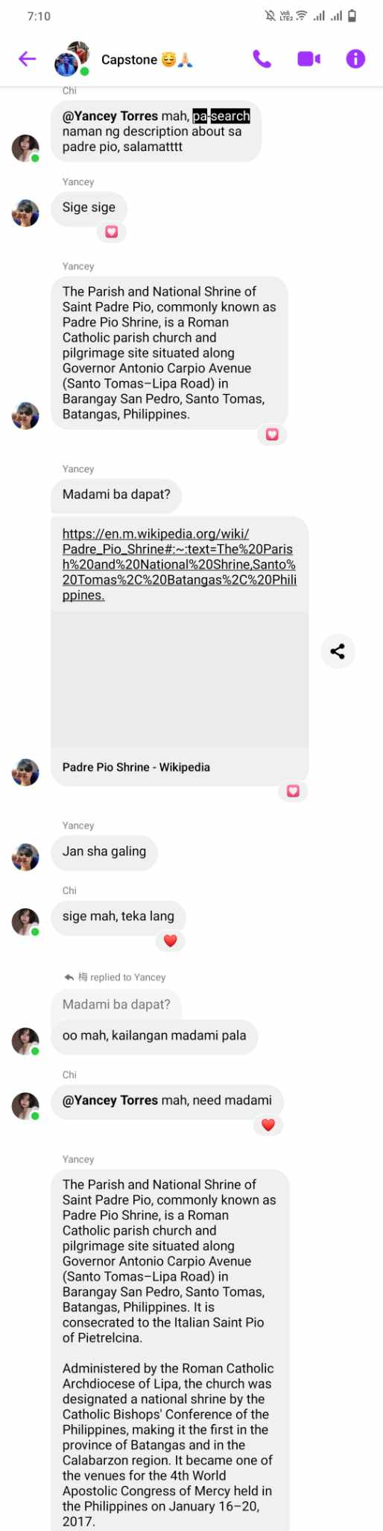 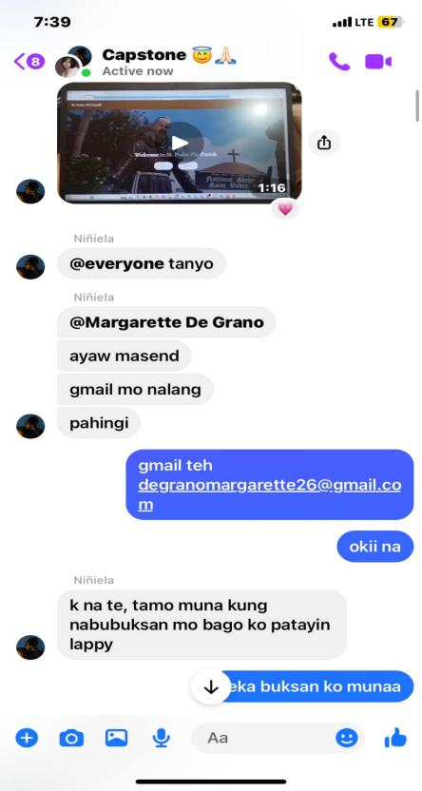 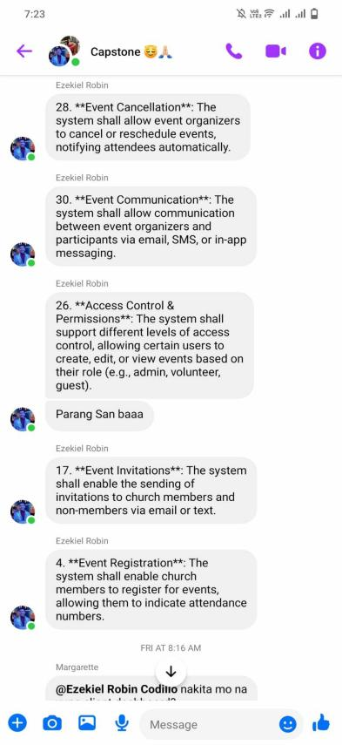

**PROTOTYPING / SKETCHING UI/UX**

