Report

Brief description
This project has been designed for a school keeping track of its students. The application is for a principal who should be able to have the student’s information in a database. The principal would need to login into the application using a password. This is to ensure that no one else but the principal can access the database. The database is set up on SQL and the java application allows the principal to use SQL database with a simple UI. The UI is a menu with six inputs.
These inputs implement the CRUD functionality. The application allows the principal the view all the students in the database along with the information of that student. If the principal wishes they can search a certain student using the student’s user ID. Each student is given a unique ID. The principal can update a student’s information if they have the ID of the student they wish to update. The principal can add new students and remove current students from the database. This is all done using the UI. The UI communicates with the server that is connecting the application to the SQL database. This means that the user can close the application, and everything is saved locally on the database. The user can open the application can continue to work on the database.

Product Backlog
- The principal should have a secure login.
- The principal should have a simple UI to interact with.
- The principal must be able to create data.
- The principal must be able to delete data.
- The principal must be able to read data.
- The principal must be able to update data.

Links
Jira Project: https://agile4u.atlassian.net/secure/RapidBoard.jspa?rapidView=5&projectKey=AAE
GitHub(Issues with bitbucket):

Definition of Done (DoD)
The project should be running with no issues. Code can only be pushed to master branch if it is fully tested with no reported bugs. This means testing should be done and project can be ready for demonstration after a sprint is complete.

Sprint Goal
SPRINT 1: The goal for this sprint was to have a basic project started with no functionality yet.
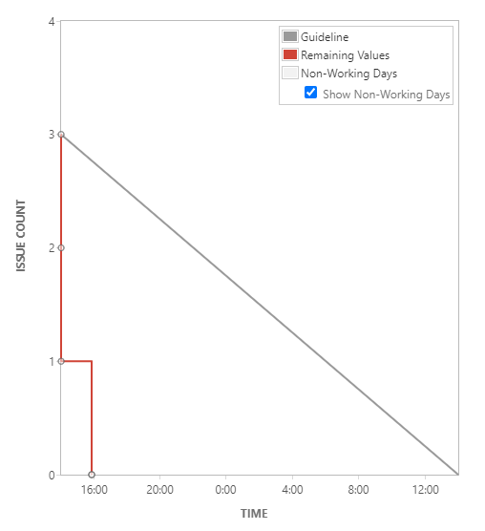
SPRINT 2: At the end of the sprint my goal was the have the basic CRUD functionality working.
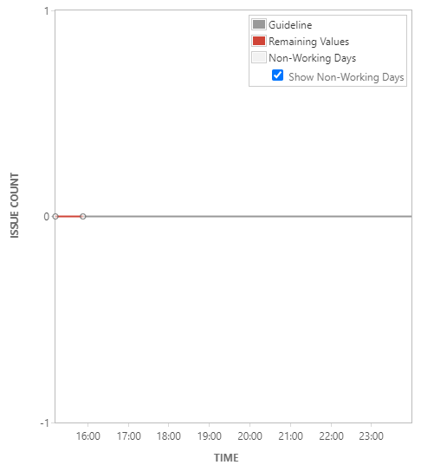
SPRINT 3: In this sprint the goal was to update and remove information from the database using a unique ID.
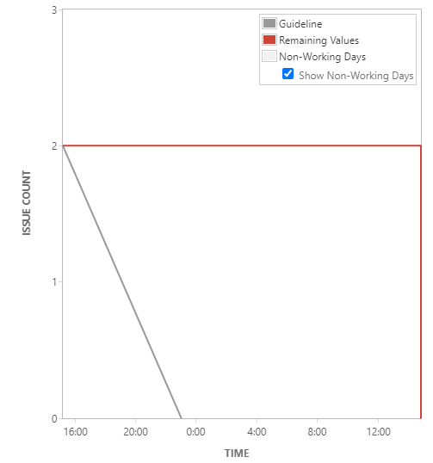
SPRINT 4: The goal for this sprint is to have all basic testing complete.
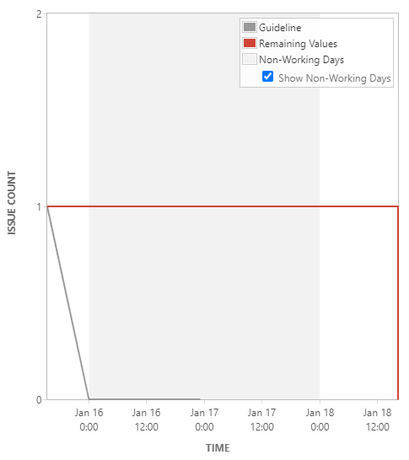

UML Diagram
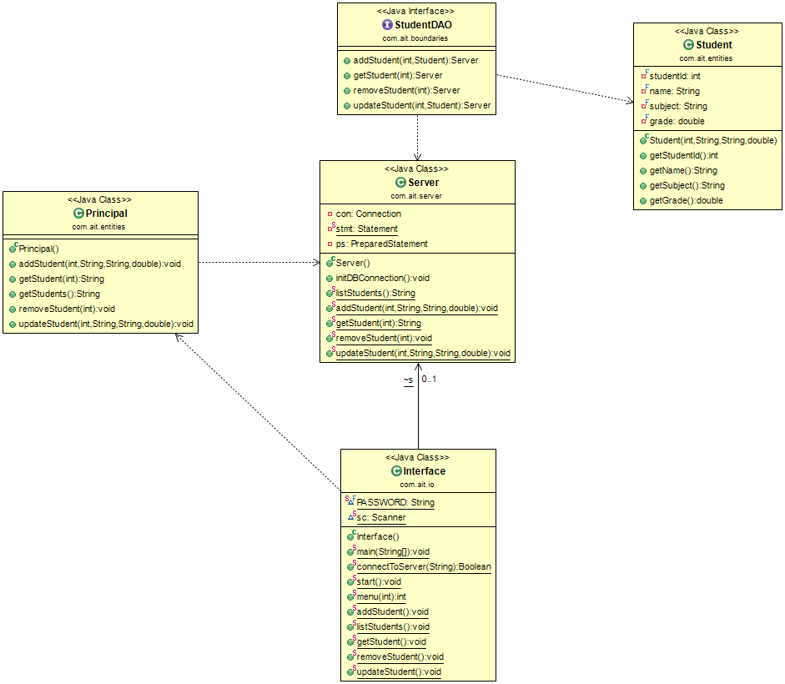

Test Report
TEST 1. User Login and Connection to Server
As a user I would like to securely log in before connecting to the database.
TEST | EXPECTED OUPUT | PASS/FAIL
Enter correct password | Menu is displayed | pass
Enter incorrect password | Invalid password! | pass
Incorrect database | Failed to initialise DB Connection | pass

TEST 2. Menu Navigation
As a user I should be able to select an option in the menu
TEST | EXPECTED OUTPUT | PASS/FAIL
Enter option 1 | List of all students in database | pass
Enter option 2 | Able to add student | pass
Enter option 3 | Able to remove student | pass
Enter option 4 | Able to update student | pass
Enter option 5 | Able to search for student | pass
Enter option 6 | Closing application | pass
Enter Invalid number | Invalid input! | pass

TEST 3. CRUD Functionality
As a user I should be able to see all the information in the database
Scenario: Listing all the students in school
Given: The application is running and option 1 is selected
And: Information from sample SQL information is added to the database
Then: A list of students should be displayed from sample database

As a user I should be able to add a student to the database
Scenario: Adding a new student to the database
Given: The application is running and option 2 is selected
When: Student information is entered with a unique student ID
Then: Student is added to the database

Scenario: Adding a new student to the database with same student ID from database
Given: The application is running and option 2 is selected
When: Student information is entered with a same student ID as student in database
Then: SQLException - Duplicate entry '1' for key 'student.PRIMARY'

As a user I should be able to remove a student from the database
Scenario: Removing a student from school
Given: The application is running and option 3 is selected
When: Student ID is entered
Then: Student with that student ID will be removed from the database

As a user I should be able to search for a student in the database
Scenario: Searching for a certain student in the database
Given: The application is running and option 5 is selected
When: Student ID is entered
Then: Student should be displayed from sample database

As a user I should be able to update an existing student in the database
Scenario: Updating a student’s information
Given: The application is running and option 4 is selected
When: Existing student ID is entered
And: information has been updated
Then: Student’s information should be updated

CODE COVERAGE
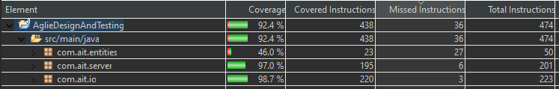

Evaluation
Each of my user stories has met the DoD. This is because I did four small sprints instead of one big sprint. This allowed me to focus on having functional code at the end of the end rather than starting the new day with code that has bugs. Before finishing a sprint, I made sure that everything was tested and working without any issues. This process improved productivity because I got rid of the small issues before they became bigger problems when move features were adding to the project. I did not do automated testing for this reason as I found that manual testing at the end of each sprint was quicker to do and log for my test report.
I believe that the quality of manual testing is the same as automated testing. If I did one sprint, I would have used automated testing then because it would have been quicker, but the small sprints allowed me to have tests done more frequently. It was more efficient to test code manually at the end of every sprint instead of writing more code for automation.
I think application can be improved by adding more users to it. Such as teachers can access the database but can only change a student’s grade while the principal can change whatever they want. If more time were given, I would have been able to increase the scope of the project and add automated testing to improve the code coverage. When designing the project, I originally designed the project so more can be added later if more time was available or certain aspects of the project can be improved upon.
There were issues using Jira and bitbucket. I got Jira working but was unable to add anyone to view the project. The issue with bitbucket was solved by pushing my code to GitHub and link can be found in the report. I also had issues using PMD because it said my java version was not compatible. So was unable to use that tool.

