Name – Sameer

Section – BE-ECE2(A)

UID - 19BEC1075

Aim :

 Design a system that automatically turns on the lights inside an almirah whenever it is opened and turns off the lights after 100 ms if there is enough light in room.

Apparatus :

Breadboard, Arduino UNO, Red LED, Push Button , Wires .

***Circuit Diagram:***

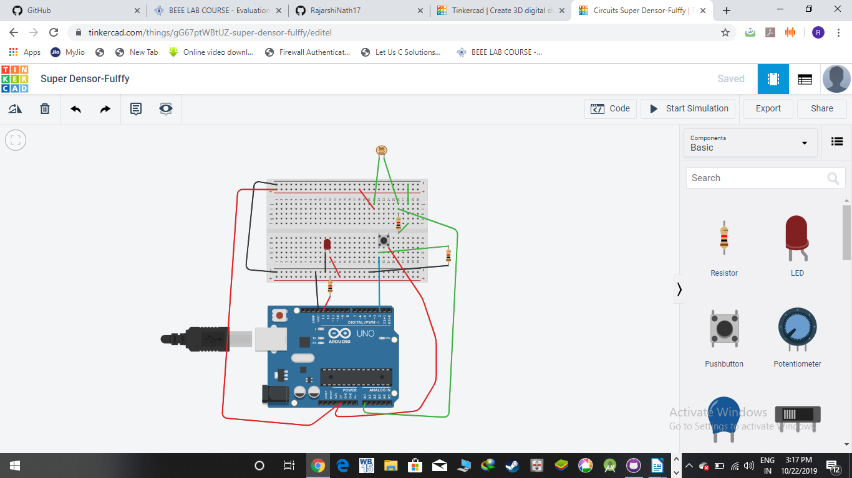

***Code :***

int button = 0;

int ldr = 0;

void setup()

{

pinMode(2, INPUT);

pinMode(13, OUTPUT);

pinMode(A0, INPUT);

Serial.begin(9600);

}

void loop()

{

button = digitalRead(2);

if (button == HIGH) {

digitalWrite(13, HIGH);

}

delay(100); // Wait for 100 millisecond(s)

ldr = analogRead(A0);

Serial.println(ldr);

if(ldr>=500)

{

digitalWrite(13, LOW);

}

else

{

digitalWrite(13, HIGH);

}

}