PROJECT
AI- Chatbox using python

Code:
from google import genai
print(“Successfully imported”)

client = genai.Client(api_key="YOUR_API_KEY")

print("Gemini Chatbot (type 'exit' to quit)")

while True:
user_input = input("You: ")

if user_input.lower() == "exit":
break

response = client.models.generate_content(
model="gemini-2.5-flash",
contents=user_input
)

print("Bot:", response.text)

Create a file chatbox.py

Install the gemini SDK
In the terminal box:
Python -m pip install google-genai

To verify:
pip show google-genai

Verify Python version.
3.12 or 3.11

Enter ctrl + shift + P
- Python : select interpreter
Python 3.12

Get your API Key:
- From Google AI Studio

MY CODE:
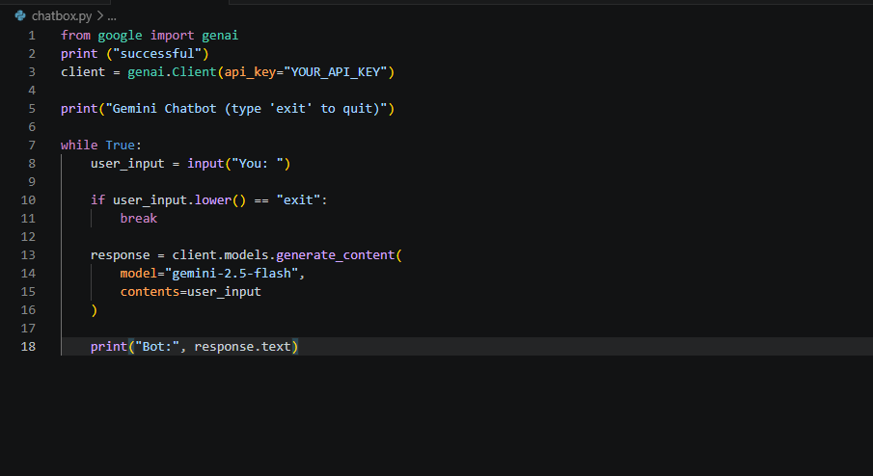

OUTPUT:
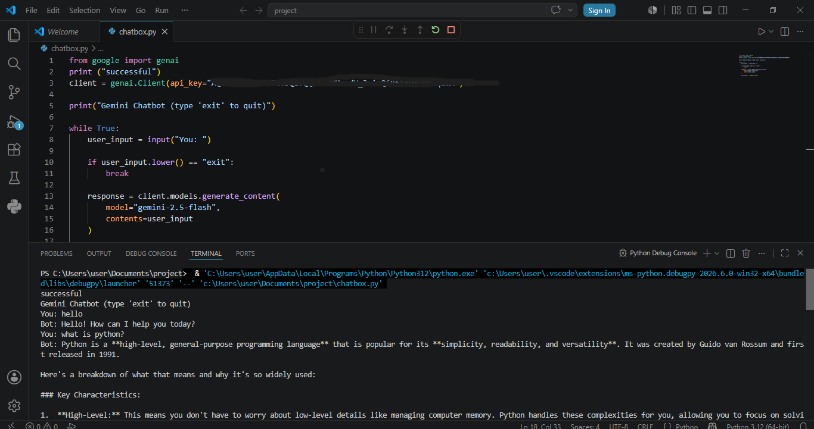
Flow of the program
Start
↓
Create Gemini Client
↓
Ask user for input
↓
Send input to Gemini
↓
Receive response
↓
Display response
↓
Repeat until user types "exit"

