Course: Data Analysis

Student’s Name and Surname ____________________________________________________

Please do the task below.

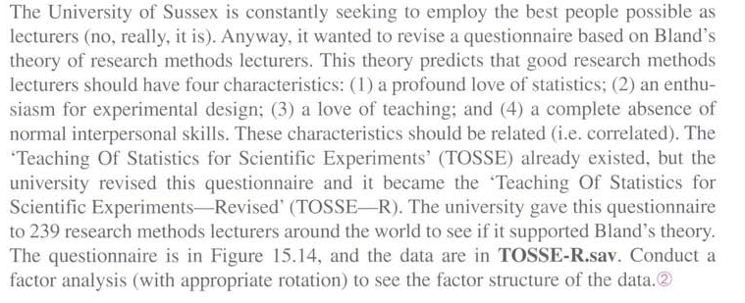

Conduct a factor analysis to see the factor structure if the data, in particular:

1. Interpret the results of KMO and Bartlett’s test.

Kaiser-Meyer-Olkin measure of sampling adequacy (overall) = 0.8941

The data is well-suited for factor analysis.

Bartlett test of sphericity

Chi-square = 2989.769

Degrees of freedom = 378

p-value = 0.000

H0: variables are not intercorrelated

As Bartlett tests says, variables are not intercorrelated

1. Interpret communalities (cut point 0,3).

Only one variable is in the cut point. Q12 uniqueness is 0.7033. Question number 12 is the following: **People fall asleep as soon as I open my mouth to speak.** The reason for that might be difference in people personal qualities the question involves among the other questions.

1. Give your comments on the cumulative variance explained by the factor model.

57,90% of variance is explained by the first 5 factors:

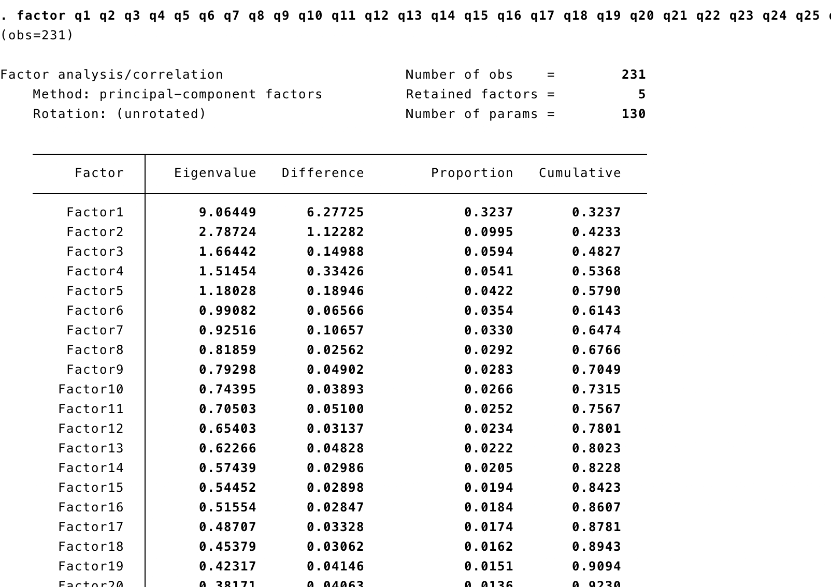

1. Interpret the rotated component matrix.

In accordance to the rotation matrix, factor 1 is the highest affected, others were not as significant.

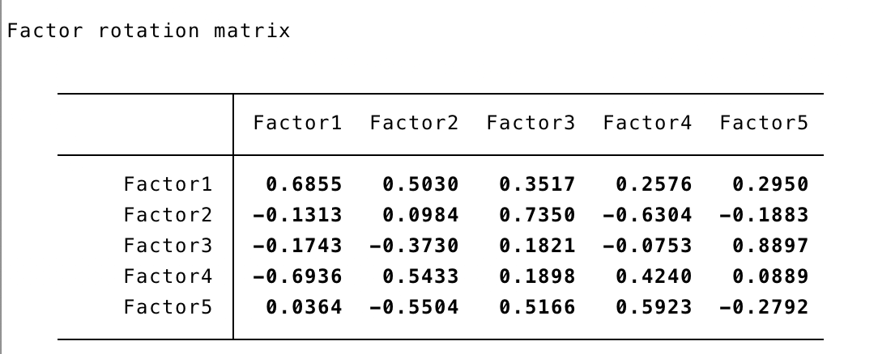

1. Give the names and interpretations for the factors.

Factor 1: Excitement: how person is exited concerning statistics  
Factor 2: Altruism: ability to help others

Factor 3: Socialization: ability to communicate and build relationship with people

Factor 4: Religious: statistics means anything for them  
Factor 5: Apathy: indifference to statistics

1. Save the factors and recode them into ordinal variables with the same scale of measurement as the initial variables.

Done. Vars: factor1_rescaled, factor2_rescaled, factor3_rescaled, factor4_rescaled, factor5_rescaled

**Send the interpretations and the modified file to** [amelikyan@hse.ru](mailto:amelikyan@hse.ru)