Course: Data Analysis

Student’s Name and Surname Pavel Drank

**Regression analysis**

Do the multiple regression analysis using the following variables from **data_games.dta**:

Dependent variable: payment

Independent variables: payment_type, payment_method, crystalls_balance_before_buy, crystalls_bought

*Describe the model:*

1. Specify the regression equation.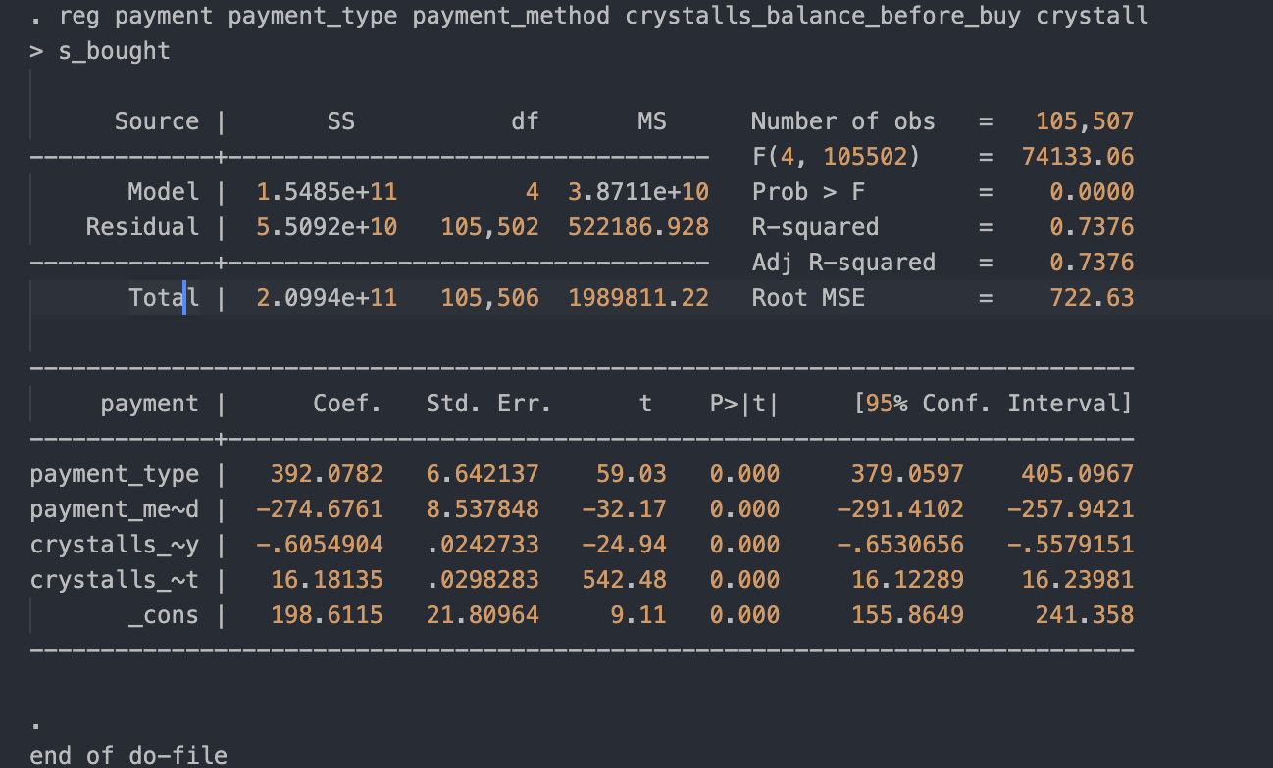

payment = 392.0782 * payment_type - 274.6761 * payment_method - 0.6054904 * crystalls_balance_before_buy 16.18135 * crystall + 198.6115

2. Assess the goodness-of-fit of the model (R-square, significance of the model);

R-square is 0.73 which is a decent fit.

3. Which independent variables significantly influence the dependent variable (explain your answer)?

payment_type’s and payment_method’s influence is significant, because of high coef.

4 is. Describe the relationship between each independent and the dependent variable.

*Do the diagnostics of the model:*

*payment_type: regular payments are used to be higher in sum then offer payments*

*payment_method: mobile payment type a way more less then general and promotion methods*

*crystalls_balance_before_buy: the more crystals a user have, the less resulted payment*

*Crystall: the more crystals, the higher payment*

5. Are the residuals normally distributed?

kdensity r, normal

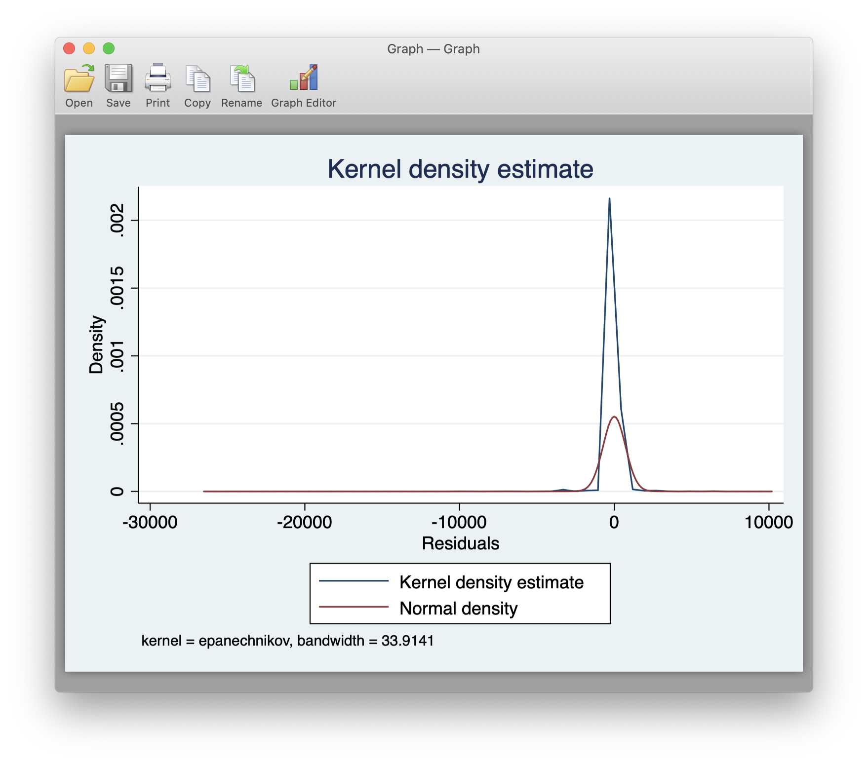

Yes, they are

6. Are there any outliers (standardized residuals greater than 3, or less that -3)?

Yes, look at picture in the prev. subtask.

7. Test the multicollinearity and heteroscedasticity.

There is no multicollinearity and heteroscedasticity: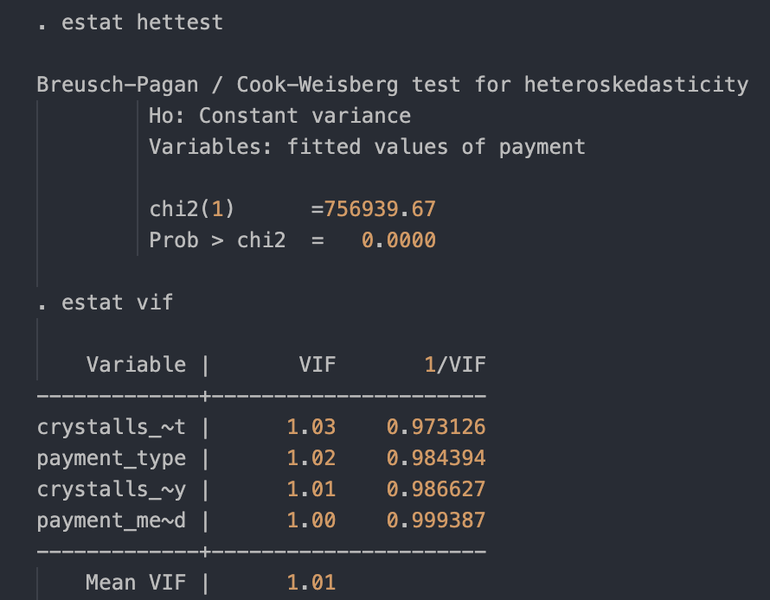

Please send this MS Word file with answers and the do-file to amelikyan@hse.ru from your personal e-mail.