MergeBathy_Qt

Instructions to setup Qt Creator development environment for MBGuiApp

Samantha Zambo  
March 27, 2017

1. QGIS 2.14.13 Opensource files
2. QtCreator
   1. <https://www.qt.io/download-open-source>
3. Qt 4.8.6
   1. <https://download.qt.io/archive/qt/4.8/4.8.6/qt-opensource-windows-x86-vs2010-4.8.6.exe>
4. OSGeo4W Network Installer
   1. <http://www.qgis.org/en/site/forusers/download.html>
   2. Advanced Install:
      1. Search:
         1. qgis
            1. Desktop > qgis-ltr (2.14)
            2. Library > qgis-ltr-common (not sure if this is needed)
         2. qwt
            1. Library > qwt-devel-qt4
5. MSVC-2010 Compiler(X86 redistributable)
   1. <https://www.microsoft.com/en-us/download/details.aspx?id=8328>
6. CMake > 3.0 (currently running with 3.3)
7. Run qt4_env_startup_qgis-ltr.bat
   1. This starts sets up the environment from which QtCreator runs.
8. Configure Kit in Qt
   1. Tools > Options… > Build & Run >
   2. Make sure you have
      1. Qt 4.8.6 in Qt Versions
      2. MSVC 2010 in Compilers
      3. A debugger in debuggers
      4. Cmake.exe in CMake
      5. Kits > clone > update fields to match the fig below:

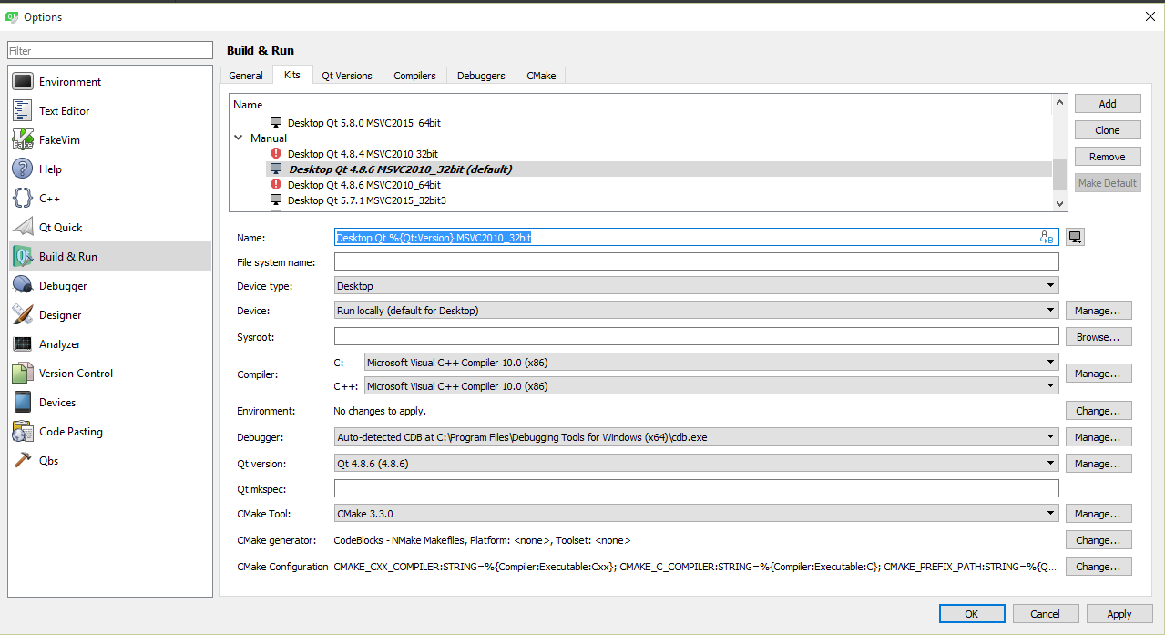

1. Third-party Libraries
   1. QtPropertyBrowser-master_Qt4.7
      1. Runs examples and places libraries in build*/lib
      2. Unzip QtPropertyBrowser-master_Qt4.7 > open > qtpropertybrowser.pro > run qmake > Qt4.8.6 MSVC 2010 Kit > release > run release (with debug info) to run examples
   2. QtPropertyBrowser-master_Qt4.7 or _Qt5.0
      1. This is a fork of qt-solutions for Qt5 support
      2. Unzip QtPropertyBrowser-master_Qt5.0 > open > qtpropertybrowser.pro > run qmake > Qt4.8.6 MSVC 2010 Kit > release (with debug info) > run release to run examples
         1. May receive error regarding max character limit reached for build directory: change build directory to > build-Qt_5_8_0_2015_32bit-RelwDeb
2. Load Project
   1. Open
   2. Check Qt 4.8.6 MSVC 2010 > configure
   3. Set as Active Project
   4. Run Clean
   5. Run Cmake & Fix Cmake errors:
      1. Project > Set missing paths to qgis libs and include directories > Apply configurations > edit > run cmake > repeat until no more errors

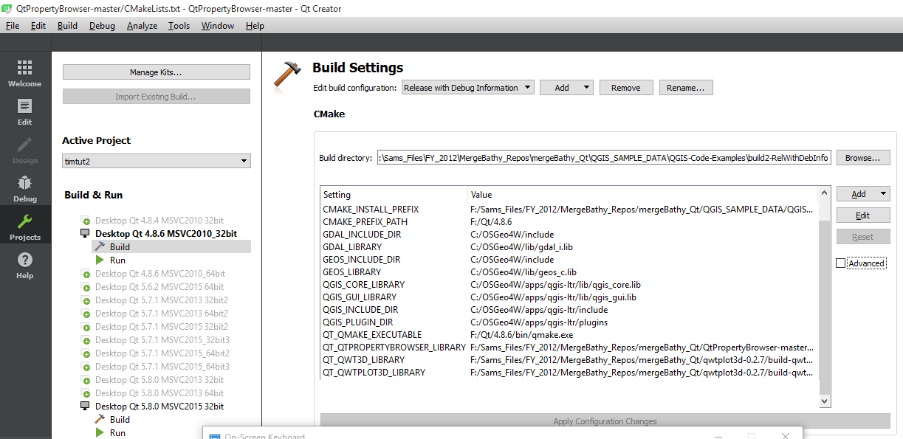



* + 1. If project does not load and you cannot run CMake
       1. Restart QtCreator via batch file > Delete cmakeLists.txt.user (to reconfigure)
       2. Tools > Options > Build & Run > CMake > Make sure cmake.exe is in and is set in kit properly
  1. Make sure Desktop Qt 4.8.6 MSVC2010_32bit > ReleaseWithDebugInfo is selected
  2. Both Run and Debug buttons work
  3. Displays window

qt4_env_startup_qgis-ltr_RUN_ME.bat

ECHO Setting up QGIS DEV ENV

set PYTHONPATH=C:\Python27;C:\Python27\Scripts;C:\Python27\libs;

set OSGEO4W_ROOT=C:\OSGeo4W

call "%OSGEO4W_ROOT%\bin\o4w_env.bat"

set GISF=qgis-ltr

@set QMAKESPEC=win32-msvc2010

@set PATH=%OSGEO4W_ROOT%\bin;%OSGEO4W_ROOT%\apps\%GISF%\bin;%PATH%

@set INCLUDE=%INCLUDE%;%OSGEO4W_ROOT%\include;%OSGEO4W_ROOT%\apps\%GISF%\include

@set LIB=%LIB%;%OSGEO4W_ROOT%\lib;%OSGEO4W_ROOT%\apps\%GISF%\lib

path %OSGEO4W_ROOT%\bin;%SYSTEMROOT%\System32;%SYSTEMROOT%;%SYSTEMROOT%\System32\wbem;C:\Progra~1\Git\bin;C:\Qt\Tools\QtCreator\bin;%PATH%

set VS100COMNTOOLS=C:\Program Files (x86)\Microsoft Visual Studio 10.0\Common7\Tools\

call "C:\Program Files (x86)\Microsoft Visual Studio 10.0\VC\vcvarsall.bat" x86

start "Qt Creator" /B F:\Qt\Tools\QtCreator\bin\qtcreator.exe %*