NRL MergeBathy User’s Guide

WARNING!!! Note there are multiple Matlab versions! This is for Paul Elmore’s (2015) as compared to Todd Hollands (2003)!
This is for the Matlab version. This is for the C++ version. There are some notable differences. The defaults in Matlab at the time of writing were mgrid 50, msmooth 200, and to keep all final depths. These were changed to mgrid 100, msmooth 100, and the removal of all bad depths by default unless modelflag specified in MergeBathy 5.0 for Matlab and C++. Furthermore, the Matlab version computes offsets by default and can be turned off with nooffset. This is opposite in C++ where by default they are not computed but can be with computeOffset. The options local, rect, smoothplots, errorplots, saveplots and plotpts are for displaying figures in Matlab only. The options itersmooth and calcsmooth are Matlab only; there is no findLambda in C++. Custom file formats and specifying output directory are not in the current Matlab or C++ but may be added in. This existed in an older Matlab. Tide corrections and maximum allowable offsets require delimiters in C++. Reference lat and lon are reversed between Matlab and C++.
Todd Holland Email: findLambda computes slopes from very smoothed version of the grid and then tries to estimate a smoothing scale from those slopes. It is not perfect nor meant to be applicable everywhere. I don’t think it is worth mentioning in much detail, something like “user defined methods can be adapted to estimate smoothing scales based on parameters such as bottom slope” is sufficient. There is also an option itersmooth to do this calculation at a higher resolution. Not really worth mentioning.

1. Purpose

The purpose of this document is to familiarize the user with the input arguments, default program execution, optional features, and inherent assumptions of the mergeBathy utility. While some discussion of technical issues is required, this document is not intended as a scientific paper. Users wishing to understand the theory and practice behind the various inner workings of this utility are referred to [XXX technical document, T. Holland and N. Plant].

2. Using mergeBathy

The mergeBathy utility was originally written as a series of interlocking MATLAB scripts. This functionality is retained, and mergeBathy can be called from within a MATLAB session just like any other MATLAB script file. Additionally, mergeBathy has been compiled into a C-based executable, which greatly reduces the run-time necessary to generate products and results. While these two methodologies require different approaches to parsing command-line arguments, significant effort has been devoted to ensuring that the methods, options, and capabilities of the two approaches are functionally identical (if not syntactically so).

2.1 Using mergeBathy from within MATLAB

From within a MATLAB session, the user must first insure that his or her MATLAB path variable contains the directory in which the mergeBathy routine has been installed. Additionally, there is a “matlabSubroutines” subdirectory that must also be included in the user’s path. Once the path is set, mergeBathy functions just like any other MATLAB script. The mergeBathy script requires five basic inputs: 1) an ASCII file containing the names of the various datafiles to be merged, 2) a reference latitude, 3) a reference longitude, 4) a user-defined arbitrary rotation angle, and 5) a root name for output files. Any other arguments are optional, and will be explained in detail later in Section 5 of this document.

Example: a user wishes to merge a set of FRF bathymetry data using mergeBathy. He or she could execute the following command in a MATLAB session:

>> mergeBathy(‘FRF_files.txt’, 36.177602, -75.749690, 18.2, ’DuckNC’);

Note that as always, the list of arguments is enclosed in parenthesis, text values are enclosed in single quotes and each input is separated by a comma.

2.2 Using mergeBathy from the UNIX command line

The mergeBathy utility has also been compiled into a C-based executable. Like any other program, it can be run from the UNIX command line, and follows the same rules and restrictions as other compiled executables. As described above, the utility requires five basic inputs: 1) an ASCII file containing the names of the various data files to be merged, 2) a reference latitude, 3) a reference longitude, 4) a user-defined arbitrary rotation angle, and 5) a root name for output files. Any other arguments are optional, and will be explained in detail later in this document.

Example: a user wishes to merge the same set of FRF bathymetry data described above. He or she could execute the following command from the UNIX command prompt:

gecko% mergeBathy FRF_files.txt 36.177602 -75.749690 18.20 DuckNC

Note that input arguments are simply typed “as is” onto the command line and are separated by spaces.

3.1 The Required Inputs: Input File List

First and foremost in the list of required inputs is an ASCII file containing the filenames of the various files containing data to be merged, one file per line. The user may also include comments in this file. Comment lines are identified by a ‘#’ as the first character. Full paths may be specified if the data files reside somewhere other than the current working directory.

Example: a hypothetical merge of three FRF data sets may be described in the following input text file:

# This is an example bathymetry merge for the USACE Field Research Facility
# based at Duck, NC
#
survey3_08092003.dat
survey4_08102003.dat
/archive/olddata/duck/survey1_07212002.dat

Note that in the above case there is no format specification for the data files to be merged. In order to accurately read and merge files of a variety of different types and formats, a format specification must be indicated for each file.

3.1.1 Format Specification

Each file specified within the input file list must be given a format specification if it is to be read and parsed correctly. This specification is simply a shorthand notation that indicates to the program how a file is to be accessed, how data are separated, whether there are any header lines, and whether the file name should be parsed for further information such as date or time.

Example: our hypothetical merge of FRF data includes files of several different formats, as described by the following input text file:

# This is an example bathymetry merge for the USACE Field Research Facility
# based at Duck, NC
#
survey3_08092003.dat xyz
survey4_08102003.dat xyz
2004_10_19_lidar.txt lidar-llz

In this example, the first two data files will be parsed according to one format, while the last is parsed according to another. The date is contained in both filenames, but the order of elements is different and they are separated differently.
File formats are user-defined to allow for maximum flexibility in reading in data of interest. For more information on creating and using format files, see Appendix A.

3.1.2 Tide Correction

Each file specified within the input file list may be given a tide value if this information is known. This tide correction value will be subtracted from the pertinent data set before any other calculations are performed. Tide values are simply specified by a numeric value, placed on the same line as the data file name, separated by white space. Note that the tide correction is assumed to be given with units and sign conventions that are consistent with the input data. Tide correction values are not required, and omitting them simply means that the input data will be unaltered prior to computation.

Example: a hypothetical merge of three FRF data sets, allowing for tide correction on each of the data sets individually may be described by the following text file:

# This is an example bathymetry merge for the USACE Field Research Facility
# based at Duck, NC, with tide correction applied
#
survey3_08092003.dat xyz 1.32
survey4_08102003.dat xyz -0.56
/archive/olddata/duck/survey1_07212002.dat xyz -1.17

3.1.3 Maximum Allowable Offset Correction

In the same method as specifying tides, the user may also specify the maximum allowable offset for each individual dataset. Since the mergeBathy routine will attempt to minimize vertical errors between data sets, an “offsetting” process is required. This process will determine the scalar offset that must be applied to each data set in order to minimize error in the merging process. Yet this offsetting process has no meta-knowledge about the data, its sources, or its absolute quality. By specifying a maximum allowable offset, the user may limit the fluctuation applied to a given data set. This is especially useful if different data sources are being used and one source has yielded values that are more “trusted” than others. If the mergeBathy determines that a particular data set’s offset is larger than that specified by the user, the user input value is taken instead. For more information on offsetting, see Section 4 on Default Program Execution.
Specification of maximum allowable offsets is done in the same way as tides, that is, on the same line as the input filename and separated by white space. Note that in order to specify a maximum allowable offset, a tide value must be specified (though this value can be zero if the tides are not known). Note that the value specified is taken as an absolute value (i.e. if the user specifies a maximum allowable offset of 1 meter and the offset calculated for that dataset is -1.5 meters, the data set will be given an offset of -1.0 meters).

Example: a hypothetical merge of two FRF data sets, allowing for tide correction on each of the data sets individually, and allowing the second dataset to have a maximum allowable offset of ±0.5m.

# This is an example bathymetry merge for the USACE Field Research Facility
# based at Duck, NC, with tide correction applied and maximum allowable
# offsets specified for the most “trustworthy” dataset
#
survey3_08092003.dat xyz 1.32
survey4_08102003.dat xyz -0.56 0.50

3.1.4 In-File commands

Both versions of mergeBathy (MATLAB-based and compiled) also allow the user to place the command-line arguments in the ASCII file containing the list of filenames containing data to be merged. This allows the user to semi-permanently associate an input list file with a set of commands for processing the data files contained in that list. Invoking the program this way is an exception to the required five inputs specified above. When using this option, the input list file must contain a line with an exclamation point as the first character. The remainder of that line must contain required input arguments 2) through 4) and any further optional arguments the user desires. Then, only the input list filename need be passed to the utility as a command-line argument.

Example:
MATLAB session: >> mergeBathy(‘FRF_files.txt’);
UNIX command line: gecko% mergeBathy FRF_files.txt

In either case, in order to duplicate the results achieved above, the input list file (e.g. FRF_files.txt) must contain the following line:

! 36.177602 -75.749690 18.20 DuckNC

Example: our hypothetical merge file list could appear as follows:

# This is an example bathymetry merge for the USACE Field Research Facility
# based at Duck, NC
#
! 36.177602 -75.749690 18.20 DuckNC
#
survey3_08092003.dat xyz
survey4_08102003.dat xyz
/archive/olddata/duck/survey1_08092003.dat xyz

Note that this method of passing command line arguments to mergeBathy uses the UNIX syntax of space-separated arguments regardless of whether mergeBathy is invoked from a MATLAB session or from the UNIX command line. Also, the line containing the arguments need not be the first line in the file.

3.2 The Required Inputs: Reference Latitude, Longitude, and Rotation Angle

Immediately after the input file list, the next three input arguments relate to the coordinate transformation to be used to reference the data to an arbitrary reference point. Within the internal workings of the mergeBathy program itself, all calculations on the computational grid are done in rectilinear coordinates with meter units. However, the reference latitude, longitude, and angle allow the user to specify the orientation of the computational grid with respect to an arbitrary coordinate system.
For example, data collected at the US Army Corps of Engineers Field Research Facility (FRF) at Duck, NC are referenced to an arbitrary “FRF” coordinate system. This coordinate system is rectilinear, with an origin at the location where the southern property boundary meets the waterline and a rotation of approximately 20 degrees from true North. This has the effect of orienting the positive X axis with increasing offshore distance and the Y axis with the along-shore direction.
While reference and rotation is not necessary, it does allow the user to orient the computational grid in an arbitrary direction in order to take advantage of geomorphology information. For example, by orienting the computational grid into the cross-shore and along-shore directions, the user can take advantage of the fact that bathymetry changes more drastically in the cross-shore dimension than the along-shore dimension. By choosing a smoothing scale for the cross-shore direction that is shorter than the smoothing scale in the along shore direction, the user can generate a smoothed, natural alongshore profile without over-smoothing and filling in cross-shore features such as bars or shoals. Note that this approach is better suited to smaller computational areas where features of interest (e.g. the coastline) can be treated as more or less linear. For more information, see the discussion on setting smoothing scales in Section 4 below, or refer to [XXX T. Holland and N. Plant].
Additionally, rotation can be performed in order to optimize the size of the computational domain. This is especially useful in merges where the data lie along a line. Since the mergeBathy routine does not know a priori where the data are located, it will set the bounds of the computational domain based on the minimum and maximum extents of the data present in the merge. By rotating the data, the user can drastically reduce the size of the total computational domain, and thus significantly reduce runtimes required for generating merged products. See Figures 1a and 1b below.

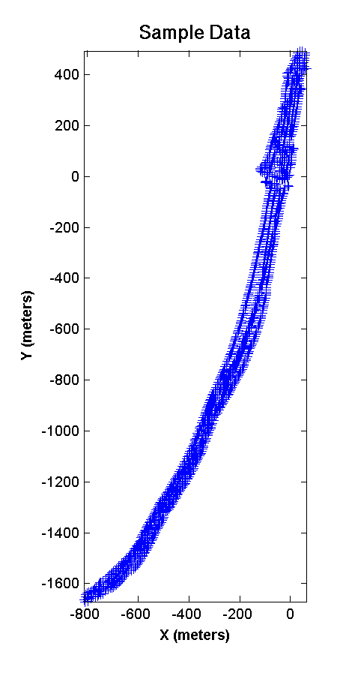 | 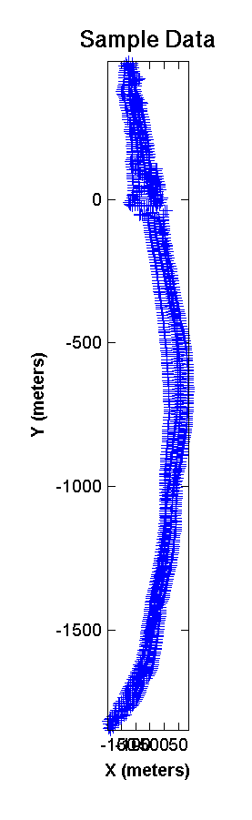
Fig 1a) Raw data, no rotation. Here, the computational domain will cover an area roughly 800mx2000m. Note that even in areas where there is no data present, the merge routine will still calculate and return areas of “no depth.” | Fig 1b) Raw data given a 20 degree rotation. In this case, the computational domain will cover an area roughly 300mx2500m. Since the total domain is smaller by roughly a factor of 2, a merge of this data will take much less computational time.

Finally, while these inputs are required, they may be set to zero. In this case, mergeBathy will reference all of the data to UTM coordinates of the nearest UTM zone. If the data fall in multiple UTM zones, mergeBathy will attempt to use the zone in which the majority of the data lie.

3.3 The Required Inputs: Output Root Filename

The last of the required inputs is the base filename for all output products. Default program execution creates only a single file (an ASCII file containing latitude, longitude, and depth for each valid point in the computational grid), but command-line options can be used to save a wide variety of intermediate or diagnostic products. The file naming convention uses extensions of the user-defined root filename such that all products from the same run of mergeBathy are named consistently. For more information, see Section 6 on output products below.

4. Default Program Execution

Once the required inputs have been given, mergeBathy will proceed to completion in its default mode. Before discussing the various optional inputs, a clear understanding of the default program operation is necessary.
Each file specified in the input file list will be read according to its type. Different data sources provide different information about any given data point, and this information will be read accordingly. Yet each data file should contain the bathymetry sounding’s location (in latitude and longitude) and its depth. The units on the depth will be kept throughout the process, so soundings specified in meters will produce results specified in meters. For this reason it is important that ones input data are consistent. Note: depths are assumed to be positive. Negative depths correspond to areas that are above water. Other information such as associated errors in depth and time of collection may also be ingested, but are not necessary for default operation.
If specified by the user in the input file list, tide correction values will be applied to the corresponding data sets. If tide correction values are unknown or omitted, the input data will remain unchanged.
Once the data are ingested, they are referenced and rotated using the coordinate transformation as dictated by the reference latitude, reference longitude, and rotation angle defined by the user. The end result is that each individual data point has an X and Y location specified in a rectilinear coordinate system with units in meters. It is this arbitrary, rectilinear X,Y coordinate system that will be used for the computational domain.
In default mode, the mergeBathy routine will determine the maximum and minimum X,Y coordinates of the input data. This area is them subdivided into a 50m x 50m grid. All smoothing, gridding, subsampling, interpolation, and output will be performed in this grid.
Once the computational grid is determined, the mergeBathy routine will begin attempting to find the vertical offset (expressed as a scalar) that must be applied to each individual data set in order to minimize errors between them. This process functions by removing a 2D (planar) trend from each dataset and attempting to find the reference level that minimizes the variation between data points in the same location from each data set. Additionally, each data point’s “contribution” is applied over an area dictated by the “smoothing scale” applied to the process (more on this below). Because of this, the offsetting process can “bridge gaps” between datasets provided that the gaps are on the order of the smoothing scale or less. Note that for default program execution, the smoothing scale applied in both the X and Y directions is 200m, and there is no smoothing performed in the temporal dimension at all.
Implicit in this process are several assumptions about the nature and extent of the data. This offsetting process is poorly behaved in areas where there is no overlap between data sets (as there is no “common ground” over which to calculate errors) and in areas with complicated bottom features (where removing a 2D trend can be misleading or inaccurate). For more information on the theory and implementation of the offsetting algorithm, see [XXX technical document, T. Holland and N. Plant].
If the user has specified a maximum allowable offset for any individual dataset, that value is used if the calculated (absolute) value exceeds the user-specified (absolute) value. The offsets are then applied to the data, and the actual merging process can begin.

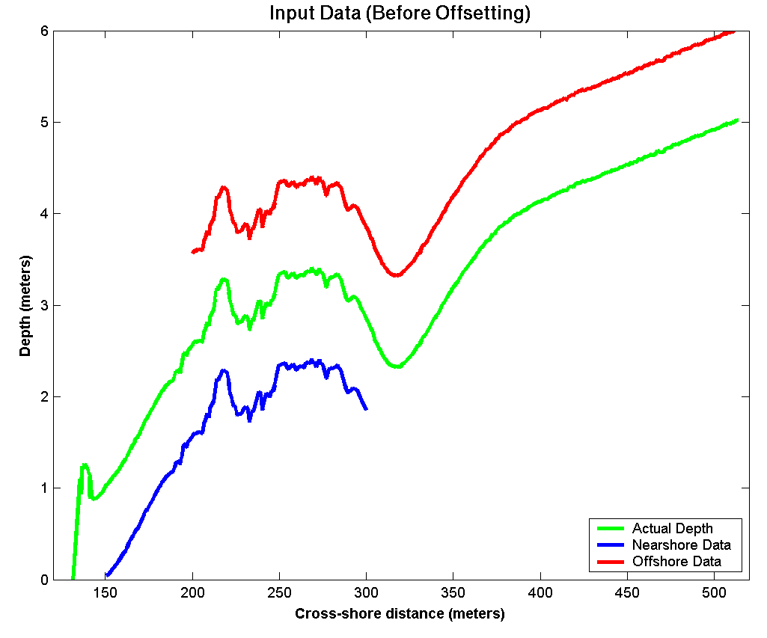
Figure 2a) A cross-shore profile with an offset between two overlapping datasets (blue and red).
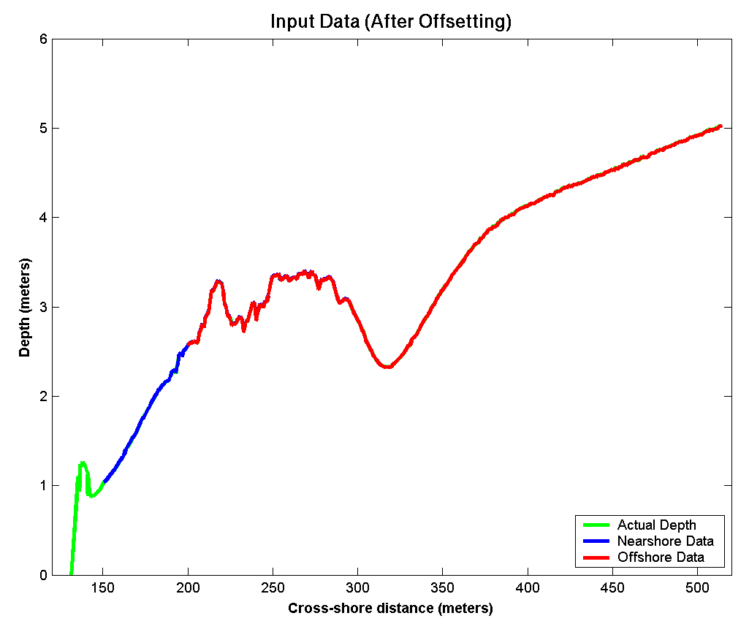
Figure 2b) Cross-shore profile after offset correction. Note that the two datasets are more or less in perfect agreement in the area of overlap.

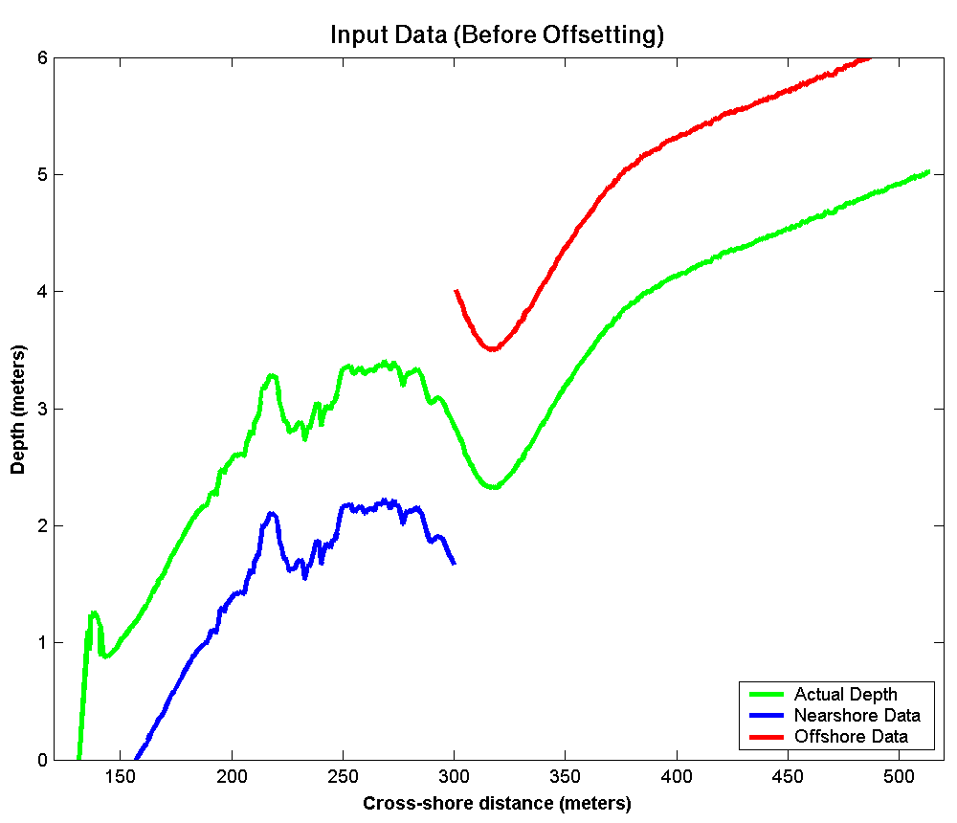
Figure 3a) A cross-shore profile with an offset between two non-overlapping datasets (blue and red).

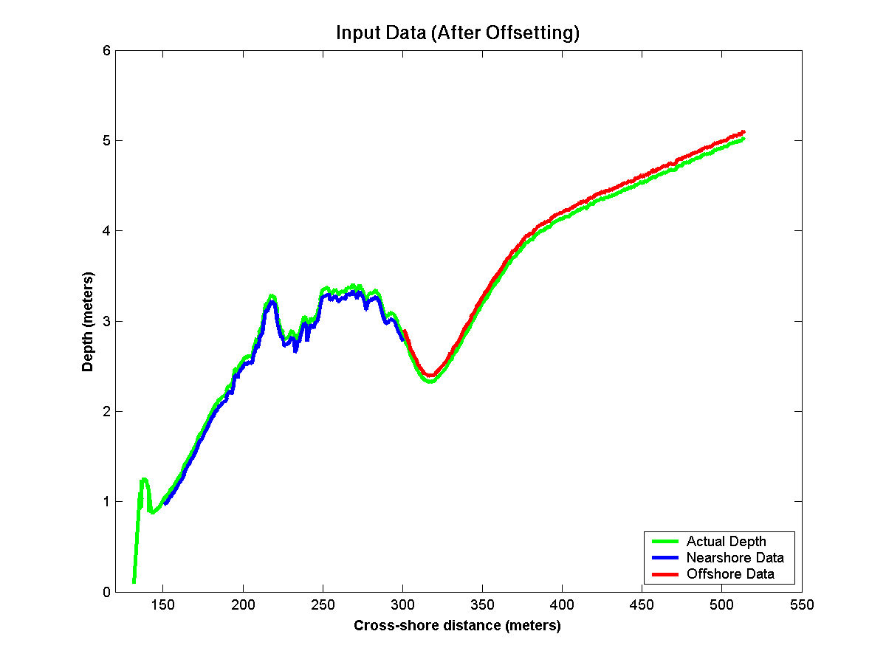
Figure 3b) Cross-shore profile after offset correction. Note that the agreement between the two datasets (in comparison to the actual data), is still very close.

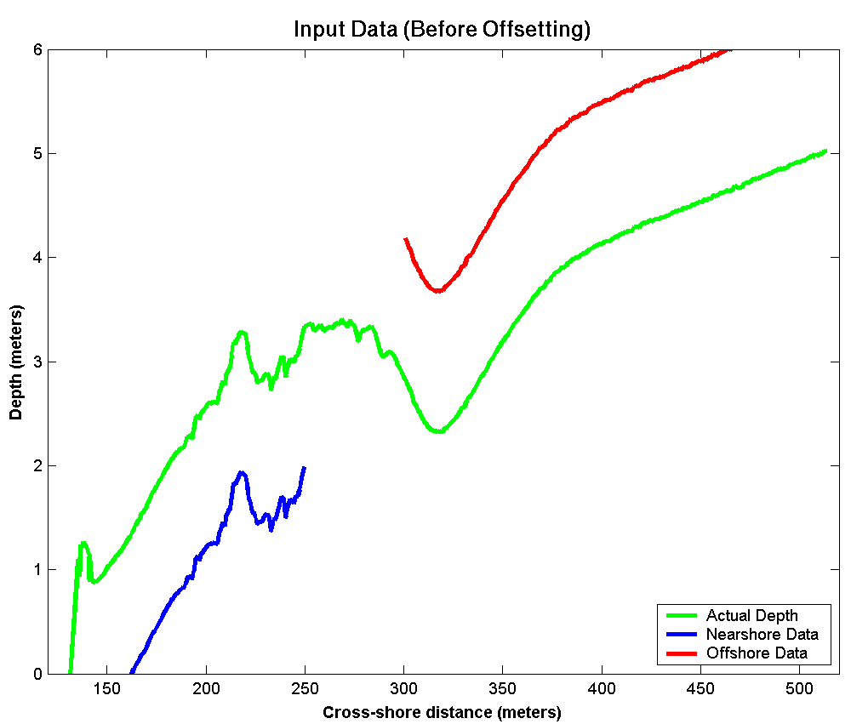
Figure 4a) A cross-shore profile with an offset between two non-overlapping datasets (blue and red) with a gap in coverage between them.

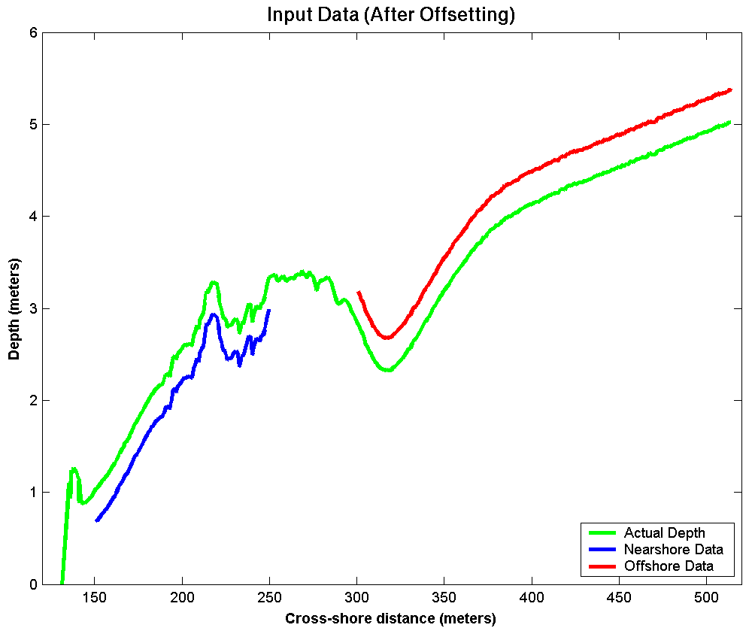
Figure 4b) Cross-shore profile after offset correction. Note that even though the data sets do not overlap, in this case the smoothing scales are enough to “link” the two datasets and preserve the overall trend of the data.
Figures 2a-4b demonstrate some of the capabilities of the offsetting algorithm. In the first case (Fig 2a-2b) there is significant overlap. This gives the offsetting routine plenty of data to work with to establish areas of commonality in order to determine “best fit” offsets that force the data to match in the area of overlap. The second example (Fig 3a-3b), there is no overlap, but the two datasets are contiguous. In this case, the algorithm still does very well in reconstructing the total surface once offsets are applied. In the last case (Fig 4a-4b), there is a significant gap between the two data sets. This gap is on the same order as the smoothing scale, and as such there is sufficient information for the offsetting algorithm to be able to make an attempt at matching the two data sets. While the overall result does not match as closely as the overlapping case in Figure 2a-2b, it is still much closer to the actual data than the two sets without any offsets applied.
These examples illustrate the fundamental nature of the offsetting algorithm: it is more effective with more extensive overlap, but it can still produce results that will cover small gaps between or within data sets.
Once the offsets have been applied to the data and all data sets are referenced to the same 2D planar trend, the mergeBathy routine will begin to calculate the final merged bathymetric product. In this process, each data point has its depth contribution applied in an area encompassed by its smoothing scale. That is, data points with large associated smoothing scales make contributions that are “felt” in the merged product farther away than points with small smoothing scales. For each point in the computational grid (as defined above), the contribution from each data point with sufficient smoothing scale to influence that location is included. From these overlapping contributions, a weighted mathematical “best fit” will be used to determine what the final overall depth is at that computational X,Y location. The weighting of this function gives priority to closer points. If error estimate or data quality metrics are available for each data point (see built-in input data formats Appendix A below), a higher weighting will be given to those points with low errors. For a further discussion of the mathematics and mechanics of the merging process, see [XXX technical document, T. Holland and N. Plant].
As mentioned above, the default X and Y smoothing scales are 200 meters. In areas of the computational grid that lie outside of the “area of influence” of all of the data points, there is insufficient information to make an estimate of depth. The mergeBathy routine will only return values for points at which it is able to calculate a depth.
Once the merged bathymetry surface has been created, the data will be displayed to screen and written to file. The output file will be in ASCII format, and will contain the latitude, longitude, depth, computational X and computational Y values for each point in the computational grid at which the routine had sufficient data to calculate a depth. Units on this output are decimal degrees, decimal degrees, input units, meters, and meters. Note again that if the reference latitude, longitude, and rotation angles are all set to zero, the output computational grid X and Y locations are in meters UTM.

5. Optional Input Commands

In addition to the five required inputs, mergeBathy also supports a wide array of optional input arguments. These are designed to allow users to tailor the merged product to their needs, as well as given them access to a range of additional intermediate or ancillary products in order to aid in interpretation of the final results. Optional arguments may be given in any order, so long as they come after the required arguments on the command line. Optional arguments are broken down into four main classes; gridding, smoothing, data handling, and plotting.
Note that several of these keyword arguments require further subsequent input (such as a number to determine grid cell size). Required arguments are delimited by angular braces ( < > ). Additionally, several can take more than one extra argument, though this is not required. Where applicable, optional additional inputs are delimited by brackets ( [ ] ).

5.1 Gridding Arguments

5.1.1 mgrid, <X> [,Y] Computational grid spacing defined in meters. Values specified for X and Y dictate the size of each cell on the computational grid. If no value is given for Y, the Y sample spacing is set to be equal to the X spacing (i.e. one that yields square output pixels).
5.1.2 llgrid, <lat> [,lon] Computational grid spacing defined in latitude/longitude. Units are assumed to be decimal degrees. If no longitude spacing is specified, it is assumed to be equal to the latitude spacing (i.e. yielding pixels that are progressively less square the farther one moves from the equator).

5.1.3 file, <filename> Computational grid spacing as defined in an arbitrary input text file. This file must consist of two columns, the first of which is latitude, the second of which is longitude (both in decimal degrees). There may be any number of lines, and output depth estimates will be reported at these arbitrary locations. Note that since the arbitrary points may not actually form a regular grid suitable for plotting, graphical output is suspended when this optional argument is specified.

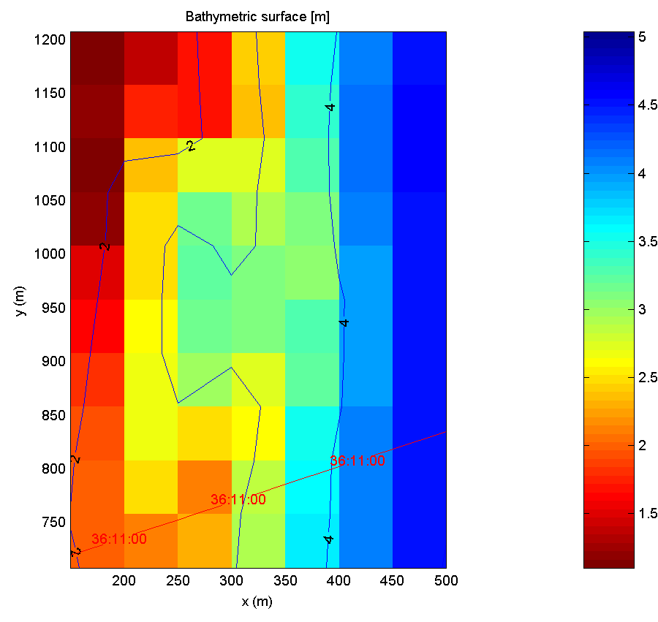
Figure 5a) Shown here is a merge of bathymetric data for the US Army Corps of Engineers Field Research Facility at Duck, NC. The computational grid used here is the default grid cell size (50 meters by 50 meters). Note that this merge has been referenced to the Field Research Facility (FRF) coordinate system.

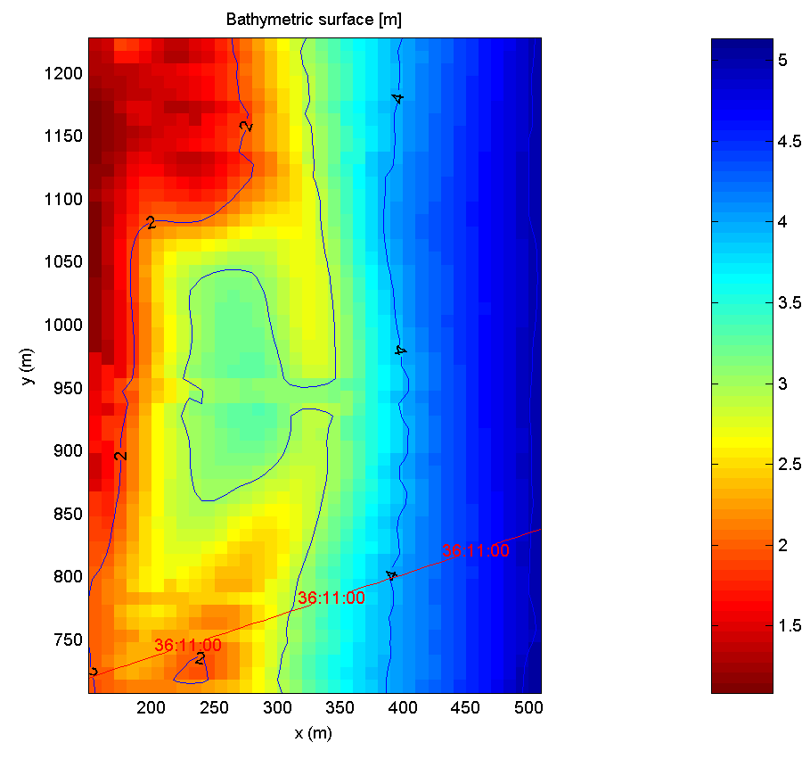
Figure 5b) Shown here is a merge of the same bathymetric data as above, but computed over a much finer grid resolution, in this case, 10 meters by 10 meters (using ‘mgrid 10’).

5.2 Smoothing Arguments

5.2.1 msmooth, <X> [, Y] [, T] This optional argument sets a constant smoothing scale defined in meters. If no value for the smoothing scale in the Y dimension is specified, it is assumed to be of the same length as the X scale (i.e. uniform in both dimensions). If no temporal smoothing scale is used, a value of zero is assumed (meaning that no temporal smoothing will be performed). Temporal smoothing weights more recent data sets or points more strongly than older data, and while not strictly necessary it can be useful when examining areas with strong temporal or cyclic bathymetry changes.

5.2.2 llsmooth, <lat> [, lon] [, T] This optional argument sets a uniform smoothing scale defined in latitude/longitude (in decimal degrees). If no value for the smoothing scale in the longitude dimension is specified, it is assumed to be of the same scale as the latitude in degrees (which may differ significantly in terms of actual linear distance at higher latitudes). If no temporal smoothing scale is used, a value of zero is assumed (meaning that no temporal smoothing will be performed). Temporal smoothing weights more recent data sets or points more strongly than older data, and while not strictly necessary it can be useful when examining areas with strong temporal or cyclic bathymetry changes.

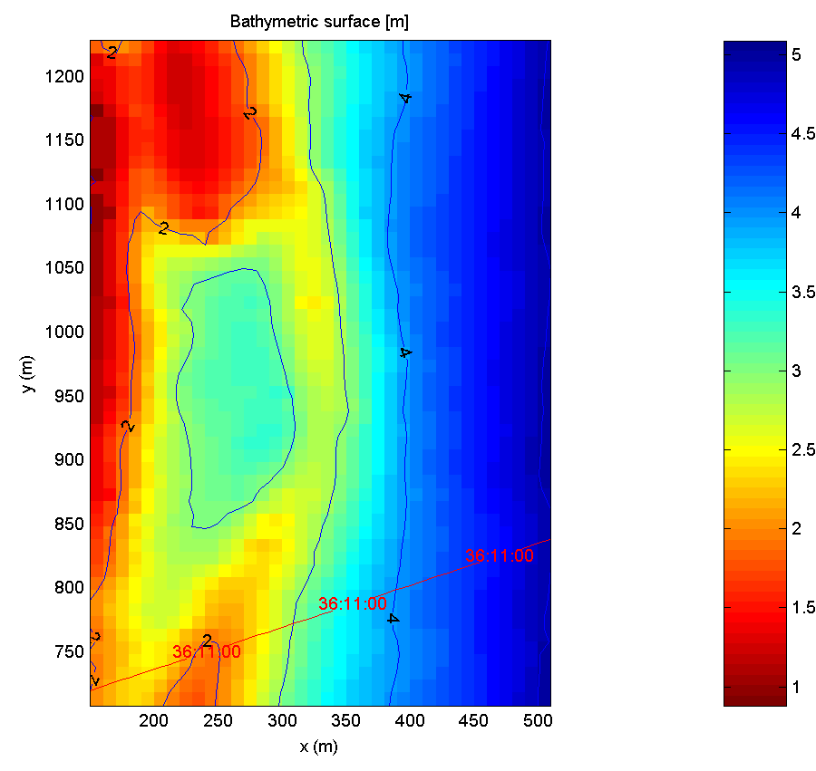
Figure 6a) Shown here is a merge of US Army Corps of Engineers bathymetric data for the Field Research Facility at Duck, NC using uniform smoothing scales in X and Y, 20 meters by 20 meters in this case (using ‘msmooth 20’). Note that with very short smoothing scales, there is a significant amount of texture or “jaggedness” to the contour lines.

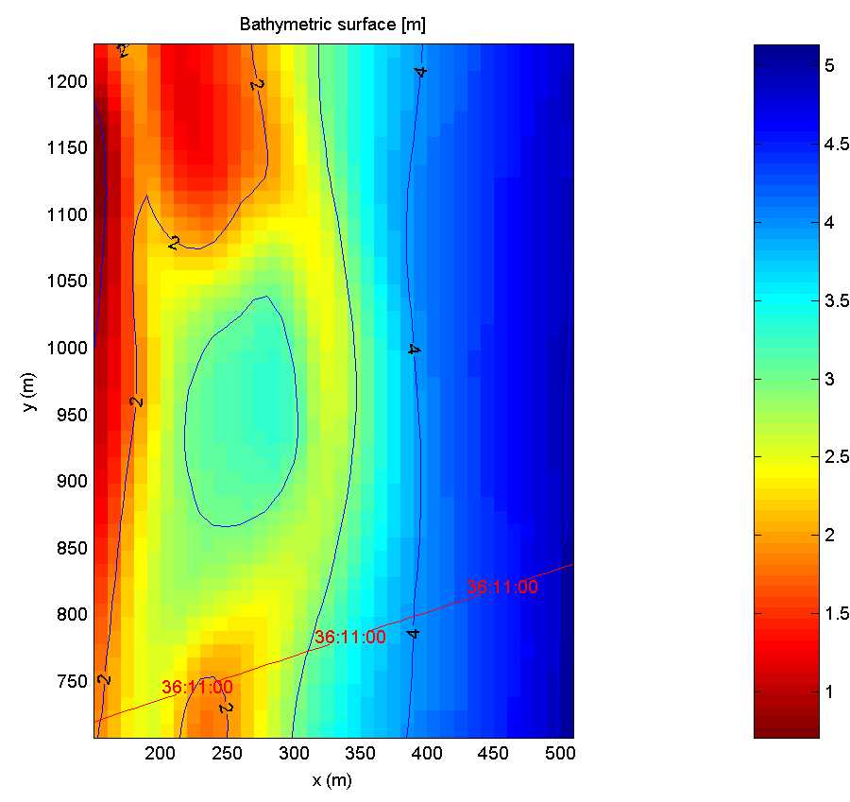

Figure 6b) Shown here is a merge of the same bathymetric data as above, this time using smoothing scales that are constant but non-uniform, in this case, 20 meters in X by 100 meters in Y (using ‘msmooth 20 100’ ). Here we can clearly see the much gentler along-shore contours given by the 100 meter Y smoothing scale, yet the cross-shore profile is still very similar to that shown in figure 6a because the cross-shore smoothing scale is the same in both merges.

5.2.3 calcsmooth This optional flag forces the program to calculate smoothing scales based on the data rather than on a user-specified, arbitrary length. This method will use the full dynamic smoothing scale approach for all bathymetry interpolation, including the interpolation used to determine offsets between data sets (unless the nooffset flag is used, see below under Data-Handling Arguments). While this has the potential to allow for more accurate offsets between data sets, it can be very time consuming, especially for large amounts of data. CAUTION: using this command line flag overrides the msmooth and llsmooth options.

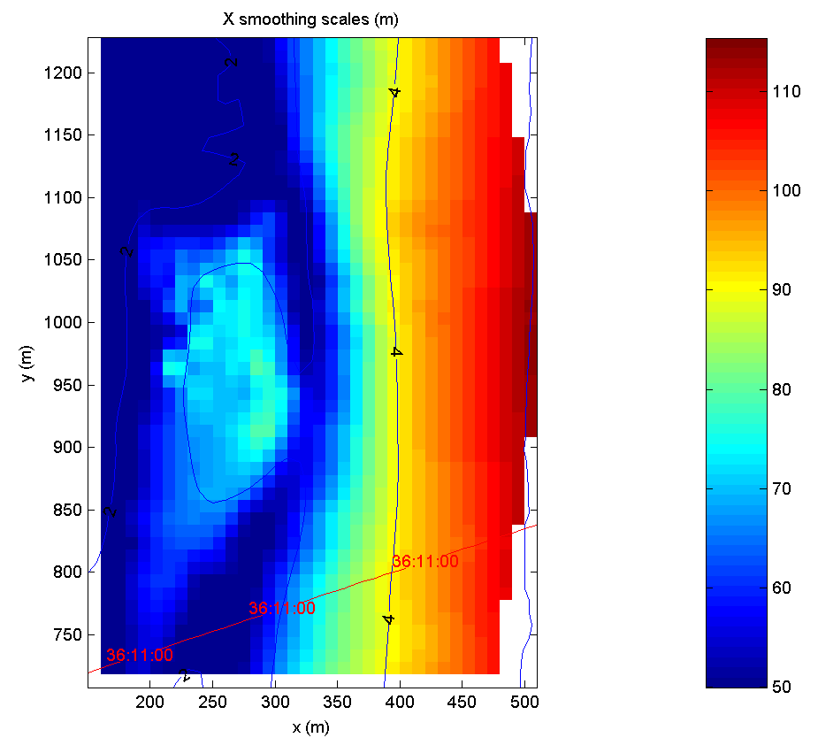
Figure 7a) Spatially variant X-axis (cross-shore) smoothing scales determined directly from the data using the ‘calcsmooth’ optional processing flag.

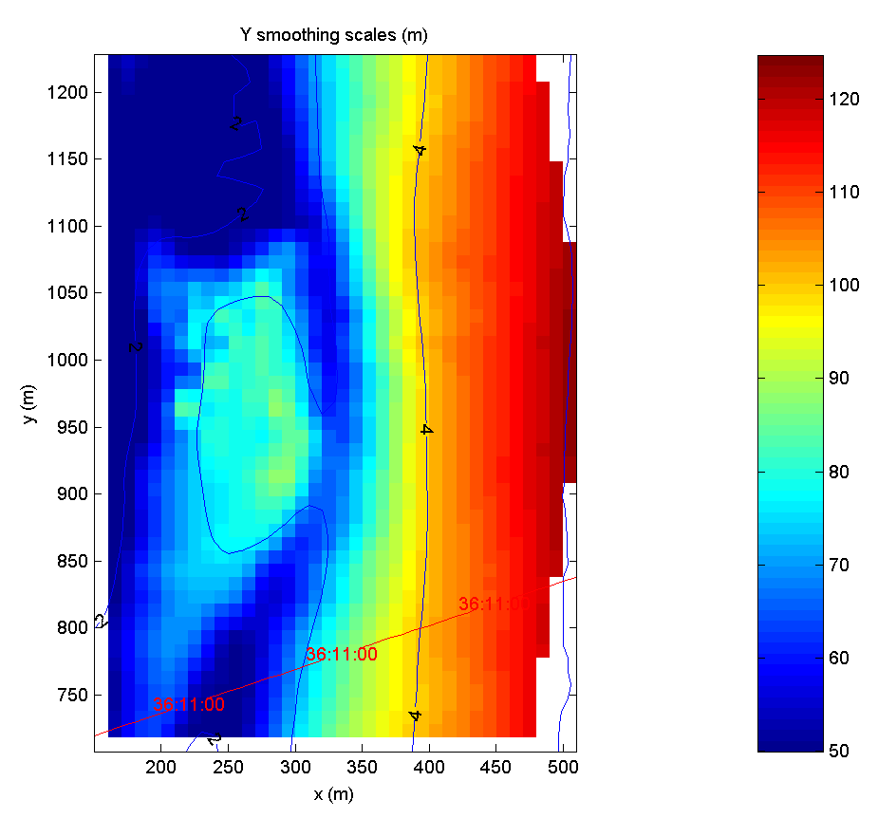
Figure 7b) Spatially variant Y-axis (along-shore) smoothing scales determined directly from the data using the ‘calcsmooth’ optional processing flag. Here, along-shore smoothing scales on the whole tend to be longer than cross-shore smoothing scales shown in Figure 7a. This is due to the fact that the bathymetry gradient is steeper in the cross-shore direction, which leads to a shortening of the associated smoothing scales in order to preserve bathymetric detail.

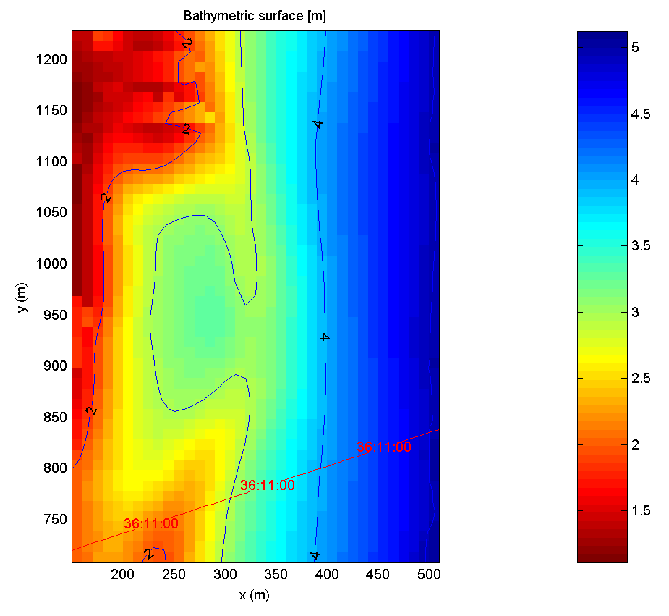
Figure 7c) Shown here is the resulting merge of the USACE Field Research Facility data using the data-determined dynamic smoothing (‘calcsmooth’ processing option). Note how this product has more fine-scale detail in shallow water, yet deeper contours are more heavily smoothed. Compare this to the constant, non-uniform bathymetric product in Figure 6b.

5.2.4 itersmooth This optional argument indicates that the full interpolated bathymetry product will be used as a “first guess” bathymetry surface. This surface is then used to calculate dynamic smoothing scales for each computational grid point based on the depth and bathymetric gradient. Once these point-by-point smoothing scales are determined, the mergeBathy routine then re-interpolates the original data to the computational grid using the new smoothing scales. Note that this process involves a second full interpolation of the data, and as such may be time consuming if large amounts of data are being merged. Also, this option may be used with either constant or dynamic smoothing scales, and will allow the user to specify constant smoothing scales for quick offsetting and “first guess” bathymetry interpolation, yet still benefit from the depth-and-gradient dependent dynamic smoothing method for final interpolation. This option is recommended.

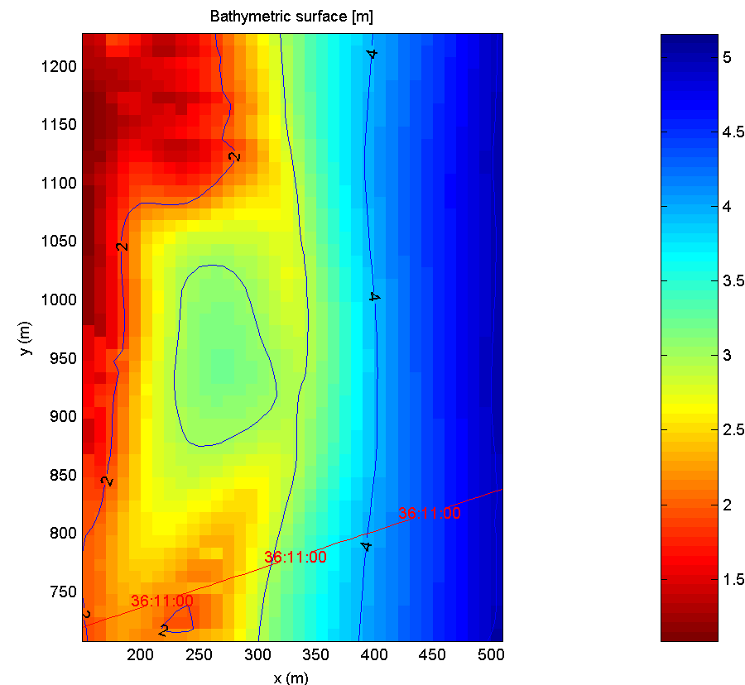
Figure 8) This merge of USACE Field Research Facility data was conducted using the iterative dynamic smoothing algorithm (‘itersmooth’ optional processing flag). In this case, a 20 meter uniform smoothing scale (‘msmooth 20’) was used as a “first guess” smoothing scale. Note that without the ‘itersmooth’ optional flag, this product would be identical to that shown in Figure 7a.

5.3 Data-Handling Arguments

5.3.1 nooffset By default offsets between datasets are calculated. This option forces the routine to skip the offset calculation (which may save significant computational time) and treat all offsets as zero. Tide correction (if specified) is still applied.

5.3.2 nodataerr This optional flag forces the program to ignore error values associated with data points. All data points are treated as “equally trustworthy” and weighted the same. Note that not all data sets have associated errors, and this option is only meaningful for those data sets that have some measure of data quality.

5.3.3 nonegdepth By default the program treats positive numbers as depths and negative numbers as elevations. Interpolation and merging can handle both positive and negative numbers in the same merge (and even in the same dataset), and the results will be displayed spanning the entire range. By specifying this optional argument, the user eliminates negative depths (elevations) from both the merge process and the display.

5.3.4 formatdir <directory> This flag specifies a root directory in which format files corresponding to the data to be merged reside. The default value is the current working directory. This option allows the user to establish a central repository for commonly used format files.

5.4 Plotting Arguments

5.4.1 rect This option forces the output (both files and plots) to be rectangular in latitude/longitude even if an otherwise arbitrarily translated or rotated reference frame was used during computation. This allows the user to orient the computational domain such that the cross-shore or along-shore direction corresponds to a given axis (for ease of non-uniform gridding or smoothing scales), yet still output the data on a regularly spaced latitude/longitude grid. Note also that this option replaces the standard X,Y (meters) axes on all plots with lon,lat (decimal degrees) axes.

5.4.2 local This optional argument forces the output graphic to be displayed in the (arbitrary) local coordinate system (X and Y as defined by the reference latitude, reference longitude, and rotation angle). X is positive to the right, Y is positive up. If this option is not specified, the output graphics will be rotated to be displayed as “mostly mappish,” with north more or less up and east more or less to the right. Note that the axes will still reflect the local (arbitrary) coordinate system, but depending on the rotation, the X axis may be vertical rather than horizontal, or with values increasing in the opposite direction. The Y axis will be similarly transformed.

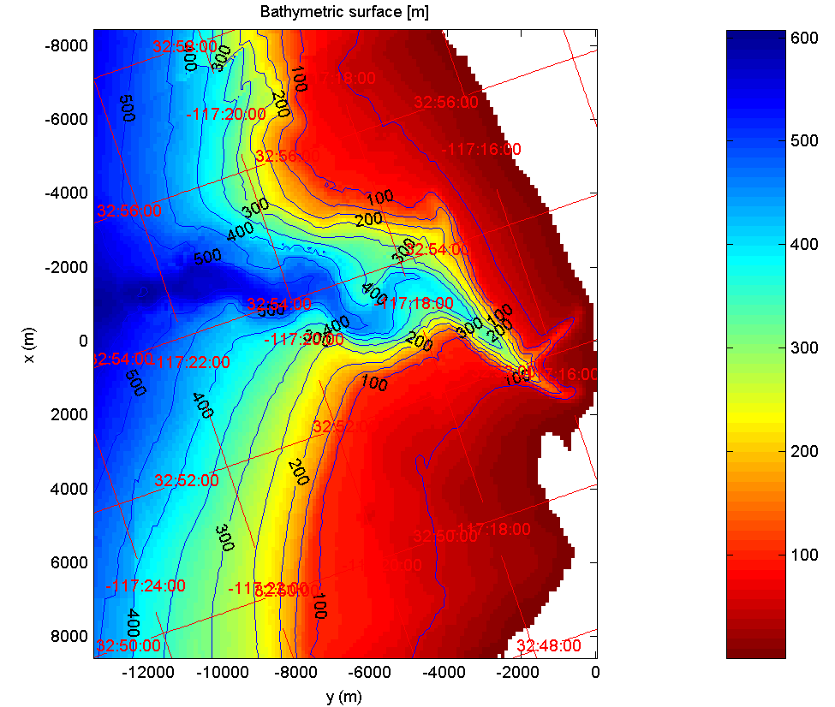
Figure 9a) This merge has been referenced to an arbitrary Scripps X,Y coordinate system. Note that the display is rotated in order to be displayed in a “mostly-mappish” format (north-up, east to the right). This is done automatically to aid users in orienting the display. Also note that the arbitrary X,Y axes are still present, but are oriented with X increasing down and Y increasing to the right.
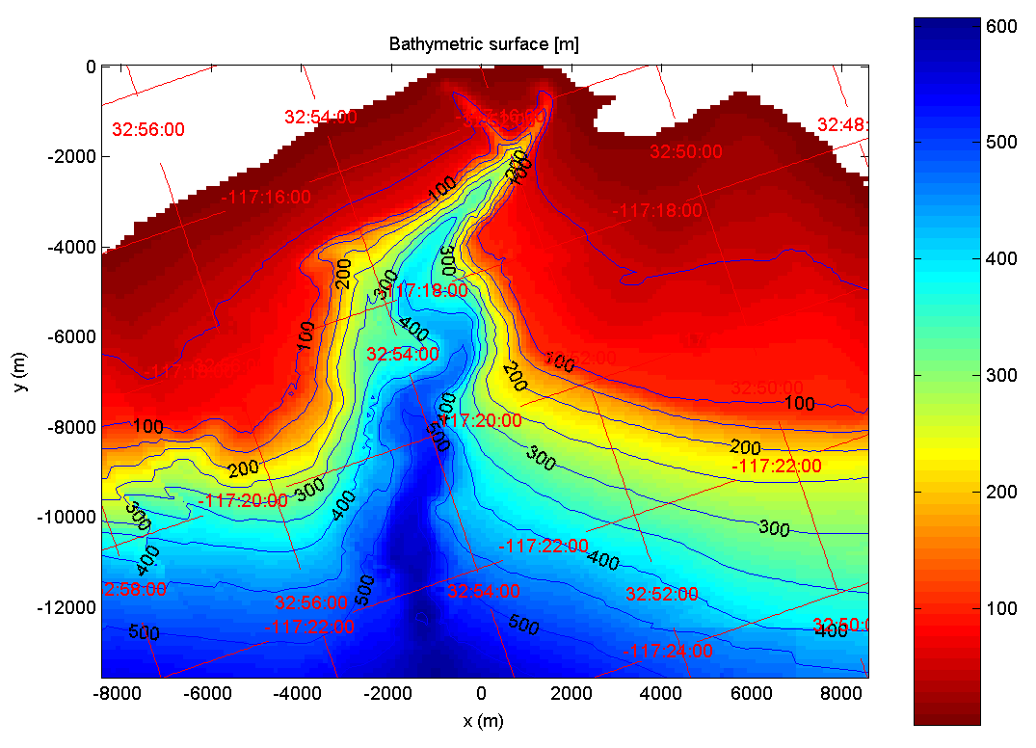
Figure 9b) This merge has been referenced to an arbitrary Scripps X,Y coordinate system. In this case, the “local” optional display flag has been specified, and the merged product is displayed in the arbitrary X,Y coordinate system.
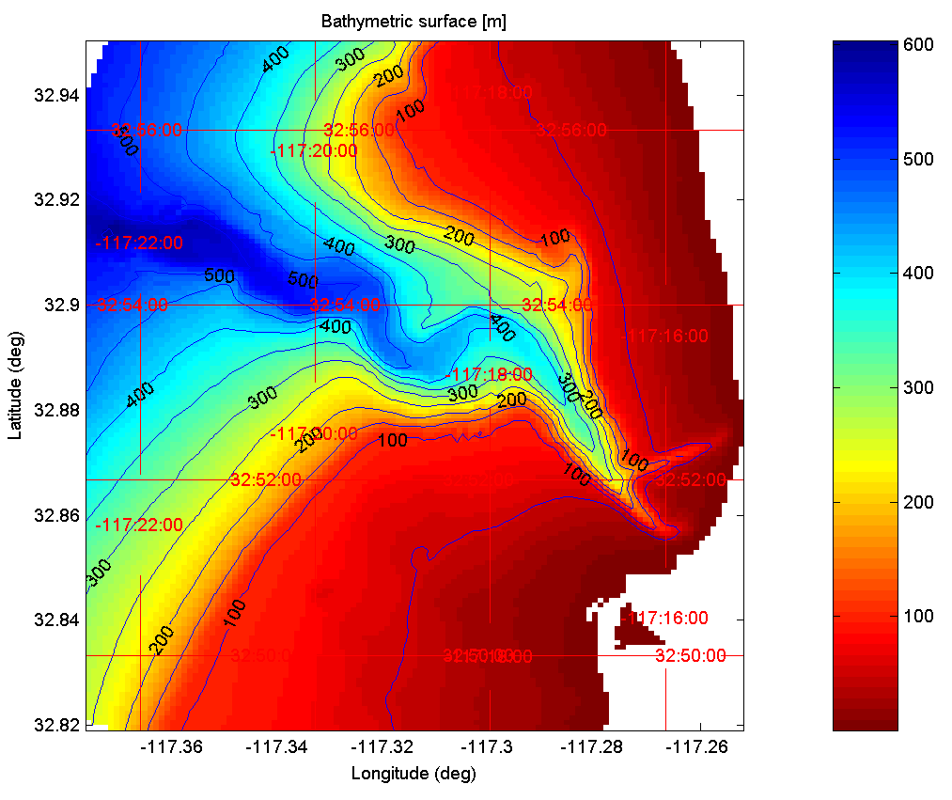
Figure 9c) This merge has been referenced to an arbitrary Scripps X,Y coordinate system, for computation, yet the output is rectilinear in latitude/longitude. This type of product is created using the “rect” optional plotting argument.

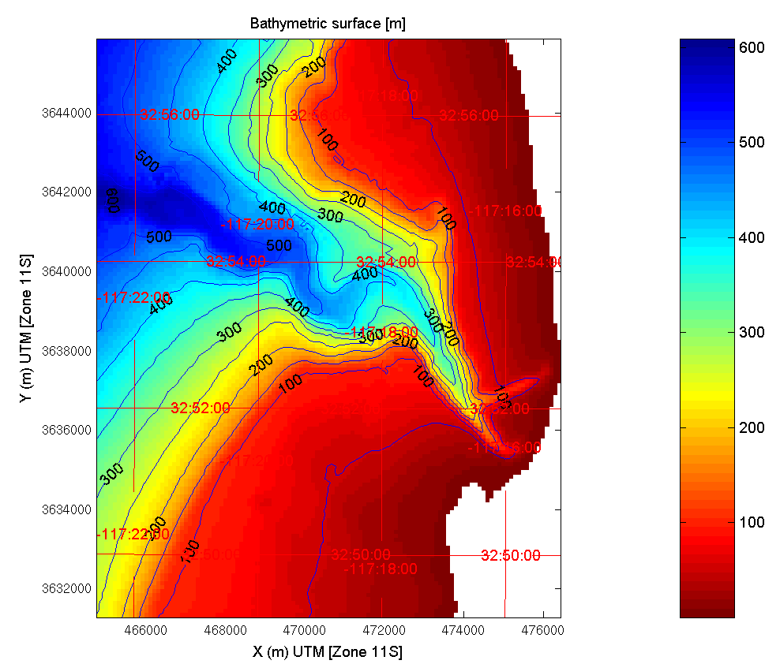

Figure 9d) Here, there input data was not referenced (reference latitude, reference longitude and rotation angle are all left as 0). As a result, the program automatically aligns the computational domain to coincide with the region’s UTM coordinates. Note also that the UTM Zone is indicated in the axes labels.

5.4.3 plotpts This option allows the user to overlay the final bathymetry plot with points for each of the individual input data samples. This can be useful in analysis and interpretation of bathymetry results. Default execution does NOT plot individual data points. CAUTION: in areas where the input data are very dense, displaying locations of input points may actually obscure the underlying bathymetric product from view. This option is generally diagnostic in nature, and probably shouldn’t be used when creating final graphical products.

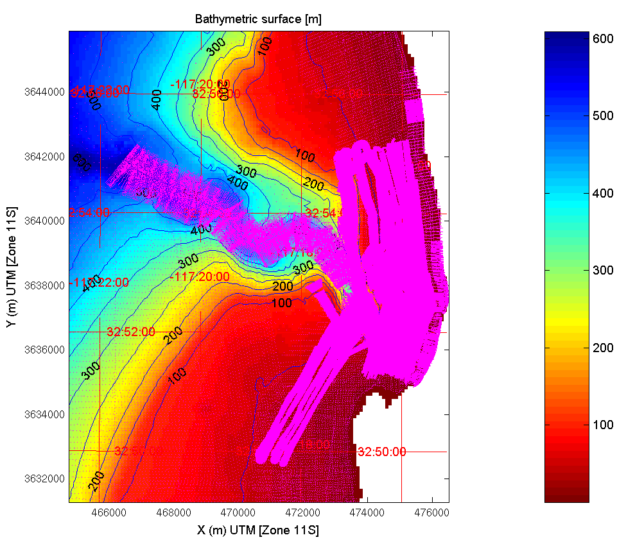
Figure 10) Shown here is a merge of NCEX data with the individual data points plotted. Here it is readily apparent where the areas of highest data density are located (in this case the trench and nearshore areas are much more heavily sampled). This product also demonstrates how high data densities can obscure the underlying bathymetric surface in output graphics.

5.4.4 errplots Allows the user to display output plots of error statistics in addition to the standard bathymetry plot. These extra plots correspond to Normalized RMS Error, RMS Error (in depth units), and Residual RMS Error (in depth units). These figures may be useful for analysis or interpretation of results and clearly indicate areas where there is poor data agreement or insufficient sample density. Default program execution does NOT display these extra figures.

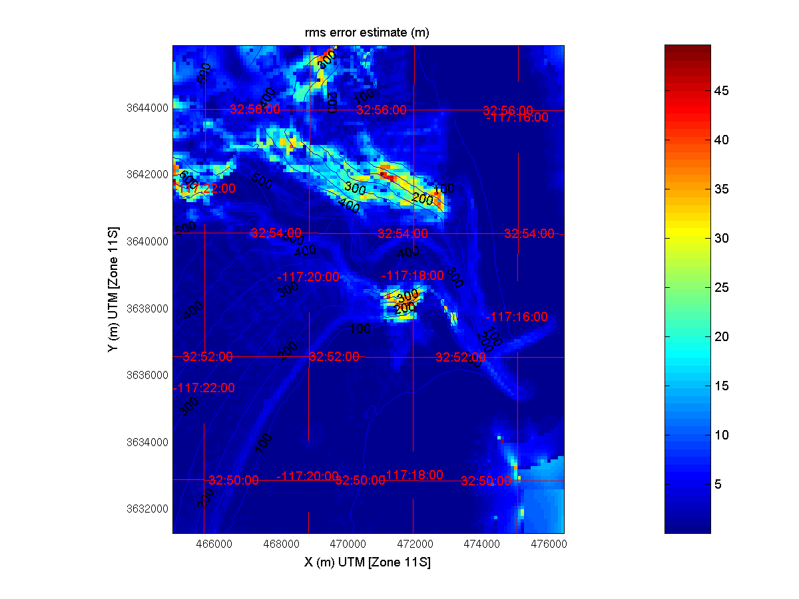
Figure 11) Shown here is a graphical representation of the RMS Error Estimate (in meters) for a merge of NCEX data. Error graphics allow the user to quickly identify areas of poor data coverage (upper left in this example) or poor agreement between data sets (the southern edge of the trench in the center of this example).

5.4.5 smoothplots Allows the user to render output plots depicting the smoothing scales used in the final bathymetric interpolation. Note that this option is only meaningful if the program is allowed to calculate dynamic smoothing scales (i.e. calcsmooth or itersmooth are used). These figures may be useful for analysis or interpretation of the bathymetric data, as they clearly indicate which areas are more heavily smoothed than others. Figures 7a and 7b are examples of the output of the smoothplots option. Note that default program execution does NOT include these extra figures.

5.4.6 saveplots This option allows the user to save the output plots to JPEG files automatically. Note that a separate JPEG file will be written for each output plot created (1 for bathymetry, 3 for error graphics if errplots is used, and 2 for smoothing scale graphics if smoothplots is specified).

6. Program Output

Upon completion, the program creates several files based on the root filename given by the associated required input argument (see Section 3, Required Inputs). Output of an ASCII-formatted bathymetry file is automatic. This file contains a single line header, and has five columns of data. These columns correspond to latitude (in decimal degrees), longitude (in decimal degrees), depth (in input units), computational X coordinate (in meters), and computational Y coordinate (in meters). Note that if the reference latitude, longitude, and rotation angle are all zero, the X and Y coordinates are in meters UTM. This file always has an output filename of [root]_bathy.txt.
Additionally, the program will display various graphical products to screen. At a minimum, the final merged bathymetry will be displayed. If the errplots or smoothplots optional arguments are specified, further graphical products will also be displayed to screen.
The creation of graphics files (in JPEG format) is activated only through use of the saveplots optional argument (though individual graphical products may be saved manually using the File->Export command within the graphics window). Files created in this manner will have a consistent naming convention described as follows:

[root]_bathy.jpg A JPEG version of the graphics figure showing the final merged bathymetric product. This file is only created if the saveplots optional argument is used.

[root] _bathy _normrms.jpg A JPEG version of the graphics figure showing the Normalized RMS Error product. This file is only created if both the saveplots and errplots optional flags are used.

[root] _bathy _rmserr.jpg A JPEG version of the graphics figure showing the RMS Error product. This file is only created if both the saveplots and errplots optional flags are used.

[root] _bathy _rmsres.jpg A JPEG version of the graphics figure showing the Residual RMS Error product. This file is only created if both the saveplots and errplots optional flags are used.

[root]_bathy_lx.jpg A JPEG version of the graphics figure showing the smoothing scales (in meters) in the computational X direction used in the final interpolation. This file is only created if both the saveplots and smoothplots optional flags are used.

[root]_bathy_ly.jpg A JPEG version of the graphics figure showing the smoothing scales (in meters) in the computational Y direction used in the final interpolation. This file is only created if both the saveplots and smoothplots optional flags are used.

Appendix A: Creating Format Files

The mergeBathy program makes use of user-defined format files in order to allow users to ingest a wide range of data in different formats, units, and file naming conventions. At its most basic level, the format files are the keys by which the mergeBathy data ingest reader interprets the files in question.

A.1. Format File Naming Convention

A format file is simply a short text file, named with the following convention:

format_<type>.txt

where “type” is a user-defined format type. As an example, a format file entitled “format_xyz.txt” might allow users to ingest text files with three columns of data consisting of arbitrary x, y, and z coordinates for data to be merged. The “type” will be the part indicated in the input file list. For example, consider the following line of an input file list:

survey3_08092003.dat xyz

In the above example, data file survey3_08092003.dat will be parsed according to the specifications laid out in format file “format_xyz.txt”.
By default the mergeBathy routine looks for format files in the current working directory, but another search path may be indicated by using the formatdir optional argument (see section 5.3.4).

A.2. Format File Contents

The format file must contain the following lines:

A.2.1 headerLines By specifying the number of header lines, the format file tells the ingest reader to skip several lines of code. Example: a data file has a single line of header information (column labels) to be skipped. The format file to read that data must contain the following line:

headerLines:1

A.2.2 columnSeparator Specifying a column separator indicates to the ingest reader where a column starts and ends. For example, if an input datafile consisted of comma-separated columns of data, the following line would be required in the format file:

columnSeparator:,

If no value is specified, the default separator is whitespace (spaces or tabs).

A.2.3 Data Value Descriptions The next line contains a list of data value descriptions corresponding to each column of input data. The actual descriptions themselves are simply keywords. By specifying the keyword descriptions, the user indicates which data fall in which column, as well as units to allow the ingest routine to be able to handle data consistently and appropriately. A list of currently implemented keywords and their descriptions follows:
ddlat Latitude in decimal degrees.
ddlon Longitude in decimal degrees.
dd:mm:sslat Latitude in degrees, minutes, and decimal seconds, separated by colons.
dd:mm:sslon Longitude in degrees, minutes, and decimal seconds, separated by colons.
latdeg Latitude degrees.
latmin Latitude minutes.
latsec Latitude seconds.
londeg Longitude degrees.
lonmin Longitude minutes.
lonsec Longitude seconds.
depth Water depth in meters.
depth_ft Water depth in feet.
elev Elevation (negative depth) in meters.
elev_ft Elevation (negative depth) in feet.
error Estimated error of a datapoint error in meters.
error_ft Estimated error of a datapoint in feet.
time_hh:mm:ss Data collection time in hours, minutes, and seconds separated by colons.
time_days Data collection time(date) in Julian days.
time_hrs Data collection time hours.
time_mins Data collection time minutes.
time_secs Data collection time seconds.
kx Arbitrary x-direction wave number at data location (in m⁻¹ units).
ky Arbitrary y-direction wave number at data location (in m⁻¹ units).
kx_ft Arbitrary x-direction wave number at data location (in feet⁻¹ units).
ky_ft Arbitrary y-direction wave number at data location (in feet⁻¹ units).
wavelength Wavelength in meters at data location.
wavelength_ft Wavelength in feet at data location.
waveheight Waveheight in meters at data location.
waveheight_ft Waveheight in feet at data location.
waveheightvar Waveheight variance in meters at data location.
waveheightvar_ft Waveheight variance in feet as data location.
ignore data in column is to be ignored.

Example: consider a sample data file containing the following text:

Longitude Latitude Depth(m)
-75.744807 36.188017 -6.44
-75.744790 36.188012 -6.57
-75.744764 36.188002 -6.10
-75.744743 36.187989 -6.45

A format file needed to describe the above data would contain the following lines:

headerLines:1
columnSeparator:
ddlon ddlat depth

A.2.4 Filename Parsing (optional) Oftentimes, valuable file information (such as date or time of data collection) will be encoded into the filename of a particular data file. By specifying a filename parsing scheme in the format file, this information can be recovered and used in the merging process (such as when files correspond to different dates and temporal smoothing is being used).
In order to parse a filename for information, an extra line must be put into the format file. Parsing of filenames happens similarly to parsing input files in that it makes use of keywords to decipher the information contained in the filename. As of this writing, the valid keywords are:

yy two-digit year (assumes 50 as pivot year)
yyyy four digit year
mm two-digit month
mon three letter textual representation of month (e.g. “jan” or “NOV”)
dd two-digit day
hr two-digit hour
mn two-digit minutes
mins four-digit minutes
sc two digit seconds
scnds five digit seconds

Keywords are set apart from the rest of the filename characters using “<” and “>” characters (as these are symbols that have meaning to the operating system and thus are not usable in filenames). Wildcard characters (“*” and “?”) may be used where filename parameters change in length or change textually. Care must be taken when using wildcard characters, as there must be some type of separator character between the wildcard character and the keyword delimiter. For example, “*_<yyyy>.dat” is acceptable as there is an underscore between the wildcard and the delimiter, but “*<yyyy>.dat” is not because there is no way to discern where the wildcard series ends and the year begins. In cases where filename length is fixed and there is no easy delimiter to use, it is better to use a series of the single-character wildcards “?” instead.

Example: an input file names survey3_08092003.dat is to be entered into the merge. In order to facilitate temporal smoothing in order to weight more recent data collections more strongly than older data, we wish to capture the date information from the filename. As such, the format file associated with this data collection may appear as follows:

headerLines:1
columnSeparator:
ddlon ddlat depth
*_<mm><dd><yyyy>.dat

In the above example, the same filename parsing method could parse files with names as diverse as:

survey3_08092003.dat
survey4_08102003.dat
/archive/olddata/duck/survey1_07212002.dat
really-long-filename-with-only-one-underscore_10282004.dat

Further, if a fully-qualified directory structure is given, the filename parser ignores all directory information and parses only the filename by default. This behavior can be overridden by the user if the user specifies keywords within the operating system’s hierarchical delimiter (“/” for UNIX systems or “\” for Windows-based systems). This behavior is useful if data files are separated into distinct file system hierarchies where directory names contain useful information.

Example: survey data are located in a directory structure separated by month of collection. The input data list file might appear as follows:

! 36.177602 -75.749690 18.20 DuckNC
#
archive/surveydata/2003/08/day09.dat xyz_datedir
archive/surveydata/2004/01/day21.dat xyz_datedir
archive/surveydata/2004/06/day17.dat xyz_datedir

To parse these files, the user would also need to define a format file (called “format_xyz_datedir.txt” in the above example) containing the following lines:

headerLines:1
columnSeparator:
ddlon ddlat depth
*/*/<yyyy>/<mm>/???<dd>.dat

