Sammav IT Services Website — Software Requirements Specification
Oct 15, 2026 · @Samuel

1. Introduction
Sammav IT Services needs a four-page WordPress website — Home, Projects, About Us, Contact Us — that presents its services, proves capability through past projects, and turns visitors into enquiries.

1.1 Purpose
This SRS defines the functional and non-functional requirements for the website. It is the reference for the client, designers, developers and testers, and the basis for acceptance.

1.2 Scope
In scope:
- A responsive public website built on WordPress with four primary menu items
- A Projects portfolio managed by staff without code changes
- A contact form that emails enquiries to Sammav and stores them in the dashboard
- Basic SEO, analytics, security hardening and backups
Out of scope for this release: e-commerce, client login portal, online payments, multilingual content and a blog (the design should allow a blog to be added later).

1.3 Definitions
Term | Meaning
CMS | Content Management System — WordPress admin dashboard
CPT | Custom Post Type — a WordPress content type, here used for Projects
CTA | Call to Action — a button or link prompting the visitor to act
Admin | Sammav staff member with full WordPress rights
Editor | Sammav staff member who can add and edit content but not change settings
WCAG | Web Content Accessibility Guidelines
SSL/TLS | Encryption for HTTPS connections

1.4 Requirement IDs
Requirements use the prefixes FR (functional) and NFR (non-functional), with a priority of Must, Should or Could.

2. Overall Description
The site is a self-contained marketing website: public visitors browse and enquire; Sammav staff maintain content through the WordPress dashboard.

2.1 Business Goals
- Establish a credible, professional online presence for Sammav IT Services.
- Showcase completed projects as evidence of capability.
- Generate qualified leads through the contact form, phone, email and WhatsApp.
- Let non-technical staff update content without a developer.

2.2 User Classes
User | Goals | Access
Prospective client | Understand services, see past work, get in touch | Public pages
Existing client | Find contact details, request support | Public pages
Job seeker / partner | Learn about the company and team | Public pages
Editor (Sammav staff) | Add projects, update page text and images, read enquiries | WordPress Editor role
Administrator | Manage plugins, themes, users, settings, backups | WordPress Administrator role

2.3 Operating Environment
- Browsers: latest two versions of Chrome, Edge, Firefox and Safari (desktop and mobile)
- Devices: phones from 360 px wide, tablets, laptops and desktops up to 1920 px
- Server: Linux hosting with PHP 8.2+, MySQL 8 or MariaDB 10.6+, HTTPS
- CMS: latest stable WordPress release at build time

2.4 Constraints
- Built on WordPress using a maintained theme and plugins from reputable sources only.
- No custom code that blocks routine WordPress, theme or plugin updates.
- Brand identity (logo, colours, fonts) supplied by Sammav.
- Must comply with applicable data protection law for contact-form data (e.g. Ghana Data Protection Act 2012 / GDPR where relevant).

2.5 Assumptions and Dependencies
- Sammav supplies text, logo, project details and photos before build starts.
- A domain name and hosting account are available or will be purchased.
- A business email account exists to receive form submissions.
Open questions:
- ☐ Confirm domain name and hosting provider
- ☐ Confirm the list of services to feature on the Home page
- ☐ Confirm whether WhatsApp and Google Maps should appear on Contact Us

3. Site Map and Navigation
The header menu holds exactly four items — Home, Projects, About Us, Contact Us — and every project in the portfolio gets its own detail page.
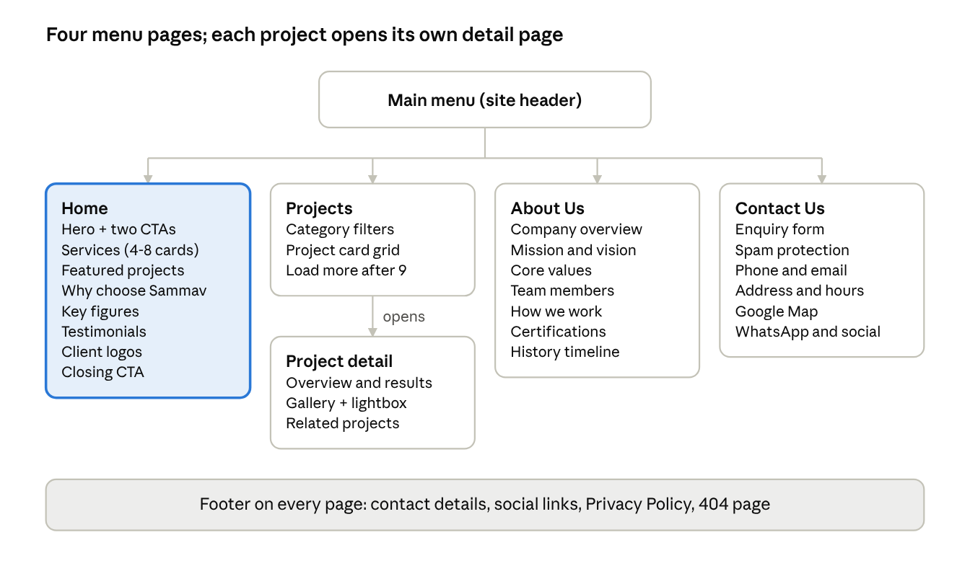
site map · 4 menu pages, 1 project detail template
Home is the landing page and the main route into Projects and Contact Us; the footer repeats contact details on every page.
Page | URL
Home | /
Projects | /projects/
Project detail | /projects/{project-name}/
About Us | /about-us/
Contact Us | /contact-us/
Privacy Policy | /privacy-policy/

4. Functional Requirements
Each page below lists what it must show and do; every item is editable from the WordPress dashboard unless noted.

4.1 Global (all pages)
ID | Requirement | Priority
FR-G1 | Sticky header with logo (links to Home) and the menu: Home, Projects, About Us, Contact Us | Must
FR-G2 | Active menu item is visually highlighted | Must
FR-G3 | On screens under 768 px the menu collapses into a hamburger toggle | Must
FR-G4 | Header CTA button "Get a Quote" linking to Contact Us | Should
FR-G5 | Footer with short company blurb, quick links, phone, email, address, social icons and copyright year | Must
FR-G6 | Footer link to Privacy Policy page | Must
FR-G7 | Floating WhatsApp chat button on mobile and desktop | Could
FR-G8 | Custom 404 page with links back to the four main pages | Should
FR-G9 | Cookie consent banner when analytics cookies are used | Must

4.2 Home
ID | Requirement | Priority
FR-H1 | Hero section: headline, one-line value statement, background image or video, two CTAs ("Our Projects", "Contact Us") | Must
FR-H2 | Services section: 4–8 service cards (icon, title, 1–2 lines), e.g. Networking, Software Development, IT Support, Cloud & Hosting, Cybersecurity, Web Design | Must
FR-H3 | Featured projects: the 3 most recent projects marked "Featured", each linking to its detail page, plus "View all projects" | Must
FR-H4 | "Why choose Sammav" section: 3–4 differentiators | Should
FR-H5 | Key figures strip (e.g. projects completed, clients served, years in business) | Could
FR-H6 | Client testimonials carousel, manageable from the dashboard | Should
FR-H7 | Client / partner logo strip | Could
FR-H8 | Closing CTA banner linking to Contact Us | Must

4.3 Projects
ID | Requirement | Priority
FR-P1 | Projects stored as a "Project" custom post type with fields: title, client name, category, completion date, short summary, full description, technologies used, featured image, gallery, optional live URL, Featured flag | Must
FR-P2 | Projects listing page shows a responsive grid of project cards (image, title, category, summary) | Must
FR-P3 | Filter buttons by category (e.g. Web, Networking, Software, Infrastructure) without page reload | Should
FR-P4 | Pagination or "Load more" after 9 projects | Should
FR-P5 | Single project page: hero image, overview, challenge, solution, results, technologies, image gallery with lightbox, client testimonial (optional) | Must
FR-P6 | "Related projects" (same category) and a CTA "Start a similar project" on each project page | Should
FR-P7 | Editors can add, edit, publish, unpublish and reorder projects without code | Must
FR-P8 | Client name can be hidden for confidential projects | Should

4.4 About Us
ID | Requirement | Priority
FR-A1 | Company overview: who Sammav is, when founded, where based | Must
FR-A2 | Mission, vision and core values | Must
FR-A3 | Team section: photo, name, role, short bio, optional LinkedIn link per member | Should
FR-A4 | Our approach / how we work: a numbered 4–5 step process | Should
FR-A5 | Certifications, partnerships and memberships with logos | Could
FR-A6 | Company history timeline | Could
FR-A7 | CTA to Contact Us at the end of the page | Must

4.5 Contact Us
ID | Requirement | Priority
FR-C1 | Contact form fields: Full name*, Email*, Phone, Company, Service of interest (dropdown), Budget range (dropdown, optional), Message*, consent checkbox* | Must
FR-C2 | Client- and server-side validation with clear inline error messages | Must
FR-C3 | Spam protection (Google reCAPTCHA v3 or Cloudflare Turnstile, plus honeypot) | Must
FR-C4 | On submit: success message shown, email sent to Sammav's inbox, auto-reply sent to the visitor | Must
FR-C5 | Submissions stored in the dashboard and exportable to CSV | Should
FR-C6 | Contact details: phone (tap-to-call), email (mailto), physical address, business hours | Must
FR-C7 | Embedded Google Map of office location | Should
FR-C8 | WhatsApp click-to-chat link and social media links | Should
FR-C9 | Form can be pre-filled with a service when reached from a service or project CTA | Could

4.6 Content Administration
ID | Requirement | Priority
FR-M1 | All page text and images editable through a visual page builder or block editor | Must
FR-M2 | Menus editable via Appearance → Menus | Must
FR-M3 | Services, testimonials and team members managed as reusable entries, not hard-coded | Should
FR-M4 | Role-based access: Administrator and Editor roles as defined in 2.2 | Must
FR-M5 | Images auto-resized and compressed on upload | Should

5. Non-Functional Requirements
The site must load in under 3 seconds on mobile, stay secure and patched, and meet WCAG 2.1 AA.
ID | Area | Requirement | Priority
NFR-1 | Performance | Largest Contentful Paint ≤ 2.5 s and total load ≤ 3 s on a 4G mobile connection | Must
NFR-2 | Performance | Google PageSpeed Insights score ≥ 85 mobile, ≥ 90 desktop | Should
NFR-3 | Performance | Page caching, lazy-loaded images, WebP images, minified CSS/JS, CDN (e.g. Cloudflare) | Should
NFR-4 | Responsiveness | Layout works from 360 px to 1920 px with no horizontal scroll | Must
NFR-5 | Security | HTTPS on all pages with HTTP → HTTPS redirect | Must
NFR-6 | Security | Security plugin with firewall, login attempt limiting and malware scanning | Must
NFR-7 | Security | Two-factor authentication for Administrator accounts; no "admin" username | Must
NFR-8 | Security | WordPress core, theme and plugins kept up to date; XML-RPC disabled if unused | Must
NFR-9 | Privacy | Privacy Policy page; form consent recorded; submissions retained no longer than 12 months | Must
NFR-10 | Accessibility | WCAG 2.1 AA: alt text, keyboard navigation, visible focus, 4.5:1 text contrast, labelled form fields | Must
NFR-11 | SEO | SEO plugin (Yoast or Rank Math): editable titles and meta descriptions, XML sitemap, Open Graph tags, schema for LocalBusiness | Must
NFR-12 | SEO | Clean permalinks, e.g. /projects/project-name/ | Must
NFR-13 | Analytics | Google Analytics 4 and Google Search Console connected; form submissions tracked as conversions | Should
NFR-14 | Availability | 99.9% monthly uptime from hosting; uptime monitoring with email alerts | Should
NFR-15 | Backup | Automated daily database and weekly full backups, stored off-site, 30-day retention; restore tested once before launch | Must
NFR-16 | Maintainability | Child theme for any custom code; no edits to core, parent theme or plugin files | Must
NFR-17 | Usability | Any page reachable within 2 clicks from Home | Should
NFR-18 | Compatibility | Works on latest two versions of Chrome, Edge, Firefox, Safari | Must

6. WordPress Technical Specification
Recommended stack: a lightweight theme (Astra, Kadence or GeneratePress) with a child theme, the block editor or Elementor, and a small, well-maintained plugin set.

6.1 Recommended Plugins
Need | Recommended plugin | Alternative
Page building | Gutenberg block editor + Kadence Blocks | Elementor
Projects CPT and custom fields | Advanced Custom Fields (ACF) + Custom Post Type UI | Pods
Contact form | WPForms Lite | Contact Form 7 + Flamingo
Spam protection | Cloudflare Turnstile or reCAPTCHA v3 (built into form plugin) | Akismet
SMTP email delivery | WP Mail SMTP | FluentSMTP
SEO | Rank Math | Yoast SEO
Caching / performance | LiteSpeed Cache (on LiteSpeed hosts) | WP Rocket
Image optimisation | ShortPixel | Smush
Security | Wordfence | Solid Security
Backups | UpdraftPlus (to Google Drive or S3) | Host backups
Cookie consent | Complianz | CookieYes
Analytics | Site Kit by Google | GA4 tag via theme

6.2 Content Model
Type | Kind | Key fields
Page | Built-in | Home, Projects, About Us, Contact Us, Privacy Policy
Project | Custom post type (slug: projects) | Client, completion date, summary, challenge, solution, results, technologies, gallery, live URL, Featured
Project Category | Custom taxonomy | Web, Networking, Software, Infrastructure (editable)
Service | Custom post type or ACF repeater | Icon, title, description
Testimonial | Custom post type | Quote, client name, company, photo
Team Member | Custom post type | Name, role, photo, bio, LinkedIn URL

6.3 Hosting and Environments
- Managed WordPress hosting with SSD storage, PHP 8.2+, free SSL, daily backups and staging
- Two environments: Staging for build and review, Production for the live site
- Business email (e.g. info@ domain) authenticated with SPF, DKIM and DMARC so form emails do not land in spam

7. Acceptance, Deliverables and Sign-off
The site is accepted when every Must requirement passes on staging and the launch checklist below is complete.

7.1 Acceptance Criteria
- ☐ All four menu items load the correct page on desktop and mobile
- ☐ An Editor can add a new project with gallery and see it appear on Projects (and Home if Featured) without developer help
- ☐ Category filter on Projects shows only matching projects
- ☐ A test contact-form submission reaches Sammav's inbox within 1 minute, the visitor gets an auto-reply, and the entry is stored in the dashboard
- ☐ Empty or invalid form fields show inline errors; spam test submissions are blocked
- ☐ PageSpeed mobile score ≥ 85 on Home and Projects
- ☐ No critical WCAG 2.1 AA issues in an automated audit (e.g. WAVE or Lighthouse)
- ☐ HTTPS valid on all pages; HTTP redirects to HTTPS
- ☐ A backup restore to staging succeeds
- ☐ Sitemap submitted to Google Search Console; GA4 receiving data

7.2 Deliverables
- Approved wireframes and visual design for the four pages
- Configured WordPress site on staging, then production
- Projects CPT with at least 6 sample projects loaded
- Admin and Editor accounts handed over with credentials stored securely
- A short user guide (PDF or video) covering editing pages, adding projects and reading enquiries
- 30 days of post-launch support for bug fixes

7.3 Indicative Phases
- Discovery and content gathering — week 1
- Wireframes and design approval — weeks 2–3
- Development on staging — weeks 3–5
- Content loading, testing and fixes — week 6
- Launch, training and handover — week 7

7.4 Sign-off
Role | Name | Signature | Date
Sammav IT Services representative
Project lead / developer

