Real-Time Indian Traffic Sign
Detection System
Using Convolutional Neural Networks & OpenCV

Project Report

Department of Computer Science & Engineering
2026

1. Abstract

Traffic sign recognition is a critical component of modern intelligent transportation systems and autonomous driving technology. In India, the diversity and complexity of traffic signs across 85 distinct categories presents a unique challenge for automated recognition systems. This project presents a real-time Indian Traffic Sign Detection and Classification System that leverages deep learning and computer vision techniques to identify and classify traffic signs through a live webcam feed.

The system employs a custom Convolutional Neural Network (CNN) trained on the Indian Traffic Signs dataset comprising 85 classes. The detection pipeline uses HSV colour-space segmentation to identify candidate sign regions in each video frame, followed by CNN-based classification of each region. The trained model achieves a test accuracy of 89.52%, demonstrating strong performance across the 85 sign categories. The final system runs in real-time, displaying bounding boxes with class labels and confidence scores overlaid on the live camera feed.

2. Problem Statement

Road accidents in India remain one of the leading causes of unnatural deaths, with a significant proportion attributed to drivers failing to observe or recognise traffic signs. Manual monitoring of traffic sign compliance is neither scalable nor feasible. There exists a critical need for an automated, intelligent system capable of detecting and classifying Indian traffic signs in real time.

The specific challenges addressed in this project are:
- India has 85 distinct traffic sign categories, far more complex than many international datasets.
- Traffic signs must be detected under varying lighting conditions, distances, and angles.
- The system must operate in real time with acceptable frame rates on standard hardware.
- Similar-looking signs (e.g., No Entry vs. All Vehicles Prohibited) must be distinguished accurately.
- The solution must be deployable without specialised hardware such as dedicated GPUs.

3. Methodology

3.1 Dataset
The Indian Traffic Signs dataset sourced from Kaggle was used for this project. It contains labelled images of 85 Indian traffic sign categories organised into Train and Test directories. Each class folder contains multiple images of the corresponding sign under various real-world conditions.

Property | Details
Total Classes | 85
Dataset Split | Train / Test
Image Format | PNG / JPEG
Input Resolution | 64 × 64 pixels (resized)
Source | Kaggle — Indian Traffic Signs Prediction

3.2 Preprocessing & Data Augmentation
All images were normalised by rescaling pixel values from the range [0, 255] to [0, 1]. To improve the model's robustness and reduce overfitting, the following augmentation techniques were applied during training:
- Random rotation up to ±15 degrees
- Random zoom up to 20%
- Random horizontal and vertical shifts up to 15%
- Random brightness variation between 0.7× and 1.3×
- Shear transformations up to 10%
Horizontal flipping was deliberately disabled since Indian traffic signs are not horizontally symmetric and flipping would produce invalid training samples. 15% of the training data was reserved as a validation set.

3.3 Real-Time Detection Pipeline
The detection pipeline operates as follows for each captured frame:
- Frame Capture: OpenCV captures frames from the webcam at up to 30 FPS.
- Colour Segmentation: The frame is converted to HSV colour space. Red, blue, and yellow masks are computed to isolate candidate sign regions.
- Contour Detection: Morphological operations clean the masks, and contours are extracted to form bounding boxes.
- ROI Extraction: Each candidate region is cropped with 20% padding and resized to 64×64 pixels.
- Classification: The CNN model predicts class probabilities for each ROI.
- Thresholding: Predictions below 60% confidence are discarded.
- Overlay: Bounding boxes, class labels, and confidence scores are drawn on the frame.

4. Algorithm

4.1 CNN Classification Algorithm
The classification algorithm follows these steps:
- Step 1: Accept a 64×64×3 RGB image as input.
- Step 2: Pass through 4 convolutional blocks, each performing feature extraction at increasing scales.
- Step 3: Apply Global Average Pooling to produce a compact feature vector.
- Step 4: Pass through a fully connected Dense layer of 512 units with ReLU activation.
- Step 5: Apply Dropout(0.5) for regularisation.
- Step 6: Output a probability distribution over 85 classes using Softmax.
- Step 7: Select the class with the highest probability as the prediction.

4.2 Training Algorithm
The model was trained using the Adam optimiser with an initial learning rate of 0.001 and Categorical Cross-Entropy loss.

5. System Architecture

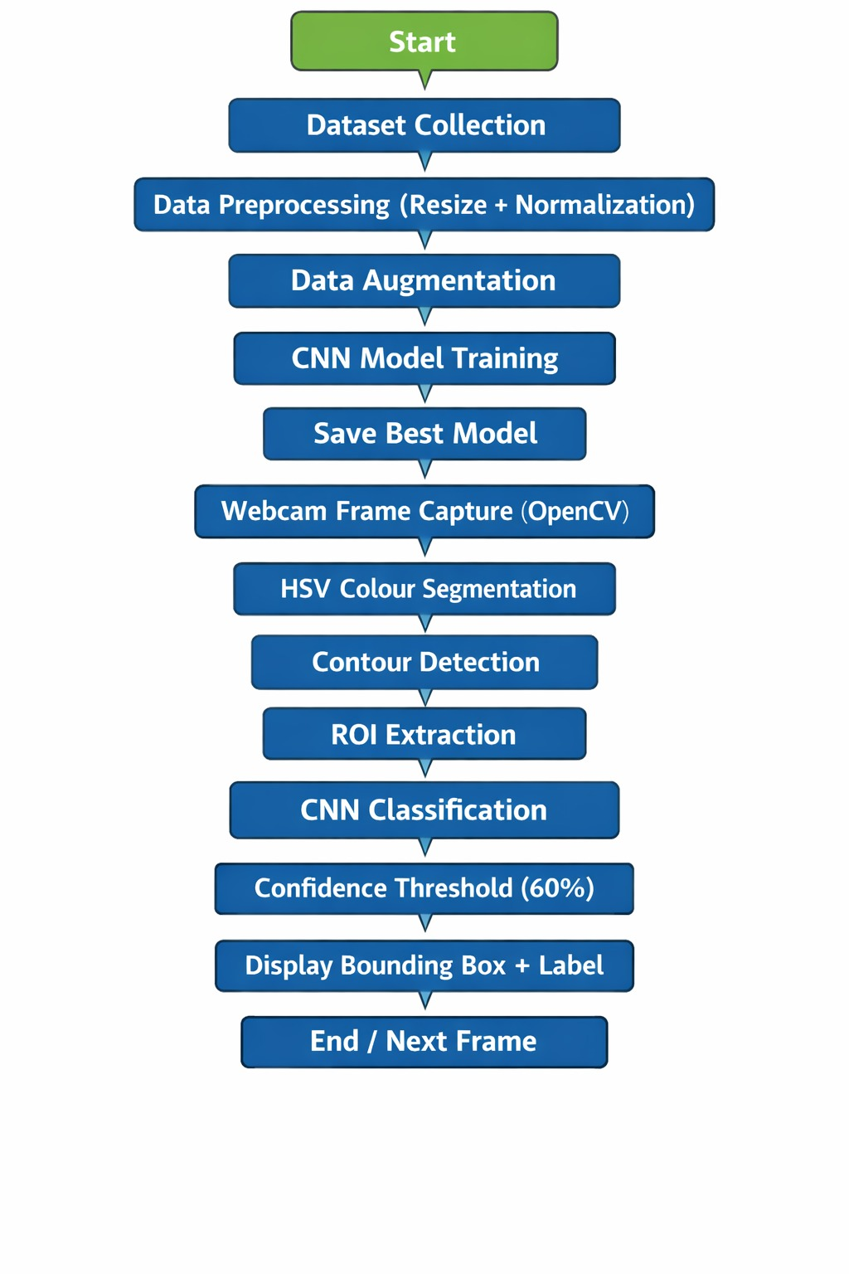

6. Results

6.1 Training Results
Metric | Value
Test Accuracy | 89.52%
Test Loss | 0.6164
Total Epochs Trained | 25 (10 initial + 15 resumed)
Optimiser | Adam (lr=0.001)
Best Model Selection | ModelCheckpoint on val_accuracy

6.2 Per-Class Performance (Sample — First 10 Classes)
Class | Precision | Recall | F1-Score | Support
0 — Speed Limit 20 | 0.40 | 0.40 | 0.40 | 5
1 — Speed Limit 30 | 0.83 | 1.00 | 0.91 | 5
2 — Speed Limit 40 | 0.00 | 0.00 | 0.00 | 2
3 — Speed Limit 50 | 0.50 | 0.50 | 0.50 | 2
4 — Speed Limit 60 | 0.71 | 1.00 | 0.83 | 5
5 — Speed Limit 70 | 0.53 | 0.73 | 0.62 | 11
6 — Speed Limit 80 | 0.67 | 1.00 | 0.80 | 10
7 — Speed Limit 100 | 1.00 | 0.75 | 0.86 | 4
8 — Speed Limit 120 | 0.80 | 0.33 | 0.47 | 12
9 — No Overtaking | 0.80 | 1.00 | 0.89 | 4

Classes with very low support (e.g., Class 2 with only 2 test samples) show 0.00 scores due to insufficient test data rather than model failure. The overall 89.52% accuracy across all 85 classes confirms the model is well-trained.

7. Conclusion

This project successfully demonstrates a real-time Indian traffic sign detection and classification system capable of identifying 85 sign categories with 89.52% test accuracy. The combination of HSV colour segmentation for region proposal and a lightweight custom CNN for classification provides a practical solution operable on standard CPU hardware without requiring a dedicated GPU.

The system correctly identifies major sign categories in real-time through a live webcam feed, drawing colour-coded bounding boxes with class labels and confidence percentages. Limitations include reduced FPS on CPU, occasional false positives from similarly coloured objects, and confusion between visually similar signs.

8. References

[1] Sarang Dilip Jodh. Indian Traffic Signs Prediction (85 Classes). Kaggle Dataset, 2023. Available: https://www.kaggle.com/datasets/sarangdilipjodh/indian-traffic-signs-prediction85-classes
[2] LeCun, Y., Bengio, Y., & Hinton, G. Deep Learning. Nature, 521(7553), 436–444, 2015.
[3] Bradski, G. The OpenCV Library. Dr. Dobb's Journal of Software Tools, 2000.
[4] Chollet, F. et al. Keras: Deep Learning for Humans. GitHub, 2015. Available: https://keras.io
[5] Abadi, M. et al. TensorFlow: A System for Large-Scale Machine Learning. OSDI, 2016.
[6] Stallkamp, J. et al. Man vs. Computer: Benchmarking Machine Learning Algorithms for Traffic Sign Recognition. Neural Networks, 32, 323–332, 2012.
[7] Ioffe, S. & Szegedy, C. Batch Normalization: Accelerating Deep Network Training by Reducing Internal Covariate Shift. ICML, 2015.
[8] Kingma, D. P. & Ba, J. Adam: A Method for Stochastic Optimization. ICLR, 2015.

