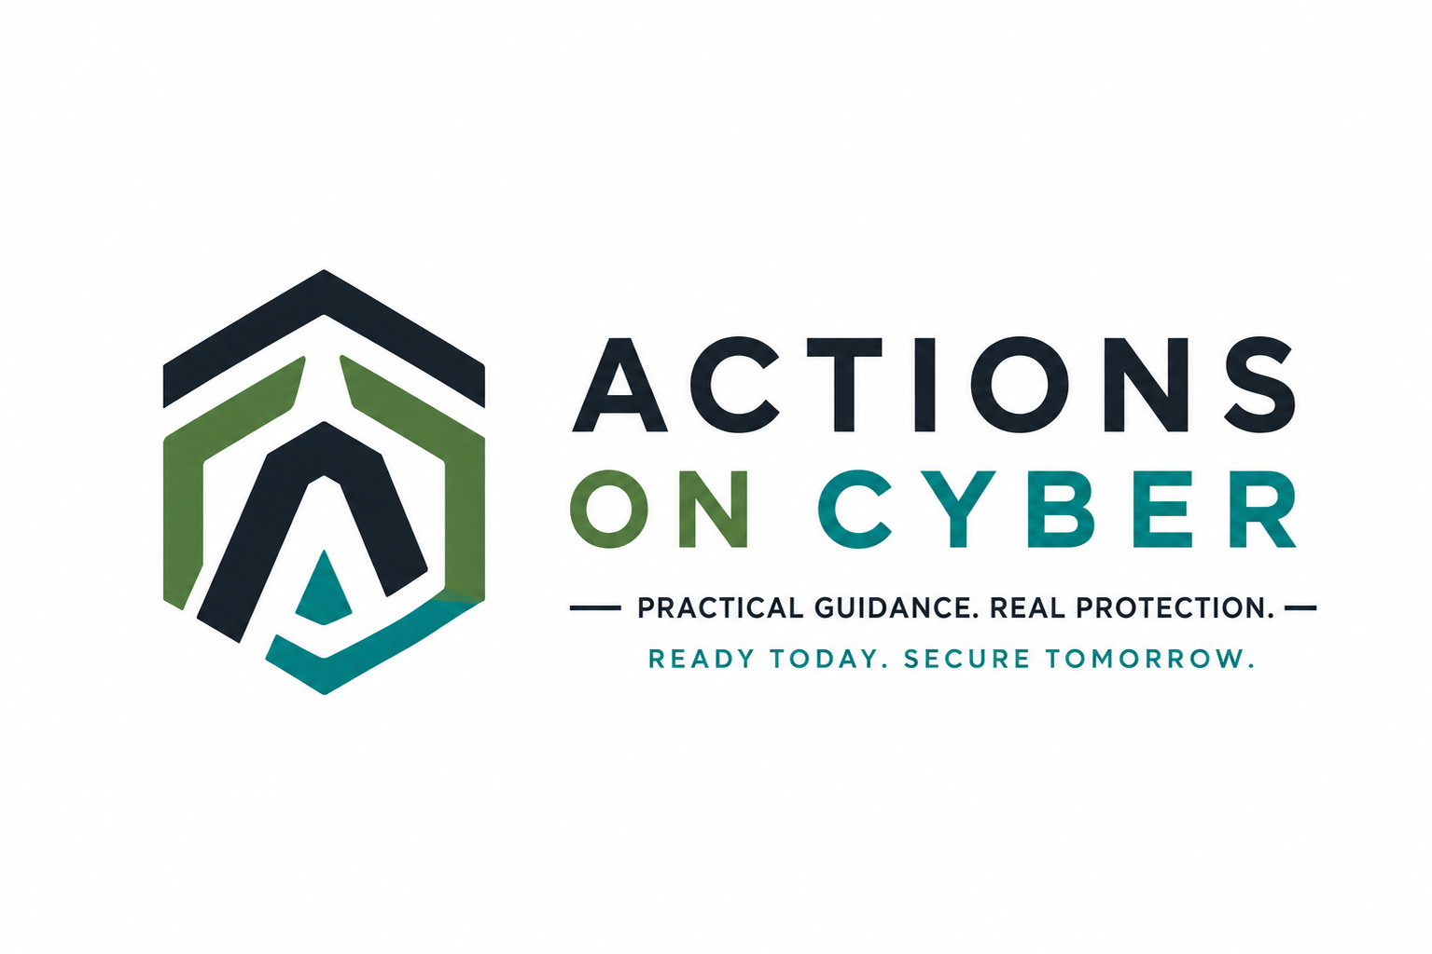
FREE SMALL BUSINESS
CYBER STARTER PACK
NCSC-inspired essentials for micro and small businesses
For cafes, shops, salons, trades, small charities and other organisations with tills, email, a few devices and maybe a website.

Prepared by | Actions On Cyber
Version | 1.0
Date | 01/05/26
Audience | Micro and small businesses
Format | Editable Word document
Branding | Logo and footer are editable. Remove by editing the cover, header and footer.

How to use this starter pack
This free starter pack is designed for small organisations that need straightforward cybersecurity documents but don't have a comprehensive governance library. It focuses on the essentials: knowing what you have, protecting accounts and devices, backing up data, spotting suspicious activity, and knowing what to do when something goes wrong.
Branding removal
The Actions on Cyber logo is inserted as a normal image on the cover and in the document header. To remove or replace it in Microsoft Word, double-click the header or select the cover logo and press Delete. The footer wording can also be edited or removed. No content is locked.

Starter item | What to do first | Why it matters
Cyber security governance lite | Name one person responsible for cyber and agree on basic rules. | Small businesses need clear ownership even when there is no IT team.
Acceptable Use Policy Lite | Tell staff how to use devices, email, tills and business systems safely. | Most cyber incidents start with everyday user behaviour.
Access, password and MFA policy lite | Use strong passwords/passphrases, and enable MFA for email, banking, and admin accounts. | Important online accounts are high-value targets.
IT asset register | List laptops, tills, phones, routers, payment devices, cloud tools and website/admin accounts. | You cannot protect or update what you do not know exists.
Backup checklist | Decide what needs backing up, how often, and how to test recovery. | Backups reduce the impact of ransomware, device loss and mistakes.
Phishing awareness checklist | Train staff to spot suspicious messages and report quickly. | Phishing and scams are common routes into small businesses.
Incident reporting form | Record what happened, when, who is affected and what has been done. | Good notes help contain incidents and support insurance, supplier and customer decisions.
10-point cyber checklist | Use the checklist monthly. | Small repeated actions are better than a policy that is never used.

Alignment note: This pack is inspired by the NCSC Small Organisations Guide themes: backing up data, protecting devices, securing email, securing important online accounts, and spotting cyberattacks. It also supports Cyber Essentials-style basics such as secure configuration, access control, malware protection, security updates and firewalls.

2. 10-Point Cyber Checklist

Document type | Checklist
Best for | Cafes, shops, salons, trades, small charities and micro businesses with tills, email, a few devices and maybe a website.
NCSC basics | Backups, devices, accounts, email and spotting attacks
Purpose | Gives a very small business a simple monthly cyber routine.
Review frequency | At least annually, after a cyber incident, or after a major technology/supplier change.

# | Check | Owner | Frequency | Evidence / notes
1 | List all business devices, tills, phones, routers and cloud tools. |  | Monthly
2 | Turn on MFA for email, banking, cloud tools, website admin and social media. |  | Monthly
3 | Remove accounts for staff who have left or no longer need access. |  | Monthly
4 | Check that devices and apps are receiving security updates. |  | Monthly
5 | Check that anti-malware or built-in security protection is enabled. |  | Monthly
6 | Confirm important files are backed up. |  | Weekly/monthly
7 | Test that one important file can be restored from the backup. |  | Quarterly
8 | Remind staff how to report suspicious emails, texts and calls. |  | Monthly
9 | Check website, booking, payment and social media admin access. |  | Monthly
10 | Record any cyber incidents, scams, suspicious messages or near misses. |  | Monthly

3. Cyber Security Governance Policy - Lite

Document type | Policy template
Best for | Cafes, shops, salons, trades, small charities and micro businesses with tills, email, a few devices and maybe a website.
NCSC basics | Governance and ownership
Purpose | Defines basic ownership, accountability and review for cyber security in a very small organisation.
Review frequency | At least annually, after a cyber incident, or after a major technology/supplier change.

3.1 Purpose
The purpose of this policy is to make sure the organisation has clear responsibility for basic cybersecurity, protects important business information, and knows what to do if a cyber incident or scam occurs.

3.2 Scope
This policy applies to all staff, contractors and volunteers who use business devices, tills, payment systems, email, cloud services, website administration tools, social media accounts or business information.

3.3 Policy owner
The business owner, manager, or nominated person is responsible for maintaining this pack, reviewing cyber risks, checking that actions are completed, and keeping evidence of key activities.

3.4 Minimum cyber rules
- Business accounts must use strong passwords or passphrases and MFA where available.
- Business devices must be kept updated and protected with anti-malware or built-in security features.
- Important business data must be backed up, and recovery must be tested.
- Staff must report suspicious emails, texts, calls, payment requests, device loss and unusual account activity quickly.
- Access must be removed when staff leave or no longer need it.
- Payment, banking, till, booking and website administration access must be restricted to authorised people.
- Cyber incidents and near misses must be recorded using the incident reporting form in this pack.

3.5 Review and sign-off

Policy owner: ____________________________________________________________
Approved by: ____________________________________________________________
Approval date: ____________________________________________________________
Next review date: ____________________________________________________________

4. Acceptable Use Policy – Lite

Document type | Policy template
Best for | Cafes, shops, salons, trades, small charities and micro businesses with tills, email, a few devices and maybe a website.
NCSC basics | Protect devices, email and business information
Purpose | Sets practical rules for the safe use of business systems by staff.
Review frequency | At least annually, after a cyber incident, or after a major technology/supplier change.

4.1 Staff rules
- Use business devices and accounts only for authorised business activity unless the owner/manager has agreed otherwise.
- Do not share passwords, passphrases, MFA codes or account recovery codes.
- Lock screens when devices are unattended and keep laptops, phones and tablets secure when away from the workplace.
- Do not install unauthorised software, browser extensions or apps on business devices.
- Do not connect unknown USB drives or removable media to business devices.
- Do not send sensitive business, customer, payment or staff information to personal email accounts.
- Check payment change requests, bank details and urgent supplier/customer requests using a trusted second method before acting.
- Report suspicious emails, texts, calls, missing devices or unusual account activity immediately.

4.2 Tills, payments and booking systems
- Only authorised staff may access tills, card payment systems, booking platforms, accounting systems or refunds.
- Default passwords on tills, routers, payment terminals and business systems must be changed.
- Payment and refund permissions should be limited to staff who need them.
- Any unusual transactions, refund requests or payment device issues must be reported to the owner/manager.

4.3 Website and social media
- Website, domain, hosting, online shop and social media admin accounts must use MFA where available.
- Admin access must be limited to authorised users and reviewed when staff change roles or leave.
- Do not reuse website, social media or email passwords on personal services.

5. Access, Password and MFA Policy – Lite

Document type | Policy template
Best for | Cafes, shops, salons, trades, small charities and micro businesses with tills, email, a few devices and maybe a website.
NCSC basics | Secure important online accounts
Purpose | Helps protect key business accounts such as email, banking, cloud tools, website admin and social media.
Review frequency | At least annually, after a cyber incident, or after a major technology/supplier change.

5.1 Account creation
- Each user should have their own account wherever possible. Shared accounts should be avoided for email, banking, admin, cloud and website systems.
- New access must be approved by the owner/manager or nominated person.
- Users should only be given the level of access they need to do their role.

5.2 Passwords and passphrases
- Use strong passwords or passphrases that are not reused across business and personal services.
- Use a password manager where practical.
- Never share passwords or MFA codes by email, text, chat or phone.
- Change passwords immediately if compromise is suspected.

5.3 Multi-factor authentication
- MFA must be enabled for email, banking, accounting, cloud storage, website administration, social media and any admin accounts where available.
- MFA recovery codes must be stored securely and only accessible to authorised people.
- Unexpected MFA prompts must be reported and not approved.

5.4 Leavers and access removal
- Access must be removed when staff, contractors or volunteers leave.
- Admin passwords, door codes, alarm codes and shared service passwords must be changed when needed.
- Website, social media, payment, booking and accounting access must be checked after any staff change.

User | System/account | Access approved by | Date added | Date removed | Notes

6. Simple IT Asset Register

Document type | Register template
Best for | Cafes, shops, salons, trades, small charities and micro businesses with tills, email, a few devices and maybe a website.
NCSC basics | Know what devices, systems and services you use
Purpose | Records the devices, systems, accounts and services that need protection.
Review frequency | At least annually, after a cyber incident, or after a major technology/supplier change.

How to use this register
List anything important to the business: tills, card machines, laptops, tablets, phones, routers, Wi-Fi, email, website, hosting, domain, online booking, accounting, payroll, social media, cloud storage and backup services.

Asset / service | Type | Owner | Location / supplier | Used for | Contains customer/staff/payment data? | MFA/updates/backups notes
Example: Microsoft 365 / Google Workspace | Email/cloud | Owner/manager | Cloud supplier | Business email and files | Yes | MFA on; admin access limited
Example: Card payment terminal | Payment/till | Owner/manager | Shop/cafe | Card payments | Payment data | Supplier maintained; default PIN changed
Example: Business laptop | Device | Owner/manager | Office/shop | Admin, accounts, ordering | Yes | Updates on; screen lock on; backed up
Example: Website/domain/admin login | Website | Owner/manager | Hosting provider | Online presence/booking | Maybe | MFA on admin account; access reviewed

7. Backup Checklist and Restore Test Record

Document type | Checklist/template
Best for | Cafes, shops, salons, trades, small charities and micro businesses with tills, email, a few devices and maybe a website.
NCSC basics | Back up important business data
Purpose | Helps decide what should be backed up and records evidence that recovery has been tested.
Review frequency | At least annually, after a cyber incident, or after a major technology/supplier change.

7.1 Backup checklist
Data/system | Where is it stored? | Backed up? Y/N | Backup frequency | Who checks it? | Last checked | Notes
Email and files
Accounting/bookkeeping data
Payroll/staff records
Customer bookings/orders
Website/online shop
Till/payment reports
Photos, menus, price lists, designs

7.2 Restore test record
Date | System/file tested | Who tested it? | Was restore successful? | Issues found | Action taken

- Keep at least one backup separate from the device or service being backed up.
- Test restoration of a small sample regularly rather than assuming backups work.
- Document failed tests and fix issues quickly.

8. Phishing and Scam Awareness Checklist

Document type | Checklist/procedure
Best for | Cafes, shops, salons, trades, small charities and micro businesses with tills, email, a few devices and maybe a website.
NCSC basics | Secure email and spot cyber attacks
Purpose | Helps staff identify and report suspicious emails, texts, calls and payment requests.
Review frequency | At least annually, after a cyber incident, or after a major technology/supplier change.

8.1 Red flags
- Unexpected requests for payment, refunds, bank detail changes or gift cards.
- Urgent messages that pressure staff to act quickly or keep something secret.
- Links to login pages, file-sharing pages or delivery/payment pages that look unusual.
- Attachments you were not expecting, especially invoices, delivery notices, CVs or zipped files.
- Messages from a known contact that use unusual wording, address, signature or tone.
- Requests for passwords, MFA codes, recovery codes or card details.
- Phone calls claiming to be from IT support, bank, card provider, supplier or a senior person asking for urgent action.

8.2 Staff response steps
- Stop and do not click links, open attachments or approve MFA prompts if something feels wrong.
- Report the message/call to the owner, manager or nominated person.
- Verify urgent payment or bank detail changes using a trusted phone number or known contact route.
- If a link was clicked or details were entered, report immediately and change affected passwords.

Date | Reported by | Message/call type | System/account affected | Action taken | Closed?

9. Cyber Incident Reporting Form

Document type | Form/template
Best for | Cafes, shops, salons, trades, small charities and micro businesses with tills, email, a few devices and maybe a website.
NCSC basics | Respond to suspicious activity and incidents
Purpose | Records facts, decisions and actions during a cyber incident or near miss.
Review frequency | At least annually, after a cyber incident, or after a major technology/supplier change.

When to use this form
Use this form for suspected phishing, payment fraud, ransomware, lost devices, website compromise, social media takeover, unusual account activity, data loss or any cyber event that worries the business.

Date/time discovered: ____________________________________________________________
Reported by: ____________________________________________________________
Contact details: ____________________________________________________________
What happened?: ____________________________________________________________
____________________________________________________________
____________________________________________________________
Systems/accounts/devices affected: ____________________________________________________________
____________________________________________________________
Customer/staff/payment data involved?: ____________________________________________________________
____________________________________________________________
Immediate action taken: ____________________________________________________________
____________________________________________________________
____________________________________________________________
Who has been told?: ____________________________________________________________
____________________________________________________________
External parties contacted: bank, supplier, insurer, IT support, regulator, police: ____________________________________________________________
____________________________________________________________
Next actions and owner: ____________________________________________________________
____________________________________________________________
____________________________________________________________
Closure notes: ____________________________________________________________
____________________________________________________________

9.1 Incident log
Time/date | Action/decision | Owner | Evidence/location | Status

10. Next steps
Once the starter pack is in place, the organisation should decide whether it needs a more complete policy set. This is usually needed when there are more staff, more devices, customer data, suppliers, cloud systems, payment platforms, multiple sites or client security requirements.

Trigger | Consider adding
You have several staff or frequent starters/leavers | Full Access Control Policy, Joiner/Mover/Leaver Procedure, User Access Review Template
You hold client, guest, patient or sensitive customer data | Data Classification Policy, Data Handling Policy, Secure File Sharing Policy, Breach Notification Checklist
You rely on suppliers, booking systems, cloud services or outsourced IT | Supplier Security Questionnaire, Supplier Security Policy, SaaS and Cloud Services Register
You need Cyber Essentials readiness | Secure Configuration Standard, Patch Management Policy, Malware Protection Standard, Vulnerability Management Policy
You have a hotel, factory, multi-site business or larger office | Incident Response Plan, Disaster Recovery Plan, Business Continuity Plan, Risk Register, Logging and Monitoring Policy

11. Source notes and disclaimer
This document is an independently produced practical starter pack by Actions On Cyber. It is not official NCSC, Cyber Essentials or NIST material, and it is not legal advice.
- NCSC Small Organisations Guide themes used for this starter pack: backing up data, protecting devices, securing email, securing important online accounts and spotting cyber attacks.
- Cyber Essentials-style baseline themes used for this pack: secure configuration, user access control, malware protection, security update management and firewalls.
- NIST CSF 2.0 function language used in the wider Actions On Cyber library: Govern, Identify, Protect, Detect, Respond and Recover.
- Organisations should tailor these templates to their size, sector, data, technology stack, supplier environment, customer obligations and risk appetite.
- This pack does not guarantee compliance, certification, insurance cover or incident prevention.

Appendix A - Tailoring checklist before use

Before publishing or using these templates, replace placeholders and adjust wording so it reflects how the organisation works.

Tailoring action | Done?
Replace [Organisation Name] and add business owner/manager details.
Delete examples that do not apply, such as website, online booking or social media if not used.
Add the real devices, tills, phones, cloud tools, website accounts and suppliers to the asset register.
Check MFA is turned on for the accounts listed in the policy.
Record where backups are stored and when restore testing will happen.
Tell staff how to report suspicious emails, calls, texts and payment requests.
Agree on who makes decisions during a cyber incident.
Review the pack after any cyber incident or major business/technology change.

