**VISVESVARAYA TECHNOLOGICAL UNIVERSITY, BELGAUM 590014**



Python projectReport on

**“Cricket Scorecard”**

by

S GAUTHAM (1BM16CS083)

SAMRUDH H N (1BM16CS086)

HRSHITH URS ( 1BM17CS407)

Under the Guidance of

**VIKRANTH B M**

Assistant Professor, Department of CSE

BMS College of Engineering

Project carried out at



Department of Computer Science and Engineering

BMS College of Engineering

(Autonomous college under VTU)

P.O. Box No.: 1908, Bull Temple Road, Bangalore-560 019

2017-2018

**BMS College of EngineerinG**

**DEPARTMENT OF COMPUTER SCIENCE AND ENGINEERING**



***CERTIFICATE***

This is to certify that the website development titled “Cricket Scorecard” has been carried out by S GAUTHAM (1BM16CS083), SAMRUDH H N (1BM16CS086) and HARSHITH URS(1BM17CS407) during the academic year 2018-2019.

**Signature of the guide** **Signature of Examiners**

**VIKRANTH B M**

Assistant Professor

Department of Computer Science and Engineering

BMS College of Engineering, Bangalore

**BMS College of EngineerinG**

**DEPARTMENT OF COMPUTER SCIENCE AND ENGINEERING**



***DECLARATION***

We, S GAUTHAM (1BM16CS083), SAMRUDH H N (1BM16CS086) and HARSHITH URS(1BM16CS407) ,students of 5th Semester, B.E, Department of Computer Science and Engineering, BMS College of Engineering, Bangalore, hereby declare that, this website development work entitled "Cricket Scorecard” has been carried out by us under the guidance of Vikranth B M, Assistant Professor, Department of CSE, BMS College of Engineering, Bangalore during the academic semester Aug-Dec 2018

We also declare that to the best of our knowledge and belief, the development reported here is not from part of any other report by any other students.

Signature

S GAUTHAM (1BM16CS083)

SAMRUDH H N (1BM16CS086)

HARSHITH URS(1BM16CS407)

**Introduction**

**A cricket scorecard stores the entire data of a cricket match being played.**

**A scorecard is essential for a match to continue.**

**Here , instead of the conventional scorebook , a computerized version is implemented.**

**Functionality**

1. **The scorer can record the core of individual batsman.**
2. **Score of an entire team is recorded.**
3. **If 10 overs up, the data is recorded and stored in database.**
4. **If all wickets are up, the same is done.**
5. **This entire process starts for the second team as well**

**Screenshot**

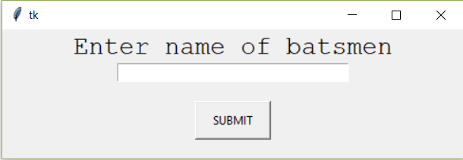

Team players entry

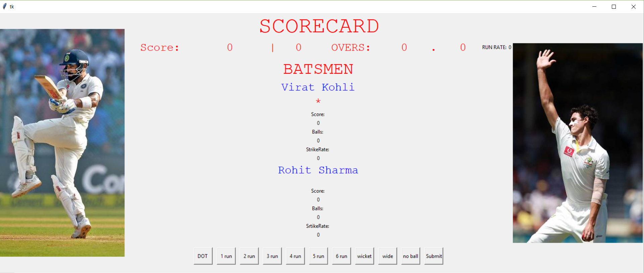

The main scorecard

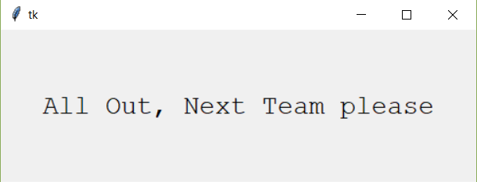

Message when all wickets down

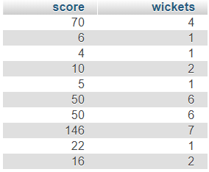

Database snippet

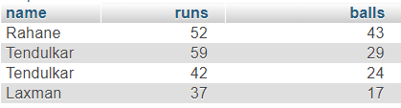

Batsman scores in database

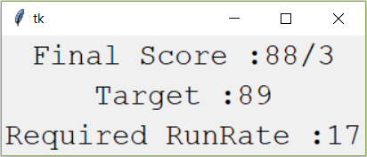

Target window

**How it Works**

It’s a dynamic program as in it is used when a match is currently being played.

Buttons are used to denote runs, wickets, extras etc.

Names of the 11 players in a team are first taken and stored in the database.

Same is done for the other team as well

Whenever a button is pressed, the scorecard is updated respectively and the scores , wickets , run rate of a team is displayed on the application and concurrently these details are stored in the database.

Whenever a team finishes playing, the runs to win and the required run rate is calculated and displayed for the other team