Project Confluence
API Ingestion Pipeline
Forty-two calls across three public APIs, driven from a call registry
Samuel Adebayo
Azure Data Factory · Azure Data Lake Storage Gen2 · Azure SQL Database

1. What this pipeline does
A second Azure Data Factory pipeline fetches reference data from three free public APIs and lands the raw responses in the bronze layer alongside the file extracts.

API | Purpose | Calls
Frankfurter | Daily European Central Bank exchange rates, used to convert Brazilian real and South African rand into US dollars at the rate that applied on the day of each order | 2
Nager.Date | Public holidays for Brazil and South Africa, which affect delivery times and explain gaps in the exchange rate series | 4
Open-Meteo | Historical daily weather for twenty-seven Brazilian states and nine South African provinces | 36

All three are free, require no API key, and were verified independently before any pipeline was built.
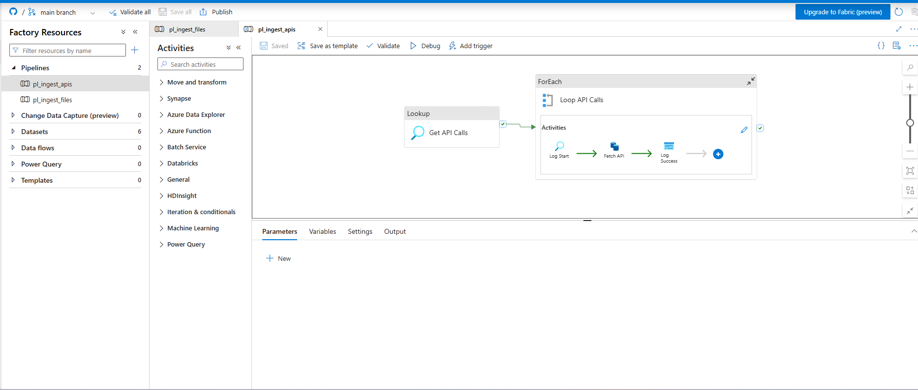
Figure 1 — The pipeline: one lookup, one loop, three activities inside it

2. A design decision forced by a platform limit
The obvious shape is three sources, each with its own set of calls: loop the sources, then loop each source’s calls inside that.
Azure Data Factory does not permit a ForEach inside a ForEach.
The documented workaround is to move the inner loop into a child pipeline and invoke it with an Execute Pipeline activity. That works, and it costs a second pipeline to build, publish and maintain.

The alternative taken here
Rather than storing three sources and deriving their calls at runtime, each individual HTTP call is stored as its own row. Forty-two rows, each fully specified. The pipeline then needs one lookup and one loop, with no nesting at all.
ctl.ApiCall
api_call_id identity
source_id → ctl.IngestionSource
call_key BRL, BR-2017, BR-SP …
base_url the API host
relative_url path and full query string
landing_folder destination in the lake
landing_file destination filename
The second benefit is where the URLs get built. Constructing them from parameters inside ADF expressions would look more elegant, but an ADF expression cannot be read easily, cannot be unit tested, and only reveals its mistakes at runtime.
A relative_url column can be inspected in a query window and pasted straight into a browser to confirm it returns data. That was done before the pipeline was built.
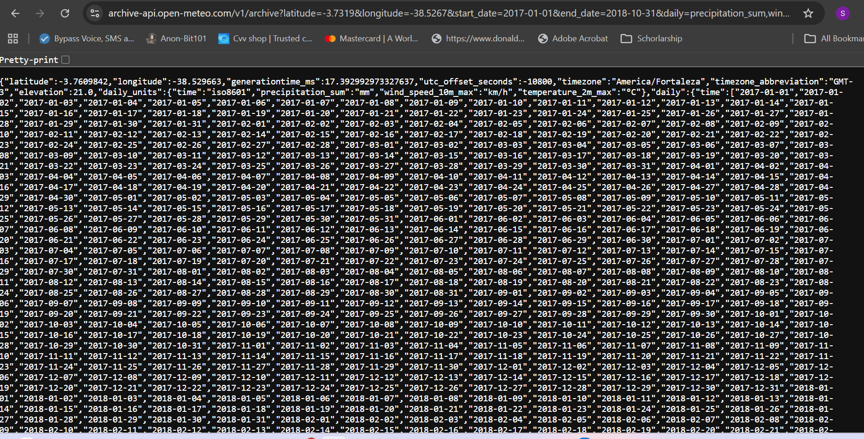
Figure 2 — A stored URL pasted into a browser, returning live data with the expected timezone and date range

3. Parameterised connections
Three APIs on three different hosts, served by one linked service and two datasets. The host arrives as a parameter rather than being fixed in the connection.
Values chain down through three objects, each referring only to itself:
pipeline supplies → dataset.baseUrl (@item().base_url)
dataset passes on → linkedService.baseUrl (@dataset().baseUrl)
linked service uses → its Base URL field (@{linkedService().baseUrl})

Object | Type | Parameters
ls_http_generic | HTTP linked service, anonymous | baseUrl
ds_http_binary | Binary dataset, source | baseUrl, relativeUrl
ds_adls_binary | Binary dataset, sink | container, folderPath, fileName
ds_sql_control | Azure SQL dataset | none — the pipeline supplies queries

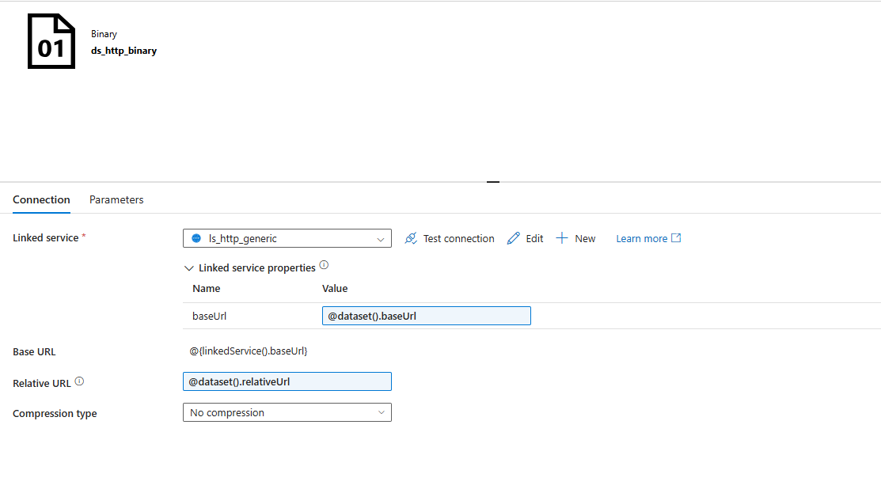
Figure 3 — The source dataset, with compression explicitly disabled
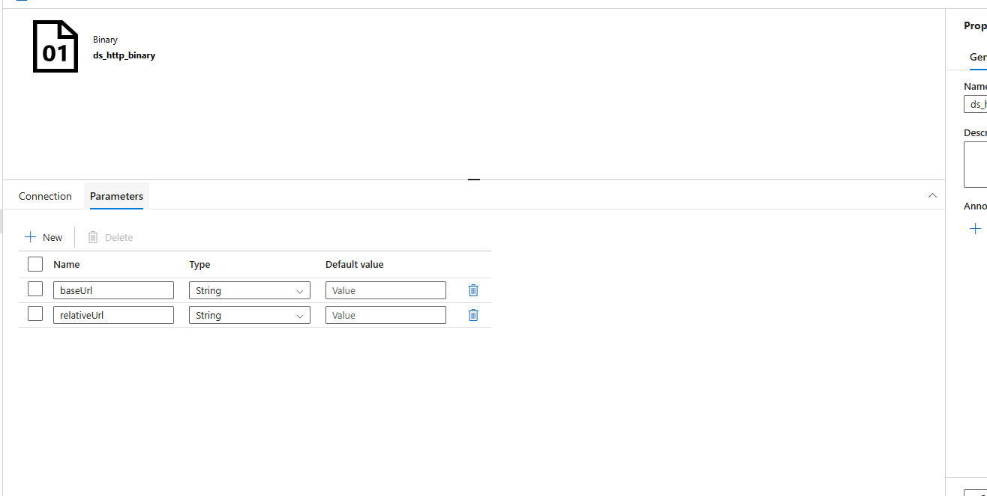
Figure 4 — Its two parameters, declared with empty defaults

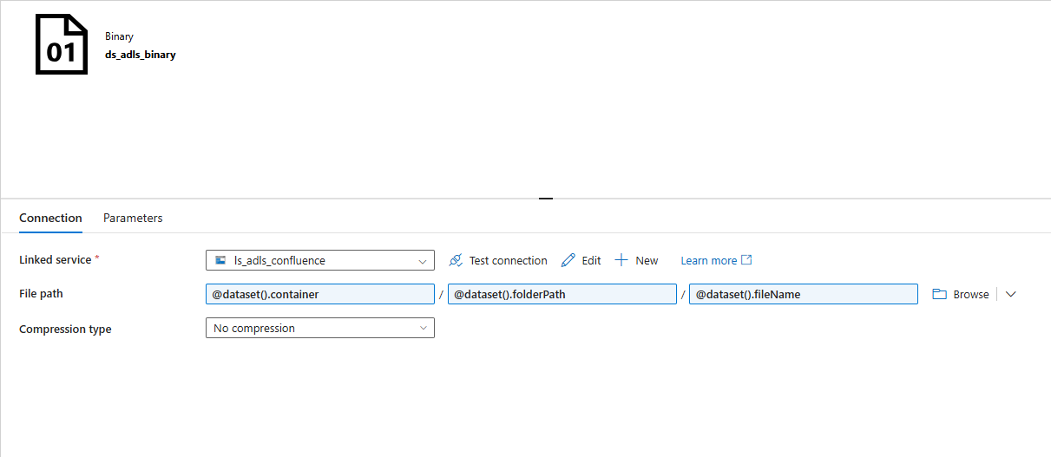
Figure 5 — The sink dataset, with all three path segments parameterised
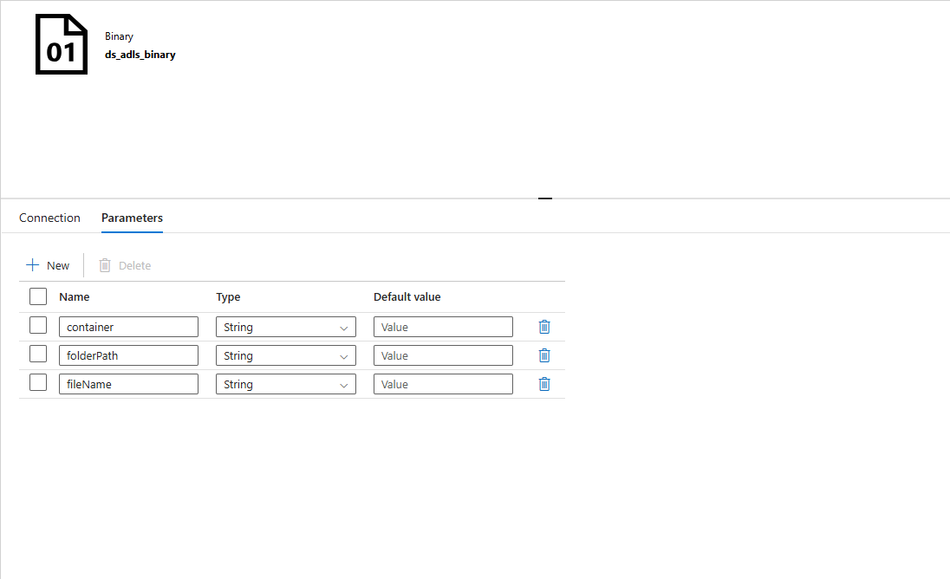
Figure 6 — Its parameters
A note on defaults: these must be left empty. Setting a parameter’s default to its own reference, for instance giving baseUrl a default of @dataset().baseUrl, is circular. The parameter is asked for its value and answers “ask me for my value”. ADF does not reject it; it passes the reference text through as a literal string, which surfaces later as a storage error about a resource name being too long.

4. Activity walkthrough

4.1 Get API Calls
A Lookup joining the call registry to the source manifest, returning forty-two rows.
SELECT c.api_call_id, c.source_id, s.source_name, c.call_key,
c.base_url, c.relative_url,
s.landing_container, c.landing_folder, c.landing_file
FROM ctl.ApiCall c
JOIN ctl.IngestionSource s ON s.source_id = c.source_id
WHERE c.is_active = 1 AND s.is_active = 1
ORDER BY c.source_id, c.api_call_id;
The Lookup activity caps at five thousand rows or four megabytes. Forty-two rows sit comfortably inside that, but the ceiling is worth knowing: a Lookup is for reading configuration, not for moving data.
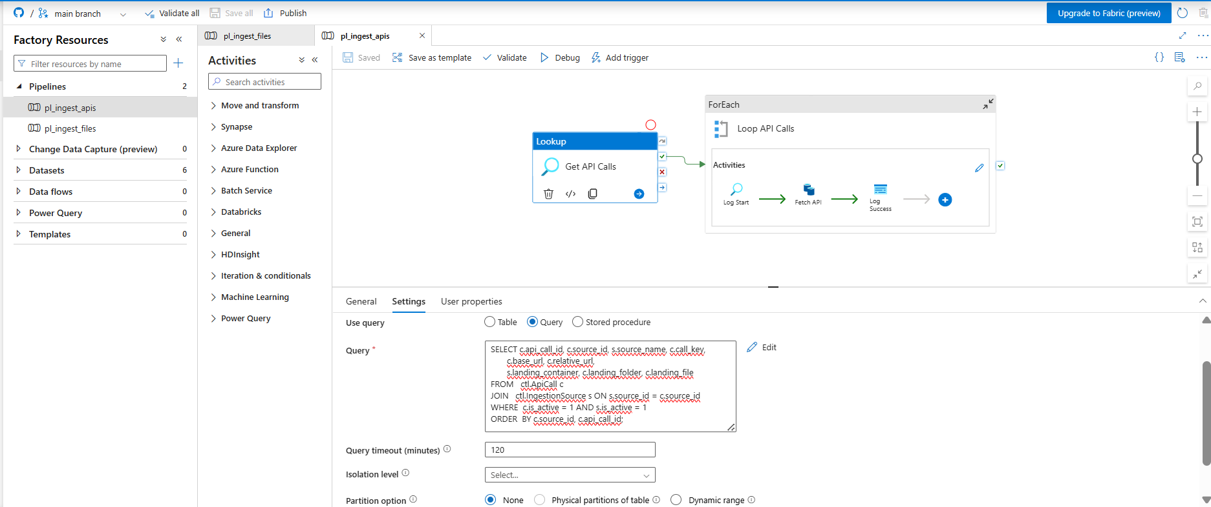
Figure 7 — The Lookup reading the call registry

4.2 Loop API Calls
A ForEach over the Lookup output, set to sequential.
Sequential matters more here than on the file pipeline. Thirty-six weather calls fired simultaneously at a free public service is the kind of behaviour that earns a rate limit. Open-Meteo asks for reasonable use, and the independent verification script had already established that one call at a time works reliably.

4.3 Log Start
Calls ctl.usp_StartRun to open an audit record. Built as a Lookup rather than a Stored procedure activity, because the Stored procedure activity discards whatever the procedure returns and the run identifier is needed downstream.

Parameter | Value
source_name | @item().source_name
adf_pipeline_name | @pipeline().Pipeline
adf_run_id | @pipeline().RunId
ceiling | null

Note that the audit record is written against the source, not the individual call. Thirty-six weather calls therefore produce thirty-six rows sharing one source identifier, which is the correct grain: each call either succeeded or did not.
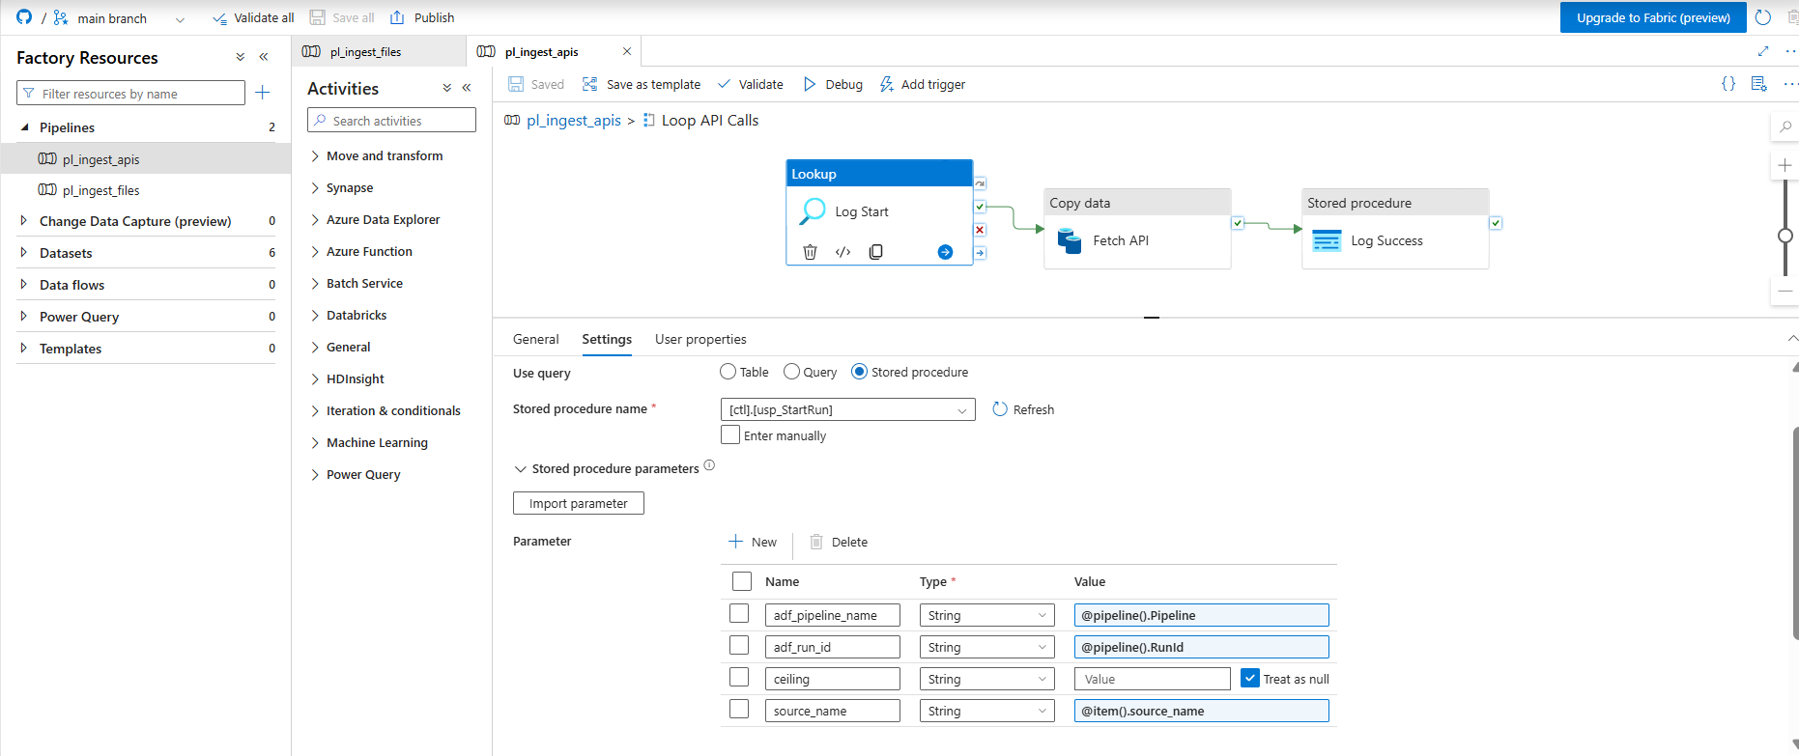
Figure 8 — Opening the audit record for each call

4.4 Fetch API
A Copy activity taking an HTTP source and an ADLS sink, both binary.

Side | Setting | Value
Source | Dataset | ds_http_binary
Source | baseUrl | @item().base_url
Source | relativeUrl | @item().relative_url
Source | Request method | GET
Source | Additional headers | Accept-Encoding: identity
Sink | Dataset | ds_adls_binary
Sink | container | @item().landing_container
Sink | folderPath | @item().landing_folder
Sink | fileName | @item().landing_file

No column mapping is configured, and that is deliberate. A binary copy streams bytes from the HTTP response straight into a blob without parsing anything. The three APIs return three genuinely different shapes — a date-keyed object, a flat array of records, and a set of parallel arrays that line up by position — and any attempt to flatten them at this stage would destroy structure the silver layer needs.
Bronze means as it arrived. Binary copy is the only copy type that actually guarantees that.
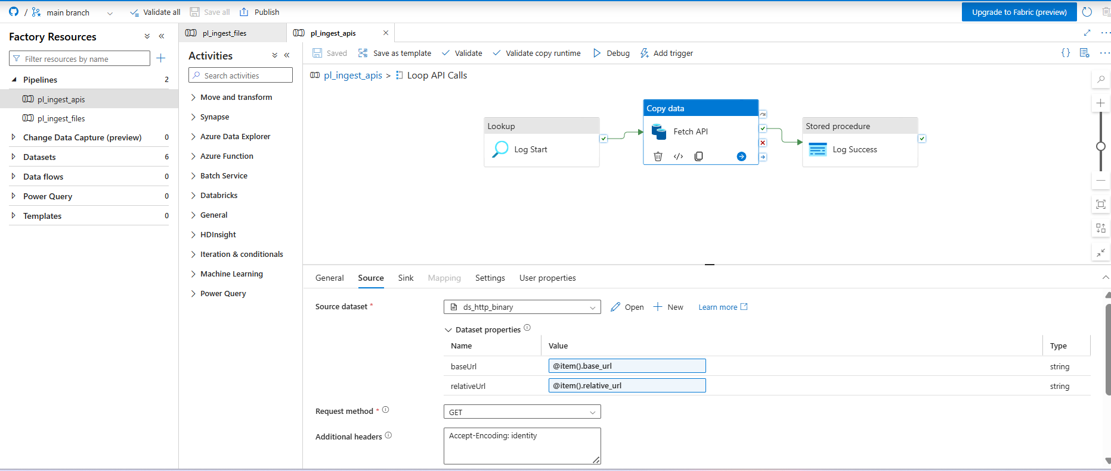
Figure 9 — The HTTP source, with the host and path supplied per call

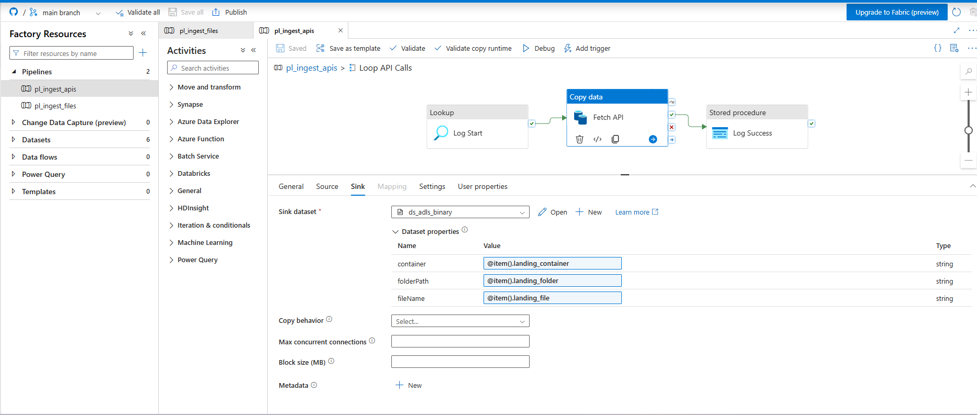
Figure 10 — The lake sink, with all three path segments supplied per call

4.5 Log Success
Closes the audit record with a status of SUCCEEDED. Every numeric field is treated as null: a binary copy reports bytes and files, not rows, and there is exactly one file per call so a count would carry no information.
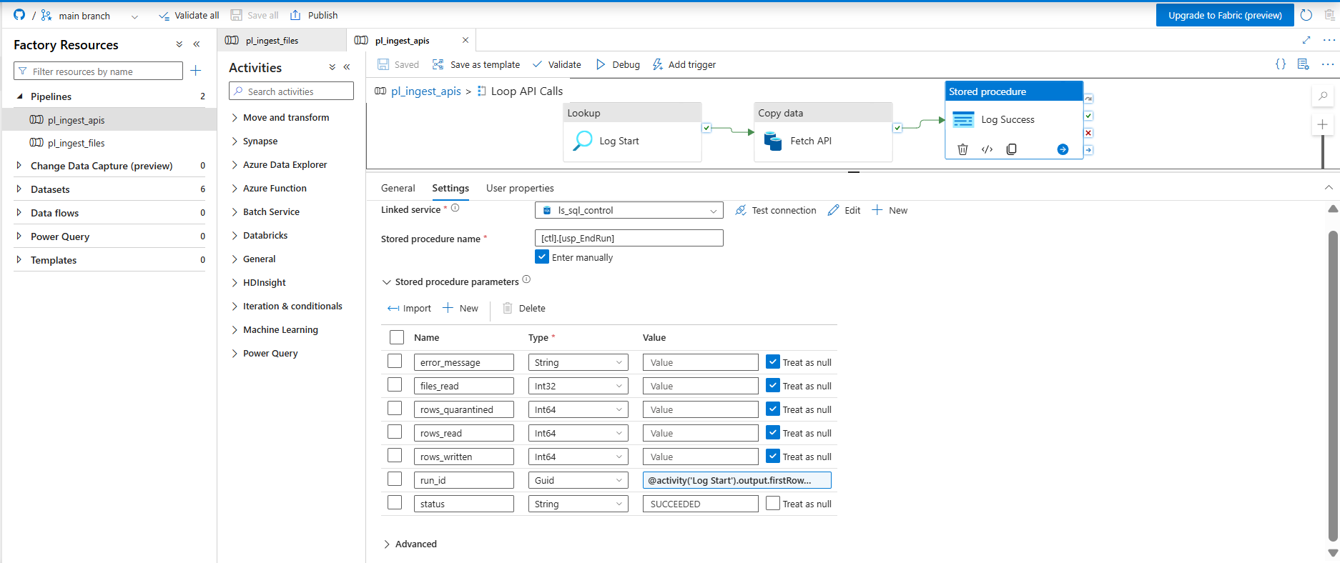
Figure 11 — Closing the audit record

Why there is no quality gate here
The file pipeline checks the number of files copied against an expected minimum. That check makes no sense on this pipeline, where every call produces exactly one file by definition.
The meaningful check is whether the response has usable content, and that requires parsing the JSON — which belongs in bronze, where something reads the payload. Putting a gate here would be ceremony rather than control.

5. The compression problem
This pipeline was first built with ADF’s REST source, which is the connector the documentation points to for JSON APIs. The exchange rate and holiday calls worked. All thirty-six weather calls failed with the same error.
Failure happened on 'Source' side.
ErrorCode=RestResourceReadFailed …
Type=System.IO.InvalidDataException,
Message=Found invalid data while decoding.
That exception comes from .NET’s decompression stream. It is what gets thrown when something attempts to decompress data that is not in the encoding it expected.
The REST source parses the response as JSON, which means it must first decode the transfer encoding. Open-Meteo’s content delivery network was compressing responses in an encoding the connector could not handle. An Accept-Encoding header requesting no compression made no difference, because the CDN compressed regardless, and the REST source offers no setting to disable decompression.

The fix, and why it is the better design anyway
Switching to the HTTP connector with binary datasets removed the problem entirely. A binary copy never parses the payload, so it never decodes anything. The Binary dataset also exposes an explicit compression setting, which the REST source does not.
The outcome is one of those cases where the workaround is more correct than the original. Bronze is supposed to hold exactly what the source returned. The REST source re-serialises what it parses; binary copy does not touch the bytes at all.
It also unified the pipeline. One connector and two datasets now serve all three APIs, where the REST approach would have needed special handling for one of them.

6. Verification before the build
Before any ADF object existed, a standalone Python script called all three APIs directly and recorded what came back. Every finding below shaped a decision.

Finding | Consequence
One call returns the entire history per currency; no pagination | The loop iterates regions and country-years, never dates
Two hundred of six hundred and sixty-nine days have no published exchange rate, with runs of up to four consecutive days | The silver layer needs a date spine with forward fill, not a plain join. Without it, every weekend order silently loses its dollar value
Two of fifty-two holidays are regional rather than national | The join key is country plus date plus county. Joining on country and date alone would duplicate fact rows on those two dates
City-level weather covers only twenty-eight per cent of orders across four thousand distinct cities | Weather is pulled at region grain instead: twenty-seven states and nine provinces, giving complete coverage
Brazil resolved to thirteen distinct timezones | Brazil observed daylight saving in this period and only some states participated, so timestamps are stored as local wall-clock and never converted
Forty-two calls in total | At roughly one dollar per thousand activity runs, API ingestion costs effectively nothing

Every problem found this way was free to find. The same problem discovered inside a Copy activity costs debug runs, and debug runs are billed whether they succeed or fail.

7. Result
Forty-two responses landed in the bronze reference area: two exchange rate series, four holiday calendars and thirty-six regional weather histories, each roughly nineteen kilobytes of untouched JSON.
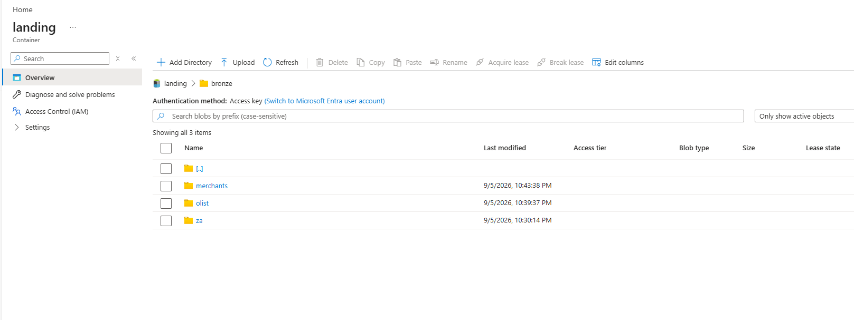
Figure 12 — The bronze layer after a complete run

Folder | Files | Contents
bronze/reference/fx | 2 | Daily rate series for both currencies across the full period
bronze/reference/holidays | 4 | Public holidays, two countries, two years
bronze/reference/weather | 36 | Daily precipitation, wind and temperature per region

8. Known limitations
- There is no retry policy on the Copy activity. A transient network failure would be logged as a failure rather than retried. Adding retry with a backoff interval would be the first production hardening step.
- The date range is hardcoded into each stored URL. Extending the period means regenerating the registry rather than changing one parameter. Acceptable for a fixed historical window, wrong for an ongoing feed.
- There is no content check. A response that returns two hundred with an empty body would be recorded as a success. Validation happens in bronze, which is the right layer for it but does mean this pipeline cannot detect it.
- Weather is measured at region grain, so a single reading represents an area the size of a small country in the larger Brazilian states. This is a documented trade-off taken in exchange for complete coverage.

