Project Confluence
File Ingestion Pipeline
Metadata-driven ingestion of fifteen file sources into an Azure Data Lake
Samuel Adebayo
Azure Data Factory · Azure Data Lake Storage Gen2 · Azure SQL Database

1. What this pipeline does
One Azure Data Factory pipeline ingests fifteen separate file sources from a source container into a bronze landing zone. Every run is logged, every source is checked against an expected file count, and two distinct kinds of failure are captured with their reasons.
The sources are not uniform. Nine are single Brazilian marketplace extracts. Two are folders of monthly merchant snapshots. Four are monthly extracts from an acquired South African platform, one of which is semicolon-delimited rather than comma-delimited, and all of which use day-first dates.
Handled naively, that is fifteen pipelines. Fifteen places to change when the error handling needs adjusting, and fifteen chances for them to drift apart.
This is one pipeline.

The design principle
Everything that differs between sources lives in a database table rather than on the pipeline canvas. Folder path, file pattern, delimiter, destination, load type and expected file count all arrive as data at runtime.
So the semicolon delimiter on the South African vendor files needs no special handling here. It is a column value in the control table, passed into a parameterised dataset when that source comes round in the loop.
The practical consequence: adding a sixteenth source is an INSERT statement. The pipeline is not touched, not republished, and not retested.
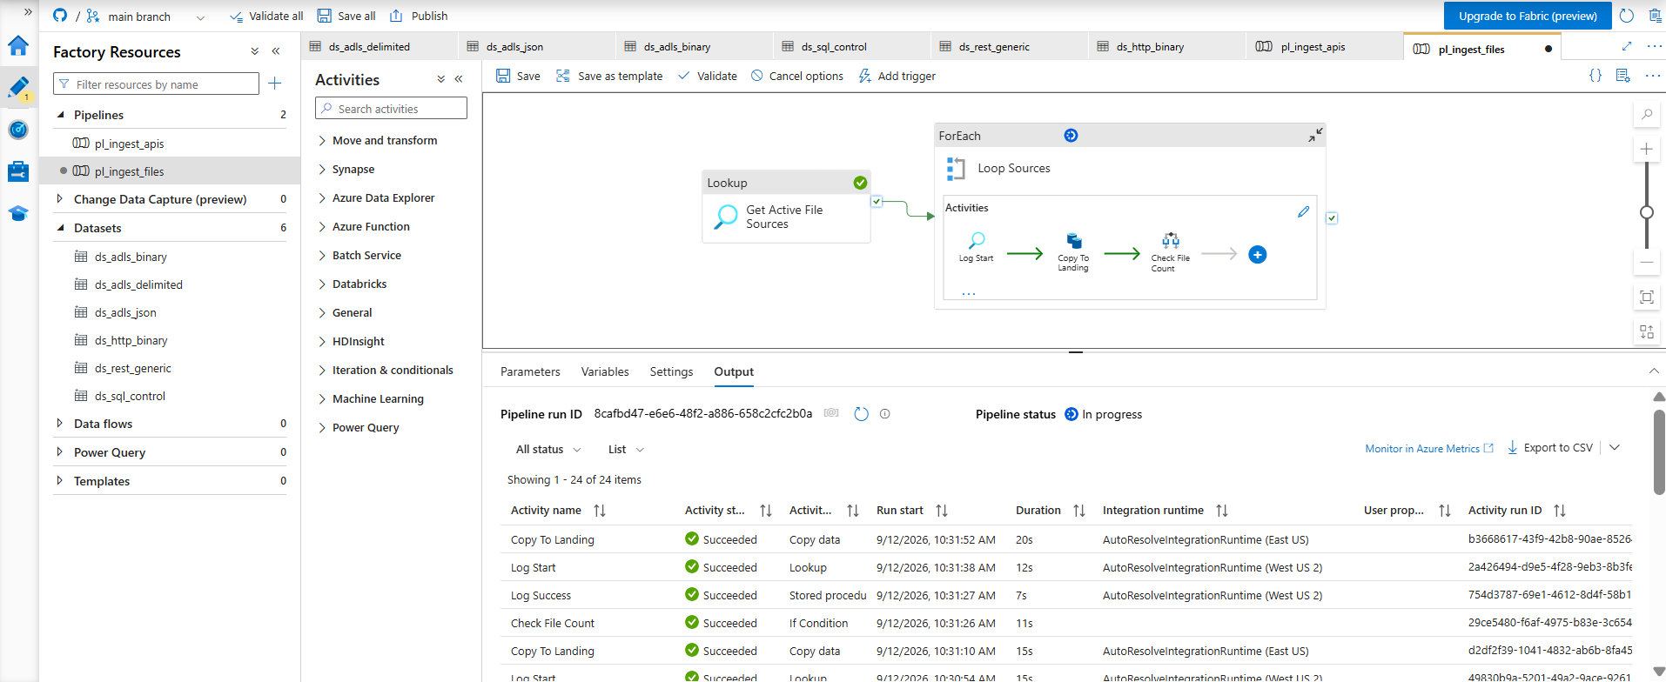
Figure 1 — Two pipelines and six datasets serve all fifty-seven sources across the project

2. The control plane
Four tables in Azure SQL Database hold everything the pipeline needs to know.

Table | Purpose
ctl.IngestionSource | The manifest. One row per source, holding its folder, file pattern, delimiter, landing path, load type and expected file count.
ctl.Watermark | Incremental state. Where each source got to on its last successful run.
ctl.PipelineRun | The audit log. Every run, its window, its outcome, its file count and its error message if it failed.
ctl.Quarantine | Rows rejected by a quality rule, with the rule that caught them.

Two stored procedures do the bookkeeping. Their design carries the single most important idea in the pipeline, covered in section 5.

Procedure | Role
ctl.usp_StartRun | Opens a run. Returns the run identifier and the load window: a floor taken from the watermark, and a ceiling frozen before any data moves.
ctl.usp_EndRun | Closes a run. Advances the watermark to that frozen ceiling, and only when the run succeeded.

3. Pipeline structure
A lookup reads the manifest. A loop walks it. Inside the loop, each source is opened, copied, checked and closed.
Get Active File Sources (Lookup)
└─ Loop Sources (ForEach, sequential)
├─ Log Start (Lookup → ctl.usp_StartRun)
└─ Copy To Landing (Copy data)
├─ on success → Check File Count (If Condition)
│ ├─ True → Log Success
│ └─ False → Log Gate Failure → Fail
└─ on failure → Log Copy Failure
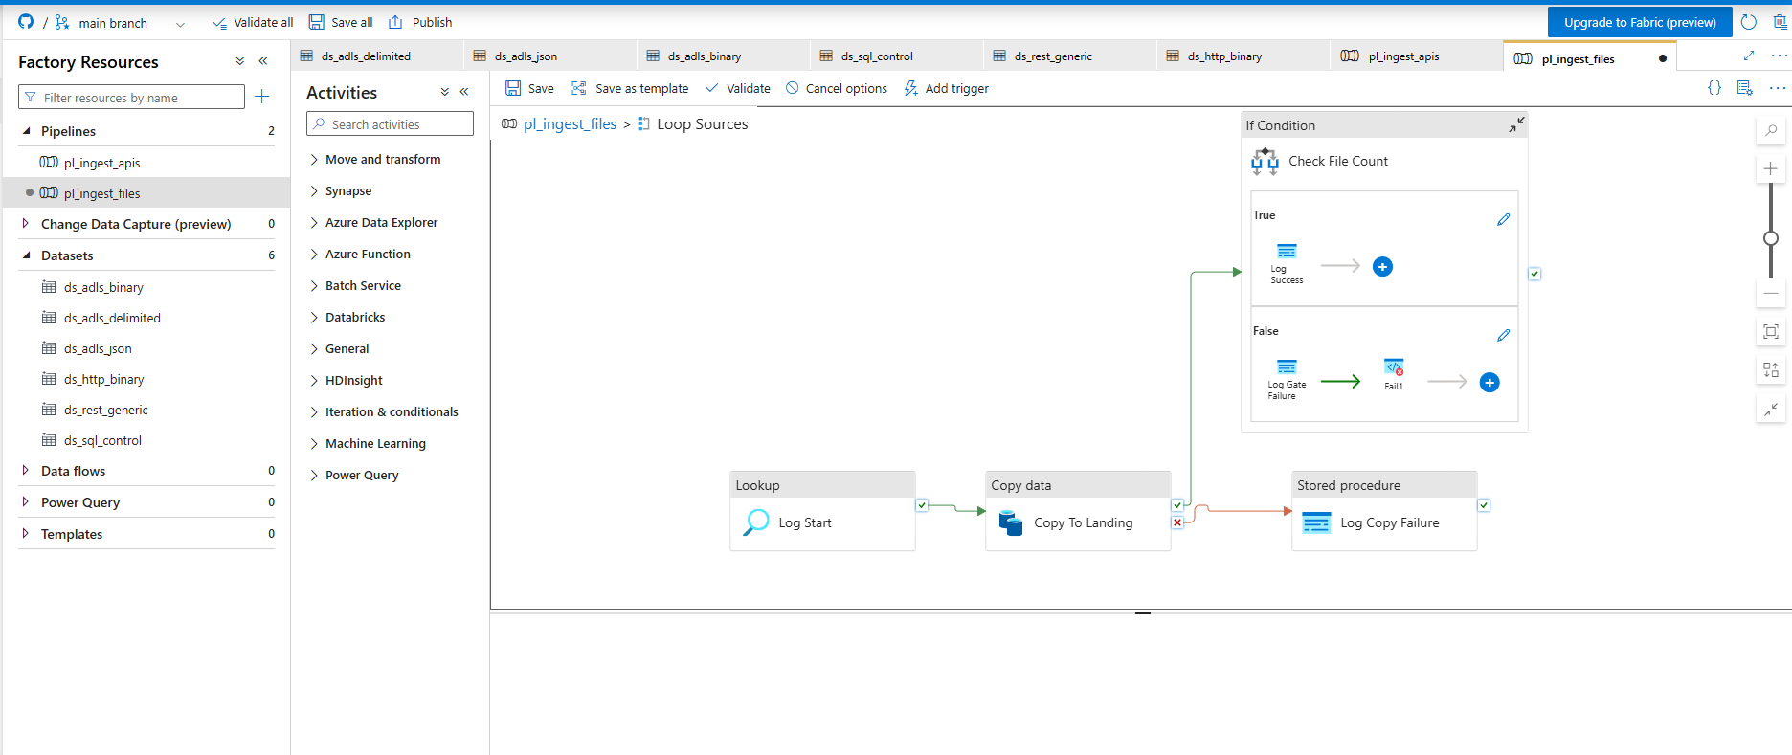
Figure 2 — The loop, with the success path branching into the quality gate and the failure path handled separately

4. Activity walkthrough

4.1 Get Active File Sources
A Lookup activity reading the manifest. It returns fifteen rows, one per active file source.
SELECT source_id, source_name, load_type, source_folder, file_pattern,
column_delimiter, landing_container, landing_folder, expected_min_files
FROM ctl.IngestionSource
WHERE is_active = 1 AND source_type = 'file'
ORDER BY load_order, source_id;
First row only must be left unticked. Ticked, the Lookup returns a single row, the loop runs once, and nothing reports an error to explain why fourteen sources were skipped.
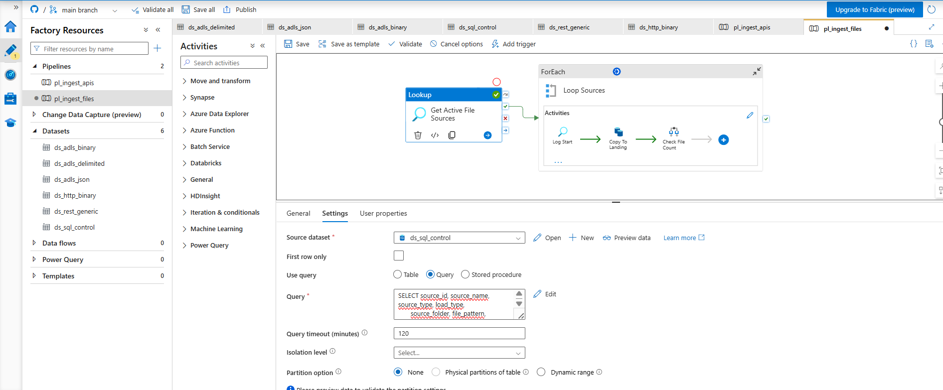
Figure 3 — The Lookup reads the manifest; First row only is deliberately unticked

4.2 Loop Sources
A ForEach activity iterating the Lookup output.
@activity('Get Active File Sources').output.value
Sequential execution is switched on deliberately. Run in parallel, ADF interleaves up to twenty iterations and the audit log becomes a jumble that cannot be attributed to a source. At fifteen small sources the time saved is not worth losing a readable trail.
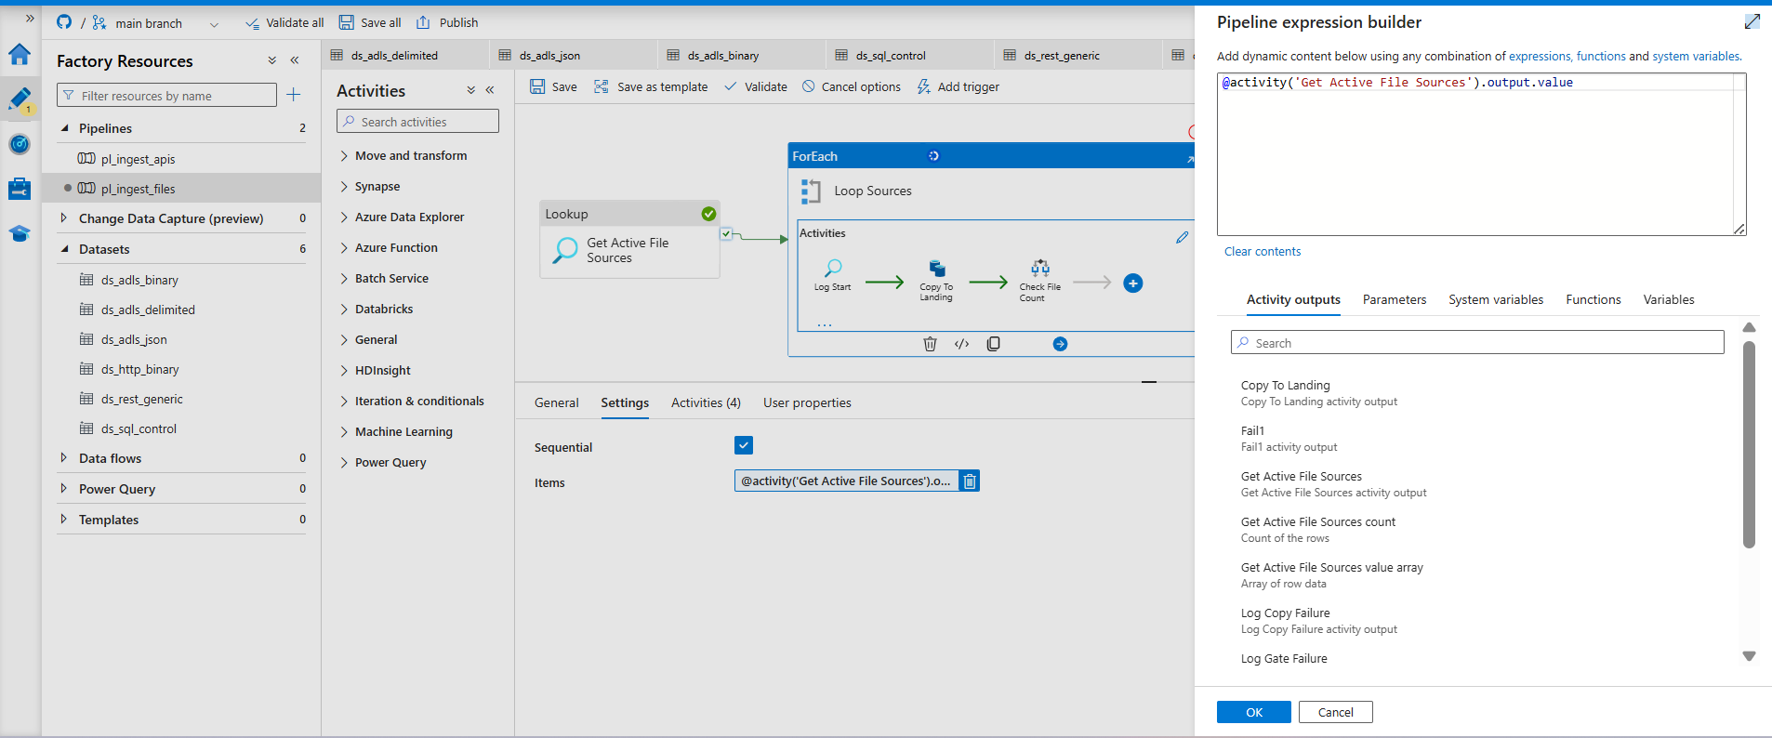
Figure 4 — The loop iterates the array returned by the Lookup, one source at a time

4.3 Log Start
This calls a stored procedure, but it is built as a Lookup activity rather than a Stored procedure activity. The reason is a real constraint worth knowing.
The Stored procedure activity has no output. It executes the procedure and discards whatever result set comes back. The Lookup activity executes it identically and keeps the result.
Since usp_StartRun returns the run identifier that every later activity needs, it has to be a Lookup. The rule that falls out of this: use a Lookup when you need something back, and a Stored procedure activity when you do not. Whether the procedure writes to a table is irrelevant.

Parameter | Value
source_name | @item().source_name
adf_pipeline_name | @pipeline().Pipeline
adf_run_id | @pipeline().RunId
ceiling | null

It returns the run identifier, the load type, the watermark floor and the frozen ceiling.

4.4 Copy To Landing
The only activity that moves data. Both its source and its sink use the same parameterised dataset, which is what allows one dataset to serve fifteen sources.

Setting | Value
File path type | Wildcard file path
Wildcard folder path | @item().source_folder
Wildcard file name | @item().file_pattern
Delimiter | @item().column_delimiter
Filter by last modified (start) | @activity('Log Start').output.firstRow.window_start
Sink folder | @item().landing_folder
Copy behavior | Preserve hierarchy

Two details matter here.
- Wildcard paths override the dataset folder and file properties. The dataset properties still need values, because ADF rejects an empty parameter, but the wildcard boxes are what take effect at runtime.
- The sink filename is left empty and Copy behavior is set to Preserve hierarchy. Together these keep each source file under its own name. Setting a sink filename instead merges every matched file into one blob, which would collapse ninety-four weekly refund drops into a single file and destroy their lineage.
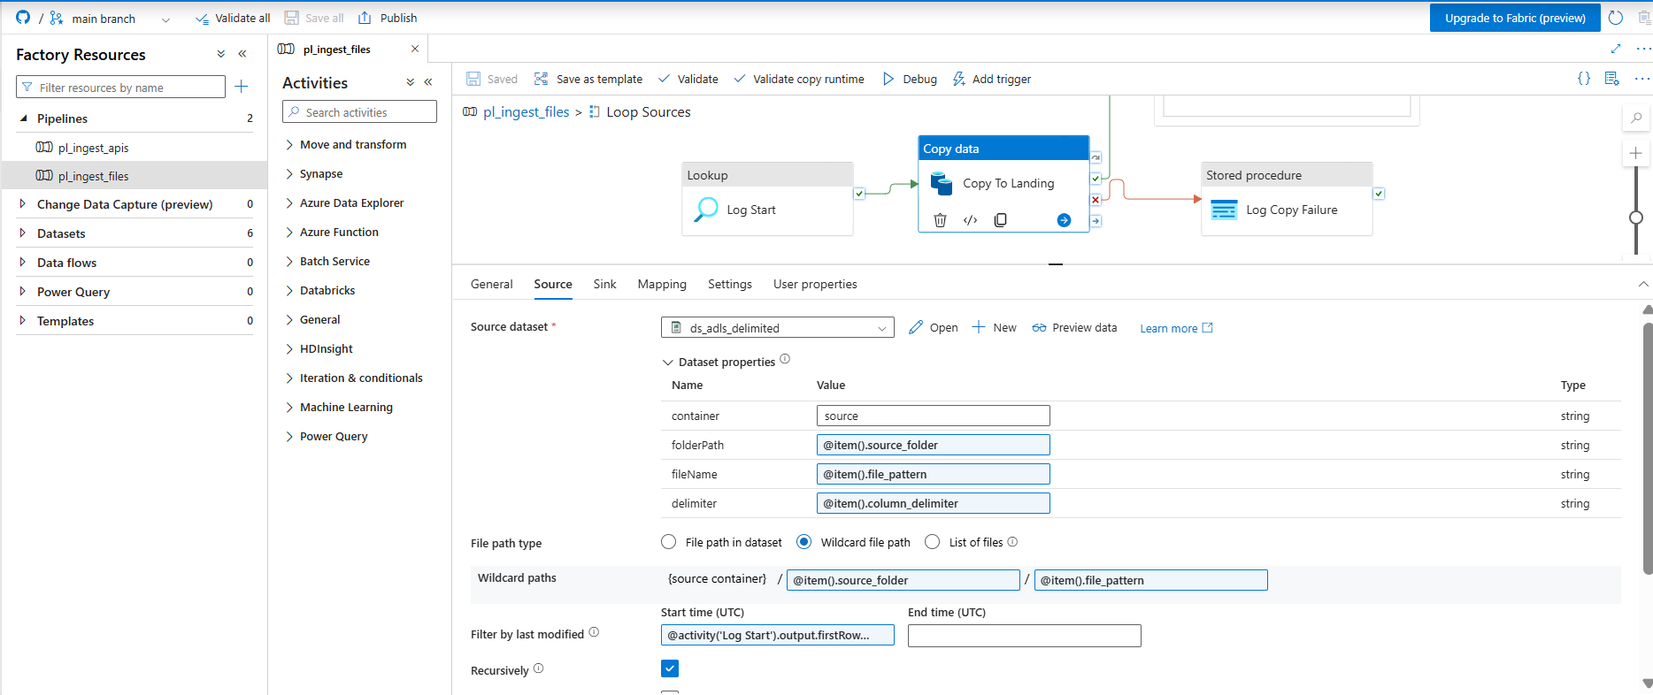
Figure 5 — Wildcard paths and the last-modified filter, all supplied from the manifest row

4.5 Check File Count
This exists because of a behaviour that catches people out: a Copy activity whose wildcard matches no files succeeds. Zero files is a valid result, so a broken path and an empty folder are indistinguishable by status alone.
During this build a misconfigured wildcard produced fifteen green runs and an empty landing container. Nothing failed, and nothing would have, until someone opened the lake.
The gate turns that silent success into a failure by comparing the file count against the expectation held in the manifest.
@or(
equals(item().load_type, 'INCREMENTAL'),
greaterOrEquals(activity('Copy To Landing').output.filesRead, item().expected_min_files)
)
The incremental clause is not a loophole. For an incremental source, zero new files is the correct answer on every run after the first.
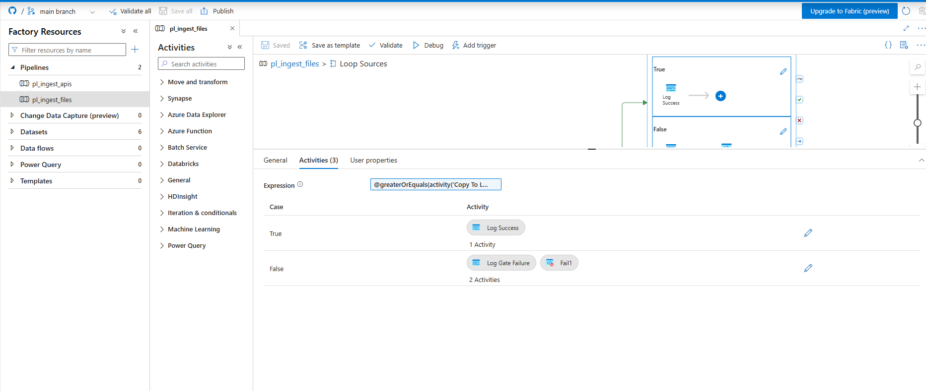
Figure 6 — The gate, with success on the True branch and logged failure on the False branch

4.6 Log Success
Closes the run with a status of SUCCEEDED and records the file count.

Parameter | Value
run_id | @activity('Log Start').output.firstRow.run_id
status | SUCCEEDED
files_read | @activity('Copy To Landing').output.filesRead
rows_read, rows_written | null

The row counts are null by design, not by oversight. Source and sink share the same format with no column mapping, so ADF performs a byte-level passthrough and never parses the files. It genuinely does not know how many rows it moved, and referencing the property throws rather than returning null. Row counts are established in the bronze layer, where something actually reads the records.
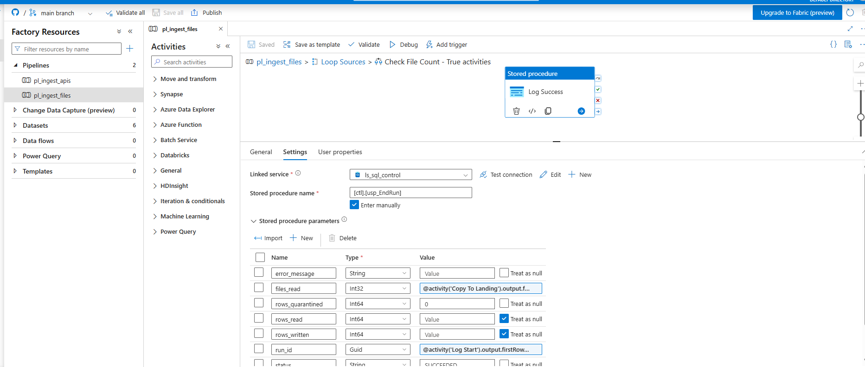
Figure 7 — Success logging; row counts are explicitly treated as null

4.7 Log Gate Failure and Fail
When the gate rejects a source, two things happen. The run is closed as FAILED with an explanatory message, then a Fail activity turns the pipeline red.
@concat('Quality gate failed: expected at least ',
string(item().expected_min_files), ' files, got ',
string(activity('Copy To Landing').output.filesRead))
The Fail activity is what makes the gate meaningful. Without it, the problem is recorded in a table nobody is watching and the pipeline still reports success.
Note that this message does not read the copy activity’s error array. On this branch the copy succeeded, so that array is empty and indexing it throws. An earlier version made exactly that mistake: the gate correctly caught a bad source, then the failure handler itself crashed and wrote nothing. The gate worked and the audit table stayed silent.
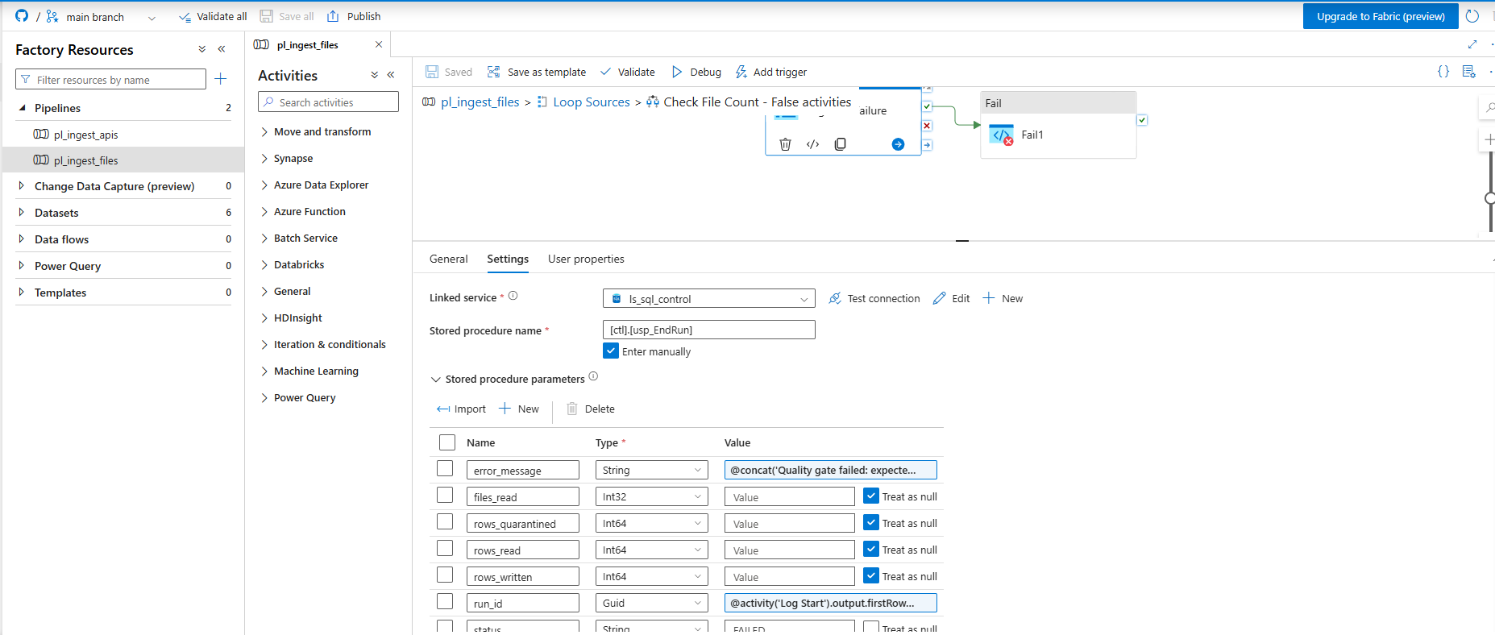
Figure 8 — Gate failure logging, with a message describing the count rather than an error
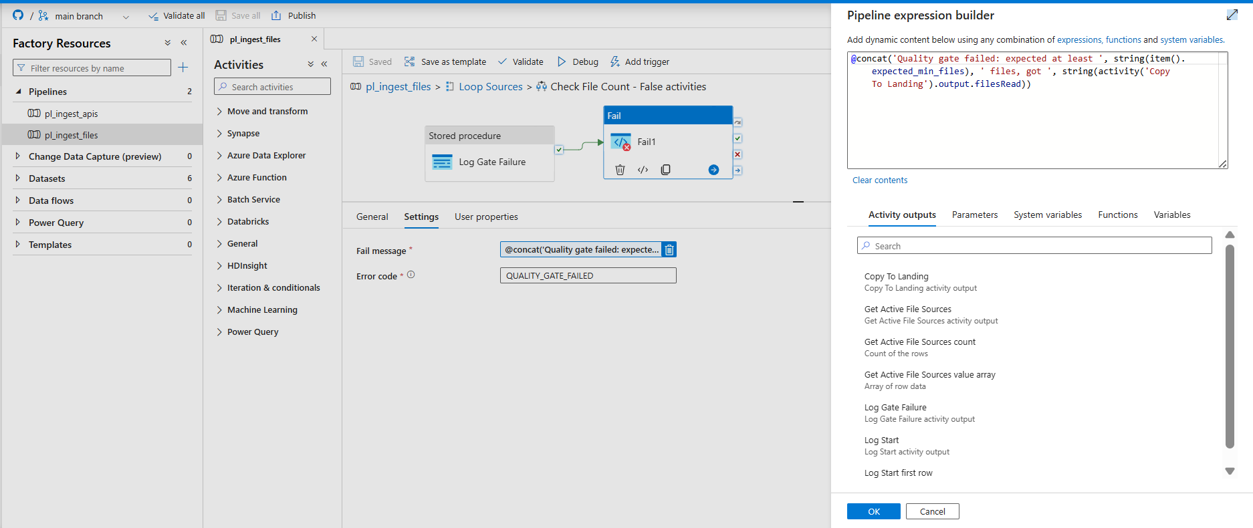
Figure 9 — The Fail activity carries the same message and a specific error code

4.8 Log Copy Failure
A second failure handler, attached to the copy activity’s failure output rather than sitting inside the gate.
Two failure modes need two handlers. A copy that fails outright never reaches the gate, because the gate sits on the success path. Without this activity such a source would sit at RUNNING in the audit table indefinitely, reading as a run that never finished rather than one that failed.
@activity('Copy To Landing').output.errors[0].Message
Because the failure path is handled, one failing source does not halt the remaining iterations. Fourteen sources still load, and the audit table names the one that did not.
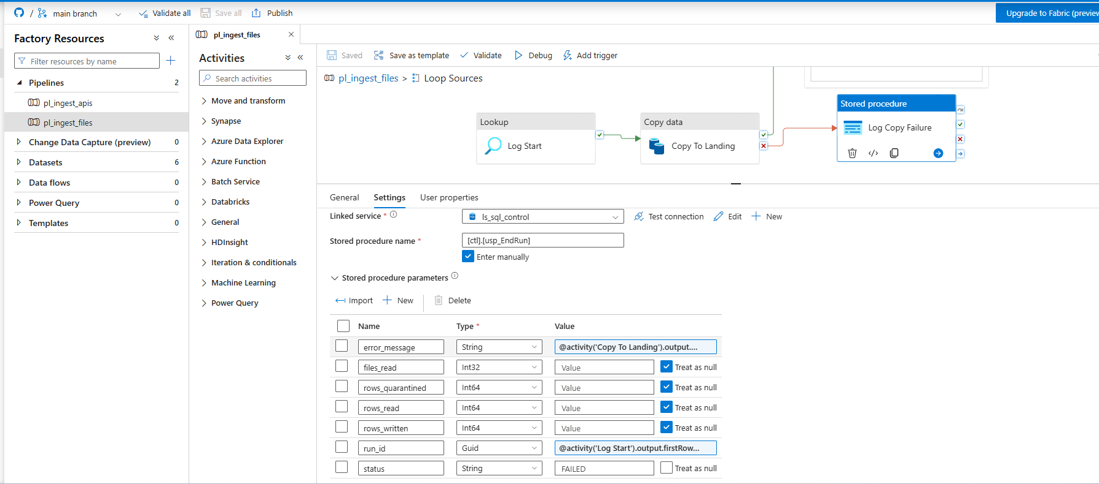
Figure 10 — Copy failure logging, capturing the underlying error text

5. Load types and the watermark

Load type | Sources | Behaviour
FULL | Nine Olist extracts | Every file copied on every run. The watermark floor is null, so the last-modified filter is unbounded.
SNAPSHOT | Two merchant masters | All monthly snapshots copied. Slowly changing dimension logic in the silver layer derives history from them.
INCREMENTAL | Four South African extracts | Only files modified since the last successful run.

Why the ceiling is frozen before the copy
This is the detail most worth understanding, because getting it wrong produces a bug that never announces itself.
The intuitive approach is to copy everything since the last run, then set the watermark to the current time. It fails like this.
A run starts at five o’clock and takes four minutes. It reads the files that exist at five. Meanwhile new files keep arriving. At four minutes past, the run finishes and sets the watermark to four minutes past.
The files that arrived at two minutes past were never copied — the run had already taken its snapshot. And they never will be, because the watermark has moved beyond them. They are skipped by this run, excluded from the next, and lost permanently. Nothing errors.
The fix is to decide the upper bound before reading anything. usp_StartRun returns a ceiling at the moment the run opens; the copy is bounded by it; usp_EndRun advances the watermark to that same frozen value rather than to the clock. Files arriving mid-run fall outside the window and wait for the next one.
One more property: usp_EndRun advances the watermark only when the status is SUCCEEDED. A failed load therefore retries the same window rather than skipping it.

6. Test evidence
A pipeline that has only ever been run successfully is untested. Each failure path was deliberately triggered.

Test | Method | Result
Full load | All sources, clean run | Fifteen of fifteen succeeded
Quality gate | Expected count raised to 999 on one source | Failed with a readable message
Copy failure | Source folder pointed at a nonexistent path | Failed, ADLS error captured in full
Incremental exclusion | Watermark floor set past all upload timestamps | Four sources read zero files, run stayed green
Incremental inclusion | One new file added to a source folder | Exactly one file picked up, others read zero
Watermark advance | Consecutive runs | Floors advanced unassisted from each frozen ceiling

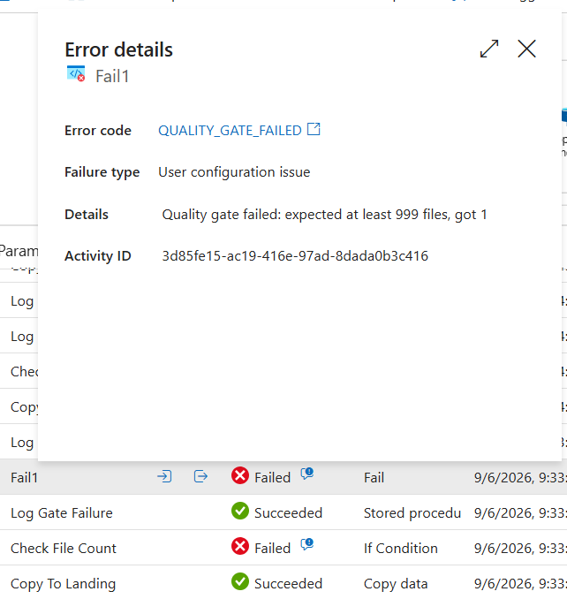
Figure 11 — The quality gate rejecting a source and naming both numbers
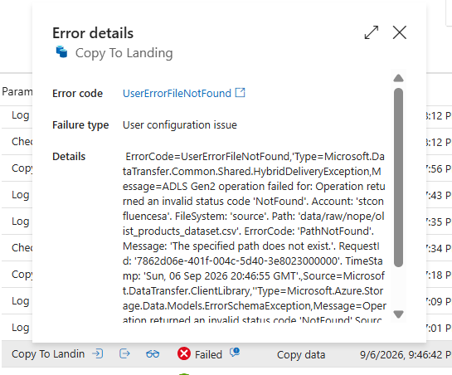
Figure 12 — A copy failure captured with the exact path that could not be found

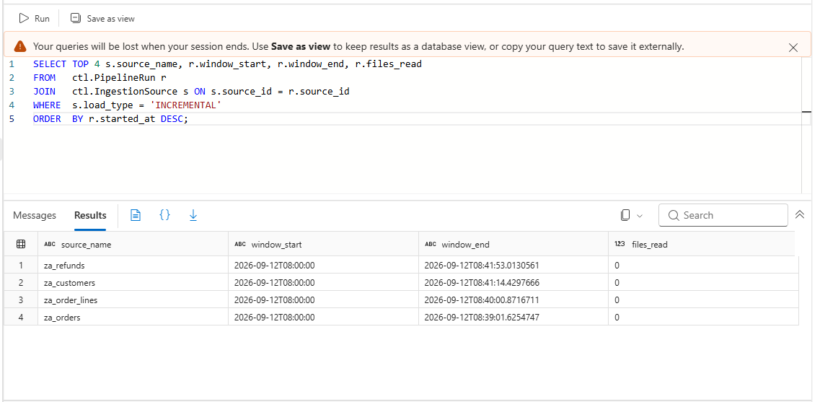
Figure 13 — With the floor set past every upload, all four incremental sources correctly read nothing
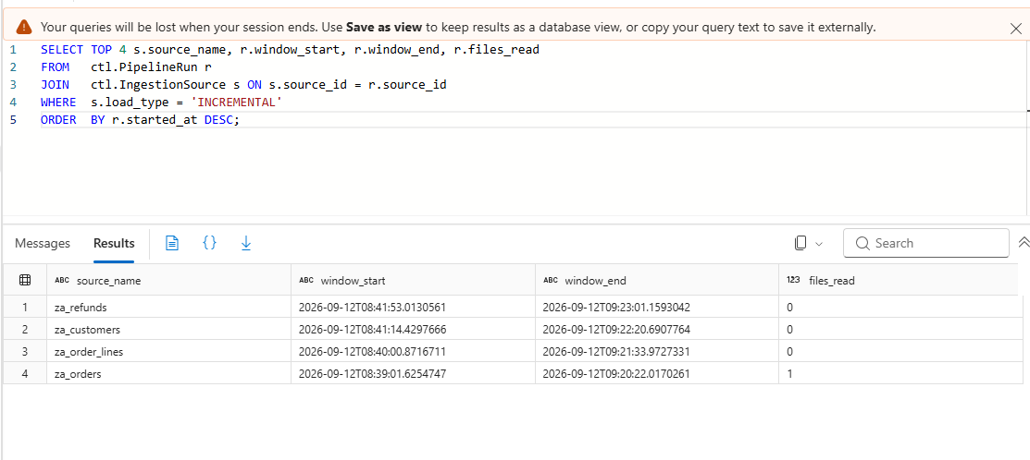
Figure 14 — One new file added: that source reads exactly one, the other three still read zero
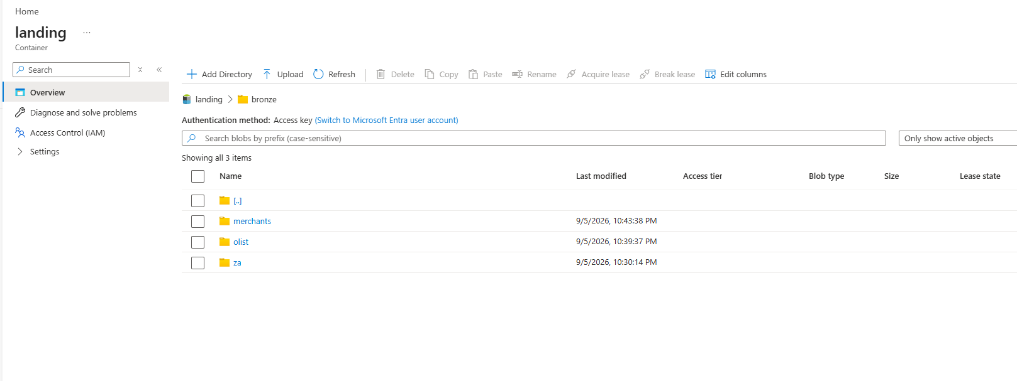
Figure 15 — The bronze landing zone after a full load

7. Implementation notes
Problems that cost real time during the build, recorded so they do not cost it twice.

Expressions silently fail to save
Typing an expression directly into a field sometimes leaves it as literal text rather than registering it as an expression. The symptom is ADF passing the expression through verbatim: one error reported a storage container named body(‘Fetch API…’)?.ds_adls_json<hash>.container.
It happened three times during this build, including once on the incremental filter, where the field simply appeared empty afterwards and every run copied everything. Expressions must be entered through Add dynamic content, and the field should render in blue with a link beneath it before moving on.

A connection test does not prove data access
Azure separates the management plane from the data plane. Test connection on the data lake linked service passed before any role was assigned, because that test only confirms the account exists and is reachable.
Reading a blob requires Storage Blob Data Contributor on the data plane, which subscription Owner does not grant. The first copy activity would have failed with a permissions error that reads nothing like a permissions error.

Uploads carry their parent folder
Azure Storage Explorer preserved the local data directory during upload, so paths became data/raw/olist rather than raw/olist and every source failed to resolve.
The fix was a single UPDATE against the manifest. No pipeline change, no republish, no retest — which is the metadata-driven design paying for itself.

Debug runs are billed
A failed copy still consumed 0.067 DIU-hours. Immaterial at this scale, but unlike debugging a script locally, iterating in ADF is not free.

8. Known limitations
- Row counts are unavailable at this layer. The file count is the reliable measure; row counts belong in bronze, where the files are actually parsed.
- Incremental detection relies on blob last-modified timestamps rather than a source-system change column. That is appropriate for a file drop, but a database source would use a watermark column instead.
- The expected file count is a static floor. A source whose volume legitimately grows would need the threshold revised, or replaced with a comparison against a trailing average.
- Sequential execution was chosen for debuggability. A production deployment handling materially more sources would enable controlled parallelism and accept the interleaved logging.

