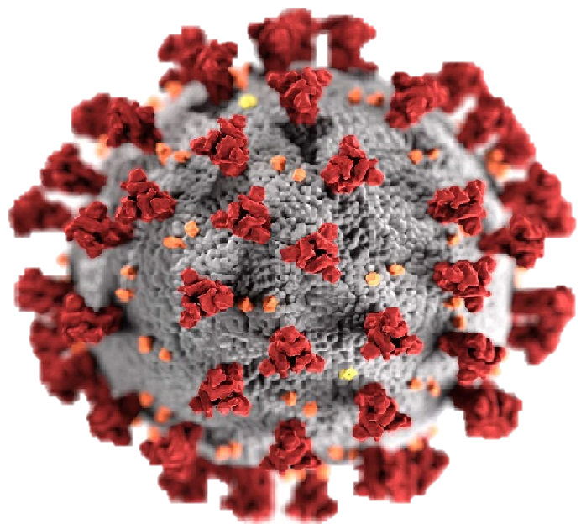

COronavirus (covid-19)

By SamY

* **Covid-19-pox: Basic Information**

Coronavirus is a novel virus that causes the disease COVID-19 (SARS-coV-2, previously known as 2019-nCoV), which causes an acute respiratory illness. The virus started in the city of Wuhan, China in December 2019 and spread throughout the world and on 30 January 2020, following their commendations of the emergency committee, the World Health Organization (WHO) Director-General declared that the outbreak constitutes a Public Health Emergency of International Concern (PHEIC). Due to outbreak of Coronavirus Disease(COVID-19) more than half of the world led to lockdown, which made a deep impact on our daily life routine, unlike we used to practice before. Scholars have come to the understanding that Coronaviruses are Zoonotic viruses responsible for mild respiratory tract infections and fatal pneumonia in humans. Human Coronaviruses (HCoV) were first identified in the 1960s in the noses of patients with common cold.

The Centre for Disease Control and Prevention identified seven Coronaviruses that can affect people as:

* 229E (alpha Coronavirus)
* NL63 (alpha Coronavirus)
* OC43 (beta Coronavirus)
* HKU1 (beta Coronavirus)
* MERS-CoV (the beta Coronavirus that causes Middle East respiratory syndrome)
* SARS-CoV (the beta Coronavirus that causes severe acute respiratory syndrome); and
* SARS-CoV-2 (the novel Coronavirus that causes Coronavirus disease 2019 or COVID-19).

The novel Coronavirus is a current pandemic of Coronavirus family that is currently ravaging the whole world. It is a new strain that has not been previously identified in humans. Identified in Wuhan, capital of Hubei Province of China in December, 2019, it was initially from animal sources; however, (it) has subsequently spread between people. Early genetic analysis of the outbreak revealed that the virus was similar to, but distinct from, SARS-CoV, but the closest genetic similarity was found in a Coronavirus that had been isolated from bats.

* **Symptoms**

The symptoms of the novel Coronavirus have been variously described to include:

* fever
* cough
* shortness of breath
* diarrhea

But cases of severe infection can result in pneumonia, kidney failure and death. The novel Coronavirus is thought to have been transmitted from animals to humans. However, the genetic epidemiology suggests that from the beginning of December, 2019, when the first cases were retrospectively traced to Wuhan, the spread of infection has been almost entirely driven by human-to-human transmission, not the continued spillover. This human-to-human transmission of the virus is primarily thought to occur through close contacts with infected persons’ respiratory droplets usually generated by sneezing and coughing.

* **Transmission**

The virus that causes COVID-19 is mainly transmitted through droplets generated when an infected person coughs, sneezes, or exhales. These droplets are too heavy to hang in the air, and quickly fall on floors or surfaces.  
You can be infected by breathing in the virus if you are within close proximity of someone who has COVID-19, or by touching a contaminated surface and then your eyes, nose or mouth.

* **Treatment**

Most people who have monkey-pox recover without needing treatment within two to four weeks. While there is no specific treatment for monkey-pox, antiviral medications that have been used to treat smallpox can be used. People who have been exposed to someone with monkey-pox may be eligible to receive a vaccine to prevent the onset of disease or reduce the severity of symptoms.

* **Prevention tips**
* Wash or sanitize your hands often

You should wash or sanitize your hands often. Use soap and water, or an alcohol-based hand rub. When you do this, this prevents you from contacting COVID-19 after touching contaminated surfaces.

* Maintain a safe distance

Maintain a safe distance from anyone who is coughing or sneezing. Also observe social distance when in public. You should be at least 1m far from anyone next to you.

* Avoid Touching of the face

Don't touch your eyes, nose or mouth to avoid transmitting the virus from your hands to your face which is more sensitive.

* Sneezing or Coughing

Cover your nose and mouth with your elbow bent or a tissue when you cough or sneeze. Stay home if you feel unwell.

* Seeking Medical Attention

If you have a fever, cough and difficulty breathing, seek medical attention. Call in advance. Follow the directions of your local health authority.

Reference

World Health Organisation (WHO)