High and low blood pressure has been a health problem most parents battle with till death. Most of you are familiar with this condition. This article will be enlightening you on the causes and preventive measures of these condition(High blood and low blood pressure).

**High**

**&**

**Low Blood Pressure**

By SamY

INTRODUCTION

* High Blood pressure is responsible for over 7.6 million deaths per annum world-wide with 45% of these deaths in Nigeria and Sub-Saharan Africa.
* 54% of death as a result of stroke and 47% as a result of coronary heart disease are attributable to high blood pressure.
* 80% of these death related to these various diseases occur in low and middle income countries.
* HYPERTENSION REMAINS A SILENT KILLER

WHAT IS HIGH BLOOD PRESSURE?

The heart as we know constantly pumps blood into the blood vessels. The amount of force exerted against the walls of the blood vessels is known as the BLOOD PRESSURE. A blood pressure reading appears as two numbers. The first and higher of the two is a measure of systolic pressure and is the pressure in the arteries when the heart beats and fills them with blood. The second number measures diastolic pressure, and is the pressure in the arteries when the heart rests between beats. It is measured in millimeter mercury (mm hg).

High Blood Pressure is also known as HYPERTENSION. This is when your blood pressure increases to unhealthy levels. Your blood pressure measurement takes into account how much blood is passing through your blood vessels and the amount of resistance the blood meets while the heart is pumping. High blood pressure can cause damage to your blood vessels and organs, especially the brain, heart, eyes, and kidneys.

TYPES OF HIGH BLOOD PRESSURE

There are two types of high blood pressure:

* Primary hypertension
* Secondary hypertension

PRIMARY HYPERTENSION

Primary Hypertension is also called essential hypertension. This type of high blood pressure, called primary (essential) hypertension, tends to develop gradually over many years. Most people have this type of high blood pressure. Researchers are still unclear what mechanisms cause blood pressure to slowly increase.

SECONDARY HYPERTENSION

Secondary Hypertension which is the most common among adult often occurs quickly and can become more severe than primary hypertension. Several conditions that may cause secondary hypertension include:

* Obstructive sleep apnoea (cessation of respiration/breathing)
* Kidney disease
* Adrenal gland problems
* Thyroid problems
* Congenital heart defects e.g. heart failure
* Side effects of medications
* Excessive use of drugs such as alcohol, cocaine and amphetamines among other
* Underline illness such as diabetes

HIGH BLOOD PRESSURE READINGS

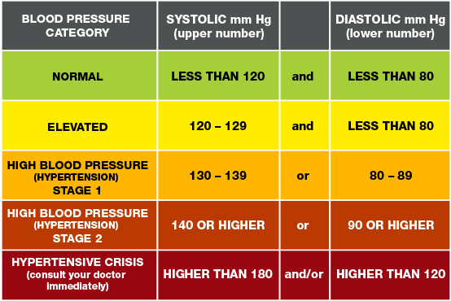

CAUSES OF HIGH BLOOD PRESURE

The common causes of high blood pressure are:

* Age
* Certain Chronic conditions such as diabetes, heart diseases
* Being overweight or obese
* Too much salt (sodium) in your diet
* Not being physically active
* Excessive use of drugs such as alcohol, tobacco, amphetamines and other sedatives
* Heredity (Family History)
* Stress
* Too much fats in the body and blood vessels

PROBLEMS THAT MAY ARISE AS A RESULT OF HIGH BLOOD PRESSURE

* Heart Attack or Stroke
* Aneurysm (abnormal blood filled swelling of an artery or vein)
* Heart Failure
* Weakened and Narrowed blood vessels in your Kidney
* Thickened, narrowed or torn blood vessels in the eyes
* Metabolic Syndrome
* Trouble with memory or understanding
* Dementia (memory loss)

PREVENTIVE MEASURES FOR HIGH BLOOD PRESSURE

* Lose excess fats in the body
* Exercise regularly
* Eat a healthy diet
* Reduce sodium in your diet
* Avoid or reduce the intake of alcohol and other drugs
* Quit smoking
* Cut back on caffeine
* Reduce your stress
* Monitor your blood pressure at home and see your doctor regularly

WHAT IS LOW BLOOD PRESSURE?

Hypotension (also known as low blood pressure) is a medical condition when the blood pressure falls below 90/60. Low blood pressure can be a sign of an underlying problem (especially in the elderly) where it may cause inadequate blood flow to the heart, brain, and other vital organs.

CAUSES OF LOW BLOOD PRESSURE

* Pregnancy.
* Heart problems. E.g. extremely low heart rate (bradycardia), heart valve problems, heart attack and heart failure.
* Endocrine problems. E.g. Parathyroid disease, adrenal insufficiency, low blood sugar (hypoglycemia) and, in some cases, diabetes can trigger low blood pressure.
* Dehydration. This is when your body loses more water than it takes in.
* Blood loss. Losing a lot of blood, such as from a major injury or internal bleeding which reduces the amount of blood in your body.
* Severe infection. When an infection in the body enters the bloodstream, it can lead to a life-threatening drop in blood pressure called septic shock.
* Severe allergic reaction. Such as from foods, certain medications, insect venoms and latex can cause breathing problems, hives, itching, a swollen throat and a dangerous drop in blood pressure.
* Lack of nutrients in your diet. A lack of the vitamin B-12, folate and iron can keep your body from producing enough red blood cells causing low blood pressure.

SYMPTOMS OF LOW BLOOD PRESSURE

* Dizziness or lightheadedness
* Fainting
* Blurred or fading vision
* Nausea
* Fatigue
* Lack of concentration
* Confusion, especially in older people
* Cold, clammy, pale skin
* Rapid, shallow breathing
* Weak and rapid pulse

HOW DO YOU PREVENT LOW BLOOD PRESSURE?

* Drink plenty of water
* Limit or avoid alcohol
* Pay attention to your body position
* Eat more low carb meals
* Exercise regularly
* Eat more salt
* Check your blood sugar
* Get your thyroid checked
* Wear compression stockings (to keep warm and prevent cold)
* Take medication
* Treat infections and other underlining illness

REFERENCES

Webmd (<https://www.webmd.com/hypertension-high-blood-pressure/guide/diastolic-and-systolic-blood-pressure-know-your-numbers>)