Part 1

Contents
Test Plan 1
Requirement observations 3
Other thoughts 5
Manual Test Scenarios 6
Exploratory testing 12
Appendix 13

Test Plan

Test Plan | Hotel Booking Test Plan
Description | Analyse the website and provide proof and confidence in the functionality being provided
Introduction | The purpose of this document is to clearly outline the processes, roles and responsibilities of the team and the testing strategy to be performed on this project. This document can be found on the confluence page www.confluence.com
Teams | QA Lead: Samuel Babalola
High Level Overview | This document will advise on the test being conducted at a high level both manual (functional and non-functional) and automated tests that are applicable to the project.
In Scope | Manual tests: Functional and Non-Functional  Mobile and Tablet tests  API and UI tests  Test CRUD (Create, Read, Update and Delete)  Test Positive and negative scenarios  Automated regression tests: Functional
Out of Scope | Automated regression tests: Non- functional  Business requirements  Localisation and translations
Test Approach | The test approach is centred on a couple of key principles  Application is ready to be tested  Leverage automation tests as much as possible  Minimise wasteful testing activities
Testing types | Manual (functional and non-functional tests)  Automation pyramid  Automated regression (End to end)  Accessibility testing  Security testing  Performance testing
Environment requirements | Environment: Test on Production  Test Data: create as required
Control Procedures | Reviews: by EqualExperts team  Tooling: Manual test – Microsoft Word document  Tooling: Automated test – Visual Studio
Test Schedule and timeline | Manual tests: 3 hours to execute (benchmark)  Automated tests: Less than 5 minutes to execute (benchmark)
Defect Management | Category: P1  Priority: Critical  Description: Severe defect affecting live users  Impact: Loss of money, corruption of data and broken user journey  Category: P2  Priority: Critical  Description: Severe defect affecting live users but with available workaround  Impact: Loss of money, corruption of data and broken user journey
Dependencies | Software dependencies: Visual studio
Exit criteria | Automated test builds  All automated tests are executable (some tests may fail due to the software)
Risk and Assumptions | N/A
References | N/A

Requirement observations
Good | (Data) Entering valid inputs and clicking Save multiple times only adds a single record to the list
Good | (Accessibility) Tabbing from firstname field tabs right to the Save button
Good | (Accessibility) Enter controls when a date is selected in the Date picker works well by adding the selected date into the date field
Good | No internet cookies are stored on the site, although if utilised can help with personalisation and advertising
User notifications | Error message not displayed after entering alphanumeric in Price field
User notifications | Error messages not displayed after leaving input fields blank
User notifications | Error message not displayed to indicate that date field does not accept special characters i.e "/ . " but accepts "-"
User notifications | Error messages not displayed when Check-out date is before Check-in date
Data Issues | Check-in and Check-out dates can have the same date values. Time should also be included
Data Issues | Price field accepts 0000, 0.0, 0000.1, 0.000001 but should have a minimum and maximum value
Data Issues | Price field accepts "1000000000000" value which then overlaps the deposit field
Data Issues | Price field accepts 10000000000000000000000000000000000000000000000000 value and displays it as 1e+49
Data Issues | Price field accepts spaces before the integer i.e. “ 1” however it stores the value as 1
Data Issues | Surname field accepts "a12345678901234567890123456789012345678901" value which then overlaps the deposit field
Data Issues | Firstname field accepts "a12345678901234567890123456789012345678901" value which then overlaps the surname field
Data Issues | Firstname and Surname fields accept alphanumeric characters but should only accept letters
Data Issues | Check-in date and check-out date can be 50 years apart in the future and in the past E.g. 2000-12-10 to 2050-12-10 and 2050-12-10 to 2000-12-10
Data Issues | Firstname and Surname fields accept single characters
Accessibility | Adding the URL to the accessibility site https://wave.webaim.org/ for a free scan 7 errors and 1 alert was detected. The errors were around the fields not having corresponding labels. The second is that a heading level skipped because H1 and H3 tags were used for title and headers but no H2 level
Usability | The input fields should be at the top of the page rather than the bottom to improve usability
Usability | Notification should be displayed to make user aware of mandatory fields
Usability | When a new record is added, it should be displayed at the top of the booking list else users would have to scroll to the bottom of the page to find the latest entry
Usability | There should be pagination on the page
Usability | The Hotel booking form page is not rendered beautifully when the browser is set to half the screen view. It is responsive but not well laid out
Usability (Localisation) | There does not appear to be localisation or languages for the site. This would help with currency and tests on the button
Usability (Mobile testing) | The page rendering on the mobile phone is not very pleasant and requires a lot of scrolling down the page
Usability (iPad) | Using Chrome browser DevTools, the page rendering on the iPad view is not very pleasant and requires a lot of scrolling down the page
Usability | Adding the URL to the Mobile performance site https://testmysite.withgoogle.com/intl/en-gb for a free scan flagged 3 issues: Use legible font sizes, configure the view port and size tap targets appropriately
Performance | There is a time delay when the Save button is clicked to when it is displayed on the booking list
Performance | Adding the URl to the Website performance site https://gtmetrix.com/ for a free scan the performance score is B with a fully loaded time of 1.7s, total page size 155kb with 30 requests
Performance (Mobile) | Adding the URL to the Mobile performance site https://testmysite.withgoogle.com/intl/en-gb for a free scan the result was 4s for lading time on 3G network which was good and an estimated 10% of visitor loss due to loading time for 20 records
Load | Adding the URL to the load site https://loadimpact.com/ and running a free test for a staggered 24 active virtual users for 3 minutes calling the Get endpoint, we got about 34 requests per second with a response time of 25ms. Please see the attachment below in Appendix
Security | Firstname and surname fields accept "SELECT * FROM Users WHERE UserId = " + txtUserId;
Security | Adding the URL to the PenTools site https://pentest-tools.com/website-vulnerability-scanning/web-server-scanner for a free scan the following vulnerabilities were mentioned: SQL injection, Cross-site scripting, phishing or XSS attacks and the web server is not configured for HTTPS
Api | 500 Internal server error is thrown when a mandatory field is not populated. Should be 400 for bad request
Api | 200 OK response is returned when a valid record entry is accepted. Should be 201 for Created  {"firstname":"TestApi","lastname":"Check","totalprice":"15","depositpaid":"false","bookingdates":{"checkin":"2018-12-10","checkout":"2018-12-10"}}
Api | 201 Created response is returned when a valid record entry is deleted. Should be 204 for No Content  Created
Api | When a new record is created a booking Id is added to the json body  {"bookingid":49168,"booking":{"firstname":"d","lastname":"d","totalprice":2,"depositpaid":true,"bookingdates":{"checkin":"2018-12-03","checkout":"2018-12-03"}}}  And it is incremental  {"bookingid":49169,"booking":{"firstname":"d","lastname":"d","totalprice":2,"depositpaid":true,"bookingdates":{"checkin":"2018-12-03","checkout":"2018-12-03"}}}
API | RestModels are case sensitive and return 500 status code when upper case characters are used
API | API doesn’t provide error messages when incorrect field is propagated

Other thoughts
- Do we monitor our website using tools like AppInsights to analyse our performance and error codes?
- Do we have access to the database so that we can validate that the data is stored correctly
- Do we ensure that our API requests and responses have the right headers and parameters (user agent, Source IP, Client City), method calls and status codes?
- Do we have multiple instances of the site running in the cloud?
- Do we have ReCaptcha that is configured by location so that we can turn it on when attacked by certain locations and IP’s
- Do we have a messaging queue (or messsagebus) for the API requests going into the database?
- Do we have ways and methods to ensure data integrity? Do we have an architecture diagram and PACT testing?

Manual Test Scenarios

Test Scenario ID: |  | AddBookings-1 |  | Test Case ID: | AddBookings-1A
Test Case Description: |  | Add a booking - Positive test case |  | Test Priority: | High
Pre-Requisite: |  | Launch http://hotel-test.equalexperts.io/ on Test Browser |  | Test Browser: | Chrome (Latest)  Version: 70.0.35  Mode: Full Screen  OS: Windows 10
Test Execution Steps:
S.No | Action | Input | Expected Output | Actual Output | Test Result | Comments
1 | Enter a valid firstname in firstname field | Robin | Robin is displayed in the field | Robin is displayed in the field | PASS
2 | Enter a valid surname in surname field | Hood | Hood is displayed in the field | Hood is displayed in the field | PASS
3 | Enter a valid price in price field | "20.00" | 20.00 is displayed in the field | 20.00 is displayed in the field | PASS
4 | Select a valid boolean in deposit field | TRUE | True is selected in the field | True is selected in the field | PASS
5 | Select the current date on the Date-Picker tool | "09/12/2018" | Date is formatted and displayed in the field | Date is formatted and displayed in the field | PASS
6 | Select the next date on the Date-Picker tool | "10/12/2018" | Date is formatted and displayed in the field | Date is formatted and displayed in the field | PASS
7 | Click the save button | N/A | Inputs are added to the display at the bottom of the booking list and the input fields are cleared | Inputs are added to the display at the bottom of the booking list and the input fields are cleared | PASS

Test Scenario ID: |  | DeleteBookings-1 |  | Test Case ID: | DeleteBookings-1A
Test Case Description: |  | Delete an existing booking - Positive test case |  | Test Priority: | High
Pre-Requisite: |  | Complete Test Case ID: AddBookings-1A |  | Test Browser: | Chrome (Latest)  Version: 70.0.35  Mode: Full Screen  OS: Windows 10
Test Execution Steps:
S.No | Action | Input | Expected Output | Actual Output | Test Result | Comments
1 | Click the Delete button to the right of the record | N/A | The record no longer exists | The record no longer exists | PASS

Test Scenario ID: |  | UpdateBookings-1 |  | Test Case ID: | UpdateBookings-1A
Test Case Description: |  | Update an existing booking - Positive test case |  | Test Priority: | High
Pre-Requisite: |  | Complete Test Case ID: AddBookings-1A |  | Test Browser: | Chrome (Latest)  Version: 70.0.35  Mode: Full Screen  OS: Windows 10
Test Execution Steps:
S.No | Action | Input | Expected Output | Actual Output | Test Result | Comments
1 | Update the existing record | N/A | Update functionality exists | No update functionality exists | FAIL | System doesn’t appear to have an easy to find update functionality

Test Scenario ID: |  | GetBookings-1 |  | Test Case ID: | GetBookings-1A
Test Case Description: |  | Get bookings - Positive test case |  | Test Priority: | High
Pre-Requisite: |  | Launch http://hotel-test.equalexperts.io/ on Test Browser |  | Test Browser: | Chrome (Latest)  Version: 70.0.35  Mode: Full Screen  OS: Windows 10
Test Execution Steps:
S.No | Action | Input | Expected Output | Actual Output | Test Result | Comments
1 | Delete all existing bookings | N/A | No records exist in the database | No records exist in the database | PASS
2 | Refresh the page | Click the refresh button or Alt+R | No record is displayed on the page | No record is displayed on the page | PASS

Test Scenario ID: |  | AddBookings-1 |  | Test Case ID: | AddBookings-1B
Test Case Description: |  | Add a booking - Negative test case (Missing field) |  | Test Priority: | High
Pre-Requisite: |  | Launch http://hotel-test.equalexperts.io/ on Test Browser |  | Test Browser: | Chrome (Latest)  Version: 70.0.35  Mode: Full Screen  OS: Windows 10
Test Execution Steps:
S.No | Action | Input | Expected Output | Actual Output | Test Result | Comments
1 | Leave the firstname field blank | N/A | The field is empty | The field is empty | PASS
2 | Enter a valid surname in surname field | Hood | Hood is displayed in the field | Hood is displayed in the field | PASS
3 | Enter a valid price in price field | "20.00" | 20.00 is displayed in the field | 20.00 is displayed in the field | PASS
4 | Select a valid boolean in deposit field | TRUE | True is selected in the field | True is selected in the field | PASS
5 | Select the current date on the Date-Picker tool | "09/12/2018" | Date is formatted and displayed in the field | Date is formatted and displayed in the field | PASS
6 | Select the next date on the Date-Picker tool | "10/12/2018" | Date is formatted and displayed in the field | Date is formatted and displayed in the field | PASS
7 | Click the save button | N/A | The entries are not added to the booking list but still exist in the fields | The entries are not added to the booking list but still exist in the fields | PASS

Test Scenario ID: |  | AddBookings-1 |  | Test Case ID: | AddBookings-1C
Test Case Description: |  | Add a booking - Negative test case (Past date) |  | Test Priority: | High
Pre-Requisite: |  | Launch http://hotel-test.equalexperts.io/ on Test Browser |  | Test Browser: | Chrome (Latest)  Version: 70.0.35  Mode: Full Screen  OS: Windows 10
Test Execution Steps:
S.No | Action | Input | Expected Output | Actual Output | Test Result | Comments
1 | Enter a valid firstname in firstname field | R | R is displayed in the field | R is displayed in the field | PASS
2 | Enter a valid surname in surname field | H | H is displayed in the field | H is displayed in the field | PASS
3 | Enter an invalid price in price field | "0" | 0 is displayed in the field | 0 is displayed in the field | PASS
4 | Select a valid boolean in deposit field | FALSE | False is selected in the field | False is selected in the field | PASS
5 | Select the current date on the Date-Picker tool | "01/12/2018" | Date is formatted and displayed in the field | Date is formatted and displayed in the field | PASS
6 | Select the next date on the Date-Picker tool | "02/12/2018" | Date is formatted and displayed in the field | Date is formatted and displayed in the field | PASS
7 | Click the save button | N/A | The entries are not added to the booking list but still exist in the fields | The entries are added to the booking list and no longer exist in the fields | FAIL

Test Scenario ID: |  | AddBookings-1 |  | Test Case ID: | AddBookings-1D
Test Case Description: |  | Add a booking - Negative test case (Invalid date) |  | Test Priority: | High
Pre-Requisite: |  | Launch http://hotel-test.equalexperts.io/ on Test Browser |  | Test Browser: | Chrome (Latest)  Version: 70.0.35  Mode: Full Screen  OS: Windows 10
Test Execution Steps:
S.No | Action | Input | Expected Output | Actual Output | Test Result | Comments
1 | Enter a valid firstname in firstname field | R | R is displayed in the field | R is displayed in the field | PASS
2 | Enter a valid surname in surname field | H | H is displayed in the field | H is displayed in the field | PASS
3 | Enter an invalid price in price field | "0" | 0 is displayed in the field | 0 is displayed in the field | PASS
4 | Select a valid boolean in deposit field | FALSE | False is selected in the field | False is selected in the field | PASS
5 | Select the current date on the Date-Picker tool | "2018-10" | Date is formatted and displayed in the field | Date is formatted and displayed in the field | PASS
6 | Select the next date on the Date-Picker tool | "2018-09" | Date is formatted and displayed in the field | Date is formatted and displayed in the field | PASS
7 | Click the save button | N/A | The entries are not added to the booking list but still exist in the fields | The entries are added to the booking list and no longer exist in the fields | FAIL | "2018-10" is formatted to 2018-10-01 and "2018-09" is formatted to 2018-09-01

Exploratory testing

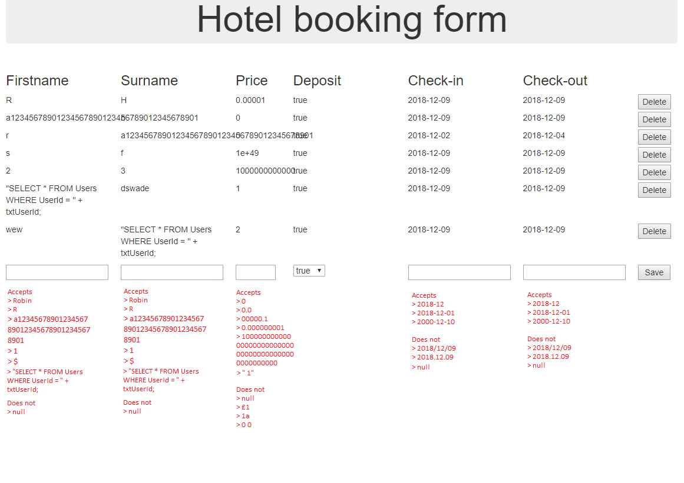

Appendix

Load test results
Site: https://loadimpact.com/
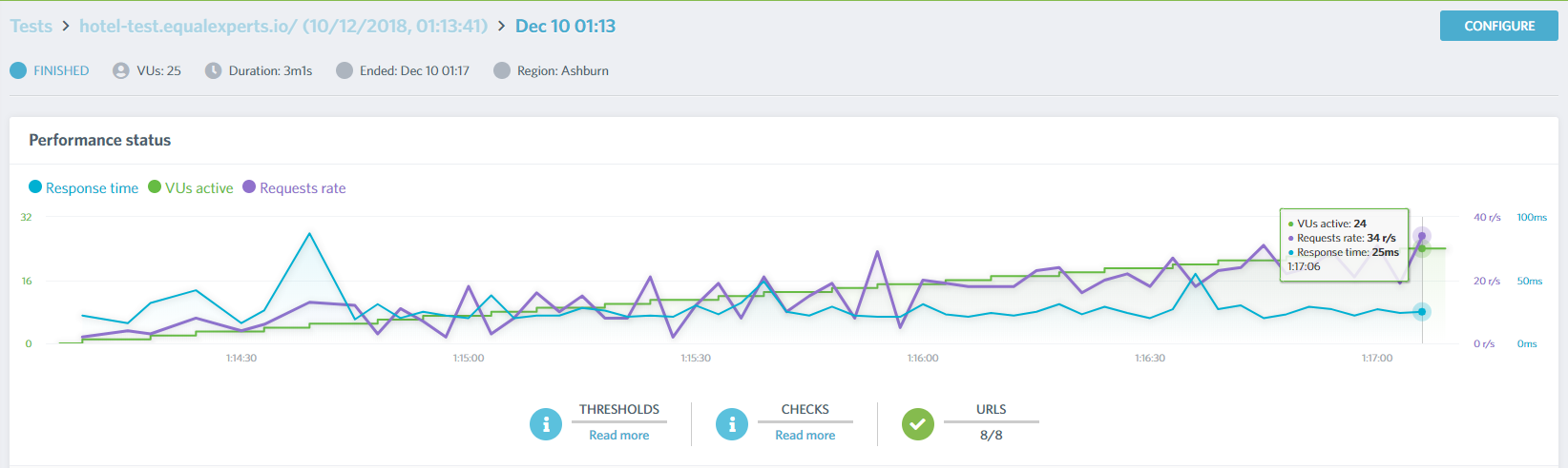

Security testing results
Site: https://pentest-tools.com/website-vulnerability-scanning/web-server-scanner
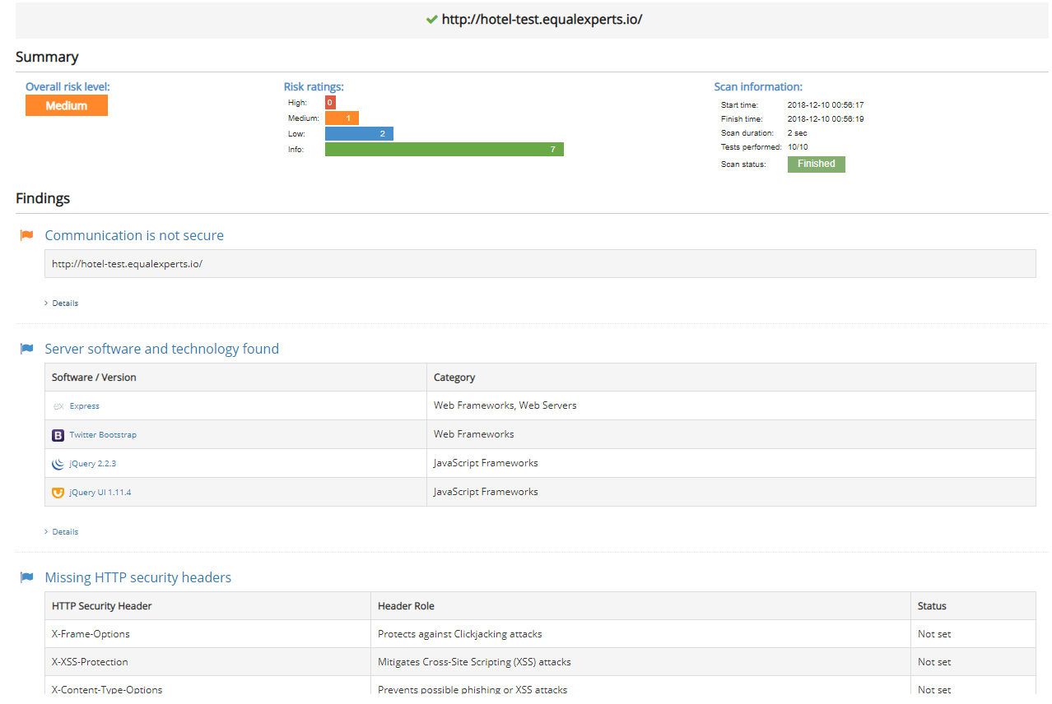

Mobile performance and Usability
Site: https://testmysite.withgoogle.com/intl/en-gb
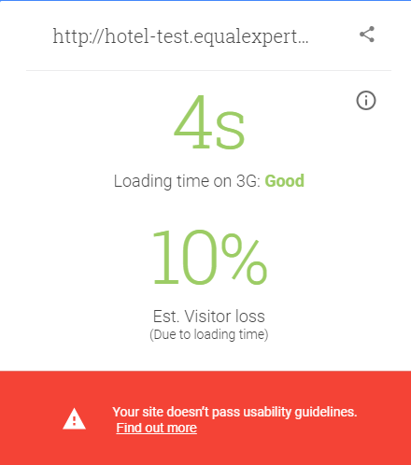

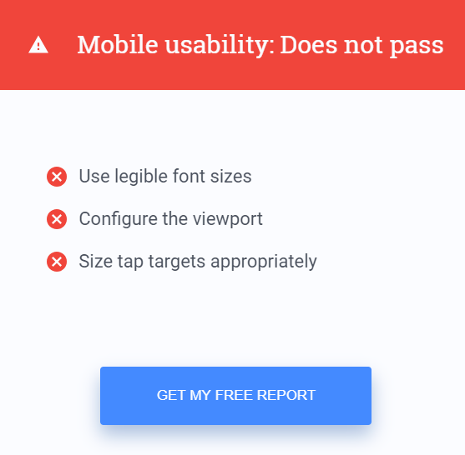

Website performance test
Site: https://gtmetrix.com/
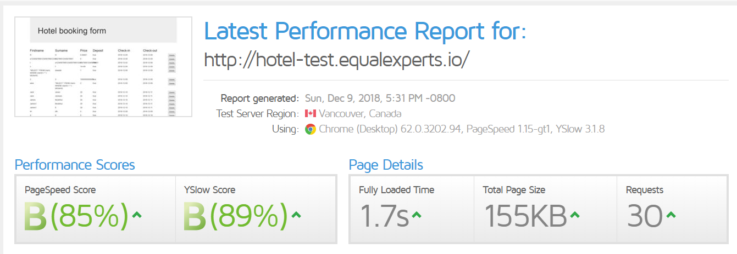
Accesibility test
Site: https://wave.webaim.org/
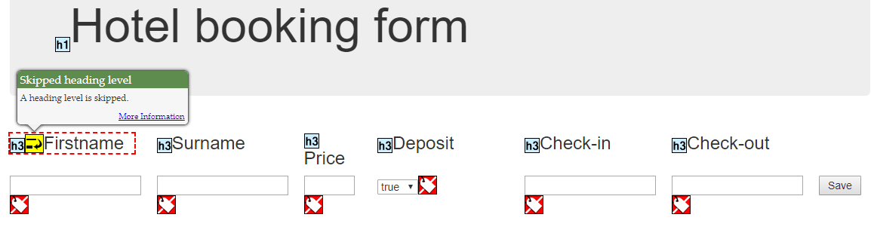

Ipad view
Browser: Chrome
