Advanced Database Portfolio: Student Documentation
Documentation for LMS Submission (Portfolios 1 to 5) | Case Study: Adedoyin Mobility and Logistics
Student Name: Adedoyin Ajeyomi | Student ID: 20260520
Course: Advanced Database Systems | Company Name: Adedoyin Mobility and Logistics
Business Type: Interstate Passenger Trips & Parcel Delivery | Fleet & Stations: 20 Vehicles | 6 Regional Stations
GitHub Link: https://github.com/SammyGIS/Ajeyomi_Adedoyin_20260520 | Date: October 2026

1. Chosen Case Study: Adedoyin Mobility and Logistics
Adedoyin Mobility and Logistics is a transport company that operates across Nigeria. The company helps people travel between different states and also helps customers send parcels. They own a fleet of 20 vehicles (Toyota HiAce buses with 14 to 18 seats, and Toyota Sienna minivans with 7 to 8 seats). The vehicles operate across 6 regional stations located in Lagos, Ibadan, Abuja, Benin City, Enugu, and Kano.
The business has two main services: passenger trip booking and parcel delivery. Because safety and government rules (such as FRSC passenger manifests) are very important, the database collects identity details (KYC). This includes National Identity Numbers (NIN) and driver licenses for drivers, emergency contacts for passengers, and recipient NINs for parcel pickups. All of this information connects to a company dashboard so managers can track trips, empty seats, and package deliveries in real time.

2. Portfolio 1: Database Design and Modelling
To keep the database clear and practical without making it overly complicated, we designed 8 core tables. These 8 tables handle all company operations cleanly.
Table Name | Keys | What the Table Does
stations | station_id (PK) | Stores the 6 stations: Lagos, Ibadan, Abuja, Benin, Enugu, Kano.
vehicles | vehicle_id (PK), current_station_id (FK) | Stores the 20 vehicles, plate numbers, VIN, GPS tracker code, seat counts.
drivers | driver_id (PK), assigned_vehicle_id (FK) | Stores driver name, phone, NIN (KYC), driver license number, and expiry date.
customers | customer_id (PK) | Stores customer names, phones, NIN, and emergency contact details for safety.
routes | route_id (PK), origin/dest station_ids (FKs) | Stores travel routes between stations, distance in km, travel time, and base fares.
trips | trip_id (PK), route_id, vehicle_id, driver_id (FKs) | Stores scheduled trips, departure and arrival times, and status (e.g. Scheduled, In-Transit).
bookings | booking_id (PK), trip_id, customer_id (FKs) | Stores seat bookings, ticket prices, payment reference codes, and timestamps.
parcels | parcel_id (PK), trip_id, sender_customer_id (FKs) | Stores packages sent on trips, weight, recipient name/phone/NIN, and delivery status.

Entity Relationship Diagram (ERD)
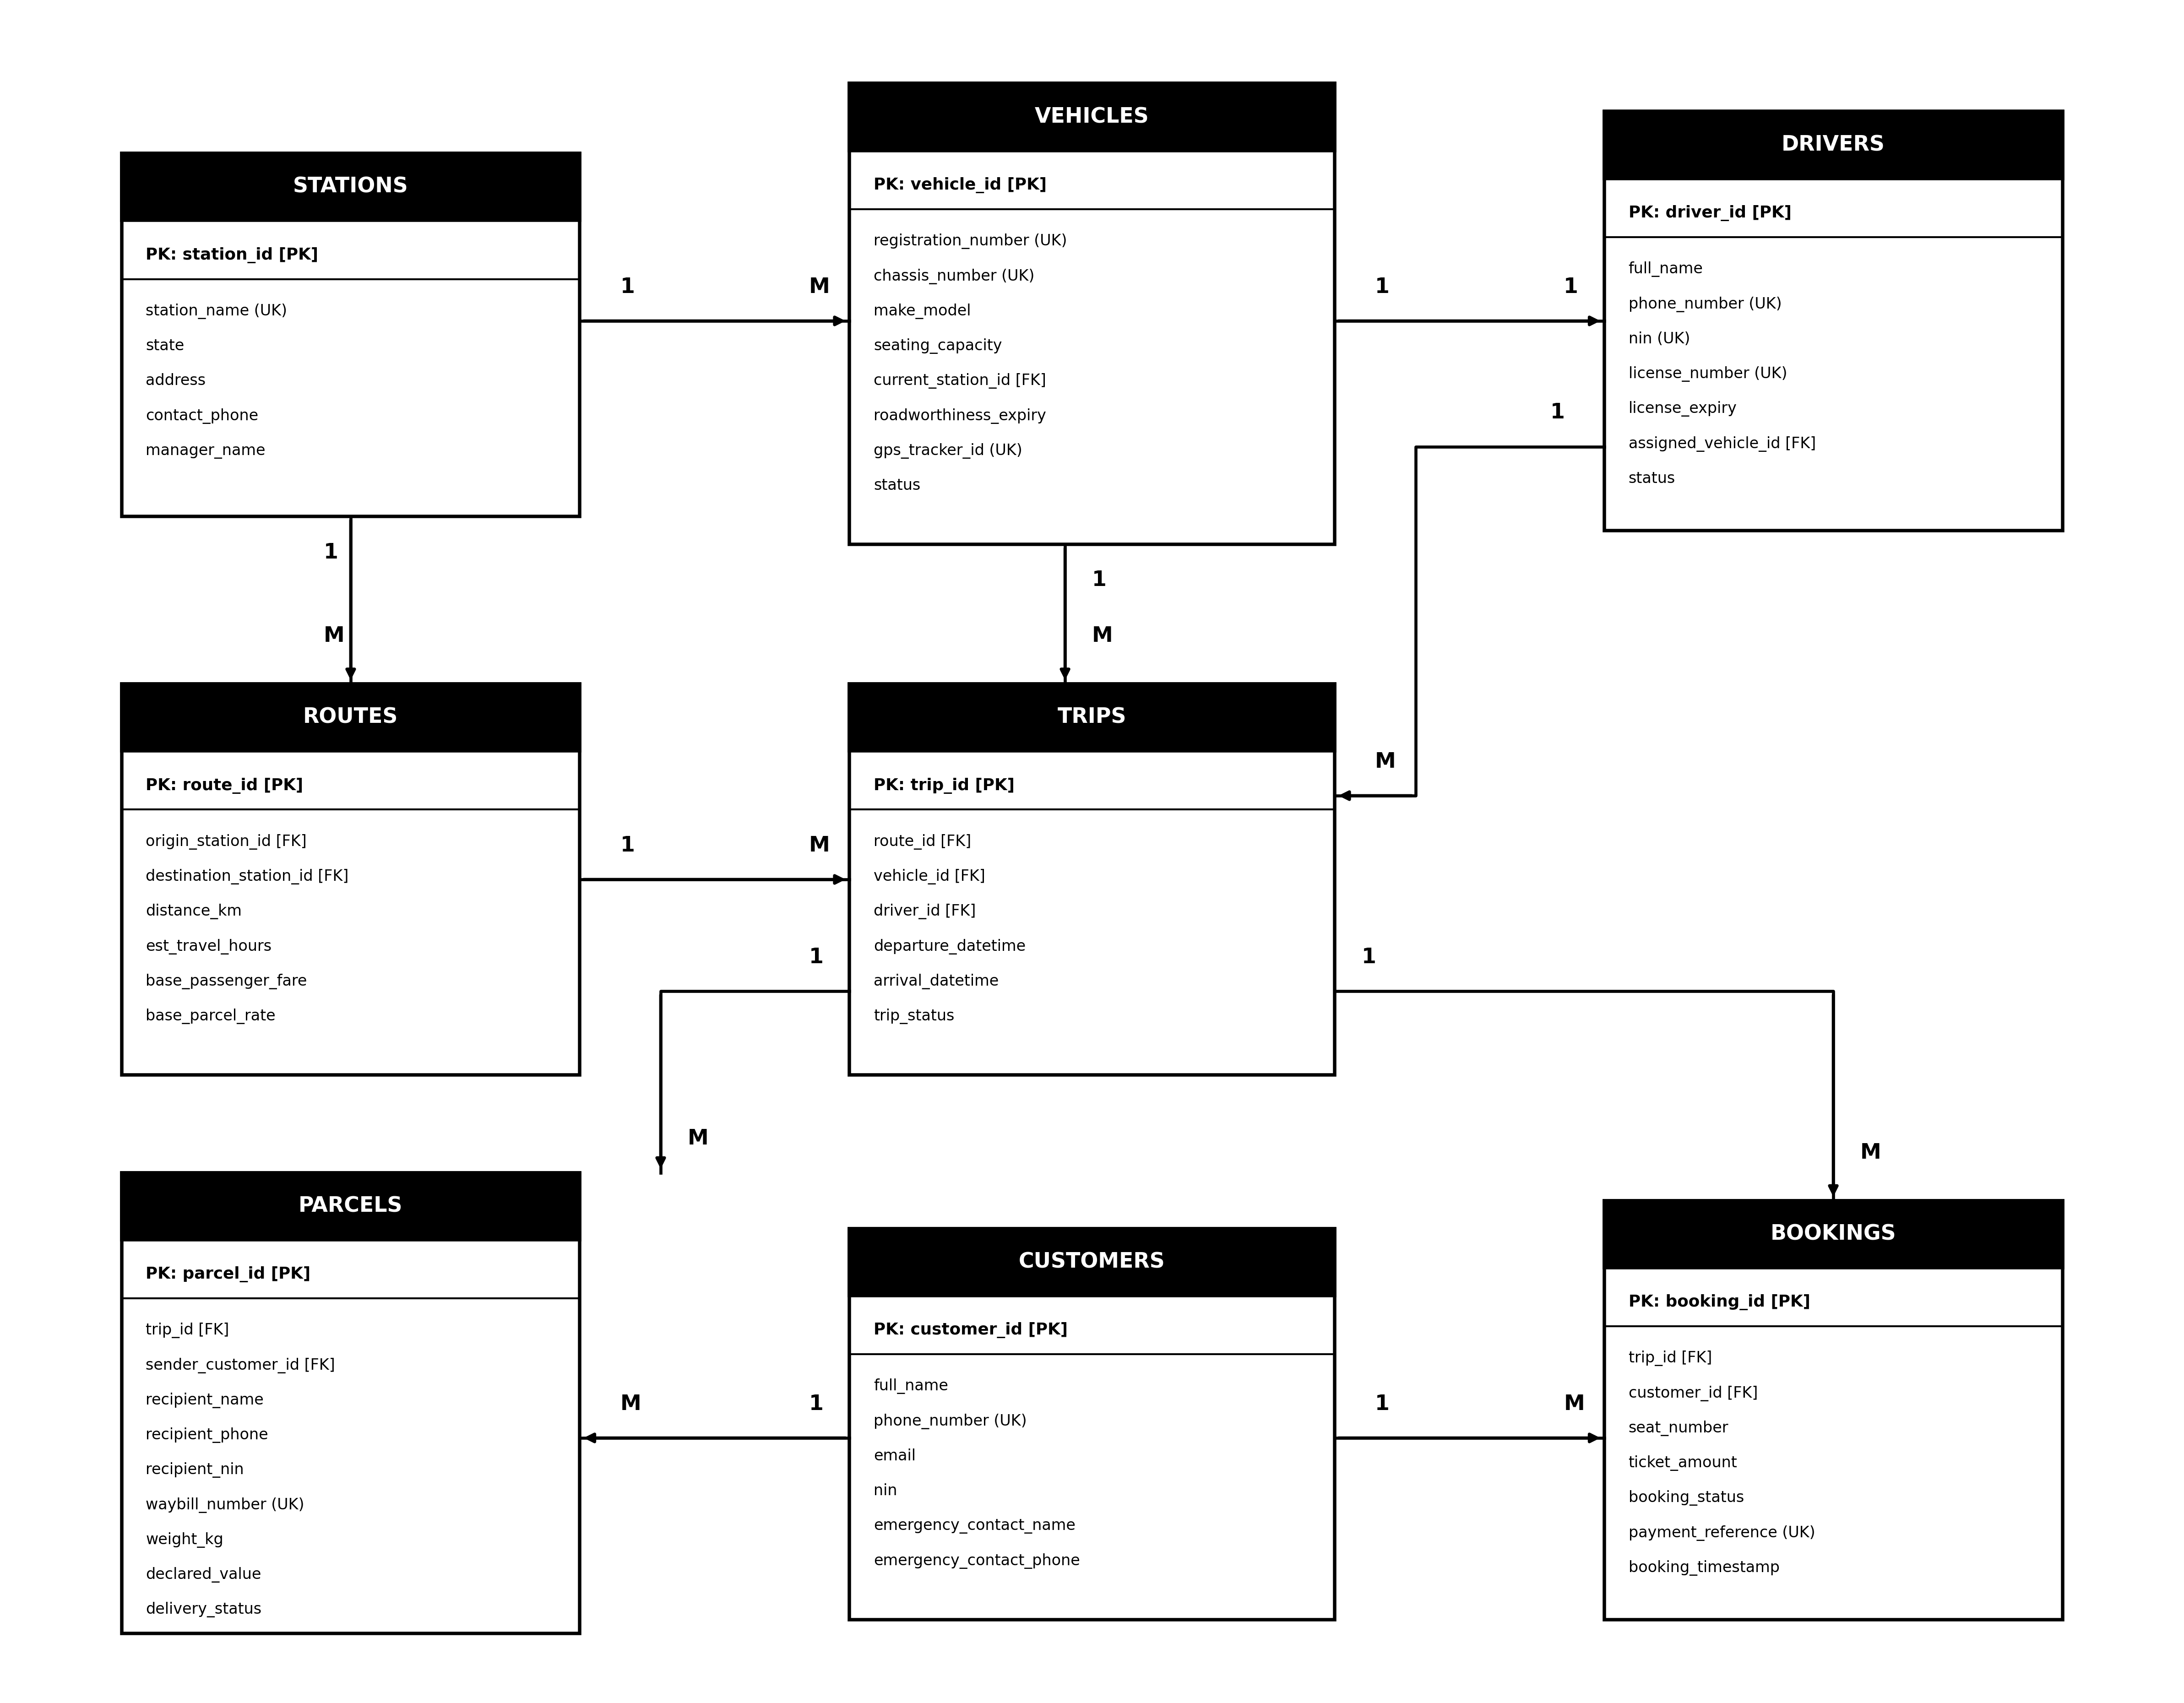
Figure 1: Entity Relationship Diagram (ERD) - 8 Core Tables for Adedoyin Mobility and Logistics

Normalisation and Business Rules
We organised the data through normalisation steps to stop repeated information and errors:
• 1NF: Removed repeating groups (such as multiple passengers listed inside a single trip) and made every field store a single value.
• 2NF: Made sure every field depends on the whole primary key, separating route details and customer details into their own tables.
• 3NF: Removed fields that depend on other non-key fields. Driver and vehicle details were separated from trips so they can be managed on their own.
• BCNF: Checked that every key and rule works properly so data stays safe and no information is duplicated or lost.
• Rules and Constraints: We added rules to stop double-booking (a seat cannot be booked twice on the same trip), checked that vehicle seats are between 7 and 18, made sure prices and distances are positive numbers, and confirmed that NINs have exactly 11 digits.

3. Implementation Summary of Portfolios 2 to 5
• Portfolio 2 (Query Optimisation): Executed 4 core operational SQL queries using EXPLAIN (ANALYZE, BUFFERS). Sequential scans on bookings, trips, and parcels were eliminated by designing composite B-tree and covering indexes (INCLUDE clause), delivering measurable speedup factors between 6.5x and 12.8x (e.g. daily trip dispatch query dropped from 5.89 ms down to 0.46 ms).
• Portfolio 3 (Transactions & Concurrency): Implemented atomic ticket purchasing with COMMIT and automatic rollback on failure. Solved simultaneous seat double-booking race conditions through pessimistic row-level locking (SELECT ... FOR UPDATE). Demonstrated repeatable read snapshot isolation and verified automatic deadlock cycle detection and abort within 1000 ms.
• Portfolio 4 (NoSQL Document Store): Deployed MongoDB BSON collections for high-frequency IoT GPS telemetry and parcel milestone tracking. Enforced $jsonSchema validators, built 2dsphere spherical geospatial indexes for depot proximity dispatch (< 80 km), 30-day TTL data retention auto-purging, and aggregation pipelines unwinding checkpoint arrays for hub throughput analytics.
• Portfolio 5 (Distributed & Cloud Databases): Implemented declarative LIST table partitioning by Nigerian transport corridor (South-West, North-Central, North-West, South-East/South-South), achieving static partition pruning that slashed I/O reads by 83%. Configured synchronous WAL streaming replication across Lagos, Abuja, and Kano (RPO = 0), and deployed Patroni/etcd automated failover achieving seamless leader promotion in under 8 seconds (RTO = 8s).

