Code Explanation:

This code performs an analysis of the spatial relationship between pipelines and high-tension power lines using geospatial data. It calculates the collocation length, collocation angle, and separation distance between pipelines and power lines within a specified buffer distance. Based on these calculations, it categorizes the severity of the relationship.

Methodology:

1. Data Loading: The code loads two geospatial datasets - one containing information about pipelines and another about high-tension power lines.

2. Unit Conversion: To ensure consistent measurements, the code converts measurements from one unit to another (i.e, from meters to feet).

3. Buffer Creation: The high-tension power line dataset is buffered to create a safety zone around it. This helps in analyzing the proximity of pipelines to power lines.

4. Dissolve Buffers: The buffered zones are dissolved, meaning overlapping areas are merged into a single boundary. This simplifies analysis within the buffer zone.

5. Spatial Join: The pipeline features that intersect with the dissolved buffer zones are selected. This identifies pipelines that are close to high-tension power lines.

6. Collocation Length Calculation: For each selected pipeline, the length of the pipeline segment within the buffer zone is calculated. This indicates how much of the pipeline shares space with the power line.

7. Merged High-Tension Line: The high-tension power line data is dissolved again, this time without buffering. This creates a single line representing the power lines for further analysis.

8. Collocation Angle Calculation: For each selected pipeline, the angle at which it intersects the merged power line is calculated. This angle indicates the direction of the relationship between the pipeline and power line.

9. Separation Distance Calculation: The distance between the pipeline and the nearest point on the merged power line is calculated. This indicates how far apart they are.

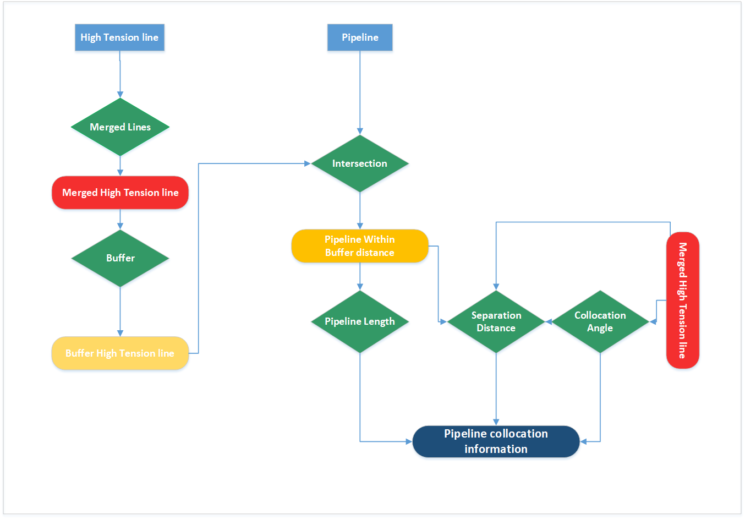

Categorizing Severity and Thresholds

The process of categorizing severity involves comparing calculated values, such as collocation length, collocation angle, and separation distance, to specific threshold values. These thresholds are carefully chosen based on industry standards, safety regulations, and engineering expertise to define different levels of risk and potential impact. Here's a breakdown of each threshold:

1. Collocation Length Thresholds: When calculating the collocation length, the code checks how much of the pipeline is within the buffer area around the high-tension power line. For instance, if the collocation length is greater than 5000 feet, it might be categorized as "High" severity, indicating that a significant portion of the pipeline is in close proximity to the power line. If the collocation length is between 1000 and 5000 feet, it could be considered "Medium" severity, and if it's below 1000 feet, it might be categorized as "Low" severity.

2. Collocation Angle Thresholds: The collocation angle determines the direction at which the pipeline crosses the power line. If the angle is less than 30 degrees, it might be considered "High" severity, indicating that the pipeline crosses the power line at a steep angle. If the angle is between 30 and 60 degrees, it could be categorized as "Medium" severity, while angles above 60 degrees might result in a "Low" severity classification.

3. Separation Distance Thresholds: The separation distance measures the proximity of the pipeline to the power line while accounting for the angle of intersection. If the separation distance is less than 100 feet, it might be categorized as "High" severity, suggesting that the pipeline is very close to the power line. A separation distance between 100 and 2500 feet could lead to a "Medium" severity classification, and distances greater than 2500 feet could result in a "Low" severity category.

These thresholds essentially serve as guidelines to evaluate the potential risk associated with various pipeline and power line interactions. By comparing the calculated values to these thresholds, the code assists in determining the appropriate severity category for each interaction. This information is invaluable for decision-makers, engineers, and maintenance teams who need to prioritize their efforts in addressing potential safety concerns.

In Summary:

This code takes geospatial data of pipelines and high-tension power lines, calculates the extent of their collocation, the angle of their intersection, and their separation distance. By comparing these measurements to predefined thresholds, it categorizes the severity of the relationships. The results are saved in a shapefile for further analysis and visualization. This analysis provides insights into how pipelines and power lines interact spatially and helps in identifying potential risks and safety concerns.