**Estimation of soil organic carbon dynamics as driven by land use in the State of Mato Grosso, Brazil: the machine learning and geostatistical approaches**

**Abstract**

To address national and global demand for agro-based products, agricultural expansion has rapidly become a norm in Brazil, thus placing the country among the top producers and exporters of agricultural products. This paradigm shift in farming system has brought significant changes in land use which consequently affects the soil system such as soil organic carbon (SOC) especially in the State of Mato Grosso being one of the most producers of the agricultural produce in the country. By applying MLA and geostatistical techniques this work aimed to unveil the nexus between long term changes in land use and changes in SOC stocks in Mato Grosso State of Brazil. The study revealed that between 2020 and 2050, croplands increased by 77.6%, pastures decreased by 31.6%, while forests decreased by 4.5%. On the other hand, in 2020, the SOC stocks range between 0 to 147.34 Mg ha-1 with very high estimated increase values in 2050, and this increase were predominantly found in the croplands. Climate-smart agriculture (e.g., crop-livestock forest, integrated crop-livestock, and other conservation agricultural practices) in the State have great potential to contribute to sustainable development of Mato Grosso, Brazil, and other regions. Therefore, agricultural policies geared towards low carbon agriculture should be fully integrated into the various governments decision making process as this will guarantee food security, and in the long run mitigate climate change by sinking excess atmospheric CO2 and sequestrating it in the soil as SOC stocks.

**Keywords**: Integrated agricultural systems, Climate-smart agriculture, Carbon sequestration, Croplands, Soybeans, food security

**1. Introduction**

Serious concerns about climate change are gaining more attention worldwide. These concerns are mostly linked to greenhouse gases (GHG), which are mostly caused by emissions of carbon dioxide (CO2), methane (CH4), and nitrous oxide (N2O) due to increase in anthropogenic activities over time (Carvalho et al., 2010). The level of CO2 concentration has increased at over 420 parts per million, which has been the maximum in the previous 63 years (Toloi et al 2022). It raises the average surface temperature globally by around 40% over preindustrial levels (Luo et al., 2017; NOAA, 2021). According to the Intergovernmental Panel on Climate Change (IPCC, 2015), constant emission of GHG has a negative influence on the productivity in the agricultural sector, which is sensitive to and dependent on climate change. These high emissions require natural components to serve as storages for the excess GHG especially CO2. Studies have established that the tropical forests contribute substantially to mitigating climate change and stocking carbon (Lal 2004a). It became worrisome to acknowledge that growth in population and infrastructure have led to acute deforestation and degradation of the forest ecosystem at every scale (local, regional, and global) (Chervier et al. 2024; Nyarko et al. 2023).

Soil has become an alternative option and a reliable medium to serve as a natural pool for terrestrial carbon. Soil is a vital element of the global carbon cycle and builds the largest terrestrial carbon storage with an estimates of 2500 Gt (1 Gt = 109 t) of total carbon stocks (Hou et al. 2020; Lal 2004a), of which soil organic had about 1550 Gt up to 1m layer depth (Lal 2004b). It has been reported that a minuscule loss or release from this large C-stock might stimulate a significant impact on future atmospheric CO2 concentration (Smith et al. 2008). SOC is an indispensable part of the soil that enhances soil richness, soil quality, soil ecosystem services, crop yields, and the global carbon cycle. In recent decades, much attention has been paid on how to promote SOC stocks to mitigate climate change, and various organizations, governments of different nations and other stakeholders have been pioneering the campaign (Amelung et al. 2020).

The strong corrections between land use changes and SOC sequestration can never be overemphasized (Wiesmeier et al. 2019). According to IPCC (2023), agriculture, forestry, and other land uses (AFOLU) contribute to 22% of global GHG emissions. Meanwhile, this report contradicts the case of Brazil which in 2021 established that AFOLU is responsible for 74% of national GHG emissions (i.e., 49% forest + other land use, and 25% agriculture) (SEEG 2021). Thus, AFOLU needs to be given utmost attention in a nation such as Brazil because the management of land use could either make or mar the environment. Further, SOC stocks dominate largely in the surface soil are threatened because most anthropogenic activities, especially agriculture, are performed in this depth (Leul et al. 2023). Understanding SOC dynamics and drivers of carbon sequestration within soil horizons is crucial in predicting the impacts of land use changes on overall soil quality and carbon emissions (Pathakoti et al. 2024; Camacho et al. 2023; Damian et al. 2023). Therefore, an effective study about the spatio-temporal distribution and variability of SOC in distinct land use requires advanced geospatial and statistical approaches including Remote sensing, GIS, MLA and geostatistics (Gao et al. 2024; Teodoro et al. 2024; Zhang and Wang 2024).

Agricultural systems characterized by extensification, and intensification have huge impacts on changes in land use and SOC stocks (Kitavi et al. 2024; Sharma et al. 2024). These impacts are typically felt in the dense population growing regions such as Brazil where there have been severe conversions from one land use to the other to increase food production (Cohn et al. 2016; Alkimim et al. 2015). Generally, in similar climate conditions, SOC stocks are believed to be higher in the forests, pasturelands, and grasslands when compared with croplands (Damian et al. 2023; Franzluebbers 2023; Padbhushan et al. 2022). In recent years this believe is not feasible in all geographical settings due to enhanced agricultural system such as CSA which has high potential for SOC enrichment in croplands (Cerri et al. 2024; Nwaogu and Cherubin 2024; Sooryamol et al. 2024). In Brazil for example, several agricultural policies have been introduced to enhance SOC through agriculture. Among the programs include the RenovaBio program (a federal biofuel policy), that certifies producers to receive C credits (CBIOs) (Cherubin et al. 2021), and the low-carbon agricultural policy, the ABC plan (Rocha and Gonçalves 2024). These integrated agricultural systems in Brazil are promoting carbon stocks and food security in most regions of Brazil especially in the agricultural frontier States such as Mato Grosso State.

Mato Grosso State contributes to about 30% of national production (CONAB, 2021; IMEA 2021; USDA, 2021), and is a major Brazilian agricultural producer in several food supply products and systems, such as soybean, maize, cotton, and meat, thereby making the State the largest in area of croplands (Margarido and Turolla 2024; FAO, 2020; Bolfe et al. 2024). Though there are few studies that dealt with land use changes in the region, but this is the first time a study has been conducted in Mato Grosso State focusing on longer-term spatial distribution and changes in SOC stocks as induced by long term changes in land use. The study applied MLA and geostatistical techniques to assess and predict the status SOC stocks in the next 3 decades under croplands and other land use. The findings from the study might contribute to the adoption of more sustainable farming systems by the farmers. It could also encourage the stakeholders and government of Brazil and other nations (especially, developing countries) to make decisions and policies geared towards low carbon agriculture. In the long run, guaranteed rewards of food security, safety environment, and climate change mitigation by sinking excess atmospheric CO2 and sequestrating it in the soils as SOC stocks.

**2. Materials and Methods**

**2.1. *Study area***

Mato Grosso State is located within the latitude 9.4624° to 17.3142° S, and longitude 50.5144° to 59.2244° W, in the Central West region of Brazil (**Figure 1**). The State is among the largest States in Brazil and is found in the It has an area of 903k km2 and a population of 3.66 million in 2022. If Mato Grosso State was a country, it would be the world’s 33rd largest country, being almost as large as Venezuela and Nigeria (Simoes et al. 2020). Mato Grosso State spans its territory between Tropical Central Brazil and Equatorial. It is the only State in Brazil which has Amazon, Cerrado, Atlantic Forests, and Pantanal, representing four of the six biomes in Brazil. Mato Grosso State is the most geographically dynamic region within South America because it has diverse agro-ecological features including vegetation, land use, climate, and altitude (which ranged from 24 to 1000 m above sea level) (Teodoro et al.2024). The average annual precipitation is 1700 mm, which ranges between 1200 mm and 2000 mm (Duo et al. 2023). Mato Grosso state is a major Brazilian agricultural producer in several supply chains, such as cotton, meat, and grains (corn and soybean). Mato Grosso State is the third largest in landmass, extending over 90 million ha (Miranda et al., 2017). The 2020/2021 harvest in this State estimates soybean production at 36 million tons, approximately 30% of national production (CONAB, 2021; IMEA 2021; USDA, 2021).

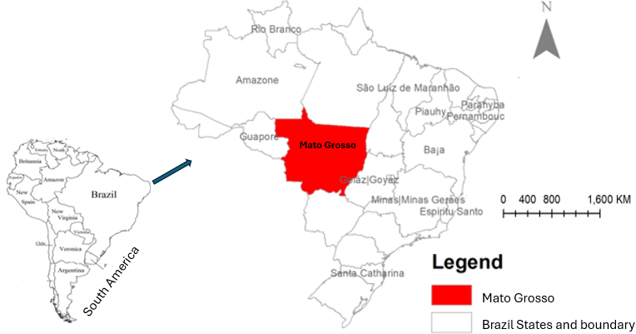

**Figure 1**. Map of South America showing Brazil and Mato Grosso State, the study area

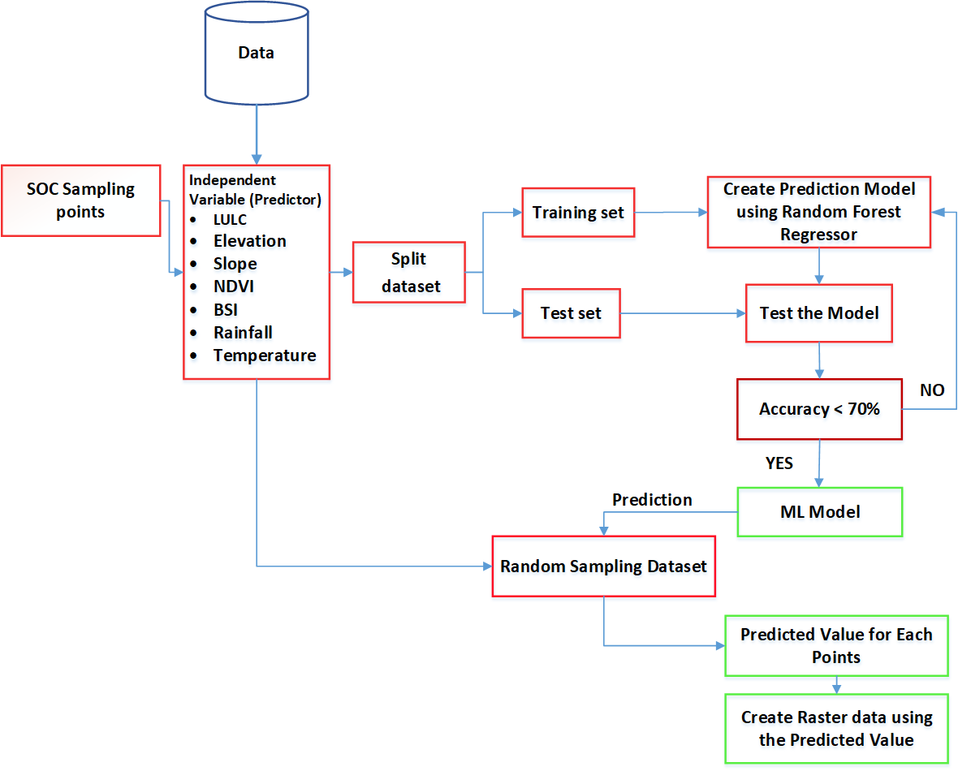

**Figure 2**. Flowchart of research methodology.

***2.2. Data collection and analysis***

The research methodology employed in this study encompasses both data collection and analysis using machine learning techniques to predict SOC stocks in the State of Mato Grosso, Brazil (**Figure 2**). The data collection process involved leveraging the capabilities of Google Earth Engine (GEE) to extract relevant geospatial information and satellite data for the study area.

The baseline dataset used as the predictor in this analysis consisted of actual SOC measurements, allowing for the establishment of a ground truth that served as both the model input and the basis for evaluating the predictive models. The sampling points were strategically distributed across various regions in Brazil, ensuring representation of diverse soil types and land cover characteristics. The Brazil SOC sampling dataset was subset to Mato Grosso, the specific study area, and the data was converted to a geospatial format from a CSV dataset.

Various predictive factors, including Average Land Surface Temperature (LST), Rainfall, Elevation, Slope, Normalized Difference Vegetation Index (NDVI), Bare Soil Index (BSI), and Land Use, were extracted from satellite imagery obtained through GEE. These factors were selected based on their relevance to SOC dynamics, as well as the findings of previous research conducted in different locations, which highlighted their potential as predictors for SOC levels.

To measure the correlation between the predictive variables and the predictors, a correlation analysis was performed on the combined datasets. The dataset was then split into training and testing datasets. The training dataset was used to build a model using the Random Forest Regression machine learning algorithm. Random Forest Regression, a powerful ensemble learning algorithm, was chosen for its ability to handle complex interactions among variables and provide accurate predictions. Many previous studies have reported high performance when using Random Forest Regression to model the relationship between predictive and predicted datasets. The testing dataset was used to evaluate the model's performance.

Furthermore, to predict SOC values across various locations, a separate set of 10,000 points was generated within the study area at an interval of 100m. These points were used to extract data from the predictive factors, and the information obtained was utilized to predict SOC values at each location.

The Random Forest Regression algorithm used in this study can be expressed by the following formula:

SOC = f(LST, rainfall, elevation, slope, NDVI, BSI, land-use)

Where:

* SOC represents the predicted Soil Organic Carbon value,
* LST represents the Average Land Surface Temperature,
* Rainfall represents the rainfall data,
* Elevation represents the elevation information,
* Slope represents the slope of the terrain,
* NDVI represents the Normalized Difference Vegetation Index,
* BSI represents the Bare Soil Index, and
* Land-use represents the land use classification.

This comprehensive research methodology encompassed data collection, feature extraction, model building using Random Forest Regression, model evaluation, feature importance analysis, and prediction of SOC values at various locations within Mato Grosso, Brazil.

The testing dataset was used to evaluate the model's performance, resulting in an accuracy score of 91.7% with a Mean Absolute Error (MAE) of 4.04.

**3. Results and discussion**

***3.1. Land use***

Significant changes in land use were observed between 2020 and 2050 (predicted) (**Table 1**). Croplands had the highest positive change (i.e., increase) of 77.6% between 2020 and 2050, while pastures recorded the highest negative change (i.e., decrease) of 31.6%. (**Figure 3**). Other land use that increased between 2020 and 2050 were settlement (8.1%), and bareland/sparse vegetation (1.6%). On the contrary, in addition to pasture, forests (4.5%), shrubland (3.8%), wetland (0.5%), and water bodies (0.1%) decreased during the three decades. Mato Grosso is one of the States in Brazil that have been experiencing many sustainable crop cultivation practices at large scales (Dou et al. 2023) thus, the substantial increase in croplands tends to be accurate prediction for the State in 2050. Brazil is the world's largest producer of many foods such as cotton, meat, corn, sugar cane and soybean (34% of the world total). The State of Mato Grosso is a major Brazilian agricultural producing State and ranks the largest in the production of most of the crop-based foods (Sun et al. 2024). The State records a high rate of annual growth, largest expansion and more than 28% of the national soybean production (Dou et al. 2023; Margarido and Turolla 2024). The 2020/2021 harvest estimates for soybean production in the State was at 36 million tons (CONAB, 2021; IMEA 2021; USDA, 2021). In the recent decades, Mato Grosso and other Brazilian States have increased its agricultural production exponentially to become one of the main global producer and exporter of food, feed, fiber, and fuel (FAO, 2020). This therefore explains the reason croplands significantly increased between 2020 and 2050 while the pastures and forests decreased as observed in our study. In affirmation to the findings of this study, the report by Bolfe et al. (2024) demonstrated that Mato Grosso State has the largest crop area of 11.78 Mha (i.e.,19.3%) of the total Brazil’s crop area as of 2022, and the next is Rio Grande do Sul which had 8.92 Mha (14.6%). It was further reported that the agricultural crop expansion potential area of Mato Grosso State is 5.12 Mha, and this value is more than 10 times when compared with most of the other Brazilian States including Rio Grande do Sul which has 0.35 Mha (Bolfe et al. 2024).



**Figure 3**. Land use in Mato Grosso for (a) 2020, (b) 2050.

Table 1. Land use, and change information in 2020 and 2050

|  |  |  |  |  |  |  |
| --- | --- | --- | --- | --- | --- | --- |
| **Land use** | **2020** | | **2050** | | **Change 2020-2050** | **Remarks** |
|  | **Area (km2)** | **%** | **Area (km2)** | **%** | **[in area(%)]** |  |
| Bareland /Spare Vegetation | 184 | 0.02 | 181 | 0.02 | 3 (1.6) | + (Increased very slightly) |
| Settlement | 876 | 0.09 | 947 | 0.1 | 71 (8.1) | + (Increased marginally) |
| Water Bodies | 3,996 | 0.43 | 3,994 | 0.43 | 2 (0.1) | - (Decreased very slightly) |
| Wetland | 22,885 | 2.45 | 22,761 | 2.44 | 124 (0.5) | - (Decreased very slightly) |
| Shrubland | 29,755 | 3.18 | 28,613 | 3.06 | 1,142 (3.8) | - (Decreased marginally) |
| Croplands | 129,714 | 13.88 | 230,317 | 24.64 | 100,603 (77.6) | + (Increased very significantly |
| Pastures | 242,417 | 25.94 | 165,835 | 17.84 | 76,582 (31.6) | - (Decreased very significantly) |
| Forests | 504,825 | 54.01 | 482,004 | 51.47 | 22,821 (4.5) | - (Decreased marginally) |
| **TOTAL** | **934,652** | **100** | **934,652** | **100** |  |  |

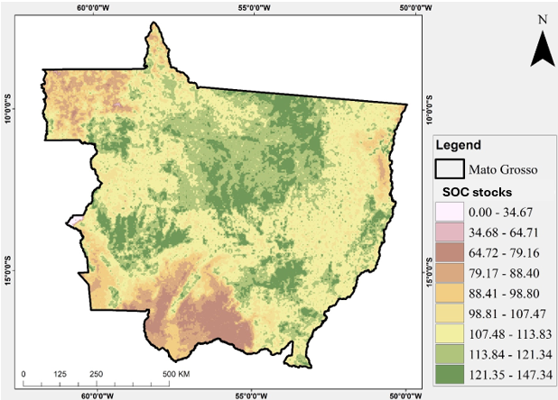

**Figure 4**. SOC stocks (Mg ha-1) in 2020

**3.2. SOC stocks**

The SOC stocks revealed high variability in area and in time during the study period (**Figure 4 and 5**). For example, in 2020, the SOC stocks range between 0 to 147.34 Mg ha-1, whereas the estimated values in 2050 were substantially higher above the values for 2020. In terms of the spatial variability and distribution, the central areas of the State showed the highest SOC stocks when compared with either the Northeast or Southern part. According to Teodoro et al. (2024) and da Silva Souza et al. (2024), spatio-temporal dynamics in SOC stocks could be attributed to many factors including (i) land use and its changes, (ii) anthropogenic activities and agricultural intensifications and management systems, (iii) environmental drivers (e.g., climate vegetation and elevation), as well as (iv) climate-smart farming policies. The adoption of good agricultural land use management will be of great benefit for both economic and ecological sectors. For example, previous studies in the region have established that a 1% increase in land productivity led to a 0.0043% reduction in GHG emissions for all Brazilian regions (Gianetti et al. 2024; Silva et al. 2016). The low SOC stocks observed in the Northeastern part could be attributed to the fact that though this region has the largest shrub but is predominated by Caatinga vegetation characterized by low rainfall where the SOC stock is approximately half of the stocks obtainable in the Atlantic Forest soils, and far below stocks in the Cerrando soils (Parras et al. 2024). The prospects of croplands and the Cerrado biome to sequestrate excess CO2 have been established in previous studies. According to Toloi et al. (2024) the Cerrado biome’s sequestration potential (3.99E + 07 tons of CO2eq) is four times higher than its actual emissions, and this neutralizes the impact caused by CO2 emissions.

**Figure 5**. predicted SOC stocks (Mg ha-1) for 2050

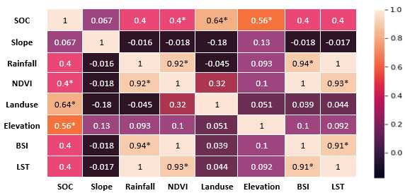

**Figure 6**. Summary of the correlation between SOC stocks and other environmental drivers

***3.3. SOC stocks, land use and other environmental drivers***

The correlation result reveals notable interrelationships between the drivers of SOC stocks (**Figure 6**). For example, soil organic carbon per hectare (Mg ha-1) exhibits a strong positive correlation with land use (r = 0.643), and elevation (r = 0.556), whereas a moderate positive correlation with rainfall (r = 0.398), normalized difference vegetation index (NDVI) (r = 0.397), bare soil index (BSI) (r = 0.395), and land surface temperature (LST) (r = 0.398). SOC shows a weak positive correlation with slope (r = 0.067). Rainfall reveals a strong positive correlation with NDVI (r = 0.919), BSI (r = 0.939), and LST (r = 0.999), indicating a robust relationship between higher rainfall and increased vegetation density and consequently enhanced vegetation health and surface temperature. These findings highlight the interlinks among the variables and provide insights into their associations. Many studies have reported strong relationships between SOC and land use in Brazil (Teodoro et al. 2024; da Silva Souza et al. 2024), and globally (Gao et al. 2024; Zomer, et al. 2017). In a global scale, it has been reported that if the SOC content in the top soil in cropland increased from 0.27% to 0.54%, a stock ranging from 0.56 to 1.15 t C.ha.yr-1 could be sequestered , and this could represent 0.90 to 1.85 Pg C yr-1 for at least a continuous 20 years of the sequestration (Zomer, et al. 2017).

**Table 2**. Summarized OLS regression results used for model validation

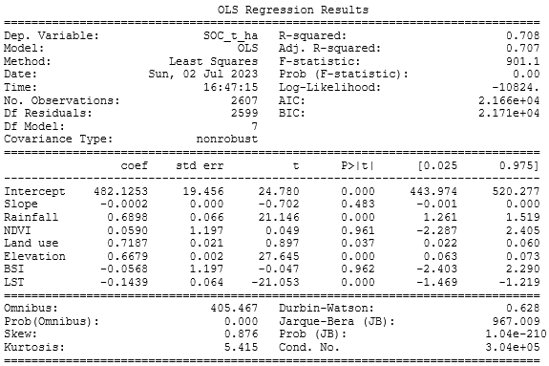

The OLS regression analysis was conducted with a dataset consisting of 2,607 observations (**Table 2**). The model yielded an R-squared value of 0.708, indicating that approximately 70.8% of the variability in the dependent variable (SOC Mg ha-1) can be explained by the independent variables included in the model (**Table 2**). The adjusted R-squared value was 0.707, suggesting that the model's predictive power remains consistent even after accounting for the number of predictors. Among the independent variables, land use, rainfall, elevation, and LST (Land Surface Temperature) were found to be statistically significant predictors of SOC. Land use, rainfall and elevations had positive coefficients of 0.7187, 0.6898, and 0.6679 respectively which implies that an increase or change in land use, rainfall, and elevations are associated with either a change in SOC (Teodoro et al. 2024; da Silva Souza et al. 2024; Zomer, et al. 2017). On the other hand, LST had a negative coefficient of -0.1439, suggesting that higher LST values are associated with lower SOC values.

**Conclusion**

The study revealed significant changes in land use between 2020 and 2050 with croplands indicating the highest positive change whereas pastures showed the highest negative change. In exclusion of croplands, settlement, and bare land/sparse vegetation also increased marginally, while forests decreased significantly as pastures, shrubland and wetland had marginal decrease during the three decades. The State of Mato Grosso as obtainable in other high agricultural producing regions of Brazil has been popular for the expansion of its arable lands by converting the pastures and forests to croplands. This approach has placed the State and the nation among the top producers and exporters of agricultural products used for different purposes including food, fodder, fibre, and energy (biofuel, biogas, etc). As the demands for these products of soybean, maize, sugar cane, oil palm, cowpea, and others continue to increase, croplands in Mato Grosso will continue to increase.

The spatio-temporal analysis demonstrated that SOC stocks had high variability with 2050 recording substantially higher (i.e., more than 50%) when compared with the stocks found in 2020. The strong relationships between land use and SOC can never be overemphasized especially when the topsoil layer is concerned as the case of this study. For example, the Central areas of the State prevailed with larger SOC stocks relative to either the Northeast or Southern part because of the adoption of climate-smart agriculture in the Cerrado region which dominates the central part. In contrast, the Northeast and South have Caatinga and Atlantic vegetations respectively with lower SOC stocks than the Cerrado croplands. The increase in SOC stocks in the next 30 years is a promising indication that the adoption of carbon farming systems (such as integrated crop-livestock forest, crop-livestock) in the established croplands were economically and environmentally sustainable. This study will contribute to informing the decision makers on the need to enact more agricultural policies geared towards low carbon farming. In addition to consolidating food security, the findings from the study will support the Brazilian government to implement additional agendas to achieve its Nationally Determined Contributions (NDCs) to the United Nations Framework Convention on Climate Change (UNFCCC) under the 2015 Paris Agreement for lower CO2 emissions and climate change mitigation though agriculture.

**Funding**

**Acknowledgements**

The authors acknowledge the support from the PhD students and others who provided part of the data.

**References**

Alkimim, A., Sparovek, G. and Clarke, K.C., 2015. Converting Brazil's pastures to cropland: An alternative way to meet sugarcane demand and to spare forestlands. Applied Geography, 62, pp.75-84. https://doi.org/10.1016/j.landusepol.2016.03.005

Almeida LLS, Frazão AA, Lessa TAM, Fernandes LA, Veloso ALC, Lana AMQ, de Souza, I.A., Pegoraro, R.F. and Ferreira, E.A. (2021). Soil carbono and nitrogen stocks and the quality of soil organic matter under silvopastoril sistems in the Brazilian Cerrado. Soil & Tillage Res. doi: 10.1016/j.still.2020.104785

Arias, P.A., Rivera, J.A., Sörensson, A.A., Zachariah, M., Barnes, C., Philip, S., Kew, S., Vautard, R., Koren, G., Pinto, I. and Vahlberg, M., 2024. Interplay between climate change and climate variability: the 2022 drought in Central South America. Climatic Change, 177(1), 6. https://doi.org/10.1007/s10584-023-03664-4

Arunrat, N., Sereenonchai, S., Kongsurakan, P., Hatano, R., 2022. Soil organic carbon and soil erodibility response to various land-use changes in northern Thailand. Catena 219, 106595. https://doi.org/10.1016/j.catena.2022.106595.

Black, E., 2024. Global change in agricultural flash drought over the 21st century. Advances in Atmospheric Sciences, 41(2), 209-220.

Bolfe, É.L.; Victoria, D.d.C.; Sano, E.E.; Bayma, G.; Massruhá, S.M.F.S.; de Oliveira, A.F. Potential for Agricultural Expansion in Degraded Pasture Lands in Brazil Based on Geospatial Databases. Land 2024, 13, 200. https://doi.org/10.3390/land13020200

Cerri, C.E.P., de Castro Mello, F.F., Renteria, N.B. and Cherubin, M.R., 2024. Public Policies and Initiatives to Promote Soil Health and Carbon Sequestration in Brazil. Soil Health and Sustainable Agriculture in Brazil, 196.

Cohn, A.S., Gil, J., Berger, T., Pellegrina, H. and Toledo, C., 2016. Patterns and processes of pasture to crop conversion in Brazil: Evidence from Mato Grosso State. Land use policy, 55, pp.108-120. https://doi.org/10.1016/j.apgeog.2015.04.008

CONAB (2021). Histórico da soja - Mato Grosso. SUREG/MT, Mato Grosso.

da Silva Souza, C.B., da Silva Farias, P.G., Rosset, J.S., Ozório, J.M.B., Panachuki, E., Schiavo, J.A. and Lima, P.R., 2024. Chemical characterization of soil organic matter in differents management practices in the Cerrado-Pantanal ecotone. Scientia Plena, 20(1), 010201. Doi: 10.14808/sci.plena.2024.010201

Das, D., Panesar, G., Panesar, P.S. and Kumar, M., 2024. Soybean Meal: The Reservoir of High-Quality Protein. In Oilseed Meal as a Sustainable Contributor to Plant-Based Protein: Paving the Way Towards Circular Economy and Nutritional Security (pp. 31-52). Cham: Springer International Publishing. https://doi.org/10.1007/978-3-031-47880-2_2

DeFries, R.S., Foley, J.A. and Asner, G.P., 2004. Land‐use choices: Balancing human needs and ecosystem function. Frontiers in Ecology and the Environment, 2(5), pp.249-257.

Dou, Y., Da Silva, R.F.B., Batistella, M., Torres, S., Moran, E. and Liu, J., 2023. Mapping crop producer perceptions: The role of global drivers on local agricultural land use in Brazil. Land Use Policy, 133, p.106862. <https://doi.org/10.1016/j.landusepol.2023.106862>.

Faggian, V., Bini, C., Zilioli, D.M., 2012. Carbon stock evaluation from topsoil of forest stands in Ne Italy. Int. J. Phytoremediation 14 (4), 415–428. https://doi.org/ 10.1080/15226514.2011.620656.

Falcão KS, Monteiro FN, Ozório JMB, Souza CBS, Farias PGS, Menezes RS, et al. Estoque de carbono e agregação do solo sob diferentes sistemas de uso no Cerrado. Braz J Environ Sci. 2020 Jun;55(2):242- 55. doi: 10.5327/Z2176-947820200695

Fantoni, S., Casagli, N., Solidoro, C. and Cobal, M., 2024. Quantitative Sustainability: Interdisciplinary Research for Sustainable Development Goals (p. 187). Springer Nature. https://library.oapen.org/handle/20.500.12657/86887

FAO, 2020, FAOSTAT Statistics Database.

Felicianno CA, Lopes AWP, Silva MC, Costa MBB, Ferrante VLSB. Qualidade do solo em sistemas de manejo convencional e orgânico na propriedade da agricultura familiar. Rev Interdiscipl Tecnol Educ. 2018;4(1):1-22.

Funes, I., Sav´e, R., Rovira, P., Molowny-Horas, R., Alcaniz, ˜ J.M., Ascaso, E., Herms, I., Herrero, C., Boixadera, J., Vayreda, J., 2019. Agricultural soil organic carbon stocks in the north-eastern Iberian Peninsula: drivers and spatial variability. Sci. Total Environ. 668, 283–294. https://doi.org/10.1016/j.scitotenv.2019.02.317.

Gao, H., Gong, J., Liu, J. and Ye, T., 2024. Effects of land use/cover changes on soil organic carbon stocks in Qinghai-Tibet plateau: A comparative analysis of different ecological functional areas based on machine learning methods and soil carbon pool data. Journal of Cleaner Production, 434, p.139854. https://doi.org/10.1016/j.jclepro.2023.139854

Gao, H., Gong, J., Liu, J. and Ye, T., 2024. Effects of land use/cover changes on soil organic carbon stocks in Qinghai-Tibet plateau: A comparative analysis of different ecological functional areas based on machine learning methods and soil carbon pool data. Journal of Cleaner Production, 434, p.139854. https://doi.org/10.1016/j.jclepro.2023.139854.

Gianetti, G.W. and de Souza Ferreira Filho, J.B., 2024. Pasture recovery, emissions, and the Brazilian Paris agreement commitments. Land Use Policy, 141, p.107118. https://doi.org/10.1016/j.landusepol.2024.107118

Hamza, M., Basit, A.W., Shehzadi, I., Tufail, U., Hassan, A., Hussain, T., Siddique, M.U. and Hayat, H.M., 2024. Global Impact of Soybean Production: A Review. Asian Journal of Biochemistry, Genetics and Molecular Biology, 16(2), pp.12-20. https://doi.org/10.9734/ajbgmb/2024/v16i2357

IMEA IMG de EA (2021). Boletim de soja. IMEA, Cuiabá.

IPCC (2015). Climate Change 2014: synthesis report. Contribution of working groups I, II and III to the fifth assessment report of the intergovernmental panel on climate change [Core Writing Team, R.K. Pachauri and L.A. Meyer (eds.)]. Intergovernmental Panel on Climate Change - IPCC, Geneva, Switzerland.

Kitavi, E.K., Ndung’u, C.K. and Mwangi, M., 2024. The influence of intensive agriculture on soil properties and nutrient availability in Kauwi and Zombe wards of Kitui County, Kenya. East African Journal of Agriculture and Biotechnology, 7(1), pp.1-12. https://doi.org/10.37284/eajab.7.1.1680

Lal R. Digging deeper: A holistic perspective of factors affecting soil organic carbon sequestration in agroecosystems. Global Chang Biol. 2018 Jan;24(8):3285-01. doi: 10.1111/gcb.14054

Lal R. Managing soils for resolving the conflict between agriculture and nature: The hard talk. Eur J Soil Sci. 2019 Jun;71(1):1-9. doi: 10.1111/ejss.12857

Li, H., Keune, J., Gou, Q., Holgate, C.M. and Miralles, D., 2024. Heat and moisture anomalies during crop failure events in the Southeastern Australian wheat belt. Earth's Future, 12(3), e2023EF003901.

Liang, S., Sun, N., Meersmans, J., Longdoz, B., Colinet, G., Xu, M. and Wu, L., 2024. Impacts of climate change on crop production and soil carbon stock in a continuous wheat cropping system in southeast England. Agriculture, Ecosystems & Environment, 365,108909.

Lozano-García, B., Parras-Alcantara, ´ L., Brevik, E.C., 2016. Impact of topographic aspect and vegetation (native and reforested areas) on soil organic carbon and nitrogen budgets in Mediterranean natural areas. Sci. Total Environ. 544, 963–970. https:// doi.org/10.1016/j.scitotenv.2015.12.022.

Lu, J., Zhang, W., Li, Y., Liu, S., Khan, A., Yan, S., Hu, T., Xiong, Y., 2023. Effects of reduced tillage with stubble remaining and nitrogen application on soil aggregation, soil organic carbon and grain yield in maize-wheat rotation system. Eur. J. Agron. 149, 126920 https://doi.org/10.1016/j.eja.2023.126920.

Luo, X.-S., Muleta, D., Hu, Z., Tang, H., Zhao, Z., Shen, S., & Lee, B.-L. (2017). Inclusive development and agricultural adaptation to climate change. Current Opinion in Environmental Sustainability, 24, 78–83. https://doi.org/10.1016/j.cosust.2017.02.004

Maier, M., Weber, T.K.D., Fiedler, J., Fuß, R., Glatzel, S., Huth, V., Jordan, S., Jurasinski, G., Kutzbach, L., Schafer, ¨ K., Weymann, D., Hagemann, U., 2022. Introduction of a guideline for measurements of greenhouse gas fluxes from soils using non-steady-state chambers. J. Plant Nutr. Soil Sci. 185 (4), 447–461. https:// doi.org/10.1002/jpln.202200199.

Majidian, P., Ghorbani, H.R. and Farajpour, M., 2024. Achieving agricultural sustainability through soybean production in Iran: Potential and challenges. Heliyon, 10(4). https://doi.org/10.1016/j.heliyon.2024.e26389

Margarido, M.A. and Turolla, F.A., 2024. Brazilian soybeans: quo vadis?. Theoretical and Applied Economics, 31(1 (638), Spring), pp.137-160.

Miranda EE de, Carvalho CA de, Oshiro OT (2017). Atribuição, ocupação e uso das terras no estado do Mato Grosso. EMBRAPA, Campinas.

Ni, H., Liu, C., Sun, B., Liang, Y., 2022. Response of global farmland soil organic carbon to nitrogen application over time depends on soil type. Geoderma 406, 115542. https://doi.org/10.1016/j.geoderma.2021.115542.

NOAA (2021). Carbon dioxide peaks near 420 parts per million at Mauna Loa observatory. https://resea rch.noaa.gov/article/ArtMID/587/ArticleID/2764/Coronavirus-response-barely-slows-rising-carbon-dioxide. Accessed Jun 9, 2021

Nwaogu, C., & Cherubin, M.R. (2024). Integrated agricultural systems: The 21st century nature-based solution for resolving the global FEEES challenges. Advances in Agronomy. <https://doi.org/10.1016/bs.agron.2024.02.003>

Nwaogu, C., Oti, N.N., Enaruvbe, G.O. and Cherubin, M.R., 2024. Crop-Livestock-Forest System as Nature-Based Solutions to Combating Climate Change and Achieving SDGs in Brazil. In: Leal Filho W, Nagy GJ, Ayal D (ed) Handbook of Nature-Based Solutions to Mitigation and Adaptation to Climate Change. Springer, Cham. pp.1-30. https://doi.org/10.1007/978-3-030-98067-2_124-1

Nyarko, I.; Nwaogu, C.; Diagi, B.E.; Hájek, M. The Dynamics and Potential of Carbon Stocks as an Indicator of Sustainable Development for Forest Bioeconomy in Ghana. Forests 2024, 15, 256. https://doi.org/ 10.3390/f15020256

Ozorio JMB, Rosset JS, Schiavo JA, Souza CBS, Farias PGS, Oliveira NS, et al. Physical fractions of organic matter and mineralizable soil carbon in forest fragments of the Atlantic Forest. Rev Ambient Água. 2020 Nov;15(6):1-19. doi: 10.4136/ambi-agua.2601

Pan, J., Zhang, L., He, X., Chen, X., Cui, Z., 2019. Long-term optimization of crop yield while concurrently improving soil quality. Land Degrad. Dev. 30 (8), 897–909. https://doi.org/10.1002/ldr.3276.

Parras, R., de Mendonça, G.C., da Costa, L.M., Rocha, J.R., Costa, R.C.A., Valera, C.A., Fernandes, L.F.S., Pacheco, F.A.L. and Pissarra, T.C.T., 2024. Land use footprints and policies in Brazil. Land Use Policy, 140, p.107121. https://doi.org/10.1016/j.landusepol.2024.107121

Pathakoti M, Rajan KS, Kanchana AL, Santhoshi T, Mahalakshmi DV, Sujatha P, Taori A, Bothale RV, Chauhan P, Shaik I, Kumar R. Neighbouring effect of land use changes and fire emissions on atmospheric CO2 and CH4 over suburban region of India (Shadnagar). Science of The Total Environment. 2024, 23:171226. https://doi.org/10.1016/j.scitotenv.2024.171226

Ramesh, T., Bolan, N.S., Kirkham, M.B., Wijesekara, H., Kanchikerimath, M., Srinivasa Rao, C., Sandeep, S., Rinklebe, J., Ok, Y.S., Choudhury, B.U., Wang, H., Tang, C., Wang, X., Song, Z., Freeman Ii, O.W., 2019. Chapter One - soil organic carbon dynamics: impact of land use changes and management practices: a review. In: Sparks, D.L. (Ed.), Advances in Agronomy. Academic Press, pp. 1–107.

Rocha, A. and Gonçalves, E., 2024. Measuring the causal effect of no-till system adoption on Brazilian natural areas. Soil and Tillage Research, 239, p.106053.

Samson ME, Chantigny MH, Vanasse A, Menasseri-Aubry S, Royer I, Angers DA. Management practices differently affect particulate and mineral-associated organic matter and their precursors in arable soils. Soil Biol Biochem. 2020 Sep;148:1-32. doi: 10.1016/j.soilbio.2020.107867

Sharma, S., Kaur, G., Singh, P., Ghuman, R.S., Singh, P. and Vyas, P., 2024. Distinct changes in soil organic matter quality, quantity and biochemical composition in response to land-use change to diverse cropping systems and agroforestry in north-western India. Agroforestry Systems, pp.1-25. https://doi.org/10.1007/s10457-024-00976-x

Silva AMM, Cardoso EJBN (2021). A Sustentabilidade ambiental e os serviços ecossistêmicos. Editora Appris

Silva, R., Barioni, O. de, L.G., Hall J.A.J., Folegatti Matsuura M., Zanett Albertini T., Fernandes F.A., Moran D. (2016). Increasing beef production could lower greenhouse gas emissions in Brazil if decoupled from deforestation Nat. Clim. Change, 6 (5) (2016), pp. 493-497, 10.1038/nclimate2916

Simoes, R., Picoli, M.C., Camara, G., Maciel, A., Santos, L., Andrade, P.R., Sánchez, A., Ferreira, K. and Carvalho, A., 2020. Land use and cover maps for Mato Grosso State in Brazil from 2001 to 2017. Scientific Data, 7(1), p.34. <https://doi.org/10.1038/s41597-020-0371-4>.

Sooryamol, K.R., Kumar, S., David Raj, A., Sankar, M. (2024). Smart Farming and Carbon Sequestration to Combat the Climate Crisis. In: Chatterjee, U., Shaw, R., Kumar, S., Raj, A.D., Das, S. (eds) Climate Crisis: Adaptive Approaches and Sustainability. Sustainable Development Goals Series. Springer, Cham. https://doi.org/10.1007/978-3-031-44397-8_16

Sun, J., Yang, L., Wang, X., Lun, F., Lu, M., Sun, X., Yang, P., Wu, W. and Liu, J., 2024. Workable solutions for sustainably feeding the Chinese population. Resources, Conservation and Recycling, 205, p.107530. <https://doi.org/10.1016/j.resconrec.2024.107530>.

Teodoro, P.E., Rossi, F.S., Teodoro, L.P.R., Santana, D.C., Ratke, R.F., de Oliveira, I.C., Della Silva, J.L., de Oliveira, J.L.G., da Silva, N.P., Baio, F.H.R. and Torres, F.E., 2024. Soil CO2 emissions under different land-use managements in Mato Grosso do Sul, Brazil. Journal of Cleaner Production, 434, p.139983. <https://doi.org/10.1016/j.jclepro.2023.139983>

Teodoro, P.E., Rossi, F.S., Teodoro, L.P.R., Santana, D.C., Ratke, R.F., de Oliveira, I.C., Della Silva, J.L., de Oliveira, J.L.G., da Silva, N.P., Baio, F.H.R. and Torres, F.E., 2024. Soil CO2 emissions under different land-use managements in Mato Grosso do Sul, Brazil. Journal of Cleaner Production, 434, p.139983. https://doi.org/10.1016/j.jclepro.2023.139983

Toloi, M.N.V., Bonilla, S.H., Toloi, R.C. and de Alencar Nääs, I., (2024). Potential for carbon sequestration in different biomes and CO2 emissions in soybean crop. Environment, Development and Sustainability, 26:3331–3347. https://doi.org/10.1007/s10668-022-02824-3.

Toloi, M.NV, Bonilla SH, Toloi RC, de Alencar Nääs I. (2022). Potential for carbon sequestration in different biomes and CO2 emissions in soybean crop. https://doi.org/10.1007/s10668-022-02824-3 1 3

USDA (2021). World Agricultural Production. https:// apps. fas. usda. gov/ psdon line/ circu lars/ produ ction. pdf. Access 20 March 2024.

Wulanningtyas HS, Gong Y, Li P, Sakagami N, Nishiwaki J, Komatsuzaki M. A cover crop and notillage system for enhancing soil health by increasing soil organic matter in soybean cultivation. Soil Tillage & Res. 2021 Jan;205:1-14. doi: 10.1016/j.still.2020.104749

Zhang, T., Li, Y. and Wang, M., 2024. Remote sensing-based prediction of organic carbon in agricultural and natural soils influenced by salt and sand mining using machine learning. Journal of Environmental Management, 352, p.120107. https://doi.org/10.1016/j.jenvman.2024.120107

Zomer, R.J., Bossio, D.A., Sommer, R., Verchot, L.V., Global Sequestration Potential of Increased Organic Carbon in Cropland Soils. Sci Rep 7, 15554 (2017). <https://doi.org/10.1038/s41598-017-15794-8>

**Requirements**

Add the 1990 information to that table

Add LULC for 1990

SOC map for 1990

Predicting Soil Organic Carbon (SOC) for the year 2050 involves leveraging historical SOC data from 1990 and 2020, alongside various environmental parameters such as slope(𝑥1​), elevation (𝑥2​), Land Cover (LC) (𝑥3​), bare soil index (𝑥4), rainfall (𝑥5​) , Land Surface Temperature (LST) (𝑥6) , and NDVI (Normalized Difference Vegetation Index) (𝑥37). Utilizing a Random Forest model, we aim to capture the intricate relationships between these parameters and SOC dynamics to forecast SOC levels for the future.

The scientific inquiry begins with the meticulous collection and preparation of data. Soil Organic Carbon (SOC) measurements spanning 1990 and 2020 constitute the focal point of our investigation. In the absence of comprehensive statewide data, we meticulously utilize measurements gathered at various points to model the relationship and predict SOC dynamics for these two pivotal years. By employing advanced statistical methodologies and machine learning, we analyze the interplay between SOC and environmental parameters to derive robust insights for both 1990 and 2020. Subsequently, armed with the results and analytical findings from these pivotal years, we extend our analysis to forecast SOC dynamics for the year 2050. This sequential approach, rooted in empirical data and methodological rigor, ensures the reliability and robustness of our scientific inquiry into the dynamics of Soil Organic Carbon over time.

Mathematically, the prediction for a new sample (𝑥​) using Random Forest regression can be calculated as follows:

y^​(*x*)=*N*1​∑*i*=1*N*​*Ti*​(*x*)

* 𝑦^(𝑥)*y*^​(*x*) is the predicted SOC value for the sample 𝑥*x*.
* 𝑁*N* is the number of decision trees in the forest.
* 𝑇𝑖(𝑥)*Ti*​(*x*) is the prediction from the 𝑖*i*-th decision tree for the input 𝑥*x*.

Once the Random Forest model is trained, it is ready for prediction. Projected values for the environmental parameters corresponding to the year 2050 are inputted into the model. These projected values serve as inputs for the model, which then generates predictions for SOC levels in 2050 based on the learned relationships between the input features and SOC.

The prediction process culminates in estimating SOC values for 2050, providing valuable insights into potential future trends in soil carbon sequestration. Through this methodology, we leverage machine learning techniques to make informed predictions about SOC dynamics, aiding in environmental management and policy decision-making.

**Another method**

The methodology begins by training Random Forest models for predicting Soil Organic Carbon (SOC) levels in 1990 and 2020. These models utilize historical SOC measurements (𝑉1990*V*1990​, 𝑉2020*V*2020​) alongside environmental parameters (𝑥1,𝑥2,...,𝑥𝑛*x*1​,*x*2​,...,*xn*​) to make predictions. The Random Forest algorithm constructs multiple decision trees, with each tree making its prediction based on a subset of the data. The predicted SOC value (𝑦^1990*y*^​1990​, 𝑦^2020*y*^​2020​) for a given set of environmental parameters (𝑥*x*) can be expressed as:

𝑦^1990=1𝑁∑𝑖=1𝑁𝑇𝑖(𝑥)*y*^​1990​=*N*1​∑*i*=1*N*​*Ti*​(*x*) 𝑦^2020=1𝑁∑𝑖=1𝑁𝑇𝑖(𝑥)*y*^​2020​=*N*1​∑*i*=1*N*​*Ti*​(*x*)

where 𝑁*N* is the number of decision trees, and 𝑇𝑖(𝑥)*Ti*​(*x*) represents the prediction from the 𝑖*i*-th decision tree for the input 𝑥*x*.

Having validated these models, the next step involves extrapolating SOC predictions for the year 2050. This extrapolation relies on projecting future values of environmental parameters (𝑥12050,𝑥22050,...,𝑥𝑛2050*x*12050​,*x*22050​,...,*xn*2050​) based on anticipated trends or predictions. The trained Random Forest models are then applied to these projected parameter values to predict SOC levels for 2050 using extrapolation. Mathematically, the predicted SOC value (𝑦^2050*y*^​2050​) for the projected environmental parameter values (𝑥2050*x*2050) can be expressed as:

𝑦^2050=1𝑁∑𝑖=1𝑁𝑇𝑖(𝑥2050)*y*^​2050​=*N*1​∑*i*=1*N*​*Ti*​(*x*2050)

where 𝑁*N* is the number of decision trees, and 𝑇𝑖(𝑥2050)*Ti*​(*x*2050) represents the prediction from the 𝑖*i*-th decision tree for the input 𝑥2050*x*2050.

Validation and uncertainty assessment are critical components of this methodology. Predicted SOC values for 2050 undergo rigorous validation using independent datasets or cross-validation techniques. Additionally, the uncertainty associated with extrapolated predictions is assessed, considering factors such as data quality, model assumptions, and the distance of extrapolation.

In conclusion, this methodology leverages Random Forest models trained on historical data to predict SOC levels for 2050 through extrapolation. By incorporating mathematical formulas and rigorous validation procedures, it provides a robust framework for forecasting SOC dynamics into the future, offering valuable insights for environmental management and decision-making.