2.5 Dataset summary and preprocessing

2.5.1 Dataset composition
The vibroacoustic recordings collected as described in Section 2.4 provided the input to the classification pipeline. Each recording corresponds to a single monitoring session of a known taxon at a known density, organised by day, batch and treatment. Following an initial inventory, the primary dataset comprised 1,801 recordings totalling approximately 146.8 hours of audio across three target taxa (ants, termites and beetle larvae) and a control condition containing no target organism. The per-taxon composition is summarised in Table 2.1. A second recording season, collected in the following year, is introduced later in relation to the cross-season generalisation experiments; unless stated otherwise, the methodology described below refers to the primary dataset.

Table 2.1. Composition of the primary dataset after cleaning, by taxon and density. Window counts refer to the 5-second analysis windows produced by the preprocessing pipeline (Section 2.5.3).
The three target taxa were near-balanced at the recording level, while the control condition was comparatively smaller. Two organism densities were represented for each taxon (low and high), enabling later analysis of the relationship between organism density and classification performance.

2.5.2 Data cleaning and quality control
Prior to analysis, several cleaning rules were applied to remove non-representative recordings and to ensure that only complete monitoring sessions contributed to the dataset. The first and last recordings of each session were excluded, as these were most likely to contain handling noise associated with the placement and removal of equipment. Recordings shorter than 60 seconds were treated as recorder glitches and discarded, while partial recordings between 60 and 290 seconds were retained and flagged. A small number of sessions exhibiting atypical recording counts or localised recording-quality issues were identified during inventory and annotated accordingly. Folder-derived labels were normalised to a consistent taxon and density scheme, and recordings from parallel monitoring chambers were treated as independent biological replicates.
Data integrity was verified before modelling. Recordings were confirmed to share identical capture settings, and a content-based comparison (using file-size screening followed by hashing of candidate matches) was used to confirm that no recording was duplicated within or across recording seasons, thereby preventing any possibility of data leakage between training and evaluation partitions.

2.5.3 Audio preprocessing pipeline
All recordings were processed through a fixed preprocessing pipeline to convert raw audio into a representation suitable for convolutional modelling. Audio was analysed at its native sampling rate of 48 kHz. A fourth-order Butterworth bandpass filter with cut-off frequencies of 200 Hz and 12 kHz was applied to each recording. The lower cut-off attenuated very-low-frequency handling and environmental noise below the range of the target signals, while the upper cut-off retained the frequency band in which biological signal was observed to occur without introducing the high-frequency recorder noise floor.
Each filtered recording was divided into non-overlapping analysis windows of 5 seconds for evaluation; during training, windows were extracted with 50% overlap to increase the number of training examples. Every window was converted to a mel-scaled spectrogram using a short-time Fourier transform with a window length of 2,048 samples and a hop length of 1,024 samples, mapped onto 128 mel-frequency bands spanning 200 Hz to 12 kHz. Spectrogram magnitudes were converted to a decibel scale using a fixed absolute reference, so that the resulting values were directly comparable across recordings. Each window was thus represented as a single-channel image of size 128 × 235.
The decibel-scaled spectrograms were standardised using global normalisation statistics (mean and standard deviation) computed once over the training data, ensuring that all windows were placed on a common scale before being presented to the network. This global scheme was adopted as the default; an alternative per-recording normalisation scheme, motivated by the cross-season experiments, is described in the relevant experimental section.

2.5.4 Dataset partitioning
The dataset was partitioned into training, validation and test sets in a 70:15:15 ratio. Partitioning was performed at the session level rather than the recording level: all recordings belonging to a given monitoring session were assigned to the same partition. This prevented recordings from the same session — which share acoustic and environmental characteristics — from appearing in both training and evaluation, avoiding an optimistic bias in reported performance. Partitioning was stratified by taxon to preserve class balance across the three sets, and a fixed random seed was used throughout to ensure reproducibility.

2.6 Deep learning process using convolutional neural networks
The classification task was framed as the assignment of each recording to one of the target taxa on the basis of its vibroacoustic signal. Because a single recording comprises many analysis windows, classification proceeded in two stages: a convolutional neural network first assigned class probabilities to each 5-second window, and these window-level predictions were then aggregated to produce a single prediction for the whole recording (Section 2.6.4). Recording-level classification was adopted as the primary objective, as it corresponds to the practical goal of identifying which invertebrate is present in a recording.

2.6.1 Baseline model
To establish a reference against which the convolutional model could be assessed, a logistic-regression baseline was trained on summary features derived from each spectrogram (the per-band mean, standard deviation and maximum). This baseline captured the average spectral profile of each window but discarded fine-grained time–frequency structure. Its performance confirmed that the target taxa were not linearly separable on summary statistics alone — in particular, ants and termites were frequently confused — motivating the use of a convolutional model able to learn spatially structured time–frequency patterns.

2.6.2 Network architecture
A convolutional neural network was designed to operate directly on the mel-spectrogram windows. The architecture followed a compact VGG-style design comprising four sequential convolutional blocks with increasing channel depth (32, 64, 128 and 256 channels). Each block contained two 3 × 3 convolutional layers, each followed by batch normalisation and a rectified-linear (ReLU) activation, and concluded with 2 × 2 max-pooling that progressively reduced the spatial resolution of the feature maps. The output of the final block was reduced to a fixed-length feature vector by global average pooling, passed through a dropout layer with a rate of 0.5 for regularisation, and mapped to the class scores by a single fully-connected layer. The complete network contained approximately 1.17 million trainable parameters. Its structure is shown in Figure 2.1.
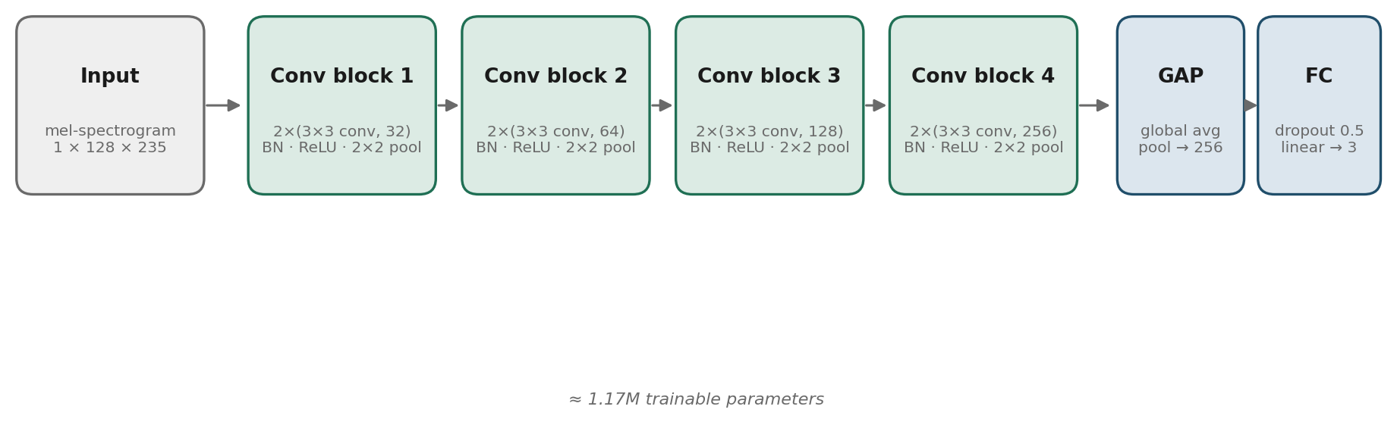
Figure 2.1. Architecture of the convolutional neural network. Each 5-second mel-spectrogram window (1 × 128 × 235) passes through four convolutional blocks of increasing depth, global average pooling, dropout and a linear classification head producing scores for the three target taxa.

2.6.3 Training procedure
The network was trained to minimise a cross-entropy loss between the predicted and true taxon labels. To account for the modest class imbalance in the training data, the loss was weighted by the inverse frequency of each class. Optimisation used the Adam optimiser with an initial learning rate of 1 × 10⁻³ and a batch size of 64. The learning rate was reduced when validation performance plateaued, and training was halted by early stopping when the validation macro-averaged F1 score failed to improve over a fixed number of epochs, with the best-performing model checkpoint retained. A fixed random seed governed weight initialisation and data shuffling to support reproducibility. Model development was carried out using GPU acceleration, with the training feature set held in memory to reduce data-loading overhead.

2.6.4 Aggregation and evaluation
Recording-level predictions were obtained by averaging the class probabilities produced by the network across all analysis windows of a recording and selecting the class with the highest mean probability. This soft-voting aggregation exploits the fact that errors on individual windows — many of which contain little biological activity — tend to average out when combined across a full recording, while consistent evidence for the true class accumulates.
Model performance was evaluated at the recording level as the primary metric, with window-level and session-level performance reported as secondary measures. Both classification accuracy and the macro-averaged F1 score were reported; the macro-averaged F1 score, which weights each class equally regardless of its frequency, was adopted as the principal summary metric in view of the class imbalance. Per-class precision, recall and F1 scores, together with confusion matrices, were used to characterise the specific patterns of misclassification between taxa.

