CS425 - Software Architecture
LAB 6
Java Development Environment
and Coding Practice Exercises
Student Records Management Command-Line Application
Prepared by: Samson Kitigo
Student ID: 618666
Date: August 4, 2026
Implementation: Java 8-compatible source and bytecode; verified on installed JDK 26
Submission package: A complete local Git repository with production source, dependency-free tests, actual terminal transcripts, rendered evidence screenshots, and this report.

Delivered Components
- Student domain model with all required fields, three constructors, getters, and setters.
- Executable student-records application with required sorting and Platinum Alumni logic.
- HelloWorld and second-biggest exercises, plus 13 automated verification checks.
- Evidence images generated from actual captured command output.

1. Assignment Coverage
The implementation maps each Lab 6 requirement to a concrete source file or verified result.
Requirement | Implementation evidence | Status
Student model | Student.java: fields, three constructors, accessors, mutators | Complete
Required packages | edu.mum.cs.cs425.demos.studentrecordsmgmtapp and .model | Complete
Ascending student names | printListOfStudents copies and sorts the array by name | Complete
Platinum Alumni | 30-year cutoff; admission date descending | Complete
printHelloWorld | Handles multiples of 5, 7, and both | Complete
findSecondBiggest | One-pass, second distinct maximum; no sorting | Complete
Execution evidence | Four transcripts and screenshots in evidence/ | Complete
Git repository | Initialized and committed locally; remote publication pending | Prepared

Project Structure
src/main/java/.../model/Student.java
src/main/java/.../MyStudentRecordsMgmtApp.java
src/test/java/.../Lab6SelfTest.java
build.sh | run.sh | test.sh | capture-evidence.sh
evidence/ | docs/ | README.md

Build and Execution
./build.sh
./run.sh all
./test.sh
./capture-evidence.sh
Compatibility: The build uses javac --release 8. javap reports class-file major version 52, which is the Java 8 bytecode level.

2. Java Development Environment
Item | Verified value
Active runtime/compiler | Oracle Java 26.0.2
Additional installed JDK | OpenJDK 21.0.9
Target compatibility | Java 8 source/bytecode via --release 8
IDE/terminal requirement | Implemented and executed as a command-line Java application

Environment note: The supplied assignment names legacy JDK 8, 11, and 13. This machine currently has JDK 21 and 26, so the evidence below reports the installed versions truthfully. The application is nevertheless compiled to Java 8-compatible bytecode.
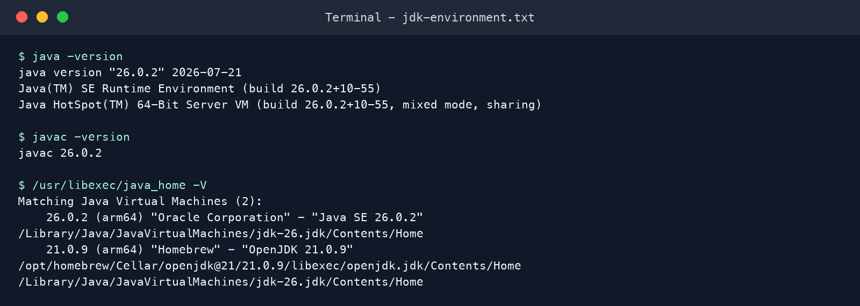
Figure 1. Actual JDK and compiler environment output.

3. Student Records Management
Student responsibilities. The model retains studentId, name, and dateOfAdmission. It provides the default constructor, a LocalDate constructor, a convenience MM/dd/yyyy constructor, and all required accessors and mutators.
public class Student {
private long studentId;
private String name;
private LocalDate dateOfAdmission;
public Student() { }
public Student(long id, String name, LocalDate admitted) { ... }
public Student(long id, String name, String admitted) { ... }
}
Ordering rules. printListOfStudents orders a defensive copy by name ascending. getListOfPlatinumAlumniStudents selects admission dates on or before the date 30 years ago, then orders the result by admission date descending.
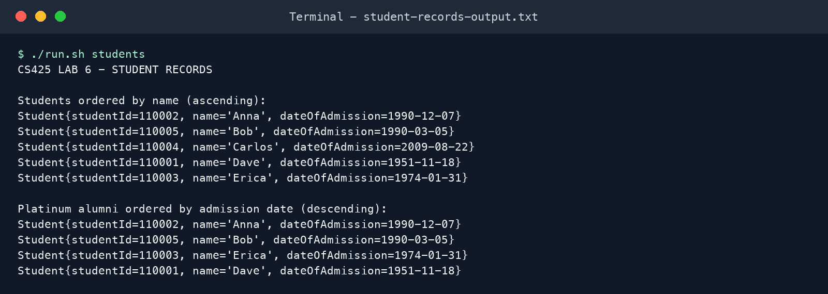
Figure 2. Actual student sorting and Platinum Alumni output.

4. Coding Practice Exercises

printHelloWorld
Each integer is evaluated once. Multiples of both 5 and 7 are checked first so 35 produces HelloWorld instead of two separate outputs. Multiples of only 5 produce Hello; multiples of only 7 produce World.

findSecondBiggest
The method tracks the largest and second-largest distinct values during a single pass. It does not sort the input array, uses O(n) time and O(1) auxiliary space, and rejects inputs without two distinct integers.
if (biggest == null || number > biggest) {
secondBiggest = biggest;
biggest = number;
} else if (number < biggest
&& (secondBiggest == null || number > secondBiggest)) {
secondBiggest = number;
}
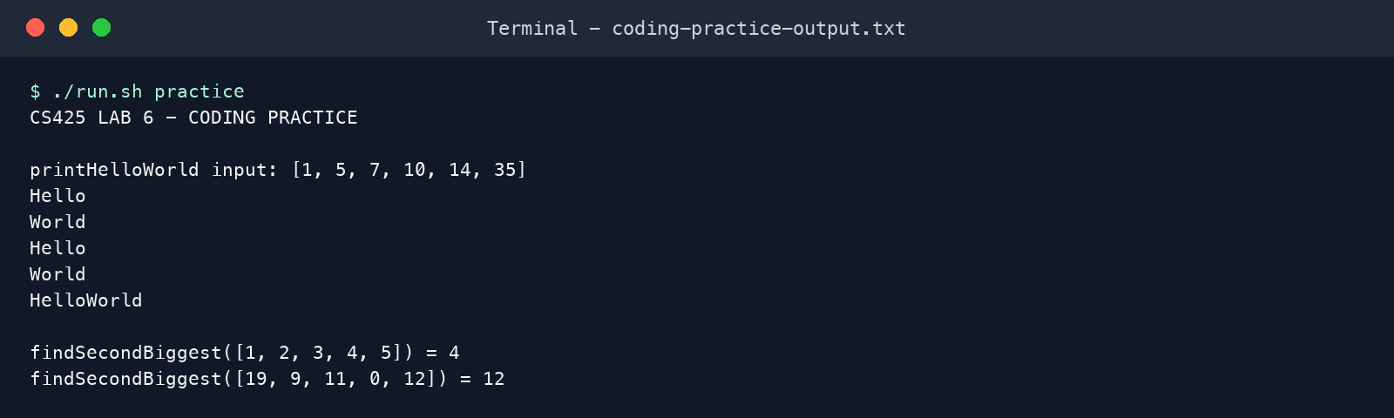
Figure 3. Actual HelloWorld and second-biggest results.

5. Verification and Repository Handoff
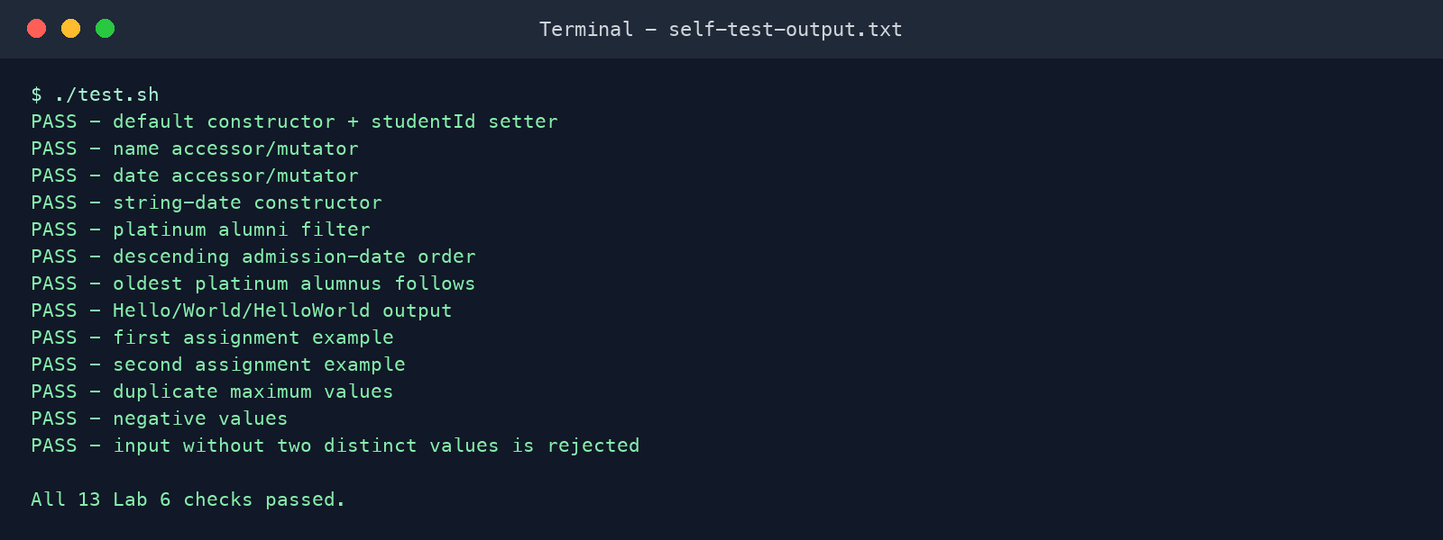
Figure 4. Dependency-free verification: all 13 checks passed.
Validation | Result | Status
Compilation | javac --release 8 | Complete
Bytecode level | Class major version 52 (Java 8) | Complete
Functional tests | 13 of 13 checks passed | Complete
Required examples | Second biggest = 4 and 12 | Complete
Repository state | Local git commit prepared | Complete
GitHub publication | Requires gh installation/authentication | Prepared

Publish and Submit
- Install GitHub CLI if needed: brew install gh
- Authenticate: gh auth login
- From the repository directory, create and push the public repository: gh repo create cs425-lab6-student-records-mgmt-app --public --source=. --remote=origin --push
- Submit the resulting GitHub repository URL in Sakai.
Publication status: The repository is fully prepared locally. Automatic GitHub publication was not performed because the required gh CLI is not installed or authenticated in this environment.

