**INFO 605: Fall 2021**

**Online Shopping Database Management**

**Author: Xuanwei Zhu**

**Date: 02-Dec-2021**

1. Summary:

ERD is very important to the project. I need to design the ERD carefully and spend more time on it. The better the ERD is, the easier the project in the future. If we find something wrong later, we need to revise the ERD again. Nobody can forecast everything, so most of the time, we must go back to the ERD to refine it.

Since I don’t put the database in practical use, creating the data for testing is very hard and very easy to make mistakes. In the beginning, I used the Drexel Oracle database, but it did not give me full privileges. Later, I found that if I want to know more about the skills, I should have full privileges. Then, I installed Oracle database 11 g on my computer. At that time, I got to know, the new version database, such as version over 12 c is not available to Ubuntu Linux, and it took me lots of time to figure out how to solve this problem.

This database is very small, it is only appropriate for small businesses. Also, I did not handle the customers’ returns. In real word, it is an important issue for business, thus, in the future, I should add the return entity to the database. In addition, the user account should separate from other entities like Order because it has customers’ confidentials.

Finally, the address should be an entity, because most customers have more than one address in the real world.

2. PROJECT STATEMENT

2.1 Overall Goals of the System

This project is an online shopping database system that will store information about the company’s resources, such as customers, accounts, products, orders, payments. The goal of this system is to create a single database that combines most of the data related to the online shopping activities. For the purposes of this project, the authors have decided to use a hypothetical organization, which reflects real-world data needs and challenges of many companies selling products online.

2.2 Context and Importance of the System

The company has its website to sell products. Customers order products through the website. After customers select products they would like to buy and put products into their shopping carts, they need to login in to check out. After checkout, the company will track the status of the order. Customers can also check their order’s status.

2.3 Scope of the Project

2.3.1 IN-Scope

This database will store data about every customer, their orders, payments and order history. The scope of this database will also include data about products, shipping statuses of orders.

2.3.2 OUT-Scope

This database will not include data about company employees, employee schedule and salary management. It will not track customers’ returns, which will be managed by another database system. It also will not track the warehouse management, and the operations expenses, budget, building and maintenance costs.

2.4 Related systems and any open source tools

The company uses an HR database to keep track of employee information, including vacation and benefits, hours worked, wages, and scheduling. It also has a warehouse database management system. When customers check out, the system will check the availability of the products through the warehouse database management system.

3.REQUIREMENTS SPECIFICATION

3.1 Data Requirements

1) The company needs to track information for each customer, including the customer’s id, name, address, phone number, email address, account, orders, and shopping cart.

2)The company also needs to track information for each product, including the products’ name, category, price, total number in stock.

3)Customers’ orders include products, number of each product.

4)Customers have one shopping cart(line items) with products’ names, number of products.

5)Customers can login to check their orders including shipping status

3.2 Business Rules and Data Logic

After checkout, the company needs to track the payment of orders, the history of customers’ orders, shipping status of orders.

3.3 Sample Output

The company hopes to use this database to pull data about all customers, the company’s products and the history of customer’s orders. It would like to analyze what products are popular and at what time. It also hopes to analyze customers behaviors and group them, then the company can market their products efficiently.

3.4 Other Assumptions

A customer’s account to the system never expires.

All customers are from the USA.

3.5 The database is designed to store information for small online businesses. It has eighty entities. I created the conceptual ERD and logical ERD. The ERD is designed for the company to know what the database will be like and gives ideas to the professionals. Then, the schema and data dictionary was created as the instruction to build the physical database implementations.

3.6 The address data was from the assignment 3 authors table. From this data, I created a sequence for the customer table to generate customerID. Customers’ first name and last name were also from the authors table, and I made some changes to produce more data. I created other data randomly.

3.7 I am using the oracle database 11g express edition, which is different from MySQL and other database systems.

4. Conceptual ERD:

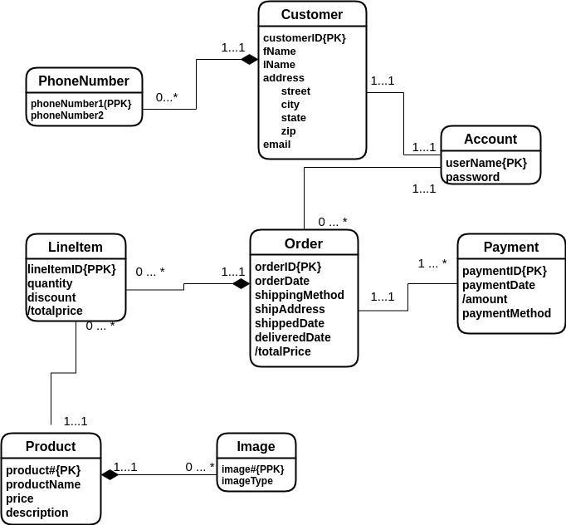

5. Relational Schema:

Customer (customerID, fName, lName, street, city, state, zip, email)

PhoneNumber (customerID, primaryNumber, alternativeNumber)

Foreign key customerID references Customer(customerID)

Account (userName, password, customerID)

Foreign key customerID references Customer(customerID)

Order(orderID, orderDate, shippingMethod, shipAddress, shippedDate, deliveredDate, userName)

Foreign key userName references Account(userName)

Payment(paymentID, paymentDate, paymentMethod,orderID)

Foreign key orderID references Order(orderID)

LineItem(orderID, lineItemID, quantity, discount, price, product#)

Foreign key orderID references Order(orderID)

Foreign key product# references Product (product#)

Product(product#, productName, price, description)

Image(product#, image#, imageType)

Foreign key product#references Product (product#)

Logical ERD:

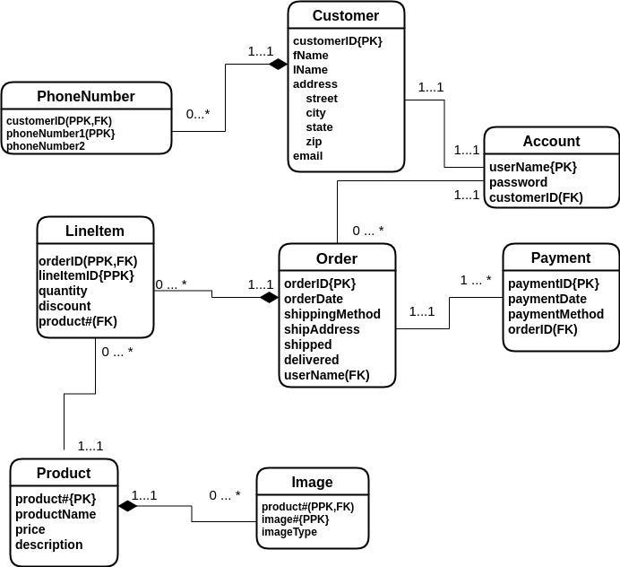

6. DATA DICTIONARY

**PhoneNumber**

| **Column** | **NULL** | **Type** | **Comments** |
| --- | --- | --- | --- |
| **customerID** | **NOT NULL** | **NUMBER(10)** | **PPK, FK** |
| **phoneNumber1** | **NOT NULL** | **NUMBER** | **PPK** |
| **phoneNumber2** |  | **NUMBER** |  |

**Customer**

| **Column** | **NULL** | **Type** | **Comments** |
| --- | --- | --- | --- |
| **customerID** | **NOT NULL** | **NUMBER(10)** | **PK** |
| **firstName** |  | **VARCHAR2(20)** |  |
| **lastName** |  | **VARCHAR2(20)** |  |
| **email** |  | **VARCHAR2(50)** |  |
| **street** |  | **VARCHAR2(40)** |  |
| **city** |  | **VARCHAR2(50)** |  |
| **state** |  | **VARCHAR2(10)** |  |
| **zip** |  | **VARCHAR2(10)** |  |

**Account**

| **Column** | **NULL** | **Type** | **Comments** |
| --- | --- | --- | --- |
| **username** | **NOT NULL** | **VARCHAR2(50)** | **PK** |
| **password** |  | **VARCHAR2(15)** |  |
| **customerID** | **NOT NULL** | **NUMBER(15)** | **FK** |

**LineItem**

| **Column** | **NULL** | **Type** | **Comments** |
| --- | --- | --- | --- |
| **orderID** | **NOT NULL** | **NUMBER(10)** | **PPK, FK** |
| **lineItemID** | **NOT NULL** | **NUMBER(10)** | **PPK** |
| **quantity** |  | **NUMBER(7)** |  |
| **discount** |  | **NUMBER(4)** |  |
| **price** |  | **NUMBER(7,2)** |  |
| **product#** | **NOT NULL** | **NUMBER(10)** | **FK** |

**Order**

| **Column** | **NULL** | **Type** | **Comments** |
| --- | --- | --- | --- |
| **orderID** | **NOT NULL** | **NUMBER(10)** | **PK** |
| **orderDate** |  | **DATE** |  |
| **shippingMethod** |  | **VARCHAR2(20)** | **CHECK{‘UPS’,’USPS’,’’FedEx’}** |
| **shipAddress** |  | **VARCHAR2(50)** |  |
| **shippedDate** |  | **DATE** |  |
| **deliveredDate** |  | **DATE** |  |
| **userName** | **NOT NULL** | **VARCHAR2(20)** | **FK** |

**Product**

| **Column** | **NULL** | **Type** | **Comments** |
| --- | --- | --- | --- |
| **product#** | **NOT NULL** | **NUMBER(10)** | **FK** |
| **productName** |  | **VARCHAR(15)** |  |
| **price** |  | **NUMBER(7,2)** |  |
| **description** |  | **VARCHAR2(300)** |  |

**Payment**

| **Column** | **NULL** | **Type** | **Comments** |
| --- | --- | --- | --- |
| **p_ID** | **NOT NULL** | **NUMBER(10)** | **PK** |
| **p_date** |  | **DATE** |  |
| **p_method** |  | **VARCHAR2(10)** | **CHECK{CREDIT, DEBIT, PAYPAL,VENMO}** |
| **orderID** | **NOT NULL** | **NUMBER(10)** | **FK** |

**Image**

| **Column** | **NULL** | **Type** | **Comments** |
| --- | --- | --- | --- |
| **product#** | **NOT NULL** | **NUMBER(10)** | **PPK, FK** |
| **image#** | **NOT NULL** | **NUMBER(4)** | **PPK** |
| **imageType** |  | **VARCHAR2(10)** |  |

7. SCHEMA and DATA(Show the CREATE TABLE and INSERT commands. Each table must have at least 3 rows. Some tables may have more than 3 rows to make your database realistic. Each member should share some workloads for insertion. For example, if there are 8 tables for 3 members, each member can insert into two or three tables. That is, each member does not have to insert one row per table. Also, display all the data by performing SELECT * FROM *your_table_name*; for all tables in a readable format.)

* 1. CREATE TABLE commands

create table Customer

(customerID NUMBER(10),

fName varchar2(20),

lName varchar2(20),

email varchar2(50),

street varchar2(40),

city varchar2(50),

state varchar2(10),

zip varchar2(10),

constraint PK_customer PRIMARY KEY (customerID));

create table PhoneNumber

(customerID NUMBER(10),

phoneNumber1 NUMBER,

phoneNumber2 NUMBER,

CONSTRAINT PK_phoneNumber PRIMARY KEY (customerID, phoneNumber1),

CONSTRAINT FK_phoneNumber FOREIGN KEY (customerID) REFERENCES Customer (customerID));

create table Account

(username VARCHAR2(50),

password VARCHAR2(30),

customerID NUMBER(15),

CONSTRAINT PK_Account PRIMARY KEY (username),

CONSTRAINT FK_Account FOREIGN KEY (customerID) REFERENCES Customer(customerID));

create table "Order"

(orderID NUMBER(10),

orderDate DATE,

shippingMethod VARCHAR2(20),

shipAddress VARCHAR2(50),

shippedDate DATE,

deliveredDate DATE,

userName VARCHAR2(20),

CONSTRAINT PK_Order PRIMARY KEY (orderID),

CONSTRAINT shipMethod CHECK (shippingMethod IN ('UPS','USPS','FedEx')),

CONSTRAINT FK_Order FOREIGN KEY (userName) REFERENCES Account(userName));

create table Payment

(paymentID NUMBER(10),

paymentdate DATE,

paymentMethod VARCHAR2(10),

orderID NUMBER(10),

CONSTRAINT PK_Payment PRIMARY KEY (paymentID),

CONSTRAINT payment_check CHECK (paymentMethod in ('CREDIT', 'DEBIT', 'PAYPAL', 'VENMO')),

CONSTRAINT FK_Payment FOREIGN KEY (orderID) REFERENCES "Order"(orderID));

create table LineItem

(orderID NUMBER(10),

lineItemID NUMBER(10),

quantity NUMBER(10),

discount NUMBER(2,2),

product# NUMBER(10),

CONSTRAINT PK_LineItem PRIMARY KEY (orderID, lineItemID),

CONSTRAINT FK_LineItem FOREIGN KEY (orderID) REFERENCES "Order"(orderID));

create table Product

(product# NUMBER(10),

productName VARCHAR2(15),

price NUMBER(7,2),

description VARCHAR2(300),

CONSTRAINT PK_Product PRIMARY KEY (product#));

create table Image

(product# NUMBER(10),

image# NUMBER(4),

imageType VARCHAR2(10),

CONSTRAINT PK_Image PRIMARY KEY (product#, image#),

CONSTRAINT FK_Image FOREIGN KEY (product#) REFERENCES Product (product#));

* 1. INSERT INTO Commands

create sequence customer_seq start with 101 increment by 1;

INSERT INTO customer VALUES (CUSTOMER_SEQ.nextval, 'Bennet', 'Abraham', '','6223 Bateman St.', 'Berkeley', 'CA','94705');

INSERT INTO customer VALUES (CUSTOMER_SEQ.nextval, 'Green', 'Marjorie', '','309 63rd St. #411', 'Oakland', 'CA', '94618');

INSERT INTO customer VALUES (CUSTOMER_SEQ.nextval, 'Carson', 'Cheryl', '', '589 Darwin Ln.', 'Berkeley', 'CA', '94705');

INSERT INTO customer VALUES (CUSTOMER_SEQ.nextval, 'Ringer', 'Albert', '', '67 Seventh Av.', 'Salt Lake City', 'UT', '84152');

INSERT INTO customer VALUES (CUSTOMER_SEQ.nextval, 'Ringer', 'Anne', '','67 Seventh Av.', 'Salt Lake City', 'UT', '84152');

INSERT INTO customer VALUES (CUSTOMER_SEQ.nextval, 'DeFrance', 'Michel', '','3 Balding Pl.', 'Gary', 'IN', '46403');

INSERT INTO customer VALUES (CUSTOMER_SEQ.nextval, 'Panteley', 'Sylvia', '', '1956 Arlington Pl.', 'Rockville', 'MD', '20853');

INSERT INTO customer VALUES (CUSTOMER_SEQ.nextval, 'McBadden', 'Heather', '', '301 Putnam', 'Vacaville', 'CA', '95688');

INSERT INTO customer VALUES (CUSTOMER_SEQ.nextval, 'Stringer', 'Dirk', '', '5420 Telegraph Av.', 'Oakland', 'CA', '94609');

INSERT INTO customer VALUES (CUSTOMER_SEQ.nextval, 'Straight', 'Dick', '', '5420 College Av.', 'Oakland', 'CA', '94609');

INSERT INTO customer VALUES (CUSTOMER_SEQ.nextval, 'Karsen', 'Livia','', '5720 McAuley St.', 'Oakland', 'CA', '94609');

INSERT INTO customer VALUES (CUSTOMER_SEQ.nextval, 'MacFeather', 'Stearns', '', '44 Upland Hts.', 'Oakland', 'CA', '94612');

INSERT INTO customer VALUES (CUSTOMER_SEQ.nextval, 'Dull', 'Ann', '', '3410 Blonde St.', 'Palo Alto', 'CA', '94301');

INSERT INTO customer VALUES (CUSTOMER_SEQ.nextval, 'Yokomoto', 'Akiko', '', '3 Silver Ct.', 'Walnut Creek', 'CA', '94595');

INSERT INTO customer VALUES (CUSTOMER_SEQ.nextval, 'O Leary', 'Michael', '', '22 Cleveland Av. #14', 'San Jose', 'CA', '95128');

INSERT INTO customer VALUES (CUSTOMER_SEQ.nextval, 'Gringlesby', 'Burt','', 'PO Box 792', 'Covelo', 'CA', '95428');

INSERT INTO customer VALUES (CUSTOMER_SEQ.nextval, 'Greene', 'Morningstar', '', '22 Graybar House Rd.', 'Nashville', 'TN', '37215');

INSERT INTO customer VALUES (CUSTOMER_SEQ.nextval, 'White', 'Johnson','', '10932 Bigge Rd.', 'Menlo Park', 'CA', '94025');

INSERT INTO customer VALUES (CUSTOMER_SEQ.nextval, 'del Castillo', 'Innes', '', '2286 Cram Pl. #86', 'Ann Arbor', 'MI', '48105');

INSERT INTO customer VALUES (CUSTOMER_SEQ.nextval, 'Hunter', 'Sheryl','', '3410 Blonde St.', 'Palo Alto', 'CA', '94301');

INSERT INTO customer VALUES (CUSTOMER_SEQ.nextval, 'Locksley', 'Chastity', '', '18 Broadway Av.', 'San Francisco', 'CA', '94130');

INSERT INTO customer VALUES (CUSTOMER_SEQ.nextval, 'Blotchet-Halls', 'Reginald', '', '55 Hillsdale Bl.', 'Corvallis', 'OR', '97330');

INSERT INTO customer VALUES (CUSTOMER_SEQ.nextval, 'Tith', 'Gander', '', '10 Mississippi Dr.', 'Lawrence', 'KS', '66044');

INSERT INTO customer VALUES (CUSTOMER_SEQ.nextval, 'Aennet', 'Bbraham', '','622 Bateman St.', 'Berkeley', 'CA','94705');

INSERT INTO customer VALUES (CUSTOMER_SEQ.nextval, 'Hreen', 'Qarjorie', '','3098 63rd St. #411', 'Oakland', 'CA', '94618');

INSERT INTO customer VALUES (CUSTOMER_SEQ.nextval, 'Darson', 'Hheryl', '', '5889 Darwin Ln.', 'Berkeley', 'CA', '94705');

INSERT INTO customer VALUES (CUSTOMER_SEQ.nextval, 'Hinger', 'Clbert', '', '617 Seventh Av.', 'Salt Lake City', 'UT', '84152');

INSERT INTO customer VALUES (CUSTOMER_SEQ.nextval, 'Jinger', 'Anne', '','167 Seventh Av.', 'Salt Lake City', 'UT', '84152');

INSERT INTO customer VALUES (CUSTOMER_SEQ.nextval, 'TeFrance', 'Nichel','', '13 Balding Pl.', 'Gary', 'IN', '46403');

INSERT INTO customer VALUES (CUSTOMER_SEQ.nextval, 'Panteley', 'Sylvia', '', '156 Arlington Pl.', 'Rockville', 'MD', '20853');

INSERT INTO customer VALUES (CUSTOMER_SEQ.nextval, 'NcBadden', 'Yeather','', '3801 Putnam', 'Vacaville', 'CA', '95688');

INSERT INTO customer VALUES (CUSTOMER_SEQ.nextval, 'James', 'Dirk', '', '542 Telegraph Av.', 'Oakland', 'CA', '94609');

INSERT INTO customer VALUES (CUSTOMER_SEQ.nextval, 'Straight', 'HHDick', '', '420 College Av.', 'Oakland', 'CA', '94609');

INSERT INTO customer VALUES (CUSTOMER_SEQ.nextval, 'Karsen', 'Livia', '', '720 McAuley St.', 'Oakland', 'CA', '94609');

INSERT INTO customer VALUES (CUSTOMER_SEQ.nextval, 'MacFeather', 'Stearns', '', '404 Upland Hts.', 'Oakland', 'CA', '94612');

INSERT INTO customer VALUES (CUSTOMER_SEQ.nextval, 'Full', 'Ann', '','410 Blonde St.', 'Palo Alto', 'CA', '94301');

INSERT INTO customer VALUES (CUSTOMER_SEQ.nextval, 'Yokomoto', 'Bkiko','', '309 Silver Ct.', 'Walnut Creek', 'CA', '94595');

INSERT INTO customer VALUES (CUSTOMER_SEQ.nextval, 'P Leary', 'Michael', '', '822 Cleveland Av. #14', 'San Jose', 'CA', '95128');

INSERT INTO customer VALUES (CUSTOMER_SEQ.nextval, 'Rringlesby', 'Burt', '', 'PO Box 792', 'Covelo', 'CA', '95428');

INSERT INTO customer VALUES (CUSTOMER_SEQ.nextval, 'Dreene', 'Morningstar', '', '922 Graybar House Rd.', 'Nashville', 'TN', '37215');

INSERT INTO customer VALUES (CUSTOMER_SEQ.nextval, 'Ehite', 'Johnson', '', '1932 Bigge Rd.', 'Menlo Park', 'CA', '94025');

INSERT INTO customer VALUES (CUSTOMER_SEQ.nextval, 'Ael Castillo', 'Innes', '', '286 Cram Pl. #86', 'Ann Arbor', 'MI', '48105');

INSERT INTO customer VALUES (CUSTOMER_SEQ.nextval, 'Bunter', 'Sheryl', '','410 Blonde St.', 'Palo Alto', 'CA', '94301');

INSERT INTO customer VALUES (CUSTOMER_SEQ.nextval, 'Qocksley', 'Chastity', '', '918 Broadway Av.', 'San Francisco', 'CA', '94130');

INSERT INTO customer VALUES (CUSTOMER_SEQ.nextval, 'Blotchet-Halls', 'Reginald', '', '855 Hillsdale Bl.', 'Corvallis', 'OR', '97330');

INSERT INTO customer VALUES (CUSTOMER_SEQ.nextval, 'Smith', 'Eeander', '','710 Mississippi Dr.', 'Lawrence', 'KS', '66044');

INSERT INTO customer VALUES (CUSTOMER_SEQ.nextval, 'kannet', 'Draham','', '22 Bateman St.', 'Berkeley', 'CA','94705');

INSERT INTO customer VALUES (CUSTOMER_SEQ.nextval, 'Geen', 'Rrjorie', '','098 63rd St. #411', 'Oakland', 'CA', '94618');

INSERT INTO customer VALUES (CUSTOMER_SEQ.nextval, 'Grson', 'Qeryl', '', '889 Darwin Ln.', 'Berkeley', 'CA', '94705');

INSERT INTO customer VALUES (CUSTOMER_SEQ.nextval, 'Winger', 'Clbert', '', '17 Seventh Av.', 'Salt Lake City', 'UT', '84152');

INSERT INTO customer VALUES (CUSTOMER_SEQ.nextval, 'Penger', 'Anne', '', '17 Seventh Av.', 'Salt Lake City', 'UT', '84152');

INSERT INTO customer VALUES (CUSTOMER_SEQ.nextval, 'KeFrance', 'aNichel','', '1 Balding Pl.', 'Gary', 'IN', '46403');

INSERT INTO customer VALUES (CUSTOMER_SEQ.nextval, 'Unteley', 'Sylvia', '', '16 Arlington Pl.', 'Rockville', 'MD', '20853');

INSERT INTO customer VALUES (CUSTOMER_SEQ.nextval, 'OcBadden', 'Keather','', '301 Putnam', 'Vacaville', 'CA', '95688');

INSERT INTO customer VALUES (CUSTOMER_SEQ.nextval, 'James', 'Cirk', '', '52 Telegraph Av.', 'Oakland', 'CA', '94609');

INSERT INTO customer VALUES (CUSTOMER_SEQ.nextval, 'Straight', 'Aick','', '40 College Av.', 'Oakland', 'CA', '94609');

INSERT INTO customer VALUES (CUSTOMER_SEQ.nextval, 'Dsen', 'Livia', '', '70 McAuley St.', 'Oakland', 'CA', '94609');

INSERT INTO customer VALUES (CUSTOMER_SEQ.nextval, 'Feather', 'Stearns', '', '404 Upland Hts.', 'Oakland', 'CA', '94612');

INSERT INTO customer VALUES (CUSTOMER_SEQ.nextval, 'Full', 'Benn', '', '40 Blonde St.', 'Palo Alto', 'CA', '94301');

INSERT INTO customer VALUES (CUSTOMER_SEQ.nextval, 'Toto', 'Bkiko', '', '39 Silver Ct.', 'Walnut Creek', 'CA', '94595');

INSERT INTO customer VALUES (CUSTOMER_SEQ.nextval, 'Leary', 'Michael', '', '22 Cleveland Av. #14', 'San Jose', 'CA', '95128');

INSERT INTO customer VALUES (CUSTOMER_SEQ.nextval, 'Dinglesby', 'Burt', '', 'PO Box 799', 'Covelo', 'CA', '95428');

INSERT INTO customer VALUES (CUSTOMER_SEQ.nextval, 'Xeene', 'Morningstar','', '92234 Graybar House Rd.', 'Nashville', 'TN', '37215');

INSERT INTO customer VALUES (CUSTOMER_SEQ.nextval, 'Zite', 'Johnson', '', '21932 Bigge Rd.', 'Menlo Park', 'CA', '94025');

INSERT INTO customer VALUES (CUSTOMER_SEQ.nextval, 'Zel Castillo', 'Innes', '', '7286 Cram Pl. #86', 'Ann Arbor', 'MI', '48105');

INSERT INTO customer VALUES (CUSTOMER_SEQ.nextval, 'Runter', 'Sheryl','', '5410 Blonde St.', 'Palo Alto', 'CA', '94301');

INSERT INTO customer VALUES (CUSTOMER_SEQ.nextval, 'Rocksley', 'Chastity','', '3918 Broadway Av.', 'San Francisco', 'CA', '94130');

INSERT INTO customer VALUES (CUSTOMER_SEQ.nextval, 'Rlotchet-Halls', 'Reginald', '', '2855 Hillsdale Bl.', 'Corvallis', 'OR', '97330');

INSERT INTO customer VALUES (CUSTOMER_SEQ.nextval, 'Fimith', 'Eeander','', '2710 Mississippi Dr.', 'Lawrence', 'KS', '66044');

INSERT INTO customer VALUES (CUSTOMER_SEQ.nextval, 'Bennet', 'Abraham','', '6223 Bateman St.', 'Berkeley', 'CA','94705');

INSERT INTO customer VALUES (CUSTOMER_SEQ.nextval, 'Green', 'Marjorie','', '309 63rd St. #411', 'Oakland', 'CA', '94618');

INSERT INTO customer VALUES (CUSTOMER_SEQ.nextval, 'Carson', 'Cheryl', '', '589 Darwin Ln.', 'Berkeley', 'CA', '94705');

INSERT INTO customer VALUES (CUSTOMER_SEQ.nextval, 'Ringer', 'Albert', '', '67 Seventh Av.', 'Salt Lake City', 'UT', '84152');

INSERT INTO customer VALUES (CUSTOMER_SEQ.nextval, 'Ringer', 'Anne', '', '67 Seventh Av.', 'Salt Lake City', 'UT', '84152');

INSERT INTO customer VALUES (CUSTOMER_SEQ.nextval, 'DeFrance', 'Michel', '','3 Balding Pl.', 'Gary', 'IN', '46403');

INSERT INTO customer VALUES (CUSTOMER_SEQ.nextval, 'Panteley', 'Sylvia','', '1956 Arlington Pl.', 'Rockville', 'MD', '20853');

INSERT INTO customer VALUES (CUSTOMER_SEQ.nextval, 'McBadden', 'Heather','', '301 Putnam', 'Vacaville', 'CA', '95688');

INSERT INTO customer VALUES (CUSTOMER_SEQ.nextval, 'Stringer', 'Dirk', '', '5420 Telegraph Av.', 'Oakland', 'CA', '94609');

INSERT INTO customer VALUES (CUSTOMER_SEQ.nextval, 'Straight', 'Dick', '', '5420 College Av.', 'Oakland', 'CA', '94609');

INSERT INTO customer VALUES (CUSTOMER_SEQ.nextval, 'Karsen', 'Livia', '', '5720 McAuley St.', 'Oakland', 'CA', '94609');

INSERT INTO customer VALUES (CUSTOMER_SEQ.nextval, 'MacFeather', 'Stearns', '', '44 Upland Hts.', 'Oakland', 'CA', '94612');

INSERT INTO customer VALUES (CUSTOMER_SEQ.nextval, 'Dull', 'Ann', '','3410 Blonde St.', 'Palo Alto', 'CA', '94301');

INSERT INTO customer VALUES (CUSTOMER_SEQ.nextval, 'Yokomoto', 'Akiko', '', '3 Silver Ct.', 'Walnut Creek', 'CA', '94595');

INSERT INTO customer VALUES (CUSTOMER_SEQ.nextval, 'O Leary', 'Michael', '', '22 Cleveland Av. #14', 'San Jose', 'CA', '95128');

INSERT INTO customer VALUES (CUSTOMER_SEQ.nextval, 'Gringlesby', 'Burt', '', 'PO Box 792', 'Covelo', 'CA', '95428');

INSERT INTO customer VALUES (CUSTOMER_SEQ.nextval, 'Greene', 'Morningstar', '', '22 Graybar House Rd.', 'Nashville', 'TN', '37215');

INSERT INTO customer VALUES (CUSTOMER_SEQ.nextval, 'White', 'Johnson', '', '10932 Bigge Rd.', 'Menlo Park', 'CA', '94025');

INSERT INTO customer VALUES (CUSTOMER_SEQ.nextval, 'del Castillo', 'Innes', '', '2286 Cram Pl. #86', 'Ann Arbor', 'MI', '48105');

INSERT INTO customer VALUES (CUSTOMER_SEQ.nextval, 'Hunter', 'Sheryl', '','3410 Blonde St.', 'Palo Alto', 'CA', '94301');

INSERT INTO customer VALUES (CUSTOMER_SEQ.nextval, 'Locksley', 'Chastity', '', '18 Broadway Av.', 'San Francisco', 'CA', '94130');

INSERT INTO customer VALUES (CUSTOMER_SEQ.nextval, 'Blotchet-Halls', 'Reginald', '', '55 Hillsdale Bl.', 'Corvallis', 'OR', '97330');

INSERT INTO customer VALUES (CUSTOMER_SEQ.nextval, 'Smith', 'Meander', '', '10 Mississippi Dr.', 'Lawrence', 'KS', '66044');

INSERT INTO customer VALUES (CUSTOMER_SEQ.nextval, 'Winnet', 'Haham', '','42 Bateman St.', 'Berkeley', 'CA','94705');

INSERT INTO customer VALUES (CUSTOMER_SEQ.nextval, 'Aeen', 'Ajorie','', '38 63rd St. #411', 'Oakland', 'CA', '94618');

INSERT INTO customer VALUES (CUSTOMER_SEQ.nextval, 'Yson', 'Gryl', '', '589 Darwin Ln.', 'Berkeley', 'CA', '94705');

INSERT INTO customer VALUES (CUSTOMER_SEQ.nextval, 'Fer', 'Clbert', '', '87 Seventh Av.', 'Salt Lake City', 'UT', '84152');

INSERT INTO customer VALUES (CUSTOMER_SEQ.nextval, 'Lger', 'Anney', '','97 Seventh Av.', 'Salt Lake City', 'UT', '84152');

INSERT INTO customer VALUES (CUSTOMER_SEQ.nextval, 'Dance', 'Tehel', '','333 Balding Pl.', 'Gary', 'IN', '46403');

INSERT INTO customer VALUES (CUSTOMER_SEQ.nextval, 'NcBadden', 'Yeather', '','6701 Putnam', 'Vacaville', 'CA', '95688');

INSERT INTO customer VALUES (CUSTOMER_SEQ.nextval, 'James', 'Herk', '','8542 Telegraph Av.', 'Oakland', 'CA', '94609');

INSERT INTO customer VALUES (CUSTOMER_SEQ.nextval, 'Bright', 'Gick', '', '8420 College Av.', 'Oakland', 'CA', '94609');

INSERT INTO customer VALUES (CUSTOMER_SEQ.nextval, 'Den', 'Via', '','3720 McAuley St.', 'Oakland', 'CA', '94609');

INSERT INTO customer VALUES (CUSTOMER_SEQ.nextval, 'Maceather', 'Larns', '','1404 Upland Hts.', 'Oakland', 'CA', '94612');

INSERT INTO customer VALUES (CUSTOMER_SEQ.nextval, 'Fell', 'Aenn', '', '1410 Blonde St.', 'Palo Alto', 'CA', '94301');

INSERT INTO customer VALUES (CUSTOMER_SEQ.nextval, 'Moto', 'Kiko', '','1309 Silver Ct.', 'Walnut Creek', 'CA', '94595');

INSERT INTO customer VALUES (CUSTOMER_SEQ.nextval, 'Leary', 'Michael', '', '5822 Cleveland Av. #14', 'San Jose', 'CA', '95128');

INSERT INTO customer VALUES (CUSTOMER_SEQ.nextval, 'Lesby', 'Durt', '', 'PO Box 555', 'Covelo', 'CA', '95428');

INSERT INTO customer VALUES (CUSTOMER_SEQ.nextval, 'Dret', 'Ningstar', '', '5922 Graybar House Rd.', 'Nashville', 'TN', '37215');

INSERT INTO customer VALUES (CUSTOMER_SEQ.nextval, 'Ehite', 'Nelson', '', '932 Bigge Rd.', 'Menlo Park', 'CA', '94025');

INSERT INTO customer VALUES (CUSTOMER_SEQ.nextval, 'Castillo', 'Vnes', '', '2786 Cram Pl. #86', 'Ann Arbor', 'MI', '48105');

INSERT INTO customer VALUES (CUSTOMER_SEQ.nextval, 'Ter', 'Jeryl', '','1410 Blonde St.', 'Palo Alto', 'CA', '94301');

INSERT INTO customer VALUES (CUSTOMER_SEQ.nextval, 'Sley', 'Tity', '', '1918 Broadway Av.', 'San Francisco', 'CA', '94130');

INSERT INTO customer VALUES (CUSTOMER_SEQ.nextval, 'Tchet-Halls', 'Ginald', '', '1855 Hillsdale Bl.', 'Corvallis', 'OR', '97330');

INSERT INTO customer VALUES (CUSTOMER_SEQ.nextval, 'Smith', 'Bander', '', '1710 Mississippi Dr.', 'Lawrence', 'KS', '66044');

INSERT INTO customer VALUES (CUSTOMER_SEQ.nextval, 'Tonet', 'Haham', '','122 Bateman St.', 'Berkeley', 'CA','94705');

INSERT INTO customer VALUES (CUSTOMER_SEQ.nextval, 'Geen', 'Jorie', '','1098 63rd St. #411', 'Oakland', 'CA', '94618');

INSERT INTO customer VALUES (CUSTOMER_SEQ.nextval, 'Grson', 'Eryl', '', '1889 Darwin Ln.', 'Berkeley', 'CA', '94705');

INSERT INTO customer VALUES (CUSTOMER_SEQ.nextval, 'Winger', 'Dbert', '', '45117 Seventh Av.', 'Salt Lake City', 'UT', '84152');

INSERT INTO customer VALUES (CUSTOMER_SEQ.nextval, 'Penger', 'Vene', '', '117 Seventh Av.', 'Salt Lake City', 'UT', '84152');

INSERT INTO customer VALUES (CUSTOMER_SEQ.nextval, 'KeFrance', 'Dhel','', '111 Balding Pl.', 'Gary', 'IN', '46403');

INSERT INTO customer VALUES (CUSTOMER_SEQ.nextval, 'Teley', 'Kvia', '', '116 Arlington Pl.', 'Rockville', 'MD', '20853');

INSERT INTO customer VALUES (CUSTOMER_SEQ.nextval, 'Badden', 'Keather', '', '1301 Putnam', 'Vacaville', 'CA', '95688');

INSERT INTO customer VALUES (CUSTOMER_SEQ.nextval, 'Fames', 'Cirk', '', '5112 Telegraph Av.', 'Oakland', 'CA', '94609');

INSERT INTO customer VALUES (CUSTOMER_SEQ.nextval, 'Aight', 'Aick', '', '410 College Av.', 'Oakland', 'CA', '94609');

INSERT INTO customer VALUES (CUSTOMER_SEQ.nextval, 'Daatsen', 'Livia', '', '710 McAuley St.', 'Oakland', 'CA', '94609');

INSERT INTO customer VALUES (CUSTOMER_SEQ.nextval, 'Ather', 'Tearns', '', '4104 Upland Hts.', 'Oakland', 'CA', '94612');

INSERT INTO customer VALUES (CUSTOMER_SEQ.nextval, 'Giull', 'Benn', '', '410 Blonde St.', 'Palo Alto', 'CA', '94301');

INSERT INTO customer VALUES (CUSTOMER_SEQ.nextval, 'Pike', 'Tooto', '', '319 Silver Ct.', 'Walnut Creek', 'CA', '94595');

INSERT INTO customer VALUES (CUSTOMER_SEQ.nextval, 'Tary', 'Michael', '', '122 Cleveland Av. #14', 'San Jose', 'CA', '95128');

INSERT INTO customer VALUES (CUSTOMER_SEQ.nextval, 'Dingle', 'Burt', '', 'PO Box 711', 'Covelo', 'CA', '95428');

INSERT INTO customer VALUES (CUSTOMER_SEQ.nextval, 'Eine', 'Star', '', '034 Graybar House Rd.', 'Nashville', 'TN', '37215');

INSERT INTO customer VALUES (CUSTOMER_SEQ.nextval, 'Zite', 'Kson', '', '732 Bigge Rd.', 'Menlo Park', 'CA', '94025');

INSERT INTO customer VALUES (CUSTOMER_SEQ.nextval, 'Zel Castillo', 'Innes', '','56 Cram Pl. #86', 'Ann Arbor', 'MI', '48105');

INSERT INTO customer VALUES (CUSTOMER_SEQ.nextval, 'Niter', 'Jyl', '','610 Blonde St.', 'Palo Alto', 'CA', '94301');

INSERT INTO customer VALUES (CUSTOMER_SEQ.nextval, 'Rock', 'Chastity', '','718 Broadway Av.', 'San Francisco', 'CA', '94130');

INSERT INTO customer VALUES (CUSTOMER_SEQ.nextval, 'Halls', 'Reginald', '', '655 Hillsdale Bl.', 'Corvallis', 'OR', '97330');

INSERT INTO customer VALUES (CUSTOMER_SEQ.nextval, 'Fimith', 'Tander', '','510 Mississippi Dr.', 'Lawrence', 'KS', '66044');

commit;

update customer set email = lname||customerid||'@drexel.edu';

insert all

into phonenumber

select customerid, 215||customerid||SUBSTR(ZIP,2,4), 267||customerid||SUBSTR(ZIP,0,4) from customer;

commit;

INSERT ALL

INTO Account

select fName || customerid, concat(lname, zip), customerid from customer;

commit;

insert all

into "Order" (orderID, orderDate, shippingMethod, shipAddress, shippedDate, deliveredDate, username)

values (1001, TO_DATE('1985-10-28', 'YYYY-MM-DD'), 'UPS', '567 Pasadena Ave., Tustin, CA',TO_DATE('1985-11-05', 'YYYY-MM-DD'), TO_DATE('1985-11-09', 'YYYY-MM-DD'),

'Panteley107')

into "Order" (orderID, orderDate, shippingMethod, shipAddress, shippedDate, deliveredDate, username)

values (1002, TO_DATE('1990-05-31', 'YYYY-MM-DD'), 'UPS', '3801 Putnam, Vacaville, CA',TO_DATE('1990-06-05', 'YYYY-MM-DD'), TO_DATE('1990-06-25', 'YYYY-MM-DD'),

'NcBadden131')

into "Order" (orderID, orderDate, shippingMethod, shipAddress, shippedDate, deliveredDate, username)

values (1003, TO_DATE('1990-05-25', 'YYYY-MM-DD'), 'UPS', '3801 Putnam, Vacaville, CA',TO_DATE('1990-05-31', 'YYYY-MM-DD'), TO_DATE('1990-06-09', 'YYYY-MM-DD'),

'NcBadden131')

into "Order" (orderID, orderDate, shippingMethod, shipAddress, shippedDate, deliveredDate, username)

values (1004, TO_DATE('1990-07-22', 'YYYY-MM-DD'), 'UPS', '3801 Putnam, Vacaville, CA',TO_DATE('1990-08-05', 'YYYY-MM-DD'), TO_DATE('1990-08-22', 'YYYY-MM-DD'),

'NcBadden131')

into "Order" (orderID, orderDate, shippingMethod, shipAddress, shippedDate, deliveredDate, username)

values (1005, TO_DATE('1990-02-22', 'YYYY-MM-DD'), 'UPS', '3801 Putnam, Vacaville, CA',TO_DATE('1990-03-05', 'YYYY-MM-DD'), TO_DATE('1990-03-12', 'YYYY-MM-DD'),

'NcBadden131')

into "Order" (orderID, orderDate, shippingMethod, shipAddress, shippedDate, deliveredDate, username)

values (1011, TO_DATE('1990-02-22', 'YYYY-MM-DD'), 'UPS', '3801 Putnam, Vacaville, CA',TO_DATE('1990-03-05', 'YYYY-MM-DD'), TO_DATE('1990-03-15', 'YYYY-MM-DD'),

'NcBadden131')

into "Order" (orderID, orderDate, shippingMethod, shipAddress, shippedDate, deliveredDate, username)

values (1006, TO_DATE('1990-05-23', 'YYYY-MM-DD'), 'UPS', '1956 Arlington Pl. Rockville MD',TO_DATE('1990-06-05', 'YYYY-MM-DD'), TO_DATE('1990-06-22', 'YYYY-MM-DD'),

'Sley212')

into "Order" (orderID, orderDate, shippingMethod, shipAddress, shippedDate, deliveredDate, username)

values (1007, TO_DATE('1990-04-26', 'YYYY-MM-DD'), 'UPS', '1956 Arlington Pl. Rockville MD',TO_DATE('1990-06-05', 'YYYY-MM-DD'), TO_DATE('1990-06-07', 'YYYY-MM-DD'),

'Sley212')

into "Order" (orderID, orderDate, shippingMethod, shipAddress, shippedDate, deliveredDate, username)

values (1008, TO_DATE('1990-06-26', 'YYYY-MM-DD'), 'UPS', '1956 Arlington Pl. Rockville MD',TO_DATE('1990-07-05', 'YYYY-MM-DD'), TO_DATE('1990-08-07', 'YYYY-MM-DD'),

'Sley212')

into "Order" (orderID, orderDate, shippingMethod, shipAddress, shippedDate, deliveredDate, username)

values (1013, TO_DATE('1990-09-26', 'YYYY-MM-DD'), 'UPS', '1956 Arlington Pl. Rockville MD',TO_DATE('1990-10-05', 'YYYY-MM-DD'), TO_DATE('1990-10-07', 'YYYY-MM-DD'),

'Sley212')

into "Order" (orderID, orderDate, shippingMethod, shipAddress, shippedDate, deliveredDate, username)

values (1009, TO_DATE('1990-03-26', 'YYYY-MM-DD'), 'UPS', '1956 Arlington Pl. Rockville MD',TO_DATE('1990-04-05', 'YYYY-MM-DD'), TO_DATE('1990-04-07', 'YYYY-MM-DD'),

'Sley212')

into "Order" (orderID, orderDate, shippingMethod, shipAddress, shippedDate, deliveredDate, username)

values (1010, TO_DATE('1990-04-27', 'YYYY-MM-DD'), 'UPS', '1956 Arlington Pl. Rockville MD',TO_DATE('1990-06-04', 'YYYY-MM-DD'), TO_DATE('1990-06-09', 'YYYY-MM-DD'),

'Sley212')

into "Order" (orderID, orderDate, shippingMethod, shipAddress, shippedDate, deliveredDate, username)

values (1012, TO_DATE('1990-07-27', 'YYYY-MM-DD'), 'UPS', '221 Cram Pl. #86 Ann Arbor MI',TO_DATE('1990-08-04', 'YYYY-MM-DD'), TO_DATE('1990-08-09', 'YYYY-MM-DD'),

'del Castillo119')

into "Order" (orderID, orderDate, shippingMethod, shipAddress, shippedDate, deliveredDate, username)

values (1014, TO_DATE('1985-10-23', 'YYYY-MM-DD'), 'USPS', '1710 Mississippi Dr., Lawrence, KS',TO_DATE('1985-11-04', 'YYYY-MM-DD'), TO_DATE('1985-11-07', 'YYYY-MM-DD'),

'Smith214')

into "Order" (orderID, orderDate, shippingMethod, shipAddress, shippedDate, deliveredDate, username)

values (1015, TO_DATE('1990-05-23', 'YYYY-MM-DD'), 'USPS', '3720 McAuley St., Oakland, CA',TO_DATE('1990-06-06', 'YYYY-MM-DD'), TO_DATE('1990-06-21', 'YYYY-MM-DD'),

'Den202')

into "Order" (orderID, orderDate, shippingMethod, shipAddress, shippedDate, deliveredDate, username)

values (1016, TO_DATE('1990-05-20', 'YYYY-MM-DD'), 'USPS', '42 Bateman St., Berkeley, CA',TO_DATE('1990-05-24', 'YYYY-MM-DD'), TO_DATE('1990-06-04', 'YYYY-MM-DD'),

'Winnet193')

into "Order" (orderID, orderDate, shippingMethod, shipAddress, shippedDate, deliveredDate, username)

values (1017, TO_DATE('1990-07-21', 'YYYY-MM-DD'), 'FedEx', '117 Seventh Av., Salt Lake City, UT',TO_DATE('1990-07-05', 'YYYY-MM-DD'), TO_DATE('1990-08-02', 'YYYY-MM-DD'),

'Penger219')

into "Order" (orderID, orderDate, shippingMethod, shipAddress, shippedDate, deliveredDate, username)

values (1018, TO_DATE('1990-01-22', 'YYYY-MM-DD'), 'FedEx', '13 Silver Ct. Walnut Creek, CA',TO_DATE('1990-02-05', 'YYYY-MM-DD'), TO_DATE('1990-02-12', 'YYYY-MM-DD'),

'Yokomoto183')

into "Order" (orderID, orderDate, shippingMethod, shipAddress, shippedDate, deliveredDate, username)

values (1019, TO_DATE('1990-02-22', 'YYYY-MM-DD'), 'FedEx', '542 Telegraph, Av. Oakland, CA',TO_DATE('1990-03-05', 'YYYY-MM-DD'), TO_DATE('1990-03-15', 'YYYY-MM-DD'),

'James132')

into "Order" (orderID, orderDate, shippingMethod, shipAddress, shippedDate, deliveredDate, username)

values (1020, TO_DATE('1990-02-23', 'YYYY-MM-DD'), 'USPS', '10932 Bigge Rd., Menlo Park, CA',TO_DATE('1990-04-05', 'YYYY-MM-DD'), TO_DATE('1990-05-22', 'YYYY-MM-DD'),

'White187')

into "Order" (orderID, orderDate, shippingMethod, shipAddress, shippedDate, deliveredDate, username)

values (1021, TO_DATE('1990-04-26', 'YYYY-MM-DD'), 'USPS', '10932 Bigge Rd., Menlo Park, CA',TO_DATE('1990-06-05', 'YYYY-MM-DD'), TO_DATE('1990-06-07', 'YYYY-MM-DD'),

'White187')

into "Order" (orderID, orderDate, shippingMethod, shipAddress, shippedDate, deliveredDate, username)

values (1022, TO_DATE('1990-06-26', 'YYYY-MM-DD'), 'USPS', '10932 Bigge Rd., Menlo Park, CA',TO_DATE('1990-07-05', 'YYYY-MM-DD'), TO_DATE('1990-08-07', 'YYYY-MM-DD'),

'White187')

into "Order" (orderID, orderDate, shippingMethod, shipAddress, shippedDate, deliveredDate, username)

values (1023, TO_DATE('1990-09-26', 'YYYY-MM-DD'), 'USPS', '10932 Bigge Rd., Menlo Park, CA',TO_DATE('1990-10-05', 'YYYY-MM-DD'), TO_DATE('1990-10-07', 'YYYY-MM-DD'),

'White187')

into "Order" (orderID, orderDate, shippingMethod, shipAddress, shippedDate, deliveredDate, username)

values (1024, TO_DATE('1990-03-26', 'YYYY-MM-DD'), 'UPS', '10932 Bigge Rd., Menlo Park, CA',TO_DATE('1990-04-05', 'YYYY-MM-DD'), TO_DATE('1990-04-07', 'YYYY-MM-DD'),

'White187')

into "Order" (orderID, orderDate, shippingMethod, shipAddress, shippedDate, deliveredDate, username)

values (1025, TO_DATE('1990-04-27', 'YYYY-MM-DD'), 'USPS', '6223 Bateman St., Berkeley, CA',TO_DATE('1990-06-04', 'YYYY-MM-DD'), TO_DATE('1990-06-09', 'YYYY-MM-DD'),

'Bennet101')

into "Order" (orderID, orderDate, shippingMethod, shipAddress, shippedDate, deliveredDate, username)

values (1026, TO_DATE('1990-07-27', 'YYYY-MM-DD'), 'FedEx', '6223 Bateman St., Berkeley, CA',TO_DATE('1990-08-04', 'YYYY-MM-DD'), TO_DATE('1990-08-09', 'YYYY-MM-DD'),

'Bennet101')

select * from dual;

commit;

INSERT ALL

INTO Payment (paymentID, paymentDate, paymentMethod, orderID)

VALUES (101, '28-Oct-85', 'CREDIT', 1001)

INTO Payment (paymentID, paymentDate, paymentMethod, orderID)

VALUES (102, '28-Oct-85', 'PAYPAL', 1001)

INTO Payment (paymentID, paymentDate, paymentMethod, orderID)

VALUES (103, '31-MAY-90', 'VENMO', 1002)

INTO Payment (paymentID, paymentDate, paymentMethod, orderID)

VALUES (104, '25-MAY-90', 'CREDIT', 1003)

INTO Payment (paymentID, paymentDate, paymentMethod, orderID)

VALUES (105, '22-JUL-90', 'DEBIT', 1004)

INTO Payment (paymentID, paymentDate, paymentMethod, orderID)

VALUES (106, '22-FEB-90', 'CREDIT', 1005)

INTO Payment (paymentID, paymentDate, paymentMethod, orderID)

VALUES (107, '22-FEB-90', 'CREDIT', 1011)

INTO Payment (paymentID, paymentDate, paymentMethod, orderID)

VALUES (108, '23-MAY-90', 'PAYPAL', 1006)

INTO Payment (paymentID, paymentDate, paymentMethod, orderID)

VALUES (109, '26-JUN-90', 'PAYPAL', 1007)

INTO Payment (paymentID, paymentDate, paymentMethod, orderID)

VALUES (110, '26-JUN-90', 'PAYPAL', 1008)

INTO Payment (paymentID, paymentDate, paymentMethod, orderID)

VALUES (111, '26-SEP-90', 'CREDIT', 1013)

INTO Payment (paymentID, paymentDate, paymentMethod, orderID)

VALUES (112, '26-MAR-90', 'DEBIT', 1009)

INTO Payment (paymentID, paymentDate, paymentMethod, orderID)

VALUES (113, '27-APR-90', 'DEBIT', 1010)

INTO Payment (paymentID, paymentDate, paymentMethod, orderID)

VALUES (114, '27-JUL-90', 'CREDIT', 1012)

INTO Payment (paymentID, paymentDate, paymentMethod, orderID)

VALUES (115, '23-OCT-90', 'DEBIT', 1014)

INTO Payment (paymentID, paymentDate, paymentMethod, orderID)

VALUES (116, '23-MAY-90', 'CREDIT', 1015)

INTO Payment (paymentID, paymentDate, paymentMethod, orderID)

VALUES (117, '20-MAY-90', 'CREDIT', 1016)

INTO Payment (paymentID, paymentDate, paymentMethod, orderID)

VALUES (118, '21-JUL-90', 'CREDIT', 1017)

INTO Payment (paymentID, paymentDate, paymentMethod, orderID)

VALUES (119, '21-Jan-90', 'CREDIT', 1018)

INTO Payment (paymentID, paymentDate, paymentMethod, orderID)

VALUES (120, '22-FEB-90', 'DEBIT', 1019)

INTO Payment (paymentID, paymentDate, paymentMethod, orderID)

VALUES (121, '23-FEB-90', 'CREDIT', 1020)

INTO Payment (paymentID, paymentDate, paymentMethod, orderID)

VALUES (122, '26-APR-90', 'CREDIT', 1021)

INTO Payment (paymentID, paymentDate, paymentMethod, orderID)

VALUES (128, '26-APR-90', 'CREDIT', 1021)

INTO Payment (paymentID, paymentDate, paymentMethod, orderID)

VALUES (123, '26-JUN-90', 'CREDIT', 1022)

INTO Payment (paymentID, paymentDate, paymentMethod, orderID)

VALUES (124, '26-SEP-90', 'CREDIT', 1023)

INTO Payment (paymentID, paymentDate, paymentMethod, orderID)

VALUES (125, '27-APR-90', 'PAYPAL', 1024)

INTO Payment (paymentID, paymentDate, paymentMethod, orderID)

VALUES (126, '27-APR-90', 'CREDIT', 1025)

INTO Payment (paymentID, paymentDate, paymentMethod, orderID)

VALUES (127, '27-JUL-90', 'CREDIT', 1026)

select * from dual;

COMMIT;

insert all

into product (product#, productName, price, description)

values (201, 'XZ-Model-B', 809, 'Faster running, new generation')

into product (product#, productName, price, description)

values (202, 'XZ-Model-A', 1000, 'Normal running, first generation')

into product (product#, productName, price, description)

values (203, 'Stroller', 10, 'Safety first')

into product (product#, productName, price, description)

values (204, 'DX-09', 1000, 'Very good condition')

into product (product#, productName, price, description)

values (205, 'DT-08', 90, 'Easy to use')

into product (product#, productName, price, description)

values (206, 'XW-03', 80, 'Man made')

into product (product#, productName, price, description)

values (207, 'TX-009', 200, 'Follow instruction')

into product (product#, productName, price, description)

values (208, 'CT-1001', 400, 'Ready to go')

into product (product#, productName, price, description)

values (210, 'WT-A-10', 200, 'Small parts available')

into product (product#, productName, price, description)

values (209, 'YT-90A', 1000, 'Can be used under any condition')

select * from dual;

commit;

insert all

into image (product#, image#, imageType) values (201, 1, 'JPEG')

into image (product#, image#, imageType) values (202, 1, 'JPEG')

into image (product#, image#, imageType) values (202, 2, 'JPEG')

into image (product#, image#, imageType) values (202, 3, 'JPEG')

into image (product#, image#, imageType) values (203, 1, 'PNG')

into image (product#, image#, imageType) values (204, 1, 'JPEG')

into image (product#, image#, imageType) values (205, 1, 'JPEG')

into image (product#, image#, imageType) values (206, 1, 'JPEG')

into image (product#, image#, imageType) values (207, 1, 'JPEG')

into image (product#, image#, imageType) values (208, 1, 'JPEG')

into image (product#, image#, imageType) values (209, 1, 'JPEG')

into image (product#, image#, imageType) values (209, 2, 'JPEG')

into image (product#, image#, imageType) values (209, 3, 'JPEG')

into image (product#, image#, imageType) values (209, 4, 'JPEG')

select * from dual;

commit;

insert all

into lineitem (orderID, lineitemID, quantity, discount, product#)

values (1001, 1, 4, 0.1, 201)

into lineitem (orderID, lineitemID, quantity, discount, product#)

values (1001, 2, 1, 0.2, 210)

into lineitem (orderID, lineitemID, quantity, discount, product#)

values (1001, 3, 2, 0, 208)

into lineitem (orderID, lineitemID, quantity, discount, product#)

values (1002, 1, 4, 0.1, 204)

into lineitem (orderID, lineitemID, quantity, discount, product#)

values (1003, 1, 2, 0.1, 205)

into lineitem (orderID, lineitemID, quantity, discount, product#)

values (1004, 1, 2, 0.1, 207)

into lineitem (orderID, lineitemID, quantity, discount, product#)

values (1005, 1, 1, 0.1, 209)

into lineitem (orderID, lineitemID, quantity, discount, product#)

values (1006, 1, 2, 0.2, 202)

into lineitem (orderID, lineitemID, quantity, discount, product#)

values (1007, 1, 1, 0.3, 204)

into lineitem (orderID, lineitemID, quantity, discount, product#)

values (1008, 1, 1, 0.2, 203)

into lineitem (orderID, lineitemID, quantity, discount, product#)

values (1009, 1, 3, 0.1, 205)

into lineitem (orderID, lineitemID, quantity, discount, product#)

values (1010, 1, 1, 0.1, 206)

into lineitem (orderID, lineitemID, quantity, discount, product#)

values (1011, 1, 3, 0.1, 207)

into lineitem (orderID, lineitemID, quantity, discount, product#)

values (1012, 1, 1, 0.1, 208)

into lineitem (orderID, lineitemID, quantity, discount, product#)

values (1013, 1, 4, 0.1, 210)

into lineitem (orderID, lineitemID, quantity, discount, product#)

values (1014, 1, 6, 0.1, 210)

into lineitem (orderID, lineitemID, quantity, discount, product#)

values (1015, 1, 2, 0.1, 209)

into lineitem (orderID, lineitemID, quantity, discount, product#)

values (1016, 1, 1, 0.1, 202)

into lineitem (orderID, lineitemID, quantity, discount, product#)

values (1017, 1, 5, 0.1, 203)

into lineitem (orderID, lineitemID, quantity, discount, product#)

values (1018, 1, 1, 0.1, 201)

into lineitem (orderID, lineitemID, quantity, discount, product#)

values (1019, 1, 1, 0.1, 205)

into lineitem (orderID, lineitemID, quantity, discount, product#)

values (1020, 1, 2, 0.1, 206)

into lineitem (orderID, lineitemID, quantity, discount, product#)

values (1021, 1, 1, 0.1, 207)

into lineitem (orderID, lineitemID, quantity, discount, product#)

values (1022, 1, 6, 0.1, 208)

into lineitem (orderID, lineitemID, quantity, discount, product#)

values (1023, 1, 4, 0.1, 209)

into lineitem (orderID, lineitemID, quantity, discount, product#)

values (1024, 1, 2, 0.1, 203)

into lineitem (orderID, lineitemID, quantity, discount, product#)

values (1025, 1, 1, 0.1, 204)

into lineitem (orderID, lineitemID, quantity, discount, product#)

values (1026, 1, 4, 0.1, 202)

into lineitem (orderID, lineitemID, quantity, discount, product#)

values (1026, 2, 1, 0.1, 209)

into lineitem (orderID, lineitemID, quantity, discount, product#)

values (1026, 3, 2, 0.1, 208)

into lineitem (orderID, lineitemID, quantity, discount, product#)

values (1026, 4, 1, 0.1, 205)

into lineitem (orderID, lineitemID, quantity, discount, product#)

values (1026, 5, 4, 0.1, 206)

select * from dual;

Commit;

* 1. Data from SELECT * FROM *your_table_name*; for all tables

SELECT * FROM Phonenumber;

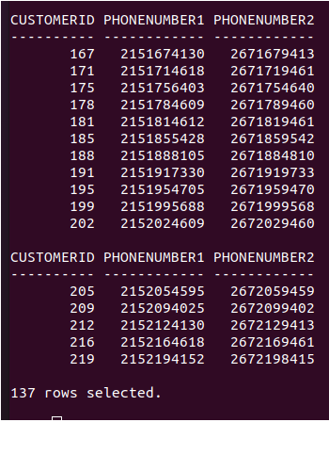

SELECT * FROM Customer;

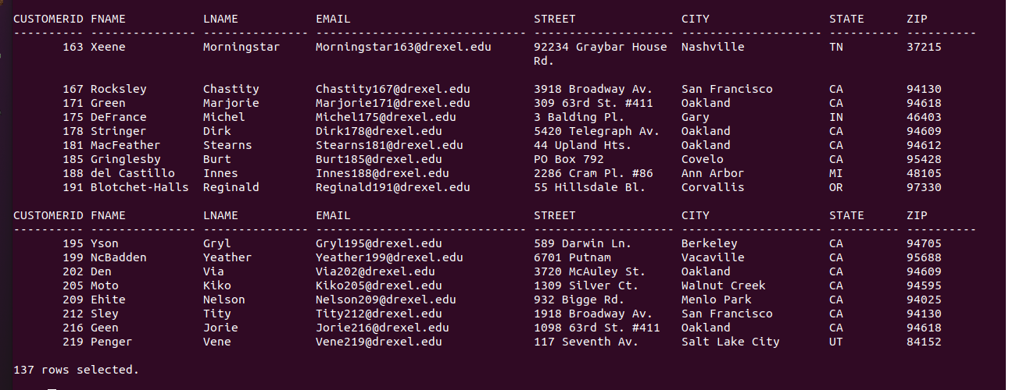

SELECT * FROM Account;

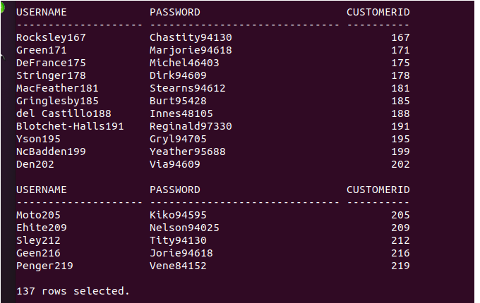

SELECT * FROM “Order”;

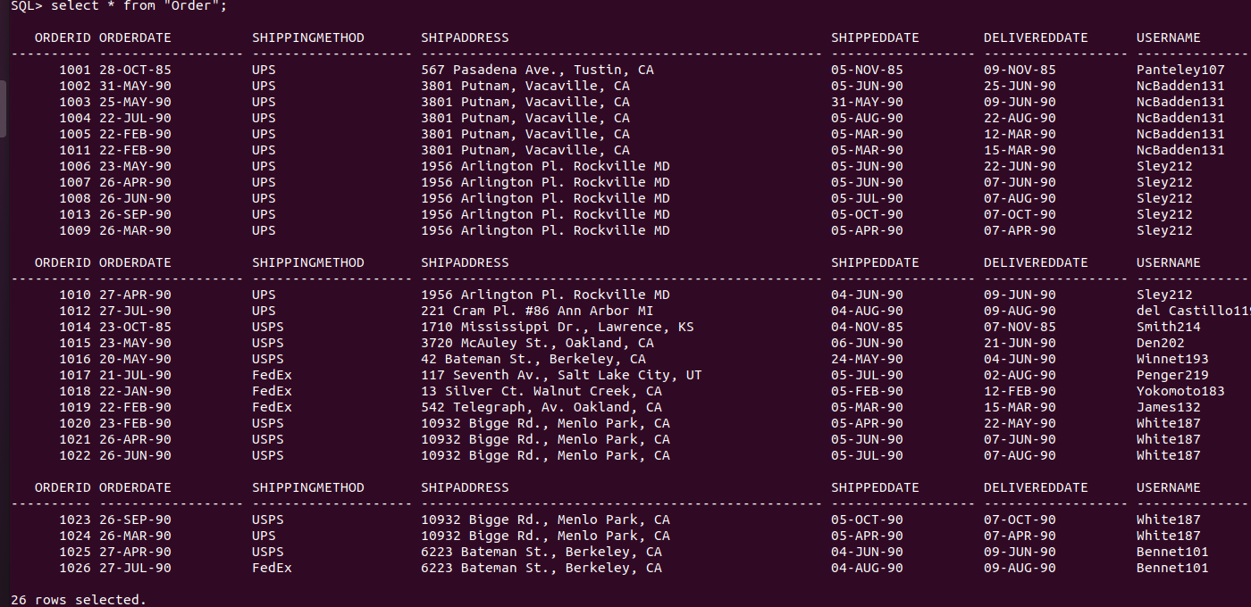

SELECT * FROM Payment;

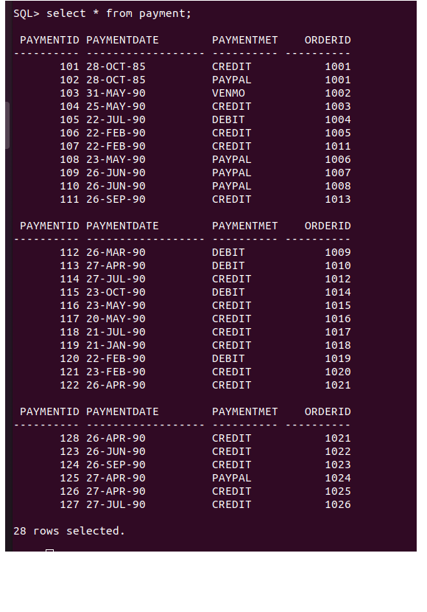

SELECT * FROM LineItem;



SELECT * FROM Product;

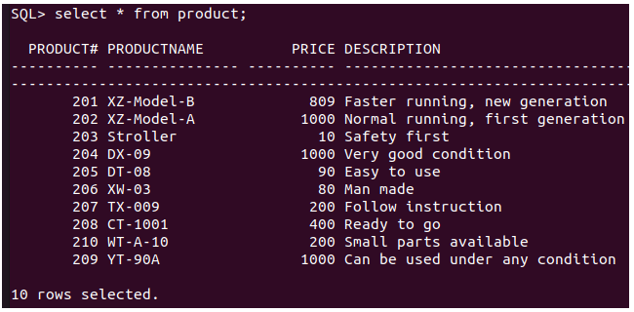

SELECT * FROM Image;

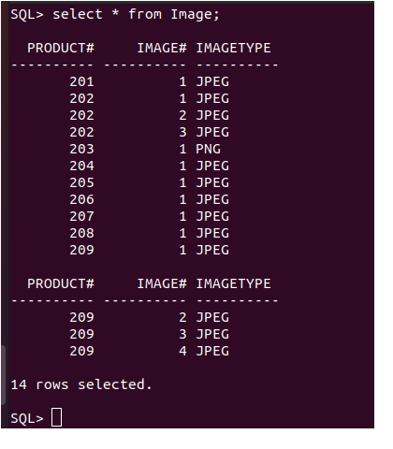

1. DATA QUERIES (Show at least three examples of SQL queries per member. All the queries must be multi-table queries that include at least one join (a subquery), an aggregate function, or joins and aggregate functions. Write down the member’s name at the beginning of the queries (or create a section for each member and list all the queries and DML commands performed by the member in the section). Show the output from the Oracle. Some of you may use views and creates indexes for the queries. Any query with no joins will take some points off.) For example,
   1. Queries by **Xuanwei zhu**
      1. Query 1 (English meaning, SQL, output, #rows)

--Display the customers' last name, first name, phonenumber1 and number of product purchased if they bought 3 or more products.

select lname "Last Name", fname "First Name", phonenumber1, count(product#) "Number of Products" from phonenumber natural join customer natural join account natural join "Order" natural join lineitem

group by lname, phonenumber.phonenumber1, fname having count(product#) >=3;

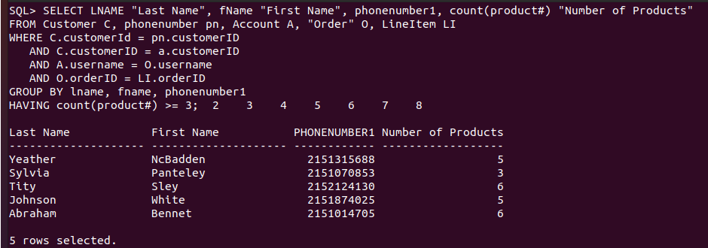

* + 1. Query 2 (English meaning, SQL, output, #rows)

--Display the customer's last name, first name, and total values of total products he purchased

--if he purchased products more than 1000 dollas, display order by total value in descending order.

SELECT LNAME "Last Name", fName "First Name", sum(LI.product# * quantity * (1-discount)) "Total Value"

FROM Customer C, phonenumber pn, Account A, "Order" O, LineItem LI,Product p

WHERE C.customerId = pn.customerID

AND C.customerID = a.customerID

AND A.username = O.username

AND O.orderID = LI.orderID

AND p.product# = LI.product#

GROUP BY lname, fname

HAVING sum(LI.product# * quantity * (1-discount)) > 1000

ORDER BY "Total Value" DESC;

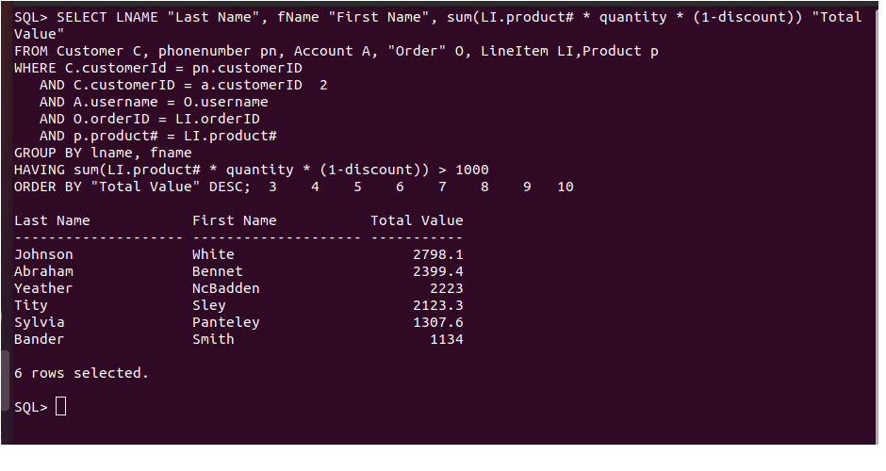

* + 1. Query 3 (English meaning, SQL, output, #rows)

--Display productName, total quantity odered by customers if the product was ordered more than 10 and the product does not have images.

SELECT productName, sum(quantity) "Total Quantity"

from LineItem LI, Product P

WHERE LI.product# = P.product# AND P.product# NOT IN (SELECT product# FROM Image)

group by productName

HAVING SUM(quantity) > 10;

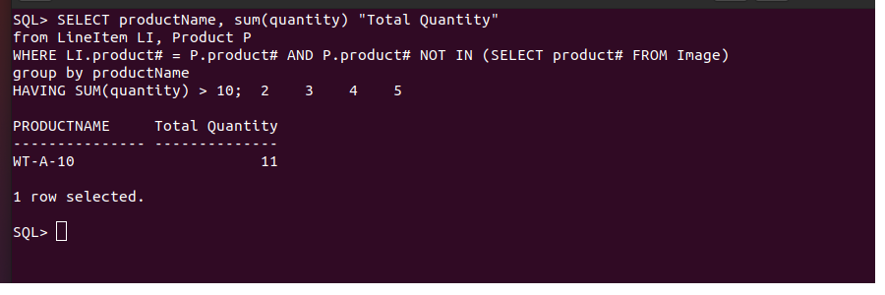

1. DATA MANIPULATION (Each member must include at least one example of UPDATE and DELETE to any table in your database in the context of your requirements. For DML commands, use SET AUTOCOMMIT OFF so that you can rollback. For each deletion and update command, you must display the data before and after the command to confirm the correctness of the command. That is, I want you to practice insertion/deletion/update in your projects. For example,
   1. DML by Xuanwei Zhu
      1. Data before the UPDATE command



* + 1. UPDATE command

Update product set imageType=’PNG’ WHERE product#=206;

* + 1. Data after the UPDATE command

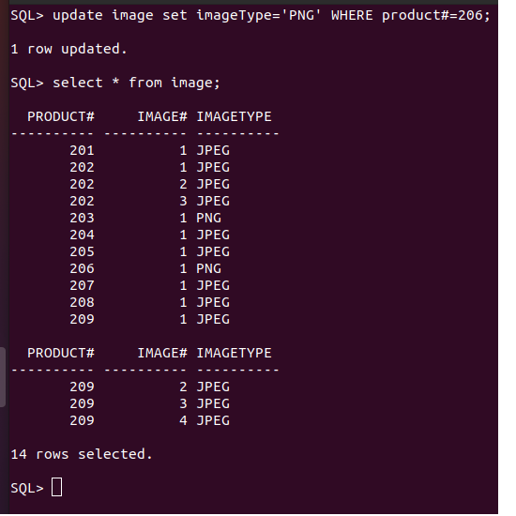

* + 1. ROLLBACK

Rollback;

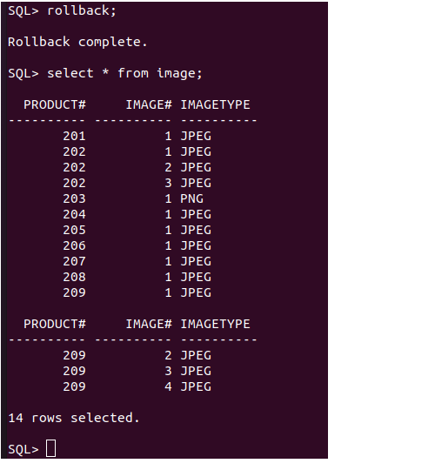

* + 1. Data before the DELETE command



* + 1. DELETE command

DELETE FROM Image WHERE product# >= 206;

* + 1. Data after the DELETE command

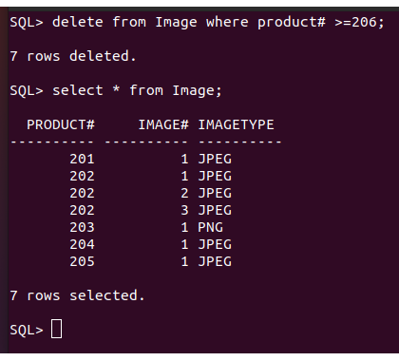

* + 1. ROLLBACK

Rollback;

1. SUMMARY (Summarize the entire project in terms of lessons learned, domain, scope, and implementation, and lessons learned. You can also explain how your database can support the goals and facilitate the data management needs in the organization. You can also add what you could do more if you have more time.) The length of the summary of each member could be one paragraph (5-10 sentences).
   1. Summary by Xuanwei Zhu

Lession1: ERD is very important to the project. I need to design the ERD carefully and spend more time on it. The better the ERD is, the easier the project in the future.

Lession2: If we find something wrong later, we need to revise the ERD again. Nobody can forecast everything, so most of the time, we must go back to the ERD to refine it.

Lession3: Since I don’t put the database in practical use, creating the data for testing is very hard and very easy to make mistakes.

Lession4: In the beginning, I used the Drexel Oracle database, it did not give me full privileges. Later, I found that if I want to know more about the skills, I should have full privileges. Then, I installed Oracle database 11 g on my computer. At that time, I got to know, the new version database, such as version over 12 c is not available to Ubuntu Linux, and it took me lots of time to figure out how to solve this problem.

Lession5: this database is very small, it is only appropriate for small businesses. Also, I did not handle the customers’ returns. In real word, it is an important issue for business, thus, in the future, I should add the return entity to the database. In addition, the user account should separate from other entities like Order because it has customers’ confidentials. For the address, it should be an independent entity, because most customers have more than one address.

1. Appendix

Division of work among team members, if any. Indicate who did which queries.

Sample input/output/program listing

(Failure to follow this format for your paper will result in a loss of up to 10 points.)

All the work has been done by XUANWEI ZHU

**Formatting your reports:**

1. Make your report ***reviewer-friendly***. That is, organize your report with an easy-to-read formatting and style. Use Time Roman 12 font style or something similar in a single space. Do not use too small or too large font size.
2. Make some effort to arrange your ERD so that it can be fitted into a normal printer paper size (8.5*11), either in Portrait format. You can move around entities, relationships and attributes, or reduce the line size to make them fit into a page. Unless your ERD is really too big to fit into a single page. However, do not make font size of entity names, relationship names, attribute names too small to read. Use the max font size that allows your **ERD to be fit into a single page**. I normally print your ERD to read and grade. If they do not fit into a single page, it gives me a lot of troubles in reading your ERD. I also found some ERDs are not very legible. Make sure it legible.
3. Add your project name on Header and page number in the footer of each page.
4. Recommendation to Create readable Oracle output:

* Use **SET LINESIZE 240** to extend the line length.
  + SQL>SET LINESIZE 500
* Use **SET PAGESIZE 30** to define the page size.
  + SQL>SET PAGESIZE 30
* Use **SET FEEDBACK ON** to display output from Oracle even though #lines is fewer than 6
* Use **COLUMN** …. **FORMAT** command for long VRACHAR2 attributes
  + SQL>**COLUMN** lastName **FORMAT** A(15)
  + SQL>**COLUMN** Salary **FORMAT** $999,999.99
  + SQL> **SET** NUMWIDTH 6
* Then, you can also use the snipping tool of Windows to capture the output image and then paste it into Word report file.