数据集：CK+

参考文章：

<https://blog.csdn.net/weixin_43202566/article/details/83303654?ops_request_misc=%257B%2522request%255Fid%2522%253A%2522161870538216780261940287%2522%252C%2522scm%2522%253A%252220140713.130102334..%2522%257D&request_id=161870538216780261940287&biz_id=0&utm_medium=distribute.pc_search_result.none-task-blog-2~all~baidu_landing_v2~default-3-83303654.first_rank_v2_pc_rank_v29&utm_term=ck%2B%E8%A1%A8%E6%83%85%E8%AF%86%E5%88%AB>

（CK+数据集中包含了FACS编码和AAM相关的东西，不知道可不可以写）

Resnet18 （本来是一千分类的，但是情绪只有7种，把out features改成7

参考文章自己搜一下

因为是多分类，损失函数是交叉熵：

https://blog.csdn.net/weixin_35129495/article/details/113551795?ops_request_misc=%257B%2522request%255Fid%2522%253A%2522161871279216780269871660%2522%252C%2522scm%2522%253A%252220140713.130102334.pc%255Fall.%2522%257D&request_id=161871279216780269871660&biz_id=0&utm_medium=distribute.pc_search_result.none-task-blog-2~all~first_rank_v2~hot_rank-11-113551795.first_rank_v2_pc_rank_v29&utm_term=%E5%A4%9A%E5%88%86%E7%B1%BB+%E4%BA%A4%E5%8F%89%E7%86%B5

Batch size设置为16，优化器使用adam，学习率为0.001

用到pretrain：（值设为true）

<https://blog.csdn.net/whut_ldz/article/details/78845947?ops_request_misc=%257B%2522request%255Fid%2522%253A%2522161870737316780255298248%2522%252C%2522scm%2522%253A%252220140713.130102334..%2522%257D&request_id=161870737316780255298248&biz_id=0&utm_medium=distribute.pc_search_result.none-task-blog-2~all~sobaiduend~default-2-78845947.first_rank_v2_pc_rank_v29&utm_term=pretrain>

训练100次

读取数据后，预处理时采用的数据增强方式：随机裁剪、规则裁剪、翻转、USM锐化增强，随机噪声、直方图均衡化、旋转、调整亮度与对比度（不全 有些自己查一下）

<https://blog.csdn.net/weixin_39540178/article/details/113520092?ops_request_misc=%257B%2522request%255Fid%2522%253A%2522161870897616780366584350%2522%252C%2522scm%2522%253A%252220140713.130102334.pc%255Fall.%2522%257D&request_id=161870897616780366584350&biz_id=0&utm_medium=distribute.pc_search_result.none-task-blog-2~all~first_rank_v2~hot_rank-4-113520092.first_rank_v2_pc_rank_v29&utm_term=%E6%95%B0%E6%8D%AE%E5%A2%9E%E5%BC%BA+%E9%9A%8F%E5%8D%B3%E8%A3%81%E5%89%AA>

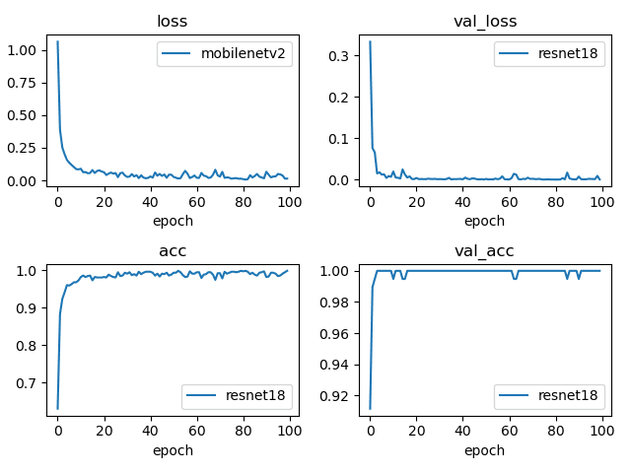

图片含义参考文章：

<https://blog.csdn.net/zhangjiali12011/article/details/88768441?ops_request_misc=%257B%2522request%255Fid%2522%253A%2522161871185516780264040368%2522%252C%2522scm%2522%253A%252220140713.130102334.pc%255Fall.%2522%257D&request_id=161871185516780264040368&biz_id=0&utm_medium=distribute.pc_search_result.none-task-blog-2~all~first_rank_v2~hot_rank-1-88768441.first_rank_v2_pc_rank_v29&utm_term=loss+val_loss>

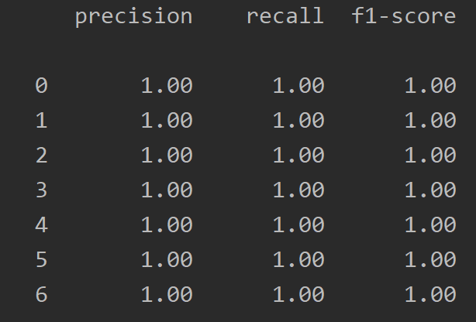

<https://blog.csdn.net/youif/article/details/105467922?ops_request_misc=%257B%2522request%255Fid%2522%253A%2522161871244216780357222127%2522%252C%2522scm%2522%253A%252220140713.130102334.pc%255Fall.%2522%257D&request_id=161871244216780357222127&biz_id=0&utm_medium=distribute.pc_search_result.none-task-blog-2~all~first_rank_v2~hot_rank-2-105467922.first_rank_v2_pc_rank_v29&utm_term=precession+recall+f1-score>

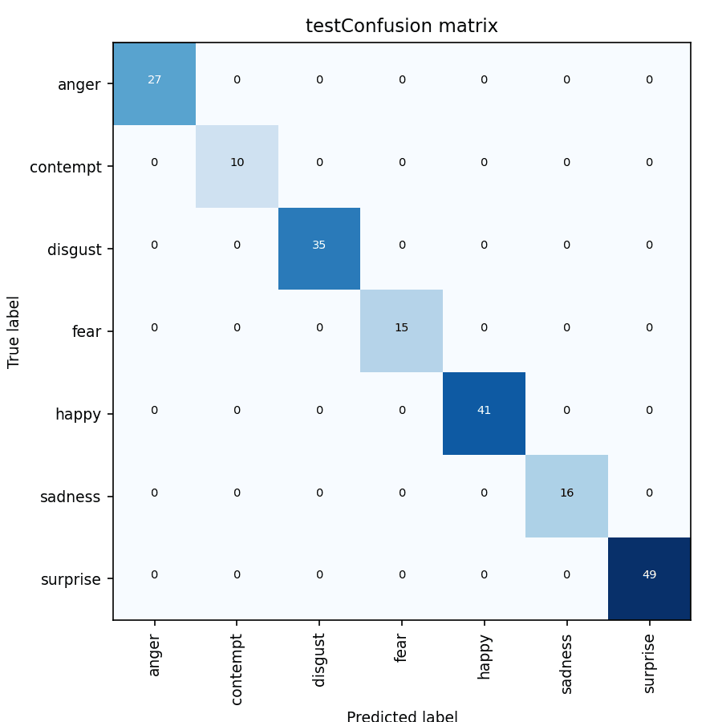

混淆矩阵：

https://blog.csdn.net/Orange_Spotty_Cat/article/details/80520839?ops_request_misc=%257B%2522request%255Fid%2522%253A%2522161870800416780265422057%2522%252C%2522scm%2522%253A%252220140713.130102334..%2522%257D&request_id=161870800416780265422057&biz_id=0&utm_medium=distribute.pc_search_result.none-task-blog-2~all~top_positive~default-1-80520839.first_rank_v2_pc_rank_v29&utm_term=%E6%B7%B7%E6%B7%86%E7%9F%A9%E9%98%B5