BOOKLOOP
Online Book Rental Subscription Platform
FINAL PROJECT REPORT

Course: IT Project Management
Team Name: Itssme
Student: Abduvoxidova Samira
Group: I24A | Student ID: 202490023
Individual academic system-planning project
Presentation date: October 20, 2026 (per Project Agreement)

Contents
1. Project Plan
2. Project Agreement / Contract
3. Use Case Modeling and Specifications
4. Business Process Model (BPM)
5. Work Breakdown Structure (WBS)
6. Gantt Chart
7. Summary, Limitations and Conclusion
References and Submitted Materials
This report consolidates the six deliverables required for the Capstone 2 midterm. BookLoop is a proposed system; a working commercial website is not claimed as completed.

Project Summary
BookLoop enables customers to rent physical books through monthly memberships. Customers choose books in an online catalog; a courier brings the next set while collecting previously rented books. The proposal covers membership and order management, inventory, deliveries, returns, and staff workflows.

Student / Team Information
Name | Student ID | Group | Role
Abduvoxidova Samira | 202490023 | I24A | Project leader; research, analysis, system modeling, documentation and presentation

Six deliverables
No. | Deliverable | Report section
1 | Project Plan | Section 1
2 | Contract / Agreement | Section 2
3 | Use Case Diagram & Specifications | Section 3
4 | Business Process Model | Section 4
5 | Work Breakdown Structure | Section 5
6 | Gantt Chart | Section 6

1. Project Plan

1.1 Background and Problem
Buying many books can be expensive, particularly for students and regular readers. Conventional libraries may require in-person visits. BookLoop proposes affordable subscriptions, online ordering, home delivery, and an exchange service for physical books.

1.2 Objectives
- Design a web-based physical-book rental system with account and membership management.
- Enable searching, book availability checks, and rental orders.
- Support home delivery and same-visit collection of previously rented books.
- Track rental periods, orders, returns, and inventory.
- Define an administrative workflow for customer, book, and order management.

1.3 Target Audience and Scope
Target audience: students, book enthusiasts, frequent readers, and customers who prefer home delivery. In scope: requirements and designs for registration, subscription plans, catalog, orders, deliveries, returns, reminders, and an admin dashboard. Out of scope for this academic submission: a production website, dedicated mobile application, e-book lending, book publishing, and international deliveries.

1.4 Proposed Membership Plans
Plan | Maximum books held | Monthly exchanges | Rental period per set
Basic | 2 | 2 | Up to 14 days
Standard | 3 | 3 | Up to 21 days
Premium | 4 | 4 | Up to 30 days
The membership rules are proposals; prices and operational constraints have not yet been finalized. A customer must have an active plan, stay within the plan limits, and select available books.

1.5 Essential System Requirements
Functional: registration/login; select a membership; browse/search catalog; check availability; place eligible orders; schedule exchanges; track delivery and return status; inspect returned books; update inventory. Non-functional: easy navigation, basic security and privacy, reliable inventory records, and accessibility through standard browsers.

1.6 Key Risks
Risk | Response
Late or incomplete returns | Due-date reminders; overdue/return status tracking
Lost or damaged books | Inspection and exception records
Unavailable titles | Check and reserve eligible copies before confirmation
Delivery delays | Delivery status and schedule updates
Incorrect membership limits | Automatic rules validation

1.7 Academic Project Timeline
Stage | Dates (2026) | Main work
Week 1 | Sep 28–Oct 4 | Topic, concept, objectives, scope and plans
Week 2 | Oct 5–8 | Project Plan and Individual Agreement; GitHub submission due Oct 8
Week 3 | Oct 9–13 | Requirements, actors, use cases and specifications
Week 4 | Oct 14–17 | BPM, WBS and Gantt planning
Week 5 | Oct 18–19 | Final Report, slides and review
Presentation | Oct 20, 22 or 23 | In-class presentation according to assigned schedule
The October 8 GitHub deadline and the October 20/22/23 presentation dates were provided in the course announcement. Other intermediate dates are proposed planning milestones. The signed-format agreement specifies October 20 as the presentation date.

2. Project Agreement / Contract
The attached Project Agreement (October 16, 2026) uses the proposed BookLoop business as the customer and Itssme as the development team. The development team has one member: Abduvoxidova Samira (202490023). It defines project purpose, scope, customer requirements, deliverables, responsibilities, budget, change handling and approval.

2.1 Main Agreement Terms
Item | Agreed approach
Project purpose | Design a subscription-based website for physical book rentals
Scope | Accounts, Basic/Standard/Premium plans, catalog, ordering, deliveries/returns, administration
Customer needs | Usable website, rental limits, available books, simultaneous book exchanges
Team responsibilities | Planning, requirements, diagrams, documents and final presentation
Budget | No actual commercial investment in this academic project
Changes | Document and review changes before including them
The agreement describes a proposed system rather than a completed commercial development contract. The full three-page Project Agreement is provided separately among the submitted materials.

3. Use Case Modeling and Specifications
The Use Case Diagram identifies four external actors: Customer, Administrator, Warehouse Staff, and Courier. The model shows access to BookLoop functions such as login, catalog browsing, membership management, ordering, preparation, delivery, collection, inspection and inventory updates.
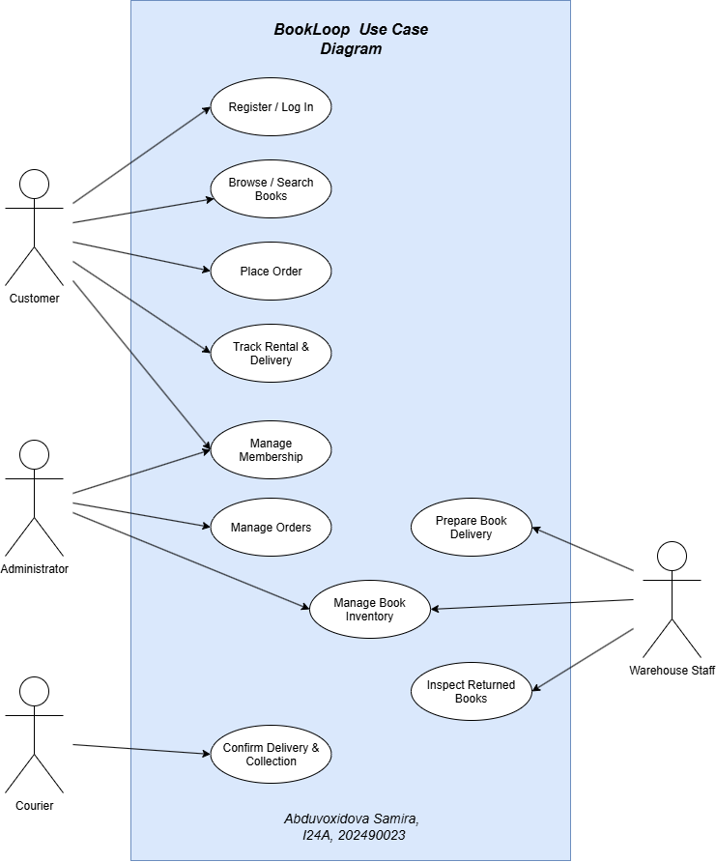
Figure 1. BookLoop Use Case Diagram (student-provided).

3.1 Detailed Use Case Specifications

UC-01 — Register / Login
Actors: Customer | Precondition: Website can be accessed
Main flow: Open Register/Login → enter information → system validates → account/session opened.
Alternative: Invalid details: show validation error. Postcondition: Customer account created or accessed.

UC-02 — Manage Membership
Actors: Customer; Administrator | Precondition: Customer logged in
Main flow: Display plans → select Basic/Standard/Premium → confirm subscription → activate after successful payment.
Alternative: Payment/eligibility failure: plan remains inactive. Postcondition: Membership and limits recorded.

UC-03 — Browse / Search Books
Actors: Customer | Precondition: Catalog available
Main flow: Search by title/author/genre → view details and availability → select titles.
Alternative: No result: show message or suggest a new search. Postcondition: Titles selected for potential rental.

UC-04 — Place Rental Order
Actors: Customer | Precondition: Active membership and available titles
Main flow: Add books → check plan allowance and stock → choose delivery details → confirm rental → create order.
Alternative: Limit exceeded or title unavailable: revise selection. Postcondition: Order recorded and ready for preparation.

UC-05 — Confirm Delivery & Collection
Actors: Courier; Customer | Precondition: Order approved and prepared
Main flow: Courier brings books → hands over new set → collects previous set if applicable → records both outcomes.
Alternative: Missing previous books: record incomplete return for follow-up. Postcondition: Delivery/collection statuses updated.

UC-06 — Inspect Returns & Update Inventory
Actors: Warehouse Staff; Administrator | Precondition: Returned books received
Main flow: Receive books → inspect condition → update return record → release suitable copies for rental.
Alternative: Damaged/missing book: flag as unavailable and report exception. Postcondition: Accurate inventory and condition records.

4. Business Process Model (BPM)
The BPM illustrates the end-to-end rental and book exchange workflow across Customer, BookLoop System, Administrator, Warehouse Staff, Courier, and Inventory roles.
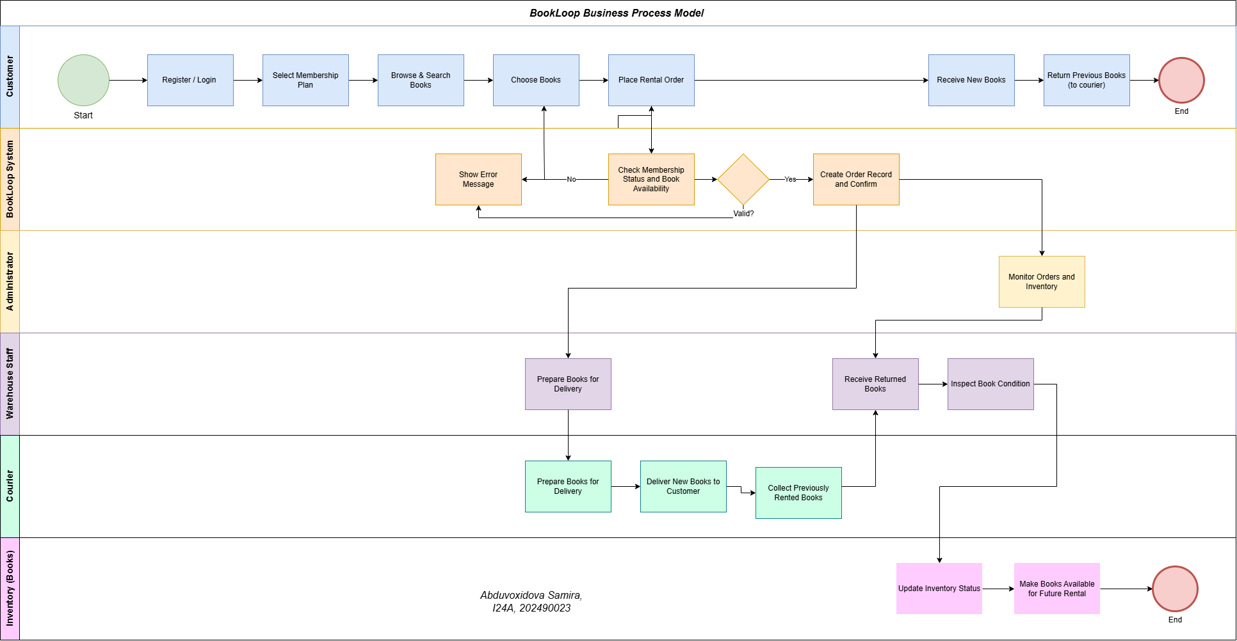
Figure 2. BookLoop Business Process Model (student-provided).
Main control: the system checks membership status and availability before confirming an order. The courier delivers new books and collects previously rented books; warehouse staff inspect returns before the inventory is made available again.

5. Work Breakdown Structure (WBS)
This WBS describes the future implementation of the BookLoop platform—not only the steps required to prepare the academic report. It decomposes the system-development project into six high-level work packages.
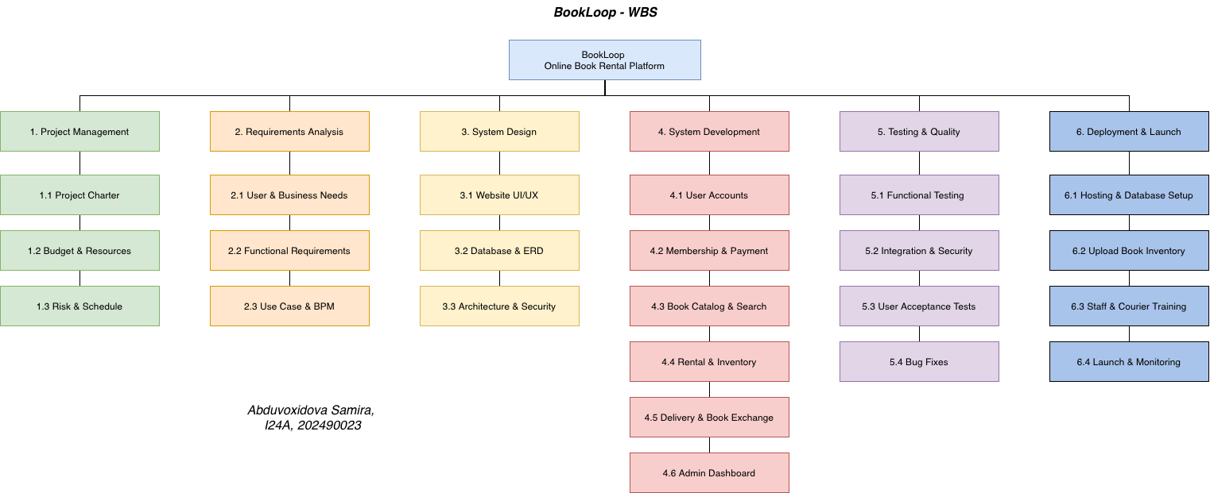
Figure 3. Future BookLoop platform-development WBS (student-provided).
WBS | Phase | Examples of work
1.0 | Project Management | Charter, budget/resources, schedule and risks
2.0 | Requirements Analysis | Business needs, system functions, Use Case and BPM
3.0 | System Design | Website UI/UX, database/ERD, architecture and security
4.0 | System Development | Accounts, memberships, catalog, rentals, exchange, administration
5.0 | Testing & Quality | Functional/integration testing, acceptance and fixes
6.0 | Deployment & Launch | Hosting, catalog setup, staff training, release and monitoring

6. Gantt Chart
The supplied Gantt Chart presents the five-week academic preparation and presentation schedule. It is a schedule for producing the current course deliverables, while the WBS in Section 5 outlines future implementation work. The chart therefore does not represent a timed development schedule for the production website.
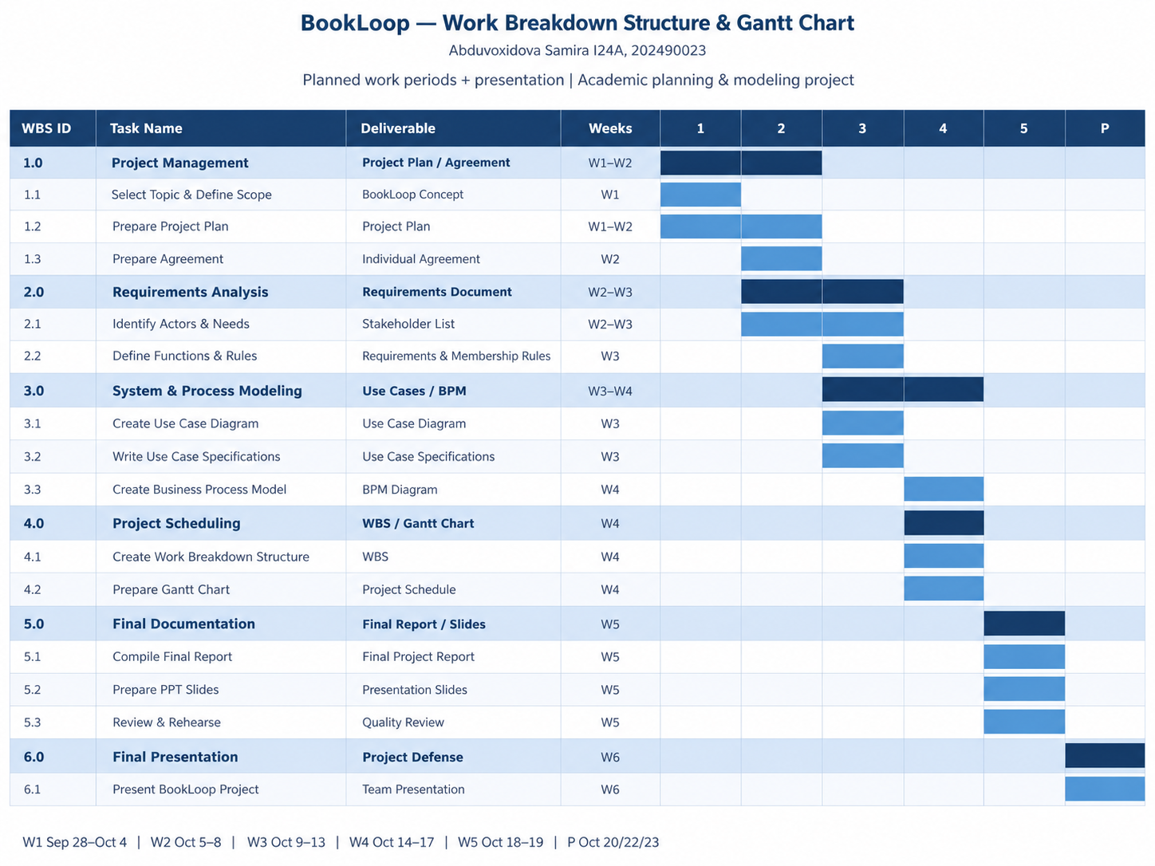
Figure 4. Academic deliverable Gantt Chart (student-provided).

7. Summary, Limitations and Conclusion

7.1 Expected Outcomes
The proposed platform provides one workflow for physical-book selection, subscription validation, orders, same-visit delivery and collection, return inspection and inventory tracking. The report documents the concept through a plan, agreement, use cases, business process map, WBS and schedule.

7.2 Project Limitations
- BookLoop is an academic system proposal; no working website or completed software testing is claimed.
- Subscription prices, delivery economics, payment provider and loss/damage policies require further business validation.
- The implementation WBS and academic Gantt Chart cover different planning horizons; a separate implementation Gantt would be required before building the website.

7.3 Conclusion
BookLoop proposes an affordable and convenient alternative to purchasing books individually. Membership tiers, online catalog access, and simultaneous courier exchange form the core service. The six project deliverables demonstrate the planned system functions, operational workflow, implementation structure, and academic project organization.

References and Submitted Materials
- IT Project Management — Capstone 2 Midterm Examination Guidelines & Grading Breakdown (course announcement, 2026).
- BookLoop Project Plan — student-provided content.
- Project Agreement.pdf — individual BookLoop agreement (October 16, 2026).
- UseCase for BookLoop.drawio.png — Use Case Diagram.
- BPM for BookLoop.drawio.png — Business Process Model.
- WBS for BookLoop.PNG — future implementation WBS.
- Gantt chart for BookLoop.PNG — academic project schedule.

