Odeja Samuel

Assignment

First of all installation of kali linux:

* Download the necessary files from the drive given by gomycode
* After install vmware on your system
* Add kali linux to virtual machine

Now we are all set up there some particular that wen to download given by gomycode it is to assist our assignment i.e the example.log,example2.log,webserver.log

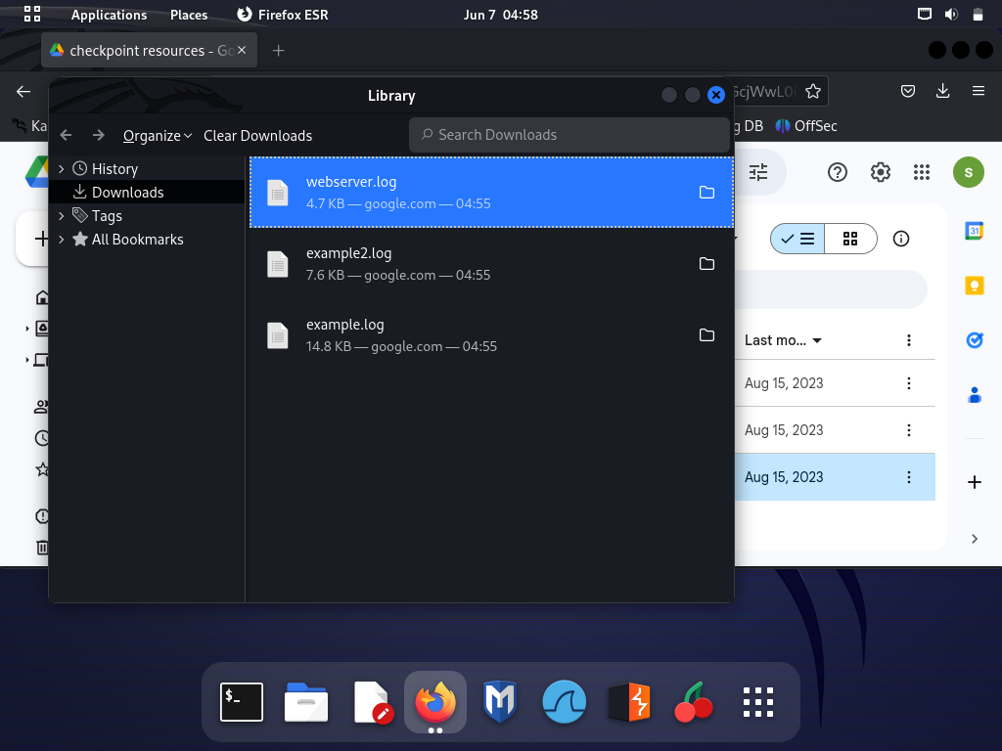

After this we would create a directory for this file

**Note:**file most be save to your home directory

Now navigate to your terminal and type the command ‘mkdir’. What the mkdir does is that it allows you to create a new directory.

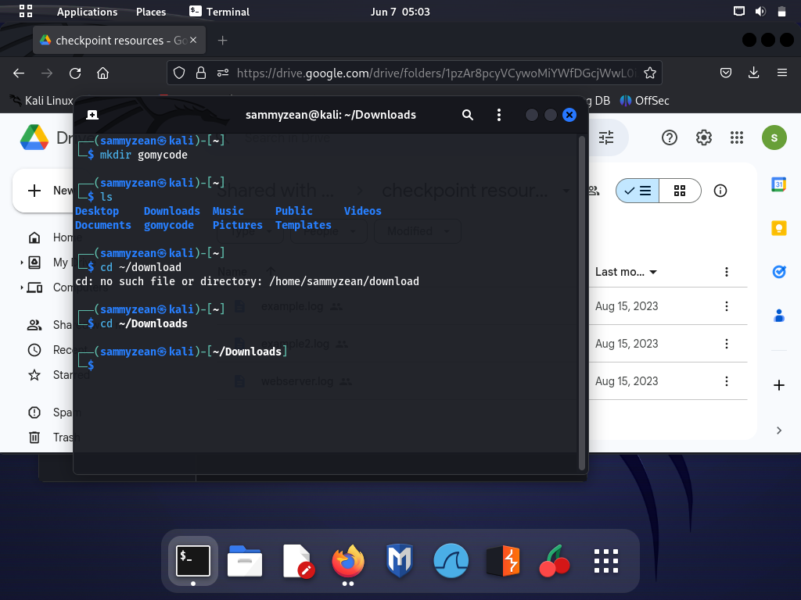

As you can see you type ‘mkdir’ followed by the name you want to give your directory in this case I have given mine ‘gomycode’. The ls function just the list of file in that directory.

After creating your directory we need to move the file from downloads to the directory that is gomycode. But first

* We change the directory to the download using the command cd
* Then we use the command ‘mv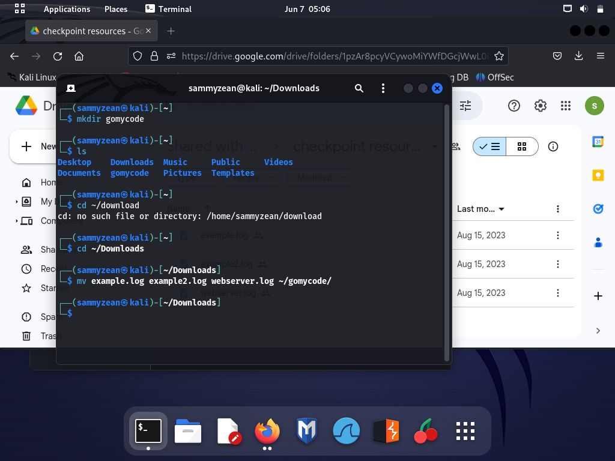

That is “mv example.log example2.log webserver.log” and you include your directory.

After we are done with setting all this up we den go into solving the checkpoint

First task in the checkpoint says we should use the ‘cat’ command to view content in example.log and example2.log

We would be using ‘cat-n example.log example2.log

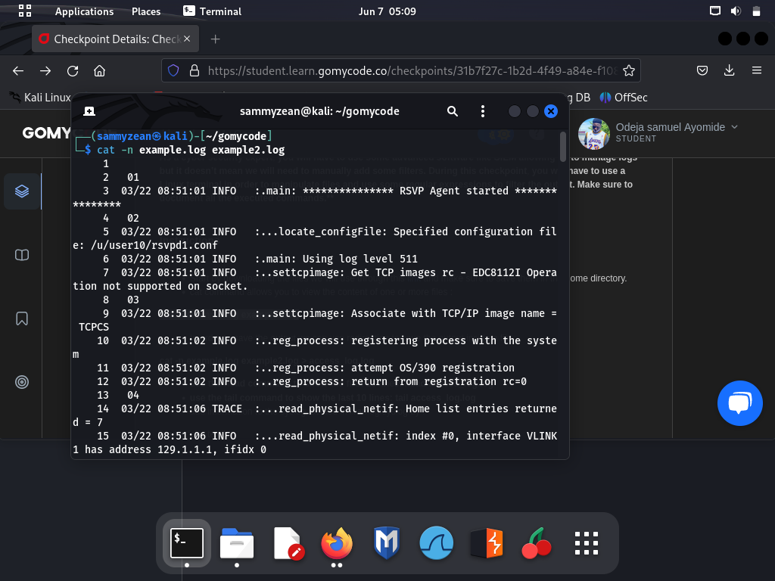

* ‘cat’ meaning concatenate, this allow you to display files
* ‘-n’ this numbers all the lines of the output

Next task is to use the ‘cat’ to display the first 10 lines and the last 10 lines. Your can do so by using the command the ‘head and tail’ command .

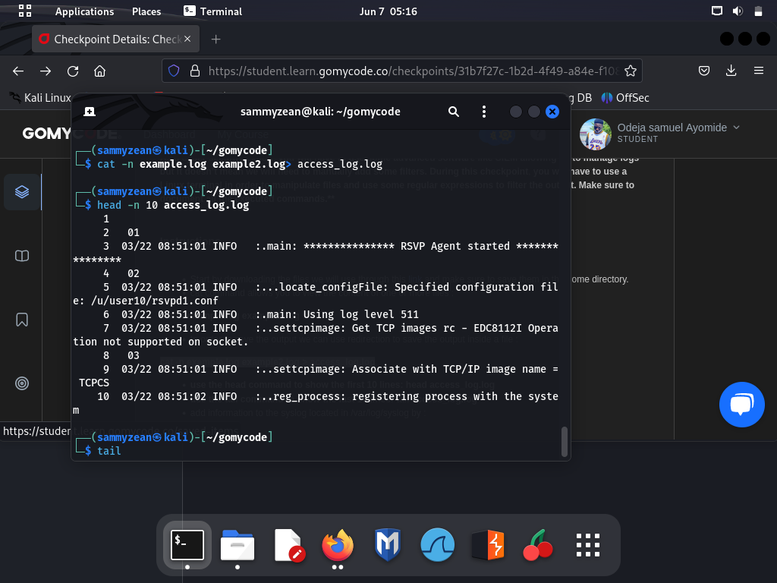

**HEAD**

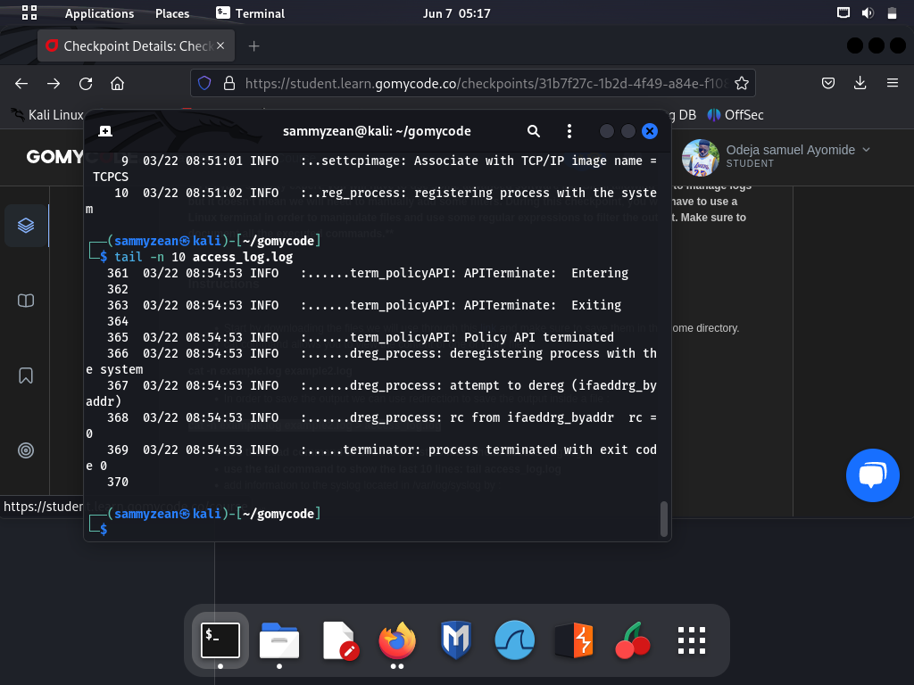

**TAIL**

The next task was to use the grep command to select a particular set of words i.e words contain p,l,c. so we would be using “grep -E ‘p|l|c’” example.log. be careful and precise when typing linux is very case sensitive make sure if you want to use get more 1 letter or word you put a pipe in between them.

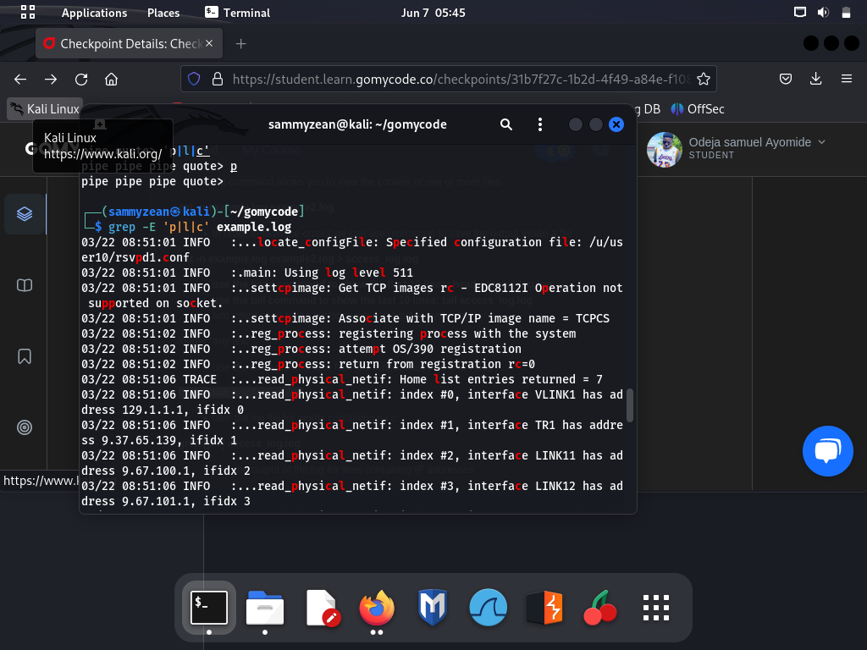

And the last task to select ip address from the webserver.log file using the same grep command giving gomycode

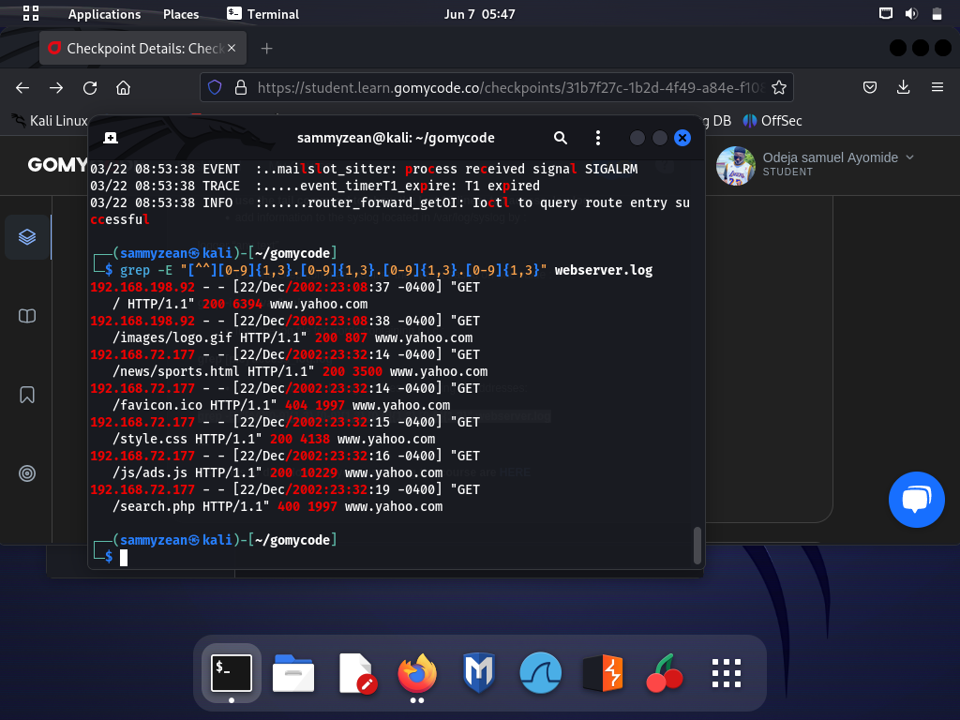

**ASSIGNMENT 2**

We were task to find the ipaddress of this 3 machine

1. kali linux
2. debian os
3. windows server

first kali linux using the **“ifconfig”** command

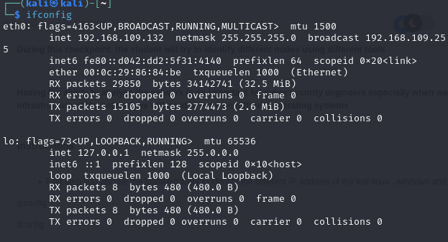

second the debian os using the “**ip addr**” command

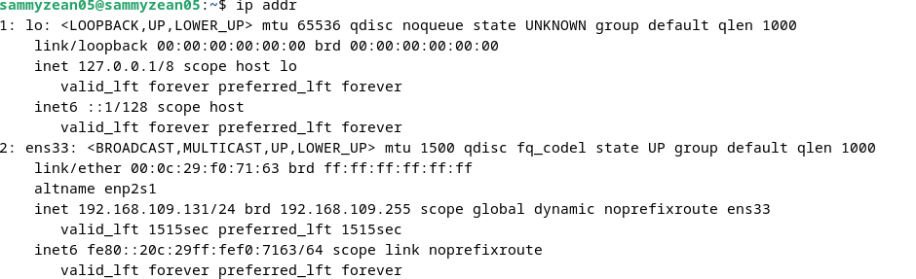

third the windows server using the “**ipconfig”** command

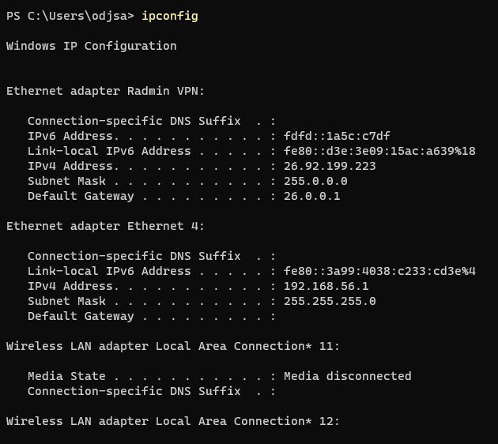

Next we task to use nmap on each of this machine

whats nmap?

nmap is a linux tool use to scan of open or close port in a network or machine e.g

for the debian os

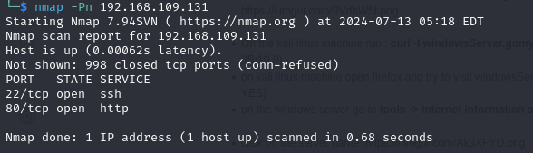

as you can see we have two open ports i.e the ssh been port 22 and the http been port 80.

another example is the windows

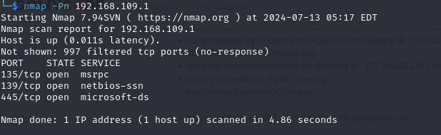

as you also we have 3 open ports i.e msrpc port 135 , netbios-ssn port 139 and microsoft-ds port 445

We would also be looking into another command called “nslookup”

whats nslookup?

this is a dns query that maps domain name to ipaddress

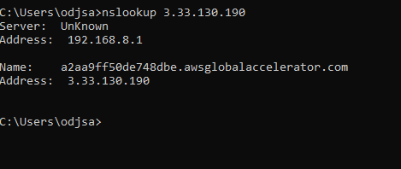

We were also task to ping our windows server

whats ping?

This a command that is use to check connectivity of a machine or network. In layman term to check if a system can be reach.

first we would be pinging our windows server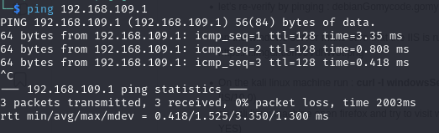

we were ask to use the dig command on this same ipaddress if you are wondering what dig is it is basically the same thing as nslookup just that nslookup supplies the fundamental of the dns data while dig supplies a large variety of record data

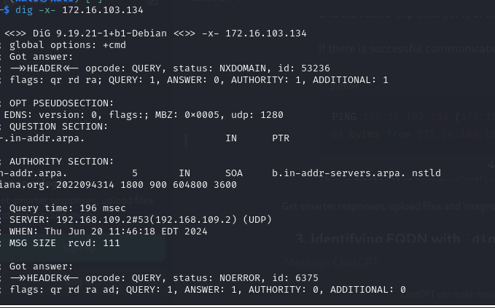

Next up we are pinging debain os

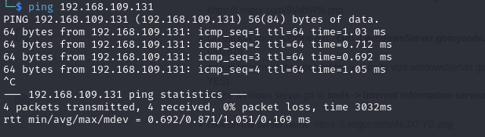

Next the curl command

what is curl

This a command used to transfer data from urls i.e the tags used in a url

