Summary Hello, I’m Samnang Yorng. I am a motivated student at AIE Sydney studying game programmer and I seeking future employment in the video games industry, mainly on mobile game development. I am very interested to develop new skills along the way to help my studies and to gain heaps of experience for my chosen industry.

Career history Warehouse Assistant Manager at Luxe Bouquet PTY

January 2021 – Present

Manage the warehouse and tell people what to do and team new people how to do their job base on their role.

Key responsibilities

* Teaching a guiding new employee on how to do their task
* Book, prep and pack order (if busy)

Kitchen Hand at I need a Chef

July 2022 – Month present

Help the chef around the kitchen to prepare food the plate.

Key responsibilities

* Organise the ingredients in its desired location.
* Prep the food nicely on to the plate

Education Academy of Interactive entertainment

Graduated: 2022 – present

Key skills Knowledge on C++ and C# programming, Unity 3D, UI elements, problem solving, strong communication within a team,

References Available upon request

Connecting with others

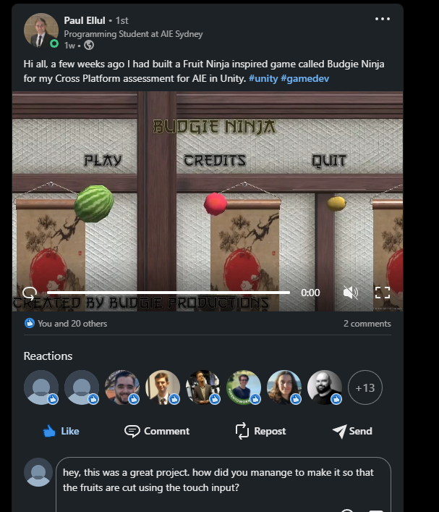

Self-Promotion

Linkedin profile: <https://www.linkedin.com/in/samnang-yorng-2a4033251/>



