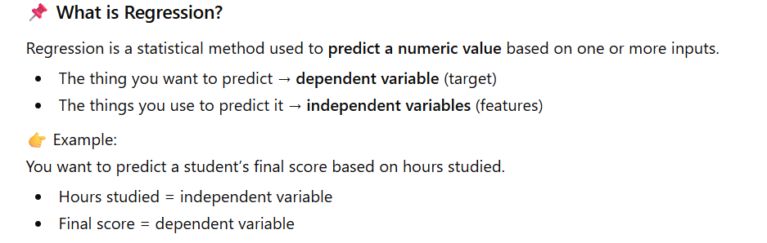
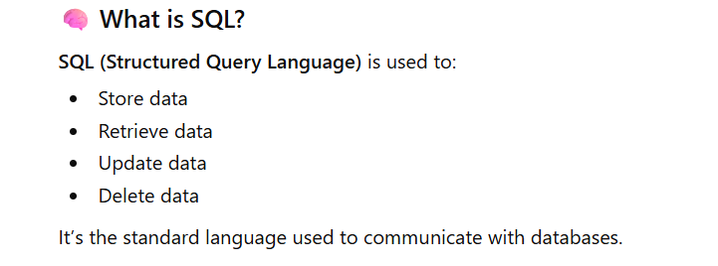
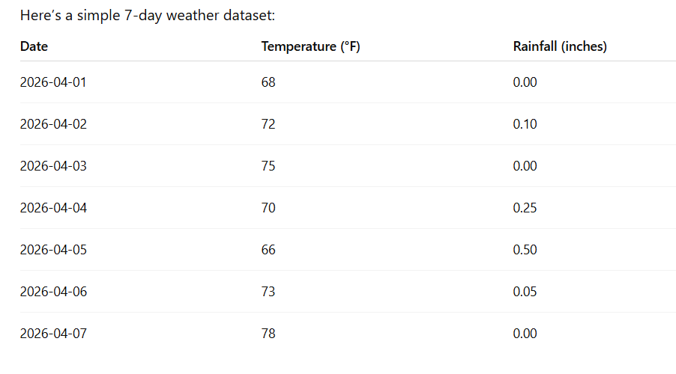
a) Explain regression to me as a student new to Data analytics
b) Help me understand SQL as someone who knows nothing about databases
c) Generate a small weather dataset with 7 rows (one per day). Include: date, temperature, and rainfall. Output the dataset as a table.
My revised prompts allowed Chat GPT to generate more accurate results. The weaker prompts were too vague and were not going to provide you with the desired results.

