Problem Statement:

Determine the best material to use for a 16-fin heat sink that is mounted on an electronic component by looking at their transient performance. Note that when the heat sink reaches a steady state, the component powers off allowing the component to cool to the ambient temperature. Furthermore, construct models that have three equal sized nodes in a single fin and a fourth node for the base. Neglect radiative heat transfer.

Given:

1. The electronic generates 250 W of heat when operating.
2. The electronic component is 6 cm by 6 cm.
3. The base plate of the heat sink is also 6 cm by 6 cm with a 0.6 cm thickness and is mounted directly on the component.
4. Each of the fins have a width of 6 cm, a thickness of 0.1 cm, and a length of 4 cm with a 0.275 cm air gap between them.
5. The ambient air has a temperature of 25°C and a fixed heat transfer coefficient of 50 W/m^2/K
6. The material properties follow:

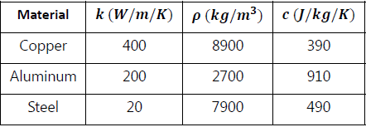

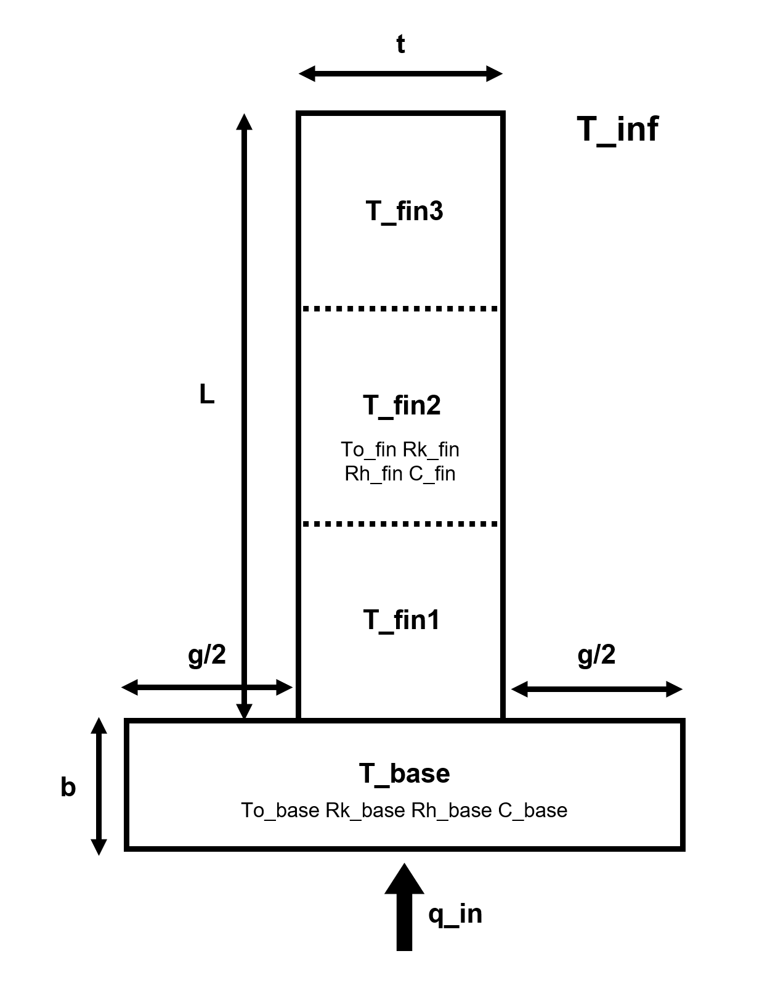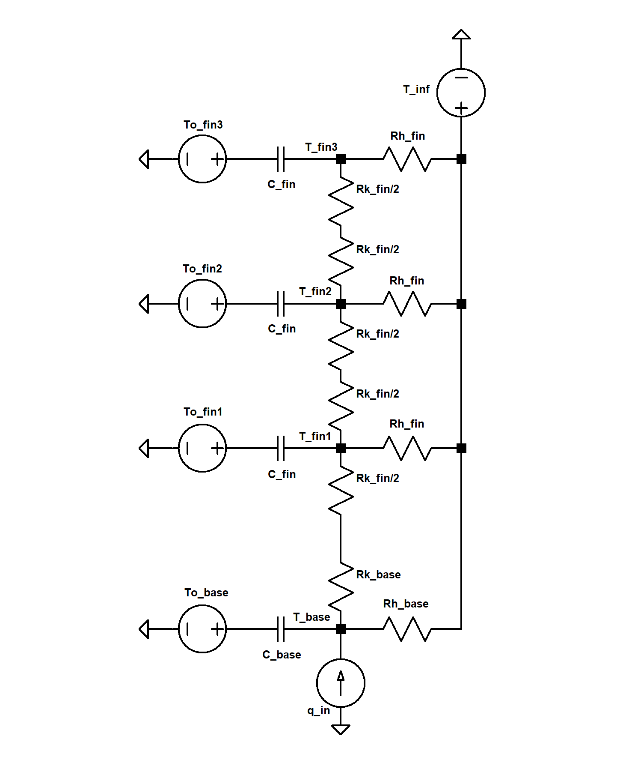

Circuit diagram and sketch

Analysis:

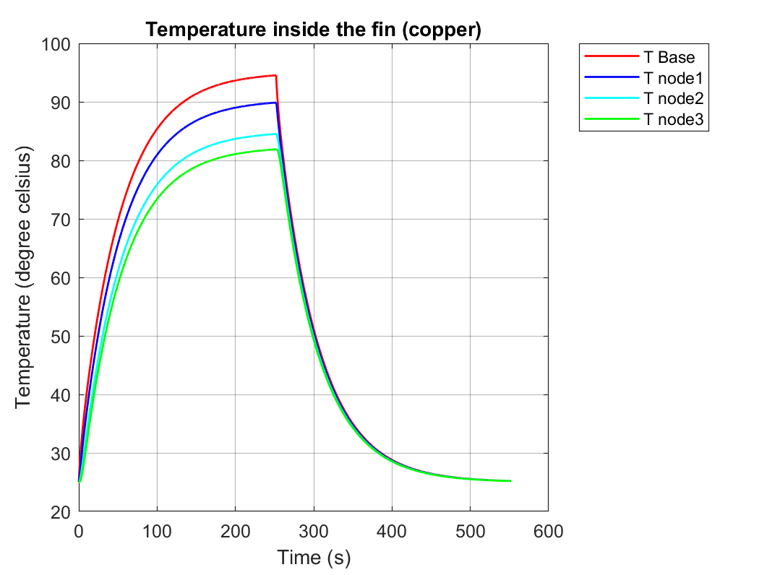

Fig.3: Transient Temperature Response of a Copper Heat Sink

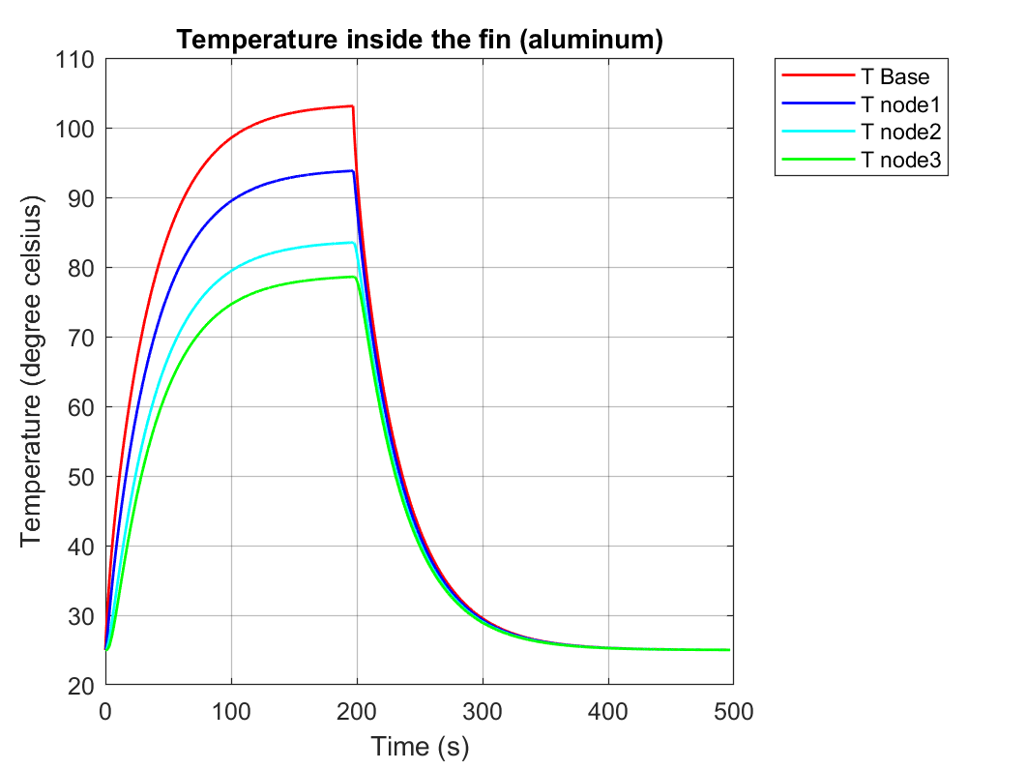

Fig.4: Transient Temperature Response of an Aluminum Heat Sink

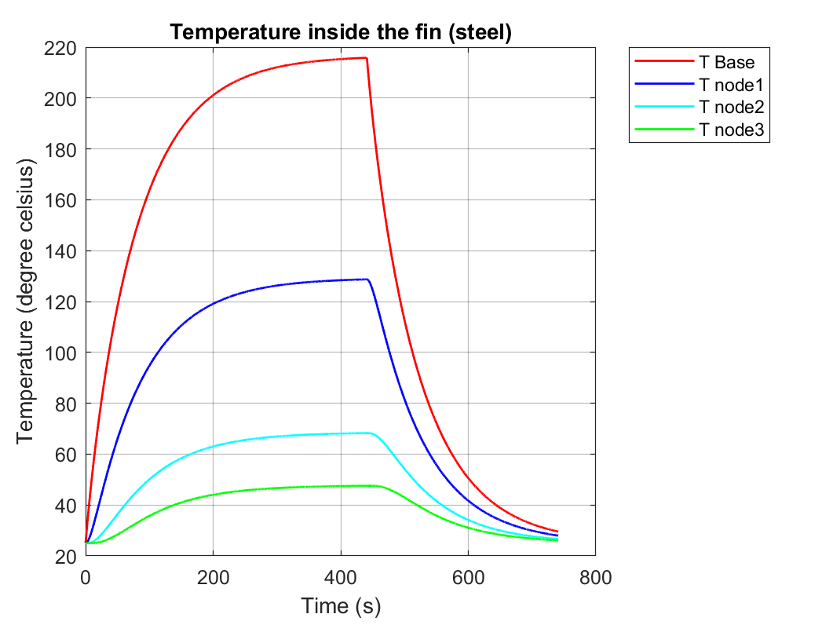

Fig.5: Transient Temperature Response of a Steel Heat Sink

According to the temperature response curves of the three material, the temperature for nodes are the least spread-out for the copper fin, and the most spread-out for the steel fin. This result corresponds to the conduction coefficients for three fins with different materials, as copper has the highest conduction coefficient and steel has the lowest conduction coefficient. The temperature spread can be un-ideal in practical situations such as a desktop computer: the base and the end of the fin’s large temperature difference can be hazardous to the core components. Due to the low conduction and relatively low specific heat capacity, the steel heat fin arrives at steady state temperatures much slower, shown especially when the constant heat input is turned off. This can be an issue in practical settings when heat needs to be dissipated at fast as possible. Although aluminum reaches a steady state temperature quicker than copper – around 100 seconds earlier – the copper reaches lower peak temperatures and has more even heating while having a similar rate of temperature decrease from peak temperature based on their respective temperature curves. Due to the even temperature spread and time required to achieve steady state temperatures, it can be inferred that the copper is the most ideal material for heat dissipation.

Appendix

%% PARAMTETERS

w=0.06; %m

th=0.001; %m

b=0.006; %m

g=0.00275; %m

L=0.04; %m

Lc=L+th*w/(2*w+2*th); %m

q0=250/16; %w

T0=25;

T01=25;

T02=25;

T03=25;

Tinf=25;

h=50; %w/m2/K

k_cop=400; %W/m/K

k_alum=200; %W/m/K

k_steel=20; %W/m/K

rou_cop=8900; %kg/m3

rou_alum=2700; %kg/m3

rou_steel=7900; %kg/m3

c_cop=390; %J/kg/K

c_alum=910; %J/kg/K

c_steel=490; %J/kg/K

%% PARAMETER IN USE

k=k_cop;

rou=rou_cop;

c=c_cop;

C=c*w*L*th*rou/3;

C0=c*w*w*b*rou/16;

Rf=L/(6*k*w*th);

Rh=1/(h*(Lc/3)*(2*th+2*w));

Rhb=1/(h*g*w);

Rb=b*8/(k*w*w);

t_end=100;

T_diff=1;

%% HEAT SINK RESPONSE FOR COPPER

s=tf('s');

A=[1/Rhb+1/(Rb+Rf)+s*C0,-1/(Rb+Rf),0,0;

-1/(Rb+Rf),1/(Rb+Rf)+s*C+1/Rh+1/(2*Rf),-1/(2*Rf),0;

0,-1/(2*Rf),1/(2*Rf)+s*C+1/Rh+1/(2*Rf),-1/(2*Rf);

0,0,-1/(2*Rf),1/(2*Rf)+s*C+1/Rh];

B=[q0/s+T0*s*C0/s+Tinf/(s*Rhb),T01*s*C/s+Tinf/(s*Rh),T02*s*C/s+Tinf/(s*Rh),T03*s*C/s+Tinf/(s*Rh)].';

X_s=A\B;

while T_diff>0.001

t_end=t_end+1;

t=(0:0.1:t_end).';

X0_t=impulse(X_s(1),t);

X1_t=impulse(X_s(2),t);

X2_t=impulse(X_s(3),t);

X3_t=impulse(X_s(4),t);

T_diff=X0_t(t_end*10+1)-X0_t(t_end*10);

end

figure(1)

plot(t,X0_t,'r','LineWidth',1.1)

hold on

plot(t,X1_t,'b','LineWidth',1.1)

hold on

plot(t,X2_t,'c','LineWidth',1.1)

hold on

plot(t,X3_t,'g','LineWidth',1.1)

hold on

T0=X0_t(t_end*10+1);

T01=X1_t(t_end*10+1);

T02=X2_t(t_end*10+1);

T03=X3_t(t_end*10+1);

B=[T0*s*C0/s+Tinf/(s*Rhb),T01*s*C/s+Tinf/(s*Rh),T02*s*C/s+Tinf/(s*Rh),T03*s*C/s+Tinf/(s*Rh)].';

X_s=A\B;

t=(0:0.1:300).';

X0_t=impulse(X_s(1),t);

X1_t=impulse(X_s(2),t);

X2_t=impulse(X_s(3),t);

X3_t=impulse(X_s(4),t);

plot(t+t_end,X0_t,'r','LineWidth',1.1)

hold on

plot(t+t_end,X1_t,'b','LineWidth',1.1)

hold on

plot(t+t_end,X2_t,'c','LineWidth',1.1)

hold on

plot(t+t_end,X3_t,'g','LineWidth',1.1)

title('Temperature inside the fin (copper)','FontSize',14)

xlabel('Time (s)','FontSize',12)

ylabel('Temperature (degree celsius)','FontSize',12)

set(gca,'FontSize',10)

grid on

set(gca,'GridAlpha',0.3)

legend({'T Base','T node1','T node2','T node3'},'Location','bestoutside')

%% PARAMETER IN USE

q0=250/16; %w

T0=25;

T01=25;

T02=25;

T03=25;

Tinf=25;

h=50; %w/m2/K

k=k_alum;

rou=rou_alum;

c=c_alum;

C=c*w*L*th*rou/3;

C0=c*w*w*b*rou/16;

Rf=L/(6*k*w*th);

Rh=1/(h*(Lc/3)*(2*th+2*w));

Rhb=1/(h*g*w);

Rb=b*8/(k*w*w);

t_end=100;

T_diff=1;

%% HEAT SINK RESPONSE FOR ALUMINUM

s=tf('s');

A=[1/Rhb+1/(Rb+Rf)+s*C0,-1/(Rb+Rf),0,0;

-1/(Rb+Rf),1/(Rb+Rf)+s*C+1/Rh+1/(2*Rf),-1/(2*Rf),0;

0,-1/(2*Rf),1/(2*Rf)+s*C+1/Rh+1/(2*Rf),-1/(2*Rf);

0,0,-1/(2*Rf),1/(2*Rf)+s*C+1/Rh];

B=[q0/s+T0*s*C0/s+Tinf/(s*Rhb),T01*s*C/s+Tinf/(s*Rh),T02*s*C/s+Tinf/(s*Rh),T03*s*C/s+Tinf/(s*Rh)].';

X_s=A\B;

while T_diff>0.001

t_end=t_end+1;

t=(0:0.1:t_end).';

X0_t=impulse(X_s(1),t);

X1_t=impulse(X_s(2),t);

X2_t=impulse(X_s(3),t);

X3_t=impulse(X_s(4),t);

T_diff=X0_t(t_end*10+1)-X0_t(t_end*10);

end

figure(2)

plot(t,X0_t,'r','LineWidth',1.1)

hold on

plot(t,X1_t,'b','LineWidth',1.1)

hold on

plot(t,X2_t,'c','LineWidth',1.1)

hold on

plot(t,X3_t,'g','LineWidth',1.1)

hold on

T0=X0_t(t_end*10+1);

T01=X1_t(t_end*10+1);

T02=X2_t(t_end*10+1);

T03=X3_t(t_end*10+1);

B=[T0*s*C0/s+Tinf/(s*Rhb),T01*s*C/s+Tinf/(s*Rh),T02*s*C/s+Tinf/(s*Rh),T03*s*C/s+Tinf/(s*Rh)].';

X_s=A\B;

t=(0:0.1:300).';

X0_t=impulse(X_s(1),t);

X1_t=impulse(X_s(2),t);

X2_t=impulse(X_s(3),t);

X3_t=impulse(X_s(4),t);

plot(t+t_end,X0_t,'r','LineWidth',1.1)

hold on

plot(t+t_end,X1_t,'b','LineWidth',1.1)

hold on

plot(t+t_end,X2_t,'c','LineWidth',1.1)

hold on

plot(t+t_end,X3_t,'g','LineWidth',1.1)

title('Temperature inside the fin (aluminum)','FontSize',14)

xlabel('Time (s)','FontSize',12)

ylabel('Temperature (degree celsius)','FontSize',12)

set(gca,'FontSize',10)

grid on

set(gca,'GridAlpha',0.3)

legend({'T Base','T node1','T node2','T node3'},'Location','bestoutside')

%% PARAMETER IN USE

q0=250/16; %w

T0=25;

T01=25;

T02=25;

T03=25;

Tinf=25;

h=50; %w/m2/K

k=k_steel;

rou=rou_steel;

c=c_steel;

C=c*w*L*th*rou/3;

C0=c*w*w*b*rou/16;

Rf=L/(6*k*w*th);

Rh=1/(h*(Lc/3)*(2*th+2*w));

Rhb=1/(h*g*w);

Rb=b*8/(k*w*w);

t_end=100;

T_diff=1;

%% HEAT SINK RESPONSE FOR STEEL

s=tf('s');

A=[1/Rhb+1/(Rb+Rf)+s*C0,-1/(Rb+Rf),0,0;

-1/(Rb+Rf),1/(Rb+Rf)+s*C+1/Rh+1/(2*Rf),-1/(2*Rf),0;

0,-1/(2*Rf),1/(2*Rf)+s*C+1/Rh+1/(2*Rf),-1/(2*Rf);

0,0,-1/(2*Rf),1/(2*Rf)+s*C+1/Rh];

B=[q0/s+T0*s*C0/s+Tinf/(s*Rhb),T01*s*C/s+Tinf/(s*Rh),T02*s*C/s+Tinf/(s*Rh),T03*s*C/s+Tinf/(s*Rh)].';

X_s=A\B;

while T_diff>0.001

t_end=t_end+1;

t=(0:0.1:t_end).';

X0_t=impulse(X_s(1),t);

X1_t=impulse(X_s(2),t);

X2_t=impulse(X_s(3),t);

X3_t=impulse(X_s(4),t);

T_diff=X0_t(t_end*10+1)-X0_t(t_end*10);

end

figure(3)

plot(t,X0_t,'r','LineWidth',1.1)

hold on

plot(t,X1_t,'b','LineWidth',1.1)

hold on

plot(t,X2_t,'c','LineWidth',1.1)

hold on

plot(t,X3_t,'g','LineWidth',1.1)

hold on

T0=X0_t(t_end*10+1);

T01=X1_t(t_end*10+1);

T02=X2_t(t_end*10+1);

T03=X3_t(t_end*10+1);

B=[T0*s*C0/s+Tinf/(s*Rhb),T01*s*C/s+Tinf/(s*Rh),T02*s*C/s+Tinf/(s*Rh),T03*s*C/s+Tinf/(s*Rh)].';

X_s=A\B;

t=(0:0.1:300).';

X0_t=impulse(X_s(1),t);

X1_t=impulse(X_s(2),t);

X2_t=impulse(X_s(3),t);

X3_t=impulse(X_s(4),t);

plot(t+t_end,X0_t,'r','LineWidth',1.1)

hold on

plot(t+t_end,X1_t,'b','LineWidth',1.1)

hold on

plot(t+t_end,X2_t,'c','LineWidth',1.1)

hold on

plot(t+t_end,X3_t,'g','LineWidth',1.1)

title('Temperature inside the fin (steel)','FontSize',14)

xlabel('Time (s)','FontSize',12)

ylabel('Temperature (degree celsius)','FontSize',12)

set(gca,'FontSize',10)

grid on

set(gca,'GridAlpha',0.3)

legend({'T Base','T node1','T node2','T node3'},'Location','bestoutside')