**Applied Machine Learning**

**Wild-animals Detection**

Group: BDA-2201

Samal

Advisor: Aiymbay Sunggat

Date of submission: November 19 2024

1. Loading data. 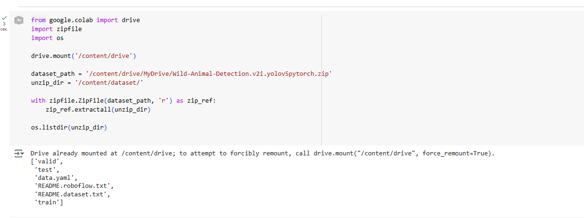
2. СUsing the TensorFlow.keras library and the ImageDataGenerator method, we perform data augmentation to improve model quality and avoid overfitting. The ResNet50 model is applied. Generators are used to load and prepare data with a size of 224x224 and a batch size of 512, as there is a large amount of data, and it is desirable to reduce training time. The model is also compiled here.

3) The training process of the model is started here.

4) The training results are visualized here, and it is evident that the model trains very well. There is no overfitting because both the training and validation accuracies are approaching 1, while their errors are inversely proportional and approaching 0.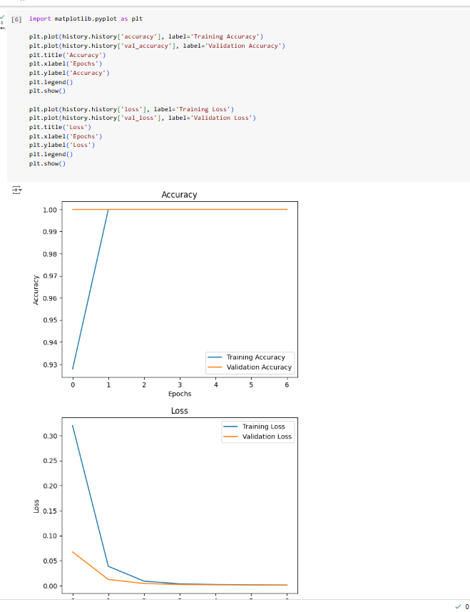

5) We apply a better model, ResNet50, by adding DropOut, BatchNormalization, and ReLU.

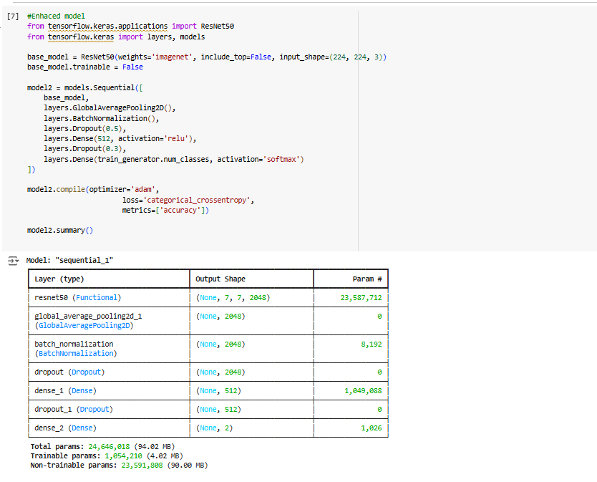

6) Its results are shown, and they are slightly better than the first time.

7) We also visualize the results as in the first case and see a similar conclusion, but slightly better.

8) In this part, we perform evaluation measurements of F1, precision, and recall. These metrics show that the model works very well and is accurate.

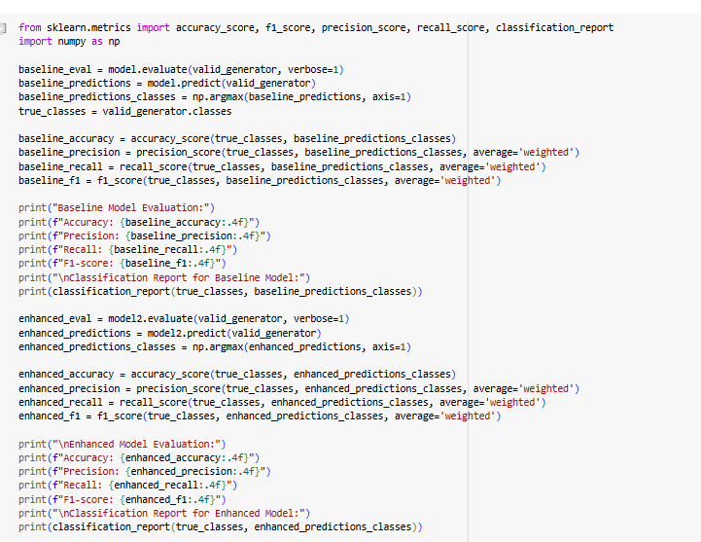

9) We apply EfficientDet and install the necessary resources.

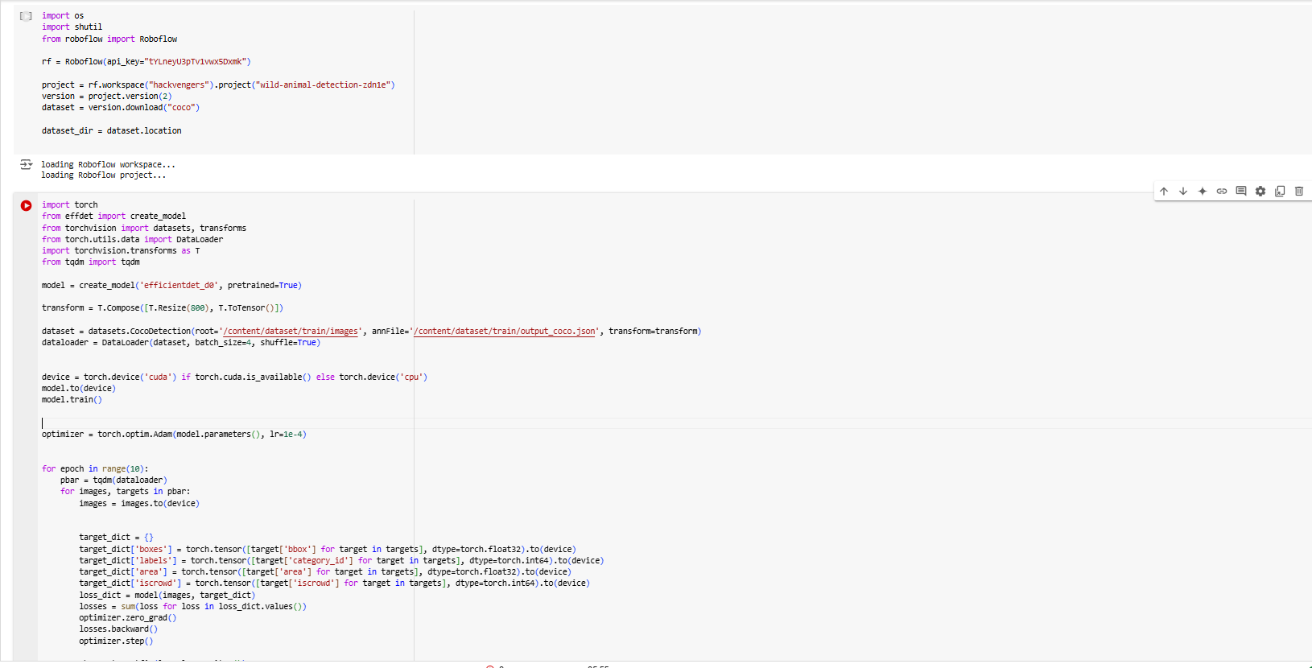

In general, many accounts were changed because the laptop doesn't support the GPU system, and it has become practically impossible to implement the final steps due to lack of time.