**DESIGN PROJECT REPORT**

**ENGR 131- Transforming Ideas to Innovation I**

Section 02

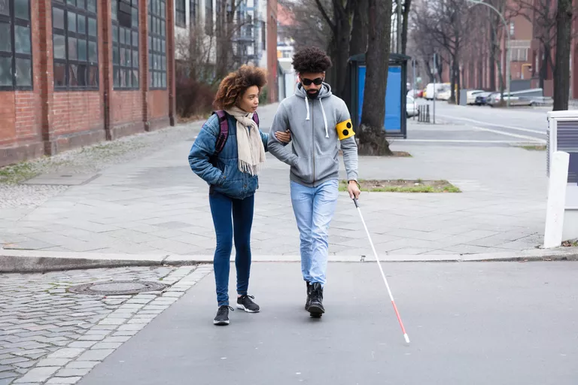

Figure 1. Cover Image (Lipner, 2021)

Team 25

Samuel Morales, Luca Rosu, Kyle Johnson and Matthew Jacobs

10/24/21

1. **Contents**

II. TEAM MEMBER ROLES 3

III. PROBLEM SCOPING 4

a. Problem Statement 4

b. Design Criteria and Constraints 4

c. Direct Users and Stakeholders 5

d. Background Information 5

e. Assumptions about the Problem 6

IV. REFERENCES 6

# TEAM MEMBER ROLES

Our project team included 4 members (See Figure 2). We allocated roles and responsibilities to each team member by/based on the abilities and skills each of us has:

Table 1. Team roles

|  |  |  |  |
| --- | --- | --- | --- |
| **Milestone** | **Name** | **Specific tasks for each milestone** | **Status** |
| Problem scoping | Luca | * Criteria | * On Time |
| Sam | * Constraints | * On time |
| Matthew | * Trade-off | * On time |
| Kyle | * Trade-off | * On time |

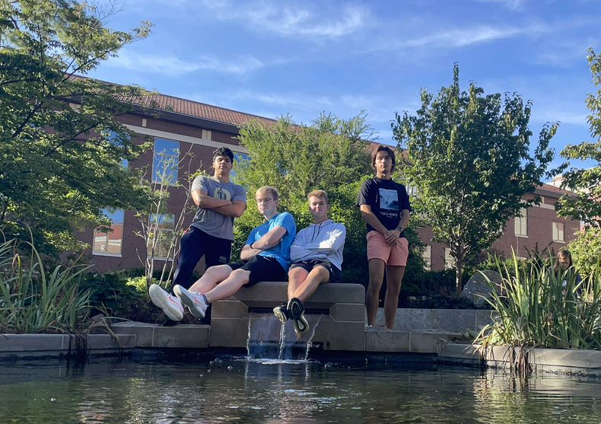

Figure 2. Project team

# PROBLEM SCOPING

## Problem Statement

Blind people are visually impaired and do not all see the world in the same way as the average person (Lipner, 2021). Currently the blind students on campus need to rely on their sense of direction and the guidance of other people in order to arrive at their destination. The combination of these two limitations means that blind students are very limited to where they can go on campus. In order to better accommodate the blind student body, it is essential to provide them with a means of getting around campus safely and quickly. Offering them safer and quicker means to move around campus could potentially enhance their experience while studying and can prevent dangerous accidents in the future.

## Design Criteria and Constraints

Our team has decided on the following criteria and constraints for the project. This will be considered in all our design processes.

Table 2. Design requirements

|  |  |  |  |
| --- | --- | --- | --- |
| **Type of requirement** | **Description** | **Metrics (ways to quantify and measure the performance of your solutions and measure success)** | **Metric units** |
| **Criteria** | Solution will attract users | Rating Survey | Percent approval |
| Solution is appropriate for a campus community | Rating Survey | Percent approval |
| mobility is enhanced by the solution | Travelling time of blind people | Minutes |
| the solution is safe for all users | Rating survey | Percent Approval |
| The solution is safe for all non-users | Rating survey | Percent Approval |
| Solution may not affect the affordability of education on campus | Amount of invested money | Dollars $ |
| **Constraints** | solution must be developed using excel | Travelling time, cost per tile, path length | Minutes, Dollars ($) and meters |
| solution must be implemented with existing infrastructure | N/A | N/A |

**Trade-off Considerations**

Our team will have problems balancing the performance of our solution with its effect on the overall landscape of campus. Presenting a more useful solution will probably mean being more invasive with the campus architecture. Also, if our team wanted to create the best solution regarding aesthetics, the solution would end up being more expensive. In our team, the safety of the user will be the top priority, followed by aesthetics and finally price.

## Direct Users and Stakeholders

On our solution we are going to consider the following users of our design idea:

Table 3. Empathizing with users

|  |  |  |
| --- | --- | --- |
| **User segment (include an image and a label)** | **Methods used to empathize with the user (interview user, survey user, observe user, read about user, simulate user behavior, put yourself in his/her shoes)** | **Lessons learned from this interaction** |
| Primary users: People with vision disabilities Students/Staff    Figure 3. Primary User photo (Peggy, n.d.) | Interview potential users in order to gain information about how to make the system as effective as possible. | How to make the system more user friendly. |
| Secondary Users: People with average vision    Figure 4. Secondary user photo (Kickham, 2016) | Interview students about their thoughts of the look of our solution, and how it affects the overall aesthetics of campus or their own personal transit | How to make the solution less invasive |

## Background Information

Our team gathered the following questions and answers to our problem, to consider them as possible solutions for the problem.

Figure 5. Information gathering for problem scoping

|  |  |
| --- | --- |
| **Question asked** | **Answer to question** |
| * What are mobility problems faced by blind people on campus? | The speed of getting around campus as well as the safety of the walk, because being blind does not allow you to follow all the recommended guidelines given by the Purdue Transportation department (Purdue Transportation Service, n.d.) |
| * Where are the problems most prevalent? | At cross walks, and sidewalks with no tactile markers and are not straight, intersections of sidewalks, intersections with bike paths (Inclusive City Makers, n.d.) |
| * What is the campus doing right now to address this problem? | At crosswalks there are speakers that say when it is safe to cross |

## Assumptions about the Problem

Our team will make the following assumptions for our idea and project design: Blind people have a walking cane to help them move around. We will also assume we have the power to make all the non-invasive modifications our team decides to do. Finally, the condition of the sidewalks is going to be consistent all year long, so there is never going to be snow on it or an object blocking the path.

# REFERENCES

Inclusive City Makers. (n.d.). *How Do the Blind Safely Cross the Road?* Inclusive City Makers. Retrieved October 24, 2021, from https://www.inclusivecitymaker.com/how-do-the-blind-safely-cross-the-road/

Kickham, D. (2016, August 10). *Dwayne Johnson to produce a competitive drumming docu-series*. Entertainment Weekly. https://ew.com/article/2016/08/10/dwayne-johnson-drumming-docu-series/

Lipner, M. (2021, May 18). *What do people without vision see?* Verywell Health. https://www.verywellhealth.com/what-do-blind-people-see-5093028

Peggy, M. (n.d.). *Blind see low vision eye - free image on Pixabay*. Pixabay. Retrieved October 23, 2021, from https://pixabay.com/illustrations/blind-see-low-vision-eye-disease-1027860/

Purdue Transportation Service. (n.d.). *Pedestrian Safety*. Purdue University.