**DESIGN PROJECT REPORT**

**ENGR 131- Transforming Ideas to Innovation I**

Section 02

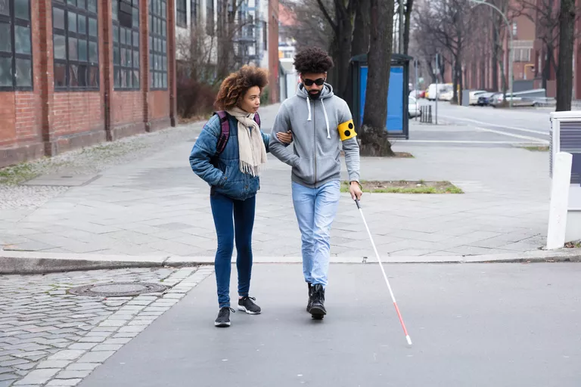

Figure 1. Cover Image (Lipner, 2021)

Team 25

Samuel Morales, Luca Rosu, Kyle Johnson and Matthew Jacobs

11/4/21

1. **Contents**

II. TEAM MEMBER ROLES 3

III. PROBLEM SCOPING 5

a. Problem Statement 5

b. Design Criteria and Constraints 5

c. Direct Users and Stakeholders 6

d. Background Information 7

e. Assumptions about the Problem 7

IV. IDEA GENERATION & THOUGHT EXPERIMENTS 7

a. Functional Decomposition 7

b. Exploring Prior Art 8

c. Sketching 9

d. Low Fidelity Prototyping 10

e. Biomimicry 10

f. Thought Experiments with Pros and Cons Evaluation 12

V. ITERATION #1 14

VI. PROTOTYPING, TESTING AND WDM 15

a. Prototypes 15

b. Prototype Testing Protocol 15

c. Test Results for Top 3 Alternatives 15

d. Weighted Decision Matrix (WDM) 15

VII. ITERATION #2 15

VIII. OVERVIEW OF FINAL DESIGN 15

a. Detailed Design 15

b. Data on Final Solution 15

d. Novel Aspects of the Solution 15

e. Trade-off Decisions and Limitations of the Solution 15

f. Lessons Learned 16

IX. REFERENCES 17

# TEAM MEMBER ROLES

Our project team included 4 members (See Figure 2). We allocated roles and responsibilities to each team member by/based on the abilities and skills each of us has:

Table 1. Team roles

|  |  |  |  |
| --- | --- | --- | --- |
| **Milestone** | **Name** | **Specific tasks for to each milestone** | **Status** |
| Problem scoping | Luca | * Criteria | * On Time |
| Sam | * Contains | * On time |
| Matthew | * Trade-off | * On time |
| Kyle | * Trade-off | * On time |
| Idea generation | Luca | * Sketching and 3D printing | * On time |
| Sam | * Sketching and Biomimicry | * On time |
| Kyle | * Sketching and patent search | * On time |
| Matthew | * Functional decomposition and feedback | * On time |

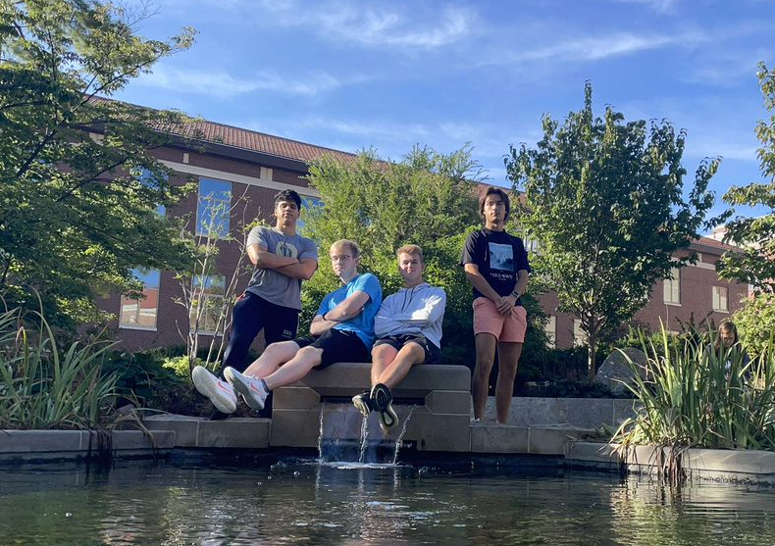

Figure 2. Project team

# PROBLEM SCOPING

## Problem Statement

Blind people are visually impaired and do not all see the world in the same way as the average person (Lipner, 2021). Currently the blind students on campus need to rely on their sense of direction and the guidance of other people in order to arrive at their destination. The combination of these two limitations means that blind students are very limited to where they can go on campus. In order to better accommodate the blind student body, it is essential to provide them with a means of getting around campus safely and quickly. Offering them safer and quicker means to move around campus could potentially enhance their experience while studying and can prevent dangerous accidents in the future. Therefore, the direct client of our solution would be the blind people on campus.

## Design Criteria and Constraints

Our team has decided on the following criteria and constraints for the project. This will be considered in all our design processes.

Table 2. Design requirements

|  |  |  |  |
| --- | --- | --- | --- |
| **Type of requirement** | **Description** | **Metrics (ways to quantify and measure the performance of your solutions and measure success)** | **Metric units** |
| **Criteria** | Solution will attract users | Rating Survey | Percent approval |
| Solution is appropriate for a campus community | Rating Survey | Percent approval |
| mobility is enhanced by the solution | Travelling time of blind people | Minutes |
| the solution is safe for all users | Rating survey | Percent Approval |
| The solution is safe for all non-users | Rating survey | Percent Approval |
| Solution may not affect the affordability of education on campus | Amount of invested money | Dollars $ |
| **Constraints** | solution must be developed using excel | Travelling time, cost per tile, path length | Minutes, Dollars ($) and meters |
| solution must be implemented with existing infrastructure | N/A | N/A |

**Trade-off Considerations**

Our team will have problems balancing the performance of our solution with its effect on the overall landscape of campus. Presenting a more useful solution will probably mean being more invasive with the campus architecture. Also, if our team wanted to create the best solution regarding aesthetics, the solution would end up being more expensive. In our team, the safety of the user will be the top priority, followed by aesthetics and finally price. Finally, the most effective solutions that generate the greatest impact will also be the most expensive and could potentially cost more than the desired budget.

## Direct Users and Stakeholders

On our solution we are going to consider the following users of our design idea:

Table 3. Empathizing with users

|  |  |  |
| --- | --- | --- |
| **User segment (include an image and a label)** | **Methods used to empathize with the user (interview user, survey user, observe user, read about user, simulate user behavior, put yourself in his/her shoes)** | **Lessons learned from this interaction** |
| Primary users: People with vision disabilities Students/Staff    Figure 3. Primary User photo (Peggy, n.d.) | Interview potential users in order to gain information about how to make the system as effective as possible. | How to make the system more user friendly. |
| Secondary Users: People with average vision    Figure 4. Secondary user photo (Kickham, 2016) | Interview students about their thoughts of the look of our solution, and how it affects the overall aesthetics of campus or their own personal transit | How to make the solution less invasive |

## Background Information

Our team gathered the following questions and answers to our problem, to consider them as possible solutions for the problem.

Table 4. Information gathering for problem scoping

|  |  |
| --- | --- |
| **Question asked** | **Answer to question** |
| * What are mobility problems faced by blind people on campus? | The speed of getting around campus as well as the safety of the walk, because being blind does not allow you to follow all the recommended guidelines given by the Purdue Transportation department (Purdue Transportation Service, n.d.) |
| * Where are the problems most prevalent? | At cross walks, and sidewalks with no tactile markers and are not straight, intersections of sidewalks, intersections with bike paths (Inclusive City Makers, n.d.) |
| * What is the campus doing right now to address this problem? | At crosswalks there are speakers that say when it is safe to cross |

## Assumptions about the Problem

Our team will make the following assumptions for our idea and project design: Blind people have a walking cane to help them move around. We will also assume we have the power to make all the non-invasive modifications our team decides to do. Finally, the condition of the sidewalks is going to be consistent all year long, so there is never going to be snow on it or an object blocking the path.

# IDEA GENERATION & THOUGHT EXPERIMENTS

## Functional Decomposition

Our team decided to focus on the following two criteria for functional decomposition: Making travel easier and faster. When thinking about possible solutions for the first one, we thought of either buying or using the campus’ golf carts to establish a route between the Honors Dorms to the Engineering fountain to make travel easier for blind people, they can just get into one of these golf carts and not worry about walking. We also thought of making tiles on the ground that are designed so blind people can use their cane to be guided by the tiles, then we would make a path from Honors dorms to the engineering fountain with these tiles.

The second function was making travel faster, to solve this problem our team thought of rerouting some busses, so they go closer to the Honors Dorms. This would mean that blind people can now access them easier and can rely on this method of transportation. We also thought of making a phone app that works like the starships program, meaning that with camera access, the app can tell you whether you can cross the street, have an obstacle in front of you, among others. Below is our functional decomposition map:

Figure 5. Functional decomposition of Improving transportation for blind people

## Exploring Prior Art

Table 5. Generating ideas by exploring prior art

|  |  |  |  |  |
| --- | --- | --- | --- | --- |
| **#** | **Image/Picture & Name of Prior Art** | **Strengths** | **Weaknesses** | **Improved alternative** |
| 1 | Enhanced Cane  ​​  Figure 6 Enhanced Crane(Tseng, 2017) | * Allows for better detection of possible objects and uneven surfaces * Makes travel safer * Works even in large crowds * Allows for unique detection of overhead obstacles * Wheels added for ease of use | * The materials required for this may be costly including aluminum and multiple sensors, wiring, circuits, and a power supply * All of these components may add significant weight to the cane and may make it hard to carry around | It may be possible to invest in lighter components to allow for users to travel with cane much easier. An additional alternative to the current solution is to provide auditory descriptions of the upcoming obstacles for larger and more serious obstructions. |

## Sketching

Table 6. Generating ideas with sketching

|  |  |  |  |
| --- | --- | --- | --- |
| **#** | **Sketch** | **Solution name** | **Unique aspects, brief description** |
| 1 | Diagram  Description automatically generated  Figure 7. Crosswalk detection system. | Crosswalk detection system | Just like crosswalks with traffic lights have a voice interface that tells people when they are allowed to cross, this solution involves adding a similar system on the crosswalks that do not have a traffic light. The person would touch a button that activates sensors that detect when cars are nearby and tells if the crosswalk is safe to cross. |
| 2 | A picture containing shoji  Description automatically generated  Figure 8. Tactile feedback device | Tactile feedback device | The tactile feedback device would use a set of sensors in order to map its surroundings. It would then give feedback to the user based on how close they are to the obstacles around them and guide them like a helping hand. Based on which of the touch points is activated the user will know how far away they are from obstacles. |

## Low Fidelity Prototyping

Table 7. Generating ideas with low fidelity prototyping

|  |  |  |  |
| --- | --- | --- | --- |
| **#** | **Prototype picture** | **Solution name** | **Unique aspects, brief description** |
| 1 | Figure Low-Fidelity prototype of Blind People Tiles. | Blind people tile | The blind people tiles are a simple tile that has a canal where blind people can put their cane on, then just follow the canal with their cane to arrive at their destination. This tile is a low-cost, safe way to help blind people with canes move around campus. They are going to be able to just follow these tales to safely make it to their desired destination. |

## Biomimicry

Table 8. Generating ideas with biomimicry

|  |  |  |  |
| --- | --- | --- | --- |
| **#** | **Sketch/picture/image** | **Solution name** | **Unique aspects, brief description** |
| 1 | Shape  Description automatically generated  Figure 10. Echolocation App | Echolocation App | The echolocation app would use unhearable sounds for humans to send sound waves and then receive them back to approximately tell if there is an obstacle nearby, then it would produce an audio feedback to the user communicating the results. The app would mimic how bats use sound to identify space around them. |
| 2 | Map  Description automatically generated  Figure 11. Map of Starship's range | Starship app | The starship app would allow for blind persons to use similar systems that exist for the starship deliver service in order to navigate campus. This system would be primarily used when at a crosswalk or other obstacle. The user would wear a modified camera that would then be connected to the starship app. In the same way that the starships are manually told when it is safe to cross the street, the user would be notified by a person remotely using the app when it is safe to cross |

## Thought Experiments with Pros and Cons Evaluation

Table 9. Thought experiments with pros and cons evaluation

|  |  |  |  |
| --- | --- | --- | --- |
| **#** | **Design Alternative (include a name and an image)** | **Pros (advantages)** | **Cons (disadvantages)** |
| 1 | Blind People Tiles    Figure . Low-Fidelity prototype of Blind People Tiles. | * Cost-effective solution * Makes travel for blind people safer and faster * Is not invasive to the campus aesthetics * Allows for users to insert cane to guide them around campus | * Might not work in extreme weather * The paths of where the tiles have to be decided * The tiles do not provide a safer crosswalk-crossing * Might experience “traffic” |
| 2 | Enhanced Cane  ​​  Figure 13. Enhanced Crane(Tseng, 2017) | * Easy for the user to adapt because they are most likely already using a cane * Safer than traditional cane due to enhanced features * Can go to more places than before due to increased sensing capabilities | * Expensive * Bulky * Will need to be recharged |
| 3 | Echolocation app  Shape  Description automatically generated  Figure 14. Echolocation App | * Uses smartphones which most people have right now * Can be easily updated to include new technology * Is not invasive at all because users can wear headphones | * May not be very accurate due to the consistency between smartphone cameras * Relies on a phone which can run out of battery and when it does the user is stuck |
| 4 | Starship app  Map  Description automatically generated  Figure 15. Map of starship's range | * It would be easy to implement since the program for starships is already created * Is not invasive since users can wear headphones * Can be easily updated with new technology | * Would require user to wear a camera * Only helps to guide at possible intersections relying on other forms of guidance for the rest of campus |
| 5 | Tactile feedback device  A picture containing shoji  Description automatically generated  Figure 16. Tactile feedback device | * Is small and very accurate and would be easy for the user to use * Adaptable to all conditions since it uses on board AI to map the space and navigate * Gives a much more accurate representation of the space to the user than any other device | * When first introduced to the user there will be a learning curve * Very expensive |
| 6 | Crosswalk detection system  Diagram  Description automatically generated  Figure 17. Crosswalk detection system | * Provides a safer cross walking for blind people * It is not invasive to the campus aesthetics * The infrastructure would be similar to the one of the traffic lights | * Would only provide a direct solution to cross walks and would not help to better all travel around campus * Cost would be expensive, but it is a one-time expend |

# ITERATION #1

Table . Responding to feedback

|  |  |  |
| --- | --- | --- |
| **#** | **Based on feedback/data from … about ….** | **We made changes in…by…** |
| 1 | We received direct feedback from our TA that our solution using Blind Tiles was a very effective and direct solution to the problem that we decided to focus on. He stated that this problem not only seems very effective for blind users, but also would be non-invasive and the most direct solution to the problem. By offering a way for blind persons to use their current walking cane and to immediately implement the new walking method with their current walking method we offer a simple and effective solution. | With the feedback that we have received we decided that we should go farther with this design and model a possible tile that would be used on campus. We decided to create a 3D model of the tile and plan to print the tile for a possible prototype of the solution. We made changes by ensuring that our current design would fully work with most canes and may offer special attachments in order for current blind persons to easily adapt to the new system. |
| 2 | We received direct feedback from our TA that the Echolocation App is not only confusing, but also may be impossible or much too expensive of a solution. By attempting to allow for the persons current phone to be able to have special awareness using echolocation is a stretch and may not be possible for most current models. | With the feedback that we received we decided that it may not be cost effective to implement a complex system of echolocation to current phone models. We also have realized that it may be impossible to use current phones for this system. Because of this we decided to explore the possibility of using some other device for the echolocation. By offering a small alternate device we may be able to offer the same sort of service but at a better and more cost-effective level. |
| 3 | We received direct feedback from our TA about the Cross Walk Detection System that it does not offer enough of a solution for blind persons to travel around campus. By only offering a solution to cross roads, we fail to offer new solutions to the majority of travel around campus. | Based on this feedback we decided to disregard the majority of this solution. We decided that the solution does not offer as good of solutions as the other designs. We thought about the possibility of altering our design to update and enhance all cross walks and intersections allowing for better verbal commands to the blind persons around campus. |

# PROTOTYPING, TESTING AND WDM

## Prototypes

## Prototype Testing Protocol

## Test Results for Top 3 Alternatives

## Weighted Decision Matrix (WDM)

# ITERATION #2

# OVERVIEW OF FINAL DESIGN

## Detailed Design

## Data on Final Solution

1. **Design Optimization**

## Novel Aspects of the Solution

## Trade-off Decisions and Limitations of the Solution

## Lessons Learned

# REFERENCES

Inclusive City Makers. (n.d.). *How Do the Blind Safely Cross the Road?* Inclusive City Makers. Retrieved October 24, 2021, from https://www.inclusivecitymaker.com/how-do-the-blind-safely-cross-the-road/

Kickham, D. (2016, August 10). *Dwayne Johnson to produce a competitive drumming docu-series*. Entertainment Weekly. https://ew.com/article/2016/08/10/dwayne-johnson-drumming-docu-series/

Lipner, M. (2021, May 18). *What do people without vision see?* Verywell Health. https://www.verywellhealth.com/what-do-blind-people-see-5093028

Peggy, M. (n.d.). *Blind see low vision eye - free image on Pixabay*. Pixabay. Retrieved October 23, 2021, from https://pixabay.com/illustrations/blind-see-low-vision-eye-disease-1027860/

Purdue Transportation Service. (n.d.). *Pedestrian Safety*. Purdue University.

Tseng, M.-C. (2017). *Electronic blind guidance cane* (Patent No. AU2012317177B2). Worldwide applications.