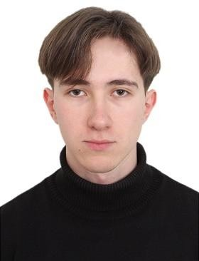

**Artyom Novikevich, Frontend Developer**

Brest, Belarus (Ready to relocate)

Date of birth: 20 October 2000

novikevichartyom@gmail.com

LINKS [Linked](https://www.linkedin.com/in/artyom-novikevich-a0b249205/), [Telegram](https://t.me/s4mota), [Email](mailto:novikevichartyom@gmail.com)

|  |  |
| --- | --- |
| PROFILE | In the field of frontend development, I use JS, React, Vue.js and CSS/SCSS/Tailwind. Have knowledge of SQL, experience in backend development using PHP and Laravel. I use GitHub as a version control system. I attended an internship at EpolSoft for 3 months as a Frontend Developer (React). Today I work for Encore Studio as a Junior Full Stack Developer and participate in the development of the application, using PHP and Laravel for backend development and JavaScript and Vue3 for frontend development. |

|  |  |  |  |
| --- | --- | --- | --- |
| EMPLOYMENT HISTORY |  |  | |
| Feb 2023 - Present | Junior Full Stack Developer, Encore Studio | Brest | |
|  | Tech stack: Laravel, Vue.js, JavaScript, Tailwind.  • Optimized existing Laravel application to improve performance and  scalability.  • Designed and implemented new frontend components.  • Developed 100+ dusk tests for a project.  • Worked closely with designers and other developers to ensure  timely delivery of a project. | |  | |

|  |  |  |
| --- | --- | --- |
| INTERNSHIP |  |  |
| Apr 2022 – Jul 2022 | Junior Frontend Developer, EpolSoft | Brest |
|  | Tech stack: React, Redux |  |

|  |  |  |  |  |
| --- | --- | --- | --- | --- |
| SKILLS | PHP | Skillfull | Laravel | Skillful |
|  | JavaScript | Skillfull | HTML\CSS\Tailwind\SCSS | Skillful |
|  | React | Skillful | MySQL | Skillful |
|  | Vue | Skillful | Git | Skillful |

|  |  |  |  |  |
| --- | --- | --- | --- | --- |
| LANGUAGES | English | B1 | Russian | Native speaker |
|  | Belarusian | Native speaker |  |  |