Campus Course & Records Manager (CCRM)

Project Overview
Campus Course & Records Manager (CCRM) is a console-based Java SE application that allows institutes to manage:
- Students (add, list, deactivate, transcript)
- Courses (add, list, filter/search)
- Enrollments and Grades (with GPA calculation)
- File operations (import/export CSV, backup with recursion)
- Menu-driven CLI workflow

How to Run
1. Save the source code as CCRMApp.java.
2. Compile:
javac CCRMApp.java
3. Run:
java CCRMApp

Evolution of Java
- 1995 – Java 1.0 released by Sun Microsystems
- 1998 – Java 2 (split into J2SE, J2EE, J2ME)
- 2004 – Java 5 (Generics, Enums, Annotations, Enhanced for-loop)
- 2011 – Java 7 (NIO.2, try-with-resources)
- 2014 – Java 8 (Lambdas, Streams, Date/Time API)
- 2017–2023 – Java 9–21 (Modules, var, records, switch expressions, pattern matching)

Java Editions – ME vs SE vs EE
Feature | Java ME | Java SE | Java EE
Scope | Embedded/mobile devices | Desktop & console apps | Enterprise/web/distributed apps
APIs | Limited core APIs | Full core APIs (IO, Streams) | Adds Servlets, JSP, JPA, EJB
Target Device | IoT, mobiles | PC, desktop, servers | Large-scale enterprise servers
Example Use | Smartcards, IoT apps | CLI apps, Swing apps | Banking, e-commerce, portals

JDK, JRE, JVM
- JDK (Java Development Kit): Compiler (javac) + JRE + tools for development.
- JRE (Java Runtime Environment): JVM + core libraries to run Java programs.
- JVM (Java Virtual Machine): Executes bytecode, provides platform independence.
Flow: .java (source) → javac → .class (bytecode) → JVM → Execution

Install & Configure Java on Windows
1. Download latest JDK from Oracle.
2. Install it → set installation path.
3. Configure environment variables:
- Add JAVA_HOME pointing to JDK folder.
- Add %JAVA_HOME%\bin to PATH.
4. Verify installation:
java -version
javac -version

Eclipse IDE Setup
1. Open Eclipse → File > New > Java Project.
2. Project name: CCRM.
3. Create a new class CCRMApp.
4. Paste the code and save.
5. Run → Run As > Java Application.

Mapping Table (Syllabus Topic → Code Location)
Topic | Implemented In
Encapsulation | Student (private fields + getters/setters)
Inheritance | Person → Student, Instructor
Abstraction | Abstract class Person
Polymorphism | profile() method overridden in subclasses
Enums | Semester, Grade
Singleton | AppConfig
Builder Pattern | Course.Builder
Nested Class | Course.CourseCode
Interfaces | StudentService, CourseService
Lambdas & Streams | Sorting/filtering in services & reports
Anonymous Inner Class | SimpleFileVisitor in BackupService
Custom Exceptions | DuplicateEnrollmentException, MaxCreditLimitExceededException
NIO.2 | Files.walkFileTree, Files.copy, Files.write
Date/Time API | LocalDate, Instant
Control Structures | switch, while, break, continue

Usage Example
CCRM started. Data folder: C:\Users\YourName\ccrm_data
1) Students 2) Courses 3) Enrollment 0) Exit
1
Add student? (y/n): y
RegNo: 101
Name: Alice
Email: alice@mail.com
Student: Alice (101) - ACTIVE
1) Students 2) Courses 3) Enrollment 0) Exit
3
Student regNo: 101
Course code: CS101
Enrolled.
Marks? (y/n): y
Enter marks: 85
Transcript for Alice
CS101 - Data Structures -> A
GPA: 9.00

Assertions
Assertions are used in constructors to ensure non-null IDs.
Enable with:
java -ea CCRMApp

Deliverables
- Source code: CCRMApp.java
- README.md (this file)
- Screenshots folder:
* Java installation verification
* Eclipse project setup & run
* Program execution screenshots
* Export/Backup folder structure
- Optional demo video (2–5 mins walkthrough)

Academic Integrity
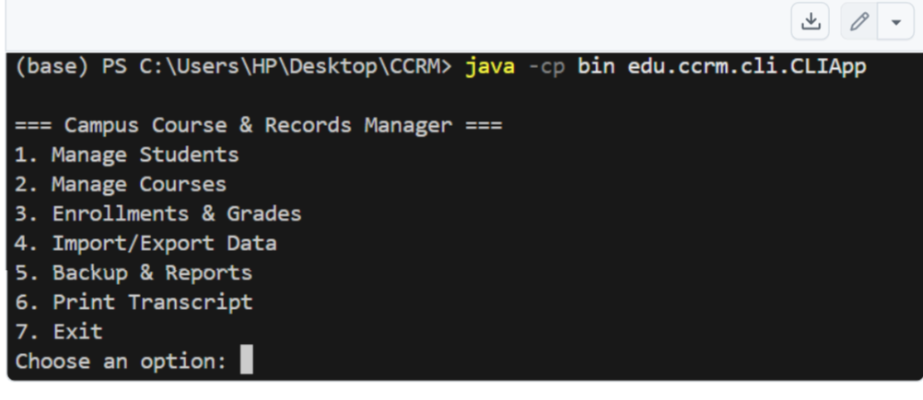
This project is for educational purposes only. Submission must be your own work. Cite any references in acknowledgements.

