**Circuit Diagram**

**Assemble the circuit as shown in diagram**

[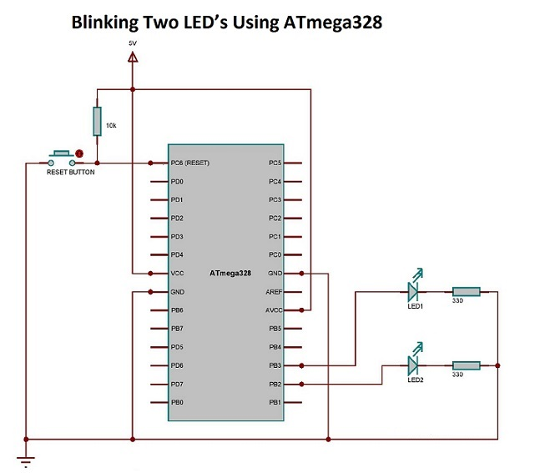](https://user-images.githubusercontent.com/101659804/164626135-eefee71e-3b88-4629-a58c-6864249ed797.jpg)

**Implementation**

[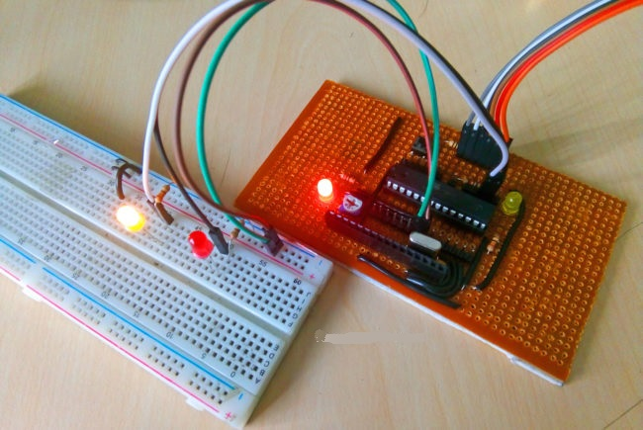](https://user-images.githubusercontent.com/101659804/164628973-6139bbb4-8507-4c9f-8f94-31d4ac4d8564.jpg)

* At the beginning of the program a pre-processor named “F_CPU” is defined. It is simply your way to tell some of the library code how many CPU cycles per second the processor is executing. Here we defined the F_CPU as 1 MHz. “#include <avr/io.h>” is a header files which provides you with various i/o operations like DDRx, PINx, PORTx, etc. “#include <util/delay.h>” is a header file which provides you with inbuilt delay functions like _delay_ms(), _delay_us(), etc. “_delay_ms(1000)” provides a delay of 1000 milliseconds (i.e., equivalent to 1 second).

**DDRx**

Data Direction Register configures data direction of the port(Input/Output). The instruction “ DDRB |= (1<<DDB2)” makes corresponding port pin as output.

**PORTx**

Port register is for assigning appropriate values for the port pins. Writing to PORTx.n will immediately change state of the port pins according to given value. “PORTB |=(1<<PORTB2)” will generate a high signal at PB2. And “PORTB&=~(1<<PORTB3)” is for generating a low signal at PB3.