**INTRODUCTION**

Recently due to technological and population development, the usage of vehicles is rapidly increasing and at the same time the occurrence of accident has also increased. No one can prevent the accident, but can save their life by expediting the ambulance to the hospital in time.

The objective of our project is to detect the location of the vehicle where accident has occurred and to save their lives in the shortest time.

This scheme is fully automated, as it locates the accident spot accurately and sends SMS via GSM for the ambulance to reach the location and to the hospital in time.

This project consists of microcontroller board with sensors and display. This display unit is provided for user to view the parameters like accident occurred and other related information (for our understanding).

The GPS is used to find the location where accident occurs as it continuously reads the data from satellite. Whenever accident occurs it sends the data to the microcontroller. The microcontroller will also communicate with the GSM.

**PROBLEM STATEMENT**

The accident victim is dependent on the mercy of others to rush him to the hospital.

Many a times an accident goes unnoticed for hours before help comes in.

Due to all these factors, there is a high rate of mortality of the accident victims.

To overcome the drawback of existing system we will implement the new system in which there is an automatic detection of accident.

A sensor, GPS, GSM unit fitted in the vehicle detects the accident and sends the message to not only the nearest hospital but also to the victims’ relatives.

**BLOCK DIAGRAM**

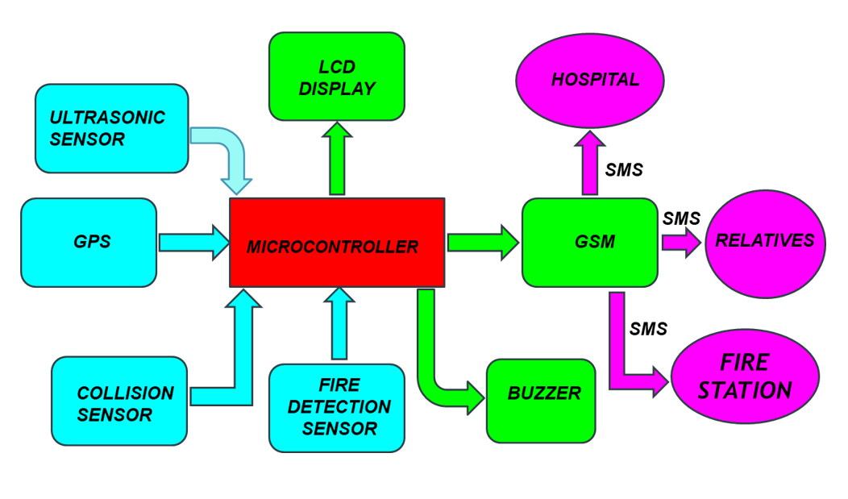

BLOCK DIAGRAM OF ACCIDENT DETECTION & AMBULANCE RESCUE USING ARDUINO & ESP8266

**WORKING**

* When a vehicle meets with an accident immediately collision sensor will detect the signal and sends it to Microcontroller.
* In case the accident is severe then the microcontroller will find the location (both latitude and longitude) coordinates of accident spot using GPS and sends a URL using GSM Module, so that ambulance could reach the accident spot in the shortest way possible.
* Not only that the device also sends SMS alerts to his/her relatives and nearest health care (so that emergency rooms are kept vacant).
* And in case of other vehicles coming close to the victim’s vehicle a buzzer will be turned on so that the driver can apply brake immediately to prevent from severe accident.
* All the details for the purpose of understanding will be displayed in the LCD.

**COMPONENTS USED**

1. NEO-6M-0-001 GPS MODULE

The module works well with a DC input in the 3.3- to 5-V range.

The NEO-6M module includes one configurable UART interface for serial communication, but the default UART (TTL) baud rate here is 9,600.

GPS signal is right-hand circular-polarized (RHCP), the style of the GPS antenna is the patch antenna.

The antenna must have full sky view for LOS (Line Of Sight) with at least three satellite to calculate 2d position.

1. HC SR04 ULTRASONIC SENSOR

HC-SR04 Ultrasonic (US) sensor is a 4-pin module, whose pin names are VCC, Trigger, Echo and Ground respectively.

The module has two eyes like projects in the front which forms the Ultrasonic transmitter and Receiver. The sensor works with the simple high school formula that Distance = Speed × Time

The Ultrasonic transmitter transmits an ultrasonic wave, this wave travels in air and when it gets objected by any material it gets reflected back toward the sensor this reflected wave is observed by the Ultrasonic receiver module.

Universal speed of US wave at room conditions which is 330m/s. The circuitry inbuilt on the module will calculate time taken for US wave come back.

1. L293d Motor Driver

The motor driver is a module for motors that allows to control the working speed and direction of two motors simultaneously. This is designed to provide bidirectional drive currents at 5-36V.

1. HC-05 BLUETOOTH

The HC-05 has two operating modes, one is the Data mode in which it can send and receive data from other Bluetooth devices

The other is the AT Command mode where the default device settings can be changed. We can operate the device in either of these two modes by using the key pin

It has an operating voltage 4-6V and current 30mA and a range of less than 100m.

Works with USART and TTL compatible. Follows IEEE 802.15.1 standard.

Frequency-Hopping Spread Spectrum is used. Can operate in master and slave mode.

1. NODEMCU ESP8266

ESP-12E module containing ESP8266 chip having Tensilica Xtensa 32-bit LX106 RISC microprocessor.

This microprocessor supports RTOS and operates at 80MHz to 160 MHz adjustable clock frequency. ESP8266 has 128 KB RAM and 4MB of Flash memory to store data and programs.

Its high processing power with in-built Wi-Fi / Bluetooth and Deep Sleep Operating features make it ideal for IoT projects.

ESP8266 can be powered using Micro USB jack and VIN pin (External Supply Pin). It supports UART, SPI, and I2C interface.

1. BUZZER

It is a piezoelectric buzzer uses piezoelectric effect ,that uses pulse current to drive the vibration of metal. operates at 1.5-15V DC, multi resonator oscillates and o/p 1.5-2.5KHz audio signal.

1. LCD(16 X 2) and I2C ADAPTER

16 characters by 2-line display has a very clear and high contrast white text upon a blue background/backlight. This is great blue backlight LCD display.

An I2C adapter is directly soldered right onto the pins of the display. Which saves 8 pins on the micro-controller. It is a type of serial bus which uses two bidirectional lines, serial data line and serial clock line.

These modules are currently supplied with a default I2C address of either 0x27 or 0x3F.

The module has a contrast adjustment pot on the underside of the display. This may require adjusting for the screen to display text correctly.

Operating Voltage for LCD is 5V.

1. ARUDINO IDE

It is used for writing code, compiling the code to check if any errors are there and uploading the code to the Arduino/ESP8266.

Arduino IDE is an open-source software that is mainly used for writing and compiling the code into the Arduino Module.

It supports C/C++ language

It supports every available Arduino board including Arduino mega, Arduino Leonardo, Arduino Ethernet and more

When a user writes code and compiles, the IDE will generate a Hex file for the codewhich is then sent to the board using a USB cable.

1. VIBRATION SENSOR

These are piezoelectric accelerometers that sense vibration. The sensitivity of these sensors normally ranges from 10 mV/g to 100mV/g.

1. ARDUINO NANO

Arduino board designs use a variety of microprocessors and controllers. The boards are equipped with sets of digital and analog input/output (I/O) pins that may be interfaced to various expansion boards ('shields') or breadboards (for prototyping) and other circuits.

The boards feature serial communications interfaces, including Universal Serial Bus (USB) on some models, which are also used for loading programs. The microcontrollers can be programmed using the C and C++ programming languages using a standard API which is also known as the "Arduino language".

It consists of ATmega328 AVR microcontroller which has a flash memory of 32KB and 16MHz clock.

8 analog and 22 digital pins (PWM pins 6).

Arduino microcontrollers are pre-programmed with a boot loader that simplifies uploading of programs to the on-chip flash memory.

**ADVANTAGES**

* As soon as accident occurs, the message is sent to the nearby hospital which saves the time in case of emergency.
* Buzzer turns on when vehicles are nearby to reduce the severity of the accident.
* Low cost for maintenance.
* Can be used by any moving vehicle as it is not bulky.

**LIMITATIONS**

* The whole system is based on the fact that network is available, if network fails then the entire system fails.
* Constant supply of power is essential and incase batteries are used it has to be replaced every time when it gets discharged completely.
* Might have a bit of delay because of all the circuit components.