**CHAPTER 1**

**INTRODUCTION**

When we are at a new place and are not aware of the roads. It is natural that we take long turns or maybe wrong turns. Now in these situations, thanks to the automatic vehicle locator which combine along with a software helps us to track our own vehicle and its path travelled. With the growing influence of technology on our lifestyle, we become more obliged to contribute to the welfare and safety of the people.

In this regard, when an accident occurs in remote areas or even in city we can’t take wiser action as quickly as possible or we can’t even know happening of such incidents unless someone reports after the incident has occurred. A gadget or a system is designed to help the people who are travelling in vehicles and face situations like accident can be made which sends an alert message and vehicle’s location to a desired person’s phone number or even to a nearby hospital.

These systems make use of GPS technology to provide precise and constant location to an individual manager.

GPS technology has become a reality through the efforts of the American military, which established a satellite-based navigation system consisting of a network of 24 satellites orbiting the earth. GPS is also known as the NAVSTAR (Navigation System for Timing and Ranging). GPS works all across the world and in all weather conditions, thus helping users track locations, objects, and even individuals. GPS technology can be used by any person if they have a GPS receiver. GPS is used to detect the latitude and longitude of any location on the earth with exact UTC time. This device receives the co-ordinate from the satellite for each and every second, with time and date. $GPGGA is referred to global positioning system fix data. These are available as string.

Arduino Nano is a small, compatible, flexible and breadboard friendly Microcontroller board, developed by Arduino.cc in Italy, based on ATmega328p (Arduino Nano V3.x) / Atmega168 (Arduino Nano V3.x). It has AVR architecture, flash memory of 32KB and SRAM 2KB. The ATmega328 also support I2C (TWI) and SPI communication. Arduino Nano is simply a smaller version of Arduino UNO. The Arduino Nano can be programmed with the Arduino Software.

* 1. **PROBLEM STATEMENT**

A number of technology improvements in traffic management helped to reduce the traffic congestion. But the late response to the emergency services when accident occurring in the remote area and in the late nights. Many a times an accident goes unnoticed for hours before help comes in. Due to all these factors there is a high rate of mortality of the accident victims.

* 1. **OBJECTIVE**

To overcome these issues we will implement the new system in which there is an automatic detection of accident. A sensor unit fitted in the vehicle detects the accident and sends the message to not only the emergency number but also to the victim’s relatives and also we used a sensor to alert the driver when unnoticed obstacle comes on the way.

* 1. **OVERVIEW ON DESIGN METHODOLOGY**

According to our system, every vehicle can have a vehicle unit. The vehicle unit consists of a collision sensor, controller, buzzer, ultrasonic sensor and GPS module. The vehicle unit is installed in the vehicle, it senses the accident and sends the location of the accident spot to the control unit. The vibration sensor will sense the vibration of vehicle and gives value to the controller. If it is high the GPS system inside the vehicle finds out the current position of the vehicle (latitude and longitude) which is the location of the accident spot and displays on the LCD. ESP266 will push to the server about the accident and phone app which is connected to server gets the trigger and sends the message to an emergency number and saved numbers. Then GPS provides latitude and longitude information about vehicle location.

* 1. **ORGANIZATION OF THE REPORT**

The report is categorised into 5 chapters

Chapter 1 An introduction to the project, methodology is deal in chapter1.It also includes problem formulation which gives the clear idea regarding the application of project.

Chapter 2 Literature survey is dealt in this chapter.

Chapter 3 Explains how the project has been developed with the help of block diagram and detailed information about hardware components and software implementation.

Chapter 4 Gives the results of project implementations. It includes various advantages and limitations of project.

Chapter 5 Concludes the project and also suggests the possible enhancements in future.

**CHAPTER 2**

**LITERATURE SURVEY**

Accident Alert and Tracking Using Arduino, Aarya D.S, Athulya C.K, Anas.P, Basil Kuriakose ,Jerin Susan Joy ,Leena Thomas at n[1] had one approach to eliminate that delay between accident occurrence and first responder dispatch is to use An Accident Alert and Vehicle Tracking System, which sense when a traffic accident is likely to occur and immediately notify emergency occurred. In this paper, that system is described the main application of which is early accident detection. In this system, initially the GPS continuously takes input data from the satellite and stores the latitude and longitude values. If we have to track the vehicle, we need to send a message to GSM device, by which it gets activated. It also gets activated by detecting accident on the shock sensor connected to Arduino Uno. Parallelly activates GPS with the help of relay. Once GSM gets activated it takes the last received latitude and longitude positions values from the buffer and sends a message to a central emergency dispatch server which is predefined in the program. This system uses the things i.e., Arduino, Vibration Sensors, GPS and GSM modules to detect traffic accidents.

Accident Detection And Alerting System With Continuous Heart Rate Monitoring Using Arduino For Two Wheeler Niranjan Kumar Mandal, Debmoy Chakraborty, Arka Kiran Majhi at n[2] as Road traffic has increased greatly in the recent days. Due to this heavy traffic, the number of accidents is also increased. According to some of the recent statistics maximum number of fatalities is being driven by two wheelers. So, our intention through this paper is to develop an Arduino based device which can detect accident and send the location of the rider to a predefined number. Along with that there will be one band in the rider's hand which will note rider's pulse rate and upload it in a website.

Accident Prevention and Alert System using Arduino Aswin M, Sujitha E, Archunan P, Sandhya Devi R S at n[3]. As over speeding was the leading cause for deaths in road accidents. So, in this proposed project we are going to control the speed of the vehicle according to the respected zones using Arduino. Our project explains that a various colour strips are marked on the roads where we need to control the speed within the limit and vehicle will have a colour sensor attached in it which will recognize the colour marked on the road and accordingly maintain the vehicles speed in that particular limit. In this project we are using vibration sensor to detect accidents and report it to the nearest available emergency responding stations. We are also using touch sensor to detect whether someone is trying to steal it while it is locked.

S.S. Kanese, S.A. Yadav, S.B Jadav, M.M Kadam at n[4] have designed a project which is used to track the stolen vehicle. In this project when they send the SMS “Track Vehicle”, the SMS received by vehicle and it will send their position. GPS is used for getting information about where our vehicle is present and GSM is used for giving commands to Arduino so that we can track the vehicle and keep on monitoring the vehicle. This project is very useful to track stolen cars. The disadvantage of this project is that the device works only when we send SMS to track the vehicle.

GPS based real time vehicle tracking system for kids’ safety using RFID and GSM. Amit Bhoyar, Rajeev Verma at n[5] proposed the system consisting of RFID tags and reader which is designed to note the entry and exit of person in vehicle, the tags of each person holds the identification details ,when the children enter the vehicle the readers reads the person tags and stores the details of entry and exit. The information is notified to concerned authority via android app and website. This system also facilitates to known about the area where the vehicle has crossed using GPS. This security system endeavours the safety transportation of school children during daily outing. The details will be updated in the school database. GPS will be used to track the position of the bus if it travels in unusual path.

Automatic Vehicle Accident Detection and Messaging System Using GSM and GPS Modem by Nimisha Chaturvedi, Pallika Srivastava at n[6] proposed a system where sensor will sense the occurrence of an accident and give its output to the microcontroller. Here a button sensor is used for detection which will get pressed when the vehicle meets with an accident. The GPS detects the latitude and longitudinal position of the vehicle. The phone numbers are pre saved in the EEPROM by the user. The microcontroller sends an alert message to these pre saved numbers using the GSM module. Any message can be pre entered in the system by the user. An LCD screen displays the status of the output. In case there is no casualty, the sending of the message can be terminated with the help of a switch. The switch will restart the microcontroller and its function will start from the beginning.

WOMEN SAFETY DEVICE WITH GPS, GSM AND HEALTH MONITORING SYSTEM Piyush Kumar Verma, Arpit Sharma, Dhruv Varshney, Manish Zadoo at n[7] proposed a system which consists of a key or button which can be pressed by the women when she is in need or when she feels insecure. As the switch is pressed by the women the microcontroller gets the command and it takes the current position with GPS module. The microcontroller switch ON the buzzer present in the device so that nearby people may notice the critical condition and may come to rescue. And microcontroller sends the SMS of current location and pulse reading to the registered mobile number of the family member and police with the help of GSM module. The GSM sends the current location and other data at every 10sec. In case if the pulse reading also goes abnormal then the microcontroller command the GSM module to send the pulse reading by SMS and to call the ambulance so that the immediate medical help can be provided.

Rashida Nazir, Ayesha Tariq, Sadia Murawat, Sajjad Rabbani at n[8] had designed technology due to increased traffic hazards. Main causes behind these road accidents include lack of training institutes, unskilled drivers, poor road conditions, use of cell phone during driving, and over loading. He provides a solution for accident detection and prevention for human life safety. It enables intelligent detection of an accident at any place and reports about the accident on predefined numbers. The system consists of two parts, alarming part and messaging part. The hardware includes SONAR ranging modules, vibration sensor, three modules GPS receiver, Microcontroller, GSM modem and an Alarm. When distance is too short between the vehicle and obstacle then alarm will be “ON” as an indicator to move vehicle in other direction which is safer but when a vehicle faces accident despite of alarm, immediately vibration sensor will detect the signal and then Microcontroller sends the alert message through the GSM modem including the location to predefined numbers that can be reserved for a rescue team. Since the system is Implemented using wireless technologies like SONAR the system is complex and application of GPS is not upgraded. The electronic equipment used is not efficient.

Pankaj Verma, J.S Bhatia at n[9] proposed an idea to design a system that can be easily installed and to provide platform for further enhancement. The GPS is used to track the vehicle and keeps regular monitoring on them. This tracking system can inform you the location and route travelled by vehicle, and that information can be observed from any other remote location. It also includes the web application that provides you exact location of target. This system enables us to track target in any weather conditions. This paper gives the concept of GPS. The system is used for tracking of vehicle using web application in personal computer.

Rajeshwari Sundar, Santhosh Hebbar and Varaprasad Golla at n[10] proposed an idea of intelligent traffic control system to pass emergency vehicles smoothly. Each individual vehicle is equipped with special radio frequency identification (RFID) tag (placed at a strategic location). The RFID reader, NSK EDK-125–TTL, and PIC16F877A system-on-chip is used to read the RFID tags attached to the vehicle. It counts number of vehicles that passes on a particular path during a specified duration. The RFID reader implemented in the system is impossible to remove if system fails, so cost becomes more to implement again.

Accident Identification and Alert System using GPS, Prof. Sujata S Kadu, Anuja Londhe, Sneha Sharma at n[11] proposed the system which is GPS based Accident Alert system which aims at providing immediate aid to the person driving whenever an accident occurs. The traffic in cities is increasing at rapid rate and the number of accidents too. This project will help to decrease the rate of accident as it will detect the accident and provide an alert to the family member as well as nearby police control rooms and hospital. This system focuses mostly on prevention of accident rather than taking instantaneous actions after an accident so that lives could be saved.

Wang Wei and Fan Hanbo at n[12] proposed an idea for traffic accident detection. It can automatically detect a traffic accident, search for the spot and then send the basic information to first aid centre within seconds covering geographical coordinates, the time and circumstances in which a traffic accident takes place. By means of satellite navigation system, first aid rescuers can locate the place with maximum error controlled by 10 meters, so that they can save the injured people as soon as possible. But in this system only the accident near the traffic junction is detected not individual accident and is operates only for limited distance.

**CHAPTER 3**

**DESIGN METHODOLOGY**

According to our system, every vehicle should have a vehicle unit. The vehicle unit consists of a collision sensor, controller, buzzer, ultrasonic sensor and GPS modem. The vehicle unit is installed in the vehicle, it senses the accident and sends the location of the accident spot to the control unit. The vibration sensor will sense the vibration of vehicle and gives value to the controller. If it is high the GPS system inside the vehicle finds out the current position of the vehicle (latitude and longitude) which is the location of the accident spot and displays on the LCD. ESP266 will push to the server about the accident and phone app which is connected to server gets the trigger and sends the message to an emergency number and saved numbers. Then GPS provides latitude and longitude information about vehicle location.

**3.1 BLOCK DIAGRAM**

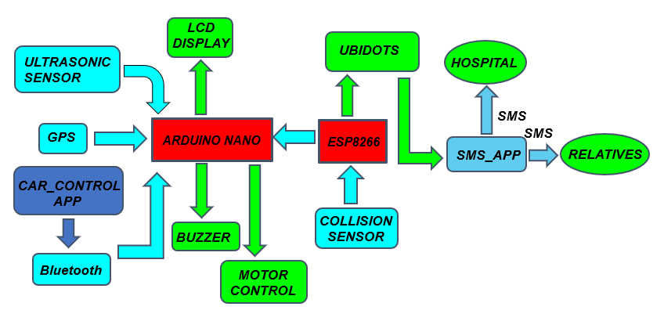

**Fig 3.1 Block Diagram**

1. Micro Controller

2. Power Supply

3. Vibration sensor

4. GPS Module

5. LCD

6. Buzzer

**1. Microcontroller**

Micro controller is the brain of the system the controller communicates with the sensor, buzzer, GPS, GSM, LCD LED, RF transmitter. The supply of 5V is applied to controller. Whenever the collision occurs the low signal from switch is given to controller the accident occurred information is displayed on LCD. The data is read from GPS and given to the controller through GSM module the message is sent to the pre-defined number of the control unit.

**2. Power Supply**

9V Hi-Watt (HW) is a handy non rechargeable batteries are used to power up.

**3. Vibration sensor**

Vibration in the car is monitored full time. They are piezoelectric accelerometer with sensitivity ranges from 10 to 100 mV/g.

**4. Global Positioning System [GPS]**

The GPS continuously reads the data from the satellite and gives the latitude and longitude information of the accident spot to the controller.

**5. Liquid Crystal Display [LCD]**

It is 16x2 LCD unit. It is used to display initialization of the system and GSM and it is a basic interface. The LCD module is interfaced with the micro controller. Data pins 11 through 14 of the LCD module is connected to port B (PB4-PB7). Register select (RS) pin 4 and enable pin 6 of the LCD are interfaced with PB2 and PB3 of the microcontroller respectively. R/W pin of the LCD pin 5 is pulled low permanently and thus is always in writing mode.

**6. BUZZER**

The piezo buzzer is used to indicate accident when collision occurred. The buzzer is interfaced to the microcontroller.

**3.2 HARDWARE REQUIREMENTS**

**3.2.1 MICROCONTROLLER (Arduino Nano)**

Arduino Nano is a small, compatible, flexible and breadboard friendly Microcontroller board, developed by Arduino.cc in Italy, based on ATmega328p (Arduino Nano V3.x) / Atmega168 (Arduino Nano V3.x). Arduino Nano is simply a smaller version of Arduino UNO, thus both has almost same functionalities. It comes with an operating voltage of 5V, however, the input voltage can vary from 7 to 12V.Arduino Nano Pinout contains 14 digital pins, 8 analog Pins, 2 Reset Pins & 6 Power Pins. Each of these Digital & Analog Pins are assigned with multiple functions but their main function is to be configured as input or output. They are acted as input pins when they are interfaced with sensors, but if you are driving some load then use them as output.

Functions like pin Mode () and digital Write () are used to control the operations of digital pins while analogRead () is used to control analog pins. The analog pins come with a total resolution of 10bits which measure the value from zero to 5V. Arduino Nano comes with a crystal oscillator of frequency 16 MHz. It is used to produce a clock of precise frequency using constant voltage.

There is one limitation using Arduino Nano that is it doesn't come with DC power jack, means you cannot supply external power source through a battery. This board doesn't use standard USB for connection with a computer, instead, it comes with Mini USB support. Tiny size and breadboard friendly nature make this device an ideal choice for most of the applications where a size of the electronic components are of great concern.

Flash memory is 16KB or 32KB that all depends on the Atmega board that is Atmega168 comes with 16KB of flash memory while Atmega328 comes with a flash memory of 32KB. Flash memory is used for storing code. The 2KB of memory out of total flash memory is used for a bootloader.

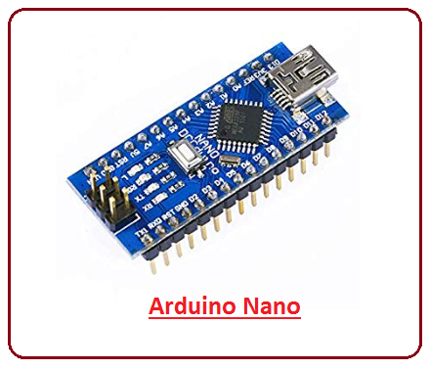

**Fig 3.2 Arduino Nano**

The SRAM can vary from 1KB or 2KB and EEPROM is 512 bytes or 1KB for Atmega168 and Atmega328 respectively. This board is quite similar to other Arduino boards available in the market, but the small size makes this board stand out from others.

It is programmed using Arduino IDE which is an Integrated Development Environment that runs both offline and online. No prior arrangements are required to run the board. All you need is board, Mini USB cable and Arduino IDE software installed on the computer. USB cable is used to transfer the program from computer to the board. No separate burner is required to compile and burn the program as this board comes with a built-in boot-loader.

**3.2.2 Node MCU ESP8266**

Node MCU is an open-source firmware for which open-source prototyping board designs are available. The Node MCU ESP8266 development board comes with the ESP-12E module containing ESP8266 chip having Tensilica Xtensa 32-bit LX106 RISC microprocessor. This microprocessor supports RTOS and operates at 80MHz to 160 MHz adjustable clock frequency. Node MCU has 128 KB RAM and 4MB of Flash memory to store data and programs. Its high processing power with in-built Wi-Fi / Bluetooth and Deep Sleep Operating features make it ideal for IoT projects. Node MCU can be powered using Micro USB jack and VIN pin (External Supply Pin). It supports UART, SPI, and I2C interface.

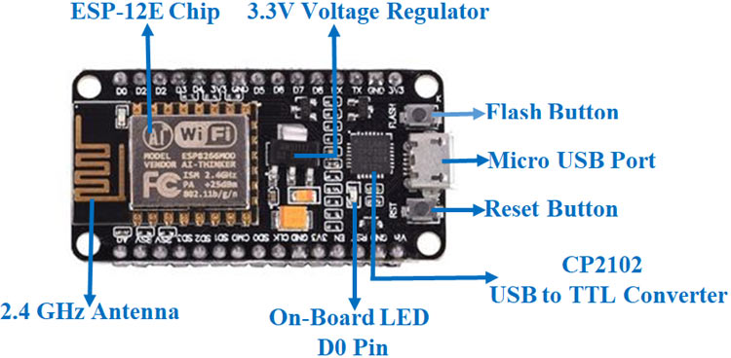

**Fig 3.3 Node MCU ESP8266 Module**

**Specifications & Features**:

* Microcontroller: Tensilica 32-bit RISC CPU Xtensa LX106
* Operating Voltage: 3.3V
* Input Voltage: 7-12V
* Digital I/O Pins (DIO): 16
* Analog Input Pins (ADC): 1
* UARTs: 1
* SPIs: 1
* I2Cs: 1
* Flash Memory: 4 MB
* SRAM: 64 KB
* Clock Speed: 80 MHz
* USB-TTL based on CP2102 is included onboard, Enabling Plug and Play
* PCB Antenna

**3.3.3 VIBRATION SENSOR**

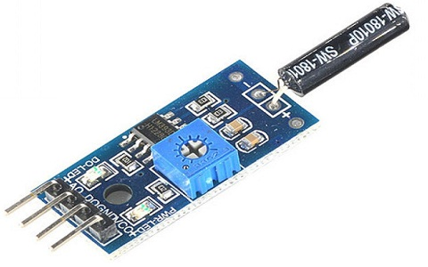

**Fig 3.4 Vibration Sensor Module**

The vibration sensor is also called a piezoelectric sensor. These sensors are flexible devices which are used for measuring various processes. This sensor uses the piezoelectric effects while measuring the changes within acceleration, pressure, temperature, force otherwise strain by changing to an electrical charge. This sensor is also used for deciding fragrances within the air by immediately measuring capacitance as well as quality.

The working principle of vibration sensor is a sensor which operates based on different optical otherwise mechanical principles for detecting observed system vibrations. The sensitivity of these sensors normally ranges from 10 mV/g to 100 mV/g, and there are lower and higher sensitivities are also accessible. The sensitivity of the sensor can be selected based on the application. It is essential to know the levels of vibration amplitude range to which the sensor will be exposed throughout measurements. We use the accelerometer sensor which is used for vibration and shock.

**3.2.4 GPS MODULE (NEO-6M)**

The u-blox NEO-6M GPS engine on these modules is quite a good one, and it also has high sensitivity for indoor applications. Furthermore, there’s one MS621FE-compatible rechargeable battery for backup and EEPROM for storing configuration settings. The module works well with a DC input in the 3.3- to 5-V range (thanks to its built-in voltage regulator).

As indicated, the GPS modules are based on the u-blox NEO-6M GPS engine. The type number of the NEO-6M is NEO-6M-0-001, and its ROM/FLASH version is ROM 7.0.3 (PCN reference UBX-TN-11047-1). The NEO-6M module includes one configurable UART interface for serial communication, but the default UART (TTL) baud rate here is 9,600. Because the GPS signal is right-hand circular-polarized (RHCP), the style of the GPS antenna will be different from the common whip antennas used for linear polarized signals. The most popular antenna type is the patch antenna. Patch antennas are flat, generally have a ceramic and metal body, and are mounted on a metal base plate. The position of the antenna mounting is very crucial for optimal performance of the GPS receiver. When using the patch antenna, it should be oriented parallel to the geographic horizon. The antenna must have full view of the sky, ensuring a direct line of sight with as many visible satellites as possible.

Some features:

* This module has an external antenna and built-in EEPROM.
* Interface: RS232 TTL
* Power supply: 3V to 5V
* Default baud rate: 9600 bps

Works with standard NMEA (National Marine Electronics Association) sentences.

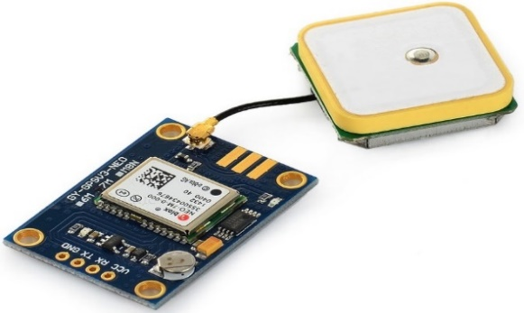

**Fig 3.5 Neo-6m GPS Module**

**3.2.5 LCD (Liquid Crystal Display)**

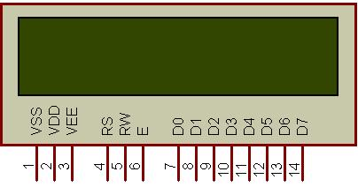

**Fig 3.6 LCD Display**

The most commonly used Character based LCDs are based on Hitachi's HD44780 controller or other which are compatible with HD44580. In this LCDs, their interfacing with various microcontrollers, various interfaces (8-bit/4-bit), programming, special stuff and tricks you can do with these simple looking LCDs which can give a new look to your application. The most commonly used LCDs found in the market today are 1 Line, 2 Line or 4 Line LCDs which have only 1 controller and support at most of 80 characters, whereas LCDs supporting more than 80 characters make use of 2 HD44780 controllers. Most LCDs with 1 controller has 14 Pins and LCDs with 2 controller has 16 Pins (two pins are extra in both for back-light LED connections).

**Pin description**

**Table 3.1 Character LCD pins with Controller**

|  |  |  |
| --- | --- | --- |
| **Pin No.** | **Name** | **Description** |
| Pin no. 1 | **VSS** | Power supply (GND) |
| Pin no. 2 | **VCC** | Power supply (+5V) |
| Pin no. 3 | **VEE** | Contrast adjust |
| Pin no. 4 | **RS** | 0 = Instruction Input 1 = Data input |
| Pin no. 5 | **R/W** | 0 = Write to LCD module 1 = Read from LCD module |
| Pin no. 6 | **EN** | Enable signal |
| Pin no. 7 | **D0** | Data bus line 0 (LSB) |
| Pin no. 8 | **D1** | Data bus line 1 |
| Pin no. 9 | **D2** | Data bus line 2 |
| Pin no. 10 | **D3** | Data bus line 3 |
| Pin no. 11 | **D4** | Data bus line 4 |
| Pin no. 12 | **D5** | Data bus line 5 |
| Pin no. 13 | **D6** | Data bus line 6 |
| Pin no. 14 | **D7** | Data bus line 7 (MSB) |

The LCD requires 3 control lines as well as either 4 or 8 I/O lines for the data bus. The user may select whether the LCD to operate with 4-bit data bus or 8-bit data bus. If 4-bit data bus is used the LCD will require a total of 7 data lines (3 control lines plus the 4 lines for the data bus). If 8-bit data bus is used the LCD will require a total of 11 data lines (3 control lines plus the 8 lines for the data bus).

The 3 control lines are referred to as **EN, RS and RW**

The **EN** line is called “Enable”. This control line is used to tell the LCD that we are sending the data, to send data to LCD our program should make sure this line is low (0) and then set the other two control lines and/or put data on data bus. When the other lines are completely ready, bring **EN** high (1) and wait for the minimum amount of time required by the LCD datasheet (this varies from LCD to LCD) and end by bringing it low (0) again.

The **RS** line is the “Register Select” line. When **RS i**s low (0), the data is to be treated as command or special instruction (such as clear screen, position cursor, etc.). When RS is high (1), the data being sent is text data which should be displayed on the screen. For example, to display the letter “T” on the screen we would set RS high.

The **RW** line is the “Read/Write” control line. When RW is low (0), the information on the data bus is being written to the LCD. When RW is high (1), the program is effectively querying (or reading) the LCD. Only one instruction (“get LCD status”) is a read command. All others are writing commands so RW will almost always be low.

Finally, the data bus consists of 4 or 8 lines (depending on the mode of operation selected by the user) in case of an 8-bit data bus, the lines are referred to as DB0-DB7.

These modules are currently supplied with a default I2C address of either 0x27 or 0x3F. To determine which version, you have to check the black I2C adaptor board on the underside of the module. If there are 3 sets of pads labelled A0, A1 and A2 then the default address will be 0x3F. If there are no pads the default address will be 0x27.

The module has a contrast adjustment pot on the underside of the display. This may require adjusting for the screen to display text correctly.

**Features:**

* Operating Voltage: 5V.
* Backlight and Contrast is adjusted by potentiometer.
* Serial I2C control of LCD display using PCF8574.
* Come with 2 IIC interface, which can be connected by Dupont Line or IIC dedicated cable.
* Compatible for 16x2 LCD.
* This is another great IIC/I2C/TWI/SPI Serial Interface.
* With this I2C interface module, you will be able to realize data display via only 2 wires.

**3.2.6 BUZZER**

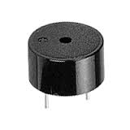

**Fig 3.7 Piezo Buzzer**

The Buzzer is a sounding device that can convert audio signals into sound signals. It is usually powered by DC voltage. It is widely used in alarms, computers, printers and other electronic products as sound devices. It is mainly divided into piezoelectric buzzer and electromagnetic buzzer, represented by the letter "H" or "HA" in the circuit. According to different designs and uses, the buzzer can emit various sounds such as music, siren, buzzer, alarm, and electric bell.

The piezoelectric buzzer uses the piezoelectric effect of the piezoelectric ceramics and uses the pulse current to drive the vibration of the metal plate to generate sound. Piezoelectric buzzer is mainly composed of multi-resonator, piezoelectric plate, impedance matcher, resonance box, housing, etc. Some of the piezoelectric buzzers are also equipped with light-emitting diodes. The multi-resonator consists of transistors or integrated circuits. When the power supply is switched on (1.5~15V DC operating voltage), the multi-resonator oscillates and outputs 1.5~2.5 kHz audio signal. The impedance matcher pushes the piezoelectric plate to generate sound. The piezoelectric plate is made of lead zirconate titanate or lead magnesium niobate piezoelectric ceramic, and silver electrodes are plated on both sides of the ceramic sheet. After being polarized and aged, the silver electrodes are bonded together with brass or stainless-steel sheets.

It uses piezoelectric material, which generates electric charge when the piezoelectric material is deformed by external force. Similarly, the piezoelectric material deforms when energized. The piezoelectric element is composed of a piezoelectric ceramic and a metal plate held together with adhesive. Both sides of the piezoelectric ceramic plate contain an electrode for electrical conduction. Piezo materials exhibit a specific phenomenon known as the piezoelectric effect and the reverse piezoelectric effect. Exposure to mechanical strain will cause the material to develop an electric field, and vice versa.

When an alternating voltage is applied to the piezo ceramic element, the element extends and shrinks diametrically. This characteristic of piezoelectric material is utilized to make the ceramic plate vibrate rapidly to generate sound waves.

**3.2.7 HC-SR04 ULTRASONIC SENSOR**

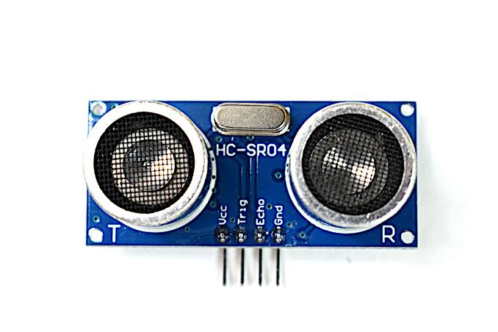

**Fig 3.8 HC-SR04 Ultrasonic Sensor**

The **HC-SR04 Ultrasonic (US) sensor** is a 4 pin module, whose pin names are Vcc, Trigger, Echo and Ground respectively. This sensor is a very popular sensor used in many applications where measuring distance or sensing objects are required. The module has two eyes like projects in the front which forms the Ultrasonic transmitter and Receiver. The sensor works with the simple high school formula that

**Distance = Speed × Time**

The Ultrasonic transmitter transmits an ultrasonic wave, this wave travels in air and when it gets objected by any material it gets reflected back toward the sensor this reflected wave is observed by the Ultrasonic receiver module as shown in the picture below

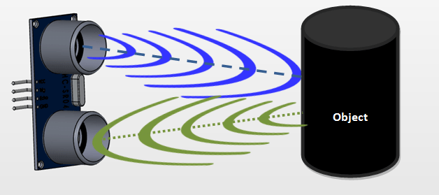

**Fig 3.9 Image of Working of Ultrasonic Sensor**

Now, to calculate the distance using the above formulae, we should know the Speed and time. Since we are using the Ultrasonic wave, we know the universal speed of US wave at room conditions which is 330m/s. The circuitry inbuilt on the module will calculate the time taken for the US wave to come back and turns on the echo pin high for that same particular amount of time, this way we can also know the time taken. Now simply calculate the distance using a microcontroller or microprocessor.

**Features:**

* Operating Voltage: +5V
* Measuring Distance: 2cm to 450cm
* Practical Measuring Distance: 2cm to 80cm
* Accuracy: 3mm
* Measuring angle covered: <15°
* Operating Current: <15mA
* Operating Frequency: 40Hz

**3.2.8 HC-05 BLUETOOTH MODULE**

HC-05 Bluetooth SPP (Serial Port Protocol) is an easy-to-use module, designed for transparent wireless serial connection setup. Serial port Bluetooth module is fully qualified Bluetooth V2.0+EDR (Enhanced Data Rate) 3Mbps Modulation with complete 2.4GHz radio transceiver and baseband. It uses CSR Blue core 04-External single chip Bluetooth system with CMOS technology and with AFH (Adaptive Frequency Hopping Feature). It has the footprint as small as 12.7mmx27mm. Hope it will simplify your overall design/development cycle.

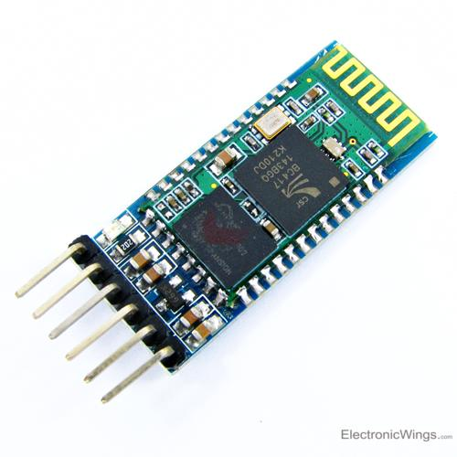

**Fig 3.10 HC-05 Bluetooth Module**

**Hardware features:**

* Typical -80dBm sensitivity
* Up to +4dBm RF transmit power
* Low Power 1.8V Operation ,1.8 to 3.6V I/O
* PIO control
* UART interface with programmable baud rate
* With integrated antenna
* With edge connector

**05 Default Settings:**

* Default Bluetooth Name: “HC-05”
* Default Password: 1234 or 0000
* Default Communication: Slave
* Default Mode: Data Mode
* Data Mode Baud Rate: 9600, 8, N, 1
* Command Mode Baud Rate: 38400, 8, N, 1
* Default firmware: LINVOR

**Software features:**

* Default Baud rate: 38400, Data bits:8, Stop bit:1, Parity: No parity, Data control: has.
* Supported baud rate: 9600, 19200, 38400, 57600, 115200, 230400, 460800.
* Given a rising pulse in PIO0, device will be disconnected.
* Status instruction port PIO1: low-disconnected, high-connected.
* PIO10 and PIO11 can be connected to red and blue led separately. When master and slave are paired, red and blue led blinks 1time/2s in interval, while disconnected only blue led blinks 2 times.
* Auto-connect to the last device on power as default.
* Permit pairing device to connect as default.
* Auto-pairing PINCODE:”0000” as default
* Auto-reconnect in 30 min when disconnected as a result of beyond the range of connection.

**3.2.9 L293D MOTOR DRIVER**

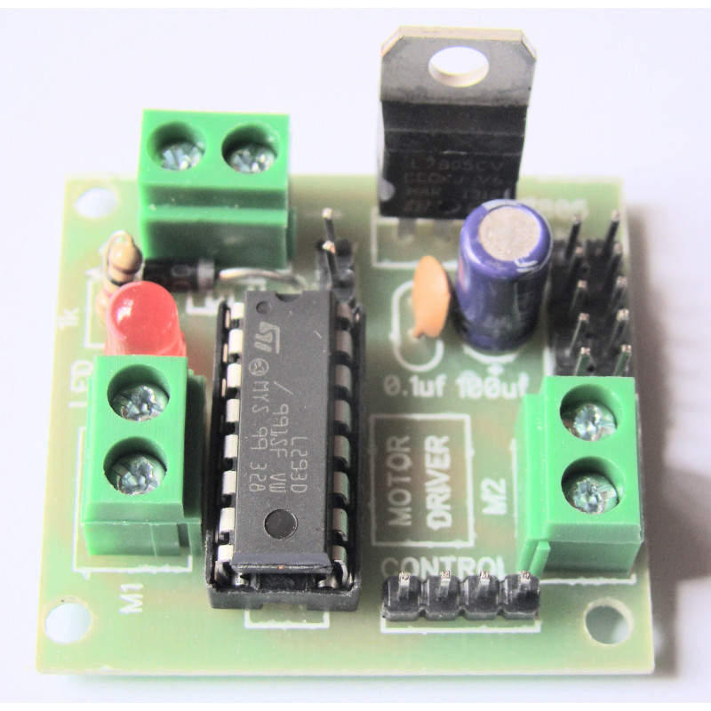

**Fig 3.11 L293D Motor Driver**

The L293D is a 16 pin IC, with eight pins on each side dedicated to the controlling of a motor. There are 2 input pins, 2 output pins and 1 enable pin for each motor. The IC works on the principle of **Half H-Bridge**, the H bridge is a setup which is used to run motors both in clock wise and anti-clockwise direction that is the dual-channel H-Bridge motor driver is capable of driving a pair of DC Motors. As said earlier this IC is capable of running two motors at the any direction at the same time.

All the Ground pins should be grounded. There are two power pins for this IC, one is the VSS (Vcc1) which provides the voltage for the IC to work, this must be connected to +5V. The other is Vs (Vcc2) which provides voltage for the motors to run, based on the specification of your motor you can connect this pin to anywhere between 4.5V to 36V, here I have connected to +12V.

**3.3 SOFTWARE REQUIREMENT**

**3.3.1 ARDUINO IDE**

The software section is the backbone of the entire project for implementation of our project we have chosen Arduino IDE. Arduino IDE where IDE stands for Integrated Development Environment - An official software introduced by Arduino.cc, that is mainly used for writing, compiling and uploading the code in the Arduino Device. Almost all Arduino modules are compatible with this software that is an open source and is readily available to install and start compiling the code on the go. open the IDE software, it will appear like an image below

The IDE environment is mainly distributed into three sections

1. Menu Bar

2. Text Editor

3. Output Panel

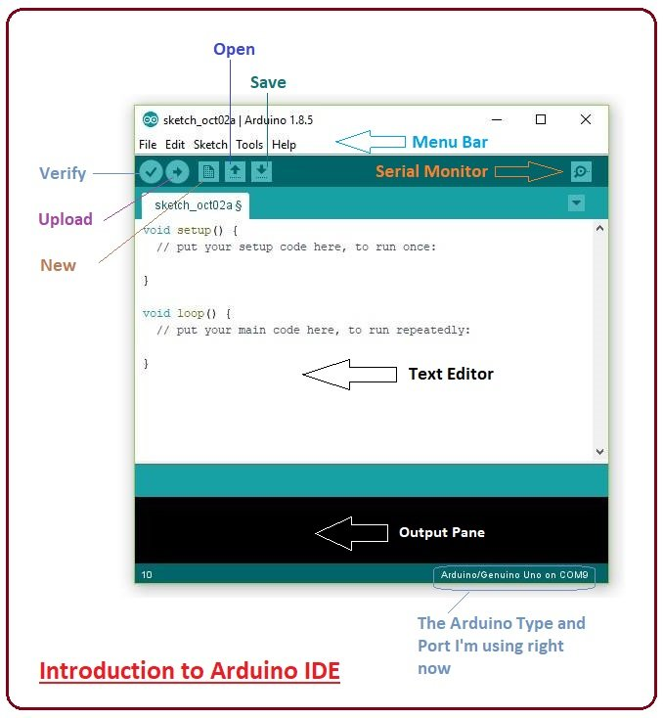

**Fig 3.12 Figure to open IDE Software**

The bar appearing on the top is called Menu Bar that comes with five different options as follow

File - You can open a new window for writing the code or open an existing one. As you go to the preference section and check the compilation section, the Output Pane will show the code compilation as you click the upload button. And at the end of compilation, it will show you the hex file it has generated for the recent sketch that will send to the Arduino Board for the specific task you aim to achieve.

Edit - Used for copying and pasting the code with further modification for font

Sketch - For compiling and programming

Tools - Mainly used for testing projects. The Programmer section in this panel is used for burning a bootloader to the new microcontroller.

Help - In case you are feeling skeptical about software, complete help is available from getting started to troubleshooting.

The main screen below the Menu bar is known as a simple text editor used for writing the required code.

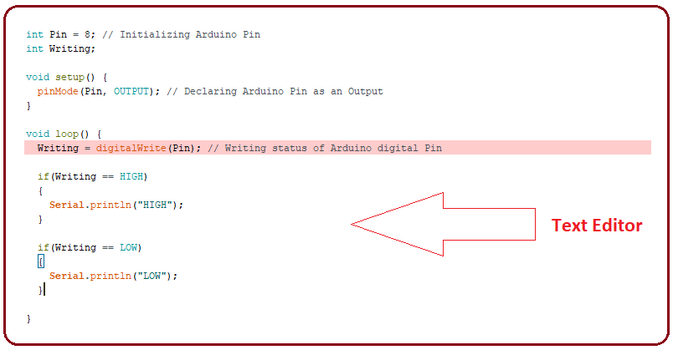

**Fig 3.13 Text Editor**

The bottom of the main screen is described as an Output Pane that mainly highlights the compilation status of the running code: the memory used by the code, and errors occurred in the program. You need to fix those errors before you intend to upload the hex file into your Arduino Module.

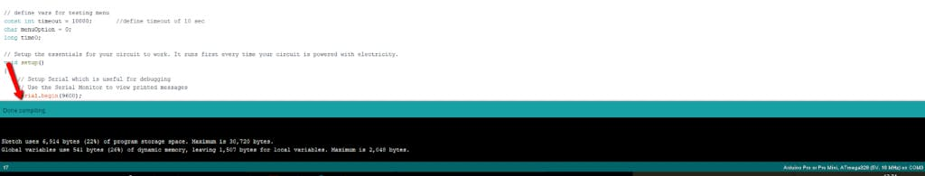

**Fig 3.14 Output Panel**

**Libraries**

Libraries are very useful for adding the extra functionality into the Arduino Module. There is a list of libraries you can add by clicking the Sketch button in the menu bar and going to Include Library.

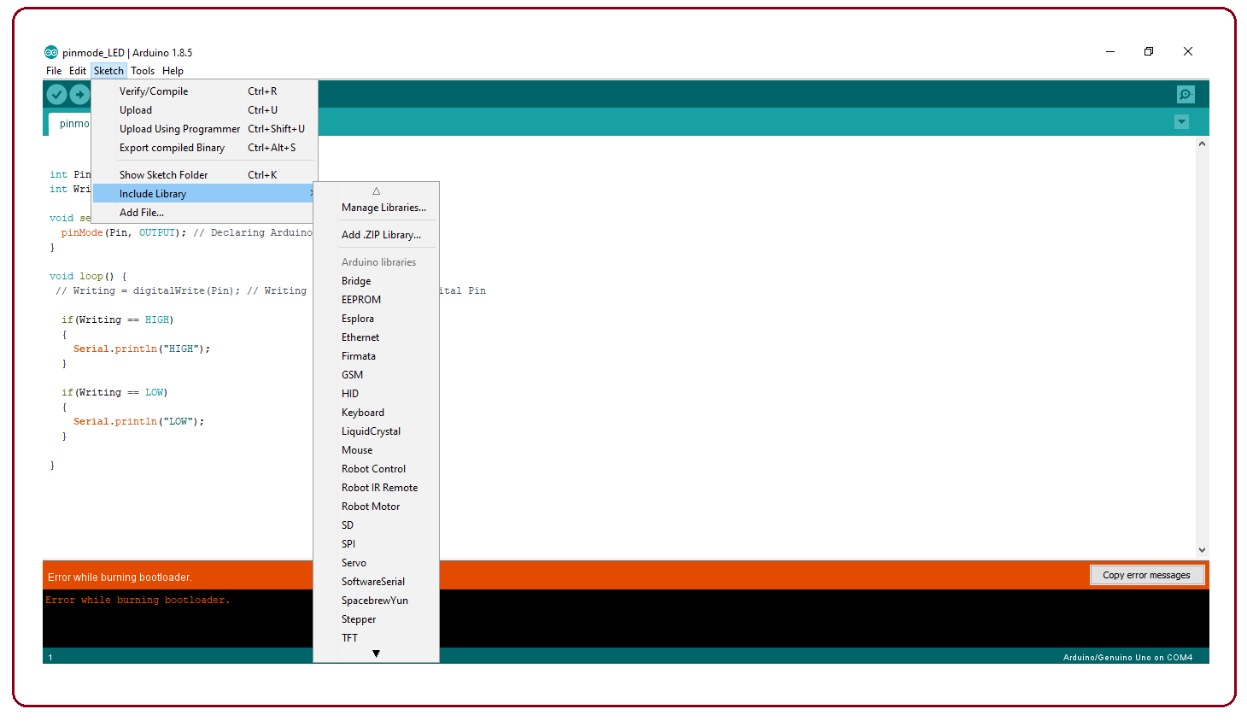

**Fig 3.15 Library Functions**

As we click the Include Library and Add the respective library it will on the top of the sketch with a #include sign.

**Making Pins as Input or Output**

The digitalRead and digitalWrite commands are used for addressing and making the Arduino pins as an input and output respectively. These commands are text sensitive that is you need to write them down the exact way they are given like digitalWrite starting with small "d" and write with capital "W". Writing it down with digitalWrite won't be calling or addressing any function.

In order to upload the sketch, you need to select the relevant board you are using and the ports for that operating system. As you click the Tools on the Menu, it will open like the figure below.

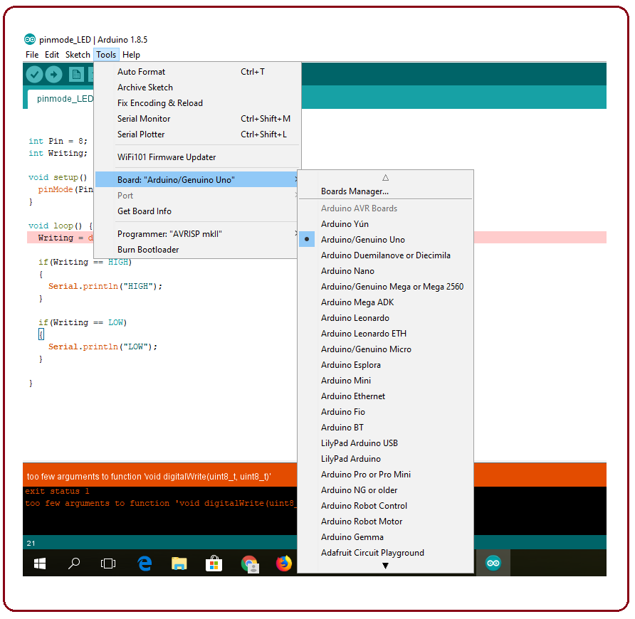

**Fig 3.16 Tools Menu**

After correct selection of both Board and Serial Port, click the verify and then upload button appearing in the upper left corner of the six button section or you can go to the Sketch section and press verify/compile and then upload. Once you upload the code, TX and RX LEDs will blink on the board, indicating the desired program is running successfully.

**Bootloader**

The new Arduino Module, the bootloader is already installed inside the controller. However, if we intend to buy a controller and put in the Arduino module, we need to burn the bootloader again inside the controller by going to the Tools section and selecting the burn bootloader.

**3.3.2 UBIDOTS**

Ubidots is an IoT Platform empowering innovators and industries to prototype and scale IoT projects to production. Use the Ubidots platform to send data to the cloud from any Internet-enabled device. You can then configure actions and alerts based on your real-time data and unlock the value of your data through visual tools. Ubidots offers a REST API that allows you to read and write data to the resources available: data sources, variables, values, events and insights. The API supports both HTTP and HTTPS and an API Key is required.

Every time a device updates a sensor value in a variable, a data-point or "**dot**" is created. Ubidots stores dots that come from your devices inside variables, and these stored dots have corresponding **timestamps**.

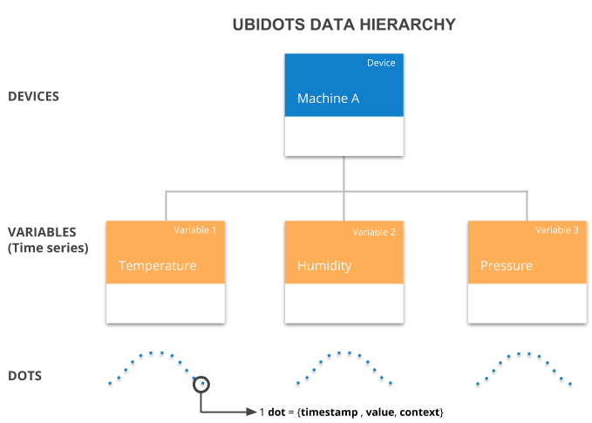

**Fig 3.17 Ubidots Data Hierarchy**

**Values**

A numerical value. Ubidots accepts up to 16 floating-point length numbers.

**Timestamps**

The UNIX time stamp is a way to track time as a running total of seconds.

**Context**

Numerical values are not the only data type supported; you can also store *string* or *char* data types inside what we call **context**. The **context** is a key-value object that allows you to store not only numerical but also string values.

**3.4 SOFTWARE IMPLEMENTATION**

**Arduino Nano Unit**

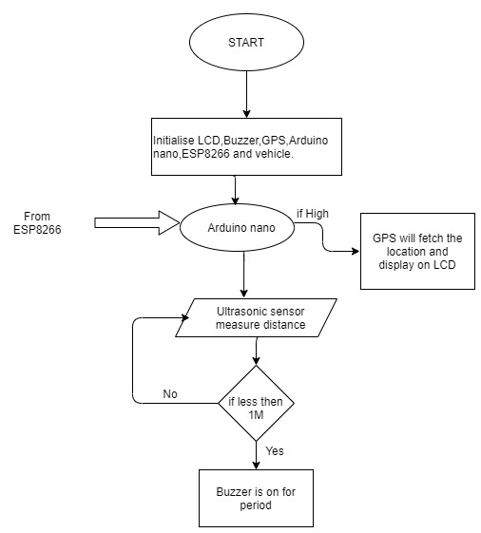

**Fig 3.17 Flow Chart of Arduino Nano Unit**

**ESP8266 Unit**

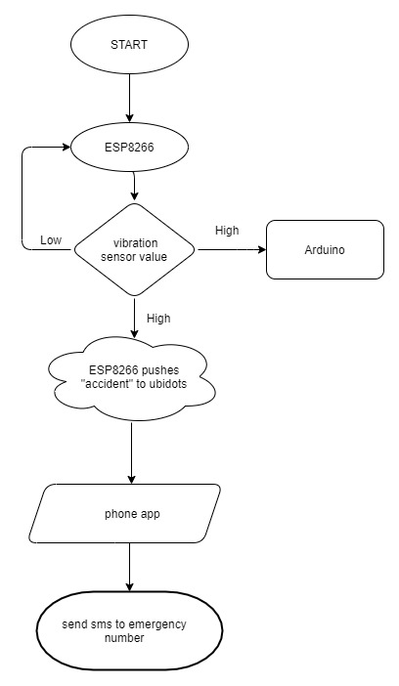

**Fig 3.18 Flow Chart of ESP8266 Unit**

The flow chart of the system is shown in the above fig. It shows the system is initialized on power ON then all sensor will start functioning. Ultrasonic sensor measure distance between the obstacle and car, if it less than the 1M the buzzer is on for a period of time. The ESP8266 is connected to vibration sensor, if there is a collision and senor value is high. ESP8266 will send a high to Arduino and pushes message “accident” to ubidots server. Arduino will fetch location from GPS and display on LCD. Phone app is connected to the server will get to know about the accident and send location to the emergency number through SMS.

**CHAPTER 4**

**RESULTS**

**Vehicle Unit**

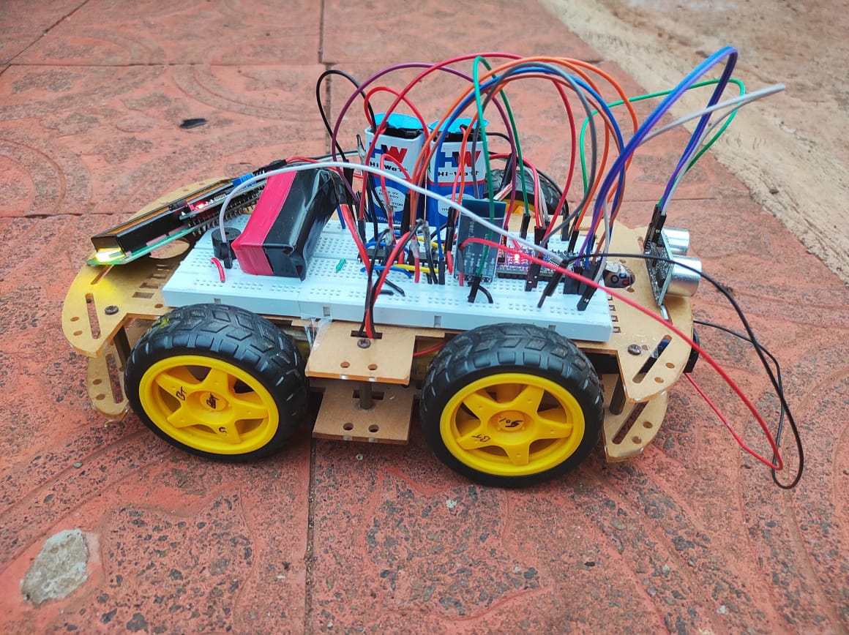

**Fig 4.1 Vehicle Unit**

**Status of Accident in Ubidots Server before Collision and after Collision**

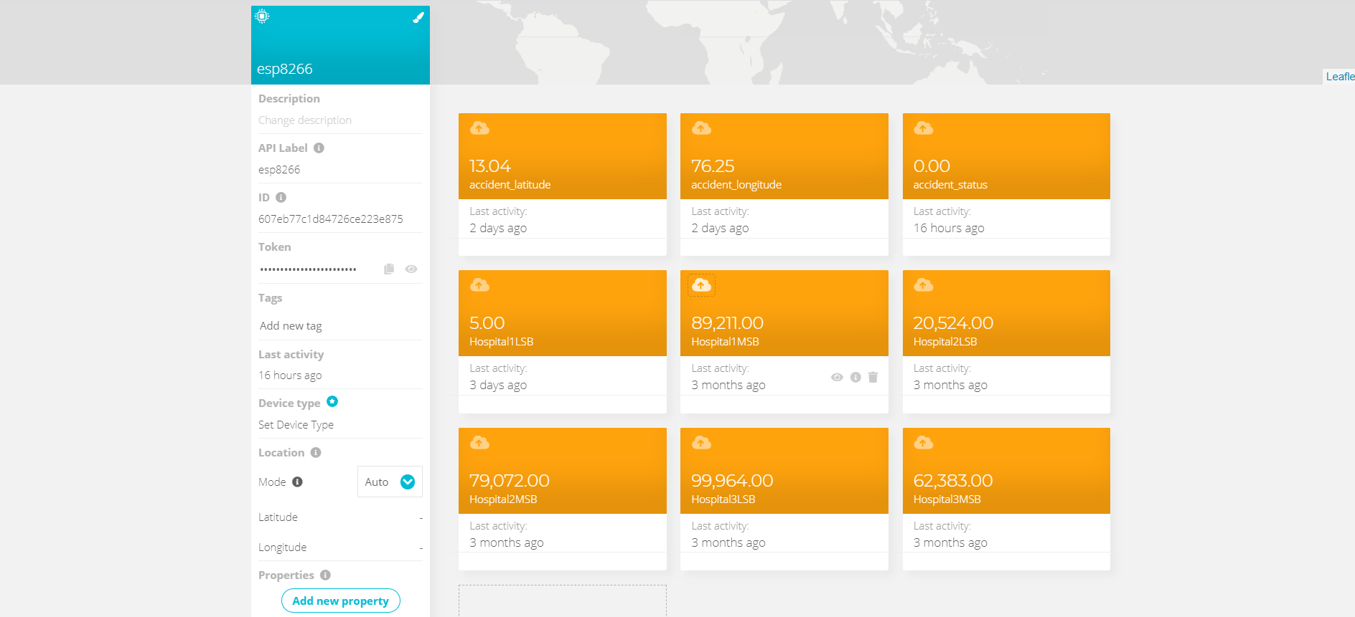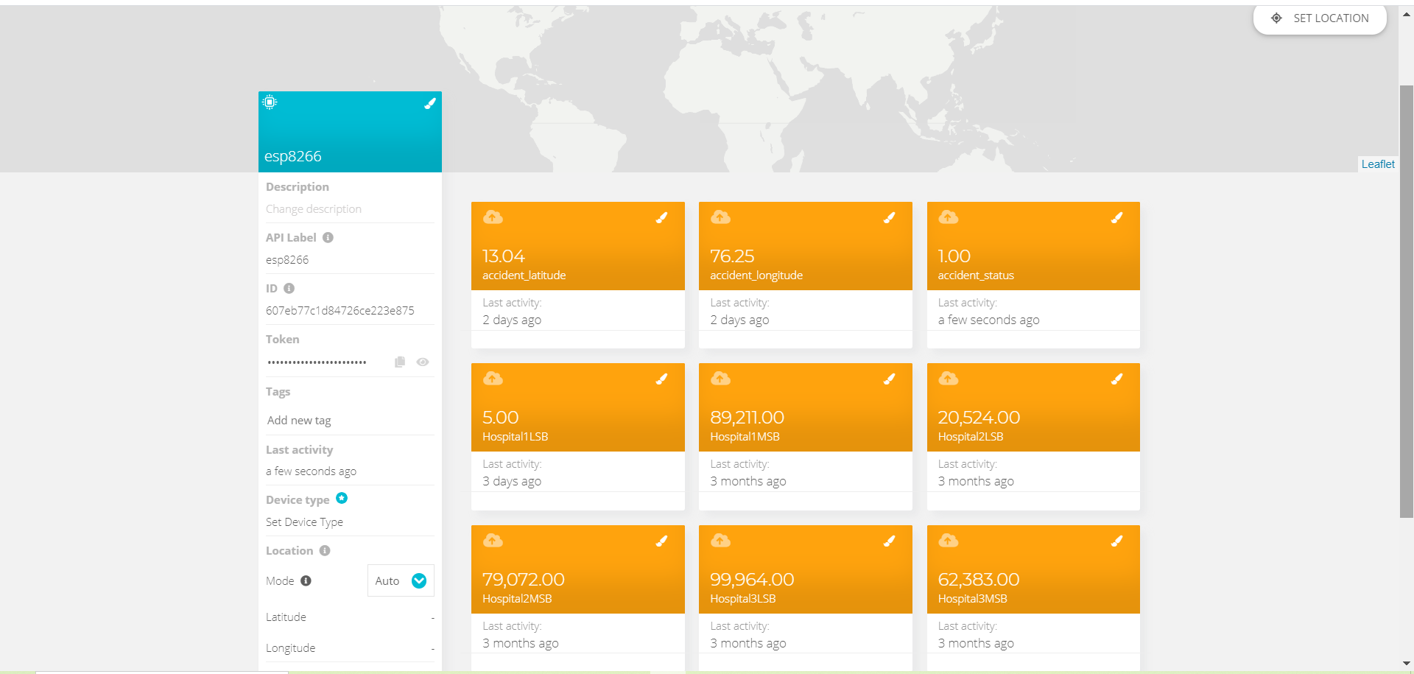

**Fig 4.2 Status of Accident**

**Mobile Application**

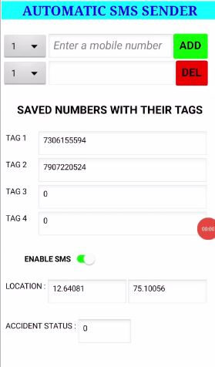

**Fig 4.3 Saved Numbers and Location Details in Mobile Application**

**SMS to the Saved Number and the location of Accident on the Map**

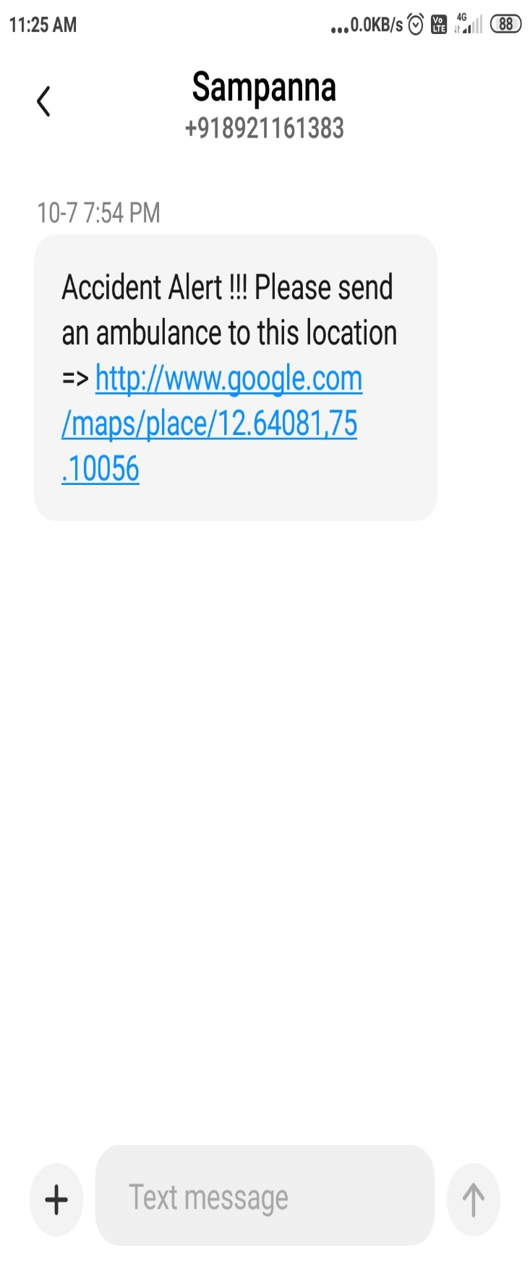

**Fig 4.4(a) SMS to the saved number**

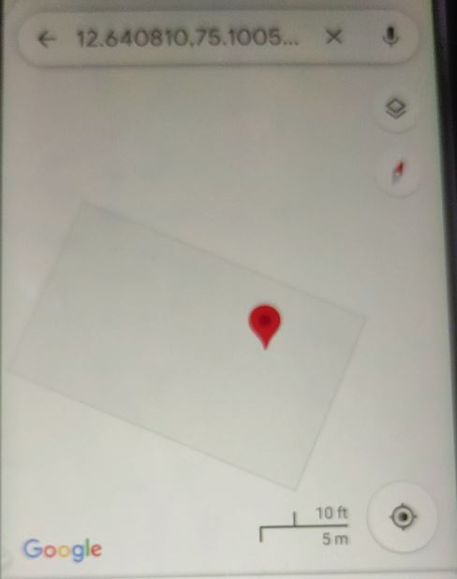

**Fig 4.4(b) Location of the Accident**

**4.1 ADVANTAGES**

* As soon as the accident occurs, the message is sent to the nearby hospital which saves the time in case of emergency.
* Low cost for maintenance.
* Can be used by any moving vehicle as it is not bulky.
* Time required to save the people is less.
* The alert message regarding the accident is sent automatically.
* This system can be used for social cause.
* It does not need any operation manually.

**4.2 LIMITATIONS**

* The whole system is based on the fact that network is available, if network fails then the entire system fails.
* Constant supply of power is essential and incase batteries are used it has to be replaced every time when it gets discharged completely.
* GPS receiver needs lots of power which drains maximum.
* Might have a bit of delay because of all the circuit components.

**4.3 APPLICATIONS**

* Stolen Vehicle recovery.
* School bus, cab of companies to detect if any accidents occur.
* The applications for this project are in military, navigation, automobiles, aircrafts, remote monitoring, remote control, security systems, tele services, etc.

**CHAPTER 5**

**CONCLUSION & FUTURE ENHANCEMENT**

**5.1 CONCLUSION**

The proposed system is developed to provide the information about the accident and the location of the accident where it has occurred. It helps to easily provide the assistant and help the victim of the accident. This system uses GPS module to locate the vehicle. This system also alerts driver if obstacle is very near to the car. The SMS is sent to the emergency number. The use of Automatic vehicle accident alert system is to minimize unwanted accidents to a great extent compared to normal behaviour.

**5.2 FUTURE ENHANCEMENT**

* The proposed system deals with the detection of the accidents. But this can be extended by providing medication to the victims at the accident spot.
* We can monitor some parameters of vehicle like overheat.
* This project can also be developed by interconnecting a camera to the controller module that takes the photo of the accident spot that makes the tracking easier.

**CHAPTER 6**

**APPENDIX**

**A.1 ARDUINO NANO**

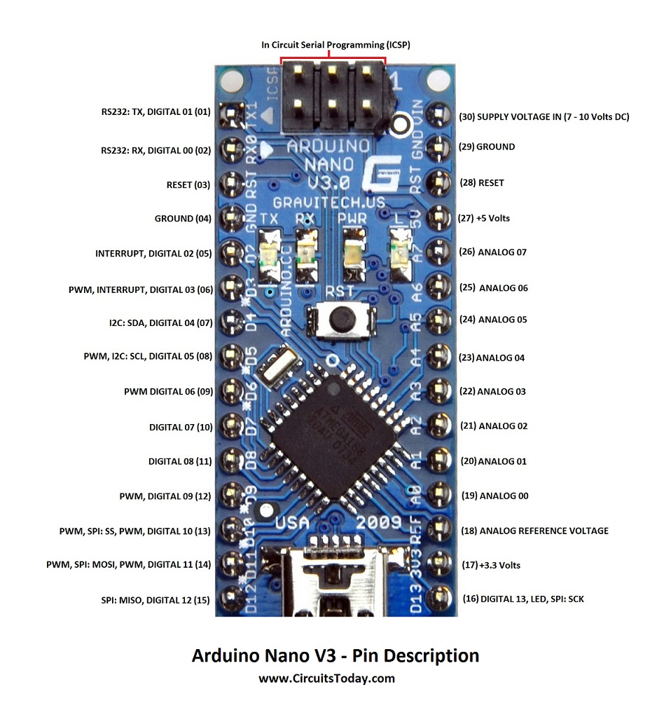

**Fig 6.1 Arduino Nano V3 – Pin Description**

**Table 6.1 Pin Description of Arduino Nano**

|  |  |  |  |
| --- | --- | --- | --- |
| Arduino Nano Pin | Pin Name | Type | Function |
| 1 | D1/TX | I/O | Digital I/O Pin Serial TX Pin |
| 2 | D0/RX | I/O | Digital I/O Pin Serial RX Pin |
| 3 | RESET | Input | Reset (Active Low) |
| 4 | GND | Power | Supply Ground |
| 5 | D2 | I/O | Digital I/O Pin |
| 6 | D3 | I/O | Digital I/O Pin |
| 7 | D4 | I/O | Digital I/O Pin |
| 8 | D5 | I/O | Digital I/O Pin |
| 9 | D6 | I/O | Digital I/O Pin |
| 10 | D7 | I/O | Digital I/O Pin |
| 11 | D8 | I/O | Digital I/O Pin |
| 12 | D9 | I/O | Digital I/O Pin |
| 13 | D10 | I/O | Digital I/O Pin |
| 14 | D11 | I/O | Digital I/O Pin |
| 15 | D12 | I/O | Digital I/O Pin |
| 16 | D13 | I/O | Digital I/O Pin |
| 17 | 3V3 | Output | +3.3V Output (from FTDI) |
| 18 | AREF | Input | ADC reference |
| 19 | A0 | Input | Analog Input Channel 0 |
| 20 | A1 | Input | Analog Input Channel 1 |
| 21 | A2 | Input | Analog Input Channel 2 |
| 22 | A3 | Input | Analog Input Channel 3 |
| 23 | A4 | Input | Analog Input Channel 4 |
| 24 | A5 | Input | Analog Input Channel 5 |
| 25 | A6 | Input | Analog Input Channel 6 |
| 26 | A7 | Input | Analog Input Channel 7 |
| 27 | +5V | Output or Input | +5V Output (From On-board Regulator) or +5V (Input from External Power Supply |
| 28 | RESET | Input | Reset (Active Low) |
| 29 | GND | Power | Supply Ground |
| 30 | VIN | Power | Supply voltage |
|  |  |  |  |

**Table 6.2 ICSP PINS**

| **Arduino Nano ICSP Pin Name** | **Type** | **Function** |
| --- | --- | --- |
| MISO | Input or Output | Master In Slave Out |
| Vcc | Output | Supply Voltage |
| SCK | Output | Clock from Master to Slave |
| MOSI | Output or Input | Master Out Slave In |
| RST | Input | Reset (Active Low) |
| GND | Power | Supply Ground |

**Pin Description**

**Pins - 1, 2**

1 - TX and 2 – RX

These two pins RX- receive and TX- transmit are used for TTL serial data communication. The pins RX and TX are connected to the corresponding pins of the USB-to-TTL Serial chip.

**Pins - 6, 8, 9, 12, 13, and 14**

Each of these digital pins provide a Pulse Width Modulation signal of 8-bit resolution. The PWM signal can be generated using analogWrite () function.

**Pins - 5, 6**

When we need to provide an external interrupt to other processor or controller we can make use of these pins. These pins can be used to enable interrupts INT0 and INT1 respectively by using the attachInterrupt () function.

**Pins - 13, 14, 15, and 16**

These pins support synchronous communication with SCK as the synchronizing clock.

The pin 16 is being connected to the blinking LED on the board.

**Pin 18**

AREF- Analog Reference pin is used as a reference voltage for analog input for the ADC conversion.

**Pins - 19, 20, 21, 22, 23, 24, 25, and 26**

Arduino Nano has 8 analog inputs (19 to 26), marked A0 through A7. This means you can connect 8 channel analog sensor inputs for processing. Each of these analog pins has a inbuilt ADC of resolution of 1024 bits (so it will give 1024 values).

**Pins 23, 24 as A4 and A5**

For long distance communication we use the I2C protocol. I2C supports multi master and multi slave with only two wires. One for clock (SCL) and another for data (SDA).

**Pin 28**

Reset pins in Arduino are active LOW pins which means if we make this pin value as LOW i.e., 0V, it will reset the controller.

**A.2 ESP8266**

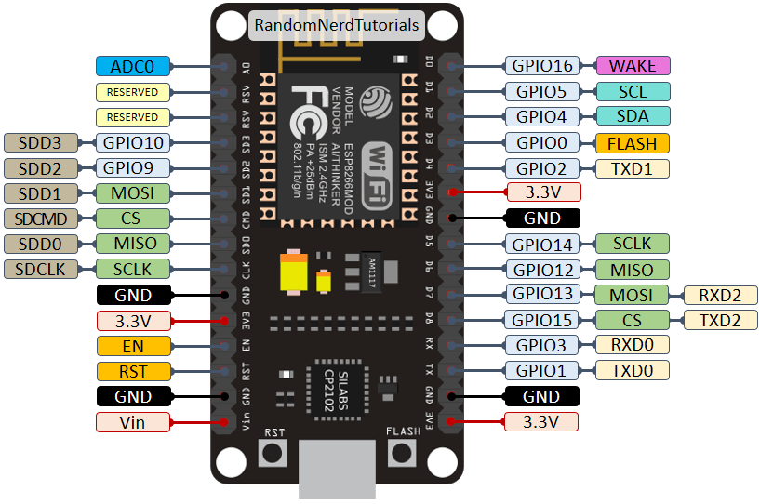

**Fig 6.2 ESP8266 Pin Description**

**Power Pins**

There are four power pins viz. one VIN pin & three 3.3V pins. The VIN pin can be used to directly supply the ESP8266 and its peripherals, if you have a regulated 5V voltage source. The 3.3V pins are the output of an on-board voltage regulator. These pins can be used to supply power to external components.

GND is a ground pin of ESP8266 NodeMCU development board.

I2C Pins are used to hook up all sorts of I2C sensors and peripherals in the project. Both I2C Master and I2C Slave are supported. I2C interface functionality can be realized programmatically, and the clock frequency is 100 kHz at a maximum. It should be noted that I2C clock frequency should be higher than the slowest clock frequency of the slave device.

GPIO Pins ESP8266 NodeMCU has 17 GPIO pins which can be assigned to various functions such as I2C, I2S, UART, PWM, IR Remote Control, LED Light and Button programmatically. Each digital enabled GPIO can be configured to internal pull-up or pull-down, or set to high impedance. When configured as an input, it can also be set to edge-trigger or level-trigger to generate CPU interrupts.

**Table 6.3 GPIO Pins**

|  |  |  |  |
| --- | --- | --- | --- |
| **Pin Name on the Board** | **Function** | **Pin Number in Arduino IDE** | **Alias Name in Arduino IDE** |
| D3 | GPIO 0 | 0 | D3 |
| TX | GPIO 1 | 1 | D10 |
| D4 | GPIO 2 | 2 | D4 |
| RX | GPIO 3 | 3 | D9 |
| D2 | GPIO 4 | 4 | D2 |
| D1 | GPIO 5 | 5 | D1 |
| D6 | GPIO 12 | 12 | D6 |
| D7 | GPIO 13 | 13 | D7 |
| D5 | GPIO 14 | 14 | D5 |
| D8 | GPIO 15 | 15 | D8 |
| D0 | GPIO 16 | 16 | D0, LED_BUILTIN |
| A0 | ADC0 | A0 | Analog IP |

ADC Channel, the NodeMCU is embedded with a 10-bit precision SAR ADC. The two functions can be implemented using ADC viz. Testing power supply voltage of VDD3P3 pin and testing input voltage of TOUT pin. However, they cannot be implemented at the same time.

UART Pins, ESP8266 NodeMCU has 2 UART interfaces, that is UART0 and UART1, which provide asynchronous communication (RS232 and RS485), and can communicate at up to 4.5 Mbps. UART0 (TXD0, RXD0, RST0 & CTS0 pins) can be used for communication. It supports fluid control. However, UART1 (TXD1 pin) features only data transmit signal so, it is usually used for printing log.

SPI Pins ESP8266 features two SPIs (SPI and HSPI) in slave and master modes. These SPIs also support the following general-purpose SPI features:

* 4 timing modes of the SPI format transfer.
* Up to 80 MHz and the divided clocks of 80MHz.
* Up to 64-Byte FIFO.

SDIO Pins, ESP8266 features Secure Digital Input/Output Interface (SDIO) which is used to directly interface SD cards. 4-bit 25 MHz SDIO v1.1 and 4-bit 50 MHz SDIO v2.0 are supported.

PWM Pins, the board has 4 channels of Pulse Width Modulation (PWM). The PWM output can be implemented programmatically and used for driving digital motors and LEDs. PWM frequency range is adjustable from 1000 μs to 10000 μs, that is between 100 Hz and 1 kHz.

Control Pins are used to control ESP8266. These pins include Chip Enable pin (EN), Reset pin (RST) and WAKE pin.

* EN pin – The ESP8266 chip is enabled when EN pin is pulled HIGH. When pulled LOW the chip works at minimum power.
* RST pin – RST pin is used to reset the ESP8266 chip.
* WAKE pin – Wake pin is used to wake the chip from deep-sleep.

**A.3 L293D**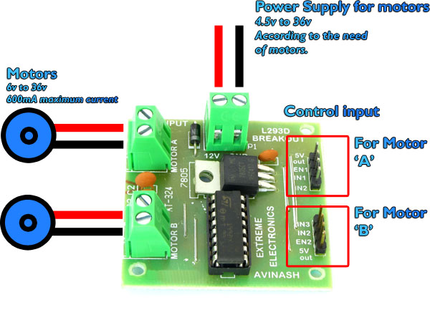

**Fig 6.3 L293D Description**

L293D is a basic motor driver integrated chip (IC) that enables us to drive a DC motor in either direction and also control the speed of the motor. The L293D is a 16 pin IC, with 8 pins on each side, allowing us to control the motor. It means that we can use a single L293D to run up to two DC motors. L293D consist of two H-bridge circuit. H-bridge is the simplest circuit for changing polarity across the load connected to it.

There are 2 OUTPUT pins, 2 INPUT pins, and 1 ENABLE pin for driving each motor. It is designed to drive inductive loads such as solenoids, relays, DC motors, and bipolar stepper motors, as well as other high-current/high-voltage loads.

IN1, IN2, and IN3, IN4 are input pins used for providing a control signal from the controller to run the motor in different directions.

If input logic at IN1, IN2 is (1,0) the motor rotates in one direction.

If input logic at IN1, IN2 is (0,1) the motor rotates in the other direction.

Power for the motor, if 12V DC gear motor is used then apply 12V.

EN1 and EN2 are enable pins. Connect 5v DC to EN1 and EN2 pin to operate the motor at its normal speed. If speed control is needed, then give PWM output at pin EN1 and En2 from the microcontroller.

**REFERENCES**

[1] S.S Kanese, S.A Yadav, S.B Jadav, M.M Kadam, “GSM & GPS Based Vehicle Theft Control System” (IRJET-- Volume: 05 Issue: 03 | Mar-2018).

[2] Nimisha Chaturvedi, Pallika Srivastava,“Automatic Vehicle Accident Detection and Messaging System Using GSM and GPS Modem”(IRJET--Volume: 05 Issue: 03 | Mar-2018).

[3] Piyush Kumar Verma, Arpit Sharma, Dhruv Varshney, Manish Zadoo, “Women safety device with gps, gsm and health monitoring system” (IRJET--Volume: 05 Issue: 03 | Mar-2018).

[4] GPS Based Real Time Vehicle Tracking System for Kid’s Safety Using RFID and GSM. (IJARIIT-- Volume: 04 Issue: 01 | 2018).

[5] Aarya D S, Athulya C K, Anas P, Basil Kuriakose, Jerin Susan Joy, Leena Thomas, “Accident Alert and Tracking using Arduino” (www.ijareeie.com Vol. 7, Issue 4, April 2018).

[6] Niranjan Kumar Mandal, Debmoy Chakraborty, “Accident Detection and Alerting System With Continuous Heart Rate Monitoring using Arduino for two-wheeler” (International Journal of Latest Trends in Engineering and Technology Vol. (16) Issue (1), pp.098-105).

[7] “Accident Detection and Alert System” (International Journal of Innovative Technology and Exploring Engineering (IJITEE) ISSN: 2278-3075, Volume-8 Issue-4S2 March, 2019).

[8] Prof. Sujata S Kadu, Anuja Londhe, Sneha Sharma, “Accident Identification and Alert System using GPS” (IRJET Volume: 07 Issue: 05 | May 2020).

[9] Aswin M, Sujitha E, Archunan P, Sandhya Devi R S, “Accident Prevention and Alert System using Arduino” (IRJET Volume: 08 Issue: 03 | Mar 2021).

[10] Wang Wei, Fan Hanbo, “Traffic Accident Automatic Detection and Remote Alarm Device” [Electric Information and Control Engineering (ICEICE), 2011 International Conference on](http://ieeexplore.ieee.org/xpl/mostRecentIssue.jsp?punumber=5766331) 15-17 April 2011 IEEE Publications, PP.910 – 913.

[11] [Rajeshwari Sundar](http://ieeexplore.ieee.org/search/searchresult.jsp?searchWithin=%22Authors%22:.QT.Rajeshwari%20Sundar.QT.&newsearch=true) , [Santhosh Hebbar](http://ieeexplore.ieee.org/search/searchresult.jsp?searchWithin=%22Authors%22:.QT.Santhoshs%20Hebbar.QT.&newsearch=true), [Varaprasad Golla](http://ieeexplore.ieee.org/search/searchresult.jsp?searchWithin=%22Authors%22:.QT.Varaprasad%20Golla.QT.&newsearch=true), “Intelligent Traffic Control System for Congestion Control, Ambulance Clearance, and Stolen Vehicle Detection”, [IEEE Sensors Journal](http://ieeexplore.ieee.org/xpl/RecentIssue.jsp?punumber=7361) (Volume:15,  [Issue: 2](http://ieeexplore.ieee.org/xpl/tocresult.jsp?isnumber=6962917))PP.1109 – 1113.

[12] https://sites.ndtv.com/roadsafety/important-feature-to-you-in-your-car-5/ road accident statics in India.

[13] World Health Organization Road Traffic Injuries Fact Sheet No 358, March 2013, Available from http://www.who.int/mediacentre/factsheets/fs358/en/

[14] Study on causes for accident http://jhtransport.gov.in/causes-of-road-accidents.html

[15] Road Traffic Accidents in India: Issues and Challenges, Sanjay Kumar Singh https://doi.org/10.1016/j.trpro.2017.05.484