Python Flow

data types
string
list
tuple
dictionary
set
conditional
loops
oops & inheritance
numpy
panda
matplotlib
scikit
tensorflow
keras
deep learning (topics yet to figure out)

AI Vs Machine learning Vs Deep learning

AI => Enables the machine to think
machine learning => It is a subset of AI
(a) Supervised => past labeled data is present already. Machine creates certain rules from these data and then applies the same for all the data.
(b) Unsupervised => when new data is given program should be able to read the data and learn from it. Ex : if we feed data of 1000 people with hair length,height,weight etc. The machine must be able to group the similar data together. This is also called clustering.
(c) Re-enforcement learning => when agent in an environment performs action the machine learns from the action consiquences. If the consequence of the action turns out to be negative then machine learns from it and tries to take postive action in the future.
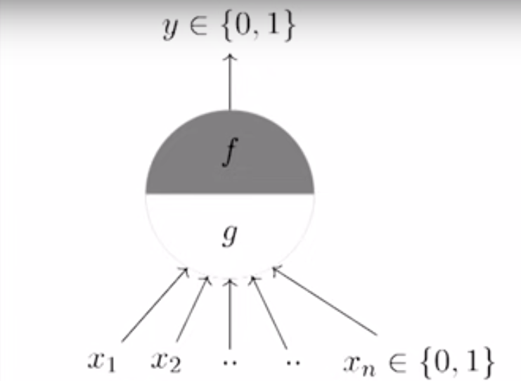
Ex : In self driving car for a certain senario if the car turns right then it causes accident so the car learns from this and doesn’t turn right.
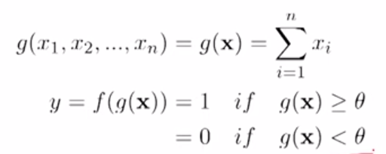
Learn => scikit learn & tensorflow

McCulloch Pitts Neuron

This model is similar to how we think the brain works.

Here if x1,x2....x2 are input decisions which may be either
0 or 1.

Inputs can be exitatory{0 or 1} or inhibitory(what ever is the input output neuron won’t be triggered)

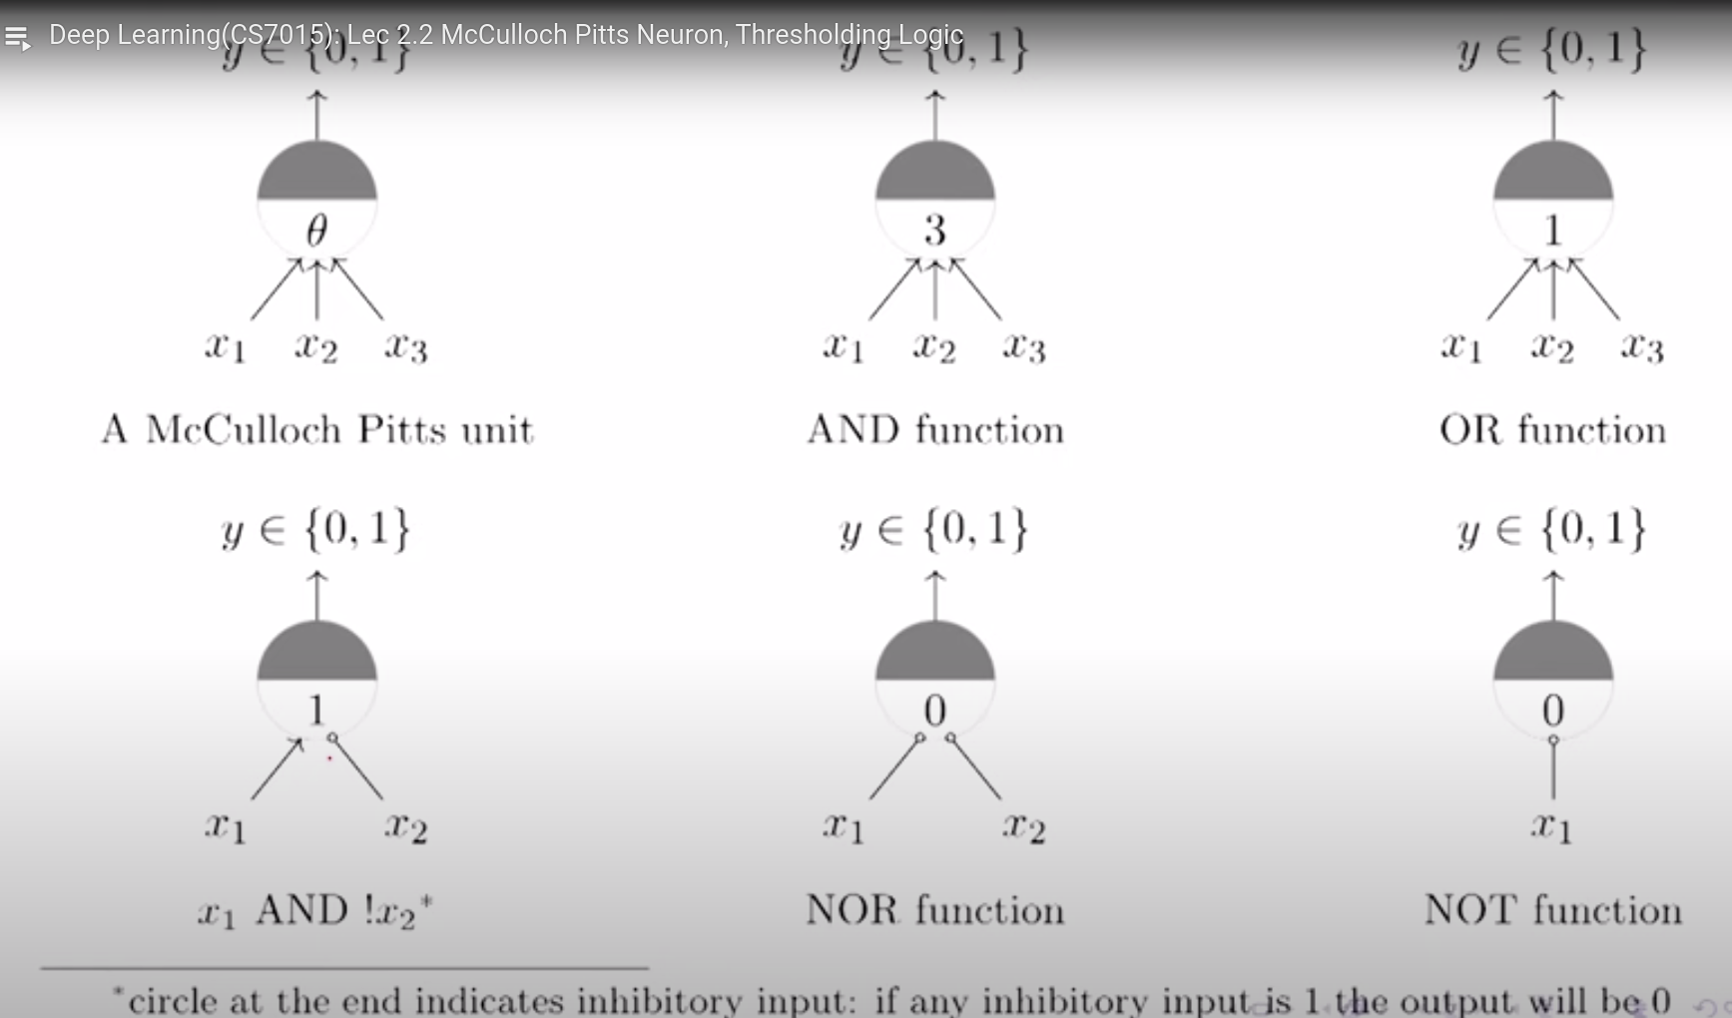
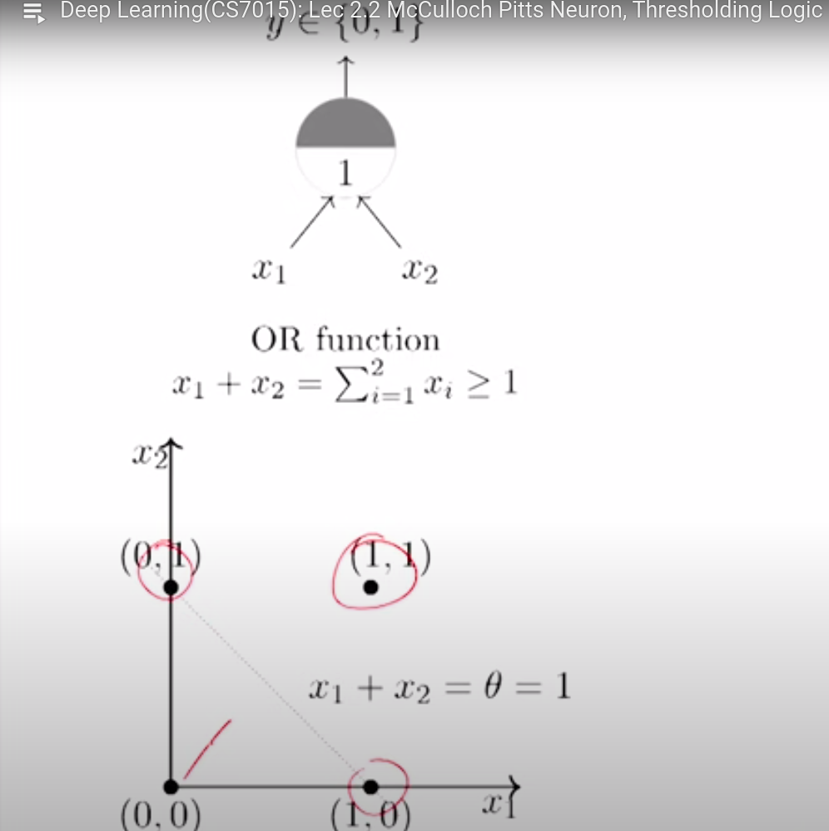
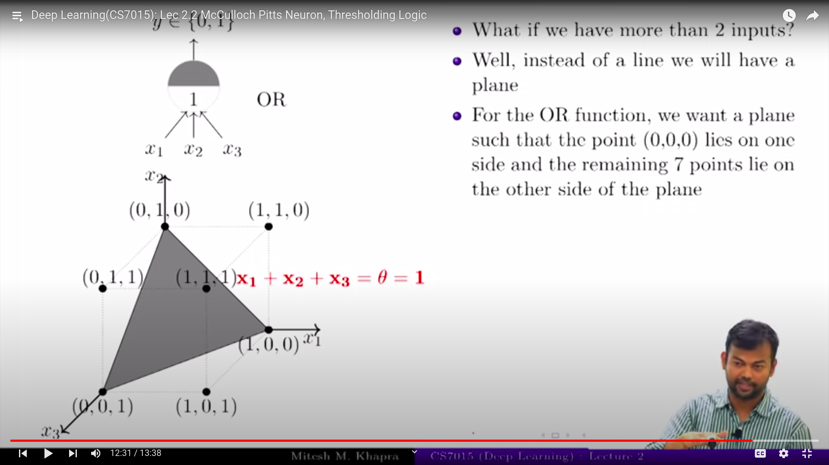
All the points above the line crossing (0,1) & (1,0) will satisy (x1+x2 >=1) or (y+x>=1) or (y>=-x+1)

Here the plane with eq x1+x2+x3>= 1 is shown which will point to all the points above the shown plane

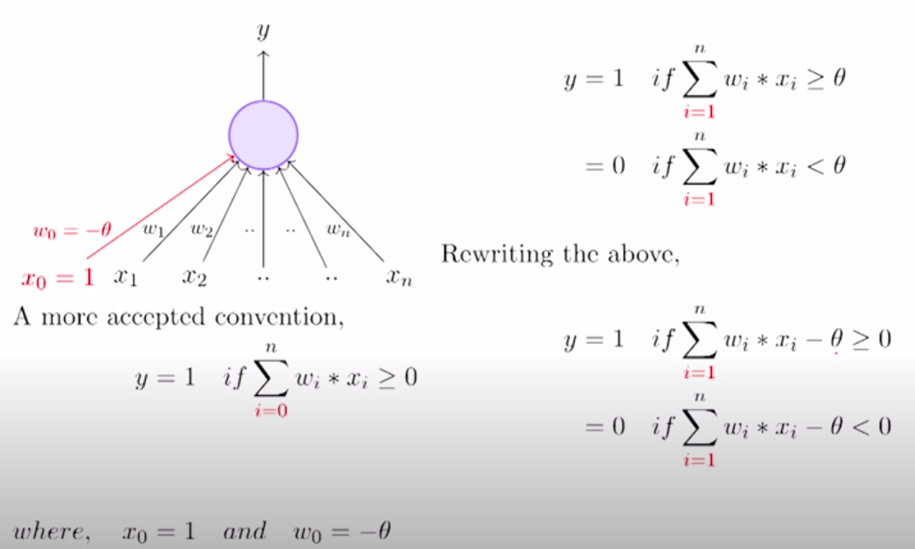
Perceptron
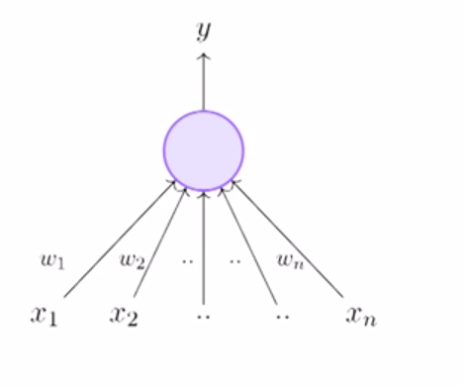

W0 & X0 are assumed to be 1 & -theta so that we can elemimitate theta(which is threshold).

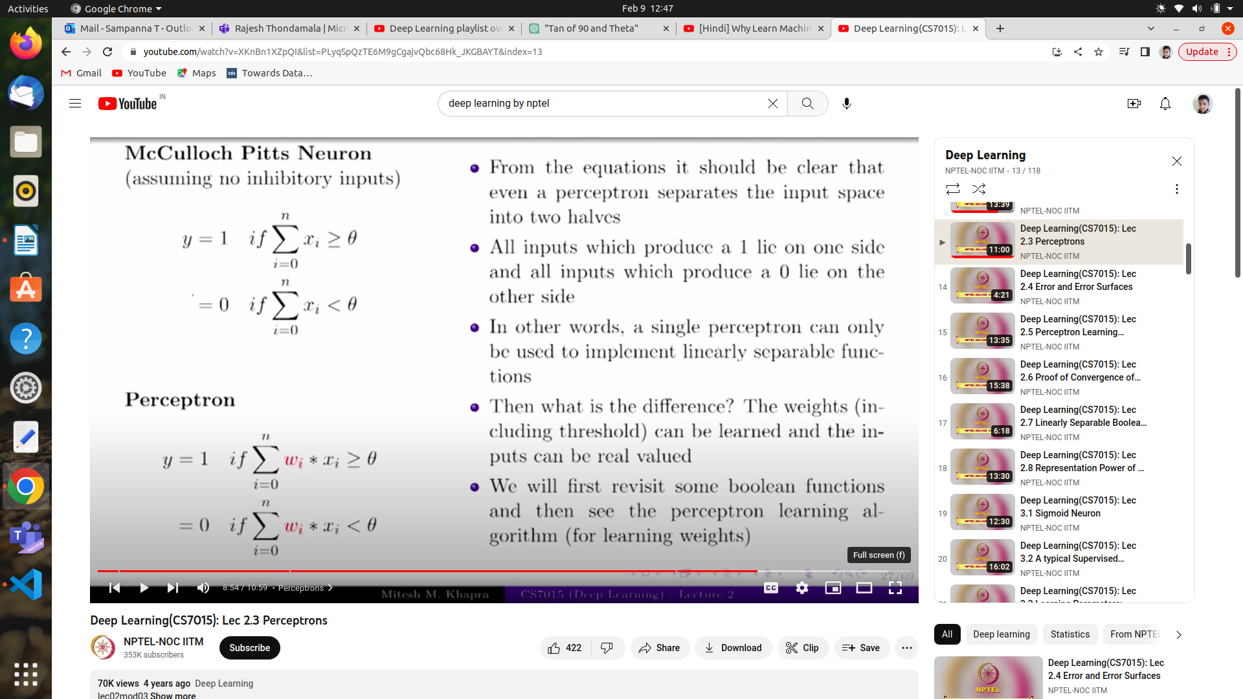
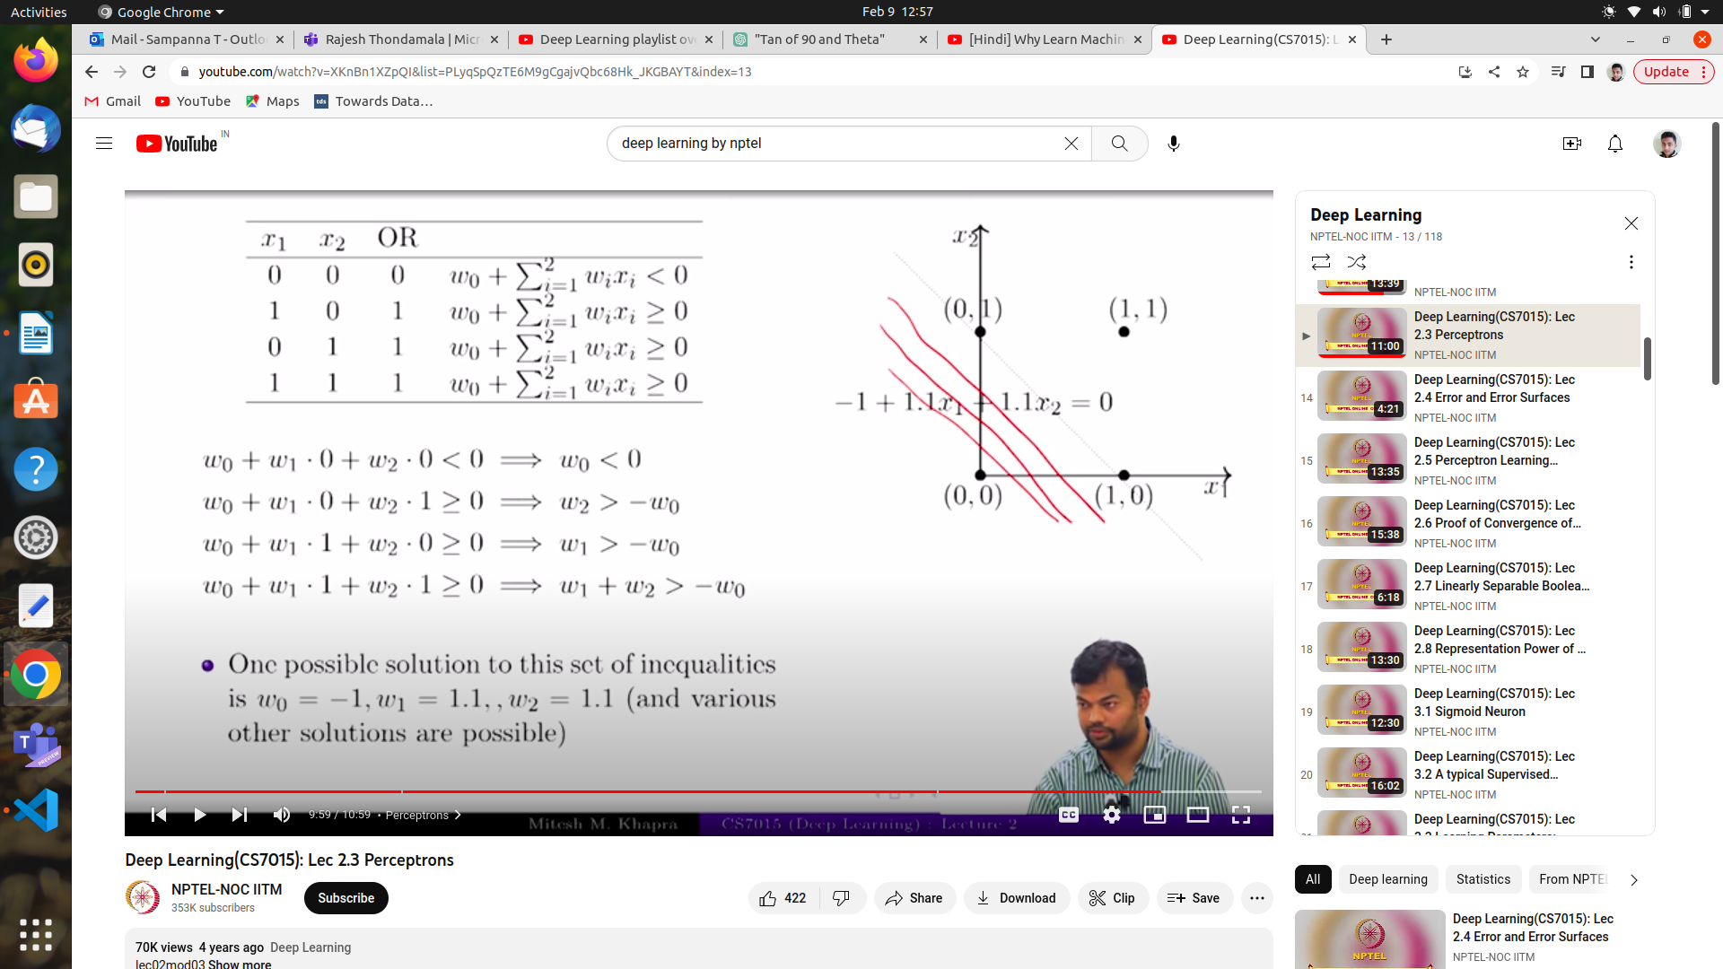

-1+w1(x1)+w2(x2)=0 => w1(x1)+w2(x2) = 1 => find w1,w2 which satisfy x1,x2={[0,0],[0,1],[1,0],[1,1]}

