In folder /Downloads/TI/edgeai-modelmaker
./docker_run.sh #to enter into docker environment
./code/edgeai-modelmaker/cling_2020-11-05_ROOT-ubuntu18.04/share/cling/Jupyter/kernel/TI_C7X_DSP_TRAINING_00.05_INTERACTIVE

exit #to exit from docker environment

[ docker container prune (if multiple containers are present) ]

ESSENTIAL TERMINOLOGIES

Data paths => It’s hardware that supports all required operations like arithmetic operations for ex ALU, registers & internal buses. (In simple words it’s like the path through which data flows)

Functional unit => It’s a part of CPU that performs operations and calculations.

Register file => .(Register banking is used to access multiple different physical registers.)

Streaming engine => Performing computation on data streams. (Ex. Vedio,audio)

LUT(Look up table)/Histogram => Look up table as the name suggests it is used to look at the table data and find the values for the same.
Histogram is like graphical representation of data in the form of bars.

Instruction Set Architecture(ISA) => It’s a part of abstract model of computer that defines how CPU is controlled by the software.
The ISA acts as an interface between the hardware and the software, specifying both what the processor is capable of doing as well as how it gets done.

FEATURES OF C66X

1) Used in vision,imaging,audio,vedio etc.
2) 2 scalar units are present which are connected to L1 cache using 64 bit data paths and themselves are connected by 64bit cross path.
3) Scalar units have functional units that perform addition,shift,load store,multiplication operations.
4) Each scalar unit has 32 32bit registers which can be shared among the scalar units.
5) L1 cache can be divided as L1D(data cache) and L1P(program cache) each of size 32KB.
6) There L2 cache (unified cache) which can be configured as SRAM or cache(size depends on the SOC(system on chip) being used.
7) It supports packed SIMD operations(8,16,32,64 bit) {Instruction to process multiple data with single instruction parallelly)
8) Supports 16/32 bit complex types
9) Supports 128 bit vector types
10) Supports 32 16bit multiply-accumulate per cycle
11) Supports 16 single precision operations per cycle for floating point numbers.(Even double preicsion operation is also supported.)
12) Supports 40 bit operations
13) Supports software pipelining & SPLOOP HW(Not very clear in google as well but rough idea is when multiple iterations in loop happen then parallelly it will be executed.).

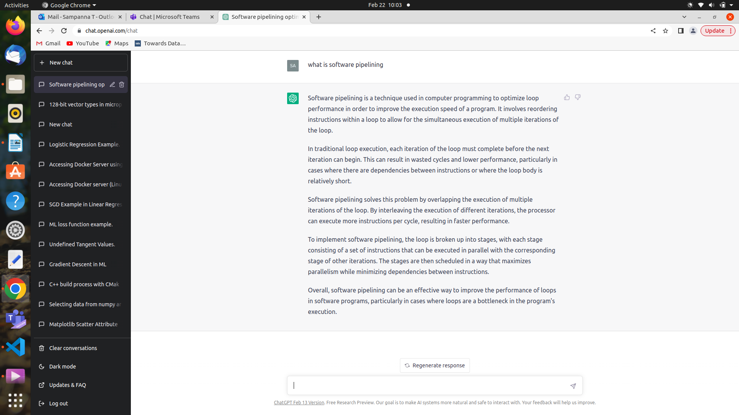

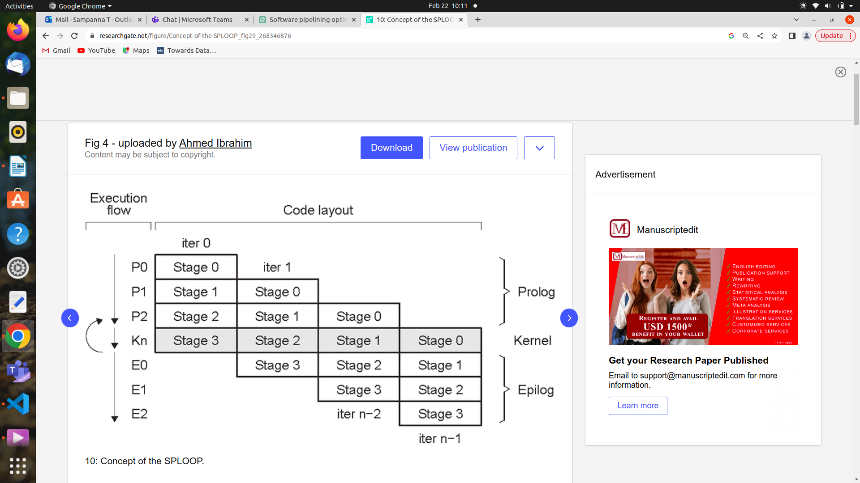
Note :
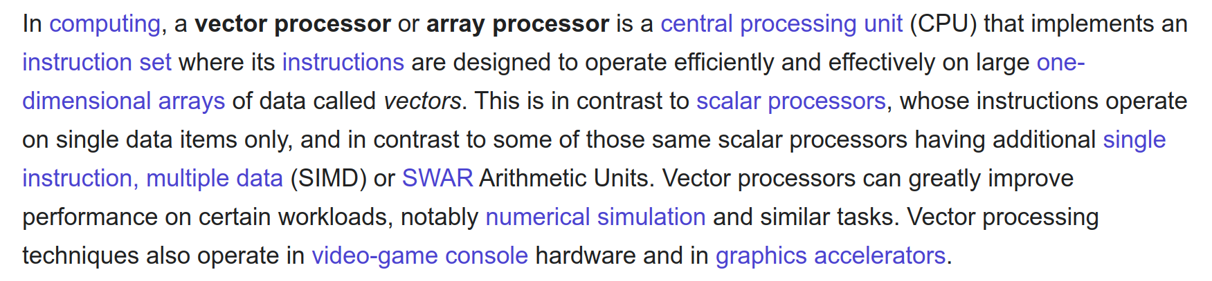

Feature of C7X

1) It is a true 64 bit floating point dsp.
2) It has scalar 64bit data path vector 512bit data path.
3) It has L1 and L2 caches.
4) Streaming engine (SE0,SE1)
5) Lookup table/Histogram present
6) Address geneartors
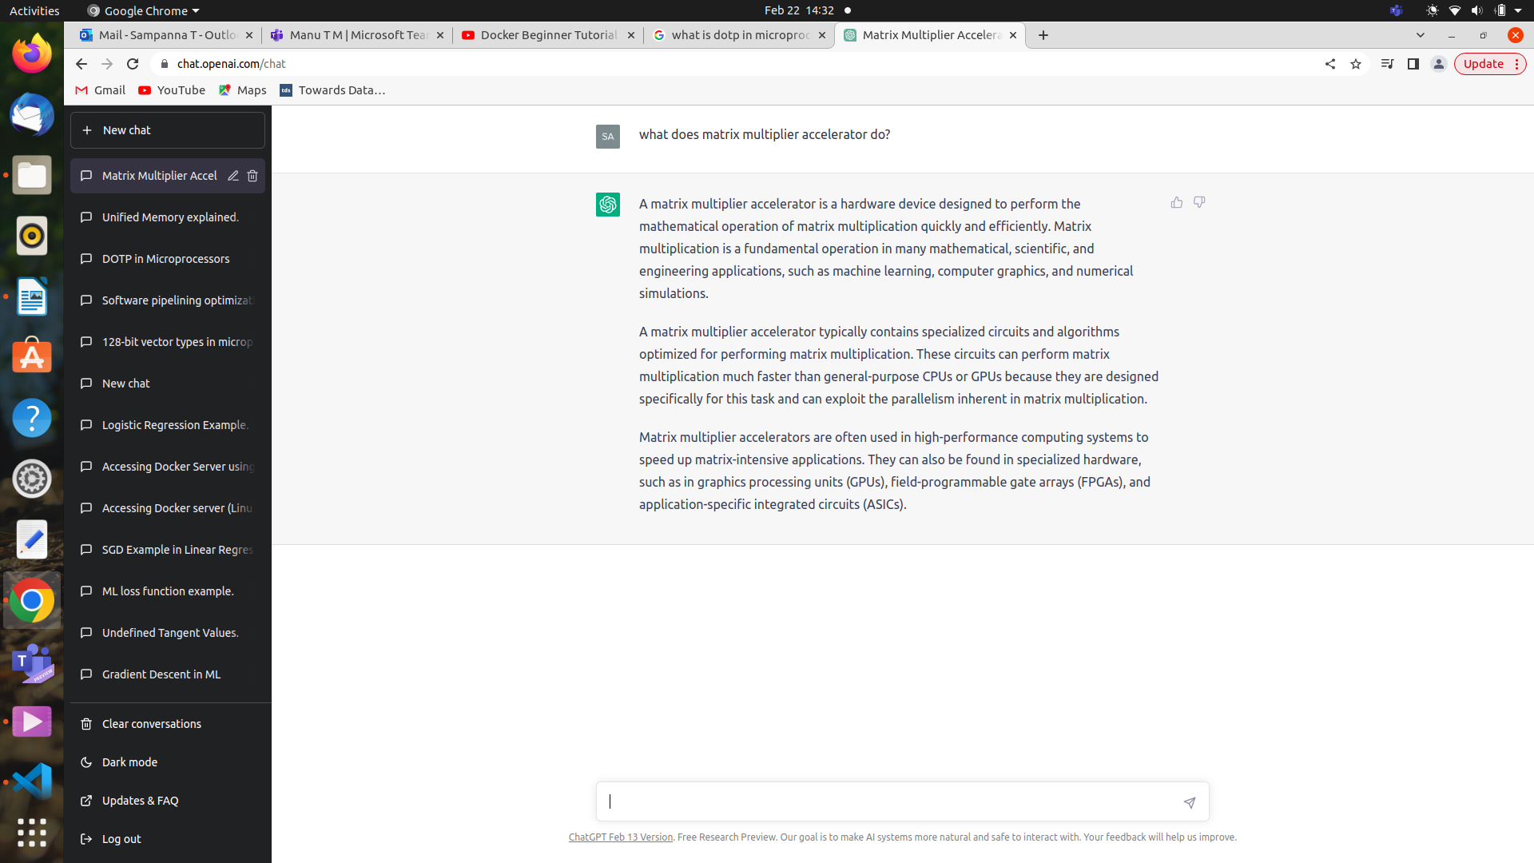
7) Matrix multiply Accelerator (MMA) is also present
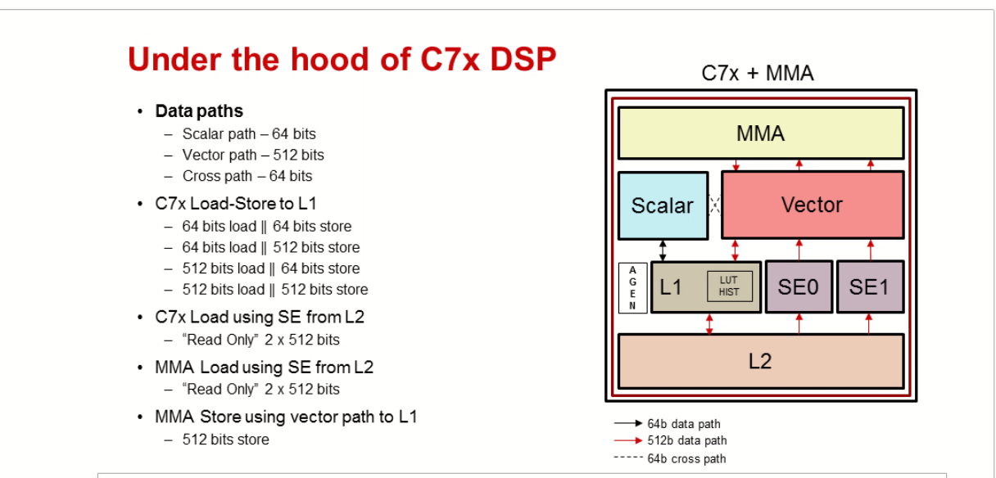
__STRM_TEMPLATE seTemplate;
__STRM_PARAM_3D seParam;
__SE_FLAGS seFlags;
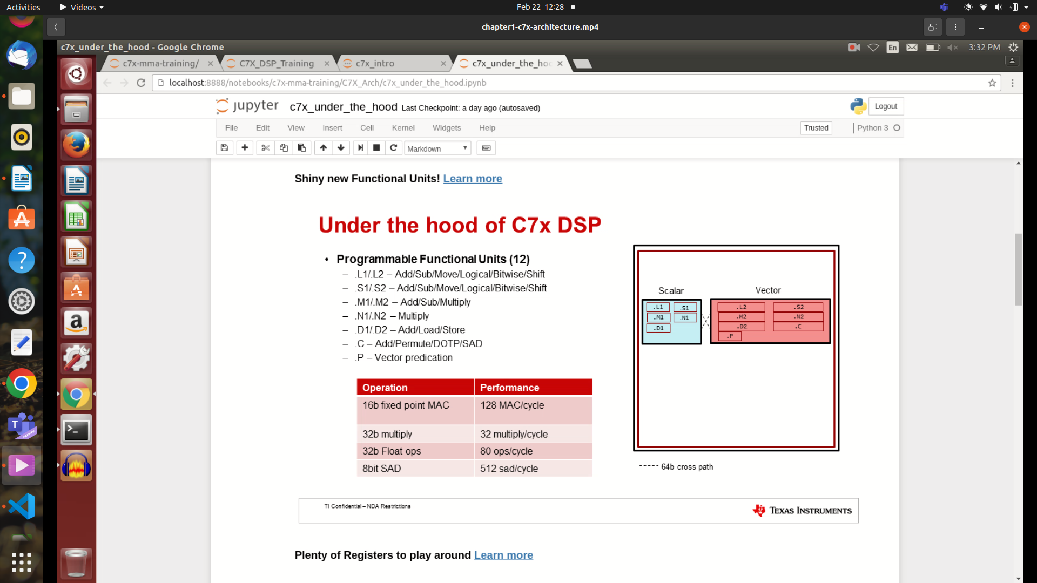
DOTP => means dot product
SAD = > Sum of absolute differences i.e difference between blocks of 2 data usually images or vedio frames.

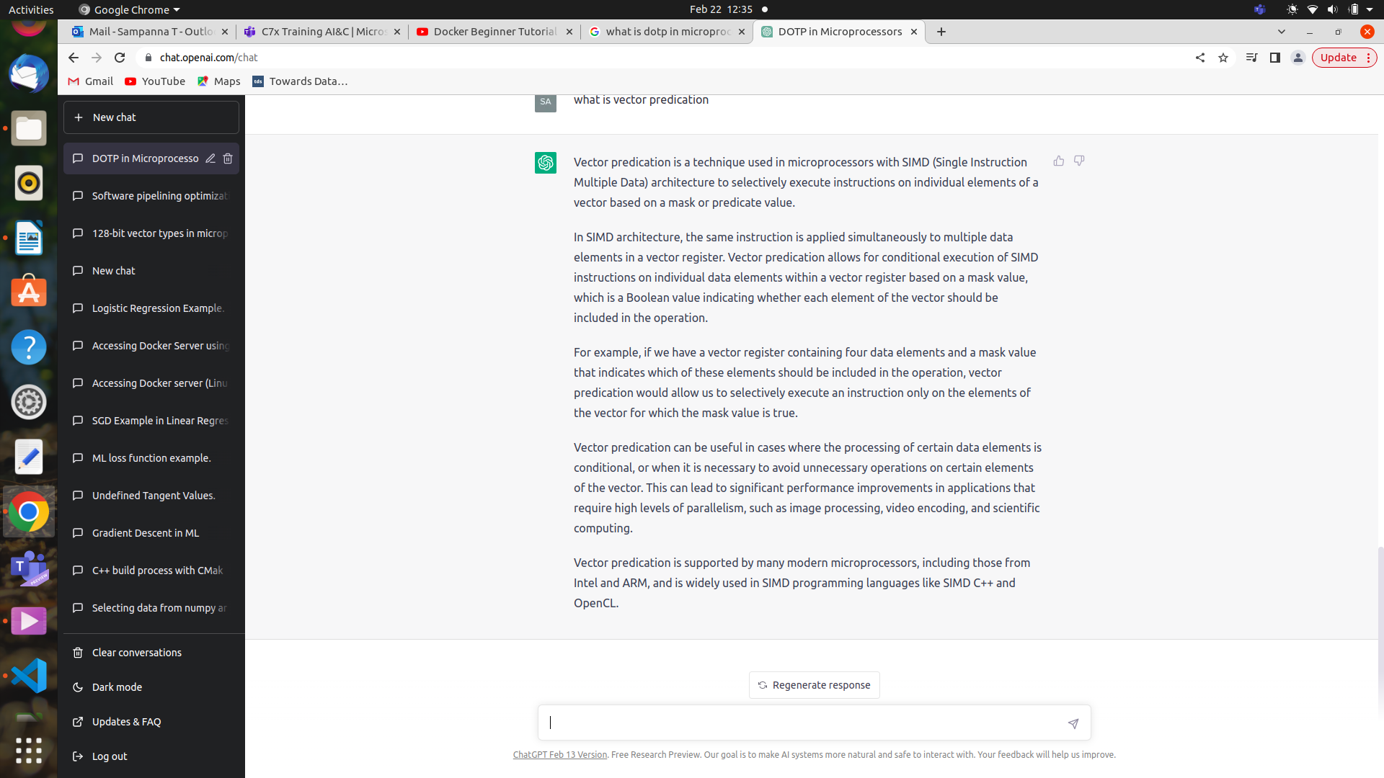

MAC/cyle => Multiply and accumulate per cycle
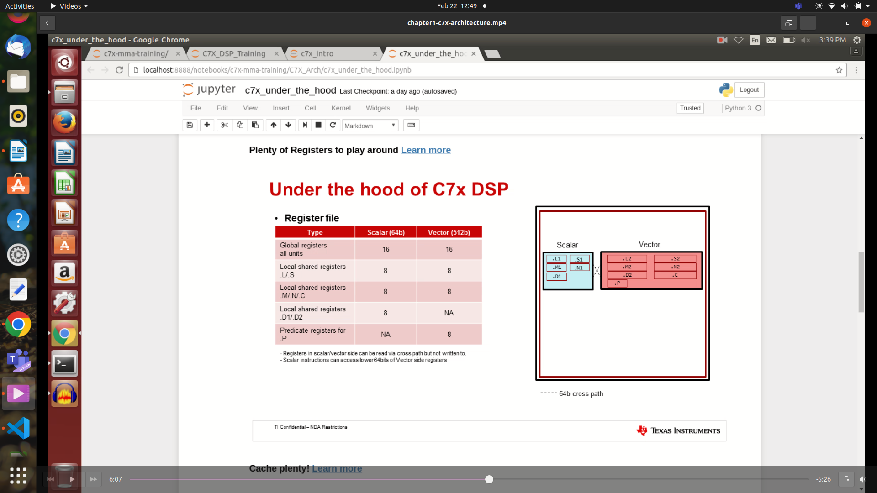

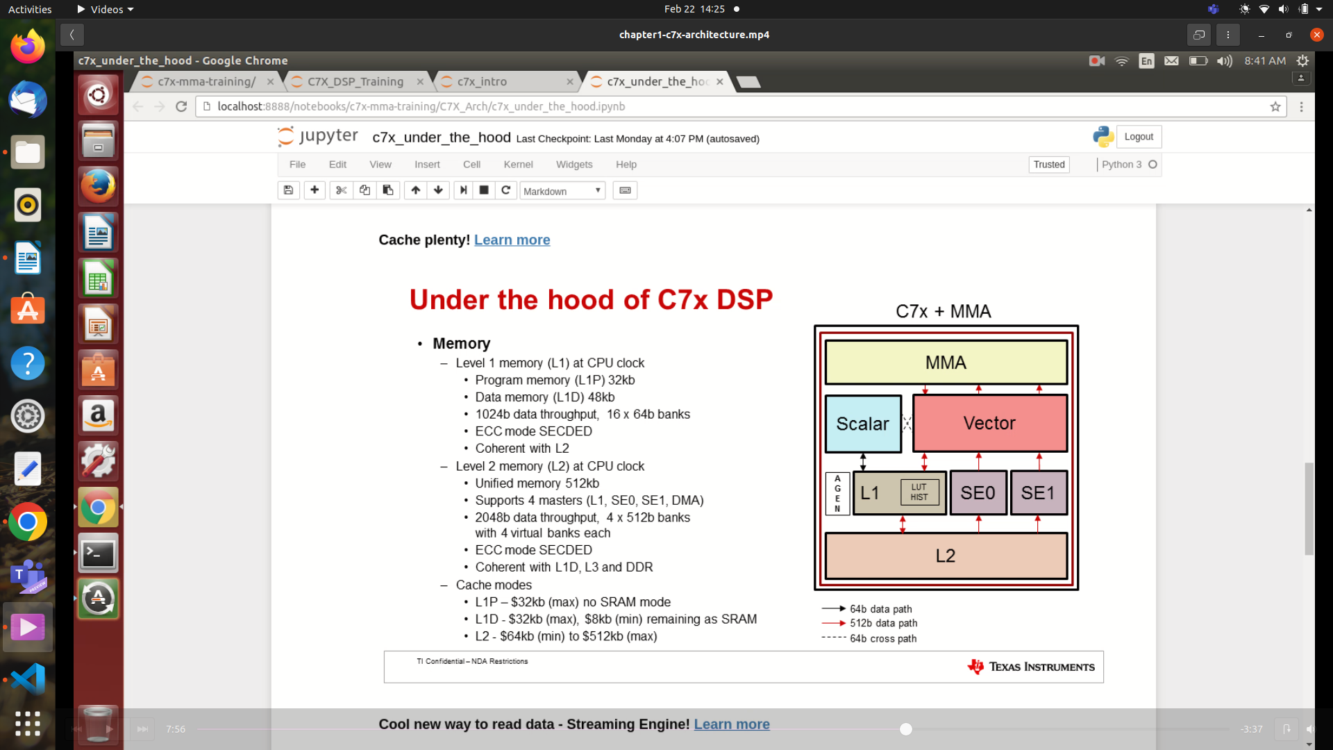
Out of 48kb max of 32kb & min of 8kb can be used as cache and remaining will be used as SRAM.

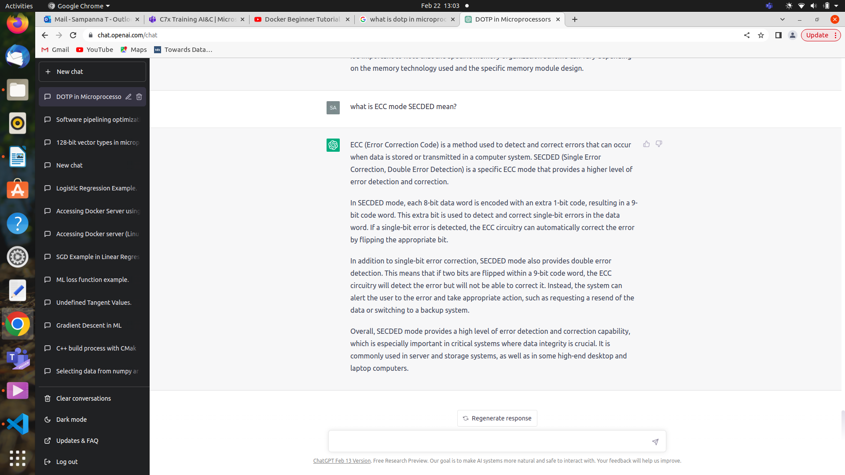

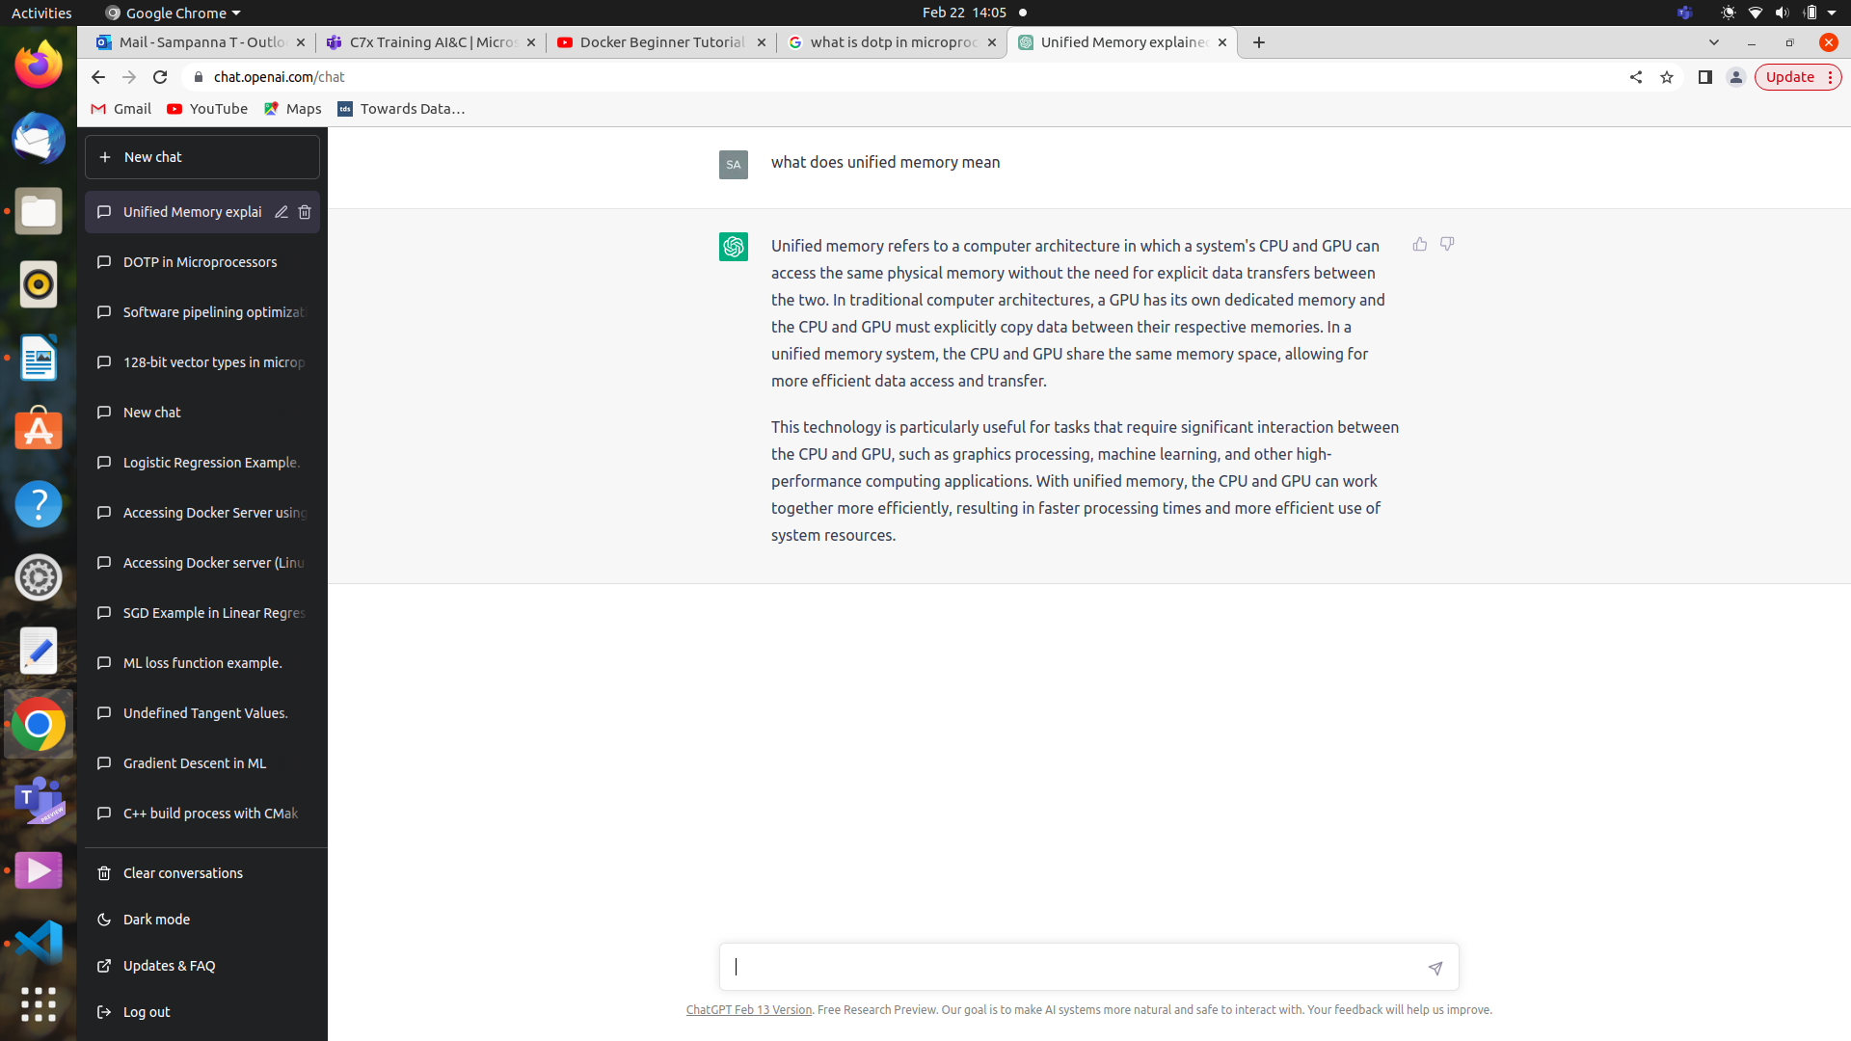

Streaming engine
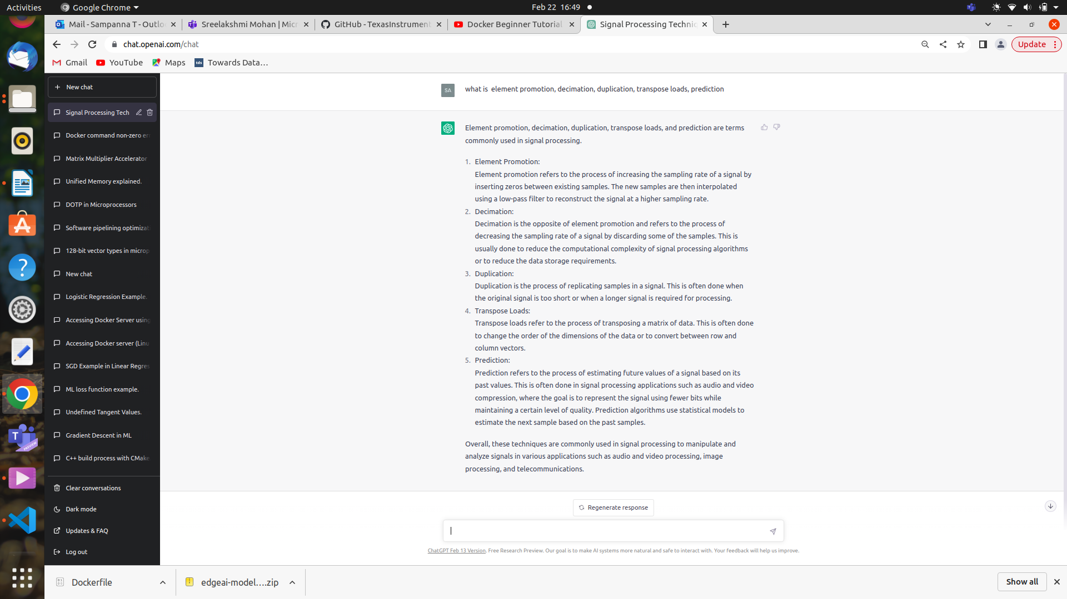
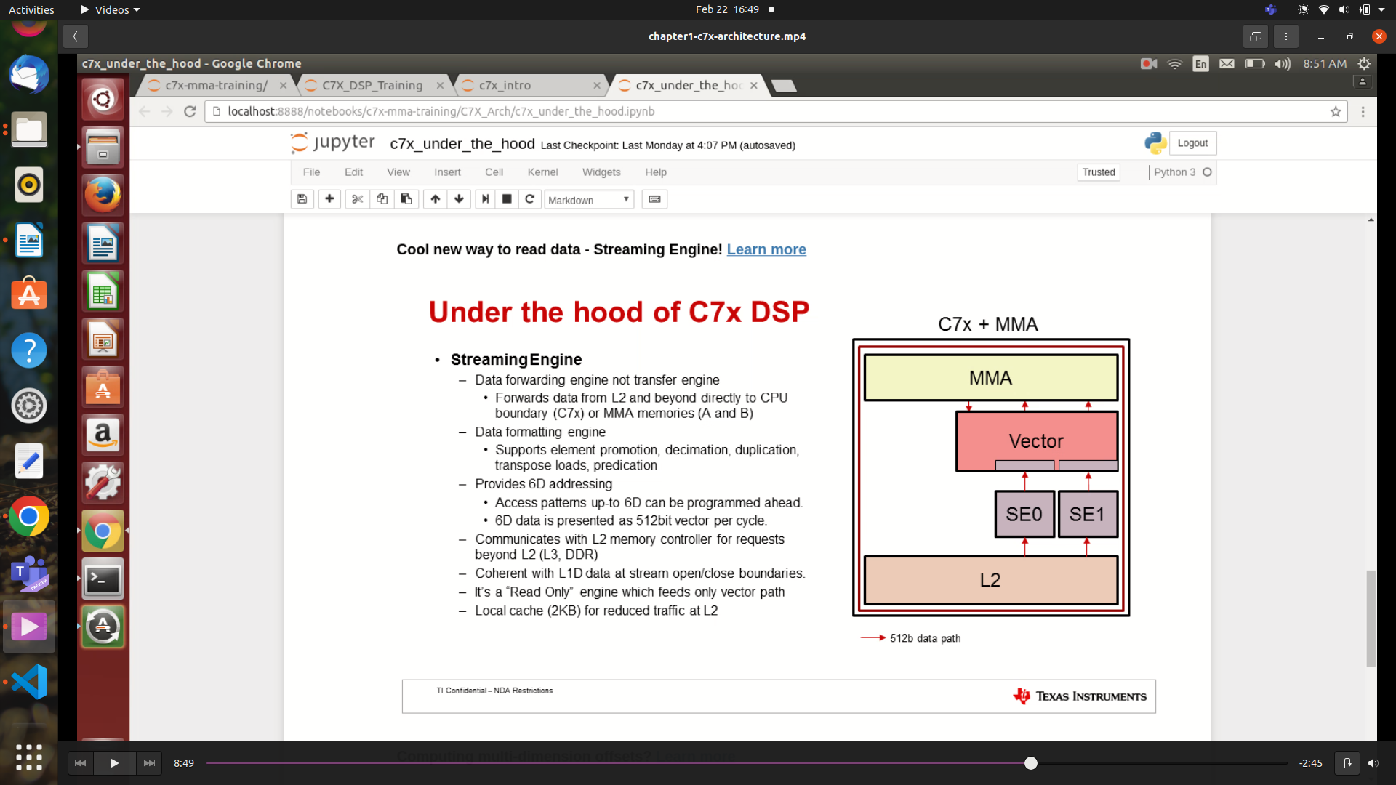
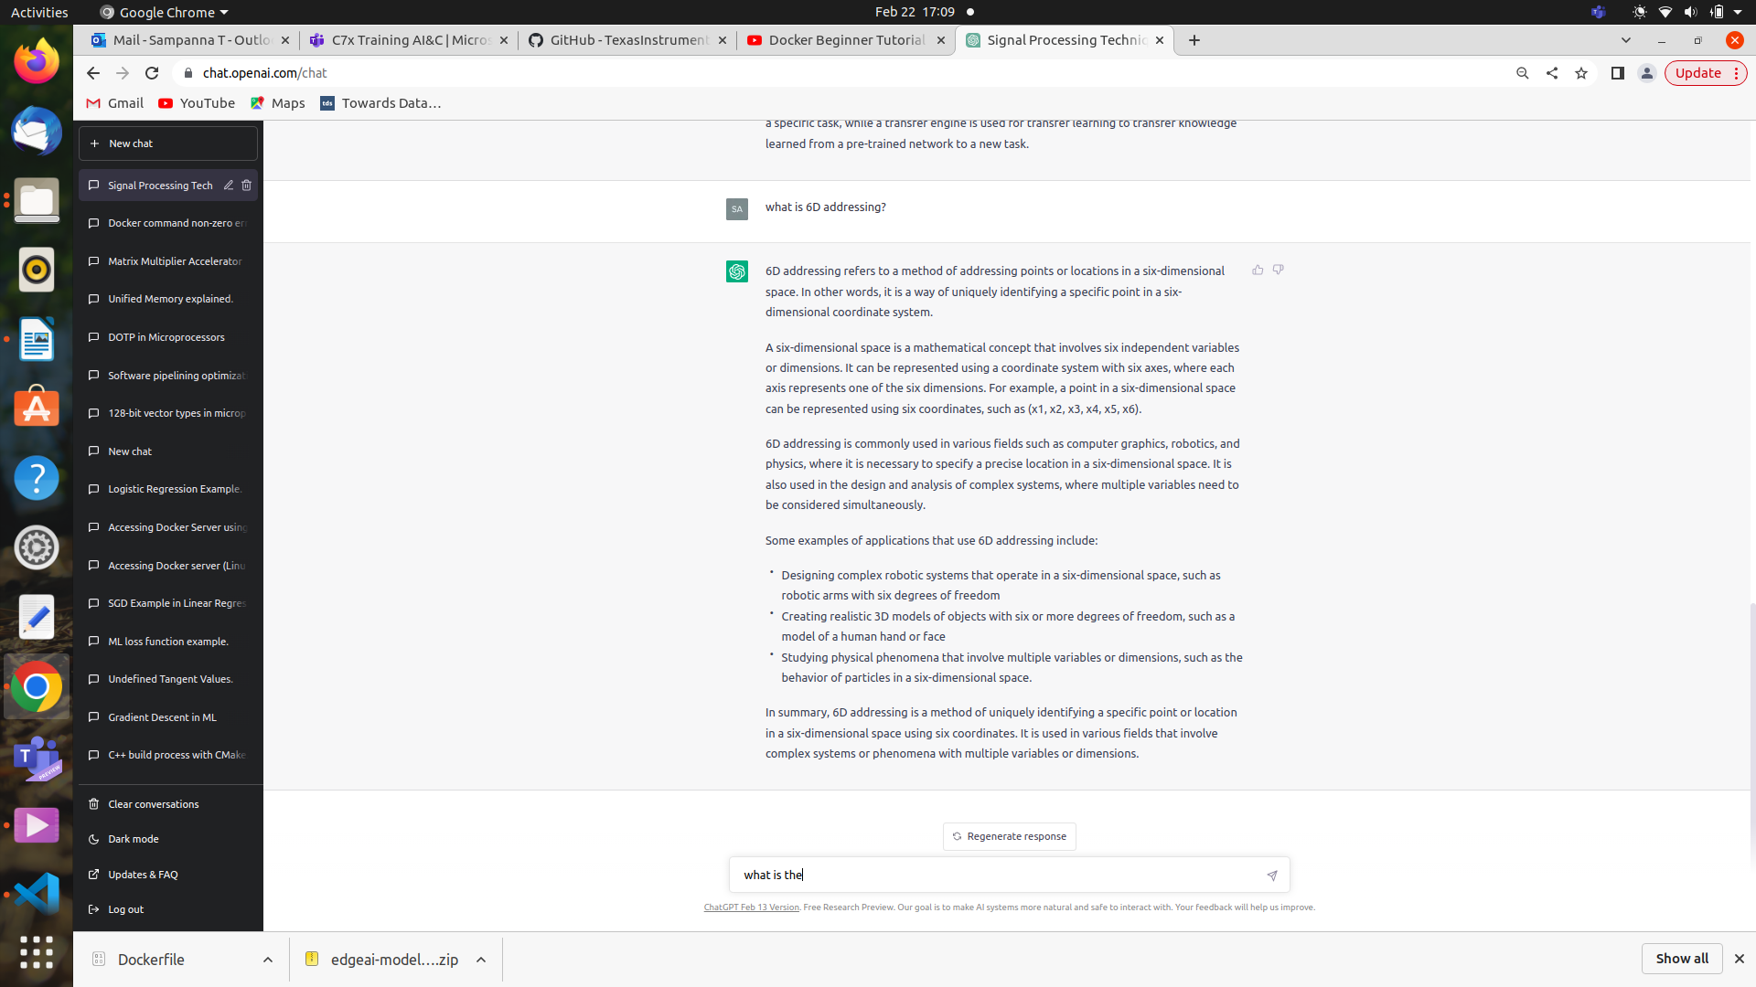
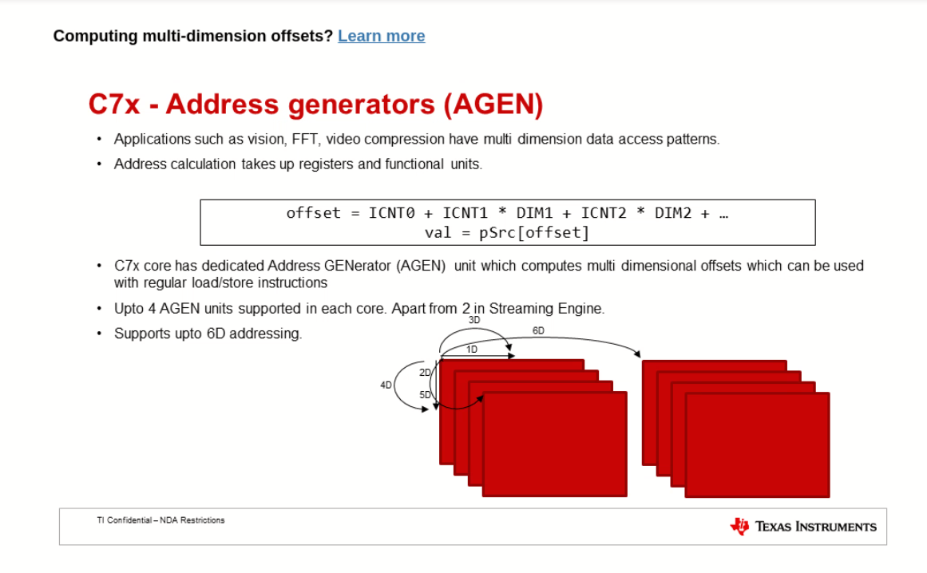

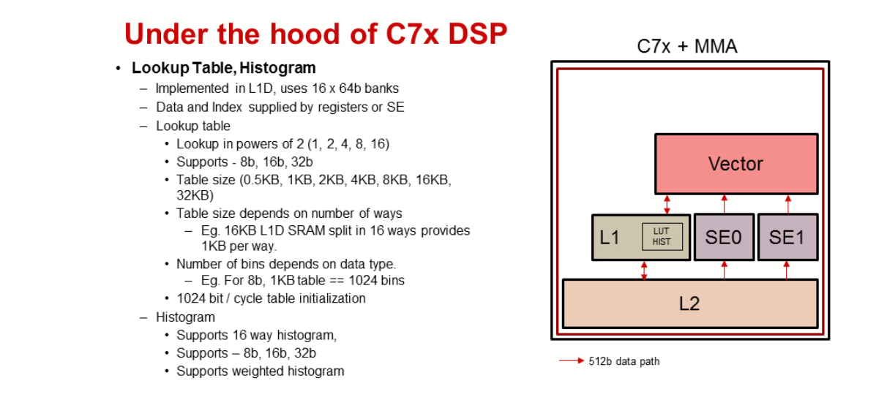

Data types

Can be classified as scalar and vector types.
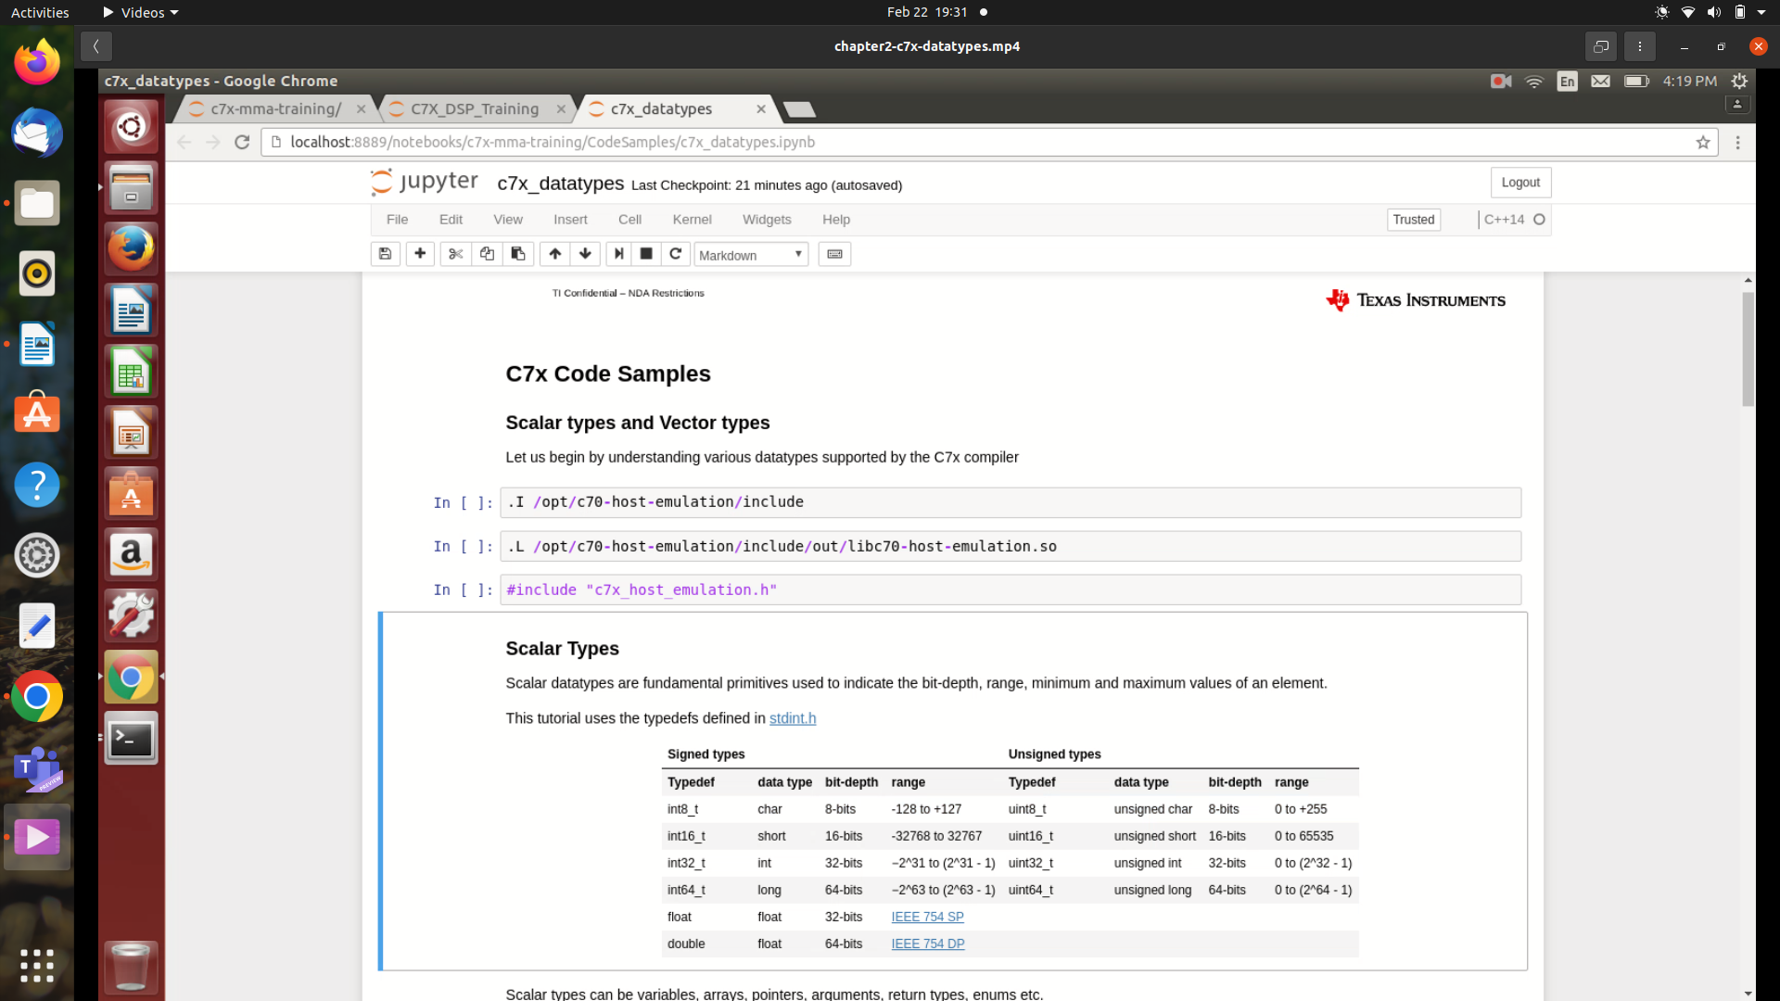
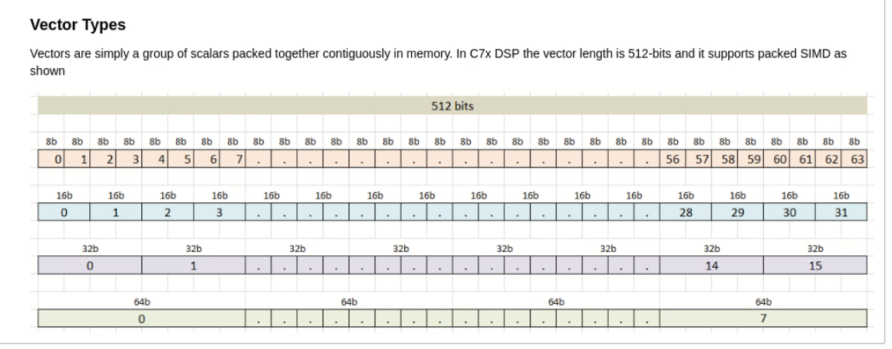
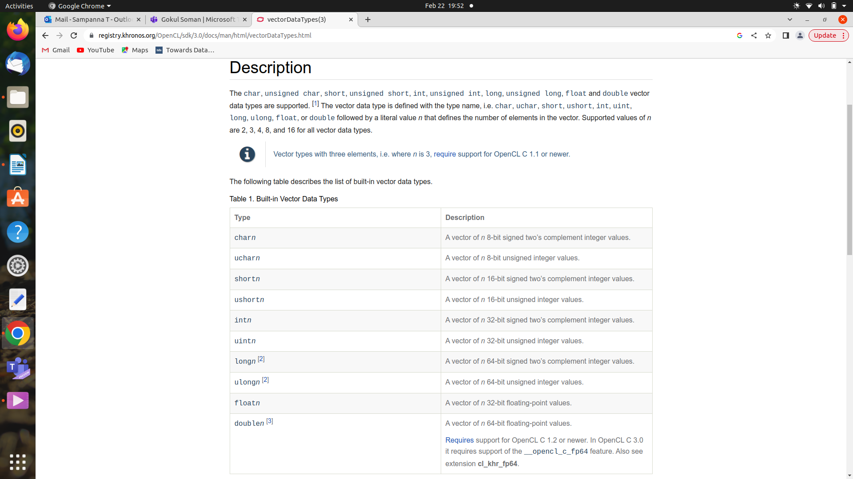

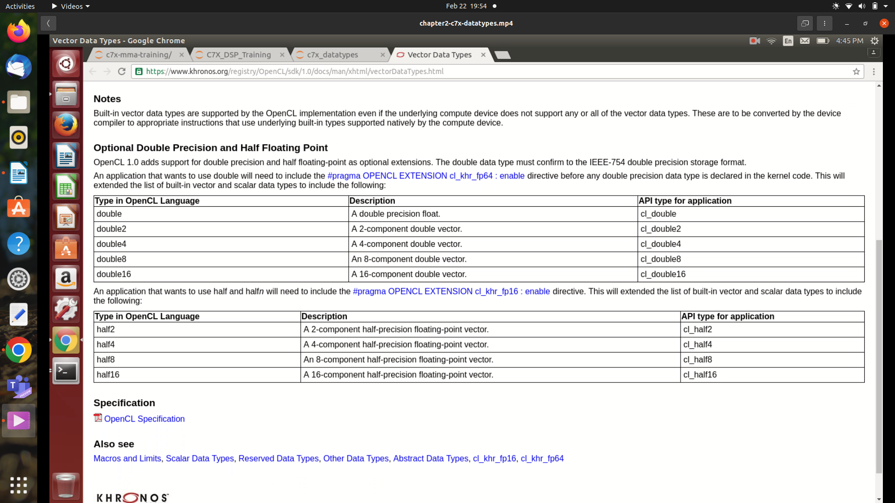
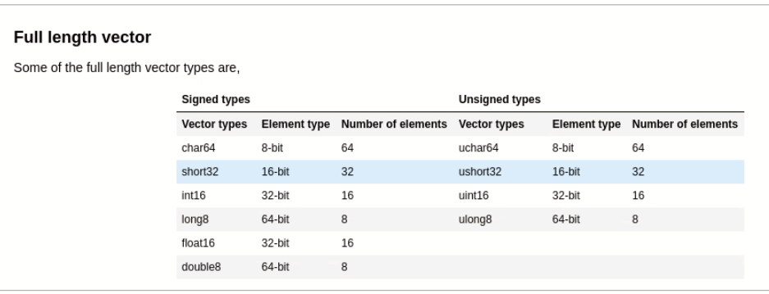
Partial length vector(But still will take 512 bits)

char64,
char32, short32
char16, short16, int16, float16
char8, short8, int8, float8, long8, double8
char4, short4, int4, float4, long4, double4
char2, short2, int2, float2, long2, double2
char1, short1, int, float, long, double

complex types(But still will take 512 bits to hold real,img pairs)

cchar32,
cchar16, cshort16,
cchar8, cshort8, cint8, cfloat8,
cchar4, cshort4, cint4, cfloat4, clong4, cdouble4
cchar2, cshort2, cint2, cfloat2, clong2, cdouble2
cchar1, cshort1, cint,f cfloat, clong, cdouble

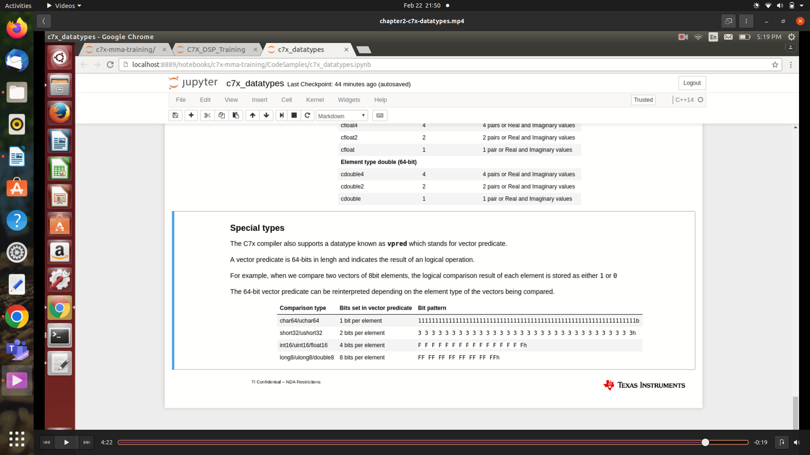
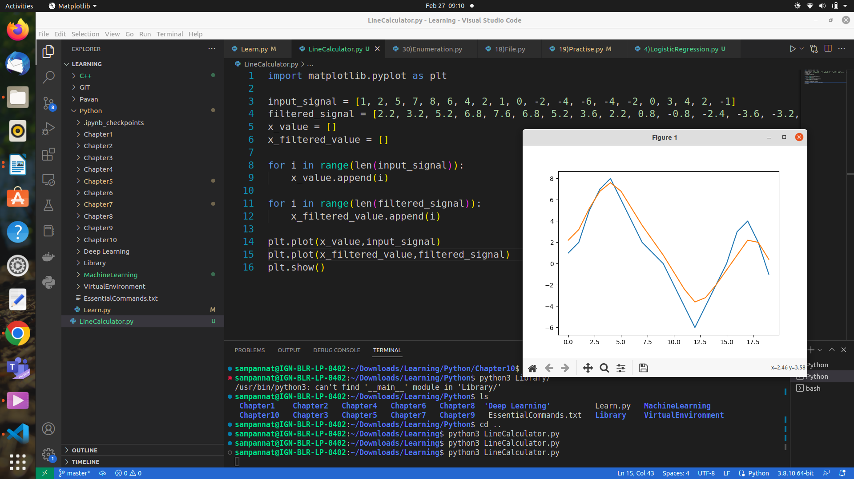
Question
1) Why p block size is 256bytes as only 192bytes are sufficient to hold 2 seTemplate and 1 saTemplate(imp)
2) sa is address gerator but why doesn’t it take base address while opening?(Less imp)
3) how does sa generate address without knowing the size of individual element?
4) Where int8_t [] is created?(imp)
5) How many cycles does stov_ptr(..,..) uses to transfer?(imp)
5) How many cycles does it take to fetch 512bit in transpose as the locations are not contiguous?

Transpose ex

Consider matrix of 16 rows and 8 columns with each element of 8 bits

0 1 2 3 4 5 6 7
8 . . . . . . 15
16 . . . . . . 23
24 . . . . . . 31
32 . . . . . . 39
40 . . . . . . 47
48 . . . . . . 55
56 . . . . . . 63
64 . . . . . . 71
72 . . . . . . 79
80 . . . . . . 87
88 . . . . . . 95
96 . . . . . . 103
104 . . . . . . 111
112 . . . . . . 119
120 . . . . . . 127

For transpose_32 bit mode veclen = 32 (width must be in multiples of 4 & height must be less than or equal to 16)
we get

(0, 1, 2, 3, 8, 9, 10, 11, 16, 17, 18, 19, 24, 25, 26, 27, 32, 33, 34, 35, 40, 41, 42, 43, 48, 49, 50, 51, 56, 57, 58, 59, 0, 0, 0, 0, 0, 0, 0, 0, 0, 0, 0, 0, 0, 0, 0, 0, 0, 0, 0, 0, 0, 0, 0, 0, 0, 0, 0, 0, 0, 0, 0, 0)

(64, 65, 66, 67, 72, 73, 74, 75, 80, 81, 82, 83, 88, 89, 90, 91, 96, 97, 98, 99, 104, 105, 106, 107, 112, 113, 114, 115, 120, 121, 122, 123, 0, 0, 0, 0, 0, 0, 0, 0, 0, 0, 0, 0, 0, 0, 0, 0, 0, 0, 0, 0, 0, 0, 0, 0, 0, 0, 0, 0, 0, 0, 0, 0)

(4, 5, 6, 7, 12, 13, 14, 15, 20, 21, 22, 23, 28, 29, 30, 31, 36, 37, 38, 39, 44, 45, 46, 47, 52, 53, 54, 55, 60, 61, 62, 63, 0, 0, 0, 0, 0, 0, 0, 0, 0, 0, 0, 0, 0, 0, 0, 0, 0, 0, 0, 0, 0, 0, 0, 0, 0, 0, 0, 0, 0, 0, 0, 0)

(68, 69, 70, 71, 76, 77, 78, 79, 84, 85, 86, 87, 92, 93, 94, 95, 100, 101, 102, 103, 108, 109, 110, 111, 116, 117, 118, 119, 124, 125, 126, 127, 0, 0, 0, 0, 0, 0, 0, 0, 0, 0, 0, 0, 0, 0, 0, 0, 0, 0, 0, 0, 0, 0, 0, 0, 0, 0, 0, 0, 0, 0, 0, 0)

(0, 1, 2, 3, 8, 9, 10, 11, 16, 17, 18, 19, 24, 25, 26, 27, 32, 33, 34, 35, 40, 41, 42, 43, 48, 49, 50, 51, 56, 57, 58, 59, 0, 0, 0, 0, 0, 0, 0, 0, 0, 0, 0, 0, 0, 0, 0, 0, 0, 0, 0, 0, 0, 0, 0, 0, 0, 0, 0, 0, 0, 0, 0, 0)
(64, 65, 66, 67, 72, 73, 74, 75, 80, 81, 82, 83, 88, 89, 90, 91, 96, 97, 98, 99, 104, 105, 106, 107, 112, 113, 114, 115, 120, 121, 122, 123, 0, 0, 0, 0, 0, 0, 0, 0, 0, 0, 0, 0, 0, 0, 0, 0, 0, 0, 0, 0, 0, 0, 0, 0, 0, 0, 0, 0, 0, 0, 0, 0)

(4, 5, 6, 7, 12, 13, 14, 15, 20, 21, 22, 23, 28, 29, 30, 31, 36, 37, 38, 39, 44, 45, 46, 47, 52, 53, 54, 55, 60, 61, 62, 63, 0, 0, 0, 0, 0, 0, 0, 0, 0, 0, 0, 0, 0, 0, 0, 0, 0, 0, 0, 0, 0, 0, 0, 0, 0, 0, 0, 0, 0, 0, 0, 0)

(68, 69, 70, 71, 76, 77, 78, 79, 84, 85, 86, 87, 92, 93, 94, 95, 100, 101, 102, 103, 108, 109, 110, 111, 116, 117, 118, 119, 124, 125, 126, 127, 0, 0, 0, 0, 0, 0, 0, 0, 0, 0, 0, 0, 0, 0, 0, 0, 0, 0, 0, 0, 0, 0, 0, 0, 0, 0, 0, 0, 0, 0, 0, 0)

(0, 1, 2, 3, 8, 9, 10, 11, 16, 17, 18, 19, 24, 25, 26, 27, 32, 33, 34, 35, 40, 41, 42, 43, 48, 49, 50, 51, 56, 57, 58, 59, 0, 0, 0, 0, 0, 0, 0, 0, 0, 0, 0, 0, 0, 0, 0, 0, 0, 0, 0, 0, 0, 0, 0, 0, 0, 0, 0, 0, 0, 0, 0, 0)

(64, 65, 66, 67, 72, 73, 74, 75, 80, 81, 82, 83, 88, 89, 90, 91, 96, 97, 98, 99, 104, 105, 106, 107, 112, 113, 114, 115, 120, 121, 122, 123, 0, 0, 0, 0, 0, 0, 0, 0, 0, 0, 0, 0, 0, 0, 0, 0, 0, 0, 0, 0, 0, 0, 0, 0, 0, 0, 0, 0, 0, 0, 0, 0)

(4, 5, 6, 7, 12, 13, 14, 15, 20, 21, 22, 23, 28, 29, 30, 31, 36, 37, 38, 39, 44, 45, 46, 47, 52, 53, 54, 55, 60, 61, 62, 63, 0, 0, 0, 0, 0, 0, 0, 0, 0, 0, 0, 0, 0, 0, 0, 0, 0, 0, 0, 0, 0, 0, 0, 0, 0, 0, 0, 0, 0, 0, 0, 0)

(68, 69, 70, 71, 76, 77, 78, 79, 84, 85, 86, 87, 92, 93, 94, 95, 100, 101, 102, 103, 108, 109, 110, 111, 116, 117, 118, 119, 124, 125, 126, 127, 0, 0, 0, 0, 0, 0, 0, 0, 0, 0, 0, 0, 0, 0, 0, 0, 0, 0, 0, 0, 0, 0, 0, 0, 0, 0, 0, 0, 0, 0, 0, 0)

For transpose_64 bit mode veclen = 32 (width must be in multiples of 4 & height must be less than or equal to 16)
we get

(0, 1, 2, 3, 4, 5, 6, 7, 8, 9, 10, 11, 12, 13, 14, 15, 16, 17, 18, 19, 20, 21, 22, 23, 24, 25, 26, 27, 28, 29, 30, 31, 0, 0, 0, 0, 0, 0, 0, 0, 0, 0, 0, 0, 0, 0, 0, 0, 0, 0, 0, 0, 0, 0, 0, 0, 0, 0, 0, 0, 0, 0, 0, 0)

(32, 33, 34, 35, 36, 37, 38, 39, 40, 41, 42, 43, 44, 45, 46, 47, 48, 49, 50, 51, 52, 53, 54, 55, 56, 57, 58, 59, 60, 61, 62, 63, 0, 0, 0, 0, 0, 0, 0, 0, 0, 0, 0, 0, 0, 0, 0, 0, 0, 0, 0, 0, 0, 0, 0, 0, 0, 0, 0, 0, 0, 0, 0, 0)

(64, 65, 66, 67, 68, 69, 70, 71, 72, 73, 74, 75, 76, 77, 78, 79, 80, 81, 82, 83, 84, 85, 86, 87, 88, 89, 90, 91, 92, 93, 94, 95, 0, 0, 0, 0, 0, 0, 0, 0, 0, 0, 0, 0, 0, 0, 0, 0, 0, 0, 0, 0, 0, 0, 0, 0, 0, 0, 0, 0, 0, 0, 0, 0)

(96, 97, 98, 99, 100, 101, 102, 103, 104, 105, 106, 107, 108, 109, 110, 111, 112, 113, 114, 115, 116, 117, 118, 119, 120, 121, 122, 123, 124, 125, 126, 127, 0, 0, 0, 0, 0, 0, 0, 0, 0, 0, 0, 0, 0, 0, 0, 0, 0, 0, 0, 0, 0, 0, 0, 0, 0, 0, 0, 0, 0, 0, 0, 0)

(0, 1, 2, 3, 4, 5, 6, 7, 8, 9, 10, 11, 12, 13, 14, 15, 16, 17, 18, 19, 20, 21, 22, 23, 24, 25, 26, 27, 28, 29, 30, 31, 0, 0, 0, 0, 0, 0, 0, 0, 0, 0, 0, 0, 0, 0, 0, 0, 0, 0, 0, 0, 0, 0, 0, 0, 0, 0, 0, 0, 0, 0, 0, 0)

(32, 33, 34, 35, 36, 37, 38, 39, 40, 41, 42, 43, 44, 45, 46, 47, 48, 49, 50, 51, 52, 53, 54, 55, 56, 57, 58, 59, 60, 61, 62, 63, 0, 0, 0, 0, 0, 0, 0, 0, 0, 0, 0, 0, 0, 0, 0, 0, 0, 0, 0, 0, 0, 0, 0, 0, 0, 0, 0, 0, 0, 0, 0, 0)

(64, 65, 66, 67, 68, 69, 70, 71, 72, 73, 74, 75, 76, 77, 78, 79, 80, 81, 82, 83, 84, 85, 86, 87, 88, 89, 90, 91, 92, 93, 94, 95, 0, 0, 0, 0, 0, 0, 0, 0, 0, 0, 0, 0, 0, 0, 0, 0, 0, 0, 0, 0, 0, 0, 0, 0, 0, 0, 0, 0, 0, 0, 0, 0)

(96, 97, 98, 99, 100, 101, 102, 103, 104, 105, 106, 107, 108, 109, 110, 111, 112, 113, 114, 115, 116, 117, 118, 119, 120, 121, 122, 123, 124, 125, 126, 127, 0, 0, 0, 0, 0, 0, 0, 0, 0, 0, 0, 0, 0, 0, 0, 0, 0, 0, 0, 0, 0, 0, 0, 0, 0, 0, 0, 0, 0, 0, 0, 0)

(0, 1, 2, 3, 4, 5, 6, 7, 8, 9, 10, 11, 12, 13, 14, 15, 16, 17, 18, 19, 20, 21, 22, 23, 24, 25, 26, 27, 28, 29, 30, 31, 0, 0, 0, 0, 0, 0, 0, 0, 0, 0, 0, 0, 0, 0, 0, 0, 0, 0, 0, 0, 0, 0, 0, 0, 0, 0, 0, 0, 0, 0, 0, 0)

(32, 33, 34, 35, 36, 37, 38, 39, 40, 41, 42, 43, 44, 45, 46, 47, 48, 49, 50, 51, 52, 53, 54, 55, 56, 57, 58, 59, 60, 61, 62, 63, 0, 0, 0, 0, 0, 0, 0, 0, 0, 0, 0, 0, 0, 0, 0, 0, 0, 0, 0, 0, 0, 0, 0, 0, 0, 0, 0, 0, 0, 0, 0, 0)

(64, 65, 66, 67, 68, 69, 70, 71, 72, 73, 74, 75, 76, 77, 78, 79, 80, 81, 82, 83, 84, 85, 86, 87, 88, 89, 90, 91, 92, 93, 94, 95, 0, 0, 0, 0, 0, 0, 0, 0, 0, 0, 0, 0, 0, 0, 0, 0, 0, 0, 0, 0, 0, 0, 0, 0, 0, 0, 0, 0, 0, 0, 0, 0)

(96, 97, 98, 99, 100, 101, 102, 103, 104, 105, 106, 107, 108, 109, 110, 111, 112, 113, 114, 115, 116, 117, 118, 119, 120, 121, 122, 123, 124, 125, 126, 127, 0, 0, 0, 0, 0, 0, 0, 0, 0, 0, 0, 0, 0, 0, 0, 0, 0, 0, 0, 0, 0, 0, 0, 0, 0, 0, 0, 0, 0, 0, 0, 0)

For transpose_128 bit mode veclen = 32 (width must be in multiples of 4 & height must be less than or equal to 16)
we get

(0, 1, 2, 3, 4, 5, 6, 7, 0, 0, 0, 0, 0, 0, 0, 0, 8, 9, 10, 11, 12, 13, 14, 15, 0, 0, 0, 0, 0, 0, 0, 0, 0, 0, 0, 0, 0, 0, 0, 0, 0, 0, 0, 0, 0, 0, 0, 0, 0, 0, 0, 0, 0, 0, 0, 0, 0, 0, 0, 0, 0, 0, 0, 0)

(16, 17, 18, 19, 20, 21, 22, 23, 0, 0, 0, 0, 0, 0, 0, 0, 24, 25, 26, 27, 28, 29, 30, 31, 0, 0, 0, 0, 0, 0, 0, 0, 0, 0, 0, 0, 0, 0, 0, 0, 0, 0, 0, 0, 0, 0, 0, 0, 0, 0, 0, 0, 0, 0, 0, 0, 0, 0, 0, 0, 0, 0, 0, 0)

(32, 33, 34, 35, 36, 37, 38, 39, 0, 0, 0, 0, 0, 0, 0, 0, 40, 41, 42, 43, 44, 45, 46, 47, 0, 0, 0, 0, 0, 0, 0, 0, 0, 0, 0, 0, 0, 0, 0, 0, 0, 0, 0, 0, 0, 0, 0, 0, 0, 0, 0, 0, 0, 0, 0, 0, 0, 0, 0, 0, 0, 0, 0, 0)

(48, 49, 50, 51, 52, 53, 54, 55, 0, 0, 0, 0, 0, 0, 0, 0, 56, 57, 58, 59, 60, 61, 62, 63, 0, 0, 0, 0, 0, 0, 0, 0, 0, 0, 0, 0, 0, 0, 0, 0, 0, 0, 0, 0, 0, 0, 0, 0, 0, 0, 0, 0, 0, 0, 0, 0, 0, 0, 0, 0, 0, 0, 0, 0)
(64, 65, 66, 67, 68, 69, 70, 71, 0, 0, 0, 0, 0, 0, 0, 0, 72, 73, 74, 75, 76, 77, 78, 79, 0, 0, 0, 0, 0, 0, 0, 0, 0, 0, 0, 0, 0, 0, 0, 0, 0, 0, 0, 0, 0, 0, 0, 0, 0, 0, 0, 0, 0, 0, 0, 0, 0, 0, 0, 0, 0, 0, 0, 0)

(80, 81, 82, 83, 84, 85, 86, 87, 0, 0, 0, 0, 0, 0, 0, 0, 88, 89, 90, 91, 92, 93, 94, 95, 0, 0, 0, 0, 0, 0, 0, 0, 0, 0, 0, 0, 0, 0, 0, 0, 0, 0, 0, 0, 0, 0, 0, 0, 0, 0, 0, 0, 0, 0, 0, 0, 0, 0, 0, 0, 0, 0, 0, 0)

(96, 97, 98, 99, 100, 101, 102, 103, 0, 0, 0, 0, 0, 0, 0, 0, 104, 105, 106, 107, 108, 109, 110, 111, 0, 0, 0, 0, 0, 0, 0, 0, 0, 0, 0, 0, 0, 0, 0, 0, 0, 0, 0, 0, 0, 0, 0, 0, 0, 0, 0, 0, 0, 0, 0, 0, 0, 0, 0, 0, 0, 0, 0, 0)

(112, 113, 114, 115, 116, 117, 118, 119, 0, 0, 0, 0, 0, 0, 0, 0, 120, 121, 122, 123, 124, 125, 126, 127, 0, 0, 0, 0, 0, 0, 0, 0, 0, 0, 0, 0, 0, 0, 0, 0, 0, 0, 0, 0, 0, 0, 0, 0, 0, 0, 0, 0, 0, 0, 0, 0, 0, 0, 0, 0, 0, 0, 0, 0)

(0, 1, 2, 3, 4, 5, 6, 7, 0, 0, 0, 0, 0, 0, 0, 0, 8, 9, 10, 11, 12, 13, 14, 15, 0, 0, 0, 0, 0, 0, 0, 0, 0, 0, 0, 0, 0, 0, 0, 0, 0, 0, 0, 0, 0, 0, 0, 0, 0, 0, 0, 0, 0, 0, 0, 0, 0, 0, 0, 0, 0, 0, 0, 0)

(16, 17, 18, 19, 20, 21, 22, 23, 0, 0, 0, 0, 0, 0, 0, 0, 24, 25, 26, 27, 28, 29, 30, 31, 0, 0, 0, 0, 0, 0, 0, 0, 0, 0, 0, 0, 0, 0, 0, 0, 0, 0, 0, 0, 0, 0, 0, 0, 0, 0, 0, 0, 0, 0, 0, 0, 0, 0, 0, 0, 0, 0, 0, 0)

(32, 33, 34, 35, 36, 37, 38, 39, 0, 0, 0, 0, 0, 0, 0, 0, 40, 41, 42, 43, 44, 45, 46, 47, 0, 0, 0, 0, 0, 0, 0, 0, 0, 0, 0, 0, 0, 0, 0, 0, 0, 0, 0, 0, 0, 0, 0, 0, 0, 0, 0, 0, 0, 0, 0, 0, 0, 0, 0, 0, 0, 0, 0, 0)

(48, 49, 50, 51, 52, 53, 54, 55, 0, 0, 0, 0, 0, 0, 0, 0, 56, 57, 58, 59, 60, 61, 62, 63, 0, 0, 0, 0, 0, 0, 0, 0, 0, 0, 0, 0, 0, 0, 0, 0, 0, 0, 0, 0, 0, 0, 0, 0, 0, 0, 0, 0, 0, 0, 0, 0, 0, 0, 0, 0, 0, 0, 0, 0)

(64, 65, 66, 67, 68, 69, 70, 71, 0, 0, 0, 0, 0, 0, 0, 0, 72, 73, 74, 75, 76, 77, 78, 79, 0, 0, 0, 0, 0, 0, 0, 0, 0, 0, 0, 0, 0, 0, 0, 0, 0, 0, 0, 0, 0, 0, 0, 0, 0, 0, 0, 0, 0, 0, 0, 0, 0, 0, 0, 0, 0, 0, 0, 0)

(80, 81, 82, 83, 84, 85, 86, 87, 0, 0, 0, 0, 0, 0, 0, 0, 88, 89, 90, 91, 92, 93, 94, 95, 0, 0, 0, 0, 0, 0, 0, 0, 0, 0, 0, 0, 0, 0, 0, 0, 0, 0, 0, 0, 0, 0, 0, 0, 0, 0, 0, 0, 0, 0, 0, 0, 0, 0, 0, 0, 0, 0, 0, 0)

(96, 97, 98, 99, 100, 101, 102, 103, 0, 0, 0, 0, 0, 0, 0, 0, 104, 105, 106, 107, 108, 109, 110, 111, 0, 0, 0, 0, 0, 0, 0, 0, 0, 0, 0, 0, 0, 0, 0, 0, 0, 0, 0, 0, 0, 0, 0, 0, 0, 0, 0, 0, 0, 0, 0, 0, 0, 0, 0, 0, 0, 0, 0, 0)

(112, 113, 114, 115, 116, 117, 118, 119, 0, 0, 0, 0, 0, 0, 0, 0, 120, 121, 122, 123, 124, 125, 126, 127, 0, 0, 0, 0, 0, 0, 0, 0, 0, 0, 0, 0, 0, 0, 0, 0, 0, 0, 0, 0, 0, 0, 0, 0, 0, 0, 0, 0, 0, 0, 0, 0, 0, 0, 0, 0, 0, 0, 0, 0)

(0, 1, 2, 3, 4, 5, 6, 7, 0, 0, 0, 0, 0, 0, 0, 0, 8, 9, 10, 11, 12, 13, 14, 15, 0, 0, 0, 0, 0, 0, 0, 0, 0, 0, 0, 0, 0, 0, 0, 0, 0, 0, 0, 0, 0, 0, 0, 0, 0, 0, 0, 0, 0, 0, 0, 0, 0, 0, 0, 0, 0, 0, 0, 0)

(16, 17, 18, 19, 20, 21, 22, 23, 0, 0, 0, 0, 0, 0, 0, 0, 24, 25, 26, 27, 28, 29, 30, 31, 0, 0, 0, 0, 0, 0, 0, 0, 0, 0, 0, 0, 0, 0, 0, 0, 0, 0, 0, 0, 0, 0, 0, 0, 0, 0, 0, 0, 0, 0, 0, 0, 0, 0, 0, 0, 0, 0, 0, 0)

(32, 33, 34, 35, 36, 37, 38, 39, 0, 0, 0, 0, 0, 0, 0, 0, 40, 41, 42, 43, 44, 45, 46, 47, 0, 0, 0, 0, 0, 0, 0, 0, 0, 0, 0, 0, 0, 0, 0, 0, 0, 0, 0, 0, 0, 0, 0, 0, 0, 0, 0, 0, 0, 0, 0, 0, 0, 0, 0, 0, 0, 0, 0, 0)

(48, 49, 50, 51, 52, 53, 54, 55, 0, 0, 0, 0, 0, 0, 0, 0, 56, 57, 58, 59, 60, 61, 62, 63, 0, 0, 0, 0, 0, 0, 0, 0, 0, 0, 0, 0, 0, 0, 0, 0, 0, 0, 0, 0, 0, 0, 0, 0, 0, 0, 0, 0, 0, 0, 0, 0, 0, 0, 0, 0, 0, 0, 0, 0)

(64, 65, 66, 67, 68, 69, 70, 71, 0, 0, 0, 0, 0, 0, 0, 0, 72, 73, 74, 75, 76, 77, 78, 79, 0, 0, 0, 0, 0, 0, 0, 0, 0, 0, 0, 0, 0, 0, 0, 0, 0, 0, 0, 0, 0, 0, 0, 0, 0, 0, 0, 0, 0, 0, 0, 0, 0, 0, 0, 0, 0, 0, 0, 0)

(80, 81, 82, 83, 84, 85, 86, 87, 0, 0, 0, 0, 0, 0, 0, 0, 88, 89, 90, 91, 92, 93, 94, 95, 0, 0, 0, 0, 0, 0, 0, 0, 0, 0, 0, 0, 0, 0, 0, 0, 0, 0, 0, 0, 0, 0, 0, 0, 0, 0, 0, 0, 0, 0, 0, 0, 0, 0, 0, 0, 0, 0, 0, 0)

(96, 97, 98, 99, 100, 101, 102, 103, 0, 0, 0, 0, 0, 0, 0, 0, 104, 105, 106, 107, 108, 109, 110, 111, 0, 0, 0, 0, 0, 0, 0, 0, 0, 0, 0, 0, 0, 0, 0, 0, 0, 0, 0, 0, 0, 0, 0, 0, 0, 0, 0, 0, 0, 0, 0, 0, 0, 0, 0, 0, 0, 0, 0, 0)

(112, 113, 114, 115, 116, 117, 118, 119, 0, 0, 0, 0, 0, 0, 0, 0, 120, 121, 122, 123, 124, 125, 126, 127, 0, 0, 0, 0, 0, 0, 0, 0, 0, 0, 0, 0, 0, 0, 0, 0, 0, 0, 0, 0, 0, 0, 0, 0, 0, 0, 0, 0, 0, 0, 0, 0, 0, 0, 0, 0, 0, 0, 0, 0)

For transpose_256 bit mode veclen = 32 (width must be in multiples of 16 & height must be less than or equal to 16)
we get

not supported because width is not in multiples of 16

VFIR =>
Accepts 16bit input and 16bit coefficient values in specific format and produces 32 bit result.
First 32 elements of SE0 is used
First 4 elements of SE1 is used
and this continues.

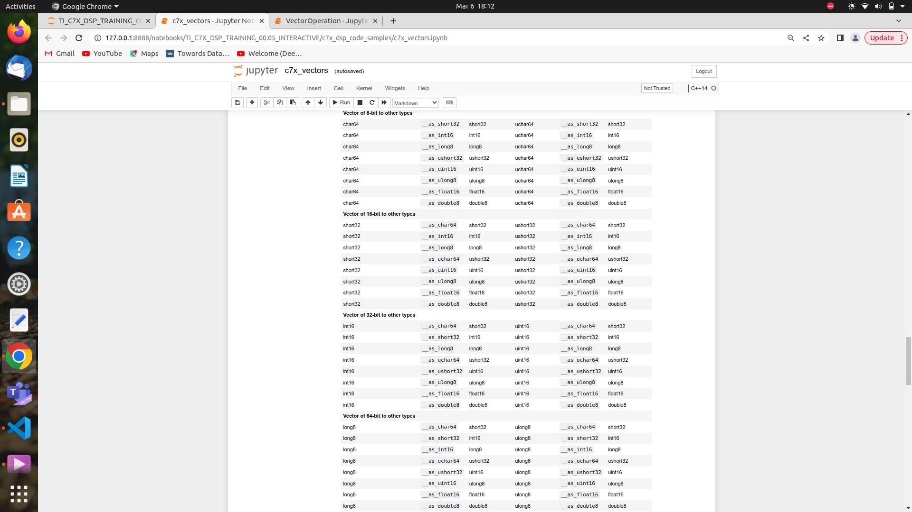

SE will pad 0’s at the end if the width is not a multiple of veclen by default for dimension0.

But SA can’t know this, hence vector predicate is used to pad 0’s in case width is less than veclen instead of accessing next elements.

As shown above if we consdier int16 then if all elements are present then it shows FFFF FFFF FFFF FFFF where each F represents for 1 int(32bit) element.

Possible operations =>

__abs(vect) => will take absolute value of all elements of the vector

vA+vB => will add every single element of A with respective element of B

vA&vB => will & every single element of A with respective element of B

__and(vPred1,vPred2) => same as above but also applicable for vector predicates

__andn(vA,vB) => same as above but with vA being 1’s complimented

__apply_sign(vA,vB) => apply same sign as vB to vA
ex: vA = {5,2,1,5,4,3} vB = {1,-2,0,0,5,-3} output = {5,-2,1,5,4,-3}

__rhadd(vA,vB) => gives avg ceil value

__hadd(vA,vB) => gives avg floor value

__popcount(vA) => counts number of bits set in each elements of vA

__popcount_int(vPred) => counts number of F’s in vPred

__deal_bit(vA) => considers alternative bytes

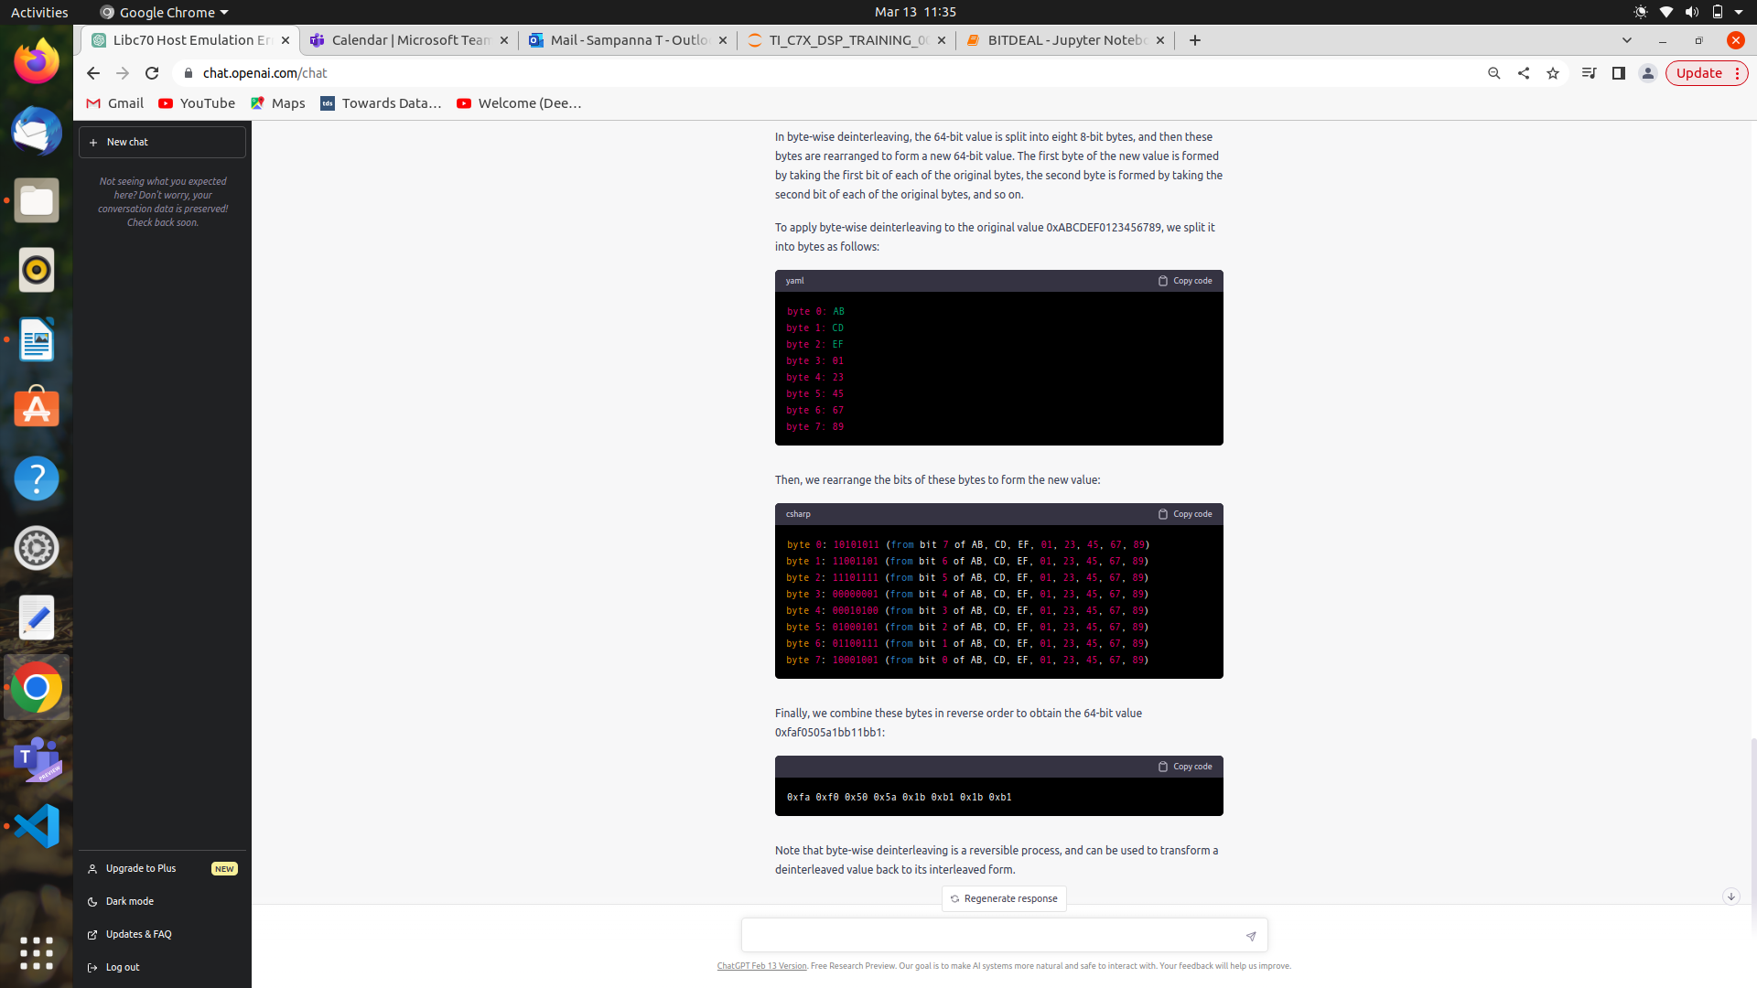

__bit_reverse(vA) => reverses the bits completely

__shuffle_bit(vA) => not understood

__bit_transpose(vA) =>not understood

