Intro

AI->ML->DL

AI =>

ML =>
Supervised =>
1)Regression => o/p is continuous values Ex:time series values
2)Classification => o/p is fixed no. of categories
a)Binary Classification => Ex: Spam or not
b)Multiclass classification => Ex: Cat or dog or tiger.
c)Multilabel => Ex: KGF movie is not romantic,has action,has graphics etc.

Unsupervised =>
1) Clustering => Ex: categorize people

Semi supervised =>
Continuously learning and making mistake and learning again.
Ex: Youtube recommendation.

DL =>
ANN(Artificial Neural Network) => Tabular data
CNN(Convolution Neural Network) => Images, vedios
Ex: Image classification,Object detection, object segmentation, tracking etc.
RNN(Recurrent Neural Network) => Text, time series, sequential data.

How does a neural network look like?
=> contains input layer, hidden layer and output layer.
While passing through the input layer weights will be multiplied and the added result will be passed to next layer.

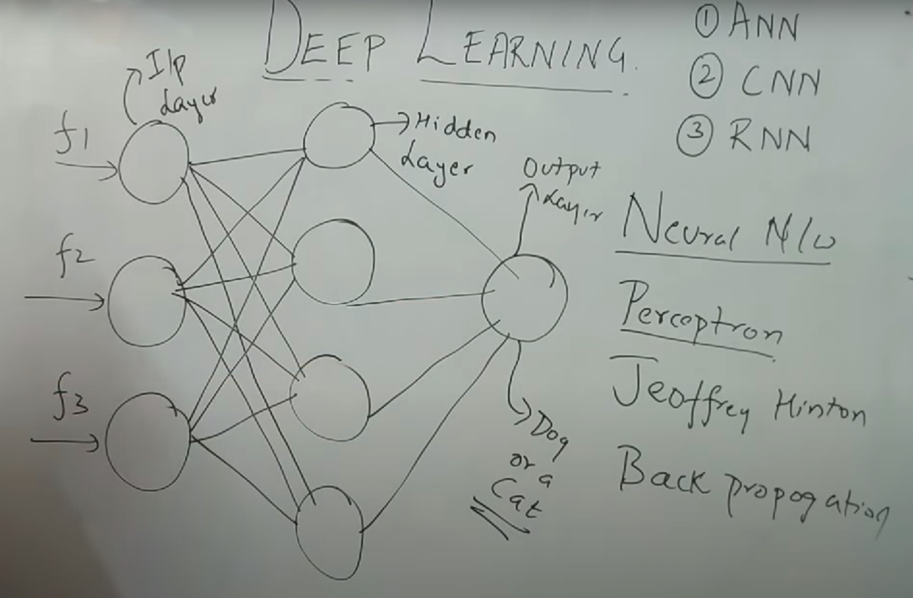

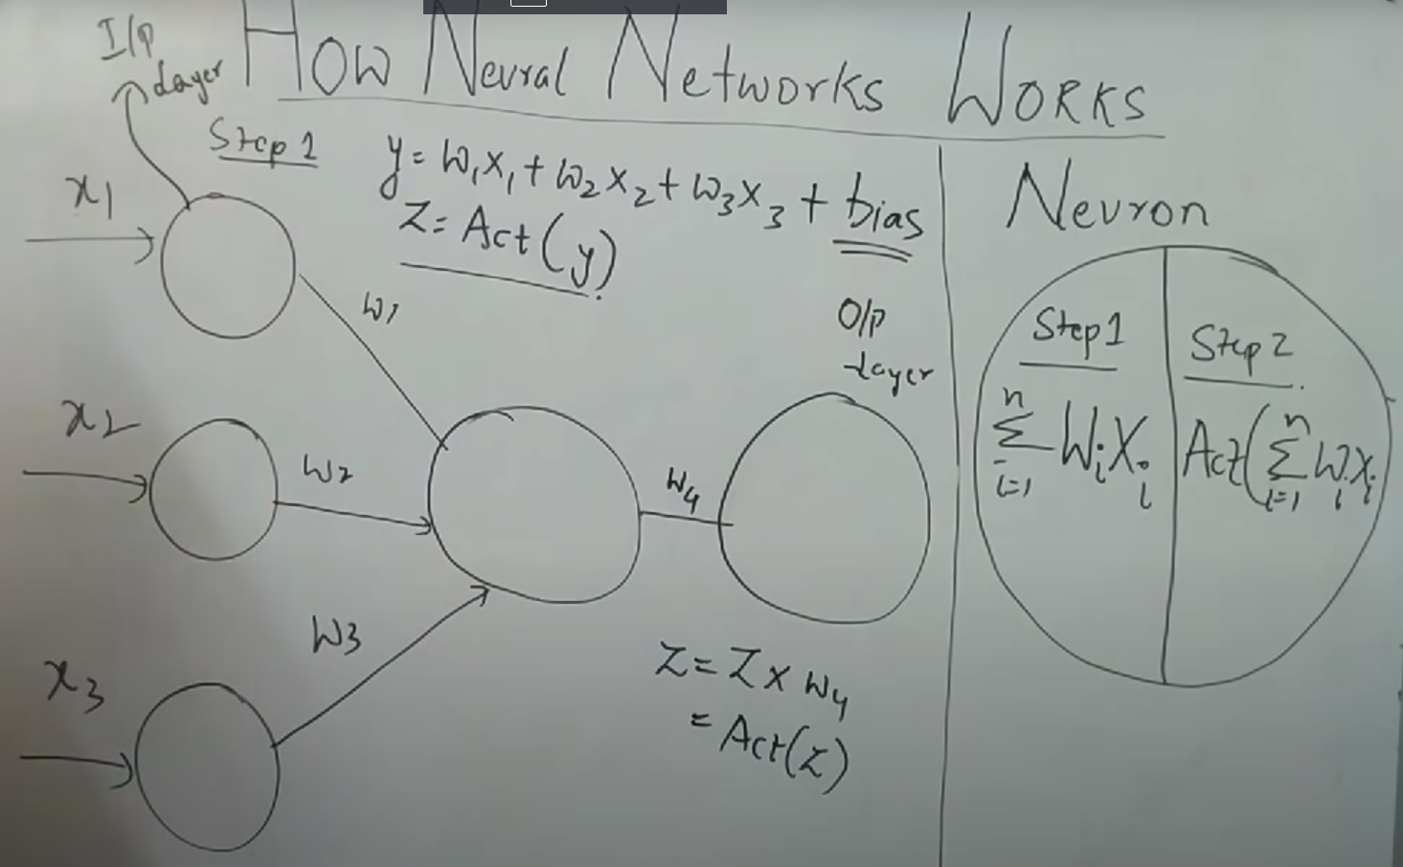

How does Neural network work?
=> Basically inputs are multiplied with weights and added & then passed through the activation function which converts the result into a form which is desired. This is how neural network works.

What is activation function?

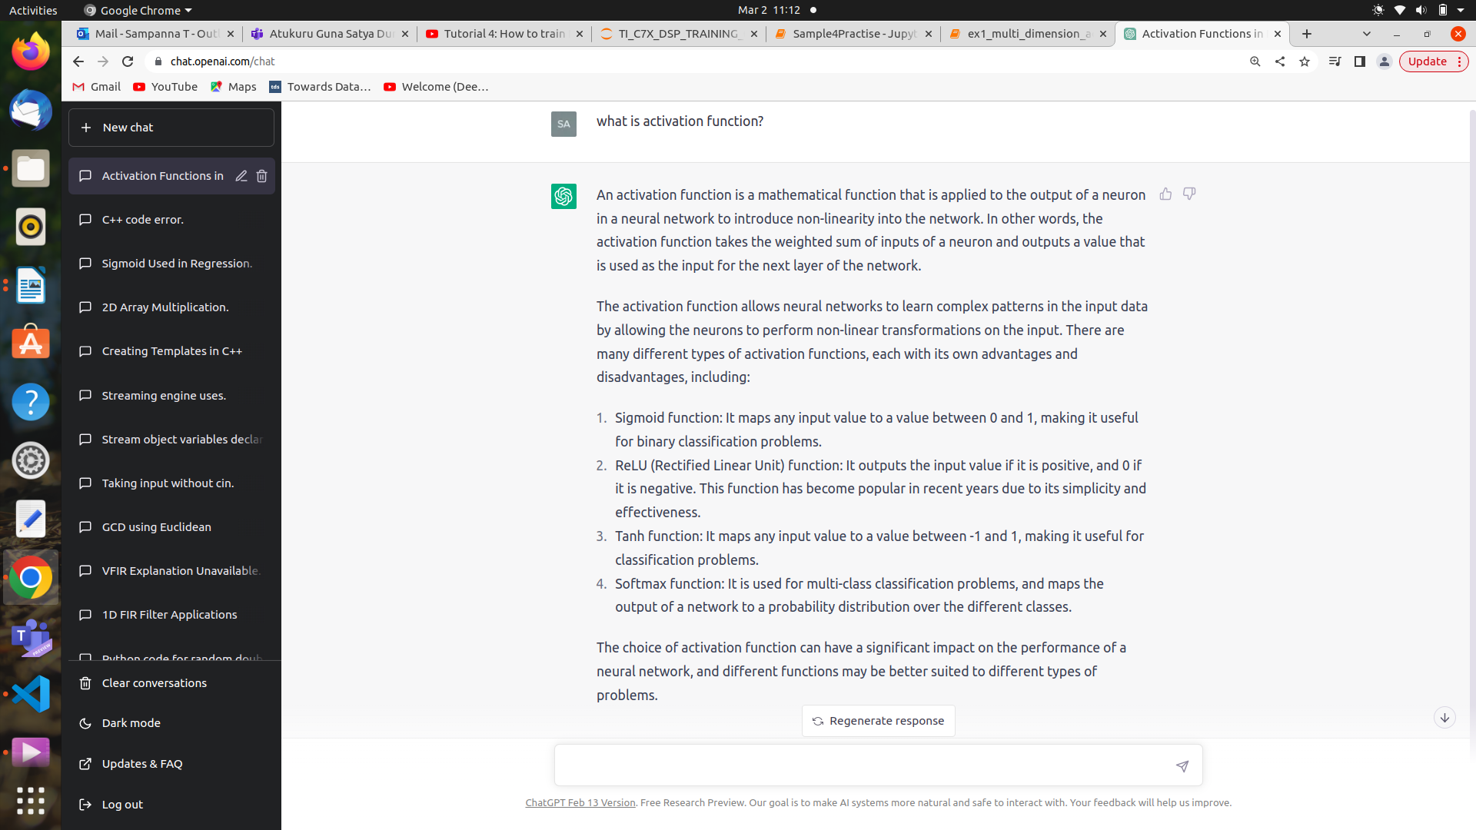
How neural network is trained?
It can be divided into forward & backward propagation=>

Here if we have 3 features x1,x2,x3 we know that weights would be w0,w1,w2,w3. Let’s say we have t1,t2,t3...t1000 training sets which holds the values of feature(x),output(y) i.e t1=>((x1,x2,x3)=(3,2,4) --> y=5), t2=>((x1,x2,x3)=(1,3,1)-->y=4),.... t1000=>((x1,x2,x3)=(1,6,7)-->y=3)
Initially we are taking some random weights i.e (w0,w1,w2,w3)=(3,5,2,1) and computing Ŷ(or predicted value) for all the training set i.e.
t1=>((x1,x2,x3)=(3,2,4) --> y=5,Ŷ=7), t1=>((x1,x2,x3)=(1,3,1)-->y=4,Ŷ=2),.... t1000=>((x1,x2,x3)=(1,6,7)-->y=3,Ŷ=4)
Now loss is computed using a function let’s say L = (y- Ŷ)² is used to compute the loss. For our case we get
L for t1 => (7-5)²
L for t2 => (4-2)²
.
.
.
L for t1000=>(3-4)²

If we take mean of this we get cost function J = (1/1000)Σ(L for ti)
where i=1 to 1000

Till here it is called forward propagation.
After this everything is backward propagation.

dJ/dw1
dJ/dw2
dJ/dw3

are computed and weights are updated based on the formula
w1 = w1-(learning_rate*dJ/dw1)
w2 = w2-(learning_rate*dJ/dw2)
w3 = w3-(learning_rate*dJ/dw3)

This process is gradient descent as weights are computed only after all the training cases loss function is computed..
But if weights are computed for every single training example case then it is called stochastic gradient descent.
Now after this weights are updated again all the above mentioned steps will be repeated.

What is an optimizer?

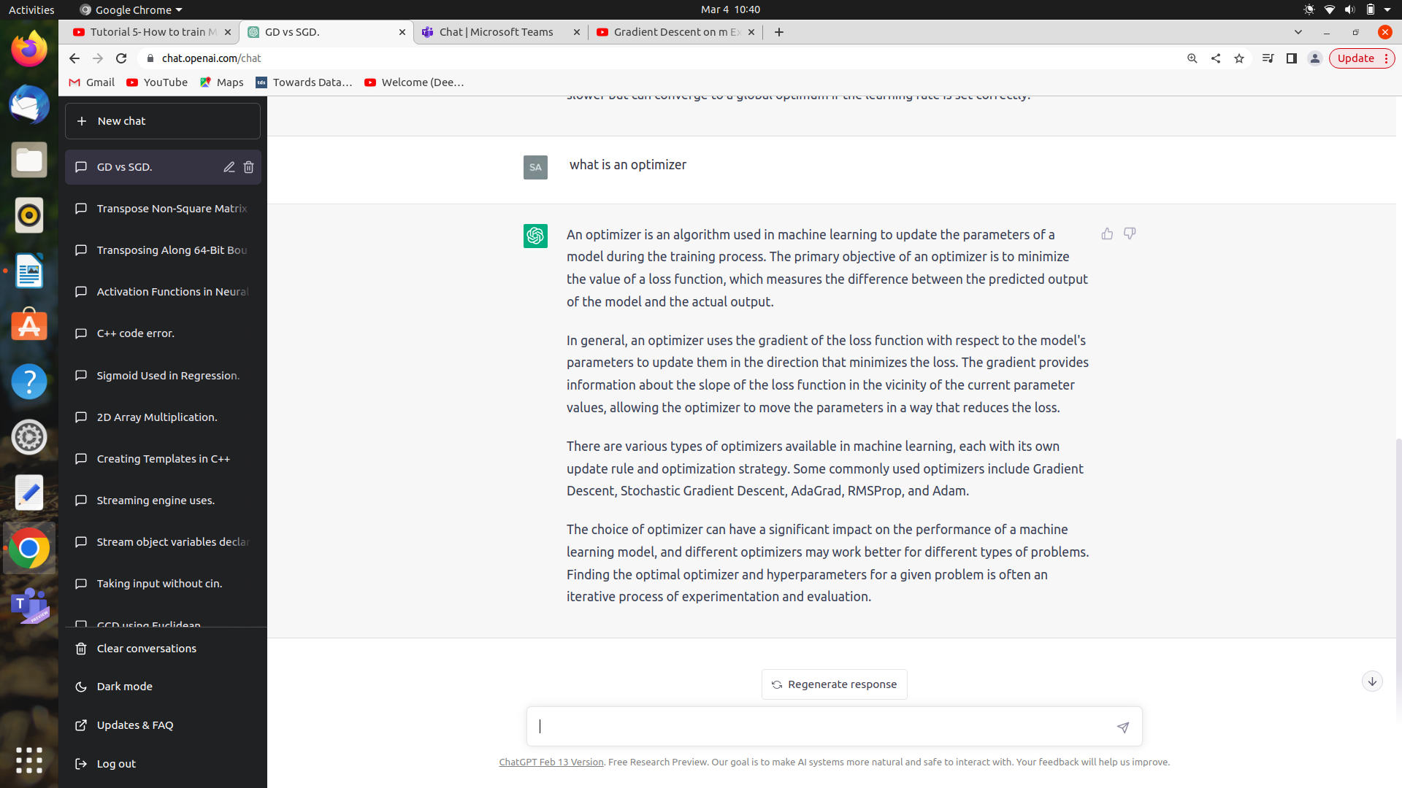

What is vanishing gradient problem?
In case of large neural network there might be chances of derivative value becoming very small so old value of weight will be updated very very slowly or stop. This situation is called vanishing gradient problem.
(in case of sigmoid function there are chances that this might happen)

What is exploding gradient problem?
While computing the weights when the product actually exceeds the range then invalid value will be taken for the weight. This situation is called exploding gradient problem.

Note: Hence even if you use sigmoid activation function try to use it at the end. Whereas in the inbetween hidden layer try to use only relu or leaky relu activation function to avoid vanishing gradient problem.

Types of optimizers
1)Gradient descent=>weights are updated only after all training set is computed
2)Stochastic gradient descent=> weights are updated after every single training set
3)minibatch stochastic gradient descent=>weights are updated after a batch from training set is computed
4)Adagrad optimizer=>Here learning rate changes after weights are updated i.e
new_learning_rate = (old_learning_rate)/sqrt(α+ϵ)
The reason why ϵ is used because if α=0 then new_learning_rate = infinity hence ϵ is taken a small positive value
So initially learning rate will be large which keeps decreasing until it reaches the convergence point.
Disadvantage => if α is very large then new_learning_rate becomes 0
So to avoid the above disadvantage we try to limit the value of α such that it doesn’t go very very high.
5)Ada delta & RMSProp => The above disadvantage of adagrad optimizer is solved here in Ada delta & RMS Prop by limiting the value of α.
6)Adam optimizer (Adaptive Moment Estimation)=> It uses the advantage of RMS prop and also tries to increase the momentum i.e. fastens the learning process.

Types of loss function
1)Squared error loss =>
loss function =>L = (y-Ŷ)²
cost function =>J = (1/t)Σ(y-Ŷ)² where t is number of test inputs

Advantages
1) As the equation is quadratic (i.e expressed as ax^2+bx+c) the plot will always have only one global minima and we don’t get any local minima.
2)Penality is provided by squaring the loss value.

Disadvantages

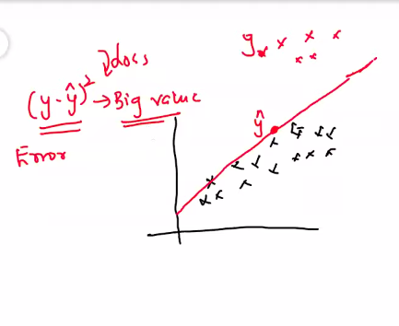

df

Here if very few points in red are so far then even that will also be penalized with a square.

2)Absolute error loss=>

loss function =>L = |(y-Ŷ)|
cost function =>J = (1/t)Σ|(y-Ŷ)| where t is number of test inputs

As the equation is linear it also has only global minima...
tries to give better outcome for outliers i.e previous case disadvatage it tries to reduce.

Disadvantage => It might have local minima

3)Huber loss=>
Combination of square error loss and absolute error loss.

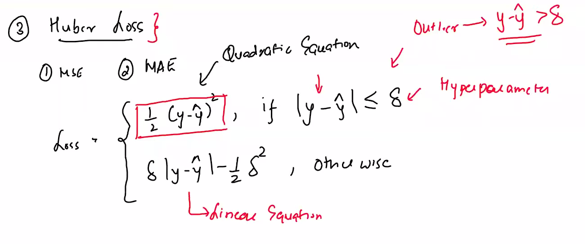
Mean square error, mean absolute error and huber loss is used in regression models.

4) Cross entropy
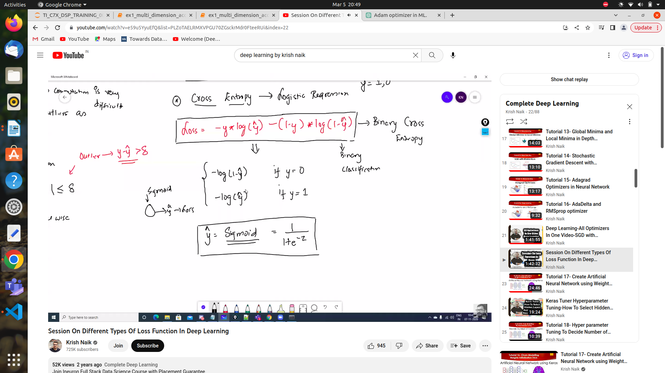

Here binary classification we use sigmoid activation function
And output prediction will be either 0 or 1.

5) Multiclass cross entropy

Heree in multiclass cross entropy we use softmax activation function
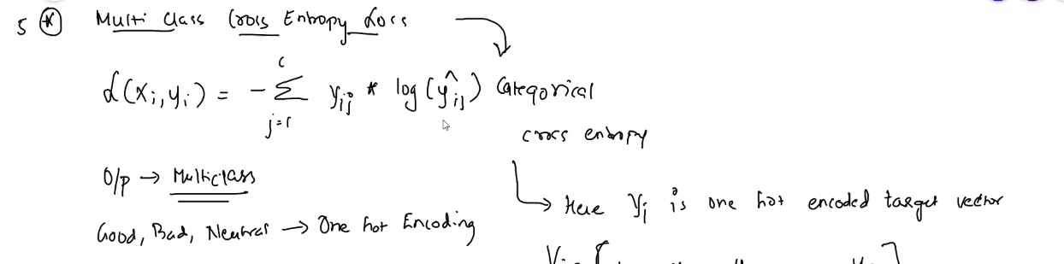
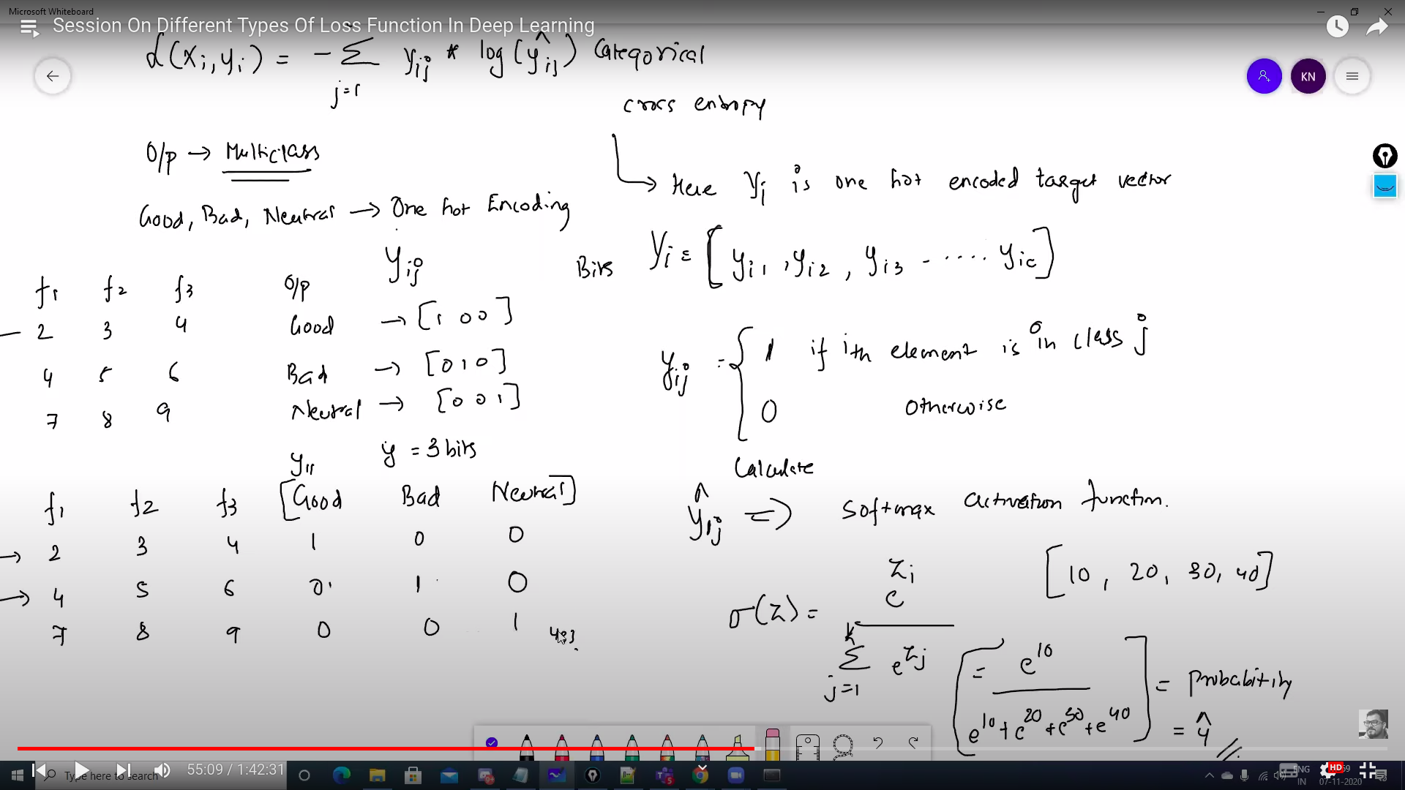
Here prediction would be [0.3,0.5,0.2] something like this.

In sparse cross entropy prediction would be max of above i.e index 1.

